**LAB : 04**

**OBJECTIVE:** GETTING FAMILIAR WITH RMI CALLBACK.

**TASK: 1:** Develop the RMI Callback application of Payroll and PayrollMessage services for calculating the earnings.

**Client Side:**

**-Interface Class**

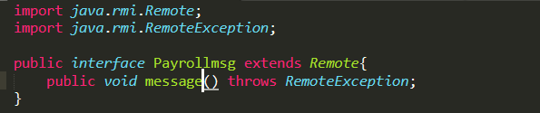

**-Remote Class**

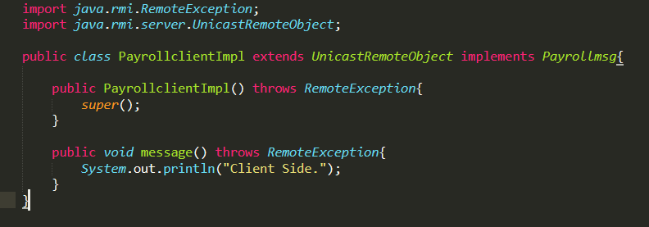

**-Client Class**

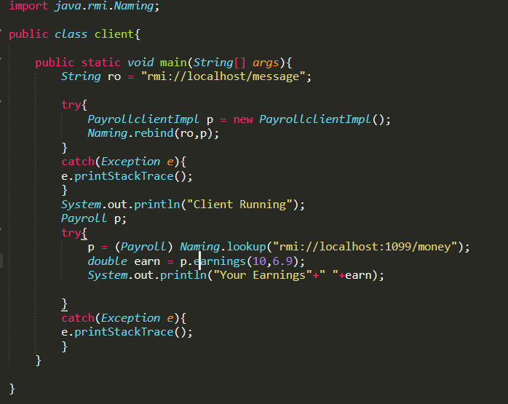

**Server Side**

**-Interface Class**

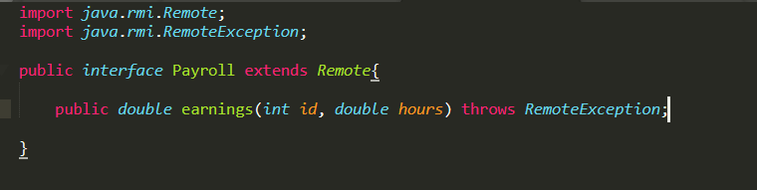

**-Remote Class:**

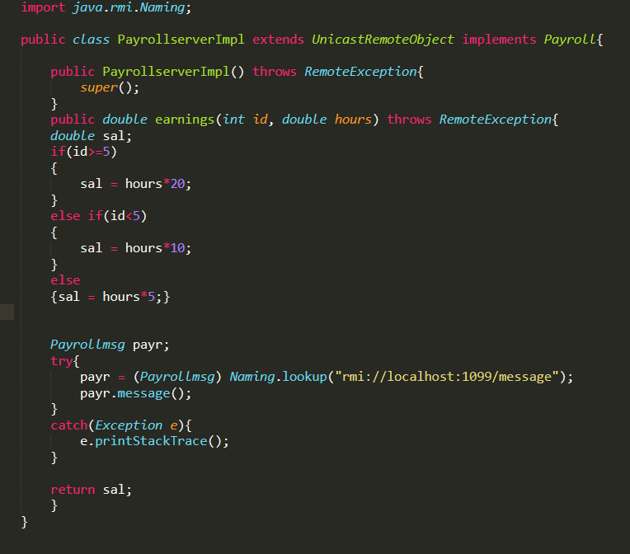

**-Server Class**

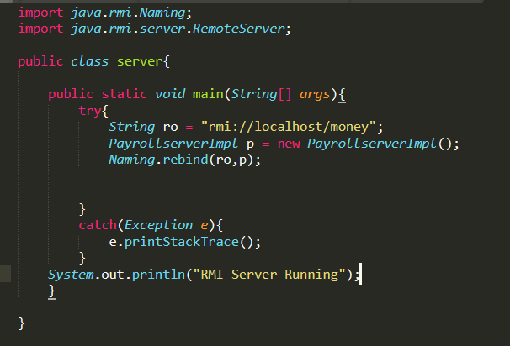

**-Output:**

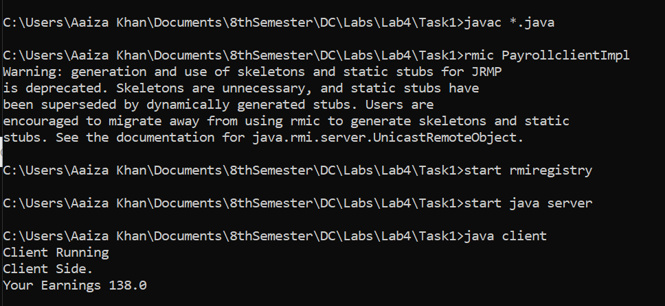

**Task: 2:** Develop an RMI application for chatting between client and server , the chatting should stop when both of them say “bye”.

**Client Class:**

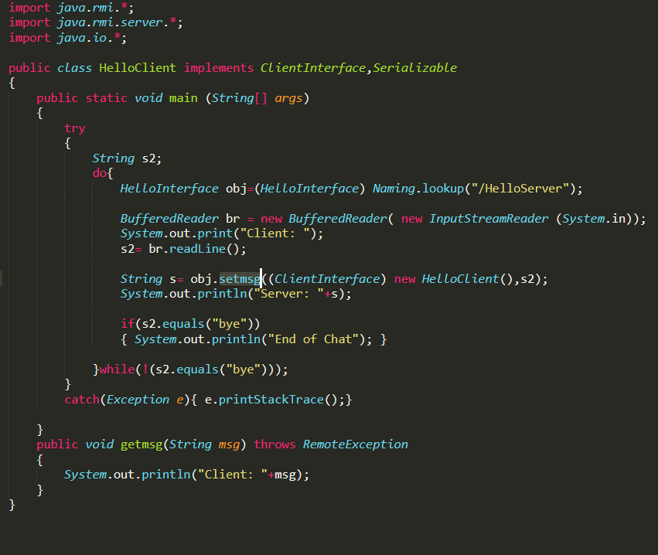

**Client Interface:**

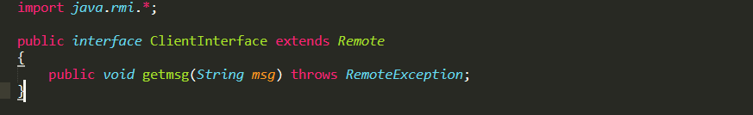

**Server Class:**

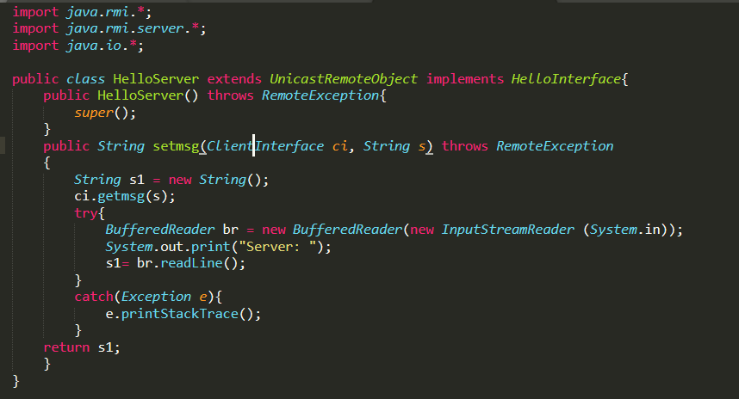

**Server Interface:**

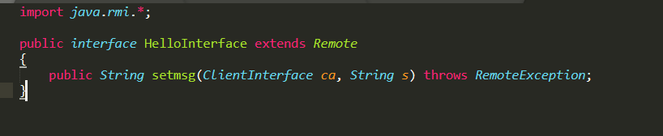

**Main Class:**

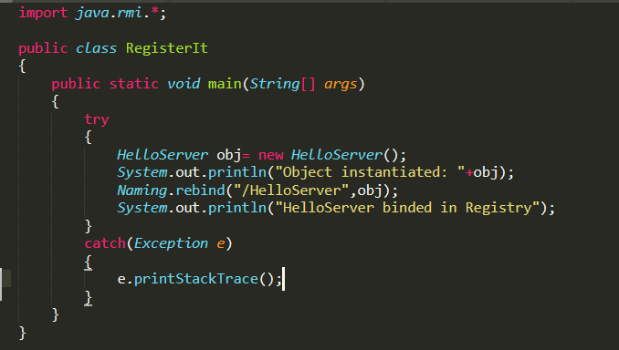

**Output:**

