**LAB : 05**

**OBJECTIVE:** TO BECOME FAMILIAR WITH RMI OBJECT SERIALIZATION.

**TASK:** Develop any simple application to demonstrate object passing in RMI. (Expl: Make a class of your own and use its objects as arguments and return types for RMI).

**-INTERFACE CLASS:**

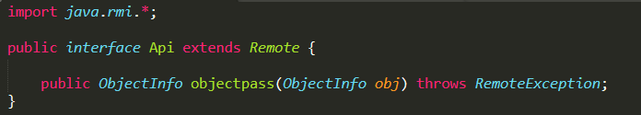

**-INTERFACE IMPLEMENTATION:**

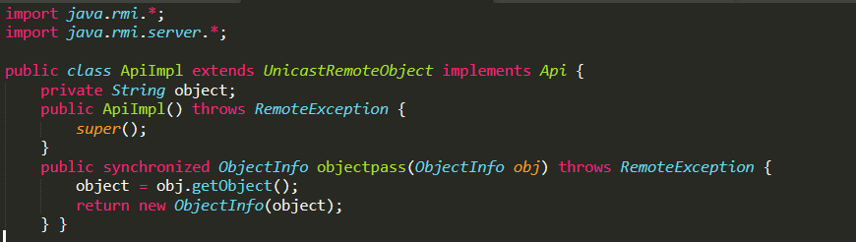

-**SERIALIZABLE CLASS:**

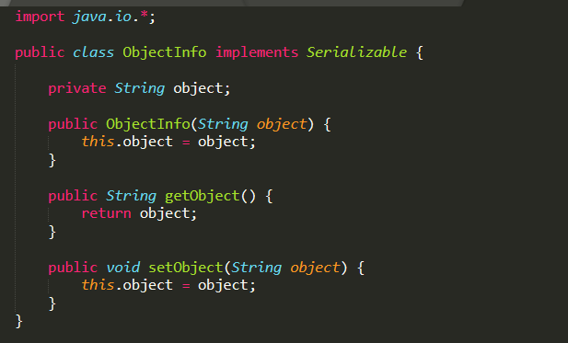

-**CLIENT CLASS:**

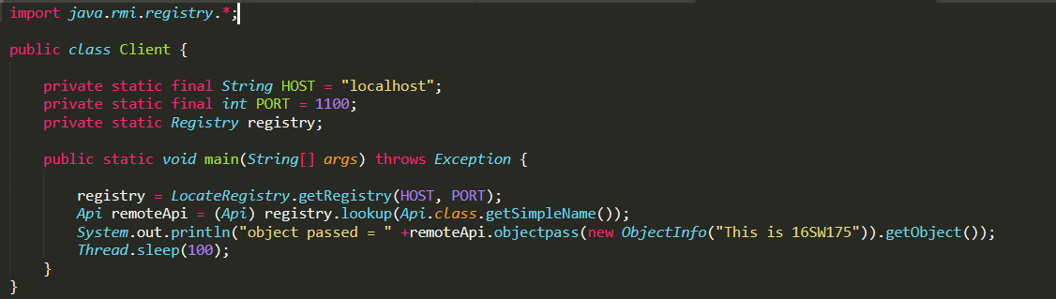

**-SERVER CLASS:**

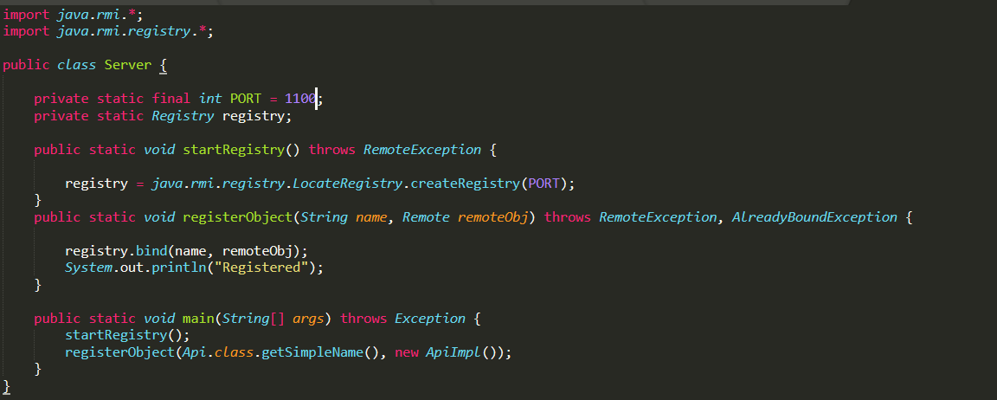

**-OUTPUT:**

