Lab#7

Task 1: Write the same code for matrix multiplication and divide the code into ten threads. Also note the timestamp at the start and end of the program. Give your conclusion.

**Simple Matrix Multiplication with main thread:**

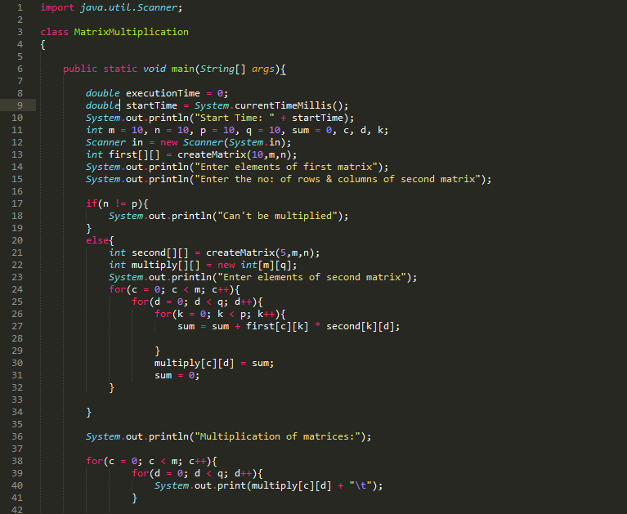

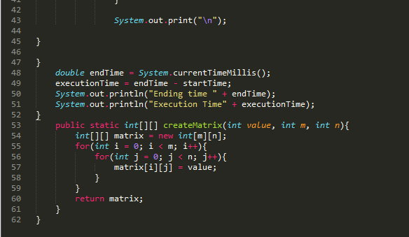

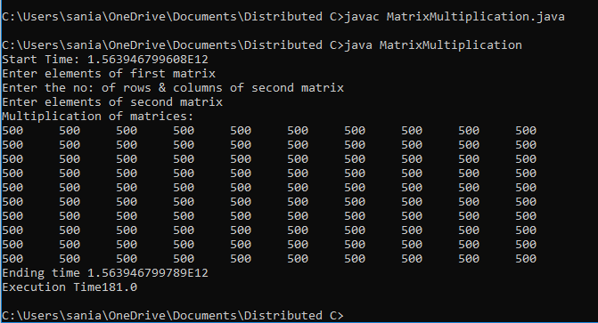

**Matrix Multiplication with multiple thread:**

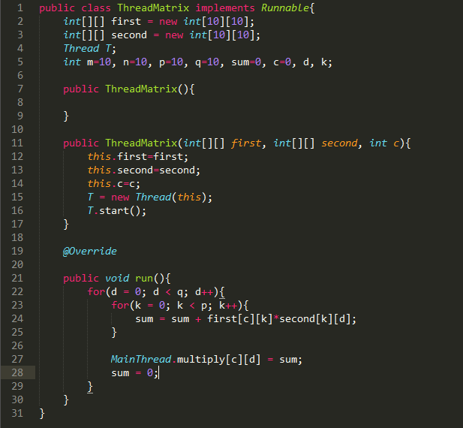

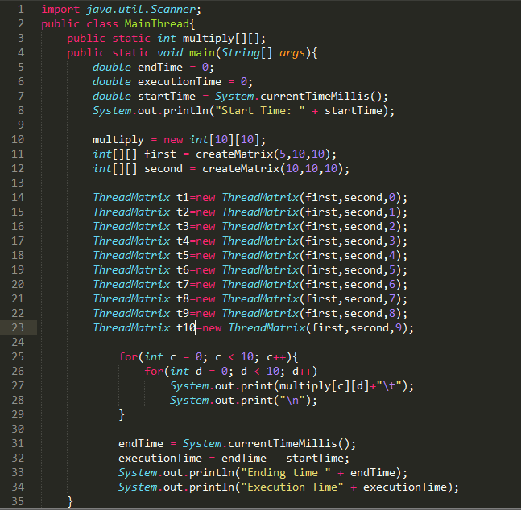

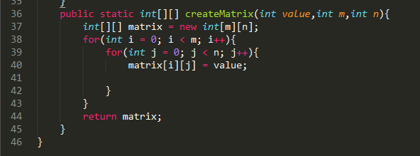

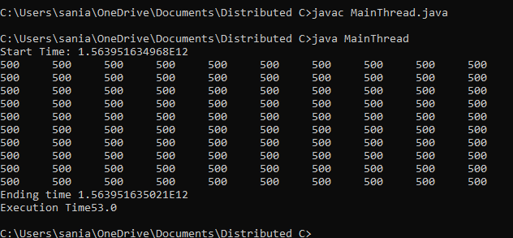

Results Conclusion: We have look at that besides threads it requires   
execution time 181 milliseconds and with threads it requires execution time 53 milliseconds.

**Synchronization task:**

With Out Synchronization

Table.java

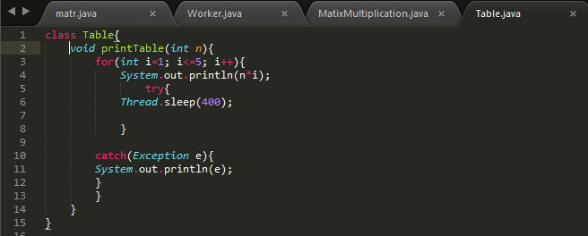

MyThread1.java

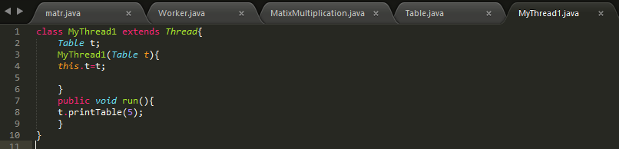

MyThread2.java

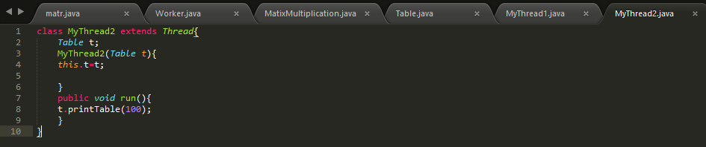

Withoutthreadsynchronization.java

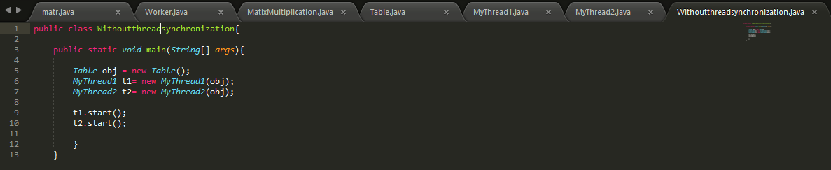

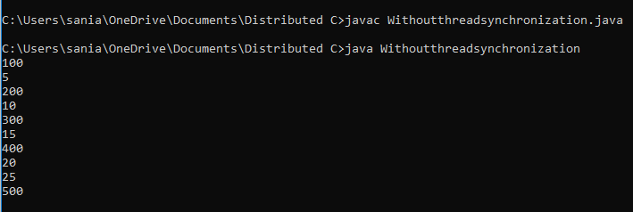

With Synchronization

Table.java

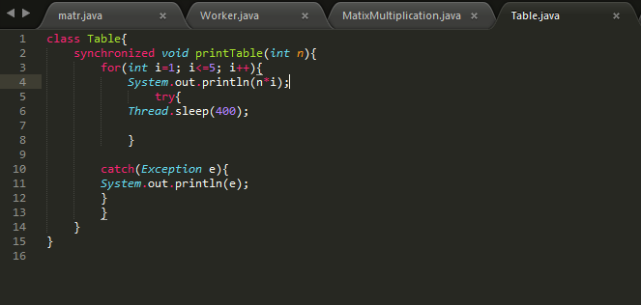

MyThread1.java

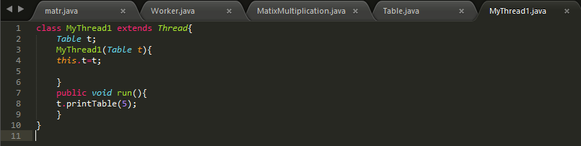

MyThread2.java

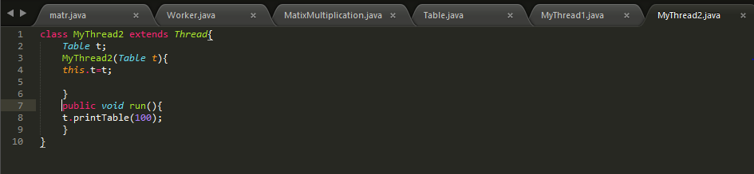

With

