**Lab # 9**

Objective : To learn ETL process for DWHs using Integration Services.

Class Task:

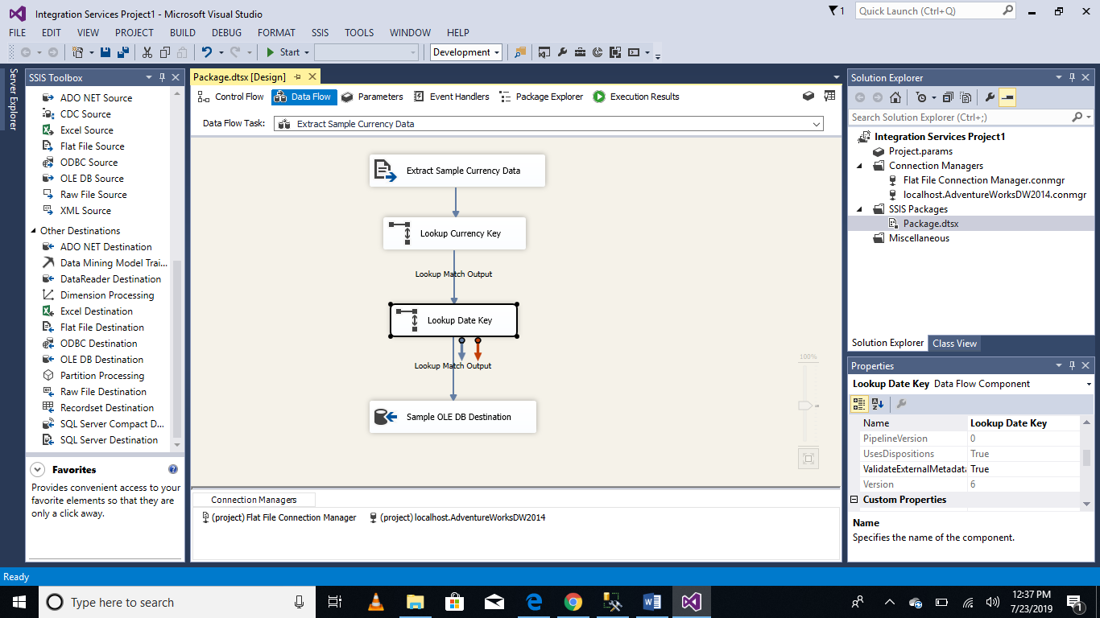

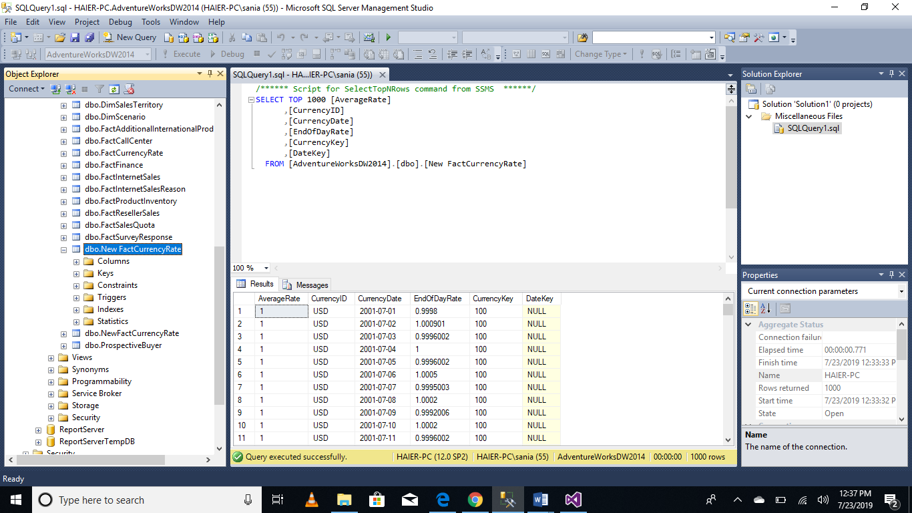

Lab Task:

Lab dealt with extracted data from a single flat file source, transformed the data using Lookup transformations, and finally loaded the data into the fact currency fact table of the adventureworksdw2014 sample database.

However, a typical ETL process would extract data from multiple flat file sources and you have to do so.

