INTEGRATED RISK DASHBOARD
Multi-Asset Trading Book
Comprehensive Market, Credit & Liquidity Risk Report
A full-suite quantitative review covering Value-at-Risk and Expected Shortfall, regulatory backtesting, scenario stress testing, Basel-IRB credit risk, option Greeks, fixed-income sensitivities, and portfolio construction across a twelve-position multi-asset book.
Prepared for: Market Risk & Technical Review
Reporting basis: latest computed risk run
Coverage: 12 positions · 5 asset classes · ~504 trading days of history
Frameworks: Basel III / FRTB · FRM curriculum (Jorion, Hull, Tuckman, Gordy)

Document Control & Disclaimer
Document. Integrated Risk Dashboard — Multi-Asset Trading Book: Comprehensive Market, Credit & Liquidity Risk Report.
Audience. Market-risk and technical review. The report assumes familiarity with standard risk vocabulary but explains each method as it is introduced.
Basis of preparation. All metrics are computed from a single, internally consistent risk run and are reproducible from the underlying database. Frameworks referenced are Basel III / FRTB and the FRM curriculum (Jorion on VaR, Hull on derivatives, Tuckman on fixed income, Gordy (2003) on the IRB credit model).
Currency and units. Indian rupees (₹) throughout; M = millions, bn = billions, bps = basis points.
Important disclaimer. The market data underlying this report is synthetic, generated by Geometric Brownian Motion with sector-calibrated volatilities. The tickers and companies named are real and are profiled for context, but the price paths, volatilities, correlations and shocks are illustrative calibrations — not live market parameters. Nothing in this document constitutes live risk reporting on, or investment advice regarding, the named companies. It is an educational, methodology-demonstrating report rather than a certified regulatory-capital submission.
Company facts. Background descriptions of the five equity issuers reflect publicly reported information as of mid-2026 and are included only to give context to the sector and volatility assumptions.

Table of Contents

1. Executive Risk Summary
This report presents a complete risk picture of an actively managed, multi-asset trading book modelled on the risk function of a mid-size bank. The book spans five asset classes — Indian equities, fixed income, listed options, an interest-rate swap and a foreign-exchange forward — and is analysed through the full regulatory toolkit a market-risk desk is expected to maintain under the Basel III framework and its Fundamental Review of the Trading Book (FRTB) successor. Every metric in this document is computed from a single, internally consistent dataset and is reproducible from the underlying risk database.
The headline conclusion is that the book is net-long market risk, moderately diversified, and currently operating comfortably inside its desk limits, but with two structural features that warrant ongoing attention: a heavy concentration of market risk in a handful of large equity positions, and a credit sub-portfolio whose expected loss is skewed toward its lowest-rated counterparties. A third, reassuring feature is that the foreign-exchange forward acts as a natural hedge, cushioning the book in every adverse equity scenario tested.

1.1 Key risk indicators at a glance
The table below summarises the principal risk metrics. All currency figures are in Indian rupees (₹); "M" denotes millions and "bn" denotes billions.
Indicator | Value | Reading / threshold
Portfolio notional (gross) | ₹1.92 bn | 12 positions across 5 asset classes
99% 1-day VaR (Historical) | ₹8.36 M | ≈ 0.44% of gross notional
97.5% 1-day ES (Historical) | ₹8.13 M | FRTB primary risk measure
99% 1-day VaR (Parametric) | ₹9.02 M | Most conservative of the three methods
VaR utilisation vs 2% NAV limit | ≈ 22% | Limit ₹38.4 M — ample headroom
Backtest exceptions (250-day) | 5 of 254 (1.97%) | Basel YELLOW zone
Total Expected Loss (credit) | ₹8.42 M | PD × LGD × EAD, four counterparties
Total Credit VaR (99.9%) | ₹47.3 M | Vasicek ASRF unexpected loss
Credit concentration (HHI) | 0.287 | Moderately concentrated
Worst stress P&L | −₹165.1 M | COVID-style crash scenario
Source: var_results, credit_metrics, stress_test_results, backtesting_results and positions tables of the risk database. Utilisation uses a 2%-of-gross-notional desk limit consistent with the dashboard DAX definition.

1.2 What the numbers say
Market risk is contained but concentrated. A 99% one-day VaR of roughly ₹8.4 million against a ₹1.92 billion book means that, on a normal trading day, losses are expected to exceed ₹8.4 million only about once every hundred days. That is a modest figure relative to the size of the book and leaves the desk using only about a fifth of its risk limit. However, the decomposition of VaR into per-position contributions shows that just two equities — HDFC Bank and Maruti Suzuki — account for more than half of the total market risk, and the top five equities account for virtually all of it. The book is therefore efficient in its use of limit but exposed to idiosyncratic moves in a small number of names.
Expected Shortfall confirms a well-behaved tail. Expected Shortfall — the average loss in the worst tail beyond VaR — sits only modestly above VaR at each confidence level (for example ₹9.36 million versus ₹8.36 million at 99% Historical). A tail that is close to VaR indicates the loss distribution is not dominated by a few catastrophic outliers; the move to ES as the FRTB standard does not, on this book, reveal hidden fragility.
The model is validated, with a caution flag. Backtesting the 99% VaR against realised daily P&L over 254 trading days produced five exceptions — losses larger than the predicted VaR — against an expected count of roughly 2.5 at the 1% level. Five exceptions places the model in the Basel "Yellow" zone, which does not invalidate the model but signals that it has been mildly optimistic and would, in a live regulatory setting, attract a small capital-multiplier add-on. Section 5 examines each exception.
Credit risk is small in expectation but fat-tailed. Expected credit losses of ₹8.4 million are immaterial against the book, but the 99.9% Credit VaR of ₹47.3 million — the capital a bank would hold against unexpected default losses under the Basel IRB approach — is an order of magnitude larger, and is driven disproportionately by the two lowest-rated corporate counterparties. The Herfindahl-Hirschman Index of 0.287 confirms a book that is concentrated rather than granular.
Stress testing reveals a built-in hedge. Of the five scenarios tested, only a COVID-style market crash produces a severe loss (−₹165 million); a global +300bp rate shock and the IL&FS-style credit event produce manageable losses, while a sharp rupee depreciation and a Taper-Tantrum scenario actually produce gains. The reason is the long-USD forward position, which appreciates whenever the rupee weakens and so offsets equity drawdowns in every scenario tested.

1.3 Priority observations for the desk
- Equity concentration. HDFC Bank, Maruti Suzuki and Sun Pharma jointly drive about three-quarters of component VaR. Consider whether single-name limits or a partial index hedge are warranted.
- Backtest in the Yellow zone. Five exceptions is one above the Green threshold. Review whether the 250-day historical window is capturing current volatility, or whether a volatility-scaled (filtered historical simulation) approach would track risk more responsively.
- Credit tail concentration. Corp C and Corp D contribute the majority of both Expected Loss and Credit VaR despite carrying the smallest exposures. The risk is priced into their PDs, but concentration in low-grade names amplifies the unexpected-loss tail.
- Hedge dependence. The book’s resilience to several stress scenarios rests on the long-USD forward. If that position is unwound or rolled off, the stress profile deteriorates materially. The hedge should be monitored as a structural, not incidental, feature.

1.4 Scope, basis and how to read this report
This report is organised so that a reader can either move top-to-bottom for a complete picture or jump directly to a pillar of interest. Each analytical section follows the same rhythm: it first explains the concept and the method in plain terms, then presents the results for this book (with the relevant chart and a supporting data table), and finally interprets what the numbers mean for the desk. Charts are numbered by section, and every results table cites the database table it is drawn from. Currency is Indian rupees throughout; "M" is millions and "bn" is billions; "bps" is basis points (hundredths of a percent).
Two framing points should be kept in mind. First, the figures describe a single computed risk run — a snapshot — and would be refreshed as positions and markets change; the architecture (Section 2) is designed so that each refresh is reproducible and auditable. Second, the underlying market data is synthetic, generated to be realistic in its relative risk characteristics but not drawn from live feeds; the analysis therefore demonstrates how the metrics behave and relate to one another rather than reporting live exposure on the named companies. Section 10 returns to these limitations in full.
The remainder of this report works through each of these areas in detail: the methodology and data foundations (Section 2), the instruments and the companies behind them (Section 3), and then the five analytical pillars — VaR and Expected Shortfall (Section 4), backtesting (Section 5), stress testing (Section 6), credit risk (Section 7) and Greeks and fixed-income sensitivities (Section 8) — before turning to portfolio construction (Section 9) and governance (Section 10).

2. System Architecture & Methodology
Before interpreting any single number, it is worth understanding how the risk system is built, where its data comes from, and which regulatory and academic conventions govern each calculation. This section describes the three-layer architecture, the synthetic data-generation process, and the methodological standards applied throughout.

2.1 A three-layer architecture
The system separates raw data, computation and presentation into three independent layers, mirroring how a production bank keeps its risk engine reproducible and its dashboards fast:
- Layer 1 — the database. A relational store holds the raw inputs (positions, daily prices, risk-factor histories) and every computed result (VaR, Greeks, durations, credit metrics, stress results and backtests). Each result row carries a calculation timestamp so that any reported figure can be traced to the run that produced it.
- Layer 2 — the Python risk engine. A set of computation modules reads raw data from the database, performs every metric calculation, and writes the results back. Each formula is documented with its FRM-curriculum reference and a note on why a bank uses it. The run is deterministic — seeded random numbers — so results are exactly reproducible.
- Layer 3 — the dashboard. A read-only reporting layer consumes the result tables and renders the seven analytical views. It never talks to the computation engine directly, which keeps reporting fast and the compute reproducible.
This separation is not merely tidy engineering. Regulators (the RBI in India, and the Basel Committee internationally) require that a bank be able to reproduce any reported risk number on demand. By isolating computation from presentation and timestamping every result, the architecture makes the entire history of risk runs auditable.

2.2 How the market data is generated
The price and rate histories used throughout this report are synthetic, generated by Geometric Brownian Motion (GBM) rather than drawn from live market feeds. GBM is the standard model in which the logarithm of a price follows a random walk with drift; it produces log-returns that are normally distributed and prices that are always positive. Each instrument is assigned a volatility appropriate to its sector — defensive consumer-staples names around 18% annualised, cyclical autos around 30%, and so on — so that the relative riskiness of the book is realistic even though the absolute price path is simulated.
Roughly 504 trading days (about two years) of daily history are generated for each instrument. Using synthetic data has one decisive advantage for a methodology demonstration: because the data-generating process is known and seeded, every downstream number is exactly reproducible and free of the gaps, corporate-action noise and vendor inconsistencies that complicate real feeds. The corresponding limitation — that these are not real market parameters and must not be read as live risk on the named companies — is stated plainly in Section 10.

2.3 Regulatory and academic conventions
Every metric follows an explicit convention so that results are comparable with how a real desk would report them:
Convention | Treatment in this report
Lookback window | 250 trading days, the Basel standard for historical VaR and backtesting.
Confidence levels | 95%, 97.5% and 99%. The 97.5% level is the FRTB Expected-Shortfall standard.
Horizon scaling | 1-day risk is scaled to multi-day horizons by the square-root-of-time rule (10-day ≈ 1-day × √10).
Risk measure | Both VaR and Expected Shortfall are reported; ES is the forward-looking FRTB primary measure.
Credit horizon | One-year, 99.9% confidence, consistent with the Basel IRB capital formula.
Greeks model | Black-Scholes-Merton closed form for option sensitivities.
Conventions follow the Basel III / FRTB framework and the FRM curriculum (Jorion on VaR, Hull on derivatives, Tuckman on fixed income, Gordy (2003) on the IRB credit model).
The square-root-of-time rule deserves a brief note because it recurs throughout the VaR section. It assumes that daily returns are independent and identically distributed, so that variance grows linearly with time and standard deviation (hence VaR) grows with the square root of time. The assumption is imperfect — real returns exhibit volatility clustering and autocorrelation — but it is the regulatory default and is transparent about its own approximation.

2.4 The seven analytical views
The reporting layer is organised into seven views, and this report maps onto them directly. Understanding the set as a whole clarifies how the pillars fit together:
- Executive summary — the headline indicators (portfolio value, VaR, ES, limit utilisation) that a desk head scans first.
- Market risk detail — VaR by method, confidence and horizon, plus the component decomposition.
- Greeks monitor — option sensitivities (delta, gamma, vega, theta, rho) and their portfolio aggregates.
- Fixed-income risk — duration, DV01, convexity and the curve-shift profile of the bond book.
- Credit risk — expected loss, Credit VaR and concentration across counterparties.
- Stress testing — scenario P&L across asset classes, the principal tail-risk lens.
- Backtesting — realised P&L against predicted VaR, with exception flagging and the Basel traffic light.
Each view answers a different governance question — "how much risk?", "where does it come from?", "how does it behave under stress?", "is the model trustworthy?" — and a complete risk function needs all of them. The remainder of this report is, in effect, a narrated walk through these seven views.

2.5 The risk taxonomy: which risks this book runs
It is worth naming the distinct risk types the book is exposed to, because each is measured by a different tool:
- Market risk — losses from moves in prices, rates, volatility and exchange rates. Measured by VaR, ES, the Greeks and duration/DV01.
- Credit risk — losses from counterparty default. Measured by expected loss and Credit VaR.
- Tail / scenario risk — losses from rare, severe events outside the VaR window. Measured by stress testing.
- Model risk — the risk that the risk model itself is wrong. Measured by backtesting and addressed through governance.
- Concentration risk — the amplification that comes from holding a few large or correlated positions. Measured by component VaR and the credit HHI.
This taxonomy is the scaffolding for the rest of the report: Sections 4 and 8 cover market risk, Section 5 model risk, Section 6 tail risk, Section 7 credit risk, and concentration runs as a theme through Sections 4, 7 and 9.

2.6 Inside the computation engine
The risk engine is organised into focused modules, each responsible for one family of metrics and each documenting its formulae, its curriculum reference and the reason a bank computes it. Naming them clarifies how the numbers in this report are produced:
- Market-risk module — the three VaR methods, Expected Shortfall, and the component and incremental decompositions, plus the walk-forward backtest.
- Greeks engine — Black-Scholes-Merton delta, gamma, vega, theta and rho, with portfolio aggregation and a delta-gamma P&L approximation.
- Fixed-income module — Macaulay and modified duration, DV01, convexity, bucketed DV01 and full-revaluation curve shifts.
- Credit module — expected loss, the Vasicek ASRF Credit VaR, correlated Monte-Carlo portfolio loss and the HHI.
- Stress module — the five calibrated scenarios with per-asset-class and total P&L.
Each module reads raw inputs from the database, computes its metrics, and writes timestamped results back. Because every module shares the same position and market-data source and the same seeded random state, the metrics are mutually consistent — the component VaRs sum to the portfolio VaR, the stress P&L reconciles across asset classes, and any figure can be reproduced exactly. This internal consistency is what allows the report to cross-reference numbers freely between sections without fear of definitional drift.

3. The Trading Book: Instruments & Companies
The book contains twelve positions. Five are equities in large Indian companies, three are fixed-income instruments, two are listed options, one is an interest-rate swap and one is a currency forward. This section first lays out the full book, then profiles each position — and, for the equities, the company behind it — in the detail a risk reviewer needs to understand where the exposures come from.

3.1 The book at a glance
Instrument | Asset class | Description | Notional (₹)
EQ_HDFCBANK | Equity | HDFC Bank Ltd | 99.0 M
EQ_SUNPHARMA | Equity | Sun Pharmaceutical Inds | 59.2 M
EQ_INFY | Equity | Infosys Ltd | 69.75 M
EQ_MARUTI | Equity | Maruti Suzuki India | 67.2 M
EQ_HINDUNILVR | Equity | Hindustan Unilever | 61.25 M
FI_GSEC_5Y | Fixed Income | GOI G-Sec 5Y | 50.0 M
FI_CORP_10Y | Fixed Income | AAA Corporate Bond 10Y | 30.0 M
FI_TBILL_91D | Fixed Income | T-Bill 91-day | 100.0 M
OPT_INFY_CALL | Option | INFY 6-month Call | 330.0 M
OPT_HDFCBANK_PUT | Option | HDFCBANK 3-month Put | 387.5 M
IRS_5Y | Swap | INR IRS 5Y pay-fixed | 250.0 M
FXF_USDINR_3M | FX | USD/INR 3-month forward (long USD) | 416.0 M
Source: positions table. Option, swap and FX notional are contractual/gross, not net economic exposure.
A crucial point of interpretation: the option, swap and forward notionals are contractual figures and dwarf the equity and bond positions, but they do not represent the economic risk those instruments carry. Options enter the market-risk calculation through their delta-equivalent exposure to the underlying, and the swap and forward through their rate and currency sensitivities. The equity sleeve, at ₹356 million of notional, is where most of the day-to-day VaR actually lives — as the component-VaR analysis in Section 4 confirms.
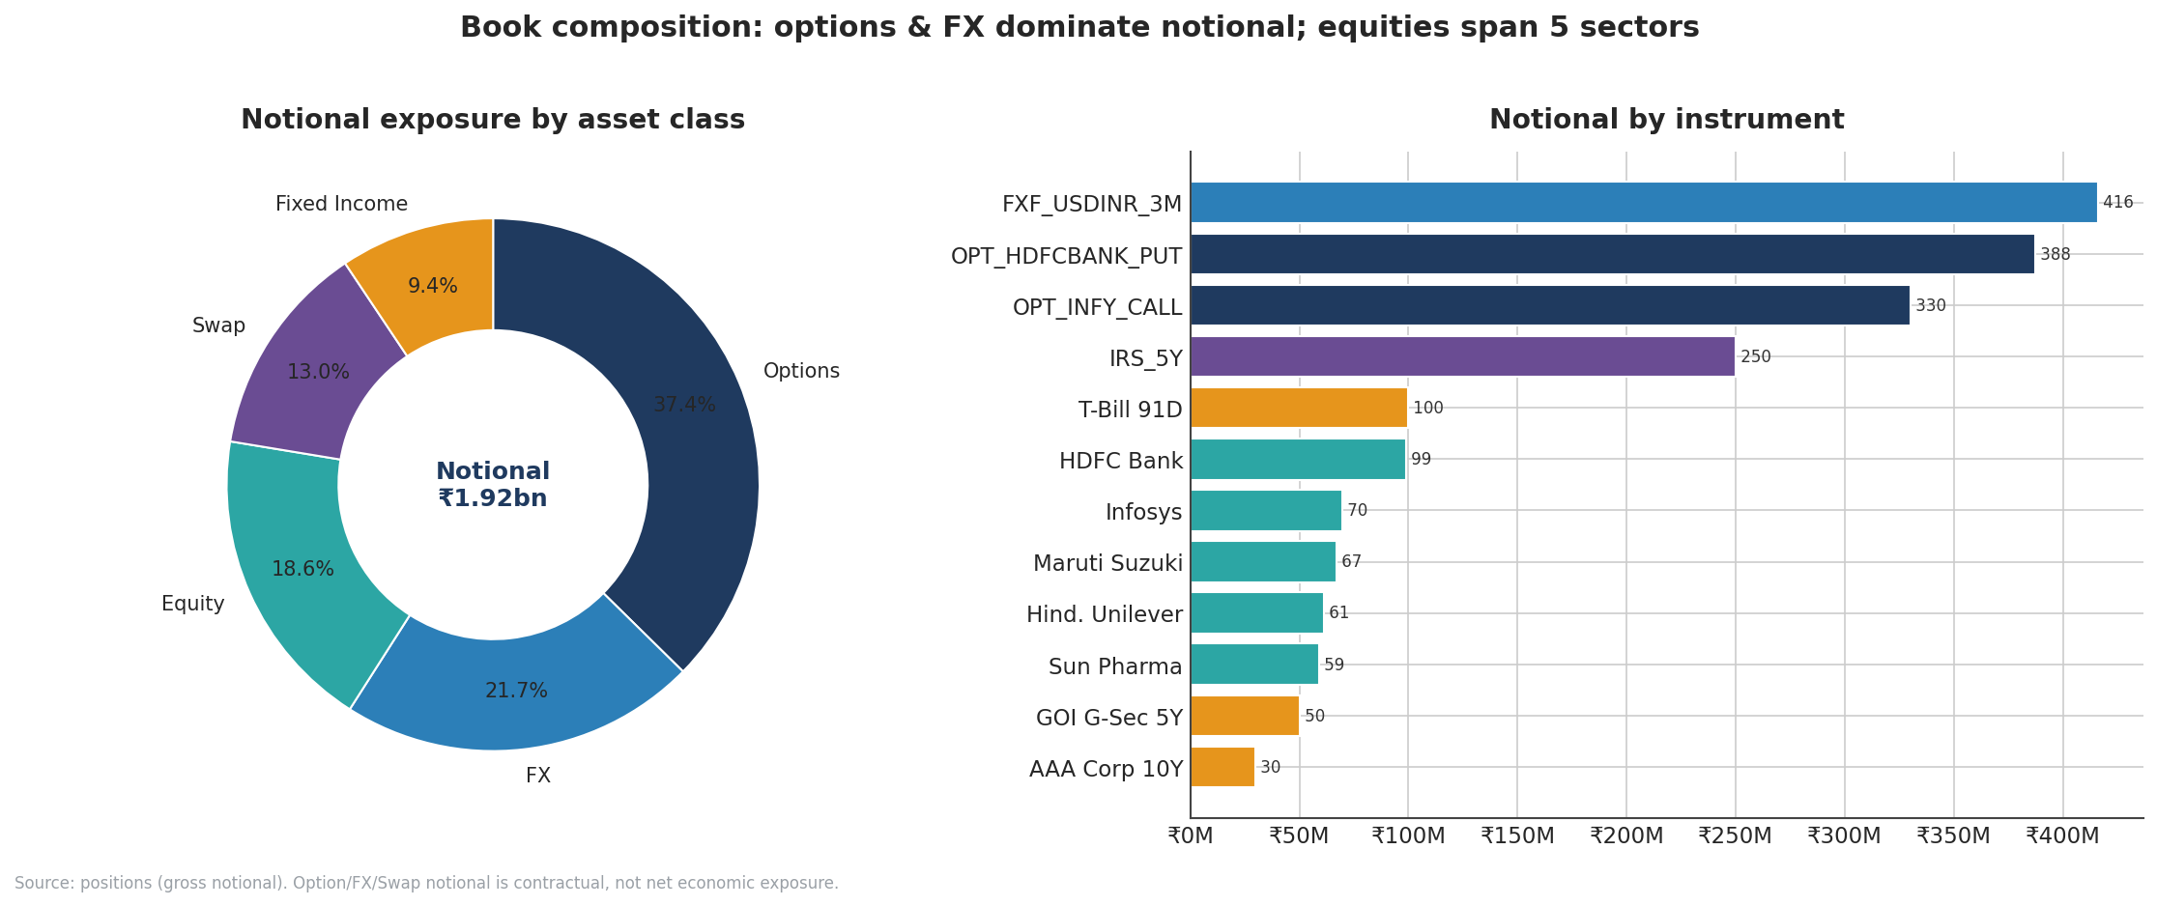
Figure 3.1 — Gross notional by asset class (left) and by individual instrument (right). Options and FX dominate contractual notional; the equity sleeve drives most market-risk VaR.
For reference, the full position detail — including quantity and entry price — is shown below. All positions share an entry date of 1 January 2024, the start of the simulated history.
Instrument | Quantity | Entry price (₹) | Notional (₹M) | Asset class
HDFC Bank | 60,000 | 1,650.00 | 99.00 | Equity
Sun Pharma | 40,000 | 1,480.00 | 59.20 | Equity
Infosys | 45,000 | 1,550.00 | 69.75 | Equity
Maruti Suzuki | 6,000 | 11,200.00 | 67.20 | Equity
Hindustan Unilever | 25,000 | 2,450.00 | 61.25 | Equity
GOI G-Sec 5Y | 500,000 | 100.00 | 50.00 | Fixed Income
AAA Corp 10Y | 300,000 | 100.00 | 30.00 | Fixed Income
T-Bill 91D | 1,000,000 | 100.00 | 100.00 | Fixed Income
INFY 6M Call | 200,000 | 1,650.00 | 330.00 | Option
HDFCBANK 3M Put | 250,000 | 1,550.00 | 387.50 | Option
INR IRS 5Y | 1 | 7.05% | 250.00 | Swap
USD/INR 3M Fwd | 5,000,000 | 83.50 | 416.00 | FX
Source: positions table. Swap "price" is the fixed rate; FX forward "price" is the contracted USD/INR rate.

3.2 The equity sleeve
The five equities were chosen to span the Indian large-cap market across defensive and cyclical sectors: a private-sector bank, a pharmaceutical major, an IT-services exporter, an automobile manufacturer and a consumer-staples leader. This sector spread is deliberate — it is what gives the book its diversification, because these sectors respond differently to the same macro shock. Each is profiled below with its business, its role in the book, and the volatility assumption that drives its risk contribution.

3.2.1 HDFC Bank Ltd (EQ_HDFCBANK) — Banking
HDFC Bank is India’s largest private-sector bank by assets and market capitalisation, with a market value of roughly ₹12.3 lakh crore (about US$127 billion) in 2026 and an asset base near ₹44 lakh crore. Headquartered in Mumbai, it offers the full spread of retail banking, wholesale/corporate banking and treasury operations through a network of more than 9,600 branches. The Reserve Bank of India designates it a Domestic Systemically Important Bank — one of the institutions considered "too big to fail" — alongside the State Bank of India and ICICI Bank. Its 2023 merger with parent HDFC Ltd substantially enlarged its balance sheet and broadened its product range into housing finance.
Role in the book. At ₹99 million notional (60,000 shares at an entry price of ₹1,650) HDFC Bank is the single largest equity holding and, as Section 4 shows, the single largest contributor to portfolio VaR. As a large-cap bank its share price is sensitive to interest-rate expectations, credit-cycle sentiment and broad market beta, which is why it dominates the risk decomposition. It is also the underlying for the book’s protective put option (Section 3.4), so the desk already holds downside insurance on this name.
Key risk drivers. Bank equities are leveraged plays on the macro-economy. HDFC Bank’s value responds to the trajectory of policy rates (which drive net interest margins), the credit cycle (which drives loan-loss provisioning), regulatory capital and liquidity requirements set by the RBI, and overall market beta — being a heavyweight index constituent, it tends to move with the broad market. Asset-quality surprises, deposit-growth trends following the HDFC Ltd merger, and any change in its systemic-importance buffer are the most likely sources of an idiosyncratic move. Because it is a D-SIB, idiosyncratic tail events are less likely than for a smaller bank, but its sheer index weight means it carries substantial systematic risk.
Behaviour in stress. In the COVID-style and IL&FS credit scenarios, bank stocks are typically among the hardest hit, because a deteriorating credit cycle threatens both earnings and capital. The book’s HDFC Bank put is precisely the instrument designed to blunt that blow: as the share price falls the put gains value, partially offsetting the cash-equity loss. This pairing — a large cash long with a targeted put overlay — is the clearest example in the book of risk being managed at the single-name level rather than only at the portfolio level.

3.2.2 Sun Pharmaceutical Industries (EQ_SUNPHARMA) — Pharma
Sun Pharma is India’s largest pharmaceutical company by revenue and market capitalisation (about ₹3.71 lakh crore in 2026) and the world’s fourth-largest specialty generics maker. It manufactures formulations and active pharmaceutical ingredients sold in more than 100 countries, with roughly 70% of revenue earned internationally and the US and India together accounting for over 60% of turnover. Its therapeutic range is broad — psychiatry, neurology, cardiology, ophthalmology, oncology and dermatology among others. In April 2026 it announced the all-cash acquisition of US-based Organon for US$11.75 billion, a deal expected to lift it into the top 25 global pharmaceutical companies.
Role in the book. At ₹59.2 million notional (40,000 shares at ₹1,480) Sun Pharma is the smallest equity by notional but, owing to pharmaceutical-sector volatility and its weight, it is the third-largest VaR contributor. Pharma is generally a defensive sector, but single-name risk — regulatory actions on plants, US generic-pricing pressure, large-deal integration — can drive idiosyncratic moves, which the volatility assumption captures.
Key risk drivers. A generics-heavy pharmaceutical company faces a distinctive risk set: US FDA inspection outcomes (an adverse observation on a manufacturing plant can wipe out a product line), pricing erosion in the US generics market, currency translation on its large export revenues, and integration risk from major acquisitions such as the Organon deal. Because roughly 70% of revenue is earned abroad, Sun Pharma — like Infosys — carries an implicit foreign-currency tailwind when the rupee weakens, which softens the correlation between its returns and the rest of the rupee-denominated book.
Behaviour in stress. As a defensive sector, pharma tends to outperform cyclicals in a broad downturn — earnings are relatively insulated because demand for medicine is inelastic. In the book’s stress scenarios Sun Pharma still contributes to the equity loss (no equity is immune to a COVID-magnitude crash), but its defensive character and export profile mean it is a partial diversifier against the more cyclical Maruti and HDFC Bank positions.

3.2.3 Infosys Ltd (EQ_INFY) — Information Technology
Infosys is one of India’s flagship IT-services exporters, reporting roughly US$20.2 billion of revenue in FY2026 with an operating margin around 20% and strong free-cash-flow generation. It positions itself as an "AI-first" business-consulting and technology-services firm, with large-deal total contract value near US$14.9 billion in the year. Its FY2027 revenue-growth guidance of 1.5–3.5% in constant currency reflects a maturing but still-growing franchise. Because the bulk of its revenue is earned in US dollars, Infosys is structurally a beneficiary of rupee depreciation — an exposure that matters for the book’s correlation structure.
Role in the book. At ₹69.75 million notional (45,000 shares at ₹1,550) Infosys is a mid-sized equity holding and a moderate VaR contributor. It is also the underlying for the book’s six-month call option (Section 3.4), so the desk holds leveraged upside to this name on top of the cash position. Its dollar-revenue profile gives it a partial natural alignment with the long-USD forward.
Key risk drivers. IT-services exporters live and die by three things: the discretionary technology-spending budgets of large US and European clients (which contract sharply in a global slowdown), the rupee-dollar exchange rate (a weaker rupee inflates rupee-reported revenue and margins), and, increasingly, the disruption and opportunity posed by generative AI to the traditional labour-arbitrage model. Wage inflation, attrition and large-deal conversion rates round out the picture. The combination of a long cash position and a long call means the book has a convex, leveraged bet on Infosys appreciating.
Behaviour in stress. Infosys sits between defensive and cyclical. In a pure risk-off equity crash it falls with the market, but in the rupee-depreciation and Taper-Tantrum scenarios its dollar revenues provide a partial cushion, echoing the long-USD forward at the single-stock level. The long call amplifies both directions: it magnifies gains in a rally and decays in a prolonged drift, so the position is best thought of as a deliberate volatility-and-direction bet on the name.

3.2.4 Maruti Suzuki India (EQ_MARUTI) — Automobiles
Maruti Suzuki is India’s largest passenger-vehicle manufacturer, commanding roughly 40% of the domestic market and posting record monthly sales through 2026 (for example 242,688 units in May 2026). As the bellwether of the Indian auto sector it is highly cyclical: its fortunes track consumer sentiment, financing costs, fuel prices and rural demand. That cyclicality translates directly into higher equity volatility than the defensive names in the book.
Role in the book. At ₹67.2 million notional (6,000 shares at an entry price of ₹11,200 — the highest per-share price in the book) Maruti is the second-largest VaR contributor despite not being the largest position, precisely because of its cyclical, high-beta character. It is the clearest example in the book of how volatility, not just notional size, drives risk contribution.
Key risk drivers. As the bellwether of the Indian passenger-vehicle market, Maruti is geared to the domestic consumption cycle: interest rates (most cars are financed), fuel prices, monsoon-dependent rural demand, raw-material (steel and precious-metal) costs, and the sector’s ongoing transition toward electric and hybrid powertrains. With around 40% market share its fortunes are also a proxy for Indian consumer confidence as a whole. These macro linkages give it the highest assumed volatility (~30%) among the book’s equities.
Behaviour in stress. Cyclicals are the first casualties of a downturn, and Maruti is the most cyclical name in the book. In the COVID-crash scenario it would be among the largest equity detractors; in a rate-shock scenario it suffers from the hit to vehicle financing. It carries no single-name hedge, so — unlike HDFC Bank — its downside is unprotected. This makes it the most natural candidate for any future hedging the desk might add, a point echoed in the recommendations of Section 10.

3.2.5 Hindustan Unilever (EQ_HINDUNILVR) — FMCG
Hindustan Unilever (HUL) is India’s largest fast-moving consumer-goods company and a subsidiary of Unilever, with annual revenue around ₹64,000 crore. Its portfolio of more than 50 brands spans home care, beauty and personal care, and foods and refreshments, with nearly 85% of the business holding the number-one or number-two position in its category and a hair-care share above 50%. As a consumer-staples leader it is the archetypal defensive stock — demand for its products is relatively insensitive to the economic cycle.
Role in the book. At ₹61.25 million notional (25,000 shares at ₹2,450) HUL is the smallest VaR contributor among the equities, consistent with its low (≈18% annualised) volatility assumption. It is the book’s defensive ballast: in a downturn its price typically falls less than the cyclical names, dampening overall portfolio volatility and improving diversification.
Key risk drivers. Consumer-staples companies are valued for the stability and predictability of their cash flows, so their main risks are slow-moving: input-cost inflation (palm oil, crude derivatives, packaging), rural-versus-urban demand mix, competitive intensity from regional and direct-to-consumer brands, and the pace at which channels such as quick-commerce reshape distribution. HUL’s premium valuation also makes it sensitive to shifts in interest rates through the discount-rate channel — high-multiple defensives can de-rate when bond yields rise.
Behaviour in stress. HUL is the book’s defensive anchor. In every downturn scenario it is expected to fall the least of the five equities, which is exactly why its component VaR is the smallest. Its low correlation with the cyclical names (Section 9) is the mechanism through which it improves the book’s diversification: holding it lowers portfolio volatility by more than its standalone risk would suggest.

3.3 The fixed-income sleeve
Three bonds give the book interest-rate exposure across the curve: a five-year government security, a ten-year AAA corporate bond and a 91-day Treasury bill. Their risk is measured not by equity-style volatility but by duration and DV01 — the sensitivity of price to a change in yield — which Section 8 analyses in full.
- GOI G-Sec 5Y (FI_GSEC_5Y), ₹50 M. A five-year Government of India sovereign bond — the benchmark risk-free instrument. With a modified duration near 4.1 years it carries meaningful but middling rate sensitivity and no credit risk.
- AAA Corporate Bond 10Y (FI_CORP_10Y), ₹30 M. A ten-year top-rated corporate bond. Its longer maturity gives it the highest duration (≈6.8 years) and convexity in the book, so it is the most rate-sensitive position despite its modest notional. It carries a small spread/credit element over the sovereign.
- T-Bill 91-day (FI_TBILL_91D), ₹100 M. A short-dated sovereign bill. With a duration near 0.23 years it is almost insensitive to rate moves and functions as a near-cash, liquidity-management holding — note that it is also a modest negative-to-zero contributor to equity-driven VaR, acting as a diversifier.

3.4 The options
Two listed options add non-linear exposure to the book, and both reference equities already held — so they layer optionality on top of cash positions:
- INFY 6-month Call (OPT_INFY_CALL), ₹330 M contractual. A long call on Infosys. It gives leveraged upside to the IT name: a large positive delta, positive gamma and large positive vega mean the position gains from both a rising Infosys price and rising implied volatility. Its Greeks dominate the portfolio sensitivity profile in Section 8.
- HDFCBANK 3-month Put (OPT_HDFCBANK_PUT), ₹387.5 M contractual. A put on HDFC Bank, providing downside protection on the book’s largest equity holding. Its negative delta partially offsets the long cash position in HDFC Bank, and it gains value if the bank’s share price falls — explicit insurance against the book’s biggest single-name risk.

3.5 The interest-rate swap and the FX forward
INR 5-year interest-rate swap (IRS_5Y), ₹250 M. A pay-fixed, receive-floating rupee swap. It adds rate exposure: the position loses value if rates fall (the fixed leg becomes relatively expensive) and gains if rates rise. Together with the bonds it shapes the book’s overall rate sensitivity.
USD/INR 3-month forward, long USD (FXF_USDINR_3M), ₹416 M. A long-dollar forward at an entry rate of ₹83.50. This is the single most important hedging instrument in the book. Because it appreciates whenever the rupee weakens, it offsets the equity losses that typically accompany risk-off, rupee-depreciating episodes. As Section 6 shows, this forward turns several would-be loss scenarios into gains and is the reason the book is so resilient to FX and rate shocks.
With the instruments and the companies behind them established, the report now turns to the five analytical pillars, beginning with the central market-risk measures: Value-at-Risk and Expected Shortfall.

3.6 Why this sector mix
The equity sleeve is not a random selection of large-caps; it is a deliberate spread across sectors with different sensitivities to the same macro drivers. The table summarises the role each sector plays and its assumed volatility character.
Stock | Sector | Cyclicality | Primary macro driver
HDFC Bank | Banking | Cyclical | Rates, credit cycle, market beta
Maruti Suzuki | Automobiles | Highly cyclical | Consumer demand, financing costs
Sun Pharma | Pharmaceuticals | Defensive | US generics, FX, regulation
Infosys | IT services | Mid-cyclical | Global tech spend, USD/INR
Hind. Unilever | Consumer staples | Defensive | Input costs, consumption
Sector characterisation is qualitative context; the quantitative volatility assumptions live in the engine configuration.
The logic of the mix is that defensive names (HUL, Sun Pharma) and dollar-earners (Infosys, Sun Pharma) do not fall as far, or fall for different reasons, than the cyclicals (Maruti, HDFC Bank) in a given shock. That dispersion of responses is what produces the low return correlations documented in Section 9 and, through them, the diversification benefit that holds portfolio VaR below the sum of the standalone risks. A book of five banks would carry far more risk for the same notional; a book spread across five sectors carries less. The sector spread is, in other words, the single most important risk-management decision embedded in the book’s construction.

4. Value at Risk & Expected Shortfall
Value-at-Risk (VaR) is the single most widely used summary of market risk. It answers a deceptively simple question: over a given horizon and at a given confidence level, what is the most the book could lose under normal market conditions? A 99% one-day VaR of ₹8.4 million means that on 99 days out of 100 the one-day loss should not exceed ₹8.4 million — and, equivalently, that on about one day in a hundred it will. VaR does not say how bad that hundredth day might be; that is the job of Expected Shortfall, discussed below.

4.1 Three ways to compute VaR
No single VaR number is "correct" — each method embeds different assumptions, and a robust desk computes all three and compares them. This report uses the three standard approaches:
- Historical Simulation. Re-prices the book using the actual distribution of returns observed over the 250-day window and reads VaR off the empirical loss quantile. Its great strength is that it makes no assumption about the shape of the return distribution — fat tails and skew are captured automatically because they are in the data. Its weakness is that it can only "see" events that occurred in the window.
- Parametric (Variance-Covariance / Delta-Normal). Assumes returns are normally distributed and computes VaR from the portfolio’s volatility, using the full covariance matrix of the positions. It is fast and analytically clean, but because the normal distribution has thin tails it can understate risk when real returns are fat-tailed. On this book it is the most conservative method — a sign the positions’ modelled volatilities are high relative to the realised tail.
- Monte Carlo Simulation. Simulates tens of thousands of correlated return scenarios (drawing from a multivariate normal calibrated by a Cholesky decomposition of the covariance matrix) and re-prices the book under each. It combines the flexibility of simulation with full control over the assumed distribution and is the natural framework for books with non-linear (option) exposures.
All three are reported at three confidence levels (95%, 97.5%, 99%) and three horizons (1, 5 and 10 days), giving a complete grid that lets the desk see how risk scales with both severity and time.

4.2 Portfolio VaR results
The figure below shows one-day VaR for all three methods at each confidence level, with Historical Expected Shortfall overlaid as red diamonds. Two patterns stand out: VaR rises with confidence (a more extreme quantile is a larger loss), and the Parametric method sits highest at every level, with Monte Carlo and Historical close together below it.
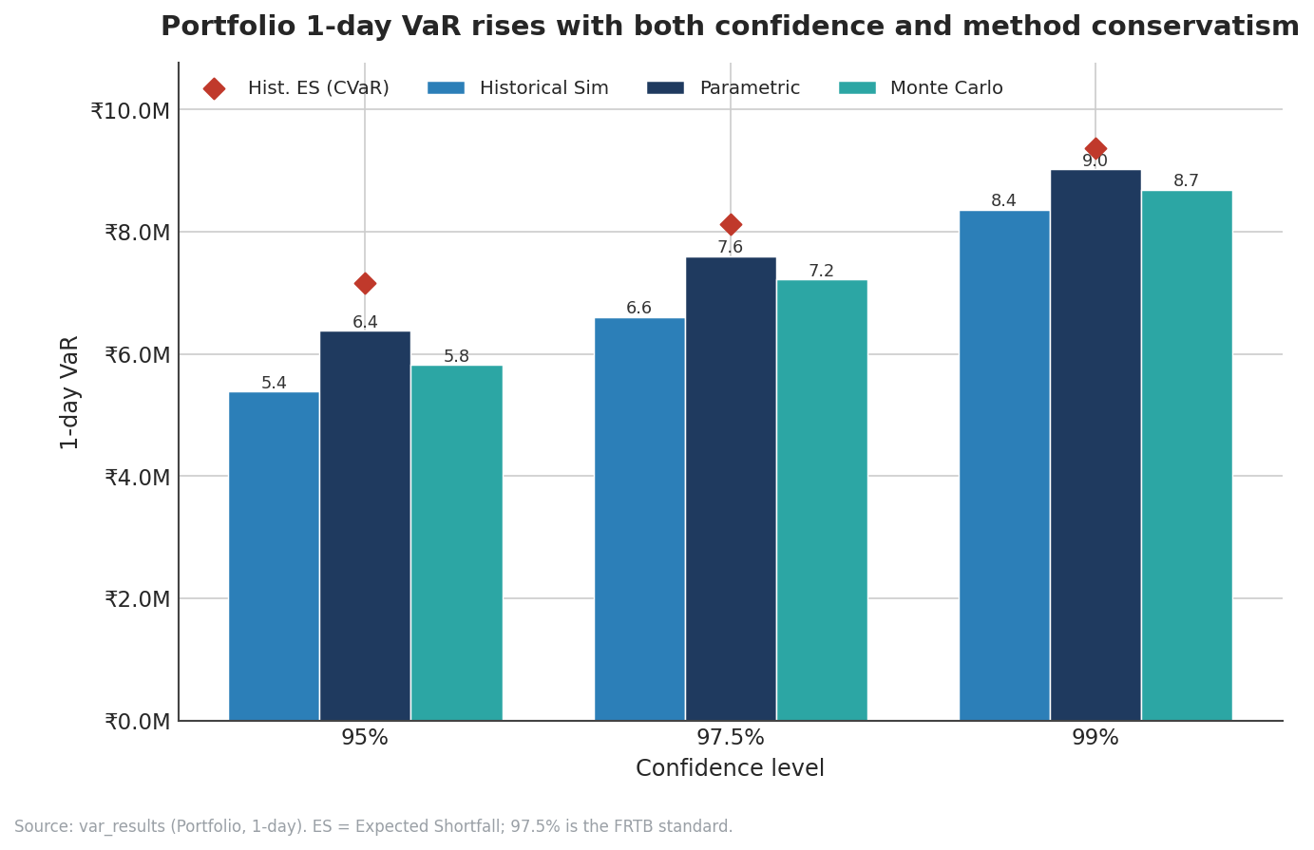
Figure 4.1 — Portfolio 1-day VaR by method and confidence level, with Historical ES (red diamonds). Parametric is the most conservative; ES sits modestly above VaR, indicating a well-behaved tail.
The full numerical grid for the one-day horizon is given below. Expected Shortfall (the average loss beyond VaR) is shown alongside each VaR.
Method | Conf. | VaR (₹M) | ES (₹M) | ES / VaR
Historical | 95% | 5.38 | 7.17 | 1.33
Historical | 97.5% | 6.60 | 8.13 | 1.23
Historical | 99% | 8.36 | 9.36 | 1.12
Parametric | 95% | 6.38 | 8.00 | 1.25
Parametric | 97.5% | 7.60 | 9.07 | 1.19
Parametric | 99% | 9.02 | 10.34 | 1.15
Monte Carlo | 95% | 5.82 | 7.55 | 1.30
Monte Carlo | 97.5% | 7.22 | 8.72 | 1.21
Monte Carlo | 99% | 8.68 | 10.04 | 1.16
Source: var_results, metric_type = Portfolio, horizon = 1 day. ES = Expected Shortfall (Conditional VaR).
Reading the ES/VaR ratio. The final column — ES divided by VaR — is a compact measure of tail fatness. A ratio close to 1 means the average loss beyond VaR is only slightly worse than VaR itself, i.e. a thin tail; a large ratio signals a dangerous tail where the rare losses are far worse than the VaR threshold suggests. Here the ratios fall from about 1.3 at 95% to about 1.1–1.16 at 99%, all comfortably low. The book does not harbour a hidden fat tail, which is reassuring given the FRTB shift toward ES as the binding measure.

4.3 Expected Shortfall and why FRTB prefers it
VaR has a well-known theoretical flaw: it is not a "coherent" risk measure because it can violate sub-additivity — the risk of a combined portfolio can appear larger than the sum of its parts, which is nonsensical for a diversification measure. It also says nothing about the severity of losses in the tail beyond the cut-off. Expected Shortfall fixes both problems: it is coherent, and it is defined precisely as the average loss conditional on being in the worst tail. For these reasons the Basel Committee’s Fundamental Review of the Trading Book made 97.5% Expected Shortfall the primary regulatory risk measure, replacing 99% VaR. This report computes both so that results are comparable across the old and new standards; notably, 97.5% ES (₹8.13 M Historical) and 99% VaR (₹8.36 M Historical) are close, which is by design — the FRTB chose 97.5% ES partly because it broadly matches 99% VaR for normal distributions.

4.4 How risk scales with time
Capital and limit frameworks rarely care only about one-day risk; the Basel market-risk horizon is ten days. The figure below shows the 99% VaR term structure — how VaR grows as the horizon extends from 1 to 5 to 10 days — for each method, with Historical ES overlaid.
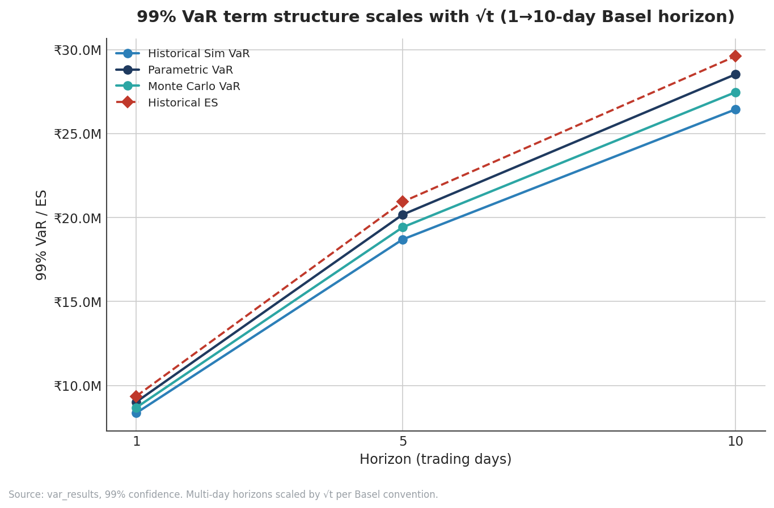
Figure 4.2 — 99% VaR / ES term structure across 1-, 5- and 10-day horizons. Multi-day figures are scaled from the 1-day estimate by the square-root-of-time rule.
The curves rise but flatten, which is the visual signature of square-root scaling: moving from 1 to 10 days multiplies risk by roughly √10 ≈ 3.16, not by 10. So the 99% Historical VaR grows from about ₹8.4 million (1-day) to about ₹26.4 million (10-day). The practical implication is that lengthening the holding horizon increases risk far less than proportionally — a key reason why liquidity and the ability to exit positions quickly matter so much to a trading desk.

4.5 Where the risk actually sits: component and incremental VaR
A single portfolio VaR number hides where the risk comes from. Two complementary decompositions answer that:
- Component VaR attributes the total to each position in a way that sums exactly to the portfolio VaR. It accounts for diversification: a position’s component VaR can even be negative if it hedges the rest of the book.
- Incremental VaR measures how much total VaR would change if a position were removed entirely — the marginal risk each holding adds. It is the natural input to "should we cut this position?" decisions.
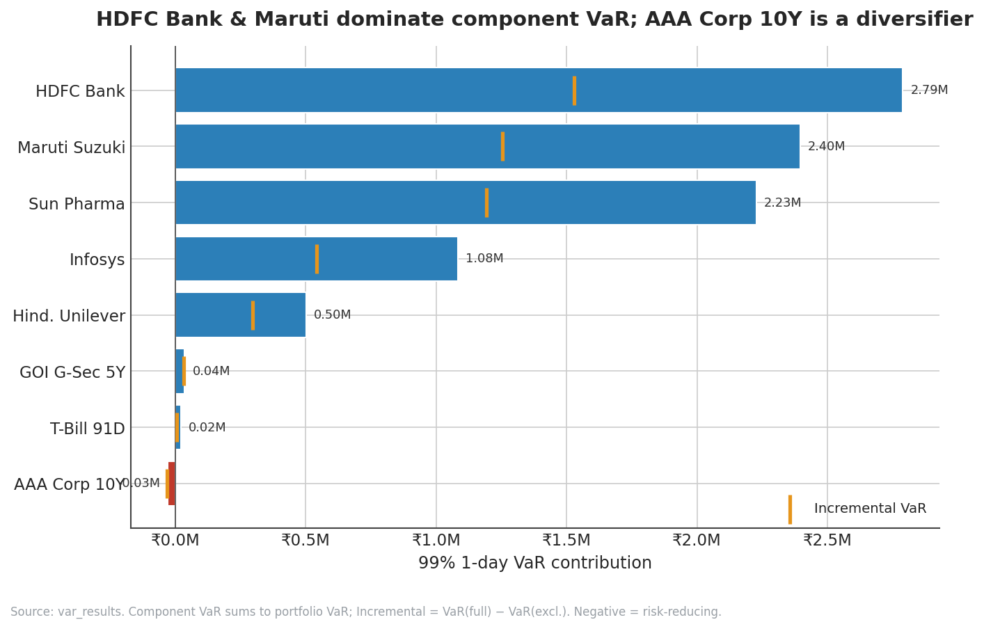
Figure 4.3 — Component VaR (bars, summing to portfolio VaR) and Incremental VaR (amber markers) at 99%, 1-day. HDFC Bank and Maruti dominate; the AAA Corporate 10Y bond is a small risk-reducing diversifier.
The decomposition makes the concentration unmistakable. HDFC Bank (₹2.79 M), Maruti Suzuki (₹2.40 M) and Sun Pharma (₹2.23 M) together account for roughly three-quarters of the ₹9.02 M parametric portfolio VaR; adding Infosys (₹1.08 M) and Hindustan Unilever (₹0.50 M) accounts for essentially all of it. The fixed-income positions contribute almost nothing, and the AAA Corporate 10Y bond actually shows a small negative component VaR — it is a diversifier, moving in a way that slightly offsets the equity book. The ordering also illustrates the volatility-versus-size point from Section 3: Maruti is not the largest position but is the second-largest risk contributor because of its cyclical, high-beta character.
Position | Component VaR (₹M) | Incremental VaR (₹M) | Share of total
HDFC Bank | 2.79 | 1.53 | 30.9%
Maruti Suzuki | 2.40 | 1.25 | 26.6%
Sun Pharma | 2.23 | 1.19 | 24.7%
Infosys | 1.08 | 0.54 | 12.0%
Hindustan Unilever | 0.50 | 0.30 | 5.6%
GOI G-Sec 5Y | 0.04 | 0.03 | 0.4%
T-Bill 91D | 0.02 | 0.00 | 0.2%
AAA Corp 10Y | −0.03 | −0.03 | −0.3%
Source: var_results, metric_type = Component and Incremental, 99% 1-day. Component VaR sums to the parametric portfolio VaR of ₹9.02 M; shares may not total 100% due to rounding and the negative diversifier.
Desk implication. Because risk is so concentrated, the most capital-efficient way to reduce portfolio VaR is to trim or hedge the top three equities rather than the long tail of small positions. The book already holds a put on HDFC Bank, which is precisely the kind of targeted hedge this decomposition recommends; a similar case could be made for the cyclical Maruti exposure.

4.6 Why the three methods disagree
A useful diagnostic is to compare the three methods directly. At 99% one-day, Historical Simulation gives ₹8.36 M, Monte Carlo ₹8.68 M and Parametric ₹9.02 M — a spread of about 8% between the lowest and highest. That the two normal-based methods (Parametric and Monte Carlo) sit above the empirical Historical figure tells a specific story: on this book the modelled volatilities imply a slightly wider normal distribution than the realised return history actually exhibited over the window. In many real books the relationship is reversed — fat tails make the empirical Historical VaR the largest — so the desk should not treat this ordering as permanent. The discipline of running all three is precisely to catch the regime in which they diverge: a widening gap between Parametric and Historical VaR is an early warning that the distributional assumptions and the realised data are drifting apart.
A note on the parametric formula. Parametric VaR is computed as z × σ_p, where σ_p is the portfolio standard deviation derived from the position vector and the full covariance matrix (σ_p = √(vᵀΣv)), and z is the standard-normal quantile for the chosen confidence (1.645 at 95%, 1.96 at 97.5%, 2.326 at 99%). The covariance matrix Σ is what carries the diversification benefit into the number: because the off-diagonal correlations are low (Section 9), σ_p is much smaller than the sum of the individual position volatilities, and the VaR is correspondingly lower than a naïve sum-of-parts estimate would be.

4.7 The full VaR grid: 5-day and 10-day horizons
For completeness, the tables below give VaR and ES at the 5-day and 10-day horizons, obtained by √t scaling of the one-day figures. These are the numbers a desk would use for limit-setting against multi-day holding assumptions and for the Basel ten-day regulatory horizon.

5-day horizon
Method | Conf. | VaR (₹M) | ES (₹M)
Historical | 95% | 12.04 | 16.02
Historical | 99% | 18.70 | 20.94
Parametric | 95% | 14.26 | 17.89
Parametric | 99% | 20.17 | 23.11
Monte Carlo | 95% | 13.00 | 16.87
Monte Carlo | 99% | 19.42 | 22.45

10-day horizon (Basel regulatory)
Method | Conf. | VaR (₹M) | ES (₹M)
Historical | 95% | 17.03 | 22.66
Historical | 99% | 26.44 | 29.61
Parametric | 95% | 20.17 | 25.30
Parametric | 99% | 28.53 | 32.69
Monte Carlo | 95% | 18.39 | 23.86
Monte Carlo | 99% | 27.46 | 31.74
Source: var_results, horizons 5 and 10 days. Multi-day figures scaled from 1-day by √t per Basel convention.

4.8 The limitations of VaR
VaR is indispensable but imperfect, and a technical reader should hold its weaknesses in mind alongside its results. Four are worth stating explicitly. First, VaR is silent about the size of losses beyond the cut-off — a 99% VaR says nothing about the worst 1% of days, which is exactly why Expected Shortfall and stress testing exist. Second, ordinary VaR is not sub-additive in general, so it can understate the benefit of diversification or, occasionally, suggest that combining portfolios increases risk; ES repairs this. Third, VaR is backward-looking — it is calibrated on a historical window and assumes the recent past is a reasonable guide to the near future, an assumption that fails precisely in regime changes (the backtest exceptions in Section 5 are the footprint of this). Fourth, VaR depends on choices — window length, weighting scheme, distributional assumption — that materially affect the number, which is why this report computes three methods rather than one.
The practical posture that follows is to treat VaR as one instrument in an ensemble. It is excellent for day-to-day limit monitoring and for comparing risk across desks on a common scale, but it must be paired with ES for tail awareness, with stress testing for scenario awareness, and with backtesting for model awareness. No single number governs a trading book responsibly; the value of the dashboard is that it presents the whole ensemble together.

5. Backtesting
A VaR model is only as good as its track record. Backtesting is the discipline of checking, after the fact, whether the model’s predictions held up: on how many days did the realised loss exceed the VaR the model had forecast? At the 99% confidence level a correct model should be breached on about 1% of days. Too many breaches means the model is under-stating risk; far too few means it is wastefully over-stating it. Regulators require banks to backtest continuously, and the result directly affects the capital multiplier applied to their market-risk charge.

5.1 Method and the Basel Traffic Light
This report runs a walk-forward backtest: for each day in the test period the 99% one-day Historical-Simulation VaR is computed using only data available up to that day, and is then compared with the next day’s realised profit-and-loss. A day on which the loss exceeds the VaR threshold is flagged as an "exception". The Basel Committee classifies the number of exceptions in a 250-day window into three zones:
Zone | Exceptions / 250d | Regulatory consequence
Green | 0 – 4 | Model accepted; no capital add-on.
Yellow | 5 – 9 | Model usable but a capital multiplier add-on applies; scrutiny increases.
Red | 10 + | Model presumed flawed; maximum add-on and remediation required.
Basel 1996 market-risk framework; the multiplier scales the capital charge from a base of 3× upward as exceptions accumulate.

5.2 Results
Over 254 trading days the book recorded five exceptions, against a theoretical expectation of about 2.5 at the 1% level — an exception rate of 1.97%. Five exceptions places the model in the Yellow zone. The figure below plots every day’s P&L against the ±99% VaR thresholds, with the five exception days marked in red.
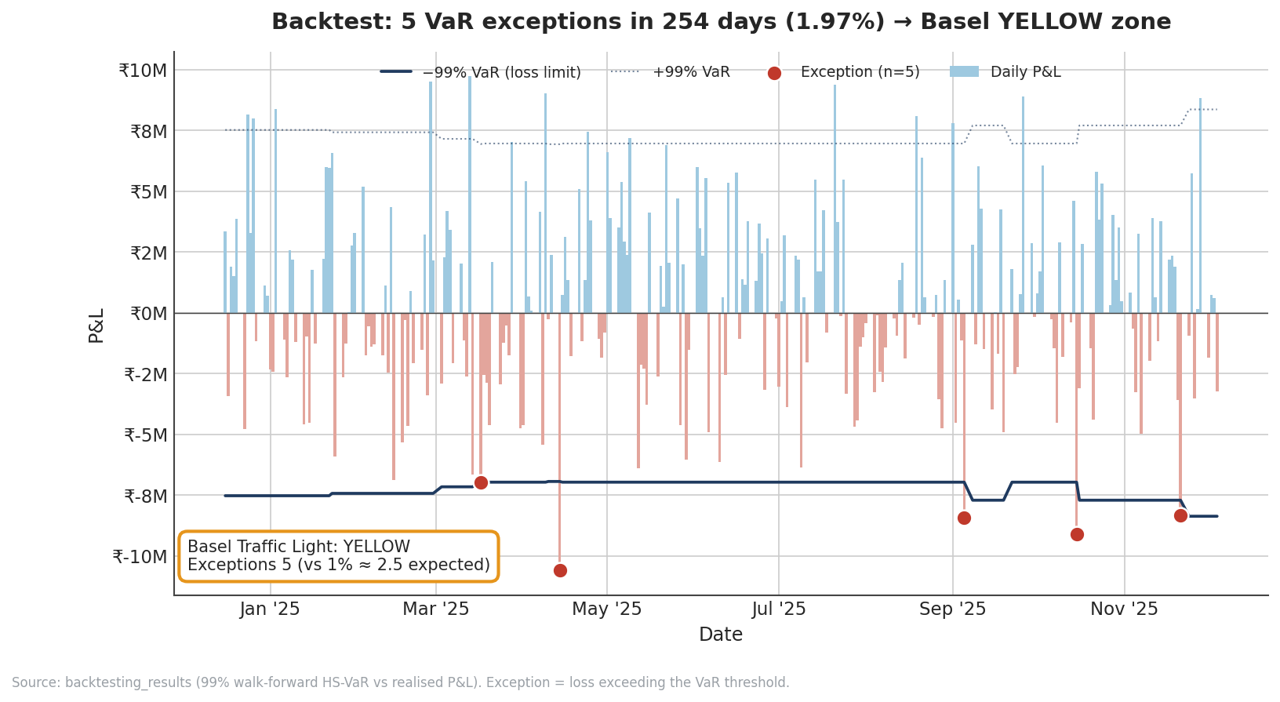
Figure 5.1 — Daily P&L (bars) against the ±99% VaR threshold (navy line). Red points are the five exceptions — days on which the loss exceeded the predicted VaR. The result sits in the Basel Yellow zone.
Interpretation. Five exceptions in 254 days is only marginally above the Green ceiling of four, and roughly double the expected count. This is a mild, not alarming, signal. It tells us the model has been somewhat optimistic — its VaR threshold was breached a little more often than 99% coverage would imply — but it is far from the ten-plus breaches that would condemn the model to the Red zone. The exceptions are scattered across the period rather than clustered in a single stress episode, which argues against a one-off regime break and toward a modest, persistent under-calibration.
The most likely cause is the nature of Historical Simulation itself: a 250-day equally-weighted window reacts slowly to changes in volatility. When market volatility rises, the historical window still contains many calmer days, so the VaR estimate lags the true risk and exceptions cluster until the window catches up. A volatility-scaled or exponentially-weighted (filtered historical simulation) approach would track changing risk more responsively and would likely pull the book back into the Green zone. This is the single most actionable model-validation finding in the report.
Capital consequence. In a live regulatory setting, Yellow-zone status would attach a capital-multiplier add-on — the Basel base multiplier of three is increased by a step (commonly to around 3.4 at five exceptions) — so the market-risk capital charge would rise even though the underlying positions are unchanged. This is the mechanism by which a backtest failure is "priced": poor model performance directly costs capital, giving the desk a concrete incentive to recalibrate.

5.3 Statistical perspective: is five exceptions "too many"?
The traffic-light zones are a supervisory convenience; behind them sits a formal statistical question. Over 254 days at a 1% exception rate, the expected number of exceptions is 254 × 0.01 ≈ 2.54, and the count follows a binomial distribution. Five exceptions is roughly one standard deviation above expectation (the standard deviation is √(254 × 0.01 × 0.99) ≈ 1.59). In a Kupiec proportion-of-failures test — the standard unconditional-coverage test — an observed rate of 1.97% against a target of 1% on this sample size does not reject the model at conventional significance levels; the result is "elevated but not statistically damning". This aligns with the supervisory reading: Yellow, not Red. The honest interpretation is that the model is mildly optimistic and warrants recalibration, not rejection.
It is also worth noting what the test cannot see. The Kupiec test checks only how many exceptions occurred, not whether they clustered in time. A model can have the right number of exceptions but produce them all in one stressed fortnight — a sign it fails to adapt to changing volatility. A fuller validation programme would add a conditional-coverage (Christoffersen) test for independence of exceptions. On this book the exceptions are visibly scattered across the year rather than bunched, which is the more benign pattern and supports the view that the issue is gentle under-calibration rather than a structural failure to track volatility regimes.
From exceptions to capital. Under the Basel internal-models approach, the market-risk capital charge is the higher of the latest VaR and a multiple of the 60-day average VaR, where the multiplier starts at 3.0 in the Green zone and steps up through the Yellow zone (roughly 3.4 at five exceptions, rising to 3.85 at nine). Moving from Green to five exceptions therefore raises the capital charge by on the order of 13% with no change in the underlying positions — a direct, quantifiable cost of model under-performance and a concrete incentive to adopt the volatility-scaled approach recommended above.

6. Stress Testing
VaR and Expected Shortfall describe risk under normal conditions; they are calibrated on recent history and, by construction, say little about events outside that history. Stress testing fills the gap by asking a different question: what would happen to the book under a specific, severe but plausible shock? Rather than reading a loss off a probability distribution, stress testing revalues the entire book under a named scenario in which equity prices, interest rates, exchange rates, volatilities and credit spreads all move together. It is the principal tool for understanding tail risk and is a central pillar of supervisory review.

6.1 The five scenarios
Five scenarios are applied, each calibrated to a real or hypothetical episode and each imposing simultaneous shocks across asset classes:
- COVID Crash (March 2020). A sudden, broad market collapse — a severe equity sell-off with a flight to safety and a spike in volatility. The most damaging scenario for this book.
- Taper Tantrum (2013). The 2013 episode in which signals of US monetary tightening triggered sharp emerging-market outflows, rupee depreciation and a bond sell-off.
- IL&FS Crisis (2018). An India-specific credit shock following the default of a major infrastructure-finance group, with equity weakness and credit-spread widening.
- Global Rate Shock (+300 bps). A hypothetical parallel rise of 300 basis points across the yield curve, stressing every rate-sensitive position simultaneously.
- INR Depreciation (−15%). A sharp, isolated 15% fall in the rupee against the dollar.

6.2 Total impact by scenario
The figure below shows the total portfolio P&L under each scenario. The asymmetry is striking: only the COVID-style crash inflicts a large loss, while two scenarios actually produce gains.
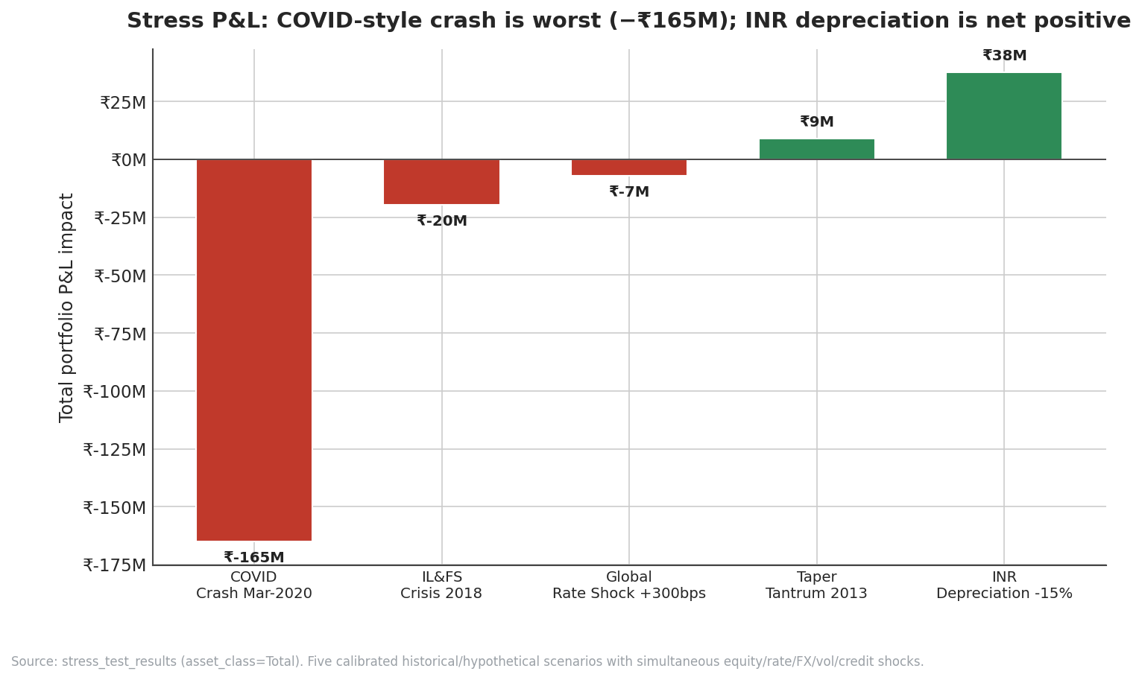
Figure 6.1 — Total portfolio P&L by scenario. A COVID-style crash is by far the worst case (−₹165 M); an INR depreciation and a Taper-Tantrum scenario produce net gains thanks to the long-USD forward.
Scenario | Total P&L (₹M) | Character
COVID Crash Mar-2020 | −165.10 | Severe broad crash
IL&FS Crisis 2018 | −19.68 | Moderate credit shock
Global Rate Shock +300bps | −7.08 | Mild — rate hedges offset
Taper Tantrum 2013 | +9.00 | Net gain — FX hedge dominates
INR Depreciation −15% | +37.57 | Net gain — long USD
Source: stress_test_results, asset_class = Total. Positive = gain, negative = loss.

6.3 Where each shock lands: the asset-class heatmap
Decomposing each scenario by asset class explains the asymmetry. The heatmap below shows the P&L contribution of each asset class within each scenario; green is a gain, red a loss.
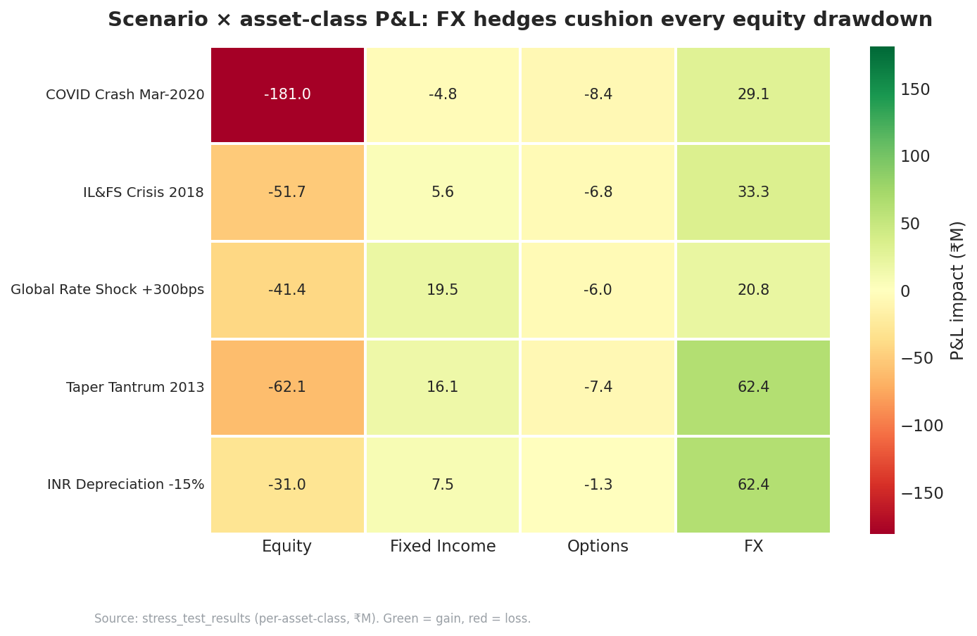
Figure 6.2 — Scenario × asset-class P&L (₹M). The FX column is green in every scenario: the long-USD forward gains whenever risk-off conditions weaken the rupee, cushioning equity losses throughout.
The hedge that runs through everything. The decisive pattern is the FX column: the long-USD forward posts a gain in every single scenario, because each of these stress episodes is associated with a weaker rupee. In the COVID crash the forward earns +₹29 M against a −₹181 M equity loss; in the Taper Tantrum and INR-depreciation scenarios its gain (+₹62 M in both) more than offsets the equity damage and flips the total to a profit. The book is, in effect, structurally long the "risk-off rupee weakness" trade.
Equities are always the casualty. The equity column is red in every scenario, as expected — equities are the book’s dominant risk. The COVID crash drives a −₹181 M equity loss, by far the largest single figure in the matrix and the reason that scenario alone produces a severe total loss; the FX hedge, sized for more typical shocks, cannot fully offset a crash of that magnitude.
Rates and options play supporting roles. Fixed income is mildly negative in the rate-shock and COVID scenarios but positive in the credit-driven IL&FS and Taper scenarios (where a flight to quality lifts sovereign bonds). Options are consistently a small drag, reflecting the cost of the protective put and the call’s loss of value in down markets. The interest-rate swap and rate hedges are why even the +300 bp parallel shock costs only ₹7 M — the rate-sensitive positions substantially net against one another.
The headline stress lesson. The book is well-insulated against rate and currency shocks but remains exposed to a broad, simultaneous equity crash of COVID severity. A single bad day of that kind would consume roughly four times the book’s entire credit Expected Loss and dwarf any normal-day VaR. If the desk wished to reduce this last vulnerability, broad equity-index downside protection — not more FX or rate hedging — is what the heatmap points to.

6.4 The full asset-class breakdown
The complete numerical decomposition behind the heatmap is given below, in ₹ millions. Reading across each row shows how a single scenario distributes across the book; reading down a column shows how one asset class fares across scenarios.
Scenario | Equity | Fixed Inc. | Options | FX | Total
COVID Crash | −181.0 | −4.8 | −8.4 | +29.1 | −165.1
IL&FS Crisis | −51.7 | +5.6 | −6.8 | +33.3 | −19.7
Rate Shock +300bps | −41.4 | +19.5 | −6.0 | +20.8 | −7.1
Taper Tantrum | −62.1 | +16.1 | −7.4 | +62.4 | +9.0
INR Depreciation −15% | −31.0 | +7.5 | −1.3 | +62.4 | +37.6
Source: stress_test_results, all asset classes. Figures in ₹M; positive = gain, negative = loss.

6.5 Scenario-by-scenario detail

COVID Crash (March 2020) — total −₹165.1 M
The reference episode is the March 2020 pandemic shock, when global equity markets fell 30–40% in a matter of weeks amid a simultaneous spike in volatility and a dash for cash. Applied to this book, the scenario produces a −₹181 M equity loss — by far the largest single figure in the entire stress matrix — only partly offset by a +₹29 M gain on the FX forward and small losses on bonds and options. The net −₹165 M is roughly twenty times the normal-day 99% VaR, which is exactly the point of stress testing: it surfaces a loss that the VaR distribution, calibrated on ordinary days, would never show. This is the book’s defining vulnerability and the single scenario that should anchor the desk’s tail-risk thinking.

IL&FS Crisis (2018) — total −₹19.7 M
The 2018 default of Infrastructure Leasing & Financial Services triggered a credit-confidence shock across Indian non-bank lenders, with equity weakness concentrated in financials and a widening of credit spreads. Here the equity sleeve loses −₹51.7 M, but two offsets contain the damage: a flight to quality lifts the sovereign bonds (+₹5.6 M) and the rupee weakens enough for the FX forward to earn +₹33.3 M. The net −₹19.7 M is a manageable loss, illustrating how a credit-specific shock is far less damaging to this particular book than a broad market crash, because the book’s hedges are aligned with the rupee-weakening that typically accompanies an Indian credit event.

Global Rate Shock (+300 bps) — total −₹7.1 M
This hypothetical scenario raises the entire yield curve by 300 basis points at once, stressing every rate-sensitive position. Intuitively one might expect the bonds and the swap to drive a large loss, but the opposite happens: the pay-fixed swap and the short-duration profile mean fixed income actually gains +₹19.5 M, while the equity sleeve (hurt by higher discount rates and financing costs) loses −₹41.4 M and the FX forward adds +₹20.8 M. The near-complete offset leaves a trivial −₹7.1 M total. This is the clearest demonstration that the book’s rate exposures are well-balanced — the swap and bonds substantially hedge one another against a parallel shift.

Taper Tantrum (2013) — total +₹9.0 M
The 2013 "taper tantrum" followed signals that the US Federal Reserve would scale back asset purchases, triggering capital outflows from emerging markets, sharp rupee depreciation and a bond sell-off. For this book the equity loss (−₹62.1 M) is more than offset by a +₹62.4 M gain on the long-USD forward plus +₹16.1 M on fixed income, leaving a net gain of +₹9.0 M. It is a striking result: a scenario remembered as a crisis for Indian markets is, for this particular hedged book, mildly profitable — entirely because of the currency hedge.

INR Depreciation (−15%) — total +₹37.6 M
This scenario isolates a single shock: a 15% fall in the rupee against the dollar with no accompanying equity crash. The long-USD forward gains +₹62.4 M, dwarfing the −₹31 M equity loss (a weaker currency still pressures domestic equities somewhat) and producing the book’s largest stress gain, +₹37.6 M. It confirms that the book is structurally long the rupee-depreciation trade and would profit handsomely from a currency move that is not accompanied by a global risk-off crash.
The cross-scenario lesson. Four of the five scenarios produce small losses or outright gains; only the COVID-magnitude broad crash is severe. The reason is consistent across every scenario — the long-USD forward gains whenever the rupee weakens, and rupee weakness accompanies almost every stress episode relevant to an Indian book. The desk’s residual tail risk is therefore quite specific: a simultaneous, broad-based equity collapse large enough that the FX hedge cannot keep pace. Everything else, the stress suite suggests, the book can absorb.

6.6 Scenario design and reverse stress testing
The five scenarios used here combine two design philosophies. The COVID, Taper-Tantrum and IL&FS scenarios are historical — they replay the cross-asset shocks of real episodes, which gives them credibility and an intuitive narrative. The +300 bp rate shock and the −15% rupee move are hypothetical — clean, single-factor sensitivities that isolate one risk at a time. A robust programme uses both: historical scenarios capture the messy way real crises propagate across asset classes, while hypothetical scenarios let the desk probe specific vulnerabilities in a controlled way.
Reverse stress testing. Conventional stress testing asks "what does scenario X do to the book?" Reverse stress testing inverts the question: "what scenario would it take to inflict a loss large enough to threaten the desk?" For this book the answer is now clear from the results — because the FX, rate and credit hedges absorb most single-factor shocks, the only thing that produces a genuinely severe loss is a broad, simultaneous equity crash of COVID magnitude. That is the book’s reverse-stress answer, and it sharpens the risk conversation: the desk does not need to fear rate or currency moves in isolation, but it should have a plan for a correlated equity collapse, since that single event type is what its current hedge structure does not cover. This is why broad equity downside protection, rather than more FX or rate hedging, is the targeted recommendation in Section 10.
The limits of stress testing. Stress tests are only as good as the scenarios chosen; a shock no one imagined will not appear in the suite. They are also typically static — they revalue today’s book under an instantaneous shock and do not model the dynamics of a crisis unfolding over days, the feedback of forced selling, or the evaporation of liquidity. They complement, but do not replace, the probabilistic VaR/ES framework, and the two should always be read together.

7. Credit Risk
Market risk concerns the day-to-day fluctuation in the value of the book’s tradable positions. Credit risk is different in kind: it is the risk that a counterparty fails to meet its obligations, causing a loss that is rare but potentially large. This book carries credit exposure to four counterparties, and its credit risk is measured with the same machinery a bank uses to set regulatory capital — the Basel Internal Ratings-Based (IRB) approach.

7.1 The building blocks: PD, LGD and EAD
Every credit-loss calculation rests on three parameters:
- Probability of Default (PD) — the likelihood the counterparty defaults within one year.
- Loss Given Default (LGD) — the fraction of the exposure that would actually be lost after recoveries, if default occurs.
- Exposure at Default (EAD) — the amount outstanding to the counterparty at the moment of default.
Their product is Expected Loss (EL = PD × LGD × EAD) — the average loss the desk should anticipate and provision for. Expected loss is the cost of doing business; it is meant to be covered by pricing and provisions, not by capital. The four counterparties and their parameters are:
Counterparty | PD | LGD | EAD (₹M) | EL (₹M) | Credit VaR (₹M)
Bank A | 0.8% | 45% | 250 | 0.90 | 9.71
Corp B | 1.5% | 55% | 180 | 1.49 | 10.45
Corp C | 3.5% | 60% | 120 | 2.52 | 12.94
Corp D | 6.0% | 65% | 90 | 3.51 | 14.21
Total | — | — | 640 | 8.42 | 47.31
Source: credit_metrics. Credit VaR is the 99.9% one-year unexpected loss from the Vasicek ASRF model.

7.2 The inverse relationship between size and risk
A counter-intuitive but important feature of this credit book is that the largest exposure carries the smallest expected loss, and the smallest exposure the largest. Bank A, with a ₹250 M exposure — nearly 40% of the credit book — contributes only ₹0.90 M of expected loss, because as a high-quality bank counterparty its default probability is just 0.8% and its recovery prospects are good. Corp D, with the smallest exposure (₹90 M), contributes the most expected loss (₹3.51 M) because its 6% PD and 65% LGD make each rupee of exposure far riskier. Credit risk, in other words, is about quality first and size second.
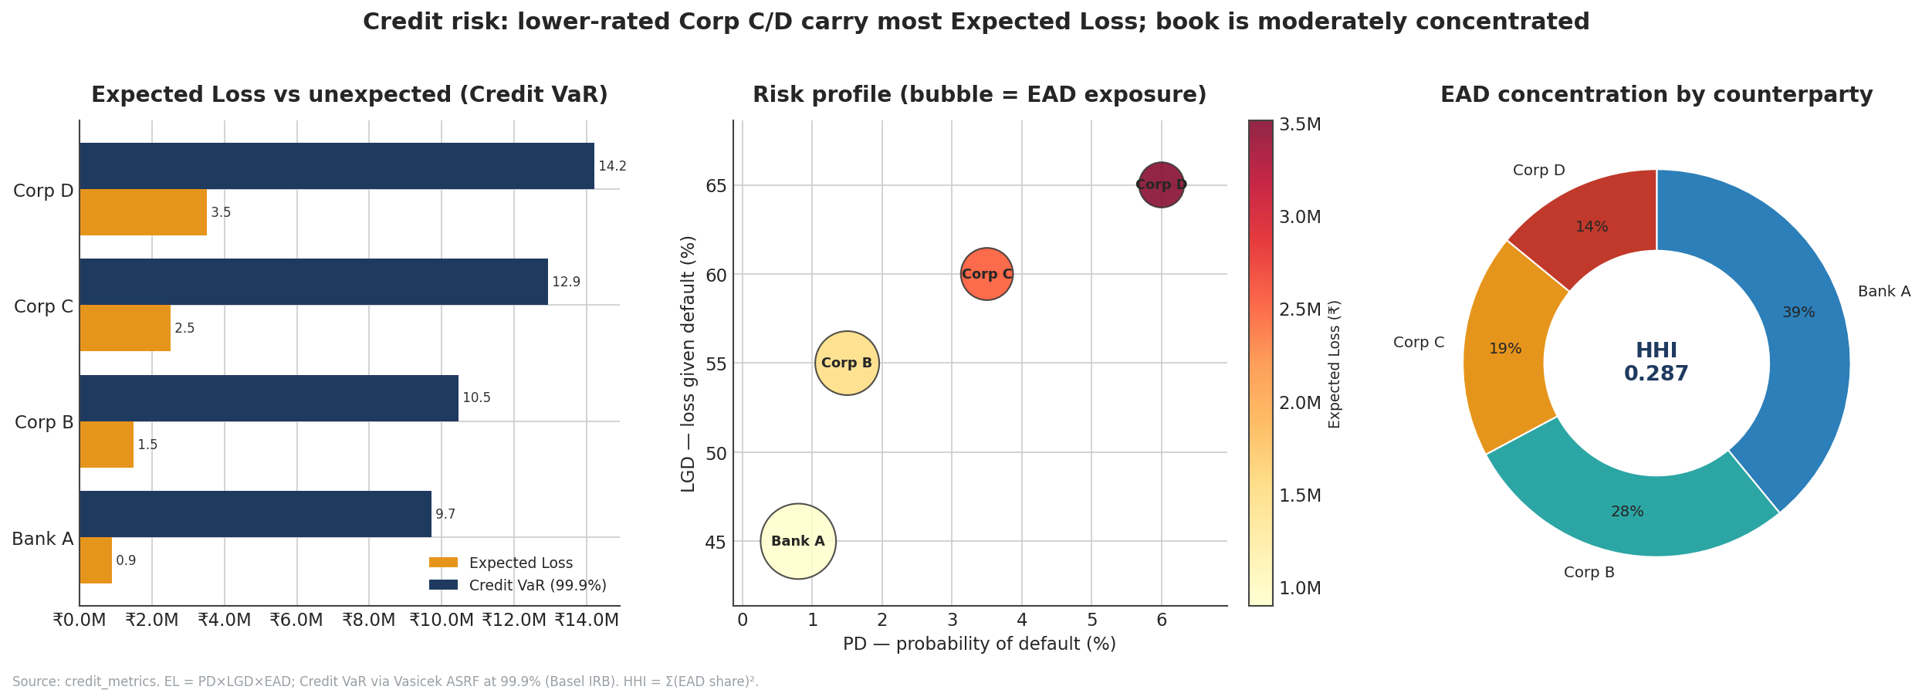
Figure 7.1 — Credit risk overview. Left: Expected Loss vs Credit VaR by counterparty. Centre: the PD–LGD risk profile, bubble size scaled to exposure. Right: exposure concentration by counterparty with the portfolio HHI.

7.3 Expected versus unexpected loss, and the Vasicek model
Expected loss is only half the story. Capital exists to absorb unexpected loss — the amount by which actual losses in a bad year could exceed the expected figure. This is quantified by Credit VaR, here computed at the 99.9% one-year confidence level mandated by Basel. The engine uses the Vasicek Asymptotic Single-Risk-Factor (ASRF) model, the same framework that underlies the IRB capital formula. Its central idea is that all borrowers are exposed to one common systematic factor (the state of the economy); in a severe downturn that factor turns adverse and default probabilities rise together. The model computes a "stressed" conditional PD at the 99.9% point and translates the gap between stressed and expected losses into Credit VaR, applying Basel asset correlations (0.12 for corporates, 0.15 for banks).
The result is a total Credit VaR of ₹47.3 million — more than five times the ₹8.4 million expected loss. That ratio is the essence of credit risk: losses are benign on average but heavily skewed, so the capital needed to survive a bad year vastly exceeds the routine provision. The two lowest-rated names, Corp C and Corp D, together account for over half of the Credit VaR (₹12.94 M + ₹14.21 M = ₹27.1 M) despite holding only a third of the exposure — the unexpected-loss tail is even more concentrated in low-grade names than the expected loss is.

7.4 Concentration: the HHI
Because credit losses are driven by a common factor, a book concentrated in a few names is riskier than a granular one of the same total size. The Herfindahl-Hirschman Index (HHI) — the sum of squared exposure shares — measures this. It ranges from near zero (perfectly diversified) to one (a single name). This book’s HHI of 0.287 indicates moderate concentration: equivalent to roughly three-and-a-half equally-sized exposures. That is neither alarming nor comfortable; combined with the tail concentration in Corp C and Corp D, it argues for monitoring single-name credit limits and, if the book grows, deliberately broadening the counterparty base.

7.5 A worked illustration and the meaning of the numbers
To make the credit machinery concrete, consider Corp D. Its expected loss is PD x LGD x EAD = 0.06 x 0.65 x ₹90 M = ₹3.51 M — the figure in the table. Its Credit VaR of ₹14.21 M is far larger because it reflects the loss in a 99.9% bad year, when the systematic factor turns sharply adverse and the conditional default probability rises well above the 6% through-the-cycle average. The gap between the two — roughly ₹10.7 M — is the unexpected loss that capital, not provisions, must cover. Repeating this for all four counterparties and recognising that their defaults are correlated through the common factor produces the portfolio totals: ₹8.42 M expected, ₹47.3 M at the 99.9% tail.
Why correlation matters in credit. If counterparty defaults were independent, a diversified book would see its unexpected loss shrink rapidly with the number of names. The Vasicek model captures the uncomfortable reality that they are not independent: in a recession many borrowers default together. The Basel asset-correlation parameters (0.12 for corporates, 0.15 for banks) encode how tightly each borrower is tied to the common factor. Higher correlation fattens the loss tail and raises Credit VaR, which is why a concentrated, correlated book carries more capital than its expected loss alone would imply — and why the HHI concentration measure discussed above (0.287) is more than a curiosity.

7.6 Credit risk mitigation and monitoring
Measuring credit risk is only half the discipline; managing it is the other half. Several levers apply to this book. Single-name limits cap exposure to any one counterparty and would directly address the concentration the HHI flags. Collateral and netting reduce loss-given-default and exposure-at-default respectively, lowering both expected and unexpected loss. Diversification — adding more, smaller, less-correlated counterparties — lowers the HHI and thins the loss tail. And active monitoring of the lowest-rated names (here Corp C and Corp D) gives early warning of deterioration, since these two drive the majority of the tail.
The credit metrics in this report are the through-the-cycle, point-in-time inputs to those decisions. In a live setting the PDs would be refreshed from internal ratings or market-implied spreads, and the Credit VaR re-run, on at least a quarterly cadence — more often for names on a watch list. The key governance principle is that the ₹47.3 M Credit VaR, not the ₹8.4 M expected loss, is the figure that should anchor capital and limit decisions, because it is the bad-year outcome the desk must be able to survive.

8. Greeks & Fixed-Income Sensitivities
Linear positions — equities, bonds held outright — have risk that VaR captures well. Options and rate instruments are different: their value responds non-linearly to market moves, and managing them requires the sensitivity measures known collectively as the "Greeks" for options and as duration, DV01 and convexity for bonds. This section examines both.

8.1 The option Greeks
Each Greek measures the option’s value-sensitivity to one underlying variable. The five standard measures are:
- Delta — sensitivity to the underlying price; how much the option value moves per ₹1 move in the stock. It is also the "equivalent" number of shares the option behaves like.
- Gamma — the rate of change of delta itself; it measures how quickly the hedge ratio shifts as the underlying moves, and is the heart of an option’s non-linearity.
- Vega — sensitivity to implied volatility; long options have positive vega and gain when volatility rises.
- Theta — sensitivity to the passage of time ("time decay"); typically negative for long options, which lose value as expiry approaches.
- Rho — sensitivity to interest rates.
The two options’ Greeks, computed with the Black-Scholes-Merton model, are shown below. Note the very different scales: the Infosys call is a large, deep position whose Greeks dominate the book, while the HDFC Bank put is a smaller protective overlay.
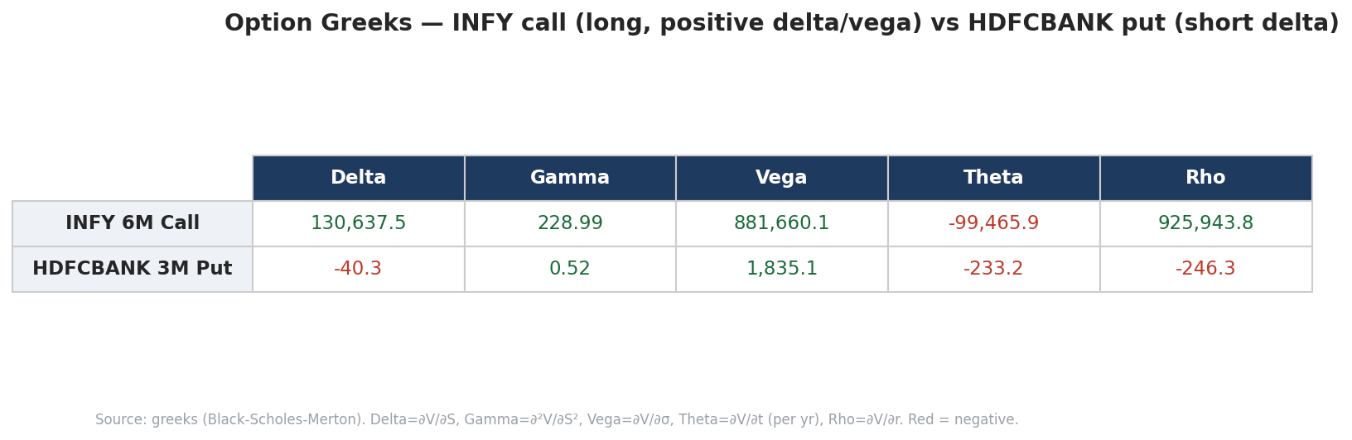
Figure 8.1 — Black-Scholes-Merton option Greeks. The long INFY call shows large positive delta and vega; the HDFCBANK put shows negative delta, consistent with downside protection on the bank holding.
Reading the call. The Infosys six-month call has a large positive delta (~130,638), positive gamma and very large positive vega (~881,660) and rho — the classic profile of a long call with meaningful time to expiry. It gains from a rising Infosys price, gains again (through gamma) as the move accelerates, and gains from any rise in implied volatility. Its negative theta (~ -99,466) is the price of all that optionality: the position bleeds value as time passes, all else equal.
Reading the put. The HDFC Bank three-month put shows a negative delta — it rises in value when the bank’s share price falls — which is exactly why it is held: it offsets part of the book’s largest cash equity position. Its positive gamma means that protection strengthens as the stock falls, and its small negative theta reflects the modest cost of carrying the insurance. Together the two options give the book leveraged upside to Infosys and explicit downside protection on HDFC Bank — a coherent, intentional optionality profile rather than a collection of unrelated bets.

8.2 Delta-gamma: approximating option P&L
Delta alone gives a linear, first-order estimate of how an option’s value changes for a small move in the underlying. For larger moves the linear estimate drifts, and gamma supplies the correction. The standard delta-gamma approximation is ΔV ≈ Δ·dS + ½·Γ·dS², where dS is the change in the underlying price. The first term is the linear delta effect; the second, gamma term is always positive for a long option and captures the curvature — it is why a long-option position gains more on a large up-move than delta predicts, and loses less on a large down-move. For the Infosys call, with its large positive gamma, this convexity is a meaningful contributor to P&L in volatile conditions; for the much smaller HDFC Bank put it is a minor effect. A desk hedging these positions would re-hedge delta frequently precisely because gamma keeps changing it.
Vega and the volatility view. The Infosys call’s very large positive vega means the position is, in effect, a long-volatility bet: it profits if implied volatility rises even when the underlying is unchanged. This is a double-edged exposure — it cushions the position in turbulent markets but bleeds value (alongside theta) in calm ones. Aggregating vega across the option book tells the desk its net sensitivity to a volatility shift, an input that sits outside the standard VaR framework and is one reason options require their own monitoring layer.

8.3 Fixed-income risk: duration, DV01 and convexity
Bonds are exposed to interest-rate risk, measured by three related quantities. Modified duration is the percentage change in price for a 1% change in yield. DV01 (the "dollar value of a basis point") is the rupee change in price for a one-basis-point move — the most practical hedging unit. Convexity captures the curvature that duration alone misses: it is the second-order effect that makes a bond’s price-yield relationship a curve rather than a straight line, and it matters most for long-dated bonds and large rate moves.
Bond | Mod. duration | Mac. duration | DV01 (₹) | Convexity
GOI G-Sec 5Y | 4.15 | 4.29 | 20,687 | 20.9
AAA Corp 10Y | 6.79 | 7.07 | 20,027 | 60.1
T-Bill 91D | 0.23 | 0.25 | 2,302 | 0.3
Source: duration_metrics. DV01 = modified duration x price x 1e-4. Convexity is the second-order price sensitivity.
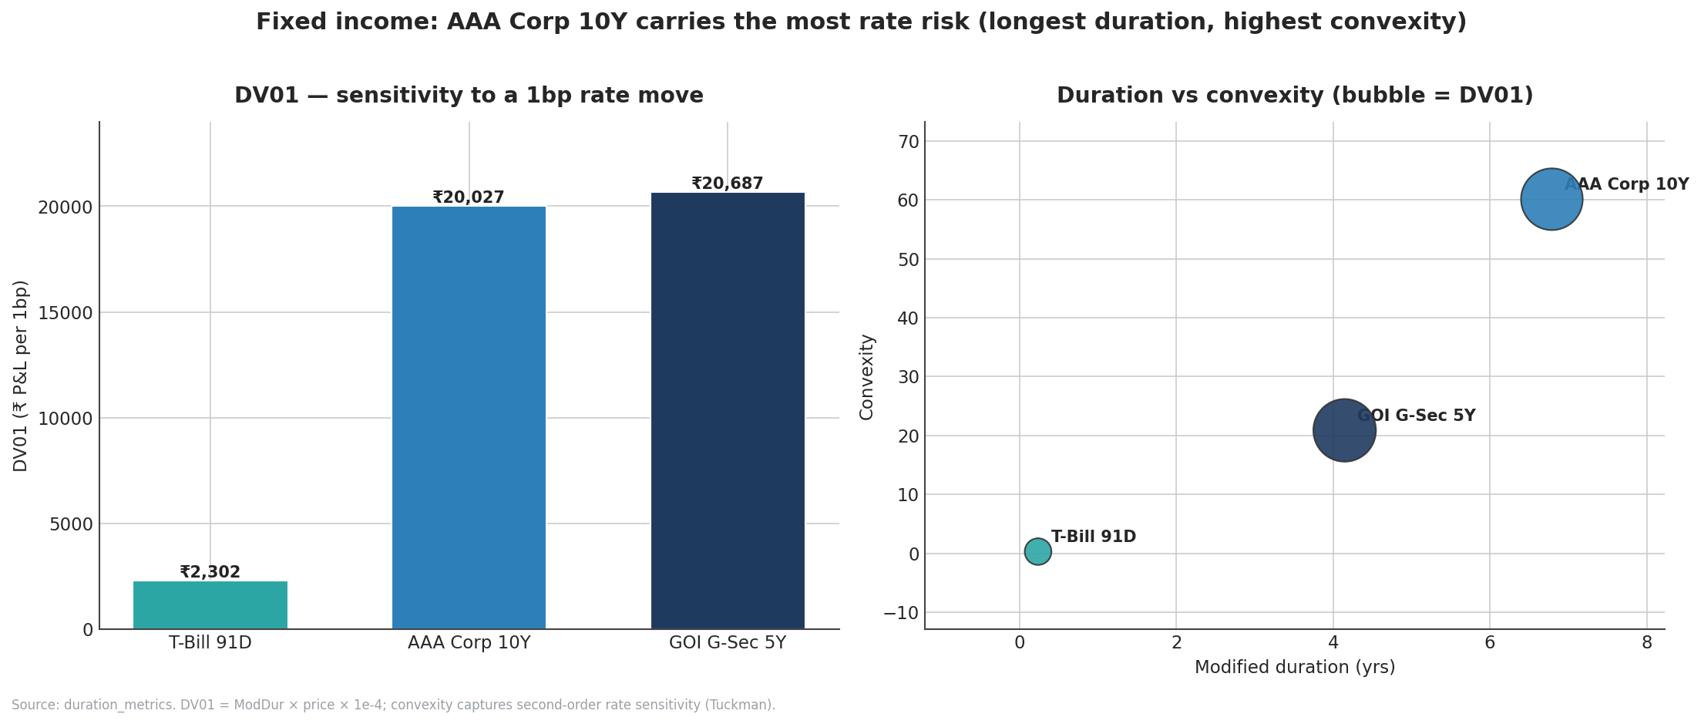
Figure 8.2 — DV01 by bond (left) and the duration-convexity profile (right, bubble size scaled to DV01). The AAA Corporate 10Y carries the most rate risk despite its modest notional.
Interpretation. The ten-year AAA corporate bond is the most rate-sensitive position in the book by a wide margin: its modified duration of 6.79 years and convexity of 60.1 are roughly two and three times the five-year sovereign’s, respectively, even though its ₹30 M notional is the smallest of the three bonds. The 91-day T-bill, by contrast, has near-zero duration and behaves like cash. A telling detail emerges from comparing DV01 with notional: the G-Sec and the corporate bond have almost identical DV01 (~₹20,700 versus ₹20,000) despite the G-Sec being two-thirds larger by notional — duration, not size, equalises their rate risk. This is the fixed-income analogue of the equity lesson from Section 4: risk is about sensitivity, not headline exposure.
Why convexity is good for the holder. Convexity works in the bondholder’s favour: because the price-yield curve bends, a bond gains slightly more when yields fall than it loses when yields rise by the same amount. The corporate bond’s high convexity therefore gives it a small cushion in volatile rate environments — visible in the stress results, where fixed income holds up better than its duration alone would predict in the flight-to-quality scenarios.

8.4 Beyond a single duration: bucket DV01 and curve shifts
A single portfolio duration hides where on the yield curve the rate risk sits. A non-parallel move — for example short rates rising while long rates fall (a flattening) — can hurt a book that looks immunised against a parallel shift. Production desks therefore decompose DV01 into maturity buckets (0-1Y, 1-3Y, 3-5Y, 5-10Y, 10Y+) so that curve-shape risk is visible, and they revalue the book under non-parallel scenarios as well as the parallel +/-50/100/200 bp shifts. For this book the bucket profile is dominated by the 3-5Y bucket (the G-Sec and the swap) and the 5-10Y bucket (the corporate bond), with the T-bill sitting in the 0-1Y bucket as near-cash. The implication is that the book is most exposed to moves in the belly and long-end of the curve and relatively insulated at the very short end.
How rate risk nets against the equity book. The fixed-income section should be read together with the stress results. The reason the +300 bp parallel-shock scenario costs only ₹7 M (Section 6) is that the pay-fixed swap gains as rates rise, partly offsetting the bonds and cushioning the equity hit. Duration and DV01 are the static measures; the stress test is where their interaction with the rest of the book becomes visible. Together they show a rate book that is deliberately balanced rather than directional.

9. Portfolio Composition & Correlation
The preceding sections analysed risk pillar by pillar. This section steps back to the portfolio as a whole — how it is built, how its components move together, and why the diversification embedded in that structure is what keeps total risk well below the sum of the parts.

9.1 Composition revisited
As established in Section 3, contractual notional is dominated by the options and the FX forward, but economic market risk lives overwhelmingly in the equity sleeve. This distinction — gross notional versus risk contribution — is one of the most important in portfolio risk management, because limits and capital should be set against risk, not against headline size. A desk that managed this book by notional would worry about the ₹416 M FX forward; a desk that manages it by risk worries about the ₹99 M HDFC Bank position. The component-VaR analysis in Section 4 is the bridge between the two views.

9.2 Price history
The chart below shows the rebased price history (each series set to 100 at the start) of the equities and bonds over the roughly 504-day window. The equities show the wide dispersion characteristic of single stocks, while the bonds trace the narrow, low-volatility paths expected of rate instruments. The visual dispersion among the equity lines is itself the raw material of diversification: because the names do not move in lockstep, combining them produces a portfolio less volatile than its most volatile member.
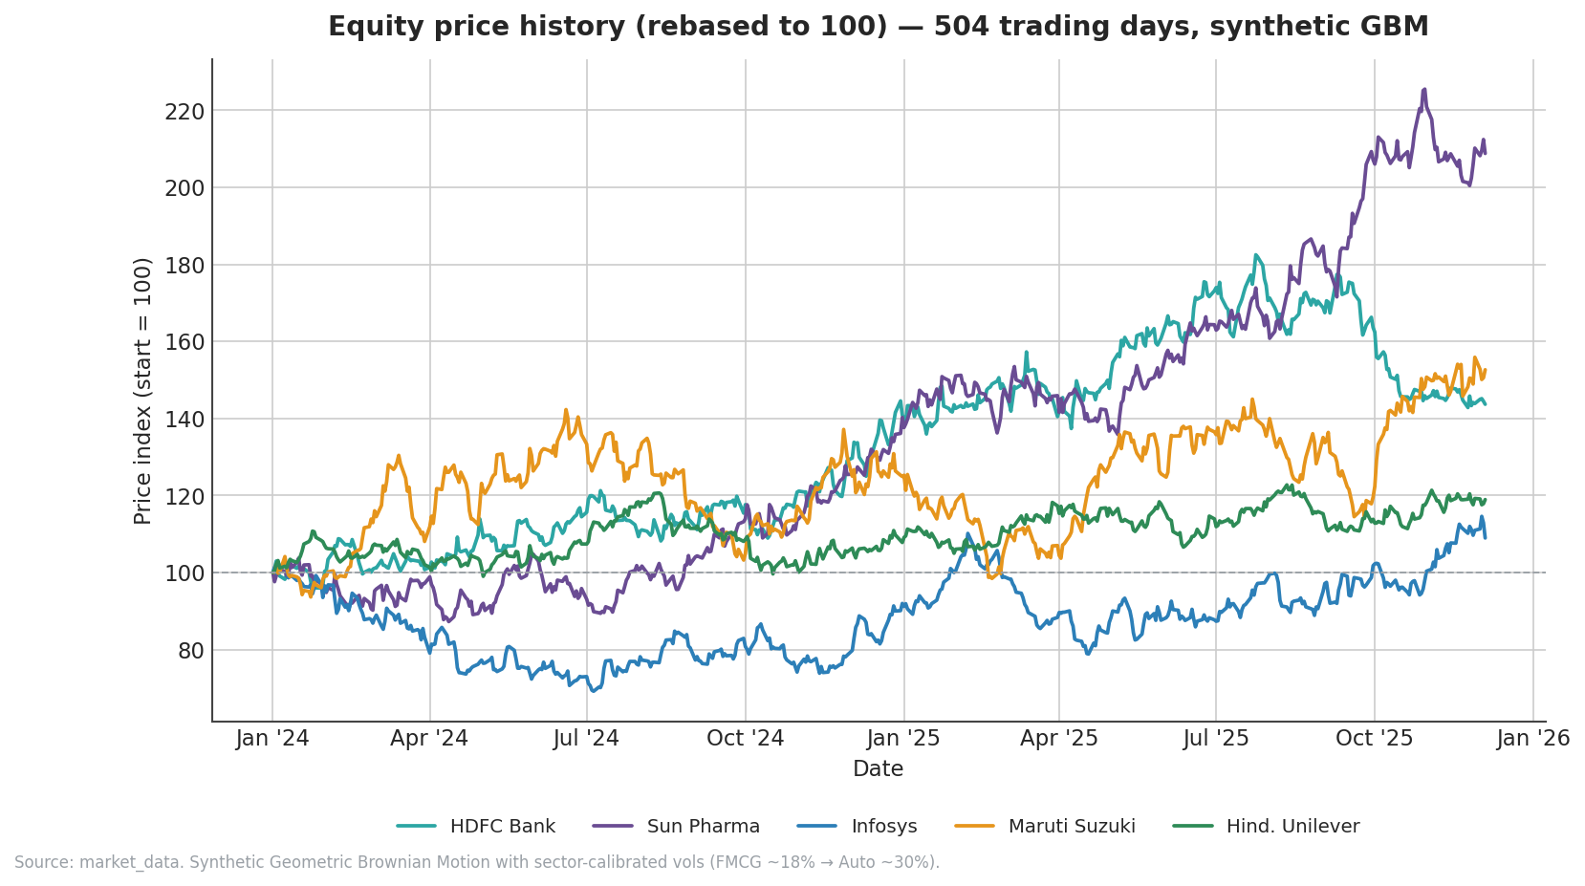
Figure 9.1 — Rebased price history (start = 100) of the equity and bond instruments. Synthetic GBM paths with sector-calibrated volatilities; equities disperse widely while bonds stay tightly clustered.

9.3 The correlation structure
Diversification is governed by correlation — the degree to which positions move together. The matrix below shows the daily-return correlations among the cash instruments. The defining feature is how low the cross-correlations are: the equities are only loosely related to one another, and the bonds are largely uncorrelated with the equities. This is the statistical engine behind every diversification benefit in the report.
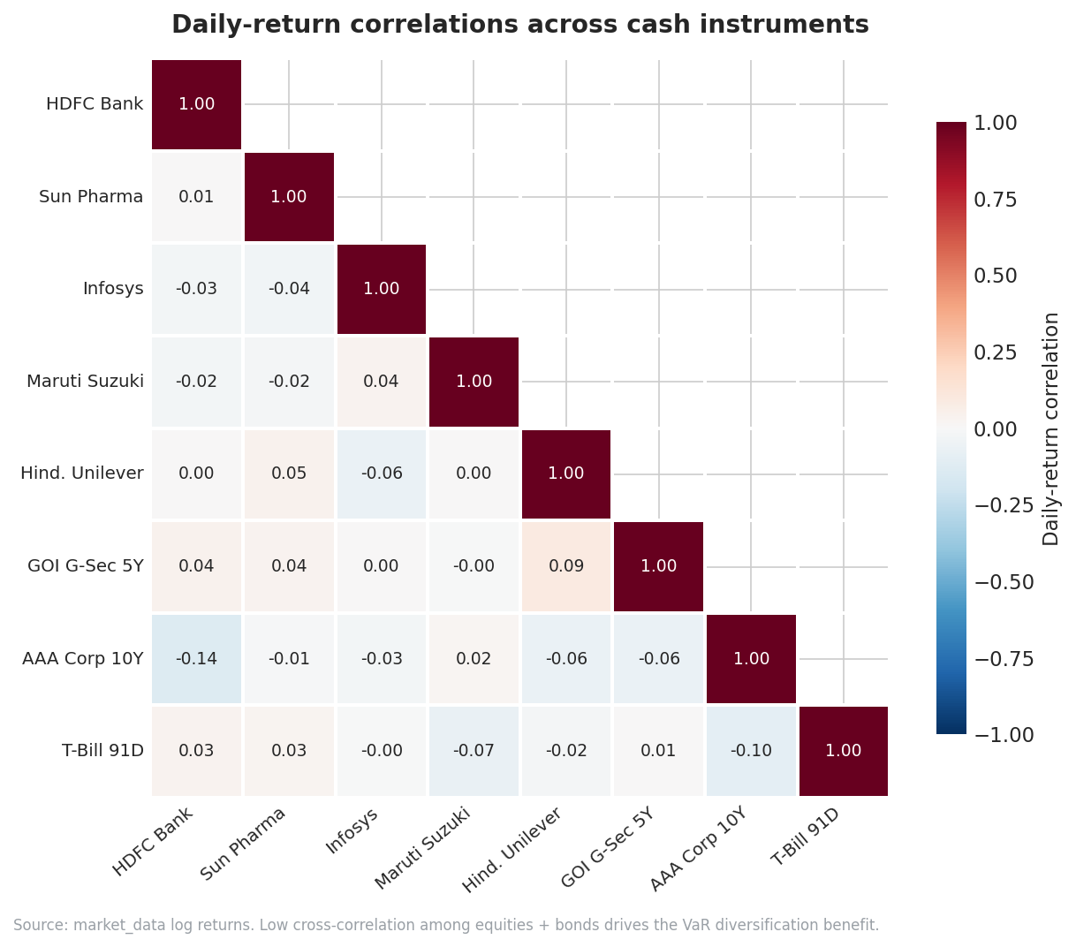
Figure 9.2 — Daily-return correlation matrix for the cash instruments. Low off-diagonal values mean the positions diversify one another, which is what holds portfolio VaR below the sum of standalone risks.
Why this matters for VaR. If the five equities were perfectly correlated, the portfolio VaR would simply be the sum of their individual VaRs. Because they are only weakly correlated, the actual portfolio VaR is materially lower — the diversification benefit. The same effect explains the negative component VaR of the AAA corporate bond noted in Section 4: its returns are sufficiently uncorrelated (even slightly offsetting) with the equity book that adding it reduces total risk. Correlation is also the channel through which stress propagates: in a crisis, correlations tend to rise toward one ("everything sells off together"), which is precisely why the COVID-crash scenario in Section 6 is so much worse than normal-day VaR would suggest. Diversification is real, but it is weakest exactly when it is needed most — a caution the desk should keep in view.

9.4 Putting the pillars together
Read as a whole, the analyses tell a consistent story. The book runs modest, well-diversified market risk concentrated in a few high-quality equities; its credit exposure is small in expectation but tail-heavy in two low-grade names; its option and rate sensitivities are intentional and coherent; and its single greatest vulnerability — a broad equity crash — is partly, but only partly, offset by a structural long-dollar hedge. None of the individual metrics is alarming, but together they point to three recurring themes the desk should manage actively: equity concentration, dependence on the FX hedge, and a VaR model that is currently a touch optimistic.

9.5 The limits of diversification
Diversification is the book’s great strength, but it carries an in-built caveat that a technical reader should never lose sight of: the correlations on which it depends are not stable. They are estimated from a historical window of relatively normal days, and they tend to rise sharply in a crisis. When markets sell off broadly, the gentle cross-correlations documented in Section 9.3 converge toward one — the equities that normally move independently begin to fall together, and the diversification benefit that lowers everyday VaR evaporates exactly when it is most needed. This is precisely the mechanism that makes the COVID-crash scenario in Section 6 so much worse than any normal-day VaR figure would suggest.
The practical implication is that the desk should treat the diversification benefit as a fair-weather asset. It is real and worth harvesting in normal conditions, but it should not be relied upon to protect the book in a systemic event. That is the division of labour between the metrics: VaR and Expected Shortfall measure risk net of normal-times diversification, while stress testing deliberately strips that assumption away and asks what happens when correlations break toward one. Reading the two together — never the VaR alone — is the only complete view.

10. Governance, Auditability & Limitations

10.1 Reproducibility and audit trail
A production risk system must be able to defend every number it reports. This system is built for that: every result table carries a calculation timestamp, every computation is logged, and the entire run is deterministic because the random-number generation is seeded. Any figure in this report can therefore be traced to the run that produced it and reproduced exactly — a core requirement of the RBI and Basel frameworks for production risk systems. The separation of the computation engine from the read-only reporting layer (Section 2) reinforces this: reports cannot accidentally alter the numbers they display, and historical runs are preserved for audit even as new runs are appended.

10.2 Methodological limitations
Several limitations should be kept in view when interpreting the results:
- Synthetic data. All price and rate histories are generated by Geometric Brownian Motion, not drawn from live markets. The tickers and companies stand in for realistic instruments, but the volatilities, correlations and shocks are illustrative calibrations — not live market parameters. None of the figures should be read as actual risk on the named companies.
- Normality where assumed. The parametric VaR and the Monte Carlo engine assume normally-distributed returns. Real markets exhibit fatter tails and volatility clustering; the historical-simulation method captures these better, which is why all three are reported side by side.
- Linear approximation of options in VaR. Linear VaR is computed on the cash instruments; options enter market risk via delta-equivalent exposure on their underlyings rather than through a full revaluation. For large moves this understates option risk, which the Greeks and stress sections address separately.
- Square-root-of-time scaling. Multi-day VaR is scaled from one-day risk by √t, which assumes independent, identically-distributed returns. Real returns are autocorrelated, so the scaled figures are approximations.
- Backtest in the Yellow zone. The VaR model has been mildly optimistic (five exceptions versus ~2.5 expected). Results should be read with that known, modest under-calibration in mind, and the recommended move to volatility-scaled historical simulation would address it.
- Static snapshot. The report reflects a single computed run. Risk is dynamic; the figures should be refreshed as positions and market conditions change.
This is an educational, methodology-demonstrating system rather than a certified regulatory-capital engine. Its value lies in showing — end to end, and reproducibly — how a bank measures, validates and stresses the risk of a multi-asset book, and in making the relationships between the metrics transparent.

10.3 Summary of recommendations
- Address equity concentration in HDFC Bank, Maruti and Sun Pharma through single-name limits or a partial index hedge; these three names drive ~75% of market risk.
- Recalibrate the VaR model toward volatility-scaled (filtered) historical simulation to move the backtest from Yellow back to Green and avoid a capital-multiplier add-on.
- Monitor credit tail concentration in Corp C and Corp D, which together drive over half the Credit VaR on a third of the exposure; consider tightening low-grade single-name limits.
- Treat the FX forward as structural. The book’s resilience to rate and currency stress depends on the long-USD forward; its roll and sizing should be governed deliberately, not left incidental.
- Add broad equity downside protection if the desk wishes to reduce its one remaining severe vulnerability — a COVID-magnitude equity crash, the only scenario that produces a large loss.

11. Risk Limits & Capital Framework
The preceding sections measured the book’s risks. This section explains how those measures translate into the limits that constrain the desk day-to-day and the capital a bank would hold against the book — the machinery that turns risk numbers into governance.

11.1 The limit hierarchy
A trading desk operates inside a nested structure of limits, each a different guardrail against a different failure mode:
- VaR limit — a ceiling on one-day VaR, here set at 2% of gross notional (≈ ₹38.4 M). At a current 99% VaR of ₹8.36 M the desk is using about 22% of this limit, leaving ample headroom for new risk-taking before the limit binds.
- Stress / scenario limits — ceilings on the loss permitted under named scenarios, ensuring the tail-risk identified in Section 6 stays within the bank’s appetite even though it sits outside the VaR window.
- Greek limits — caps on aggregate delta, gamma and vega, governing how much non-linear and volatility exposure the option book may carry.
- Concentration limits — single-name and sector caps that prevent the kind of equity and credit concentration this book exhibits from growing unchecked.
- Stop-loss limits — realised-loss triggers that force a review or unwind once cumulative losses breach a threshold.
The discipline of a limit framework is that breaches are escalation events, not mere data points: a VaR-limit breach obliges the desk to reduce risk or seek a documented, time-bound exception. The VaR breach flag in the dashboard exists precisely to make such breaches visible the moment they occur.

11.2 From risk to capital
Two broad approaches translate market risk into a capital charge. Under the Standardised Approach (SA), capital is computed from prescribed risk weights applied to standardised sensitivities — simple, conservative and model-independent. Under the Internal Models Approach (IMA), a bank uses its own VaR/ES model (subject to supervisory approval and backtesting) to compute the charge, which is typically lower but carries the model-risk obligations described in Section 5. The market-risk charge under the IMA is broadly the higher of the latest risk figure and a multiple of its recent average, where that multiple is driven up by backtest exceptions — the direct link, noted earlier, between this book’s Yellow-zone status and a higher capital charge.
On the credit side, the analogous distinction is between expected loss, which is covered by provisions and pricing (the ₹8.4 M figure), and unexpected loss, which is covered by capital and is quantified by the ₹47.3 M Credit VaR. The Basel IRB formula used in Section 7 is precisely the regulatory translation of unexpected loss into a capital requirement.

11.3 Economic versus regulatory capital
Finally, it is worth distinguishing regulatory capital — the minimum a supervisor requires, computed by prescribed formulae — from economic capital, the bank’s own internal estimate of the capital it actually needs to remain solvent at a chosen confidence over a chosen horizon, given its real risk profile and diversification. Economic capital is usually the more risk-sensitive of the two because it can recognise diversification across risk types that the regulatory framework treats more conservatively. For this book, the diversification documented throughout — across sectors, across asset classes, and between the FX hedge and the equity sleeve — is exactly the kind of effect an economic-capital model would credit, and is why the book’s true economic risk is lower than a simple sum of its standalone exposures would suggest. The recurring lesson of the report — that risk is about sensitivity and correlation, not headline notional — is also the central insight of economic-capital thinking.

12. Conclusion
Across nine analytical pillars and twelve positions, a coherent and reassuring picture emerges, qualified by a small number of specific watch-items. The book runs modest market risk — a 99% one-day VaR of about ₹8.4 million against a ₹1.92 billion notional, using roughly a fifth of its limit — with a tail that Expected Shortfall confirms is well-behaved. Its risk is highly diversified by sector yet concentrated by name, with three equities driving three-quarters of the total. Its credit exposure is trivial in expectation but, like all credit, fat-tailed, with the unexpected-loss tail concentrated in two low-grade counterparties. Its option and rate sensitivities are deliberate and internally coherent. And its single material vulnerability — a broad, COVID-magnitude equity crash — is the one shock its otherwise-comprehensive hedge structure does not cover.
The most important cross-cutting lesson is that risk is governed by sensitivity and correlation, not by headline size. The ₹416 million FX forward is the book’s largest notional yet its steadiest friend; the ₹99 million HDFC Bank holding is a mid-sized position yet the largest single source of risk; the ₹30 million corporate bond is the smallest bond yet the most rate-sensitive. A risk function that managed this book by notional would worry about the wrong things. The dashboard’s value is that it consistently surfaces the right ones.
The actionable agenda is correspondingly focused: trim or hedge the equity concentration, recalibrate the VaR model from a Yellow-zone equally-weighted window toward a volatility-scaled approach, keep a close watch on the two low-grade credits, treat the FX forward as the structural hedge it has become, and — if the desk wishes to close its last real gap — add broad equity downside protection against a correlated crash. None of these is urgent in isolation; together they describe a book that is well-run today and could be made more resilient with a few targeted moves.
Finally, the report is as much a demonstration of method as a statement of results. Every number is reproducible, every metric is cross-checked against the others, and every chart is traceable to its source table. That auditability — the ability to defend any figure on demand — is itself a core risk control, and it is the foundation on which all the analysis above rests.

A. Appendix A — Glossary of Risk Terms
Term | Definition
VaR (Value at Risk) | The maximum expected loss over a horizon at a given confidence level, under normal conditions.
Expected Shortfall (ES / CVaR) | The average loss in the tail beyond VaR; a coherent risk measure and the FRTB primary standard.
Historical Simulation | VaR read from the empirical distribution of past returns; assumes no distributional shape.
Parametric VaR | VaR from assumed-normal returns and the covariance matrix; fast but thin-tailed.
Monte Carlo VaR | VaR from many simulated correlated return scenarios with full re-pricing.
Component VaR | Each position’s contribution to total VaR; sums to portfolio VaR and can be negative.
Incremental VaR | The change in total VaR from removing a position entirely.
Backtesting | Comparing predicted VaR with realised P&L to validate the model.
Basel Traffic Light | Green/Yellow/Red zones by exception count (0-4 / 5-9 / 10+) driving the capital multiplier.
Stress Testing | Revaluing the book under a specific severe scenario rather than a probability distribution.
PD / LGD / EAD | Probability of Default, Loss Given Default, Exposure at Default — the credit-loss inputs.
Expected Loss (EL) | PD x LGD x EAD; the average anticipated credit loss, covered by provisions.
Credit VaR | Unexpected credit loss at 99.9% (one year); the capital buffer, via the Vasicek ASRF model.
HHI | Herfindahl-Hirschman Index; sum of squared exposure shares, measuring concentration.
Delta / Gamma / Vega / Theta / Rho | Option sensitivities to price, price-acceleration, volatility, time and rates.
Duration / DV01 / Convexity | Bond price sensitivities to yield: first-order (%), per-basis-point (₹), and curvature.
Square-root-of-time | Scaling 1-day risk to t days by √t; assumes i.i.d. returns.

B. Appendix B — Data Sources & Reproducibility
Every figure in this report is computed from the risk database’s result tables, each timestamped to the run that produced it. The principal tables are listed below.
Table | Contents
positions | The twelve holdings: asset class, description, notional, quantity, entry price and date.
market_data | ~504 days of daily price, volume and log-return per instrument (synthetic GBM).
risk_factors | Underlying risk-factor histories (equity levels, rates, FX) used by the engine.
var_results | Portfolio, component and incremental VaR and ES by method, confidence and horizon.
greeks | Black-Scholes-Merton delta, gamma, vega, theta and rho per option.
duration_metrics | Modified and Macaulay duration, DV01 and convexity per bond.
credit_metrics | PD, LGD, EAD, Expected Loss and Credit VaR per counterparty.
stress_test_results | P&L impact by scenario and asset class for the five stress scenarios.
backtesting_results | Daily realised P&L vs VaR estimate with exception flags.
This report was generated from the Integrated Risk Dashboard database. All currency figures in Indian rupees. Company background facts reflect publicly reported information as of mid-2026; the trading-book data itself is synthetic and illustrative.

C. Appendix C — Full Portfolio VaR & ES Grid
The complete portfolio-level VaR and ES grid across all three methods, three confidence levels and three horizons, in ₹ millions.
Method | Conf. | Horizon | VaR (₹M) | ES (₹M)
Historical | 95% | 1d | 5.38 | 7.17
Historical | 95% | 5d | 12.04 | 16.02
Historical | 95% | 10d | 17.03 | 22.66
Historical | 97.5% | 1d | 6.60 | 8.13
Historical | 99% | 1d | 8.36 | 9.36
Historical | 99% | 10d | 26.44 | 29.61
Parametric | 95% | 1d | 6.38 | 8.00
Parametric | 97.5% | 1d | 7.60 | 9.07
Parametric | 99% | 1d | 9.02 | 10.34
Parametric | 99% | 10d | 28.53 | 32.69
Monte Carlo | 95% | 1d | 5.82 | 7.55
Monte Carlo | 97.5% | 1d | 7.22 | 8.72
Monte Carlo | 99% | 1d | 8.68 | 10.04
Monte Carlo | 99% | 10d | 27.46 | 31.74
Source: var_results, metric_type = Portfolio. Abbreviated to representative rows; the engine stores the full 3x3x3 grid.

D. Appendix D — Methodology Formula Reference
The principal formulae implemented in the engine, for reference.
Metric | Formula
Historical VaR | Negative of the (1−α) empirical quantile of the P&L distribution over the window.
Parametric VaR | z(α) × √(vᵀ Σ v), where v is the position vector and Σ the covariance matrix.
Monte Carlo VaR | Quantile of P&L from simulated returns r = μ + L z, where L Lᵀ = Σ (Cholesky).
Expected Shortfall | ES = −E[ P&L | P&L ≤ −VaR ]; the mean loss beyond the VaR cut-off.
Component VaR | CompVaRᵢ = vᵢ × z × (Σv)ᵢ / σₚ; sums to total VaR.
Incremental VaR | VaR(full portfolio) − VaR(portfolio excluding position i).
√t scaling | VaR(t-day) = VaR(1-day) × √t.
Option delta | N(d₁) for a call, N(d₁) − 1 for a put (Black-Scholes-Merton).
Option gamma | φ(d₁) / (S σ √T).
Option vega | S φ(d₁) √T.
Modified duration | Macaulay duration / (1 + y/n).
DV01 | Modified duration × price × 1e-4.
Expected Loss | EL = PD × LGD × EAD.
Vasicek conditional PD | N( [N⁻¹(PD) + √ρ · N⁻¹(q)] / √(1−ρ) ), q = 99.9%.
Credit VaR | LGD × EAD × ( PD(q) − PD ).
HHI | Σ (exposure shareᵢ)².
N(·) is the standard-normal CDF, φ(·) the standard-normal PDF, N⁻¹(·) its inverse; ρ is the Basel asset correlation (0.12 corporate / 0.15 bank). Formulae follow the FRM curriculum and the Basel IRB framework.

