DATA-DRIVEN DELIVERY TIME PREDICTION
AND LOGISTICS OPTIMIZATION
Week 3 Report
Advanced Data Analysis and Visualization in Logistics
Prepared by: Aakaash N
Internship Project: YUVA Technical Internship
Dataset: Delivery Logistics Dataset (India – Multi-Partner)
Tools: Python, Pandas, Matplotlib, Seaborn, Google Colab

1. Introduction
This report presents the Week 3 phase of the project titled “Data-Driven Delivery Time Prediction and Logistics Optimization.” The purpose of this phase is to explore the cleaned logistics dataset through descriptive statistics, distributions, group-wise comparisons, scatter plots, and correlation analysis. The analysis is intended to identify patterns that may influence delivery time, delivery cost, and delayed deliveries.
The dataset is a public, synthetic logistics dataset representing delivery operations in India. It is used for educational analysis and should not be interpreted as confidential or real company data.

2. Objectives
- Understand the distribution and central tendency of important logistics variables.
- Compare average delivery time across vehicle types, weather conditions, delivery partners, and regions.
- Examine relationships among distance, delivery time, expected time, rating, and delivery cost.
- Identify possible operational bottlenecks and cost drivers.
- Create clear visualizations that can support future delivery-time prediction and logistics decisions.

3. Dataset Description
The cleaned dataset contains 25,000 records and 15 variables. The main fields used in this analysis include distance_km, package_weight_kg, delivery_time_hours, expected_time_hours, delivery_rating, delivery_cost, delayed, delivery_partner, vehicle_type, region, and weather_condition.
During Week 2, the dataset was checked for missing values and duplicate rows. The time fields were converted into numerical values, selected numerical variables were treated for outliers using the IQR method, and distance, package weight, and delivery cost were normalized using Min-Max scaling. Therefore, normalized variables should be interpreted as scaled values rather than their original physical units or currency.

4. Tools and Methodology
The analysis was performed in Google Colab using Python. Pandas was used for data loading, grouping, descriptive statistics, and correlation calculations. Matplotlib and Seaborn were used to create histograms, bar charts, scatter plots, boxplots, and the correlation heatmap.
The main analytical steps were:
- Load the cleaned CSV file into a Pandas DataFrame.
- Inspect columns, data types, and numerical summaries.
- Calculate mean and median values.
- Plot distributions of delivery time and delivery cost.
- Compare delivery time by operational categories.
- Calculate delay rates by weather condition and delivery partner.
- Study numerical relationships using a correlation matrix and scatter plot.
- Interpret the findings from an operational logistics perspective.

5. Descriptive Statistics
The descriptive analysis showed that the average delivery time was approximately 6.23 hours, while the median delivery time was approximately 6 hours. The mean delivery rating was about 3.67 and the median rating was 4. The expected delivery time had a higher average than the actual delivery time in the processed dataset. Distance, package weight, and delivery cost were represented in normalized form because of the preprocessing completed in Week 2.

6. Visual Analysis and Findings

6.1 Average Delivery Time by Vehicle Type
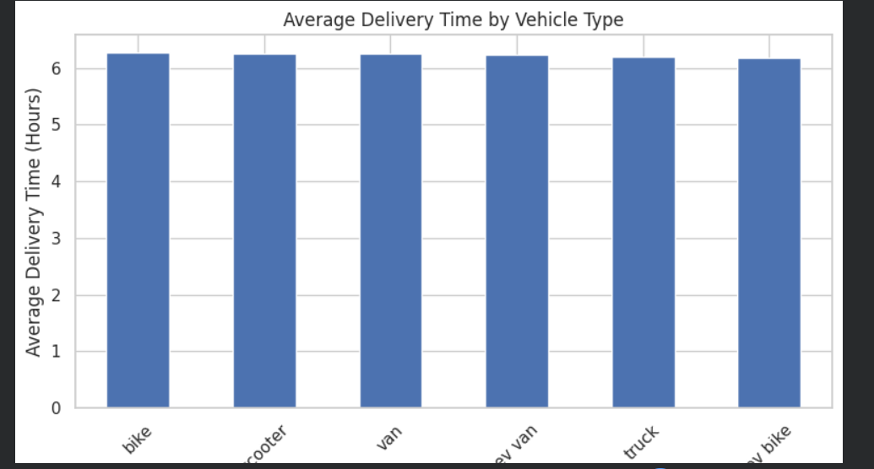
Figure 1: Average delivery time by vehicle type.
The average delivery time is very similar across all vehicle types, with values approximately between 6.1 and 6.3 hours. The small difference suggests that vehicle type does not have a strong influence on average delivery time in this dataset. Factors such as distance, weather, traffic, and region may have a greater effect.

6.2 Average Delivery Time by Weather Condition
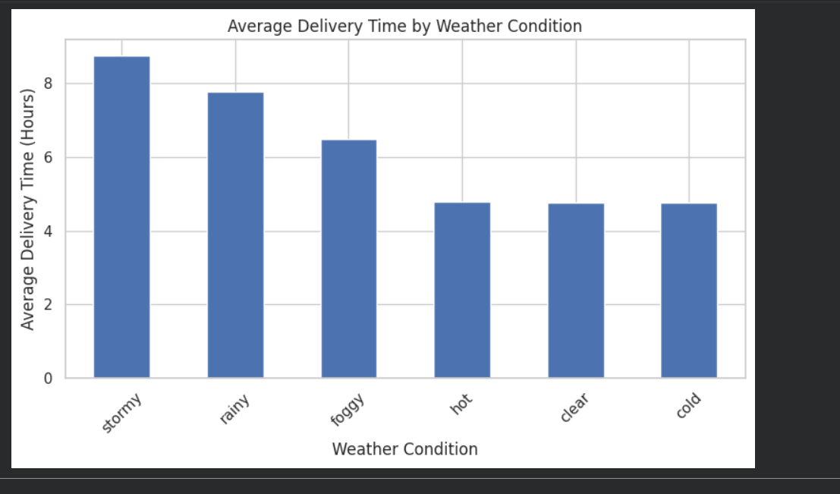
Figure 2: Average delivery time by weather condition.
Weather conditions show a more noticeable relationship with delivery time. Stormy weather has the highest average delivery time at approximately 8.7 hours, followed by rainy weather at approximately 7.7 hours. Foggy weather is around 6.5 hours, while hot, clear, and cold conditions are close to 4.7–4.8 hours. This pattern suggests that storms and rain may increase delivery time because of reduced visibility, unsafe road conditions, and slower movement.

6.3 Correlation Heatmap
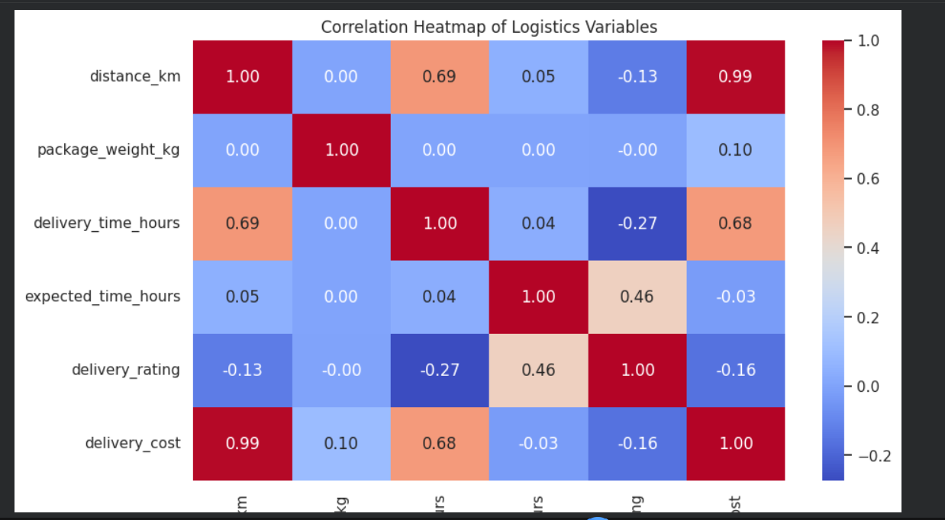
Figure 3: Correlation heatmap of numerical logistics variables.
The heatmap shows a very strong positive correlation between distance and delivery cost (approximately 0.99). Distance also has a moderate positive correlation with delivery time (approximately 0.69), while delivery time and delivery cost have a moderate positive correlation (approximately 0.68). Delivery time has a weak negative correlation with delivery rating (approximately −0.27), suggesting that longer delivery times may be associated with slightly lower customer ratings. Package weight has very weak correlations with most variables. Correlation indicates association, not causation.

6.4 Average Delivery Time by Delivery Partner
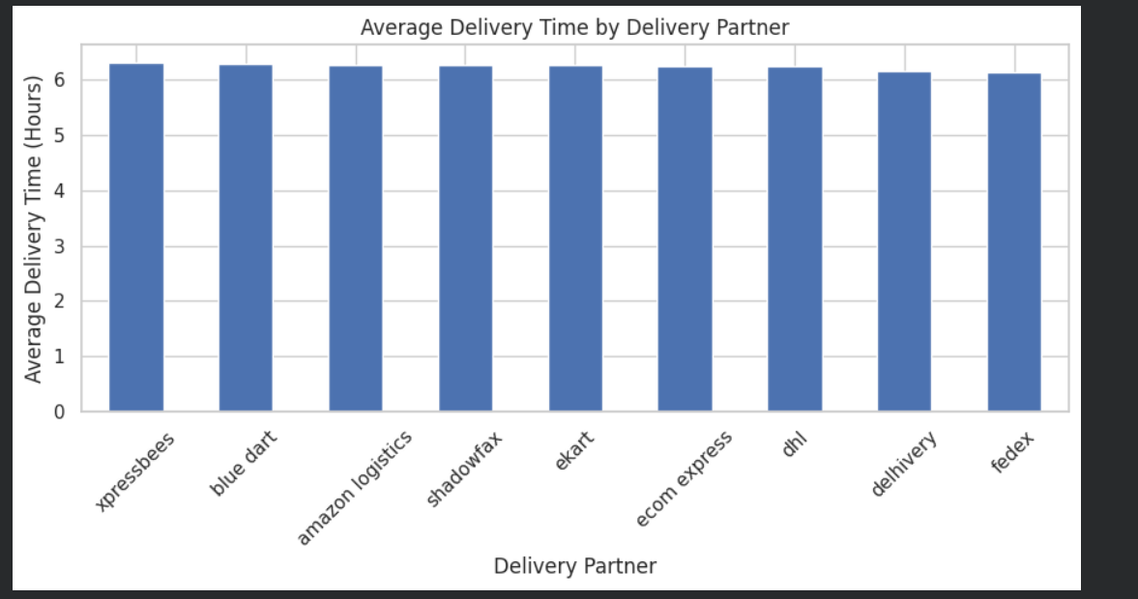
Figure 4: Average delivery time by delivery partner.
The delivery partners have very similar average delivery times, generally close to 6.1–6.3 hours. Xpressbees is slightly higher, while FedEx and Delhivery are slightly lower. The small differences suggest that partner selection alone may not explain delivery performance. Additional factors such as route distance, weather, and shipment characteristics should be considered before judging partner performance.

6.5 Average Delivery Time by Region
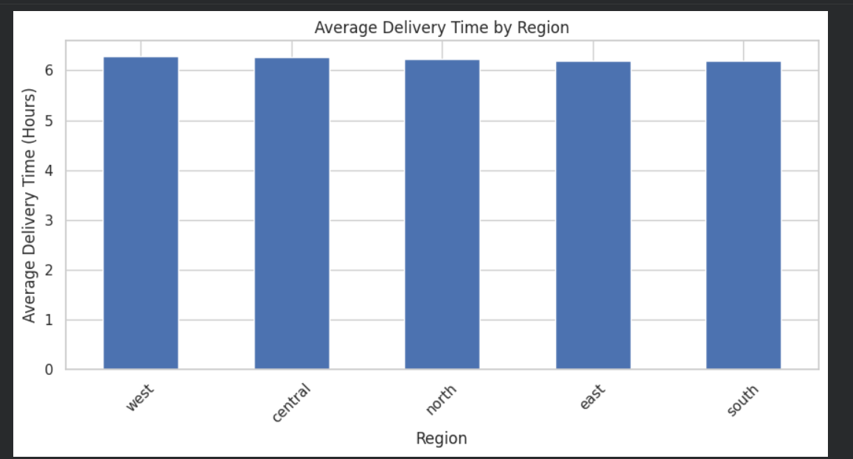
Figure 5: Average delivery time by region.
The regional averages are also very close, approximately 6.1–6.3 hours. West and Central have slightly higher averages, while East and South are marginally lower. The limited variation indicates that region does not create a major difference in average delivery time in this dataset. More detailed analysis using distance and weather within each region may reveal hidden differences.

6.6 Delay Rate by Delivery Partner
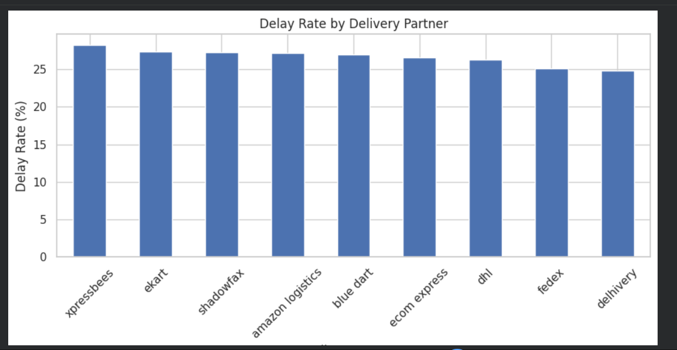
Figure 6: Delay rate by delivery partner.
The delay rates range approximately from 25% to 28%. Xpressbees has the highest delay rate at around 28%, while Delhivery has the lowest at approximately 25%. Although the differences are not very large, they may help identify partners that require further investigation. A fair comparison should control for distance, weather, region, and package characteristics.

7. Python Code Used
# Descriptive statistics
numerical_columns = [
"distance_km",
"package_weight_kg",
"delivery_time_hours",
"expected_time_hours",
"delivery_rating",
"delivery_cost"
]
df[numerical_columns].describe()
df[numerical_columns].mean()
df[numerical_columns].median()
# Average delivery time by category
average_time_vehicle = (
df.groupby("vehicle_type")["delivery_time_hours"]
.mean()
.sort_values(ascending=False)
)
# Correlation heatmap
correlation_matrix = df[numerical_columns].corr()
sns.heatmap(correlation_matrix, annot=True, cmap="coolwarm", fmt=".2f")
# Delay-rate preparation
df["delayed_numeric"] = (
df["delayed"].astype(str)
.str.strip()
.str.lower()
.map({"yes": 1, "no": 0, "1": 1, "0": 0})
)
# Delay rate by delivery partner
delay_rate_partner = (
df.groupby("delivery_partner")["delayed_numeric"]
.mean()
.sort_values(ascending=False) * 100
)

8. Operational Insights and Recommendations
- Weather-aware planning: Increase estimated delivery time during stormy and rainy conditions.
- Dynamic ETA calculation: Include distance and weather condition when estimating delivery time.
- Cost monitoring: Since distance and delivery cost are strongly related, optimize routes and delivery zones.
- Partner evaluation: Compare partners after controlling for route difficulty and weather rather than using delay rate alone.
- Regional investigation: Although regional averages are similar, region-level analysis combined with distance may reveal specific bottlenecks.
- Customer experience improvement: Monitor long delivery times because they may contribute to lower ratings.
- Future predictive modeling: Use delivery_time_hours as the target variable in Week 4 and test regression models.

9. Limitations
- The dataset is synthetic and intended for educational use.
- The normalized variables do not retain their original units in the cleaned file.
- Correlation values describe relationships but do not prove cause and effect.
- The visual analysis does not include every possible factor, such as traffic intensity, route congestion, or time of day.
- Partner comparisons may be affected by differences in shipment mix and operating conditions.

10. Conclusion
The Week 3 analysis provided a clearer understanding of the logistics dataset through statistics and visualization. Weather conditions, especially storms and rain, were associated with higher average delivery times. Distance showed strong relationships with delivery cost and a moderate relationship with delivery time. Vehicle type, delivery partner, and region showed relatively small differences in average delivery time. These findings indicate that a future delivery-time prediction model should prioritize distance, weather, and other relevant operational variables. The results also demonstrate how data visualization can support logistics planning, cost control, service improvement, and more realistic delivery-time estimates.

11. References
1. Kaggle – Delivery Logistics Dataset (India – Multi-Partner), by Kundan Sagar Bedmutha.
2. Python Pandas documentation – data manipulation and descriptive statistics.
3. Matplotlib documentation – plotting and visualization.
4. Seaborn documentation – statistical data visualization.
5. Google Colab – Python notebook environment.

