Tool Used: MS SQL Server

**All Data:**

SELECT * FROM pizza_sales;

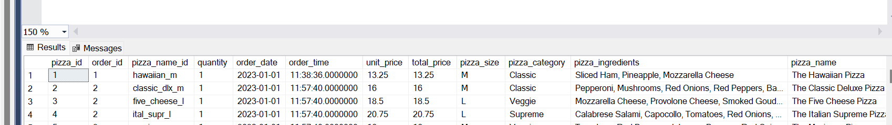

**1.Total Revenue:**

select SUM(total_price) AS Total_Revenue FROM pizza_sales;  
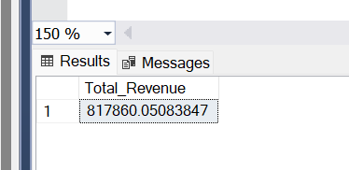

**2.Average Order Value;**

SELECT SUM(total_price)/COUNT(DISTINCT order_id) as Avg_Order_Value from pizza_sales;

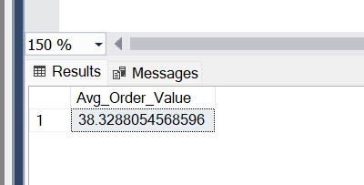

**3.Total Pizza Sold**

SELECT SUM(quantity) AS Total_pizza_sold FROM pizza_sales;

**4. Total Orders**

SELECT COUNT(DISTINCT order_id) AS Total_Orders FROM pizza_sales;

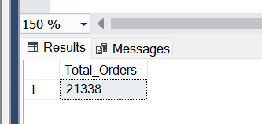

**5.Average Pizzas Per Order**

SELECT CAST(CAST(SUM(quantity) AS decimal(10,2))/CAST(COUNT(DISTINCT order_id) AS decimal(10,2)) AS decimal(10,2)) AS Avg_Pizza_Per_Order FROM pizza_sales;

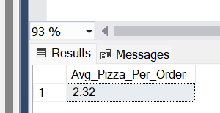

**6.Hourly Trend for Total Pizzas Sold**

SELECT DATEPART(hour, order_time) AS Order_Hour,SUM(quantity) AS Total_Pizza_Sold from pizza_sales

group by DATEPART(hour, order_time)

order by DATEPART(hour, order_time);

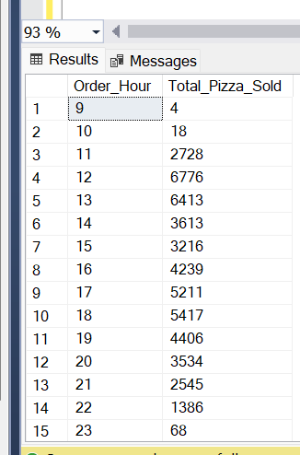

**7. Weekly Trend for Total Orders**

SELECT DATEPART(ISO_WEEK, order_date) AS Order_week_number,YEAR(order_date) as order_year,COUNT(distinct order_id) AS Total_orders

from pizza_sales

group by DATEPART(ISO_WEEK, order_date),YEAR(order_date)

order by DATEPART(ISO_WEEK, order_date),YEAR(order_date) ;

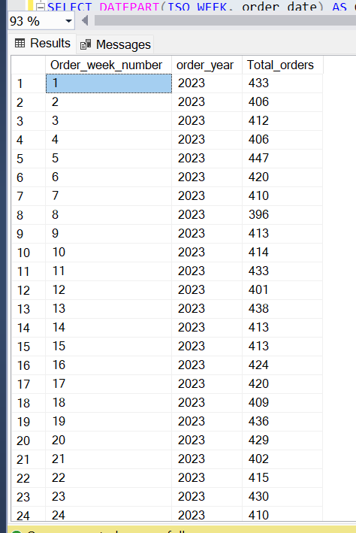

**8. Pizza Category wise sales and pct of Total Sales**

SELECT pizza_category, sum(total_price) AS Total_Sales,SUM(total_price)*100/(select sum(total_price) from pizza_sales) As Pct_Total_Sales

from pizza_sales

group by pizza_category;

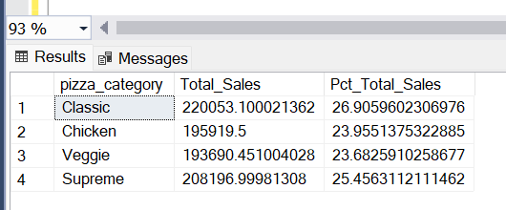

**9. Pizza Category wise sales and pct of Total Sales for jan month**

SELECT pizza_category, sum(total_price) AS Total_Sales,SUM(total_price)*100/(select sum(total_price) from pizza_sales where MONTH(order_date)= 1) As Pct_Total_Sales

from pizza_sales

where MONTH(order_date) = 1

group by pizza_category;

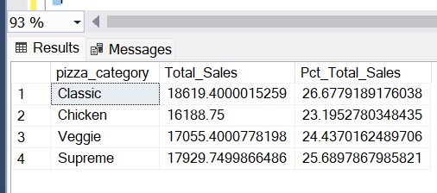

**10. Pizza Size wise sales and pct of Total Sales for jan month**

SELECT pizza_size, cast(sum(total_price) AS decimal(10,3)) AS Total_Sales,cast(SUM(total_price)*100/(select sum(total_price) from pizza_sales) as decimal(10,2)) As Pct_Total_Sales

from pizza_sales

group by pizza_size

order by Pct_Total_Sales;

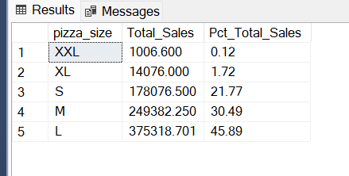

**11. Top 5 best selling/revenue pizza_names**

select top 5 pizza_name,sum(total_price) as pizzas_Total_Revenue from pizza_sales

group by pizza_name

order by pizzas_Total_Revenue desc ;

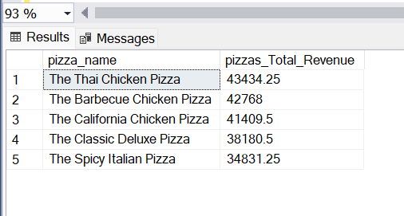

**12. Top 5 worst selling/revenue pizza_names**

select top 5 pizza_name,sum(total_price) as pizzas_Total_Revenue from pizza_sales

group by pizza_name

order by pizzas_Total_Revenue ;

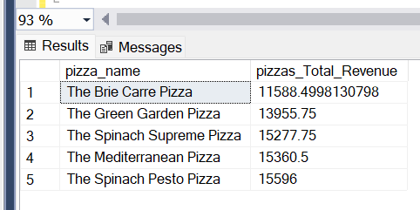

**13. Top 5 best quantity selling/revenue pizza_names**

select top 5 pizza_name,sum(quantity) as Total_Qunatity from pizza_sales

group by pizza_name

order by Total_Qunatity desc;

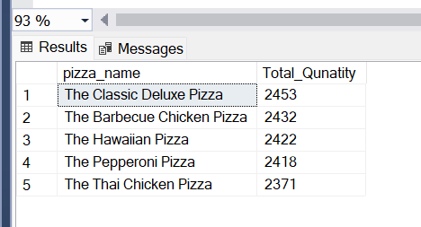

**14. Top 5 worst quantity selling/revenue pizza_names**

select top 5 pizza_name,sum(quantity) as Total_Qunatity from pizza_sales

group by pizza_name

order by Total_Qunatity ;

