Que:1

<!doctype html>

<html lang="eng">

    <head>

        <meta charset="UTF-8">

        <meta name="viewport" content ="width=device-width,onitial-scale=2.0">

        <title>

            css selector examples</title>

            <link rel="stylesheet"href="style.css">

        </head>

        <body>

            <h1> css selectors</h1>

            <p class="intro">tjis is a paragraph</p>

            <p> this is second paragraph</p>

            <div id="main-container">

                <h2> main  section</h2>

                <p> this is inside main container</p>

                <a href="#">click hear</a>

            </div>

            <li>item 1</li>

            <li>item 2<li>

            <li>item 3</li>

            <ul>

            </body>

            </html>

css files

\*{

    font-family:Arial, Helvetica, sans-serif;

}

h1{

    color: black;

    background-color:rgb(119, 43, 226);

    text-align: center;

}

.intro

{

    font-size: 18px;

    background-color:blueviolet;

}

#main-container{

    background-color:grey;

    padding: 15px;

    border-radius: 5px;

}

#main-container p{

    color: blue;

}

Output:

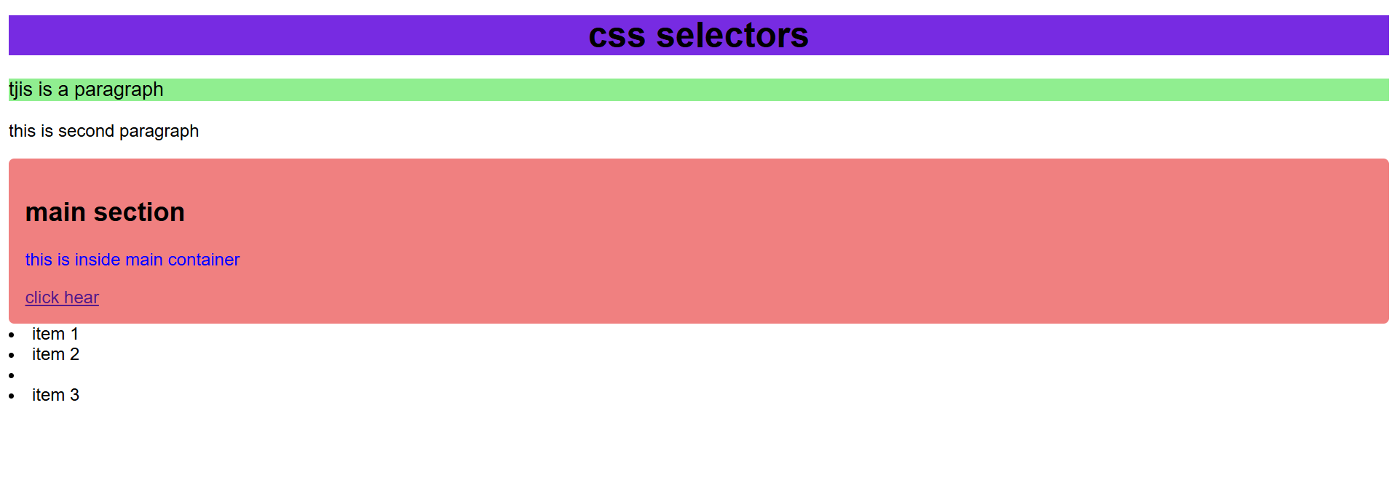

Que2:

<!doctype html>

<html>

    <head>

        <title>

            box model</title>

            <link rel="stylesheet"type="text/css" href="1.css">

        </head>

        <body>

            <div class="box-model">

                <h2>heading</h2>

                    <p>this is paragraph</p>

                    <div>

                    </body>

                    </html>

Css file:

.box-model{

    width:300px;

    height:200px;

    margin:20px;

    padding: 20px;

    border:5px solid red;

    background-color: yellow;

}

.bow model h2{

    font-size:24px;

    margin-bottom: 10px;

}

 .box-model p{

    font-size: 18px;

    margin-bottom: 20px;

 }

Output:

Que 3: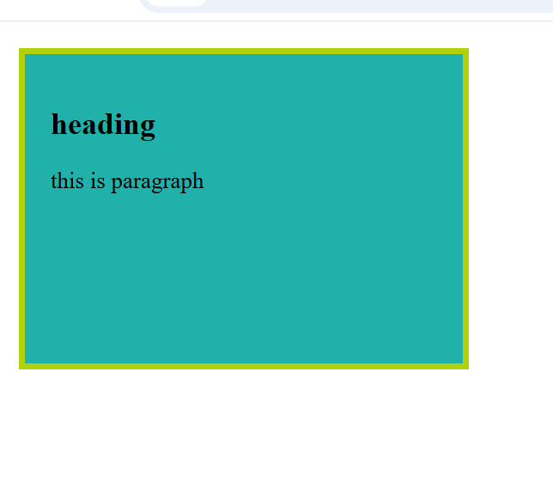

<!DOCTYPE html>

<html>

    <head>

    <title>HTML FORM</title>

</head>

<body>

    <center><h1>student regitration form </h1></center>

    <form name="my form" action=" " method="">

        <table cellpadding="5" cellspacing="5" bgcolor="lightblue" align="center">

            <tr><td> first name:</td><td><input type="text" name="fname"size=""></td></tr>

            <tr><td> last name:</td><td><input type="text" name="lname"size=""></td></tr>

            <tr><td>date of birth:</td><td><input type="text" name="date" size=""></td></tr>

            <tr><td>dob:</td><td><input type="date" name="date" size=""></td></tr>

            <tr><td>email:</td><td><input type="email" name="email" size=""></td></tr>

            <tr><td> gender:</td><td><input type="radio" id ="male" name="gender" value="male">male

            <input type="radio" id ="female" name="gender" value="female">female</td></tr>

            <tr><td> course details:</td><td>

            <select name="course">

                <option name="">---select---</option>

                <option name="">html</option>

                <option name="">php</option>

                <option name="">java</option>

            </select>

            <tr><td> interest:</td><td><input type="checkbox"id ="reading" name="interest" value="reading">reading

            <input type="checkbox"id ="sports" name="interst" value="spotrs">sports

            <input type="checkbox"id ="dancing" name="interst" value="dancing">dancing</td></tr>

            <tr><td></td><td><button type="submit">submit</button>

            <button type="reset">reset</button></td></tr>

        </table>

    </form>

</body>

    </html>

</html>

Output:

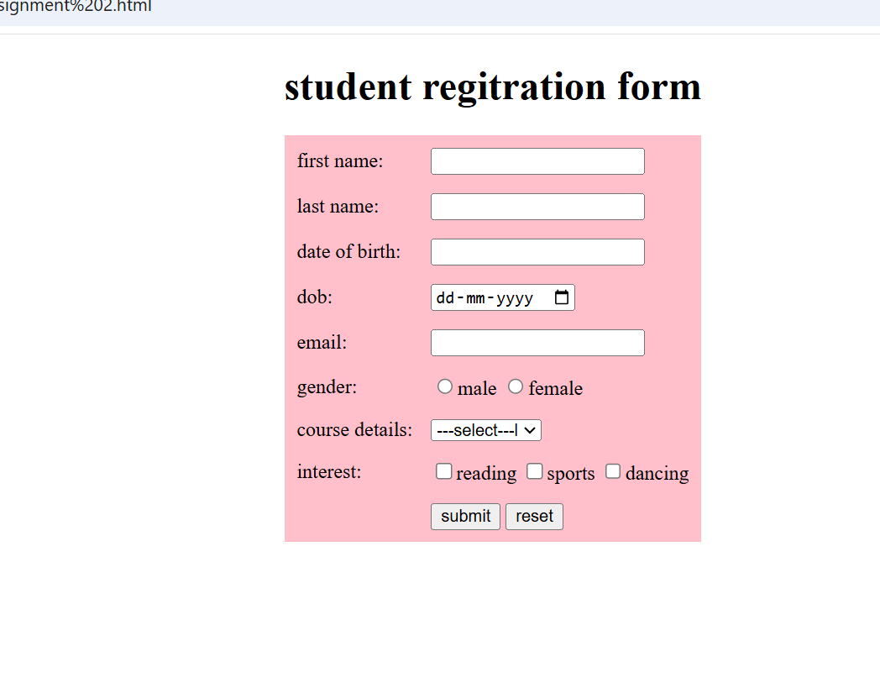

Que 4:

<!doctype html>

<html lang="en">

    <head>

        <meta charset="UTF-8">

        <meta name="viewport" content="width=device-width,initial-scale=1.0">

        <title>responsive design with media query</title>

        <link rel="stylesheet"href="2.css">

    </head>

    <body>

        <div class="contenr">

            <h1> responsive media query with text and background</h1>

            <p>when the screen size will be less than 600px to see the changes</p>

        </div>

    </body>

    </html>

Css file:

body{

    background-color:purple;

    margin: 10px;

    padding: 20px;

    font-size: 20px;

    font-family: arial,sans-serif;

    justify-content: center;

    text-align: center;

    color: blue;

}

.content{

    max-width:800px;

    margin:auto;

}

@media(max-width:600px)

{

    body{

        background-color:lightskyblue;

        font-size: 20px;

        text-align: center;

        color:black;

    }

    @media(min-width:600px)and(max-width:900px)

    {

        body{

            font-size: medium;

            background-color: blue;

        }

    @media(min-width:901px)

    {

        body {

            font-style: 22px;

            background-color:purple;

        }

    }

    }

}

Output:

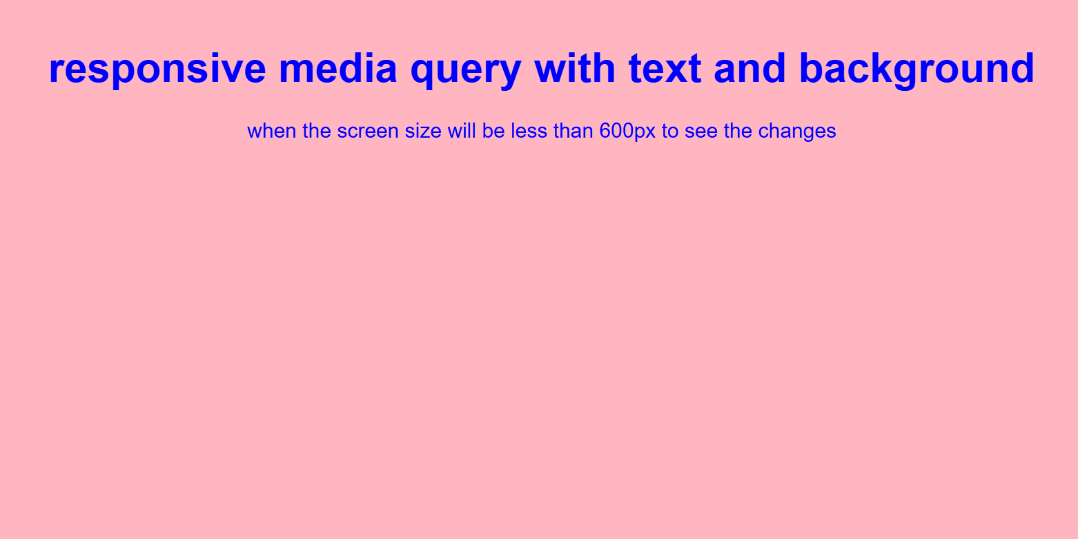

When media query <=600px than output will be:

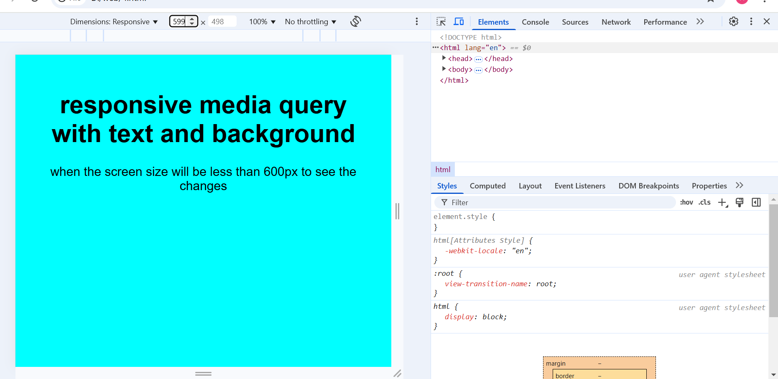

When media query will be more then 600px:

