Question 1:

<!DOCTYPE html>

<html lang="en">

<head>

<meta charset="UTF-8">

<meta name="viewport" content="width=device-width,

initial-scale=1.0">

<title>CSS Grid Layout</title>

<link  rel="stylesheet" href="a.css">

</head>

<body>

<div class="grid-container">

<div class="grid-item item-a">1</div>

<div class="grid-item item-b">2</div>

<div class="grid-item item-c">3</div>

<div class="grid-item item-d">4</div>

<div class="grid-item item-e">5</div>

<div class="grid-item item-f">6</div>

<div class="grid-item item-g">7</div>

<div class="grid-item item-h">8</div>

<div class="grid-item item-i">9</div>

</div>

</body>

</html>

css file:

body {

display: flex;

justify-content: center;

align-items: center;

height: 100vh;

background-color: #f4f4f4;

margin: 0;

}

.grid-container {

display: grid;

grid-template-columns: 1fr 1fr 1fr;

grid-template-rows: auto;

gap: 10px;

width: 60vw;

height: 60vh;

background-color: white;

}

.grid-item {

display: flex;

justify-content: center;

align-items: center;

font-size: 24px;

font-weight: bold;

color: white;

}

.item-a

{

grid-column: 1 / 2;

grid-row: 1 / 2;

background:#00aaff;;

}

.item-b

{

grid-column: 2 / 3;

grid-row: 1 / 2;

background:#ff4500;;

}

.item-c {

    grid-column: 3 / 3;

background: #4169e1;

 }

.item-d {

    grid-column: 1 / 2;

background:#ffd700;

}

.item-e {

    grid-column: 2/ 2;

background: #8a2be2;

 }

.item-f {

     grid-column: 3/3;

background: #32cd32;

 }

.item-g {

     grid-column: 1 /2;

background: #ff7f50;

 }

.item-h {

    grid-column: 2 / 2;

background: #20b2aa;

}

.item-i {

    grid-column: 3 / 3;

 background: #8b0000;

}

@media(max-width:658px)

{

    .item-a

    {

        background-color: #ffd700;

    }

    .item-b

    {

        background-color: #00c8ff;

    }

    .item-c

    {

        background-color: #ff0000;

    }

    .item-d

    {

        background-color: #37ff00;

    }

    .item-e

    {

        background-color: #ff2600;

    }

    .item-f

    {

        background-color: #99ff00;

    }

    .item-g

    {

        background-color: #5500ff;

    }

    .item-h

    {

        background-color: #00fff7;

    }

    .item-i

    {

        background-color: #ff00c3;

    }

}

Output:

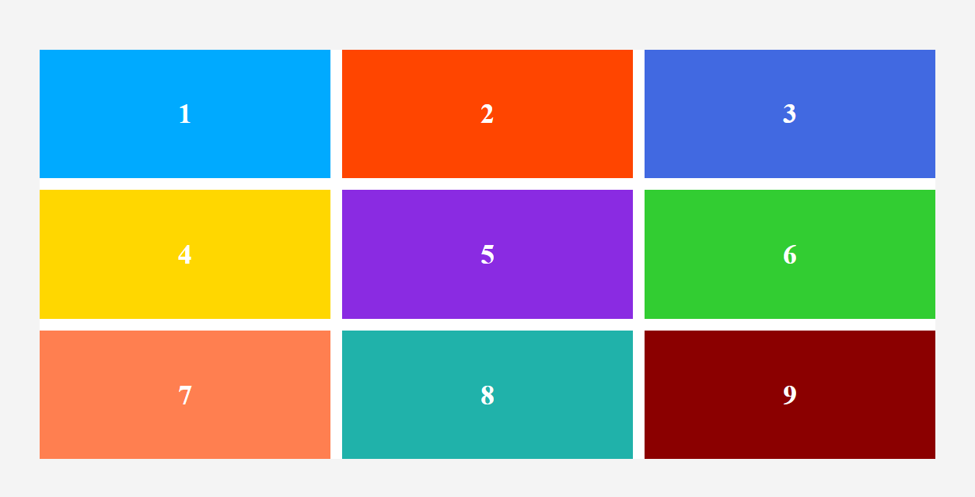

After add responsive media query <658

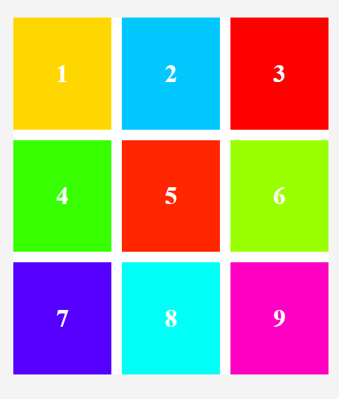

Question 2:

Time table

<!DOCTYPE html>

<html lang="en">

<head>

    <meta charset="UTF-8">

    <meta name="viewport" content="width=device-width, initial-scale=1.0">

    <title>Document</title>

</head>

<body>

    <h1>COLLEGE TIME TABLE</h1>

    <table border="5">

        <tr>

            <th>  </th>

            <th>8:30-9:30</th>

            <th>9:30-10:30</th>

            <th>10:30-11:30</th>

            <th>11:30-12:30</th>

            <th>12:30-2:00</th>

            <th>2:00-3:00</th>

            <th>3:00-4:00</th>

            <th>4:00-5:00</th>

        </tr>

        <tr>

            <td>MONDAY</td>

            <td>---</td>

            <td style="color:blue;">SUB1</td>

            <td style="color:orange;">SUB2</td>

            <td style="color:blueviolet">SUB3</td>

            <th rowspan="6">LUNCH</th>

            <td style="color:green;">SUB4</td>

            <td style="color:red;">SUB5</td>

            <th colspan="2">COUNSELLING CLASS</th>

        </tr>

        <tr>

            <td>TUESDAY</td>

            <td style="color:blue;">SUB1</td>

            <td style="color:orange;">SUB2</td>

            <td style="color:blueviolet">SUB3</td>

            <td>---</td>

            <td style="color:orange;">SUB2</td>

            <td style="color:orange;">SUB2</td>

            <th colspan="2">LIBRARAY</th>

        </tr>

        <tr>

            <td>WEDNESDAY</td>

            <td style="color:blue;">SUB1</td>

            <td style="color:orange;">SUB2</td>

            <td style="color:red;">SWA</td>

            <td>---</td>

            <th colspan="4">LAB</th>

        </tr>

        <tr>

            <td>THURSDAY</td>

            <td style="color:blue;">SUB1</td>

            <td style="color:orange;">SUB2</td>

            <td style="color:blueviolet">SUB3</td>

            <td>---</td>

            <td style="color:orange;">SUB2</td>

            <td style="color:orange;">SUB2</td>

            <th colspan="2">LIBRARAY</th>

        </tr>

        <tr>

            <td>FRIDAY</td>

            <td style="color:blue;">SUB1</td>\

            <td style="color:orange;">SUB2</td>

            <td style="color:blueviolet">SUB3</td>

            <td>---</td>

            <td style="color:green;">SUB4</td>

            <td style="color:red;">SUB5</td>

            <th colspan="2">LIBRARAY</th>

        </tr>

        <tr>

            <td>SATURDAY</td>

            <td style="color:blue;">SUB1</td>

            <th colspan="3">SEMINAR</th>

            <td style="color:green;">SUB4</td>

            <td style="color:red;">SUB5</td>

            <th colspan="2">LIBRARAY</th>

        </tr>

    </table>

</body>

</html>

Output:

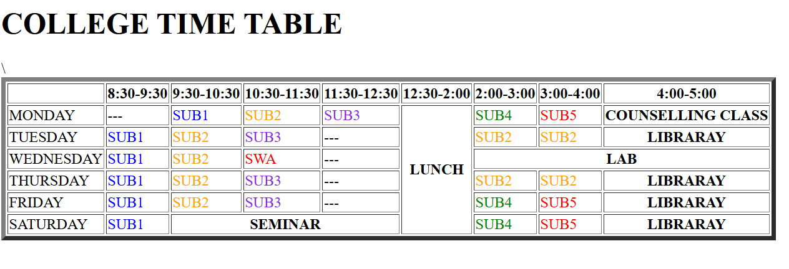

Question 3:

<!DOCTYPE html>

<html lang="en">

<head>

    <meta charset="UTF-8">

    <meta name="viewport" content="width=device-width, initial-scale=1.0">

    <title>time table</title>

</head>

<body>

    <h1> My TimeTable</h1>

    <table border="6">

    <tr>

        <th rowspan="2">Day</th>

        <th colspan="2">session</th>

        </tr>

        <tr>

        <th>schedule</th>

        <th>course name</th>

 </tr>

 <tr>

    <td>sunday</td>

    <td>16:00-16:50</td>

    <td>Web Technology</td>

 </tr>

 <tr>

    <td>sunday</td>

    <td>17:00-17:50</td>

    <td>Network Mangement</td>

 </tr>

 <tr>

    <td>monday</td>

    <td>18:00-18:50</td>

    <td>It Project Mangement</td>

 </tr>

</body>

</html>

Output:



Question 4:

<!DOCTYPE html>

<html lang="en">

<head>

    <meta charset="UTF-8">

    <meta name="viewport" content="width=device-width, initial-scale=1.0">

    <title>box model</title>

    <link rel="stylesheet" href="b.css">

</head>

<body>

    <div class="conatiner">

        <p>centered box</p>

        <div class="box">centered box</div>

    </div>

</body>

</html>

Css file:

\*

{

    margin: 0;

    padding: 0;

    box-sizing: border-box;

}

body{

    height: 100%;

    display: flex;

    justify-content: center;

    align-items: center;

    background-color: #f0f0f0;

}

.container

{

    justify-content: center;

    align-items: center;

    height: 100vh;

    width: 100vw;

    display: flex;

}

.box

{

    width: 400px;

    height:300px;

    background-color: aqua;

    color: black;

    display: flex;

    justify-content: center;

    align-items: center;

    border-radius: 10px;

    font-size: 20px;

    font-weight: bold;

    border: 5px solid black;

}

Output:

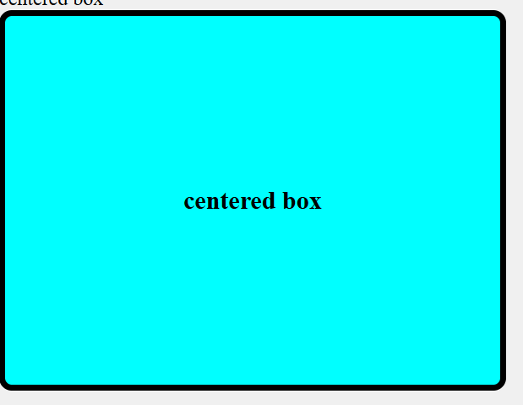

Question 5:

<!DOCTYPE html>

<html lang="en">

<head>

    <meta charset="UTF-8">

    <meta name="viewport" content="width=device-width, initial-scale=1.0">

    <title>responsive navbar</title>

    <link rel="stylesheet" href="d.css">

</head>

<body>

    <nav class="navbar">

        <ul class="nav-links">

            <li><a href="#">HOME</a></li>

            <li><a href="#">ABOUT</a></li>

            <li><a href="#">CONTACT</a></li>

        </ul>

    </nav>

        <footer>

            <p>&copy; 2025 My Website. All rights reserved.</p>

            <p>

                <a href="#">Privacy Policy</a> |

                <a href="#">Terms of Service</a>

            </p>

        </footer>

</body>

</html>

Css file:

\*

{

    margin: 0;

    padding: 0;

    box-sizing: border-box;

}

body{

    font-family: Arial, sans-serif;

}

.navbar{

    display: flex;

    justify-content: center;

    align-items: center;

    background-color:palevioletred;

    padding: 15px;

}

.nav-links{

    list-style: none;

    display: flex;

    gap: 20px;

}

.nav-links li{

    display: inline;

}

.nav-links a{

    text-decoration: none;

    color: white;

    font-size: 18px;

    padding: 8px 12px;

    transition: 0.3s;

}

.nav-links a:hover{

    background-color:blueviolet;

    color: black;

    border-radius: 5px;

}

footer {

    background-color: #333;

    color: white;

    text-align: center;

    padding: 10px 0;

    position: fixed;

    width: 100%;

    bottom: 0;

}

@media(max-width:768px)

{

    .navbar{

        flex-direction: column;

    }

    .nav-links{

        flex-direction: column;

        text-align: center;

        gap:10px;

    }

}

Output:

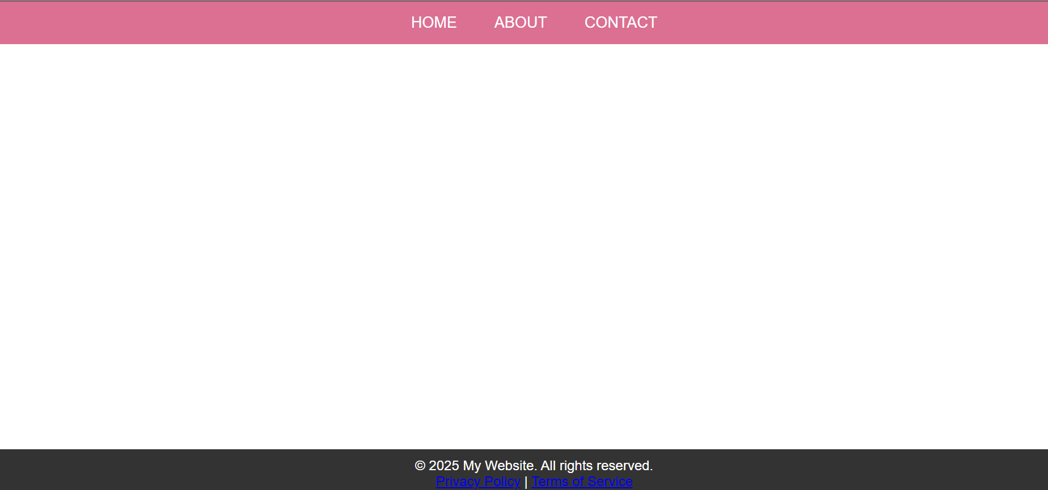

After responsive add:

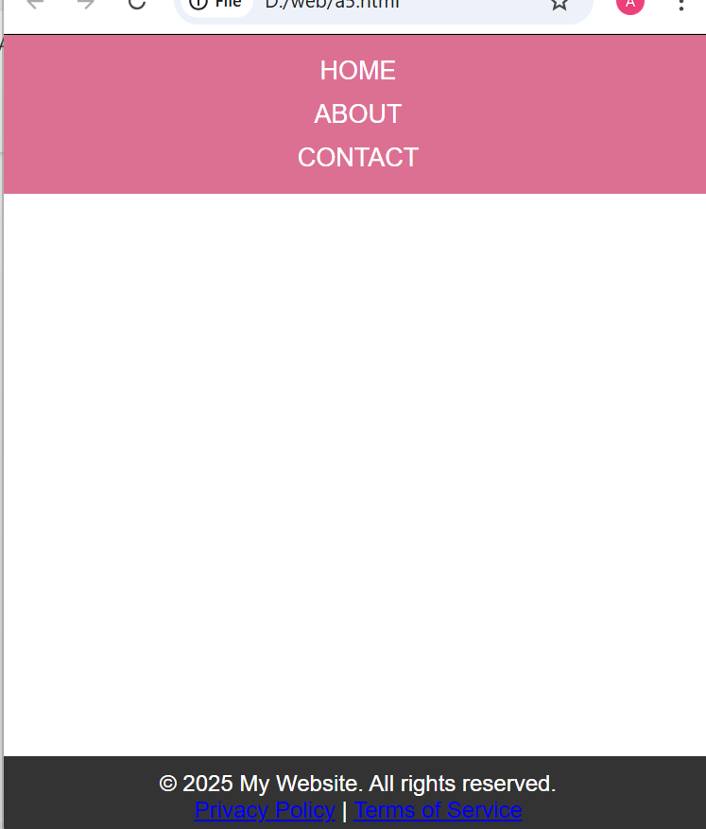

Question 6:

<!DOCTYPE html>

<html>

    <head>

        <title>Responsive Card Design using HTML and CSS</title>

    <meta charset="UTF-8">

    <meta name="viewport" content="width=device-width, initial-scale=1.0">

    <link rel="stylesheet" type="text/css" href="c.css">

</head>

<body>

    <div class="card-container">

        <div class="card">

            <img src="C:\Users\DELL\Pictures\Screenshots\Screenshot 2025-04-03 182206.png">

            <div class="card-content">

                <h3>Card 1</h3>

                <p>t is a long established fact that The point of using Lorem Ipsum is that it has a more-or-less normal distribution of letters, </p>

            </div>

        </div>

        <div class="card">

            <img src="D:\Cards\img3.png">

            <div class="card-content">

                <h3>Card 2</h3>

                <p>t is a long established fact that  The point of using Lorem Ipsum is that it has a more-or-less normal distribution of letters, </p>

            </div>

        </div>

        <div class="card">

            <img src="C:\Users\DELL\Pictures\Screenshots\img1.jpg">

            <div class="card-content">

                <h3>Card 3</h3>

                <p>t is a long established fact that The point of using Lorem Ipsum is that it has a more-or-less normal distribution of letters, </p>

            </div>

        </div>

    </div>

</body>

</html>

Css files:

\*{

    margin: 0px;

    padding: 0px;

    box-sizing: border-box;

    font-family: sans-serif;

}

body{

    background-color:tomato;

}

@media (max-width: 600px) {

    body {

      background-color: lightblue;

    }

  }

.card-container{

    display: flexbox;

    display: flex;

    justify-content: center;

    margin-top: 100px;

}

.card{

    width: 325px;

    background-color:aqua;

    border-radius: 8px;

    box-shadow: 0px 2px 4px rgba(0,0,0,0.2);

    margin: 20px;

    overflow: hidden;

}

.card img {

    width: 100%;

    height: 50%;

}

.card-content{

    padding: 16px;

}

.card-content h3{

    font-size: 28px;

    margin-bottom: 8px;

}

.card-content p{

    color: #666;

    font-size: 15px;

    line-height: 1.3;

}

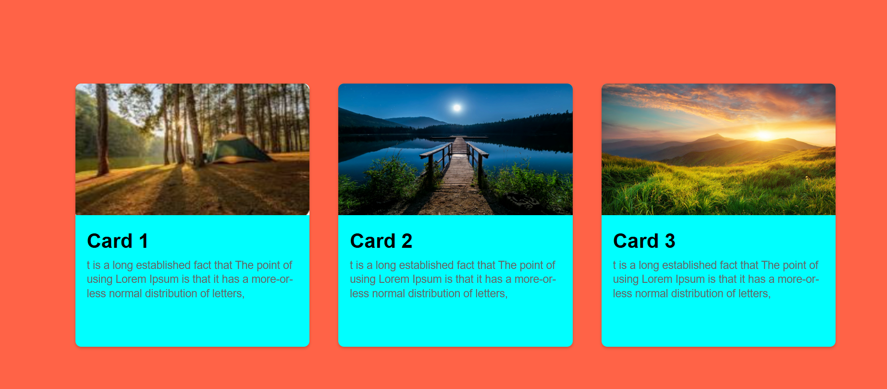

After add media query:

