**6.DOCKER with AWS**

**Agenda**

* **Create a React Project (Take code from S3)**
* **Install & Create a Docker Image for the Project**
* **Build and Run the Docker Image**
* **Deploy the Docker Image to AWS Cloud**

**PART 1: Set up React App (on EC2)**

**Step 1: Launch EC2 Instance**

* Go to AWS Console → **EC2** → Launch an instance.

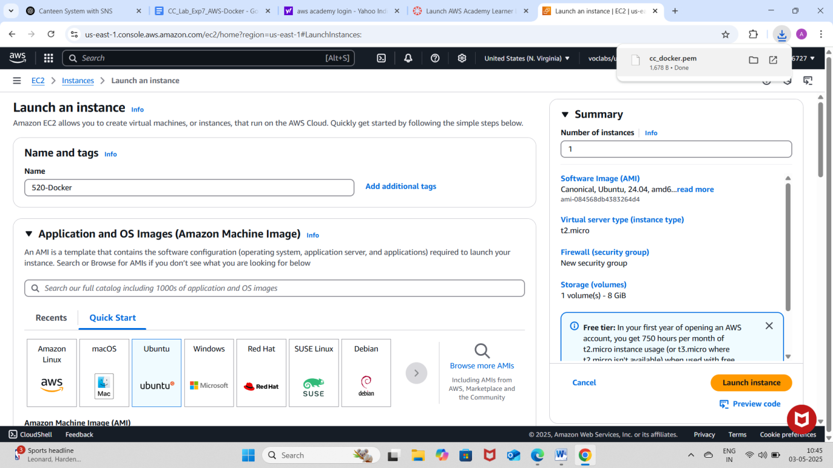

* Choose:
  + AMI: **Ubuntu 22.04 LTS**
  + Instance type: **t2.micro**

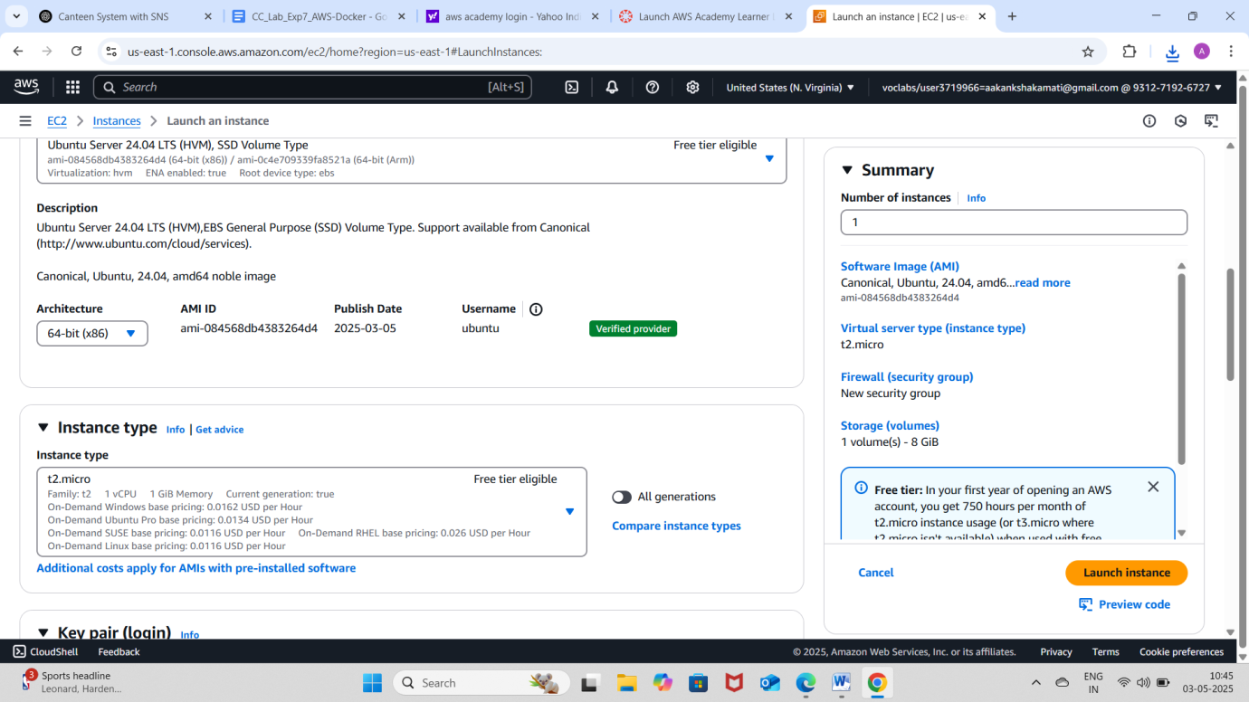

* + Key pair: Create/download one.
  + Security group: Allow ports **22 (SSH)** and **3000 (React app)**.

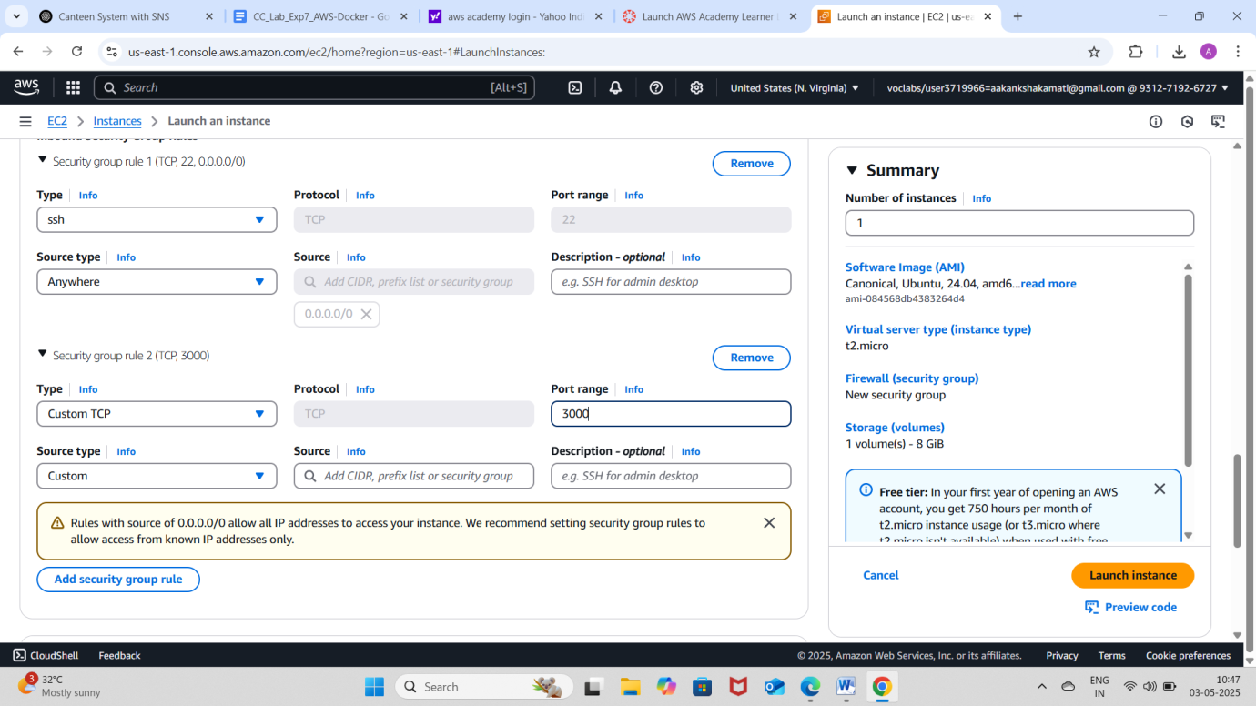

* Launch the instance.

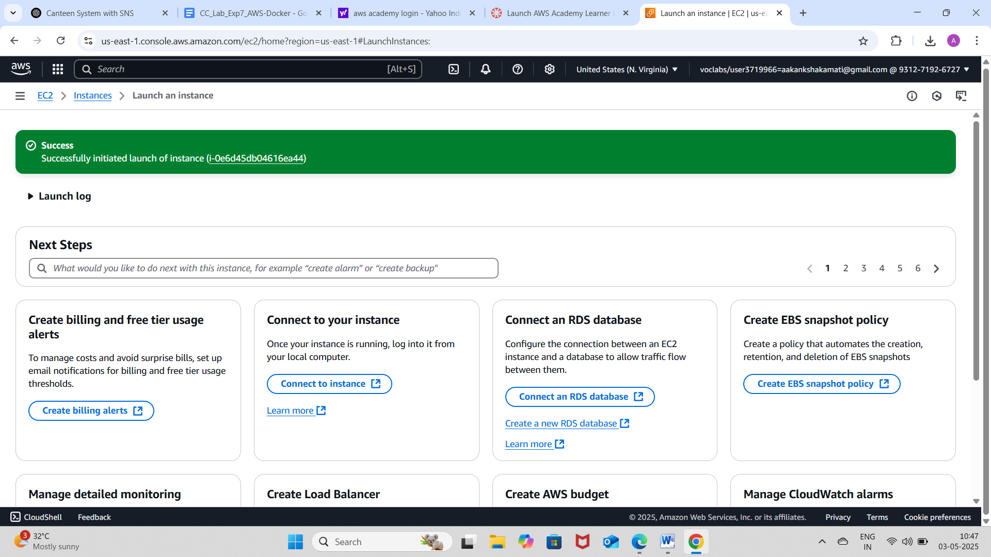

**Step 2: Connect to EC2**

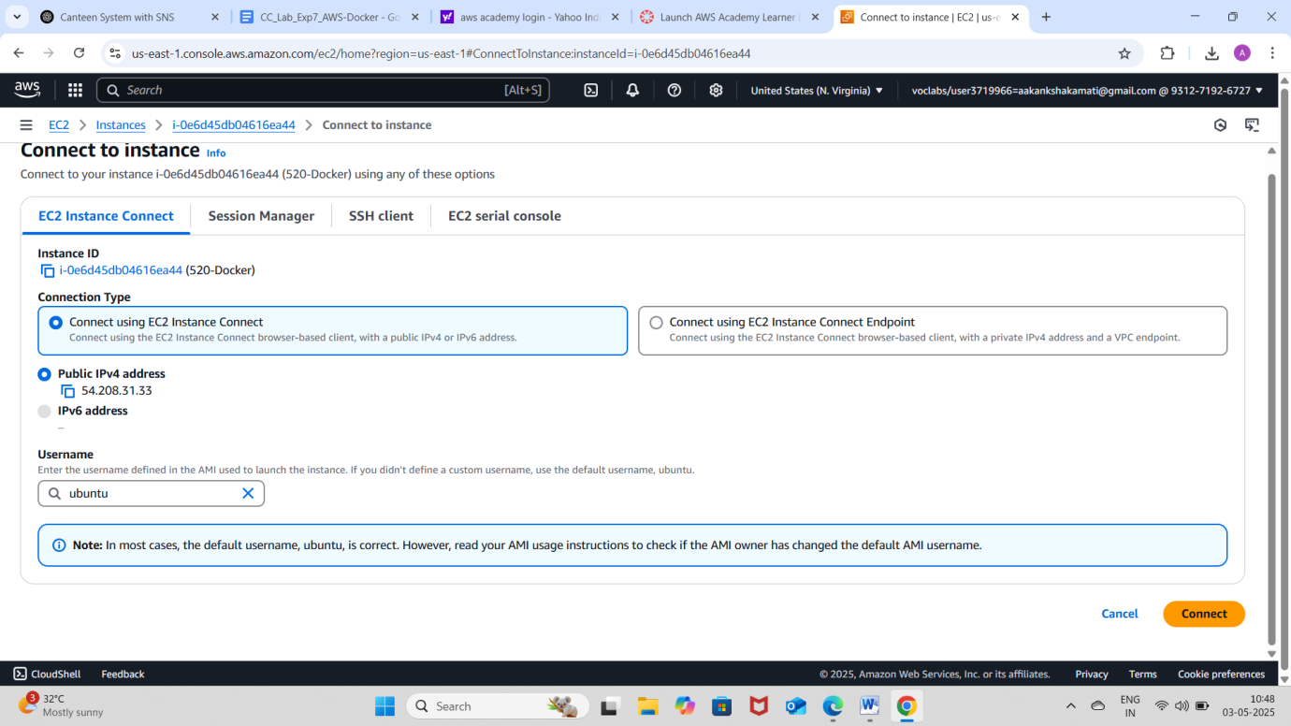

**Step 3: Install Node.js and npm**

* curl -fsSL https://deb.nodesource.com/setup_16.x | sudo -E bash –
* sudo apt install -y nodejs

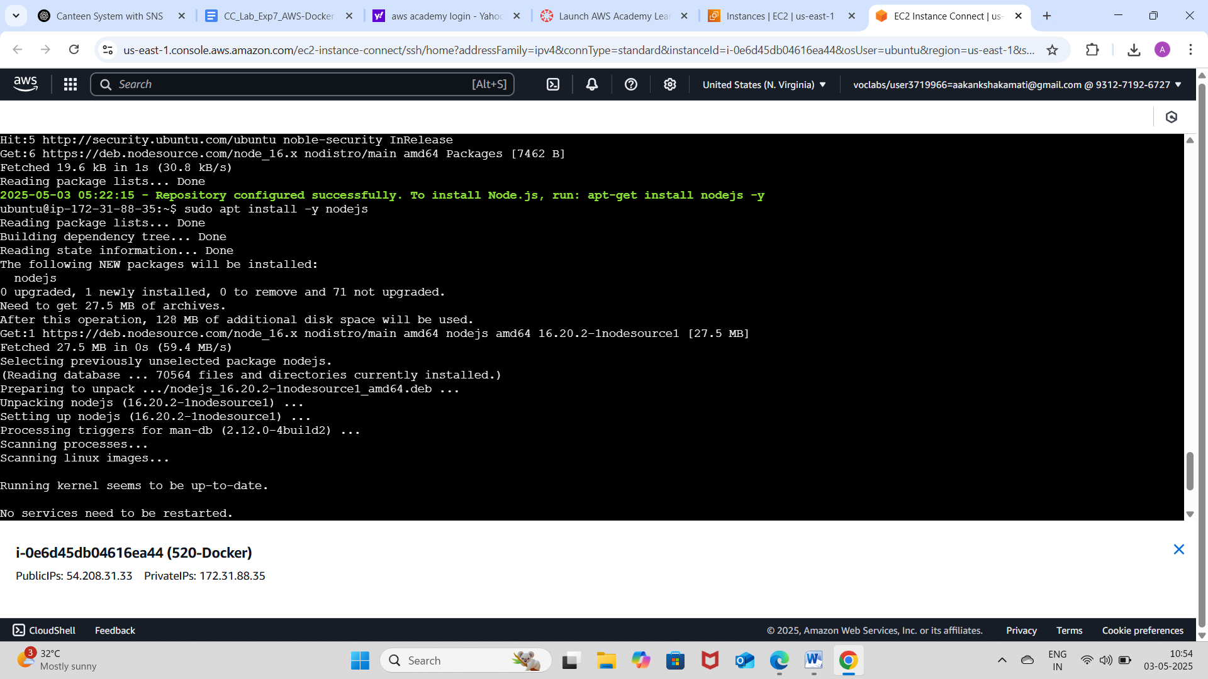

* node -v
* npm –v

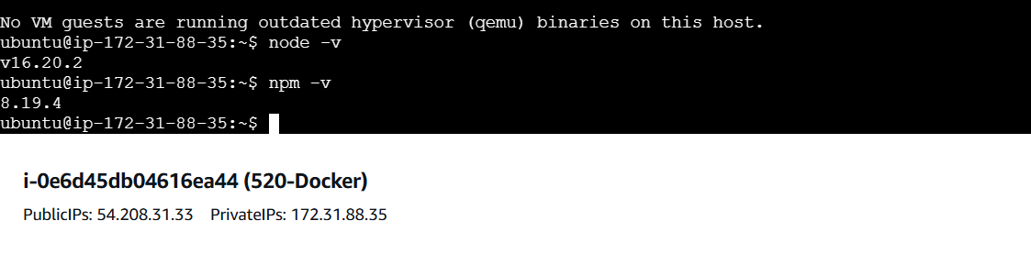

Figure-1

**Step 4: Install git (if needed)**

* sudo apt install git –y

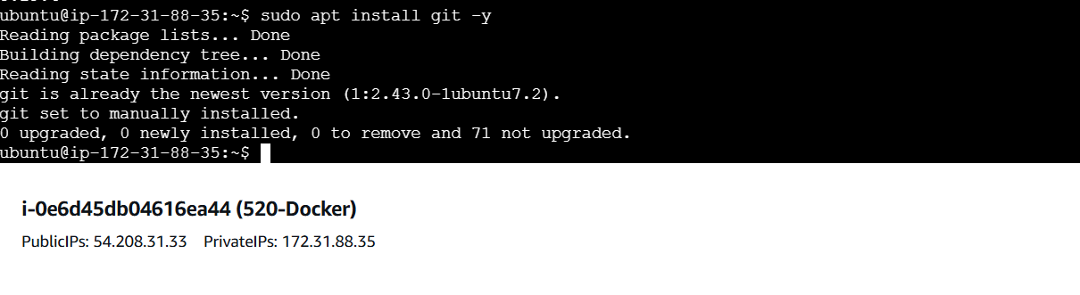

Figure-2

**Step 5: Create the React App**

* npx create-react-app 23BD5A0520-app

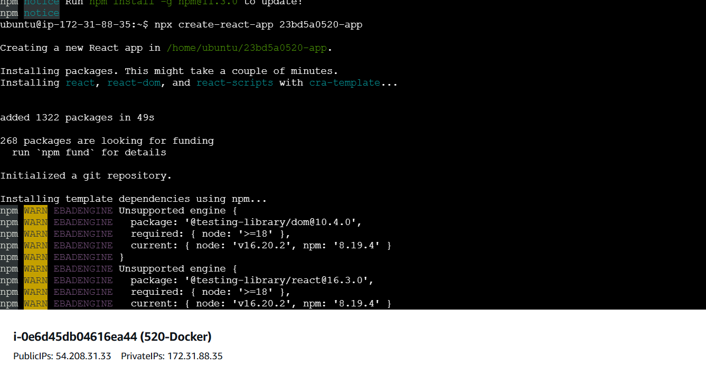

Figure-3

* cd 23BD5A0520-app

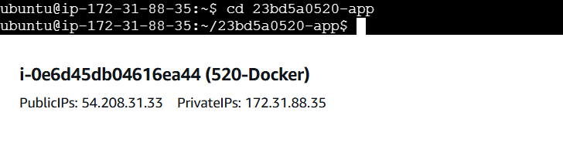

**Step 6: Create the Component**

* Inside the src/ folder, create a file welcome.js:
* nano src/welcome.js
* Paste the below code:

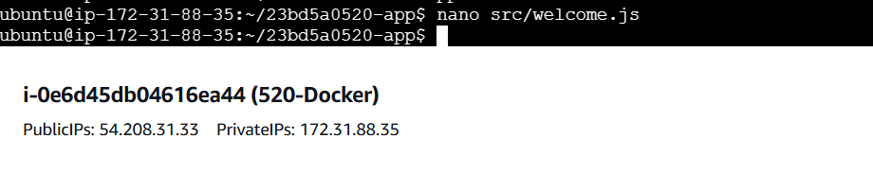

***import React, { useState } from 'react';***

***const WelcomeMessage = () => {***

***const [name, setName] = useState(‘Aakanksha');***

***const [showMessage, setShowMessage] = useState(false);***

***const handleButtonClick = () => {***

***setShowMessage(true);***

***};***

***return (***

***<div>***

***<input***

***type="text"***

***value={name}***

***onChange={(e) => setName(e.target.value)}***

***placeholder="Enter your name"***

***/>***

***<button onClick={handleButtonClick}>Show Welcome Message</button>***

***{showMessage && <p>Hi "{name}!!!" Welcome to Docker Image</p>}***

***</div>***

***);***

***};***

***export default WelcomeMessage;***

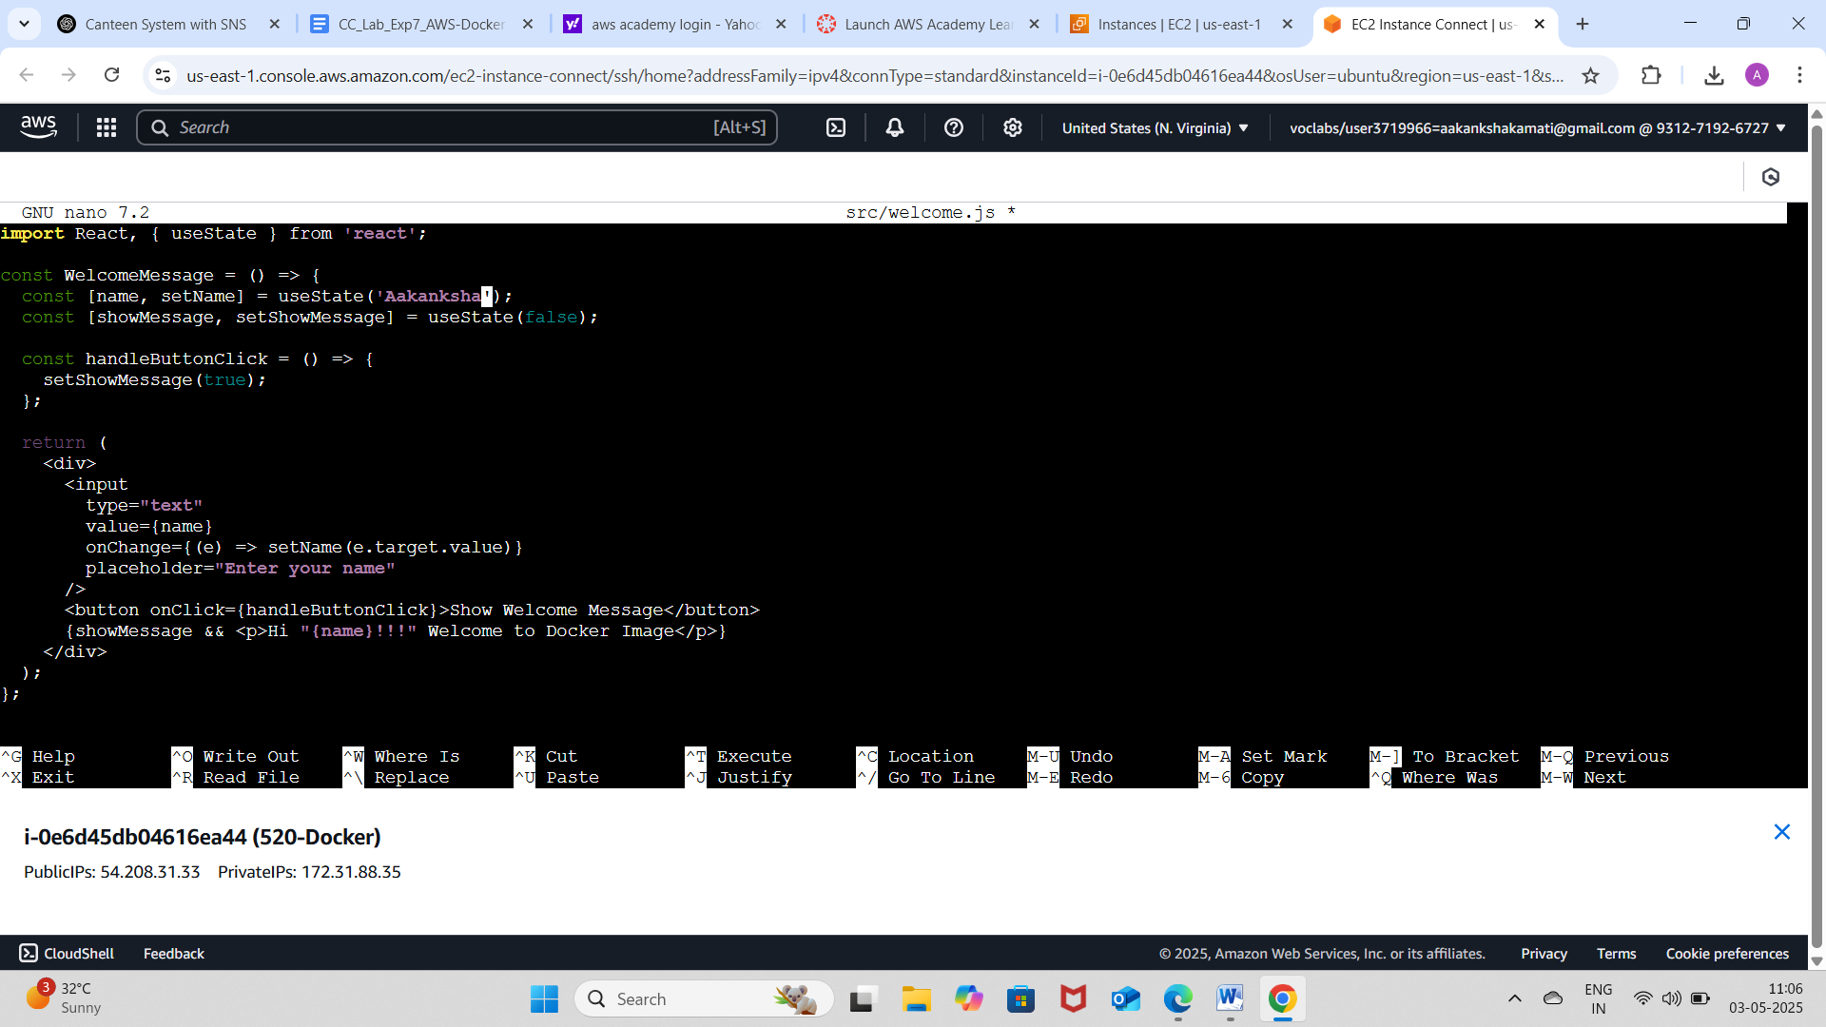

**Step 7: Modify App.js**

* nano src/App.js
* Modify like this:

***import React from 'react';***

***import WelcomeUser from './welcome';***

***function App() {***

***return (***

***<div className="App">***

***<WelcomeUser />***

***</div>***

***);***

***}***

export default App;

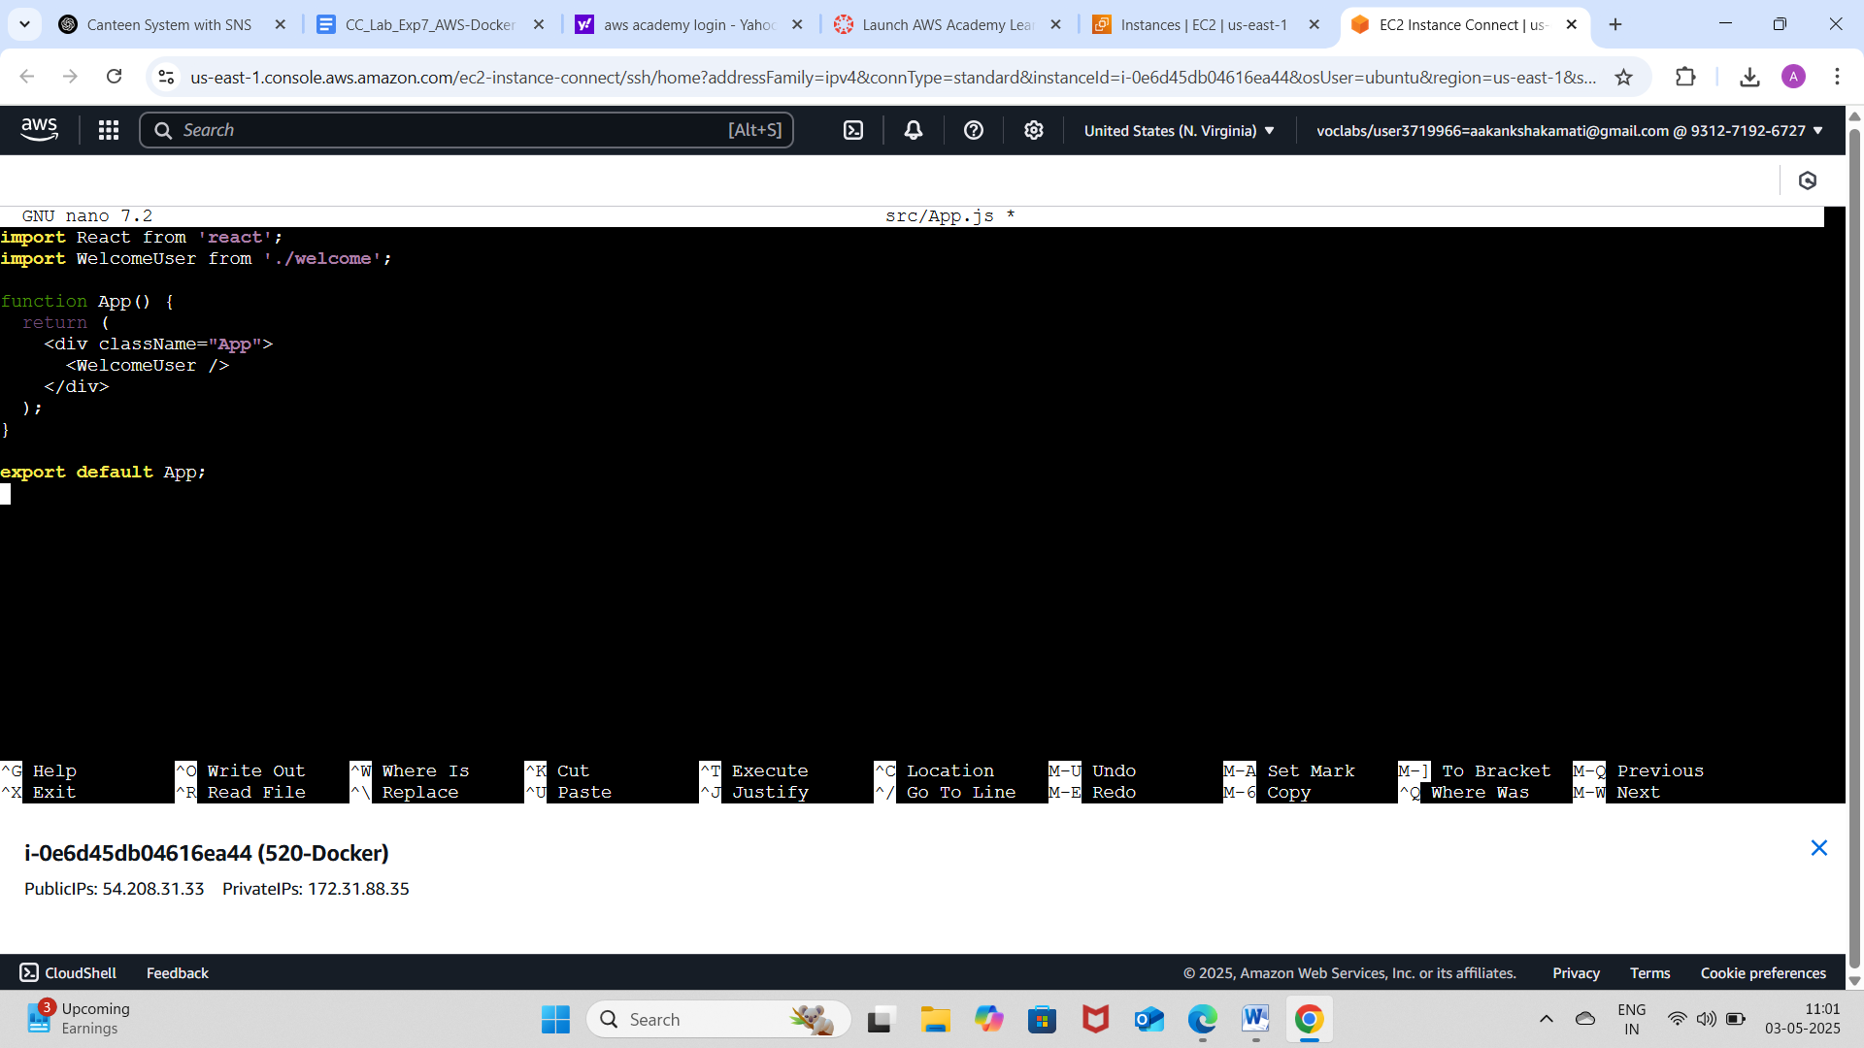

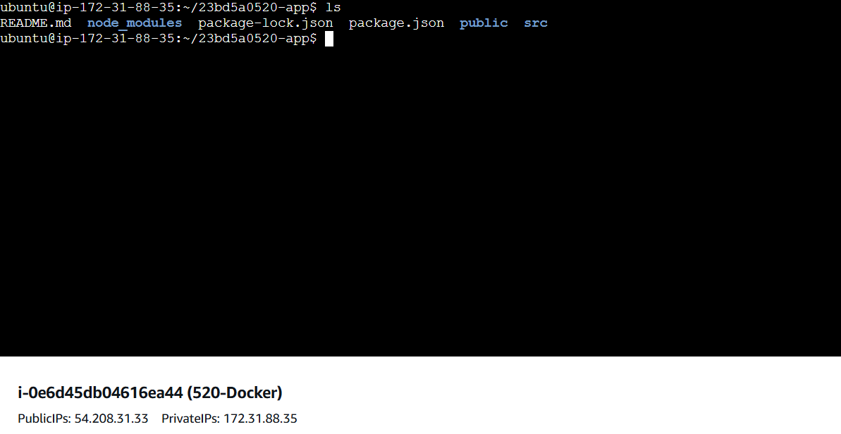



Figure-4

**Step 8: Test React App (Optional)**

* npm start

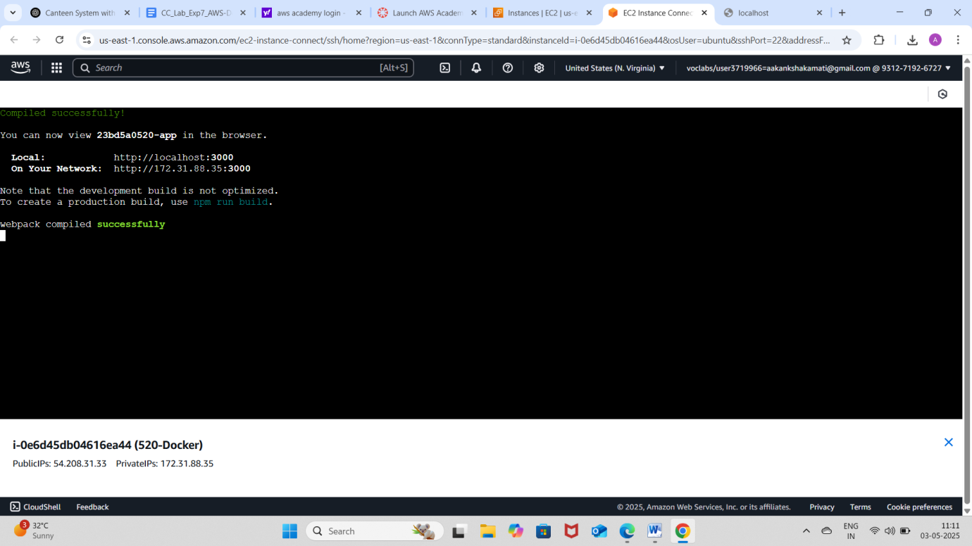

Figure-5

* Open browser: http://54.208.31.33:3000
* If you don't see the app, allow port 3000 in **Security Group**.

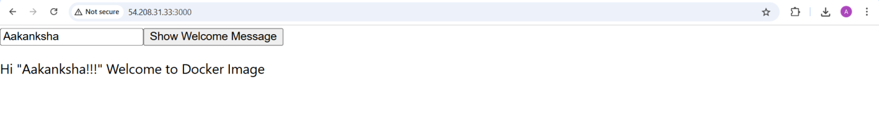

Figure-6

**Step 9: Build React App**

* npm run build
* This generates build/ folder.

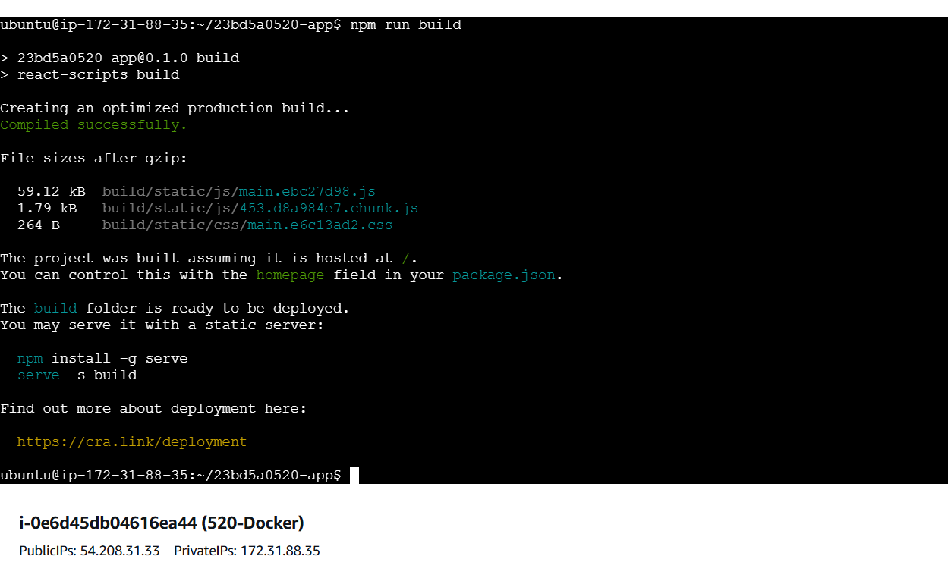

**PART 2: Dockerize React App on EC2**

**Step 1: Install Docker**

* sudo apt update

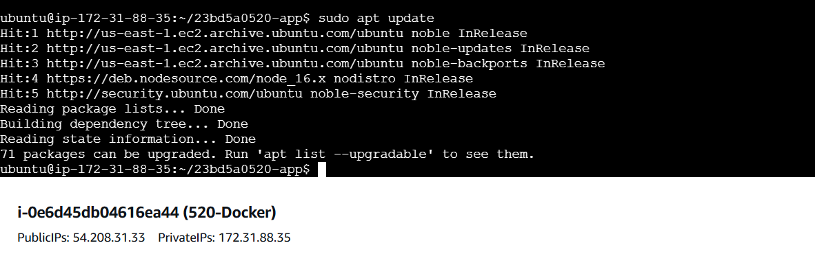

* sudo apt install docker.io –y

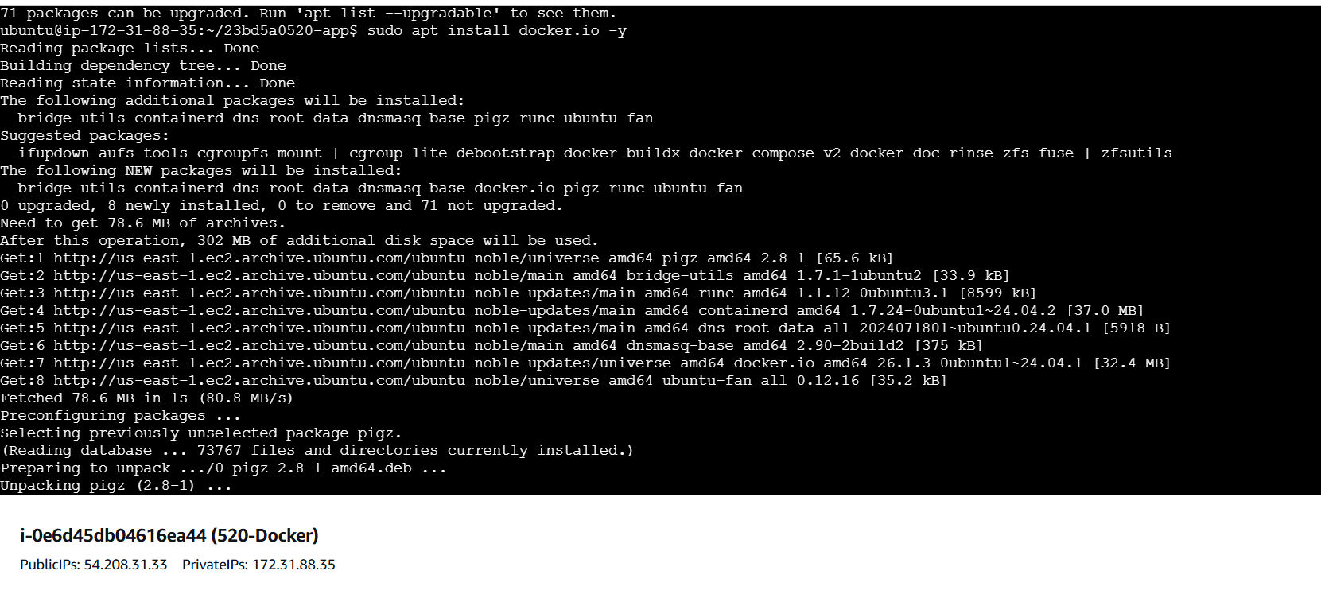

* sudo systemctl start docker
* sudo systemctl enable docker
* docker –version



Figure-7

**Step 2: Add Dockerfile (in project root — NOT src/)**

* nano Dockerfile

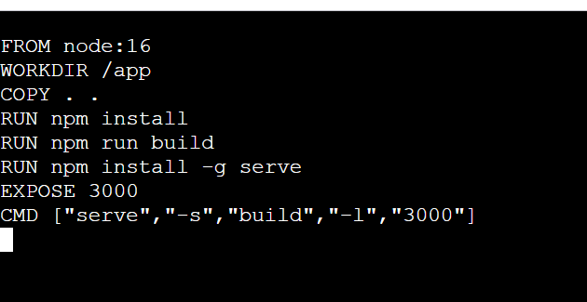

Figure-8

**Step 3: Create .dockerignore**

* nano .dockerignore

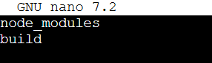

Figure-9

**Step 4: Build Docker Image**

* sudo docker build -t 23bd5a0520-react-app .

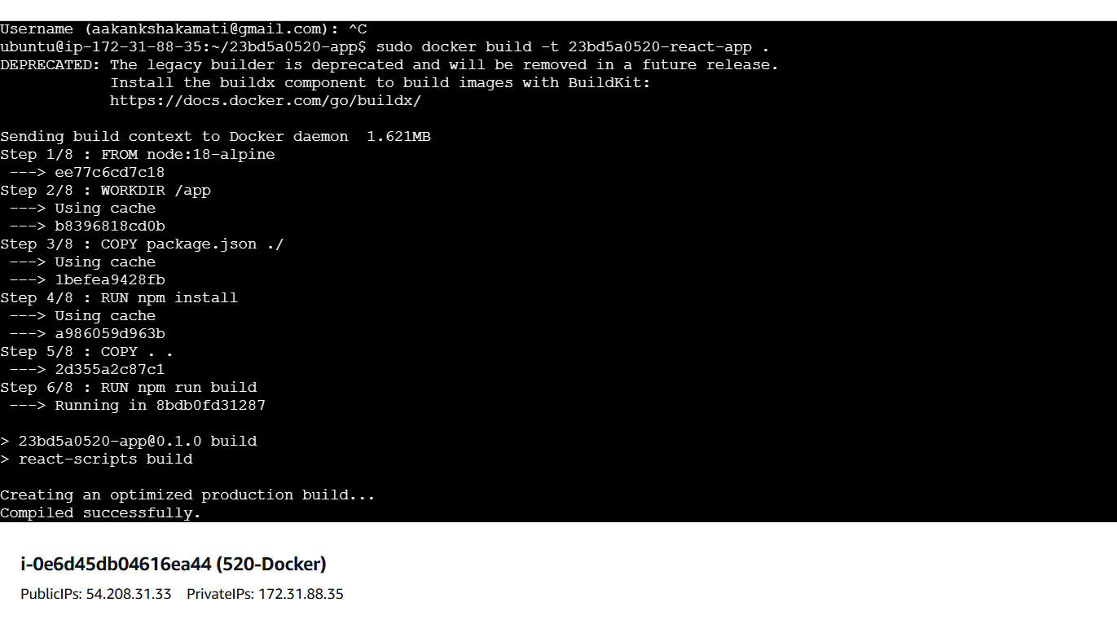

Figure-10

**Step 5: Run the Docker Container**

* sudo docker run -d -p 3000:3000 23bd5a0520-react-app

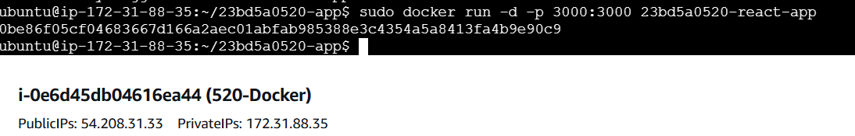

Figure-11

**Step 6: Access from Browser**

* Visit: http://54.208.31.33:3000
* You should see:
  + Input: Enter your name
  + Button: On click → Shows welcome message with your name.

