**EXPERIMENT-8: SQS**

**1. Create an IAM User with Programmatic Access**

* Log in to AWS Management Console.

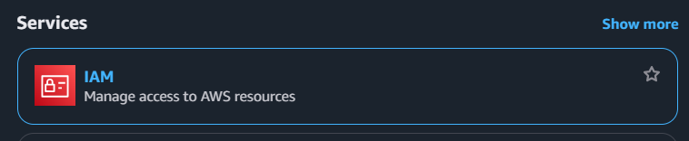

* Navigate to IAM > Users.
* Click Add user.

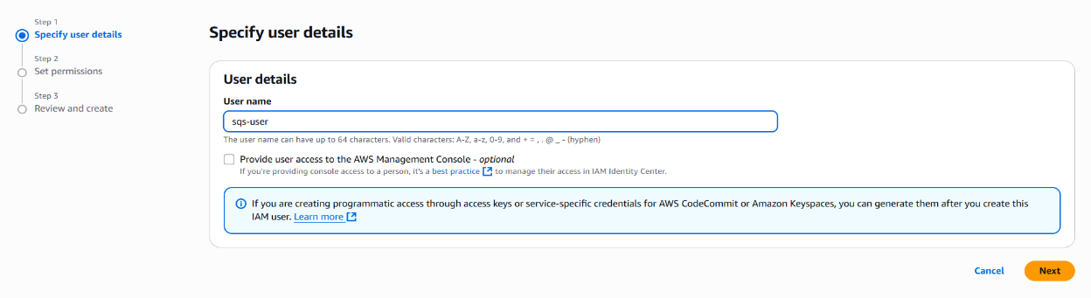

* Enter a user name (e.g., sqs).
* Set permissions (Attach existing policies or create a custom policy with at least SQS access).

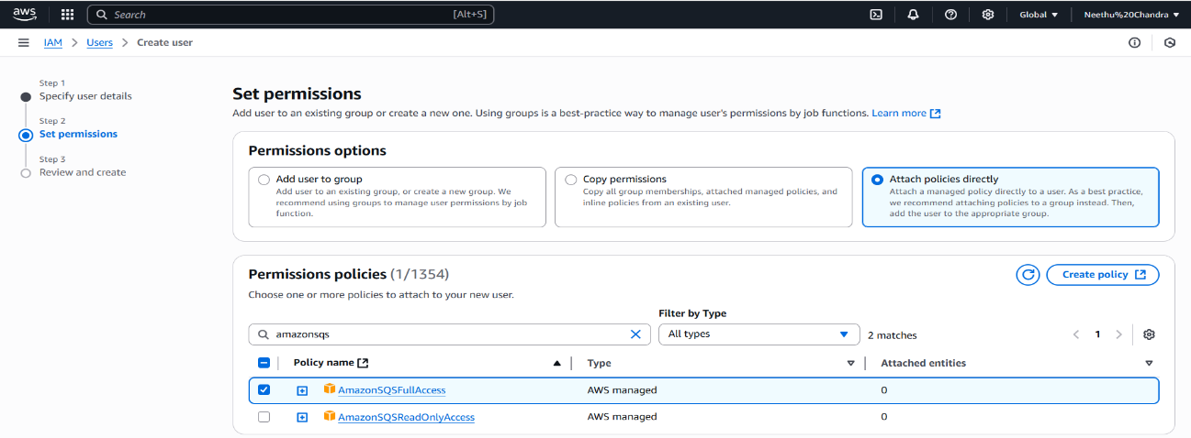

* Review and create the user.

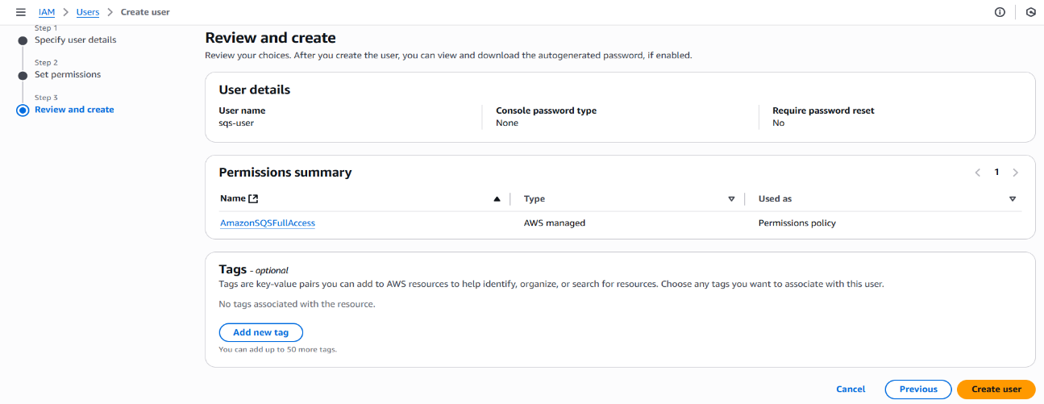

* Save your Access Key ID and Secret Access Key — you’ll need these for authentication**.**

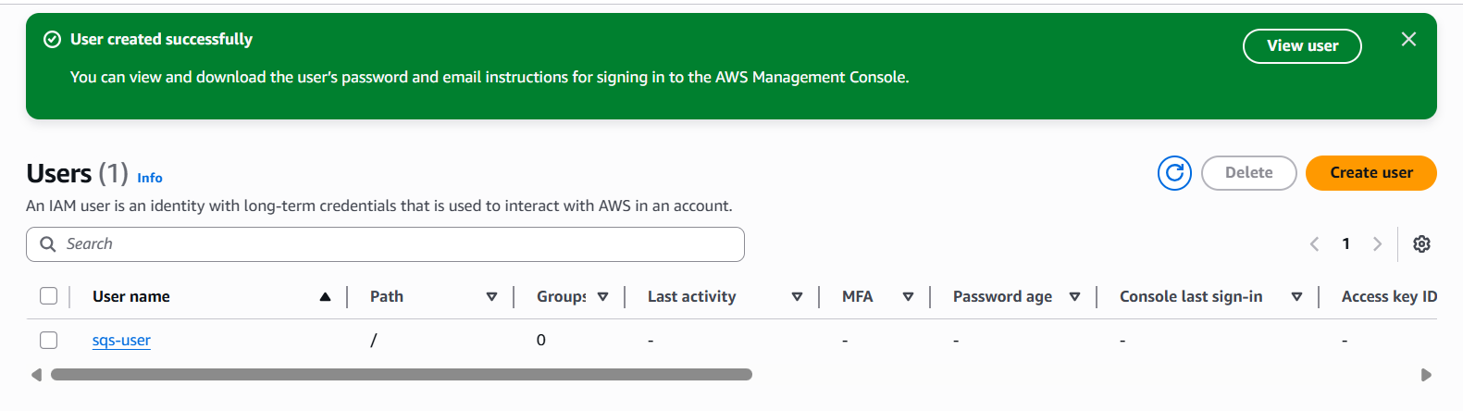

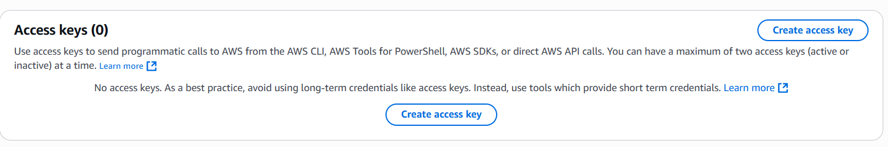

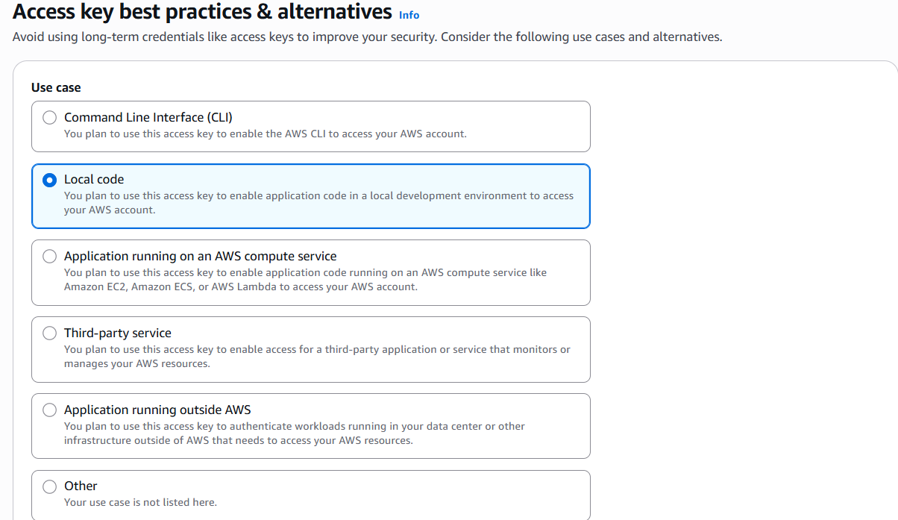

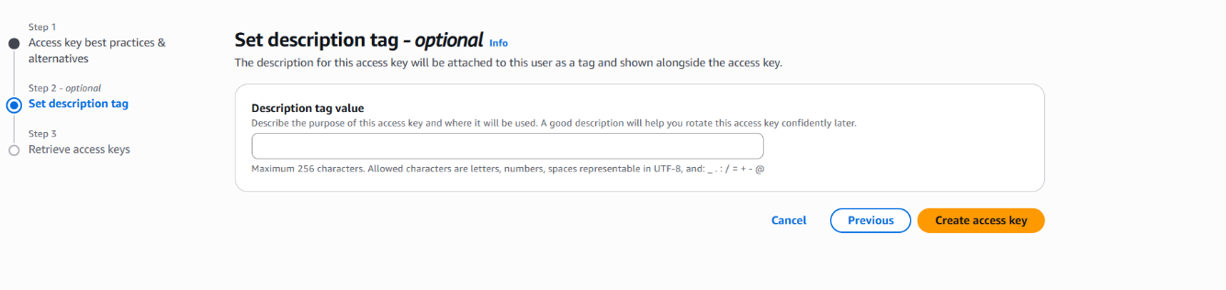

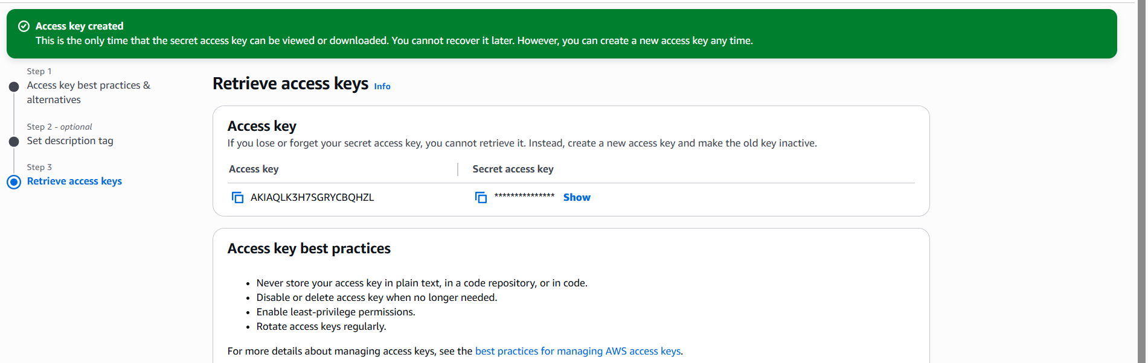

**2. Install AWS CLI (Optional but Recommended)**

Download and install AWS CLI from [AWS CLI Installation Guide](https://docs.aws.amazon.com/cli/latest/userguide/install-cliv2.html).

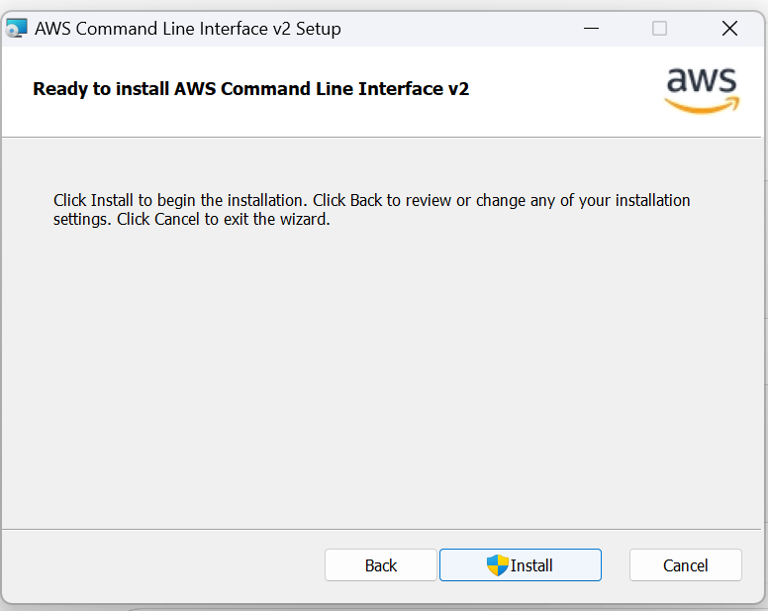

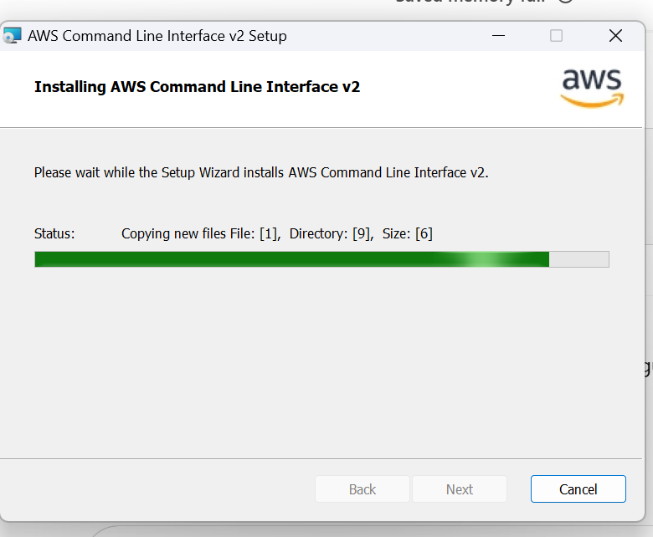

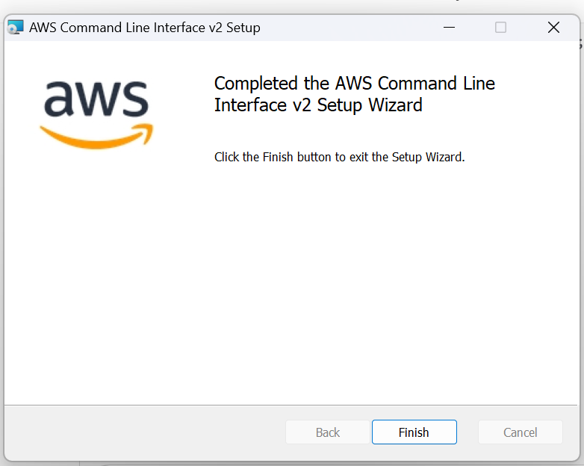

* Configure AWS CLI with your credentials:

aws configure

Enter:

* AWS Access Key ID
* AWS Secret Access Key
* Default region name (e.g., us-east-1 or your region)
* Default output format (e.g., json)

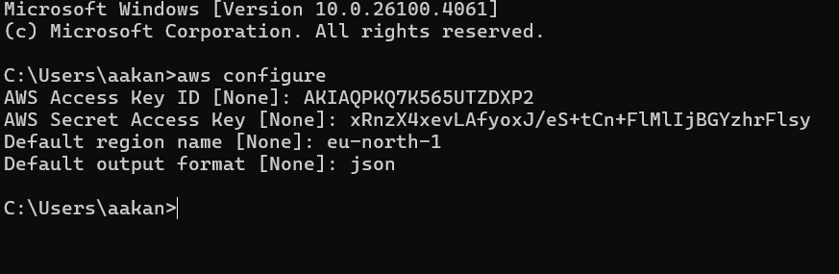

**Create an SQS Queue**

* Go to [Amazon SQS Console](https://console.aws.amazon.com/sqs/home).
* Click **Create queue**.

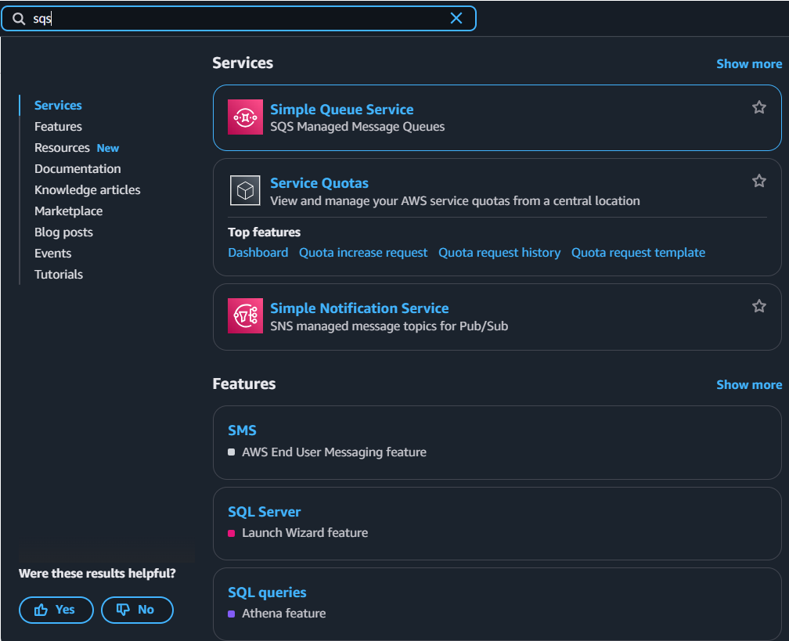

* Enter queue name (e.g., MyQueue).

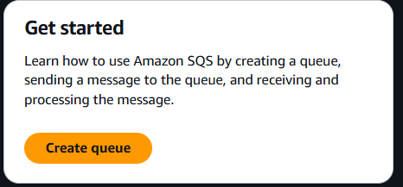

* Choose queue type (Standard or FIFO).

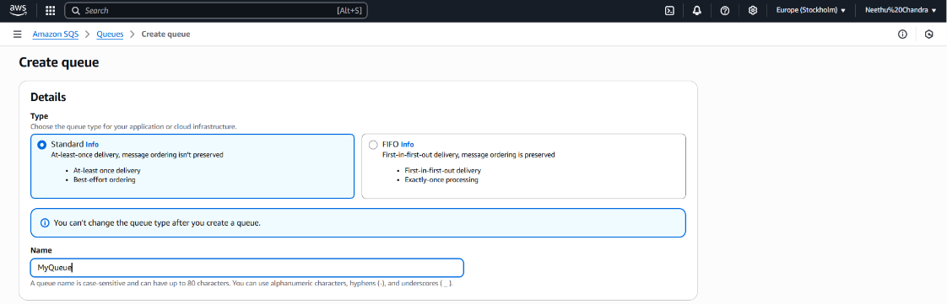

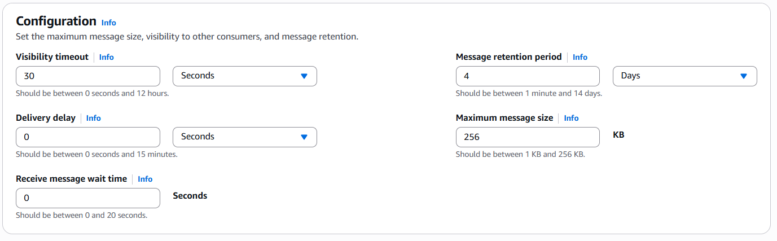

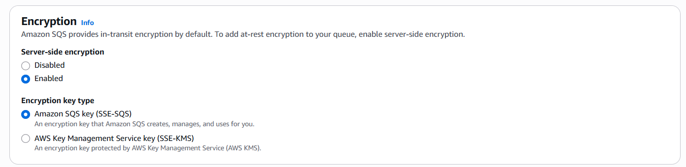

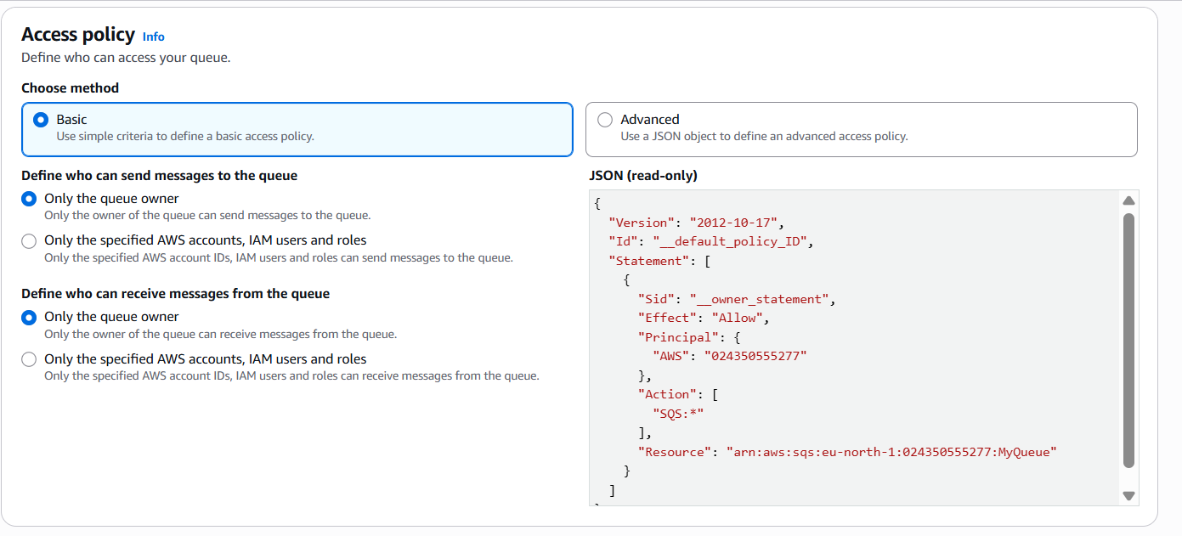

* Configure settings as needed.
* Create the queue.

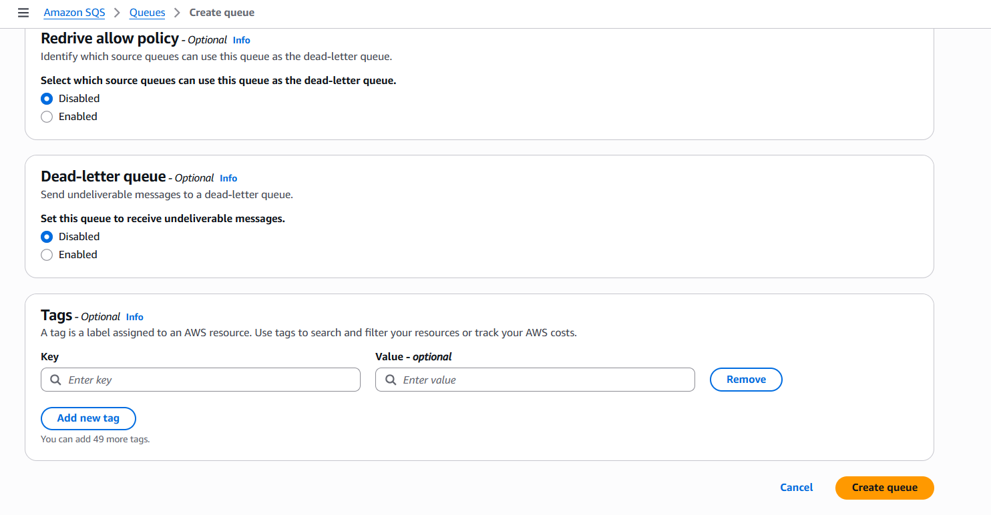

* Note the **Queue URL** (e.g., <https://sqs.us-east-1.amazonaws.com/123456789012/MyQueue>).



**4. Set Up Node.js Project**

Open your terminal or CMD and run:

mkdir sqs-app

cd sqs-app

npm init -y

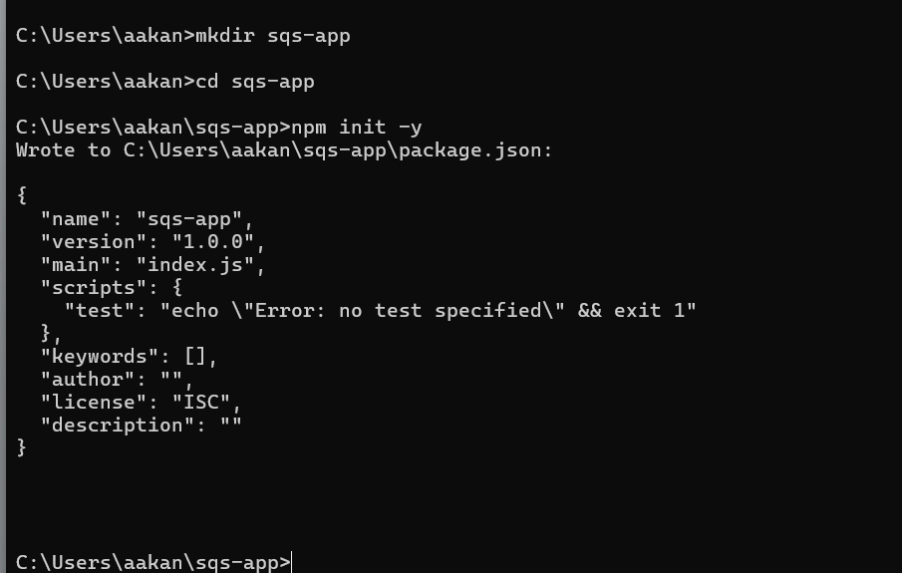

npm install @aws-sdk/client-sqs

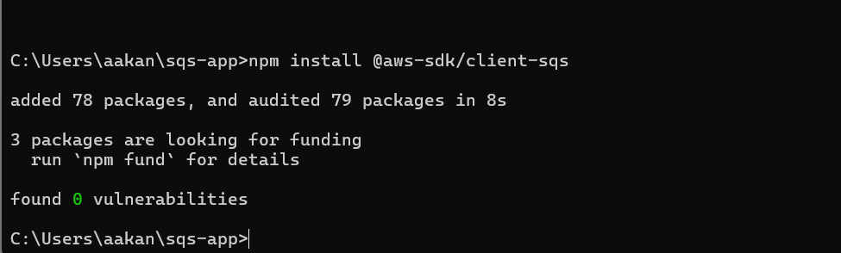

**. Create and Write the SQS Code**

Create a file named sqs.js inside your sqs-app folder:

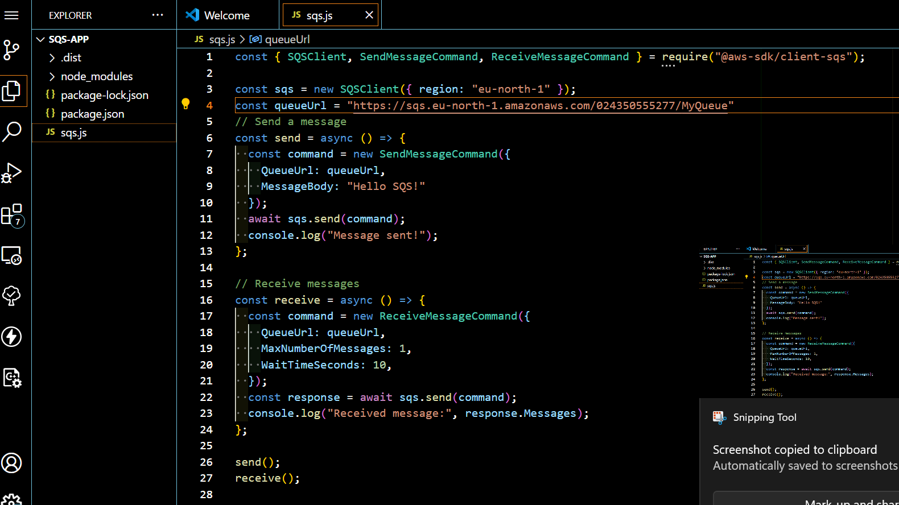

**7. Run the Code**

In your terminal, run:

node sqs.js

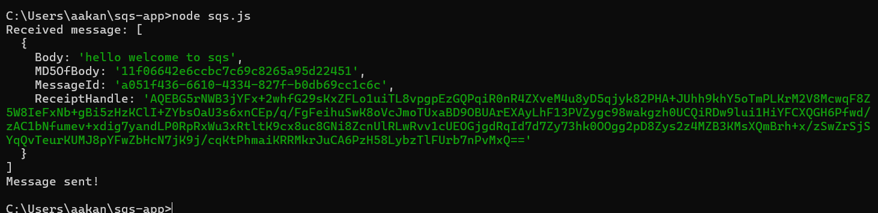

**. Verify Message in AWS Console**

* Open [Amazon SQS Console](https://console.aws.amazon.com/sqs/home).
* Select your queue (MyQueue).

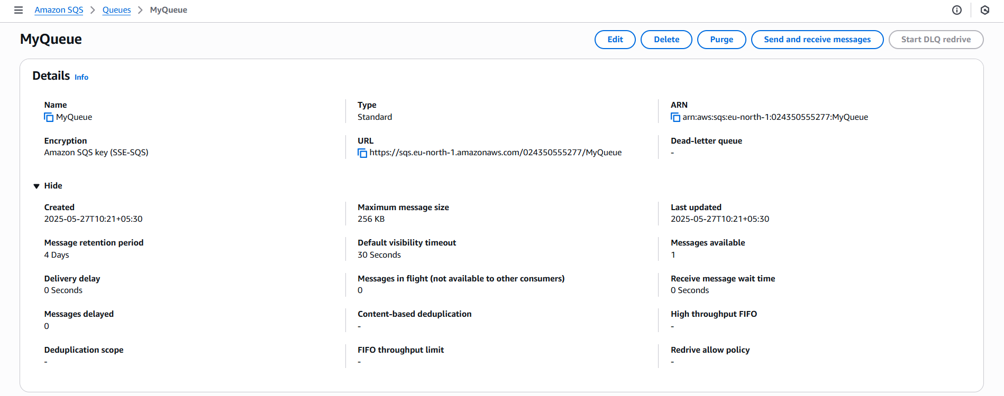

* Click **Send and receive messages**.
* Click **Poll for messages**.

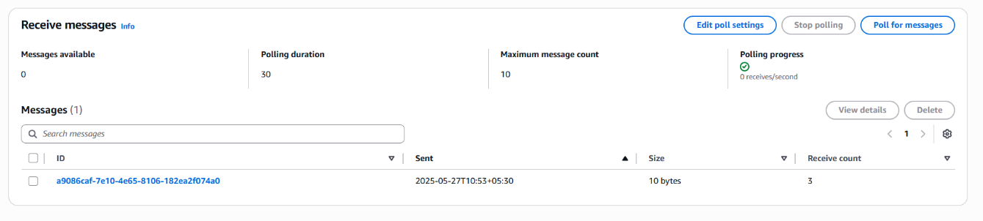

* You will see the message(s) you sent.

