**Experiment: 4**

**Create and configure storage services and upload files and objects using Amazon EBS, Amazon EFS and Amazon S3**

**Part-3:  ELASTIC FILE SYSTEM (EFS)**

1. **Login** into AWS Account

**Start Lab and** Launch **AWS Console Home**

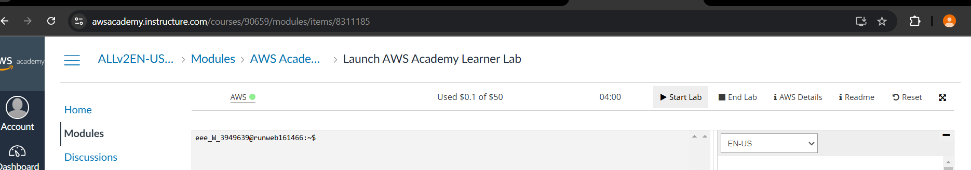

. Create 2 Instance namely

23bd5a0520_EFS_1

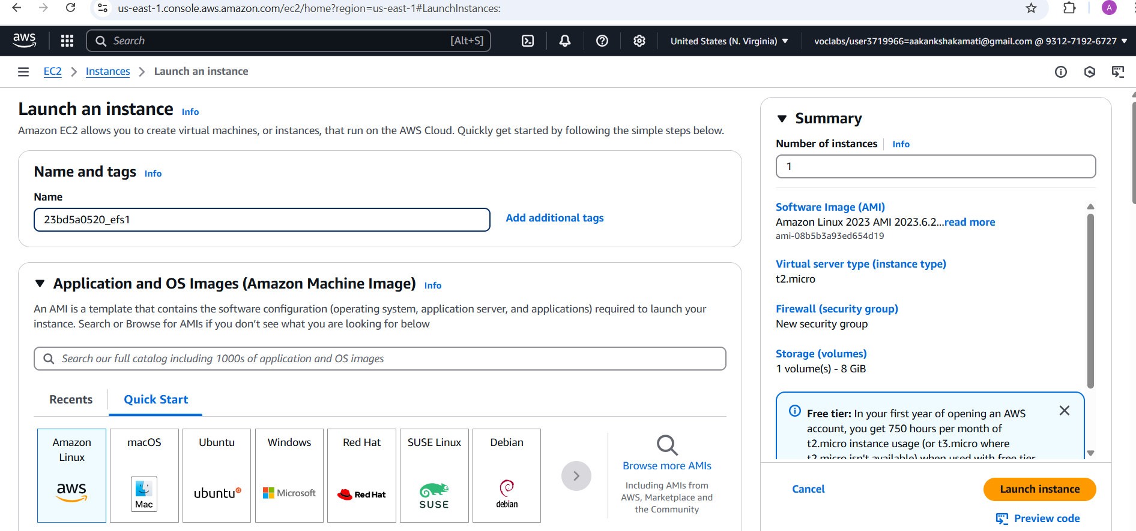

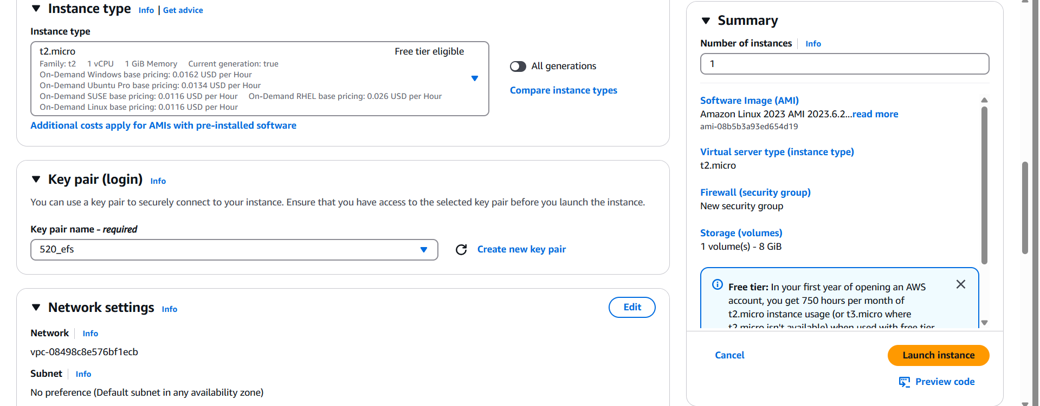

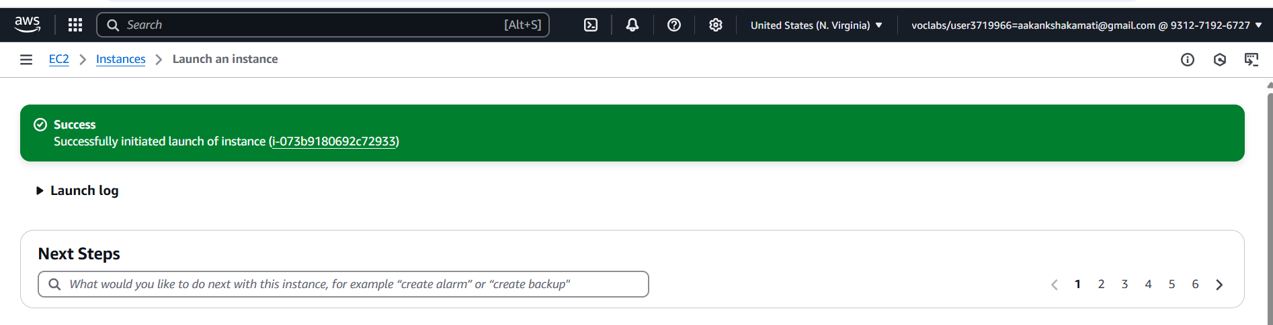

3 . Create second instance

23bd5a0520_EFS_2

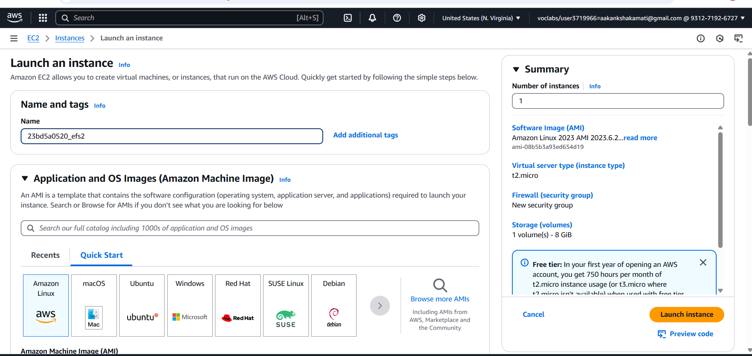

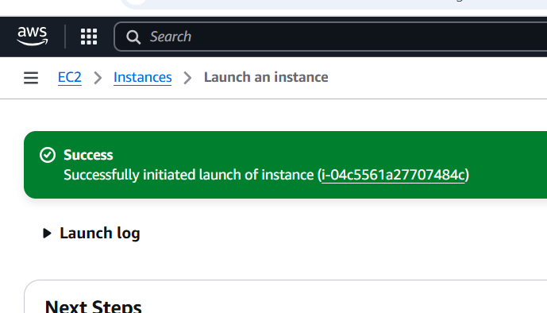

5 . Launch 2 Instance & Mount EFS File System.

**EC2 Dashboard → Security Group → Create  security Group**

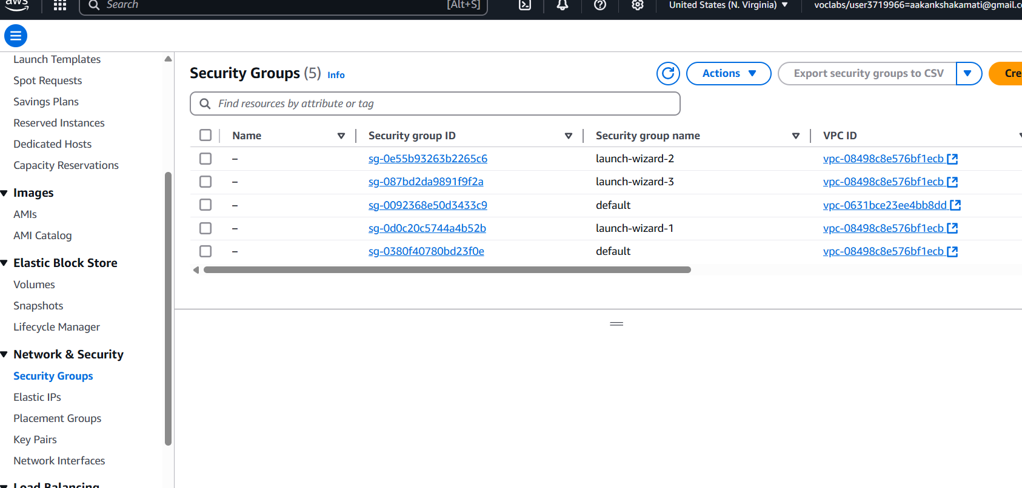

**Basic Details:**

**\*\*Security group name:** 23bd5a0520_EFS

**Description :** EFS SG

VPC: Default

Add Rule: Type: NFS, Port Range:2019, Add Security Group (Copy from EC2) or source: Anywhere

6 . Create security group.

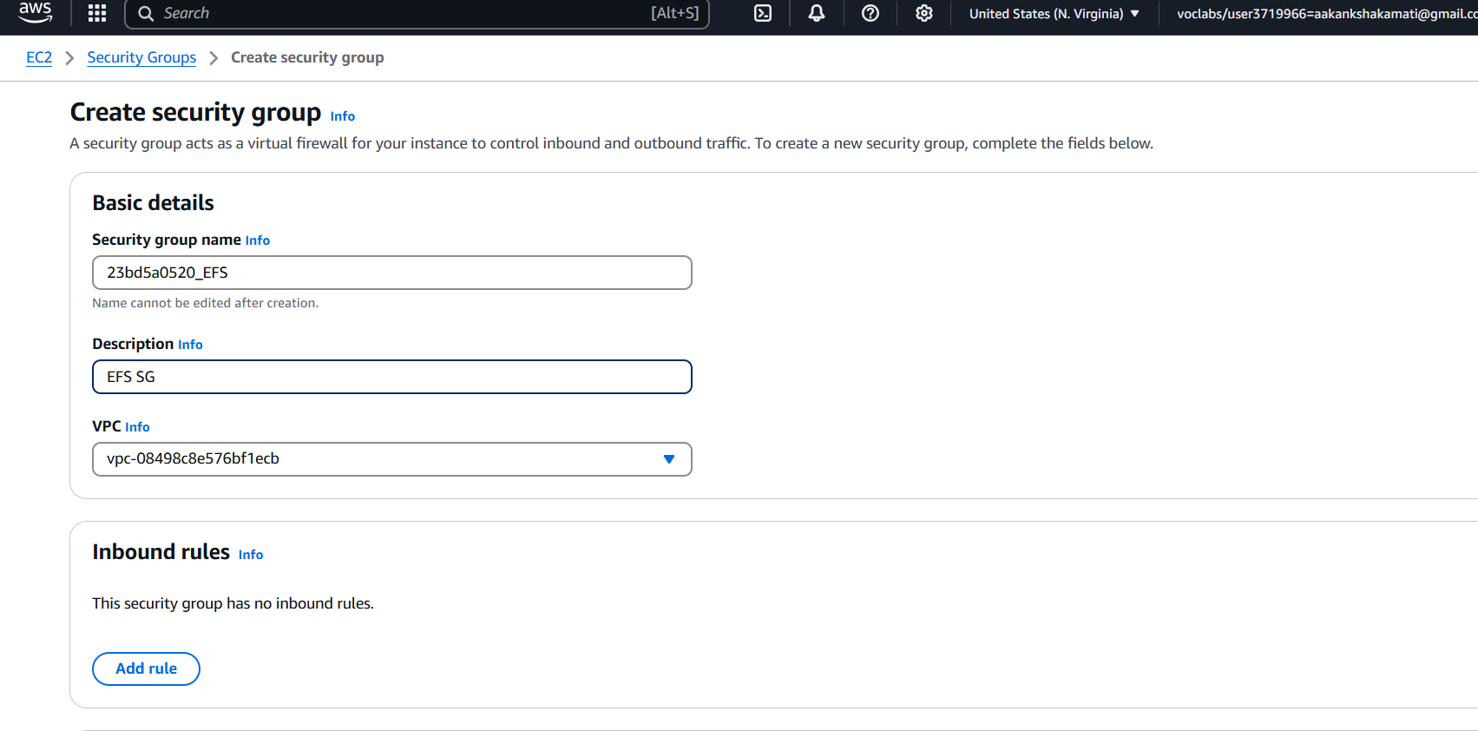

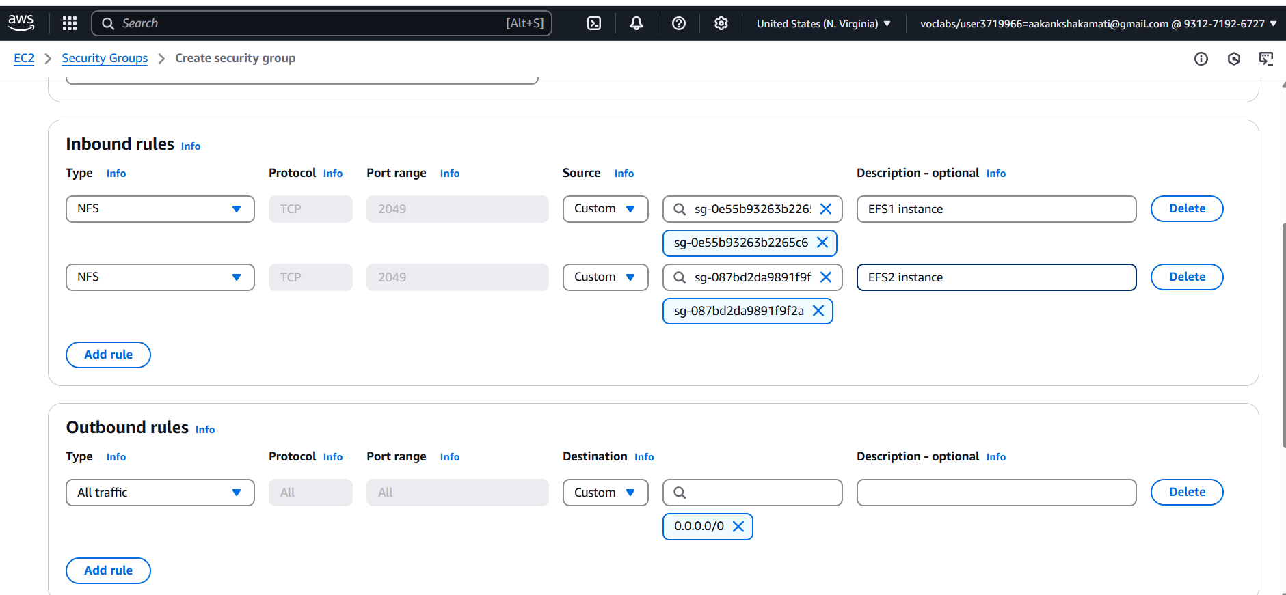

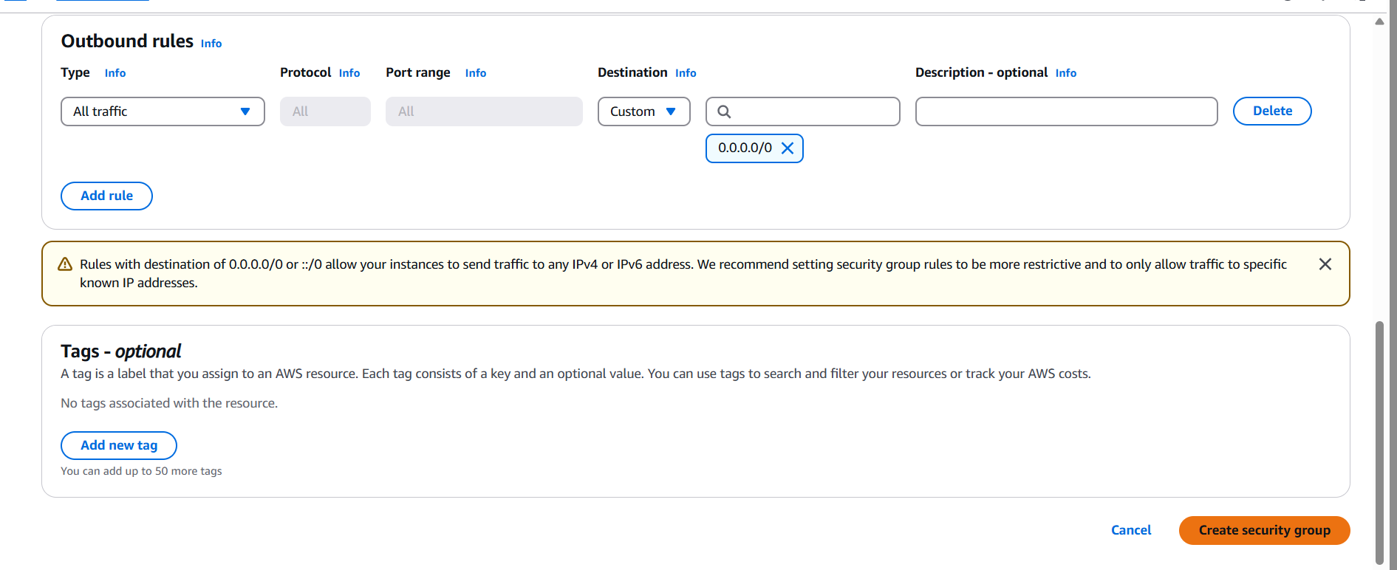

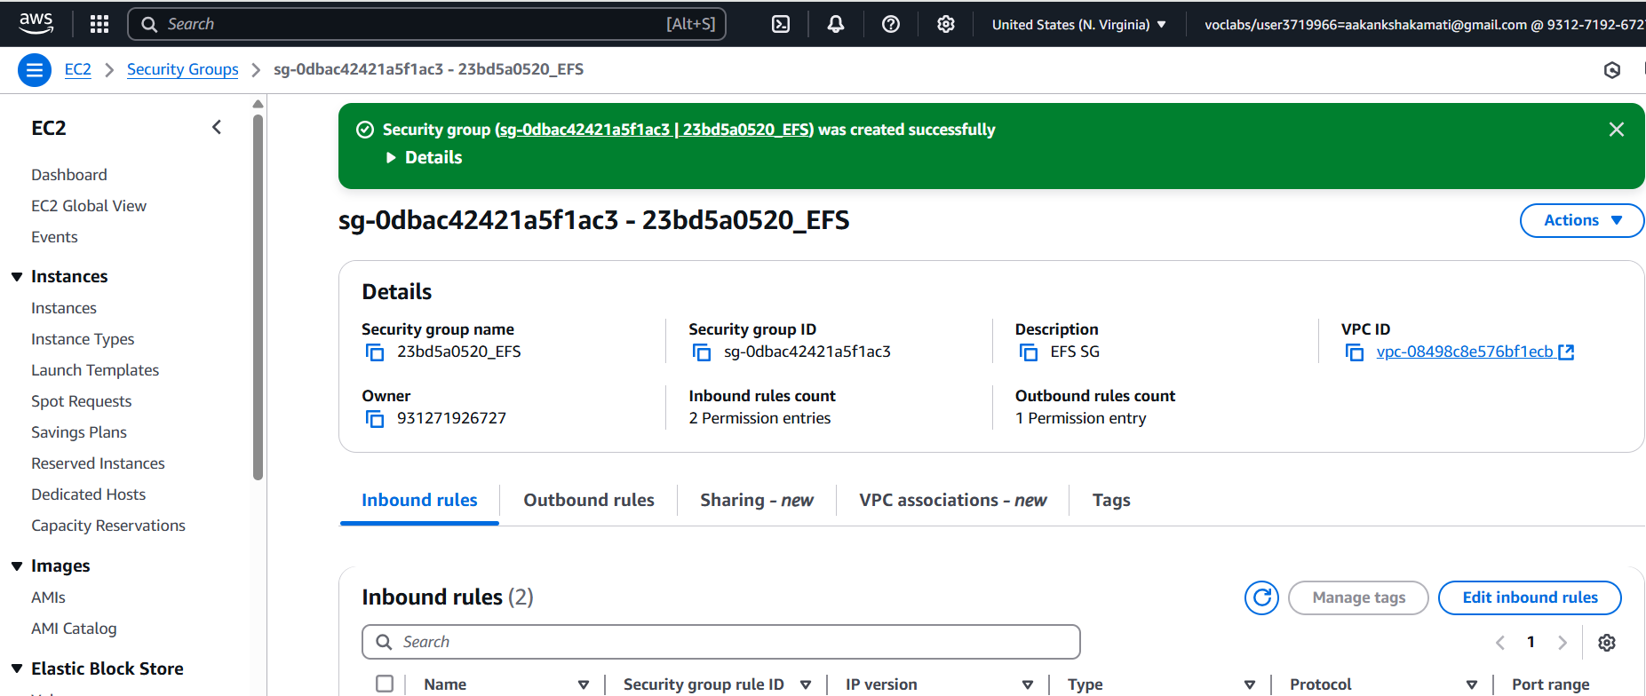

7 . Search EFS in search Bar

Create File System :

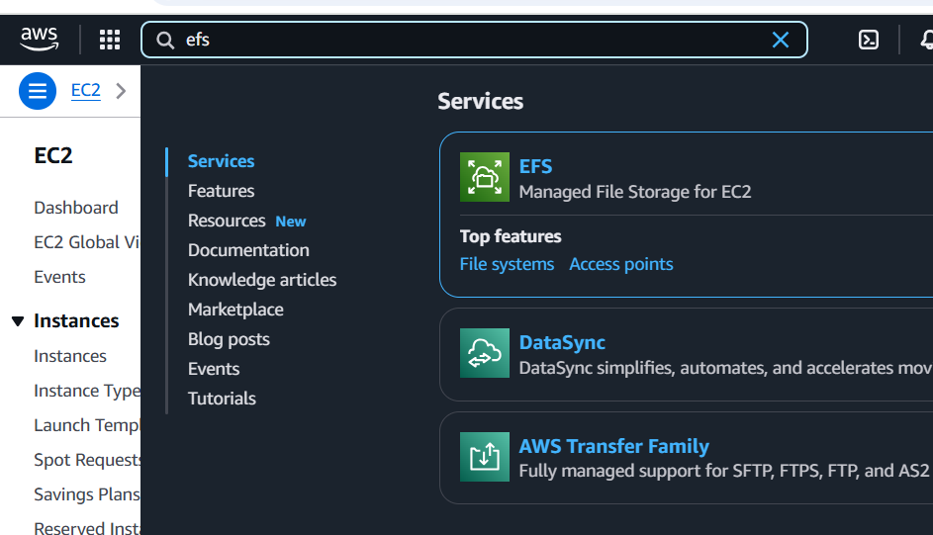

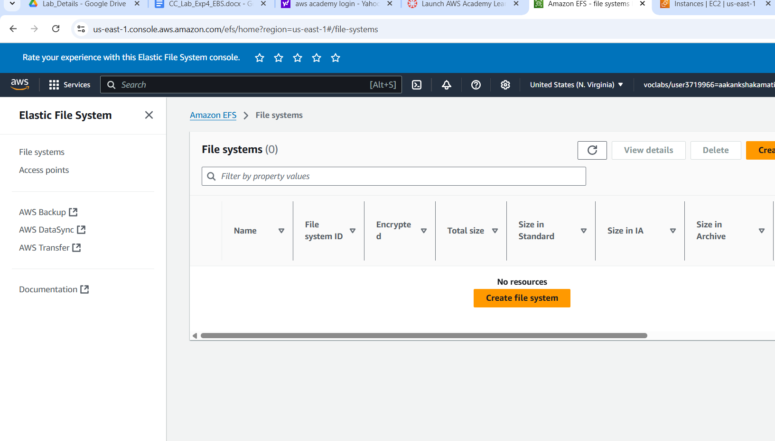

Name : 23bd5a0520

VPC : Select Region

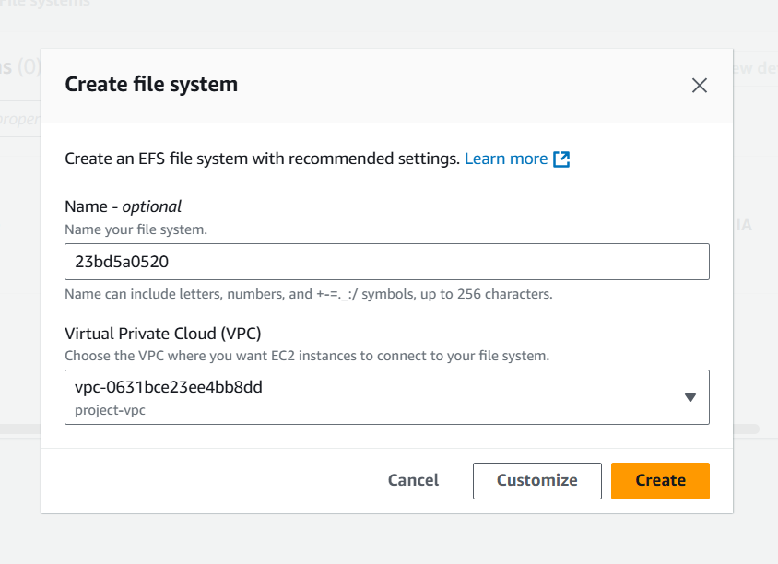

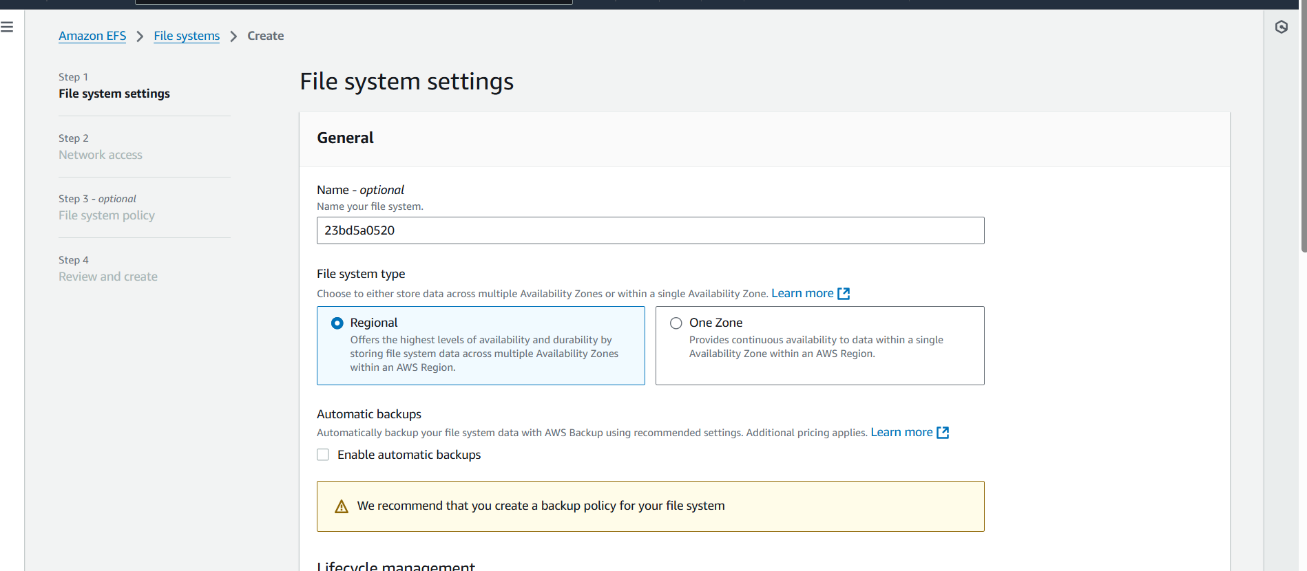

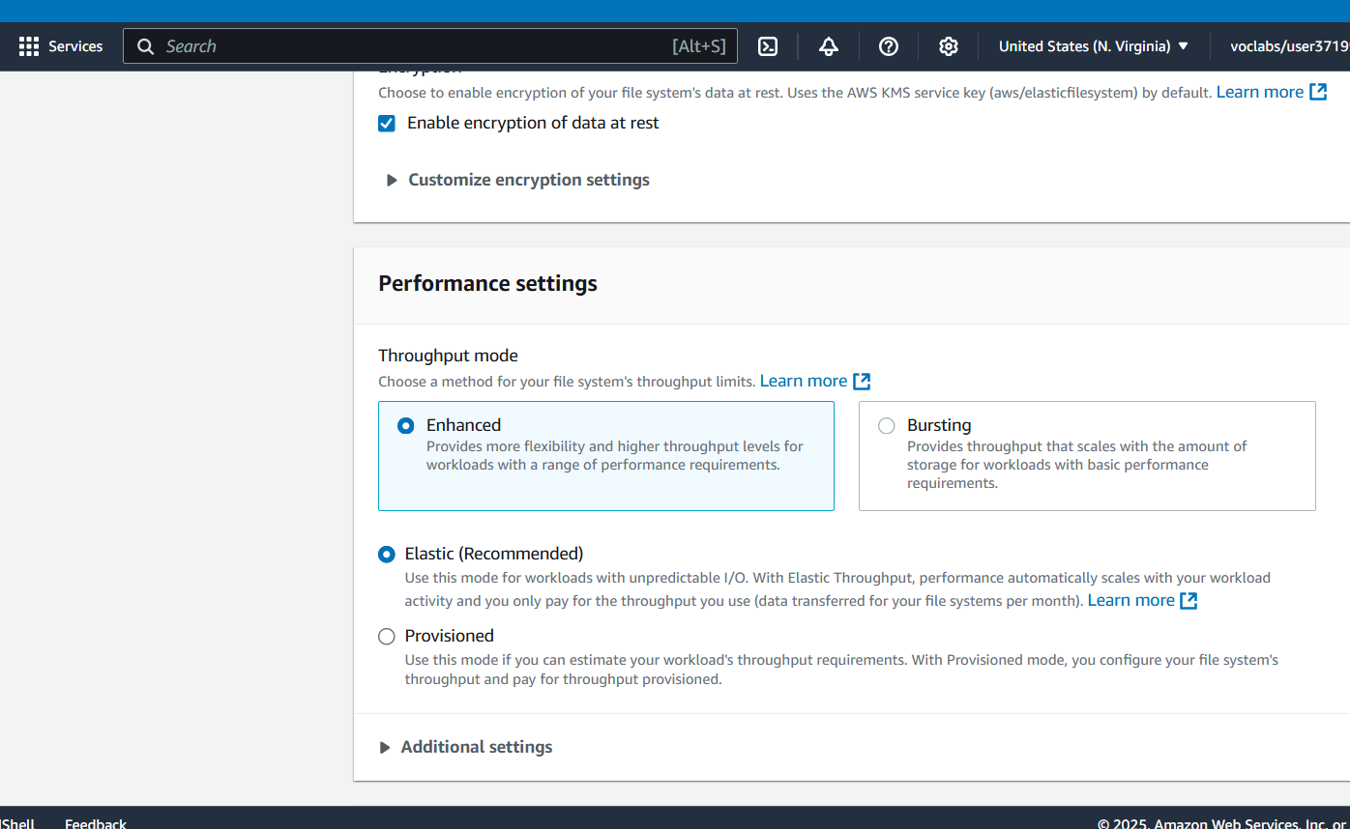

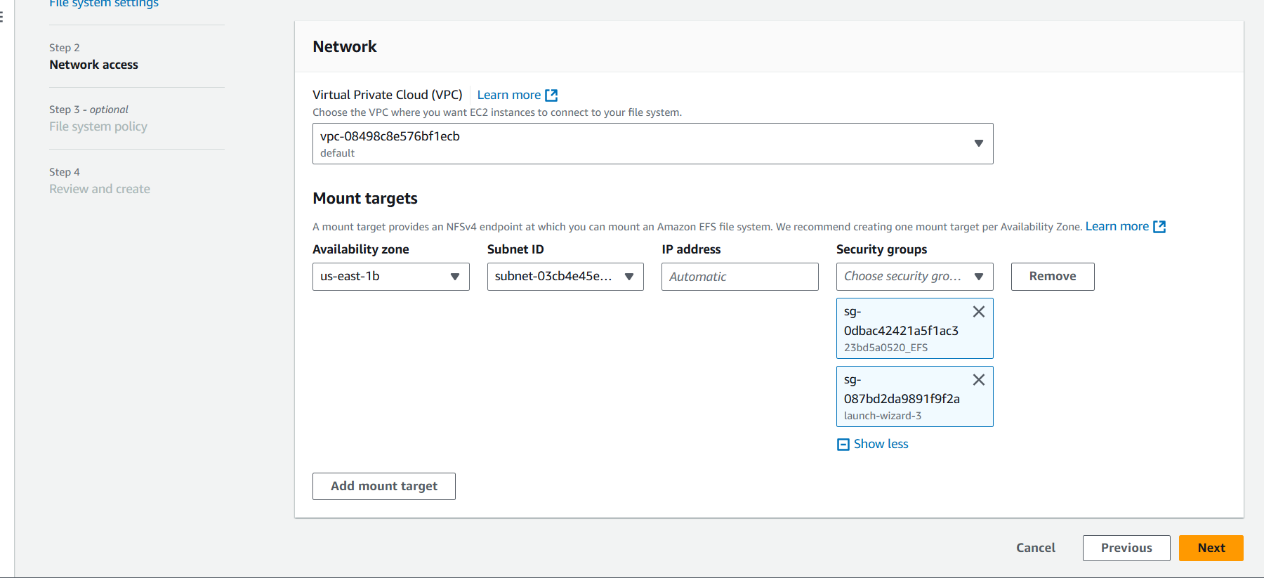

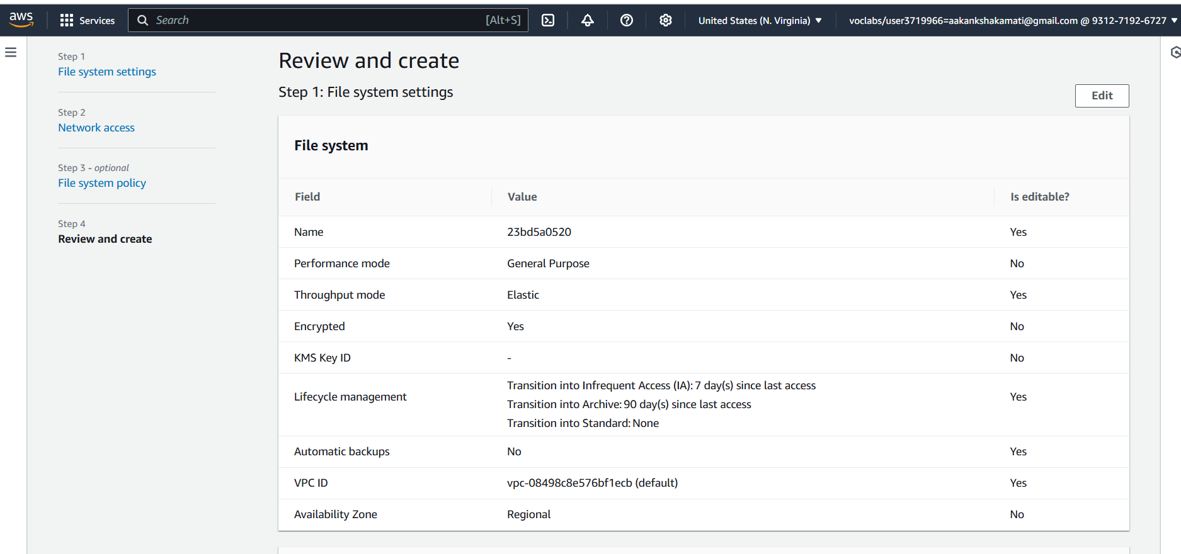

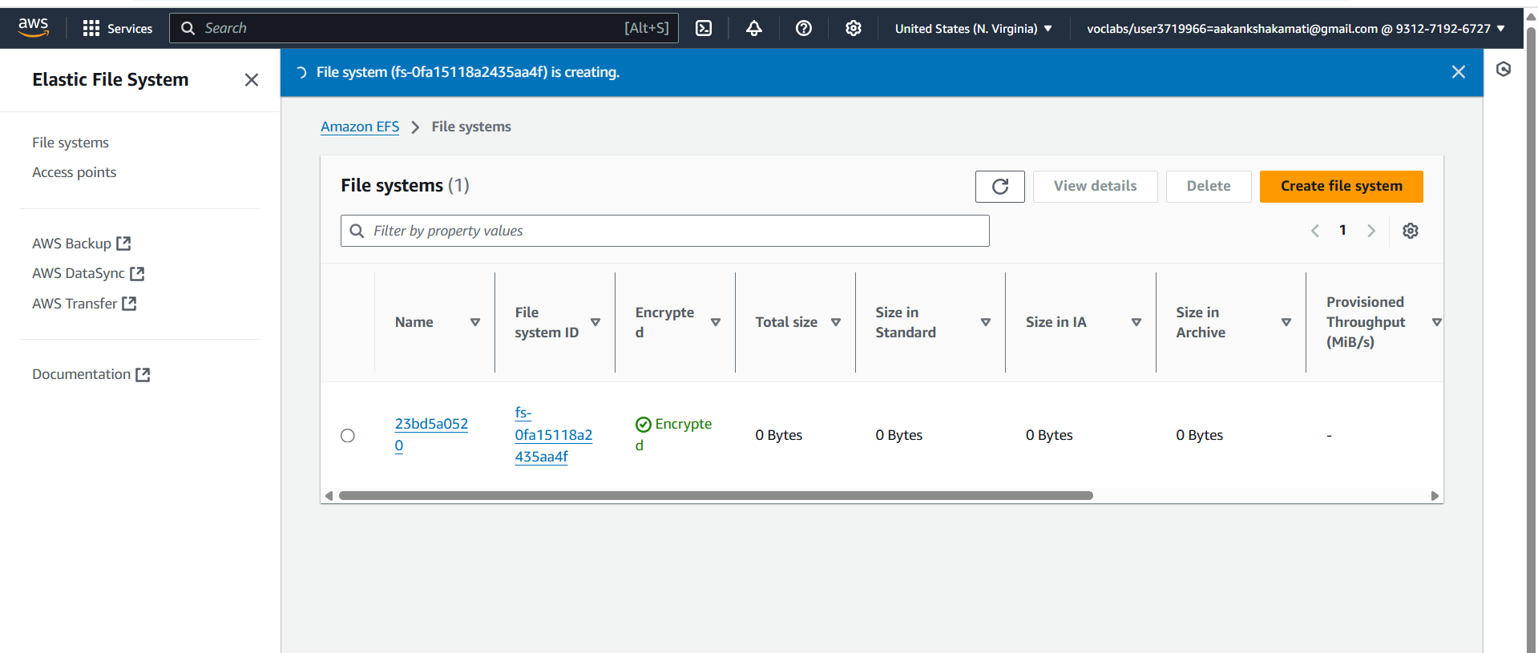

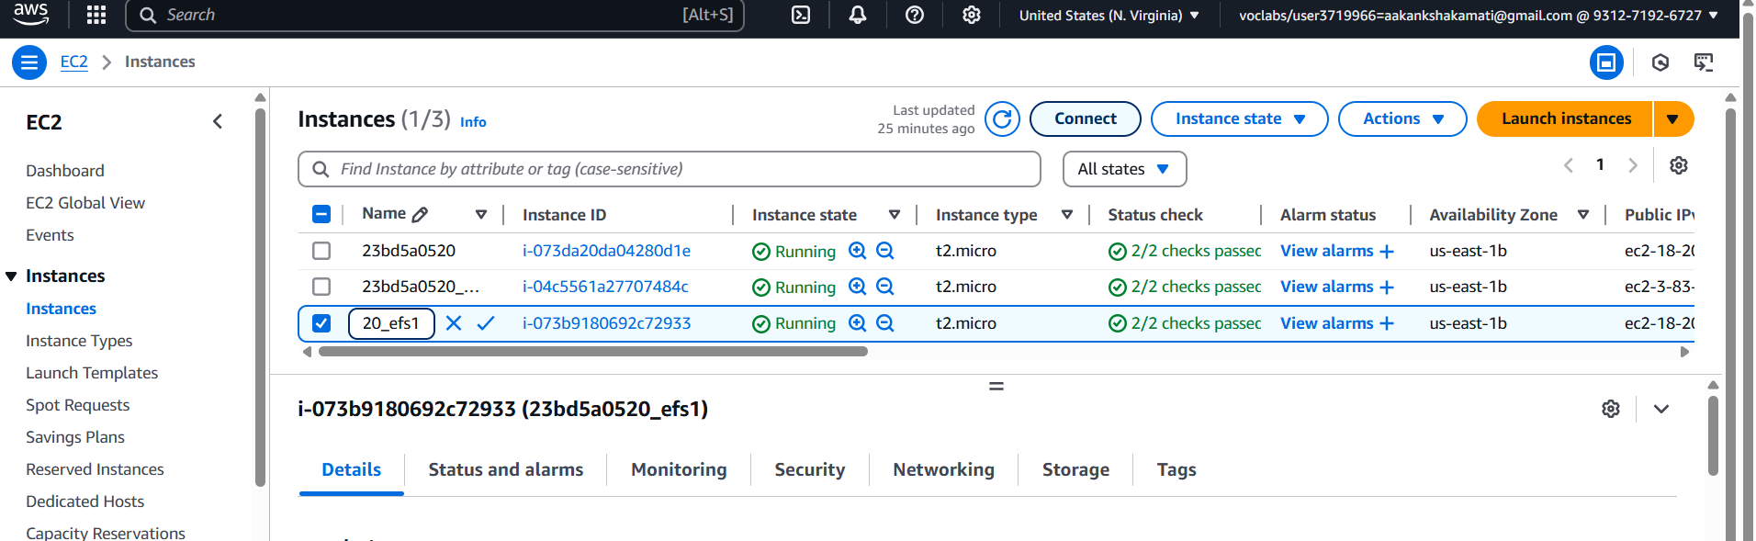

**. Connect to Instance-1(Server1) from Putty using PEM File**

1. **Connect to Instance-1 (23bd5a0520-KMIT)** using PuTTY or SSH
2. Switch to root
3. Install **Amazon EFS utilities**

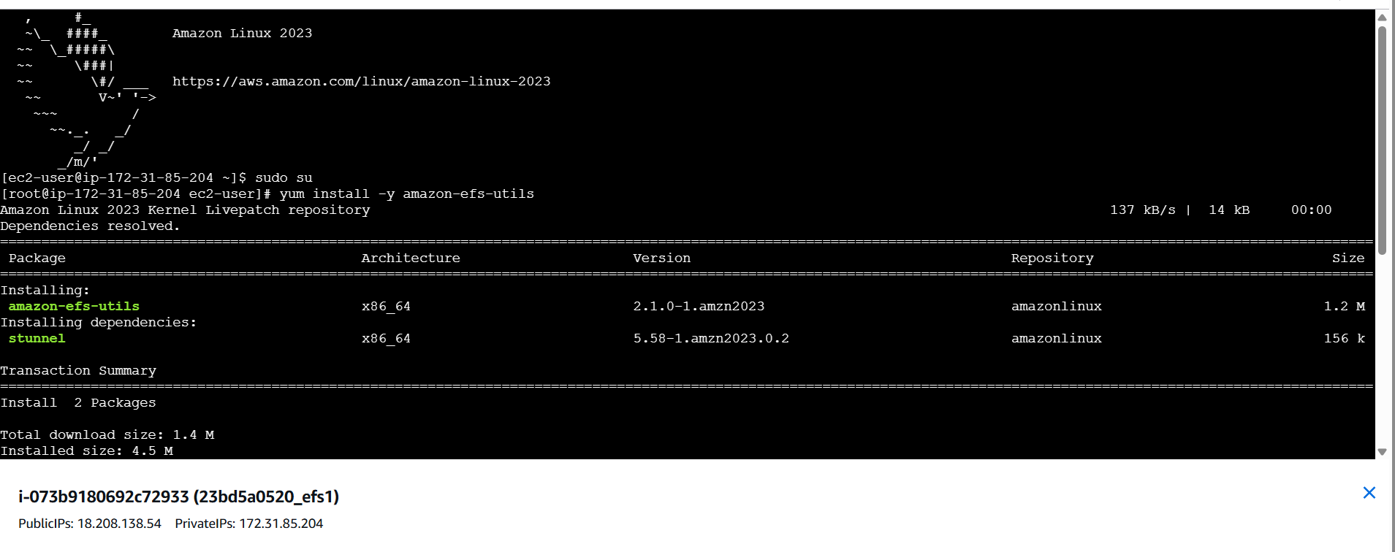

1. . Create a directory for mounting



5.Mount the **EFS**:

* + Go to **EFS Dashboard → Click on the created EFS → Attach**

Copy the **mount command (NFS Client method**

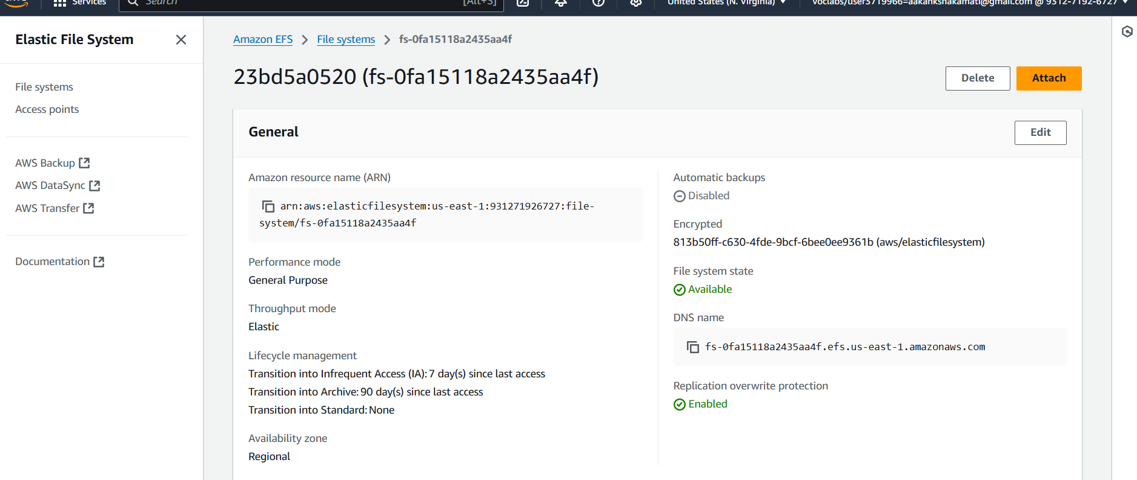

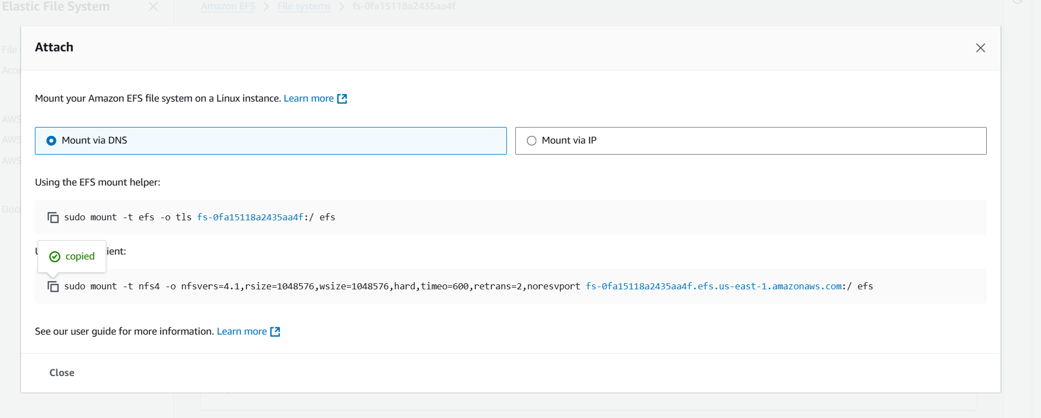

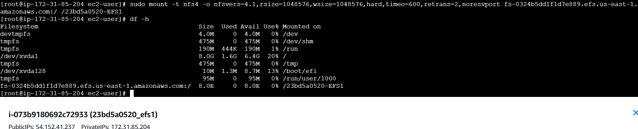

6. **Connect to Instance-2 & Mount EFS**

1. **Connect to Instance-2 (Rollno-NGIT)** using PuTTY or SSH
2. Switch to root
3. Install **Amazon EFS utilities**



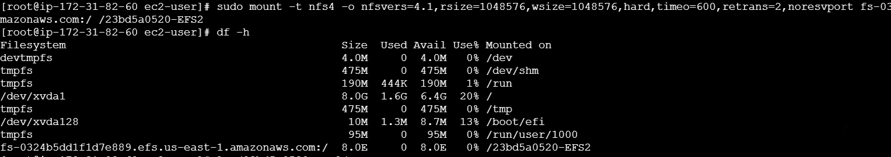

**7 : Verify Communication Between Instances Using File1.html**

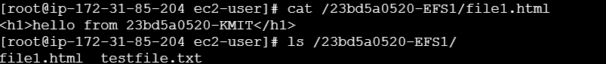

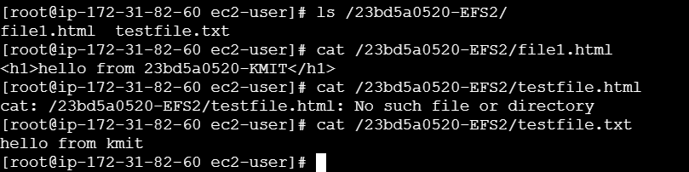

8. End the lab.

