| **Experiment-4:**  Create and configure storage services and upload files and objects using Amazon EBS, Amazon EFS and Amazon S3 |
| --- |

**Part-1: Attach and Mount Extra EBS(Amazon Elastic Block Store) Volume to Linux EC2 in AWS**

**Step 1:** Login into <https://awsacademy.instructure.com/> then move to Launch **AWS Academy Learner Lab** & **Start lab**. Finally click **AWS** Button to activate

**Step 2:** We are adding EBS extra volume(10GB) for already existing EC2 Instance with your Roll No.

1. Click & select your Instance you will find Storage

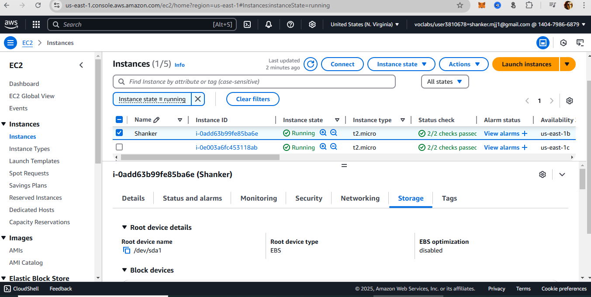

1. While clicking Storage you can see the below details with **Volume size 8(GiB), Volume ID, etc**

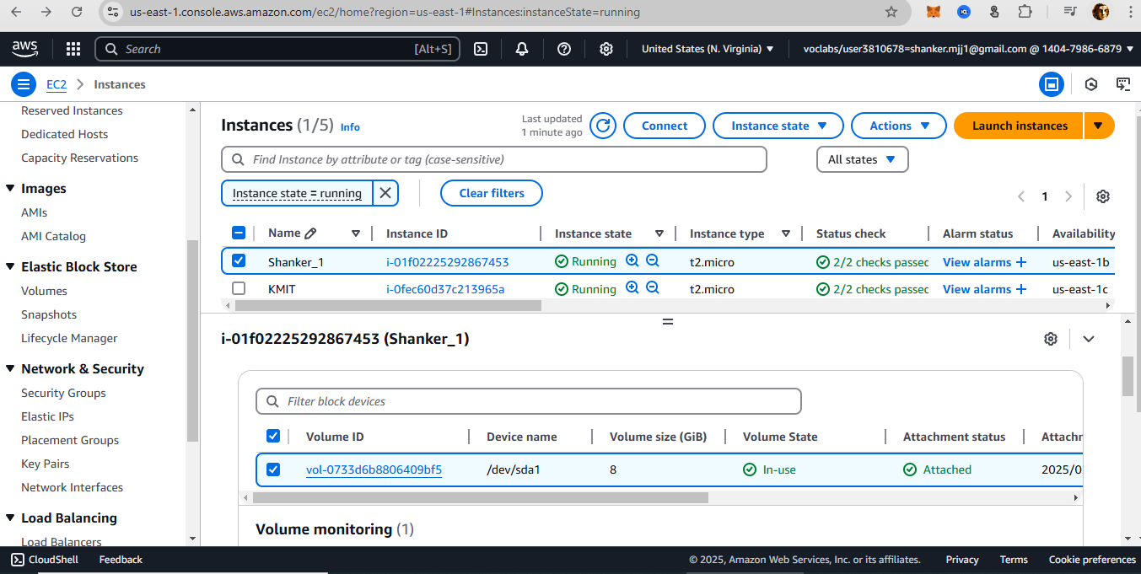

**Step 3:** To create New Volume of **10GB** on left hand size pallet you find **Elastic Block Store** under that Volume

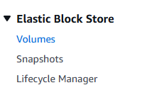

1. Click on Volumes as a new tab, you will navigate to below picture

Note: Check the Instance **Volume ID** & EBS **Volume ID** should be same

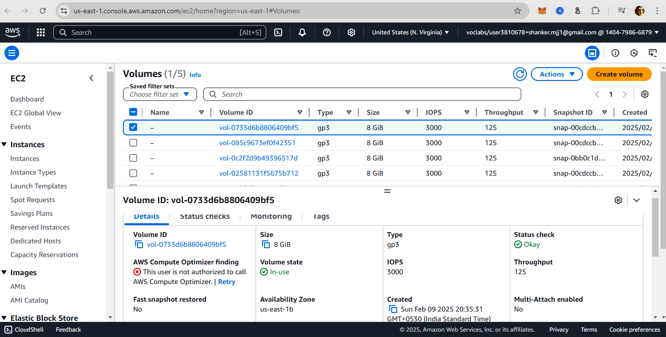

1. Now **connect** your Instance by clicking connect with **EC2 Instance connect**

**I.** Perform commands like root user, disk Info to see volume Size

$ sudo su - //login into root user

$ df -h //shows the volume attached to that devices

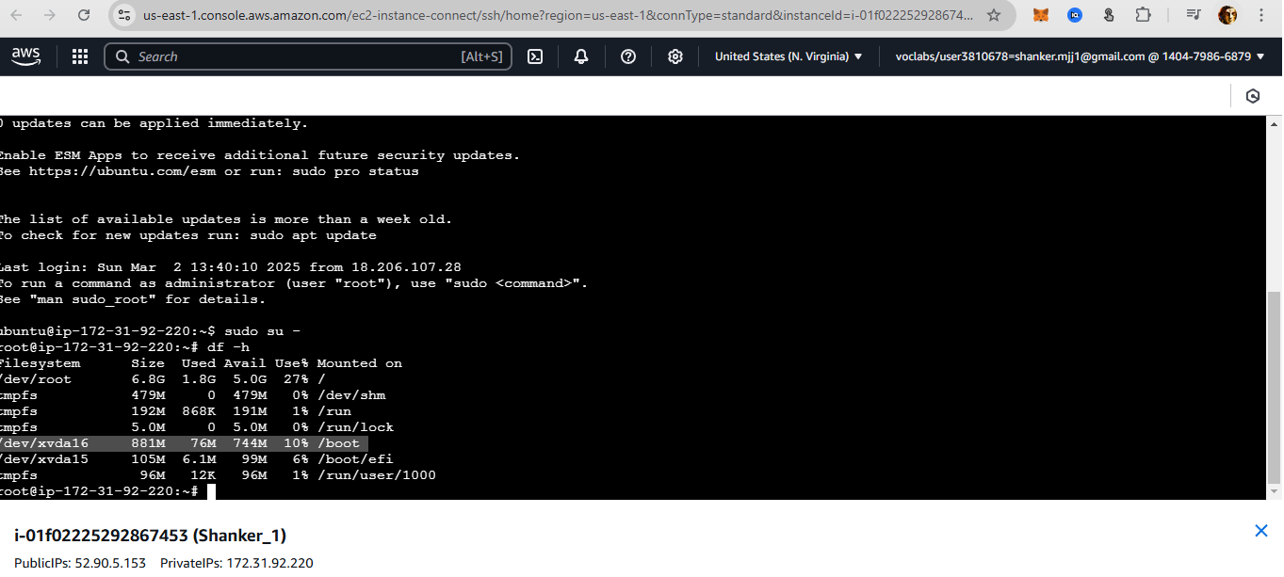

1. Click **create volume** on right most corner of your Page with following settings
   1. **Volume type : General purpose (gp2)** //select based on your requirement
   2. **Size (GiB) : 10 GiB**
   3. **Remaining : Default, but Availability Zone should be careful**

**NOTE:** You need to create & attach volume same availability Zone & Verify ur exactly located mine is: United States(N. Virginia) us-east-1b

* 1. Tags : Optional (Add Tag)

Key: Roll no Value: Extra-Volume-Rollno

* 1. Finally Click on **Create Volume**

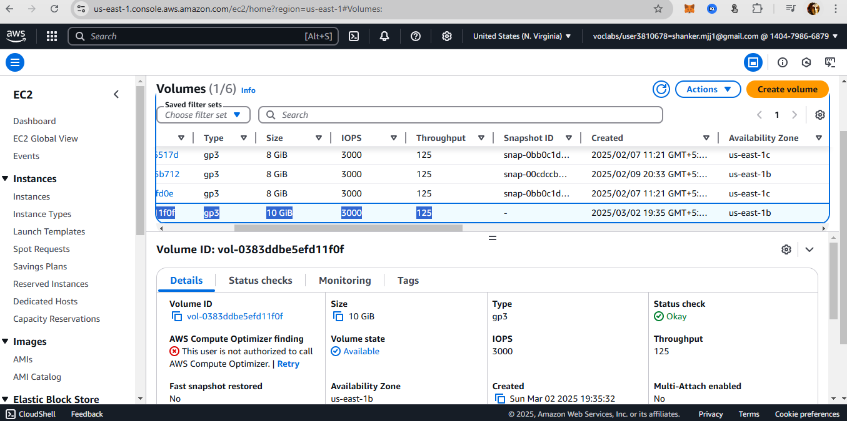

**Step 4:** Attach Volume:

1. Now select created Volume & Click on **Actions** (Besides create volume) & select attach

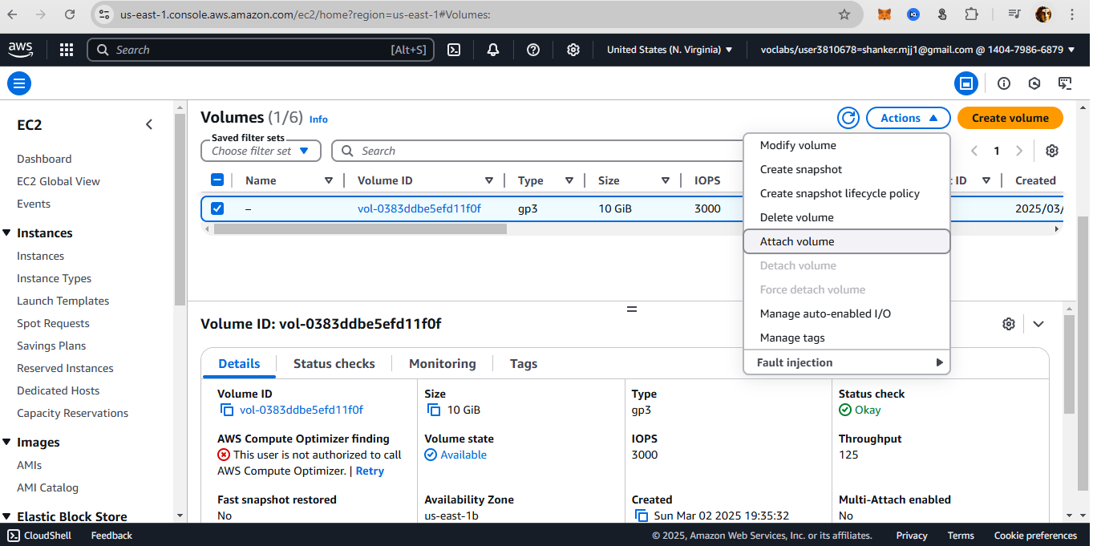

1. Select your Instance you have created with your rollno

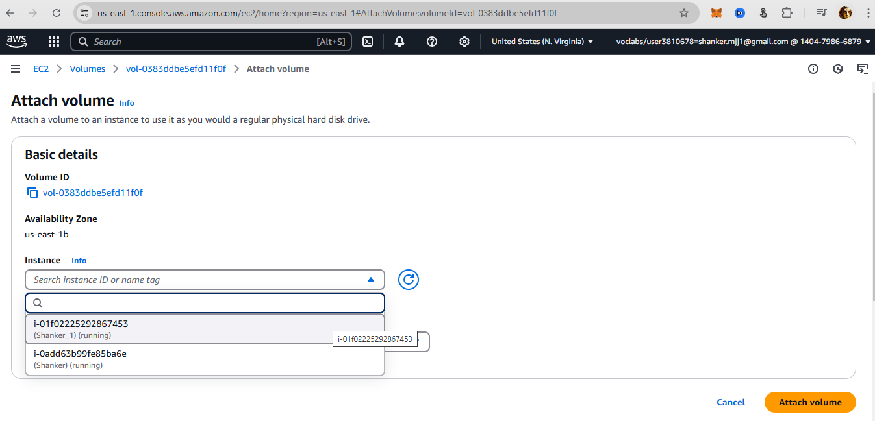

1. Choose **Device name : /dev/sdk (Default)**
2. Click on attach volume
3. It will create volume with 10(GiB) & status is: in-use

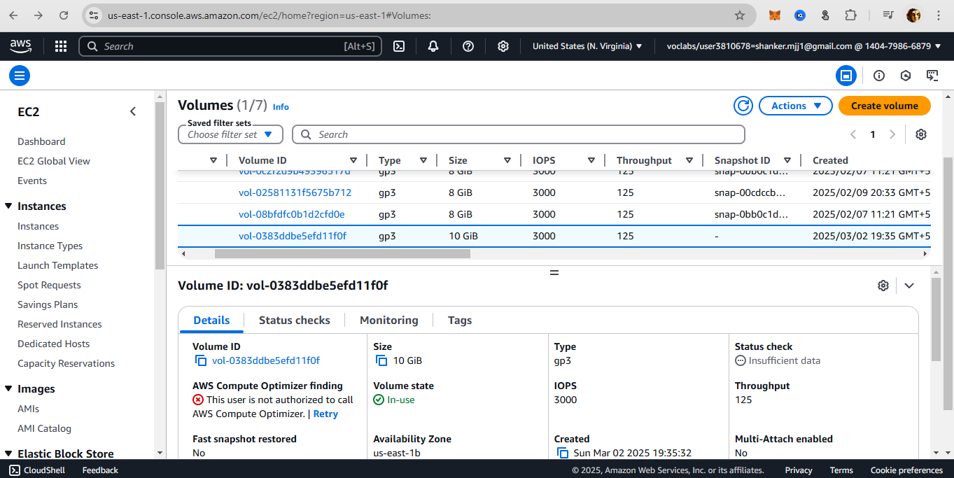

1. Click that volume you can see that **Status is insufficient,** Wait until **Okay (Green)**

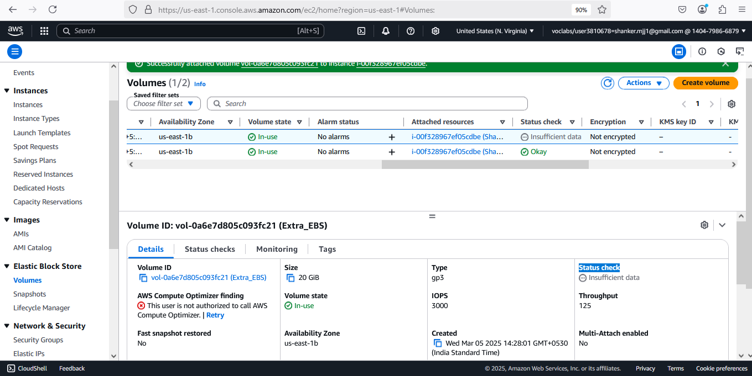

**Step 5:** Now go to **EC2 Instance connect** check whether Volume attached or not by typing command like df -h (It Will not show, the reason is: After creating & Attaching, you need to create a directory & Mount the EBS volume into EC2 Instance) it have set of procedure listed below

| * lsblk * sudo su * lsblk -list * lsblk -fs | * Lists all the block devices in the Linux Machine & you can ckek that new Volume with 10(GiB) Created * Login as Super User * List all/ **shows the physical disk (sda)** * **List all disk with root directories** |
| --- | --- |
| * fdisk -l * fdisk /dev/xvdf * Press: m-help   n- add new Partition  p - Primary  Enter (Default Partition)  Enter (First Partition)  Enter (Last Partition)  w - write Changes to disk & exit   * partprobe | * Displays all the device Partition Info with GB * Navigate to /dev/xvdf device path * Performing Partitioning of a Disk with commands * Inform to kernel about Changes |
| file -s /dev/xvdf | Check if there is any file System on new EBS Volume  (If you see Data, Meaning you need to setup file system for this block device…) |
| mkfs -t xfs **/dev/xvdf**  **NOTE :** PATH /dev/xvdf of Extra volume | Create a file system on volume to mount it to EC2    Again run same command it shows File System as SGI XFS FileSystem Data |
| file -s /dev/xvdf | Now It will Create File System |
| mkdir -p /Rollno | Create a new Directory |
| cd /Rollno | Moving into directory |
| * touch 1.txt * vi 1.txt * ESC+ : + wq * cat 1.txt | * creating a File called 1.txt * Open vi editor & Insert your Roll no * To save 1.txt File * Prints your Roll No |
| mount /dev/xvdf /Rollno  Note : Disk Path(/dev/xvdf)  Folder: /Rollno | Mounting the Volume /dev/xvdt to EC2 instance (automatically) |
| ls -lart /Rollno/ | You can see/able access the Directory |
| df -h | To see mounted in EC2 with Volume  NOTE: Some memory Consumes for File Creation Format |
| fdisk -l | You can see the Total Size |

**NOTE:** You can Modify the Volume Size by moving into Volume→ Select Volume ID→ Modify → Choose Size (You can increase the volume but you can’t decrease)

**Part-2: Inserting a Files in EBS, Taking a Snapshot & Attaching to another Region EBS**

**Step 1: Creating Files**

1. pwd
2. cd /Rollno
3. sudo touch 2.py //create a 2.py File & Write add 2 numbers Code
4. sudo touch 3.java //create a 3.txt File & Write Welcome with Roll no Code
5. ls -lart  **// To see the File**

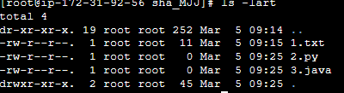

**Step 2: Create Another Instance EC2 in Another Region : By Looking Below PIC**

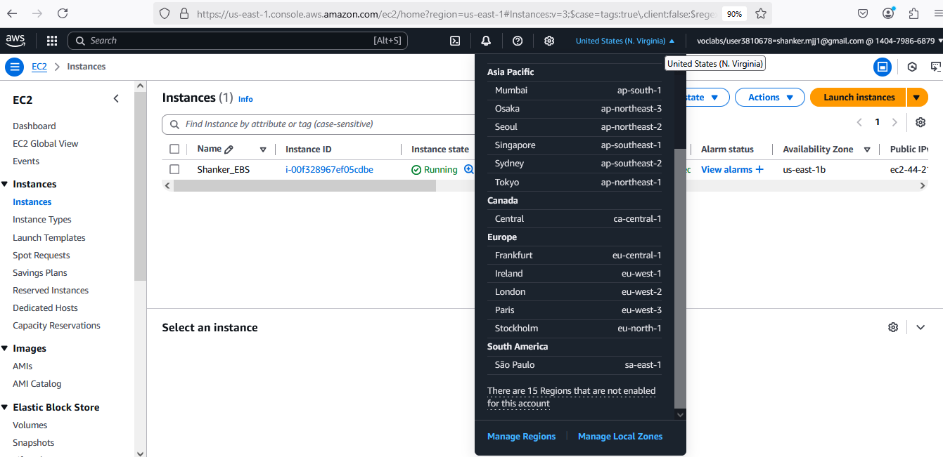

1. Instance Name: Rollno_EBS_OtherRegion (I Chosen :**United States (Oregon)** )
2. Key Pair : Old One (Existing)
3. Default Storage : 8 (GiB)
4. Launch IT
5. Connect with SSH Client with Command line
6. Now Copy the old region SSH path from old instance
7. Click Enter & Type Yes
8. Now type **sudo fdisk -l**  To verify disk size (only 8 GiB will displays)

**Step 3: Creating a Snapshot:**

1. Go to old Instance
2. Move to Volumes → Select the Volume 10 GiB
3. Click on Action → Click on Create SnapShot

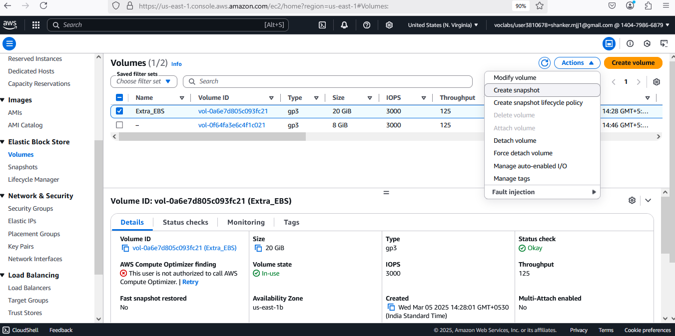

1. Supply Below details:

Snapshot details:

* 1. Description : Snapshot_Rollno
  2. Just Click on Create Snapshot

1. To See Snapshot Go to Left Pallet Elastic Block Store → Snapshot

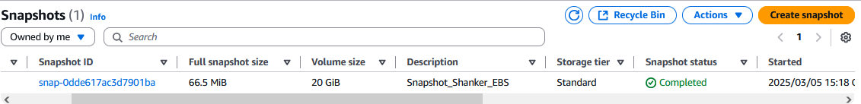

**Step 4: Attach our Snapshot to Second EC2 Instance**

1. Wait Until Snapshot created with Snapshot ID & Status: Okay
2. Goto **Snapshot** → **Action** → click on **Create volume from snapshot** 
   1. You will get Information like
      1. Volume settings ,
      2. Tags - optional ,
      3. Snapshot summary
   2. This are default information which are get by Snapshot
   3. Click on Create volume, now it will successfully create volume [ID vol-0df027b98bd332f6e](https://us-east-1.console.aws.amazon.com/ec2/home?region=us-east-1#VolumeDetails:volumeId=vol-0df027b98bd332f6e).
3. Now Rename the Snap-Volume as **Snap-Rollno-otherRegion**
4. Now Select Particular snap-volume ID → goto → Action → click Attach Volume →
   1. Basic details: Select Other Region Instance
   2. Device Name: /dev/sdk
   3. Click on attach volume
   4. Thats it Volume is attached to other Instance
5. Go to Terminal Region-2
6. Now run the command as **sudo fdisk -l (You will get 10GiB Data Attached)**
7. Repeated the Commands earlier we did

| sudo su  file -s /dev/xvdf  ls -lart /Rollno (All Files as to Display 1.txt, 2.py, 3.java in other Region) |
| --- |

**Part-3: ELASTIC FILE SYSTEM (EFS)** Theory + Practical communicating with 2 servers with EFS

1. EFS provides a simple, **serveless** & elastic file system that let you share file data without provisioning or managing storage
   1. File Storage we uses AWS EFS
   2. Object Storage uses AWS S3
   3. Block Storage uses AWS EBS

|  |  |
| --- | --- |

1. EFS Does not support Windows OS, No provision required -unlimited storage, Automatically it send in-frequently not used files, It has more Durability, Availability secure & Reliable.
2. EFS Works on NFS (Network File System: Port:2049)
3. Serverless Flexibility (Server required Size,Storage, Patching, hourly rent, Maintenance Cost, Data Transfer cost) No provisioning(Unlimited size) Required.
4. EFS supports EC2 Instance, ECS, EKS, AWS Lambda. Free Trial 5GB validity 12 Months.

**Agenda : Creating EFS and mounting to EC2**

1. Create 2 Instance namely Rollno-KMIT, Rollno-NGIT
2. Creating EFS System
3. Communicate with two servers

**Step 1: Launch 2 Instance & Mount EFS File System**

1. **EC2 Dashboard → Security Group → Create security Group**
   1. **Basic Details:**

**\*\*Security group name:** Rollno_EFS

**Description :** EFS SG

VPC: Default

Add Rule: Type: NFS, Port Range:2019, Add Security Group (Copy from EC2) or source: Anywhere

* 1. Create Security Group

Step 2: Search EFS in search Bar

1. Create File System
   1. Name :Rollno
   2. VPC : Select Region (or)

| Customized Configuration:  Step 1: File System Settings:  Storage Class: **Standard**  or One Zone  Enable automatic backups (not Enable)  Lifecycle Management: 7days data not access data move into infrequent(Save Money)  Encryption: NO  Performance Setting : Enhanced  Elastic (Enable) → unable to predict work load  Provisioned Throughput (dont select)  Add Tags: Optional  Step 2: Network Access:  VPC: default  Availability Zone: add Security group  Step 3: File System Policy (OS level Security)  Step 4: Review & Create  Click Create |
| --- |

* 1. Click on Create

df - Th // To see attach EFS

**Step :3 Connect to Instance-1(Server1) from Putty using PEM File**

1. sudo su
2. Create a Folder with Roll No-EBS1
3. **yam install -y amazon-efs-utils**
4. **Create** File1.html (Insert code)
5. Mount the EFS

PATH: goto EFS(just now created)

1. Select the EFS Created by you → Click Attach
2. (**Mount**) :Select created EFS & Click on Attach & copy the Command from **Using NFS Client**
3. 
4. Instead of /efs provide your Directory Roll No-EBS1
5. Copy the above code & paste the link for mounting

Step 4: **Connect to Instance-2 (Server2) from Putty using PEM File**

1. Create a Folder with Roll No-EBS2
2. **Create** File2.html (Insert code)
3. Mount the EFS like above
4. Press df -h (To check the whether its mounted or not)

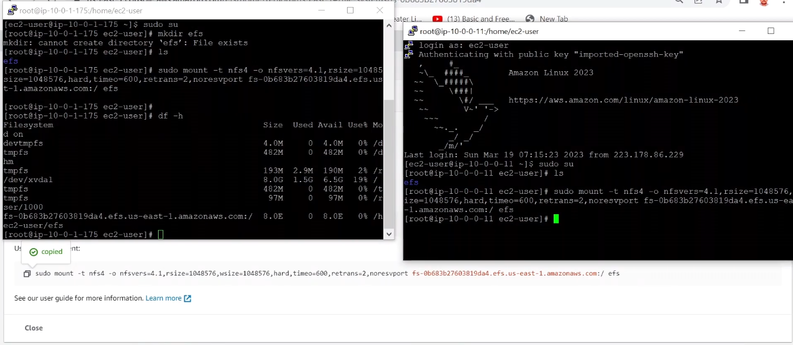

**Step 5:** Now go to Instance-1 & see that two servers are communicating with each other

$ df -h

$ ls

$ sudo su -

$ cd Roll No-EBS1 //from server2 to connect

—-- END—-

**EXTRA:**

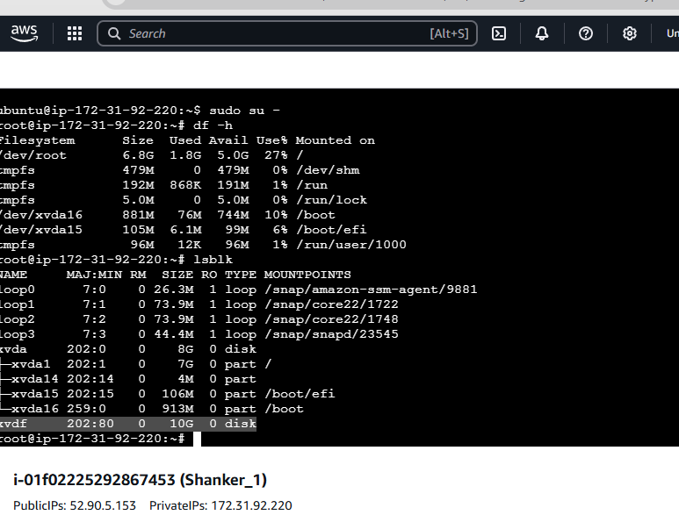

**Figure:** Shows mounting points

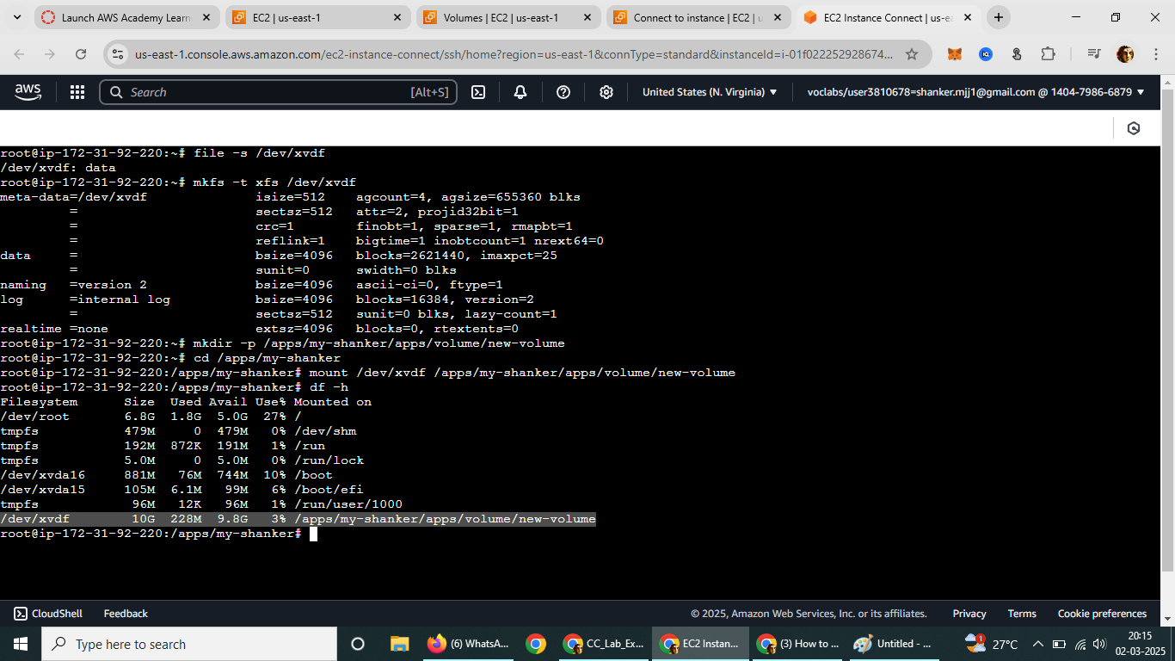

**Figure:** All Commands in 1 pic

EXTRA:

sudo fdisk -l //list all the disk Partition

file -s /dev/xvdf // Check if there is any file System on new EBS Volume

mkfs -t xfs /dev/xvdf //create File System

mkdir /Rollno //Create a Directory

mount /dev/xvdf /Rollno //mount Directory called Rollno into that particular

ls -lart /Rollno/ //able to access directory

df -h // to see mounted in EC2 + Consumes Memory for File Creation Format

fdisk -l //you can see the Size //https://youtu.be/WO5OqXVsxtw

EFS: https://youtu.be/y7KH7LtJl8Y