**EXPERIMENT-4 :** **Create and configure storage services and upload files and objects using Amazon EBS, Amazon EFS and Amazon S3**

**Part-1:  Attach and Mount Extra EBS(Amazon Elastic Block Store) Volume to Linux EC2 in AWS**

**Step 1:** Login into <https://awsacademy.instructure.com/> then move to Launch **AWS Academy Learner Lab** & **Start lab**. Finally click **AWS** Button to activate

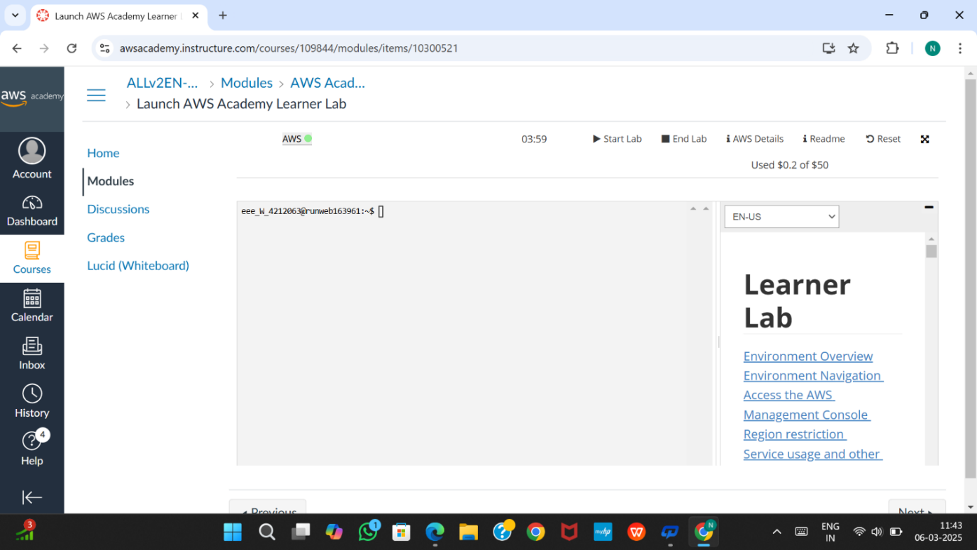

Figure:4.1

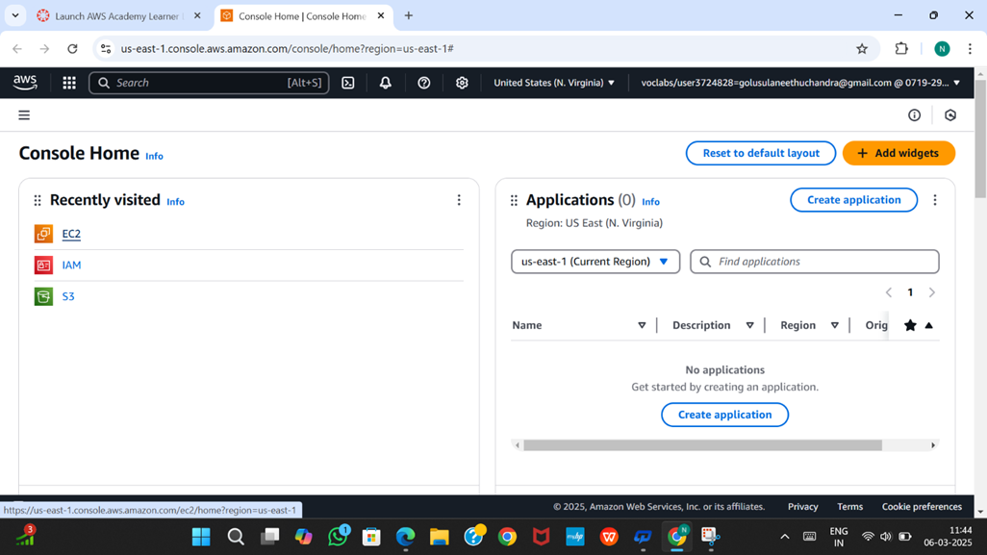

Figure:4.1

**Step 2:** We are adding EBS extra volume(10GB)  for already existing EC2 Instance with your Roll No.

Click & select your Instance you will find Storage

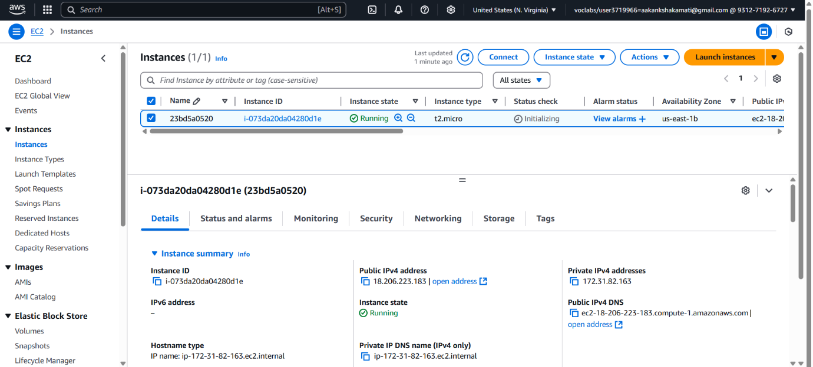

Figure:4.3

1. While clicking Storage you can see the below details with **Volume size 8(GiB), Volume ID, etc**

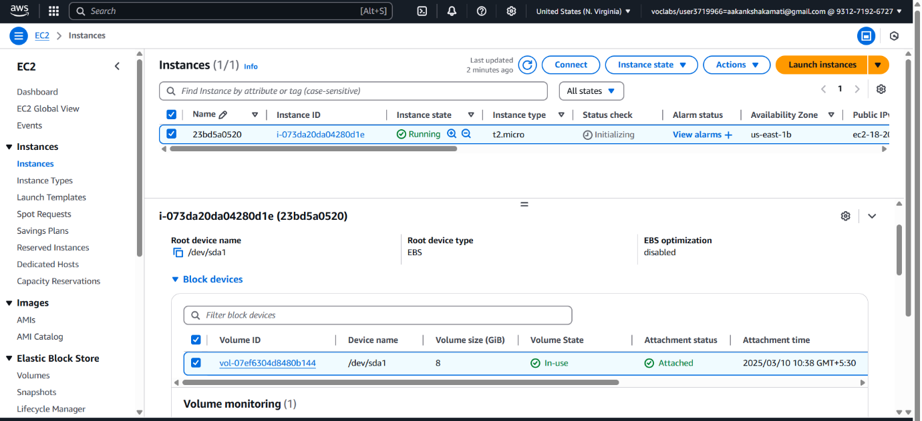

**Step 3:** To create New Volume of 10GB on left hand size pallet you find Elastic Block Store under that Volume

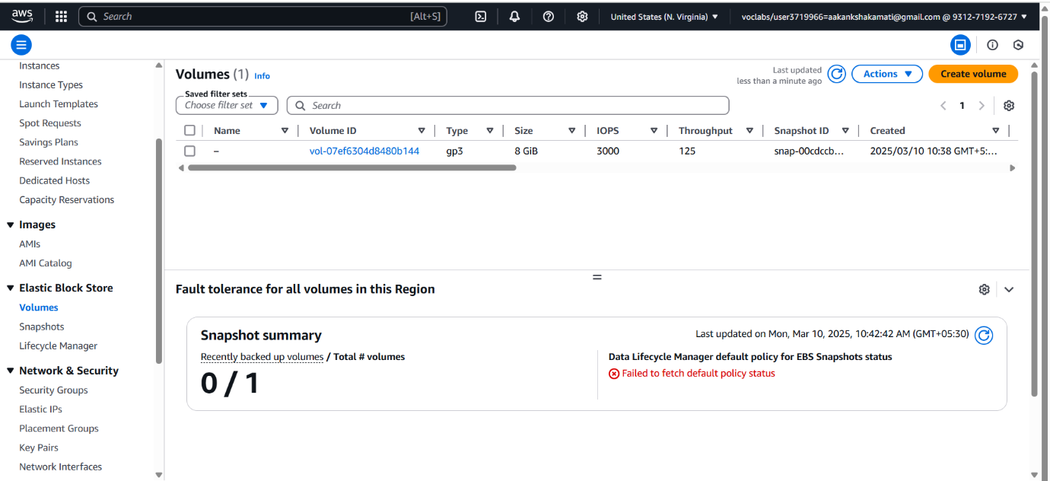

Figure:4.3

a.Click on Volumes as a new tab, you will navigate to below picture

Note: Check the Instance **Volume ID** & EBS **Volume ID** should be same

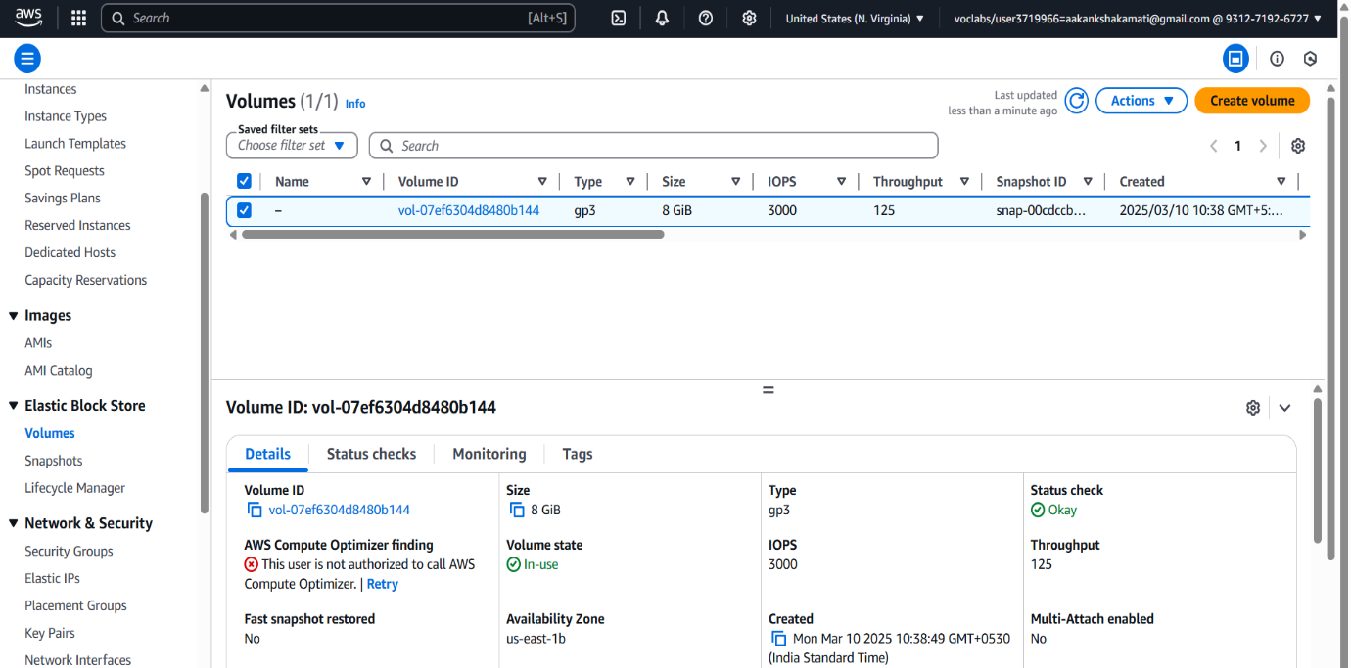

**Figure:4.4**

1. Now **connect** your Instance by clicking connect with **EC2 Instance connect**

**I.** Perform commands like root user, disk Info to see volume Size

$ sudo su -    //login into root user

$ df -h //shows the volume attached to that devices

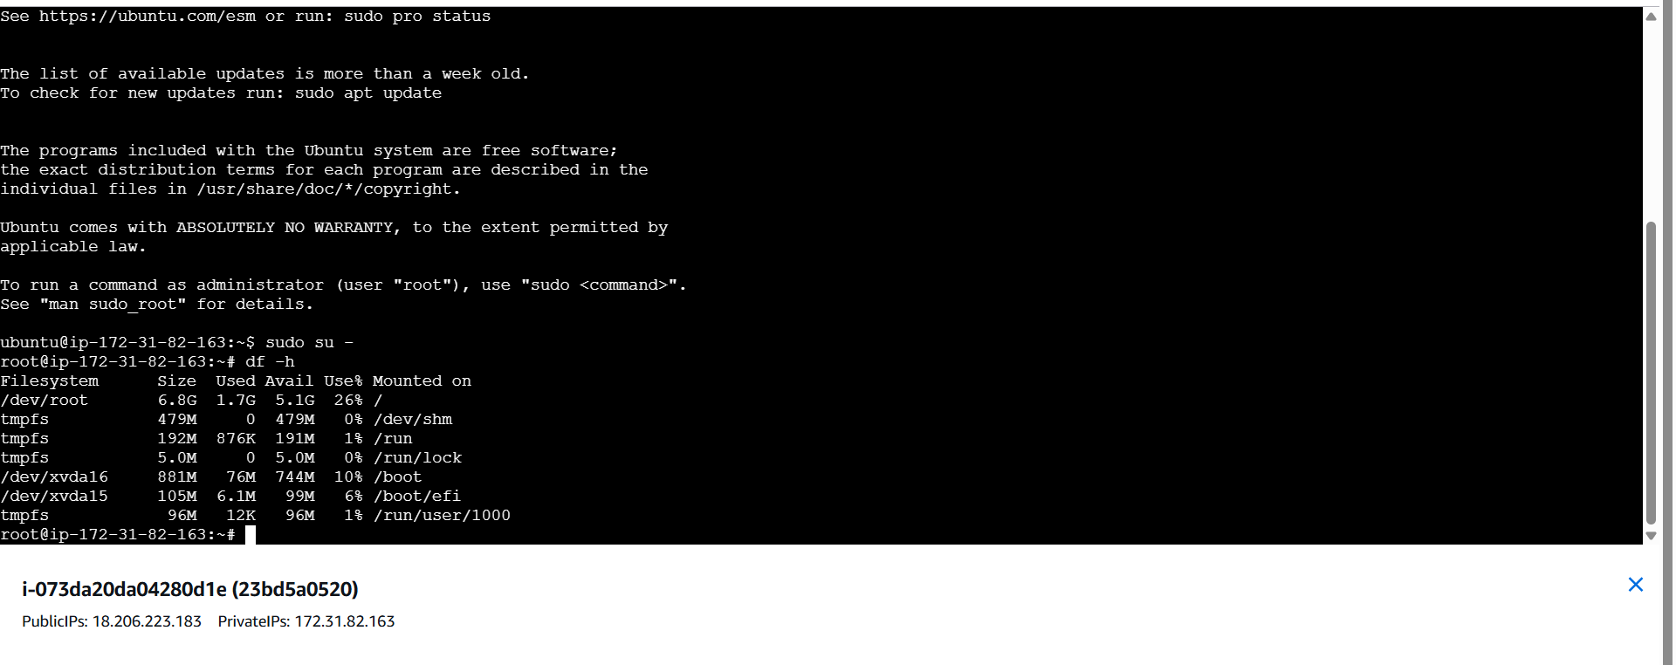

Figure :4.5

c. Click **create volume** on right most corner of your Page with following settings

**Volume type : General purpose (gp2)** //select based on your requirement

**Size (GiB) : 10 GiB**

**Remaining : Default, but Availability Zone should be careful**

**NOTE:** You need to create & attach volume same availability Zone & Verify ur exactly located

Tags : Optional (Add Tag)

Key: Roll no

Value: Extra-Volume-Rollno

Finally Click on **Create Volume**

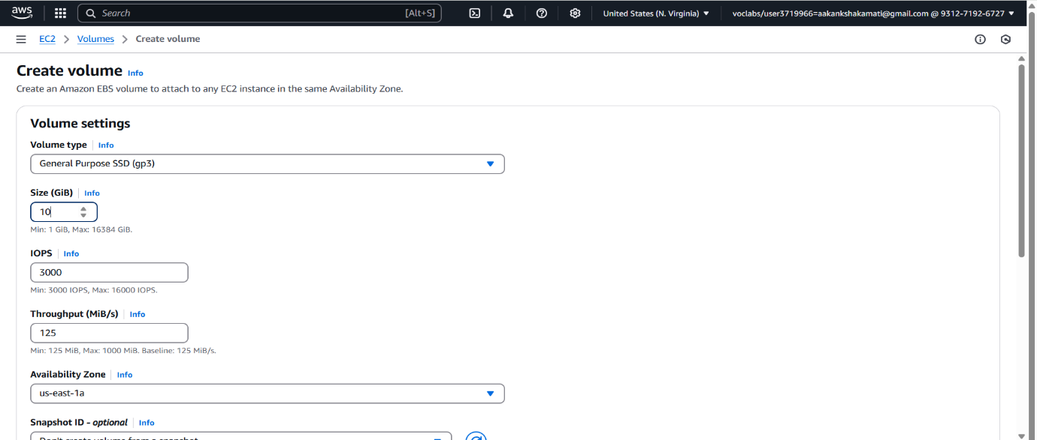

Figure:4.6

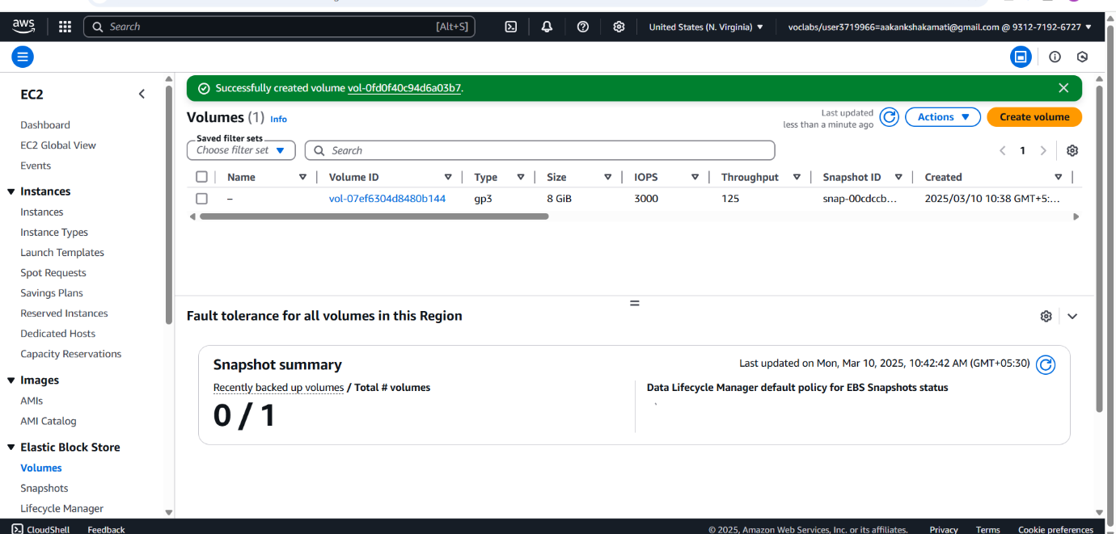

Figure:4.7

**Step 4:** Attach Volume:

a.Now select created Volume & Click on **Actions** (Besides create volume)  & select attach

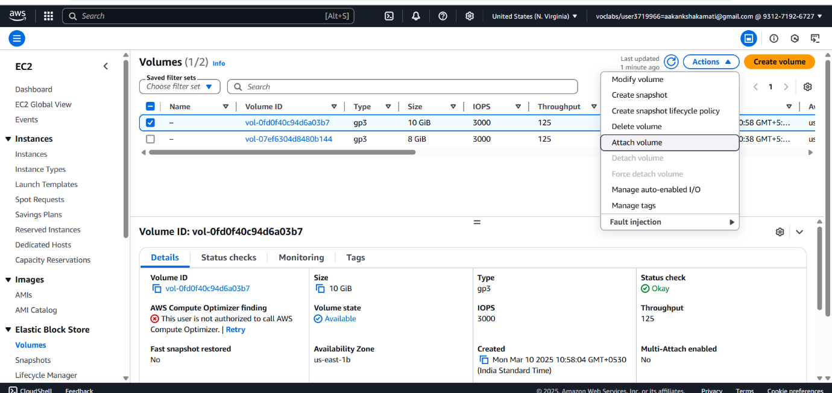

Figure:4.8

b.Select  your Instance you have created with your rollno

c.Choose **Device name : /dev/sdk (Default)**

d**.**Click on attach volume

e.It will create volume with 10(GiB) & status is: in-use

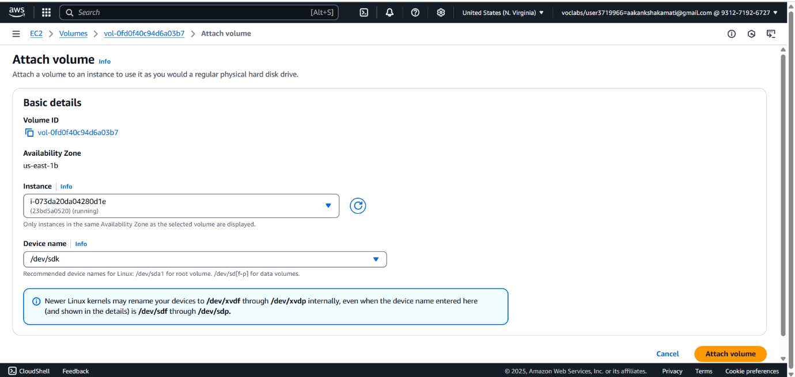

Figure:4.9

1. Click that volume you can see that **Status is insufficient,** Wait until **Okay (Green)**

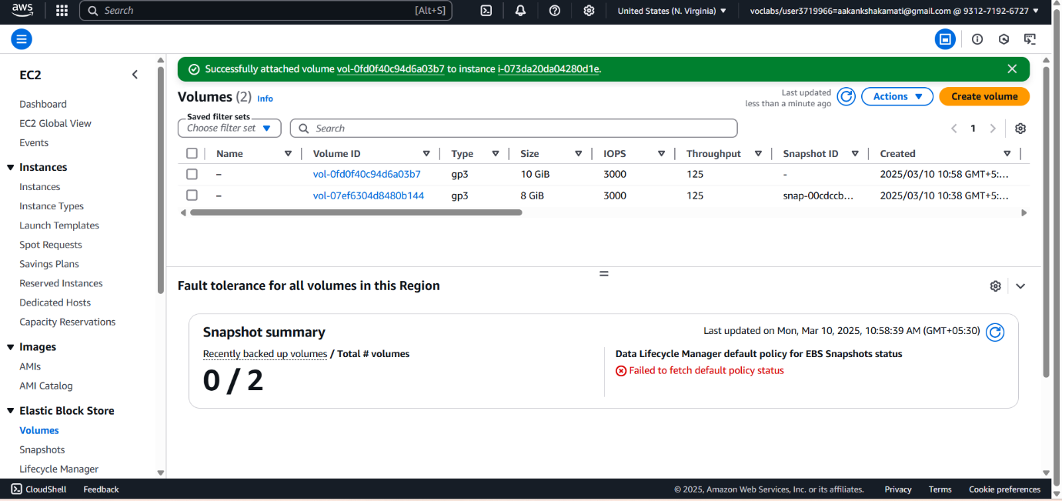

Figure:4.10

Step 5: Now go to EC2 Instance connect check whether Volume attached or not by typing command like df -h (It Will not show, the reason is: After creating & Attaching, you need to create a directory & Mount the EBS volume into EC2 Instance) it have set of procedure listed below

|  |  |
| --- | --- |
| 1. lsblk 2. sudo su 3. lsblk -list 4. lsblk -fs | * Lists all the block devices in the Linux Machine & you can ckek that new Volume with 10(GiB) Created * Login as Super User * List all/ **shows the physical disk (sda)** * **List all disk with root directories** |

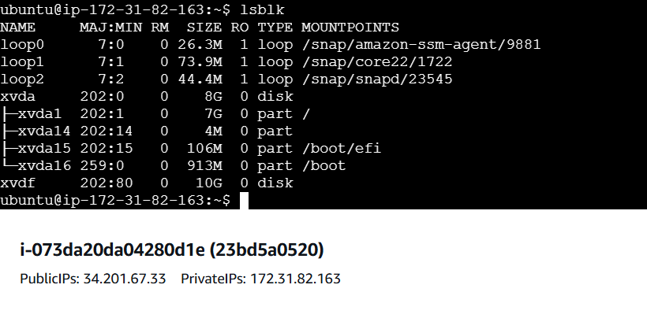

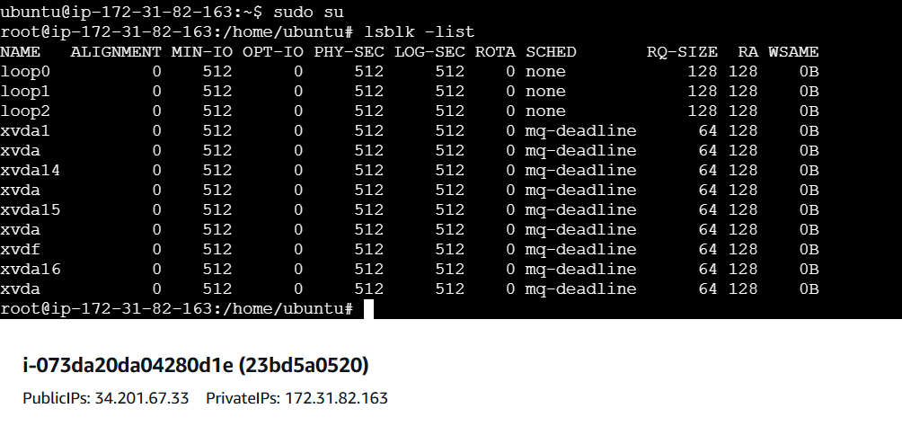

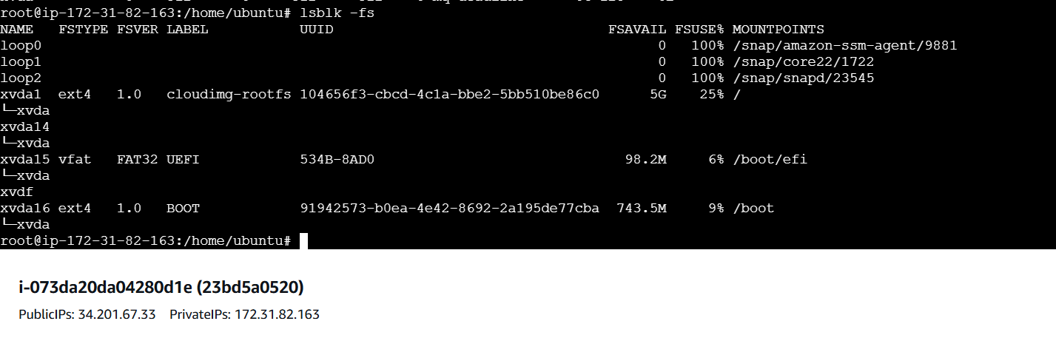

|  |  |
| --- | --- |
| * fdisk /dev/xvdf * Press: m-help                  n- add new Partition                p - Primary                Enter (Default Partition)                 Enter (First Partition)                 Enter (Last Partition)                w - write Changes to disk & exit  partprobe | * Displays all the device Partition Info with GB * Navigate to /dev/xvdf device path * Performing Partitioning of a Disk with commands      * Inform to kernel about Changes |

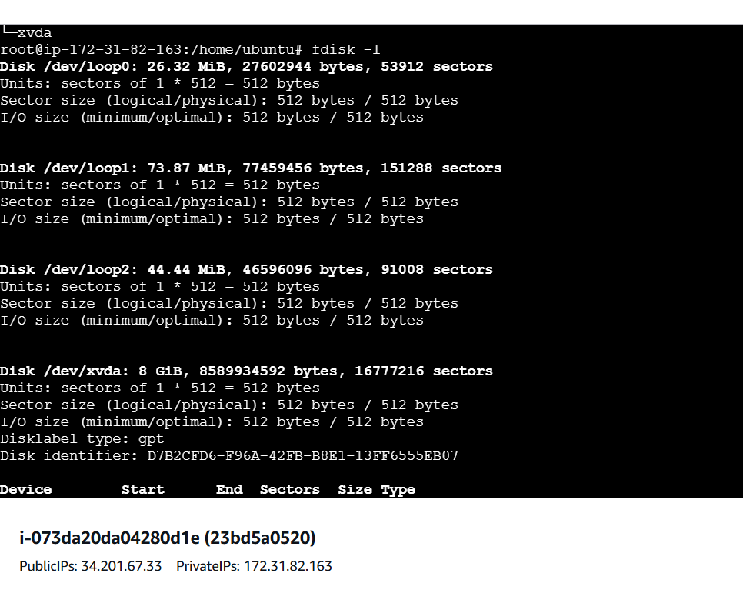

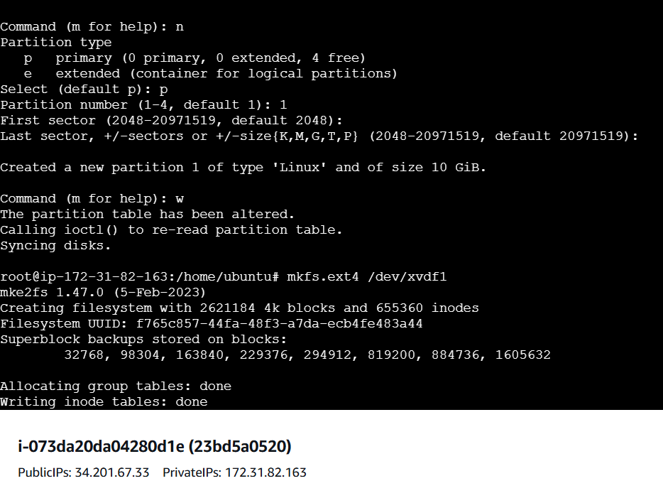

|  |  |
| --- | --- |
| file -s /dev/xvdf | Check if there is any file System on new EBS Volume  (If you see Data, Meaning you need to setup file system for this block device…) |

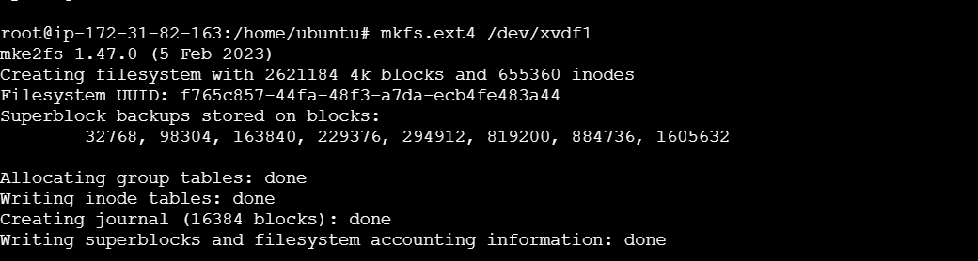

|  |  |
| --- | --- |
| mkfs -t xfs **/dev/xvdf**  **NOTE :** PATH /dev/xvdf of Extra volume | Create a file system on volume to mount it to EC2  Again run same command it shows File System as SGI XFS FileSystem Data |

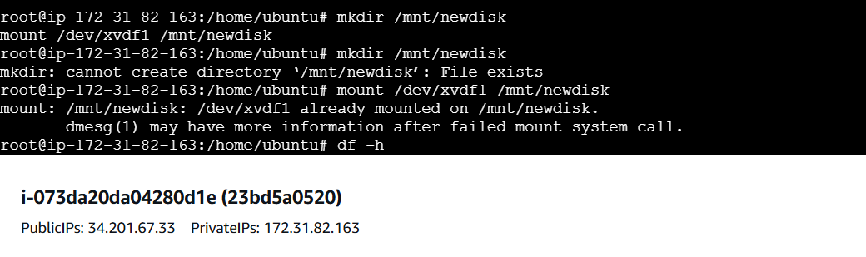

|  |  |
| --- | --- |
| file -s /dev/xvdf | Now It will Create File System |

|  |  |
| --- | --- |
| mount /dev/xvdf /Rollno  Note :  Disk Path(/dev/xvdf)              Folder: /Rollno | Mounting the Volume /dev/xvdt to EC2 instance (automatically) |
| ls -lart /Rollno/ | You can see/able access the Directory |
| df -h | To see mounted in EC2 with Volume  NOTE: Some memory Consumes for File Creation Format |

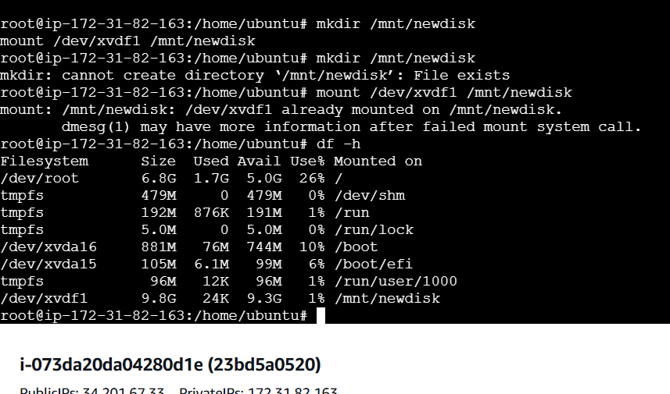

|  |  |
| --- | --- |
| fdisk -l | You can see the Total Size |

