**Part-2:  Inserting a Files in EBS, Taking a Snapshot & Attaching to another Region**

**EBS**

**Step 1: Creating Files**

1. **pwd**
2. **cd /Rollno**
3. **sudo touch 2.py //create a 2.py File & Write add 2 numbers Code**
4. **sudo touch 3.java //create a 3.txt File & Write Welcome with Roll no Code**
5. **ls -lart // To see the File**

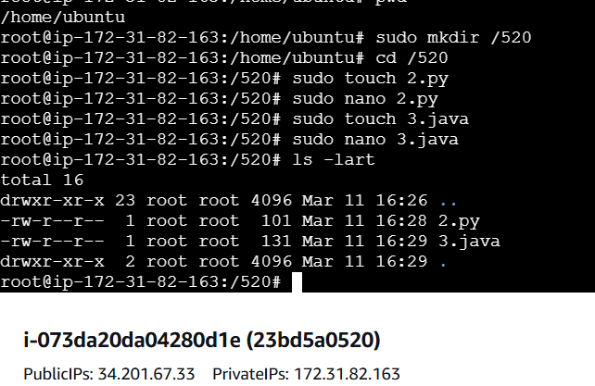

**Step 2: Create Another Instance EC2 in Another Region : By Looking Below PIC**

1. **Instance Name: Rollno_EBS_OtherRegion (I Chosen :United States (Oregon) )**
2. **Key Pair : Old One (Existing)**
3. **Default Storage : 8 (GiB)**
4. **Launch IT**
5. **Connect with SSH Client with Command line**
6. **Now Copy the old region SSH path from old instance**
7. **Click Enter & Type Yes**
8. **Now type sudo fdisk -l  To verify disk size (only 8 GiB will displays)**

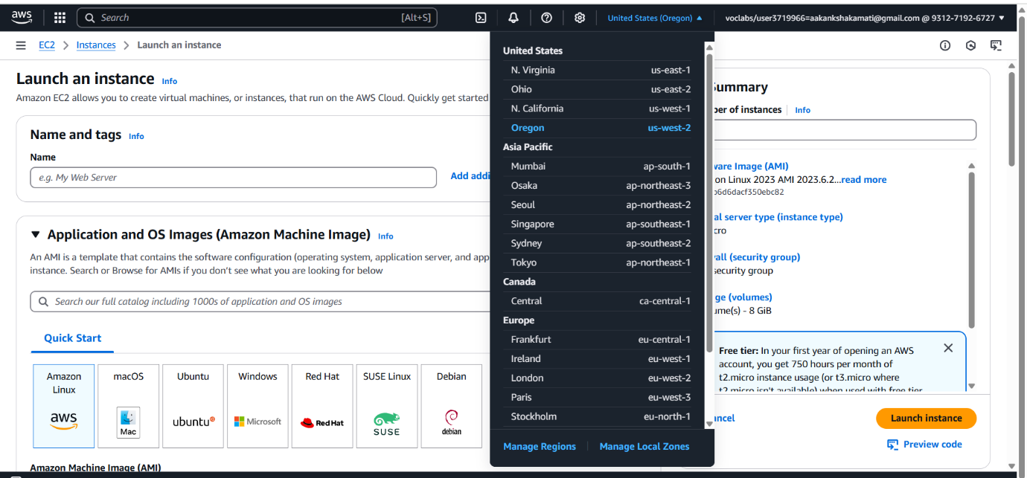

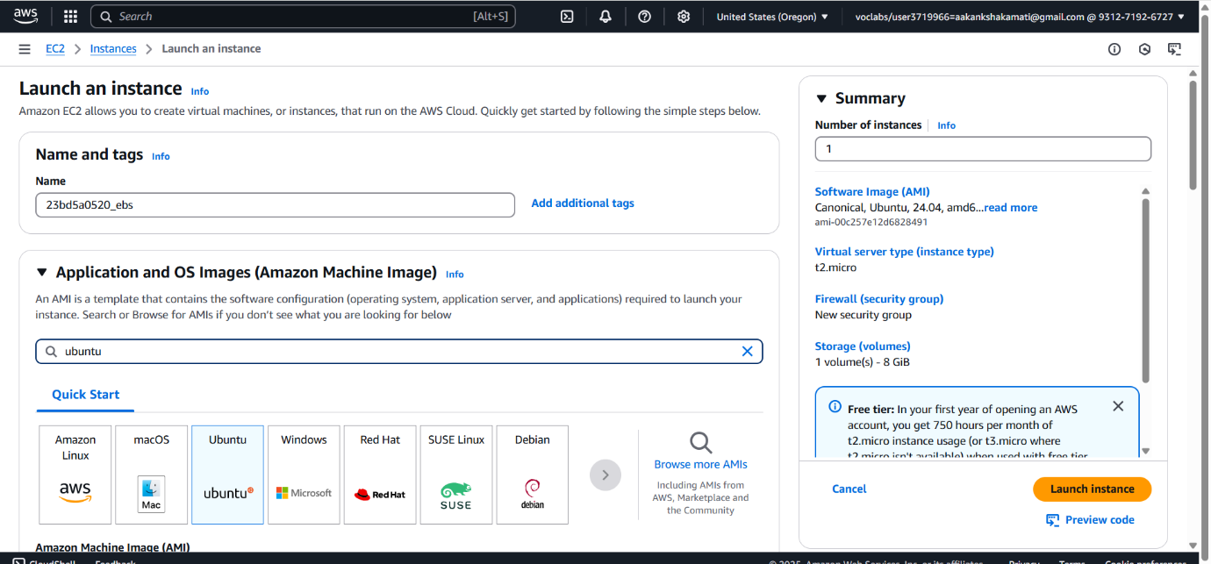

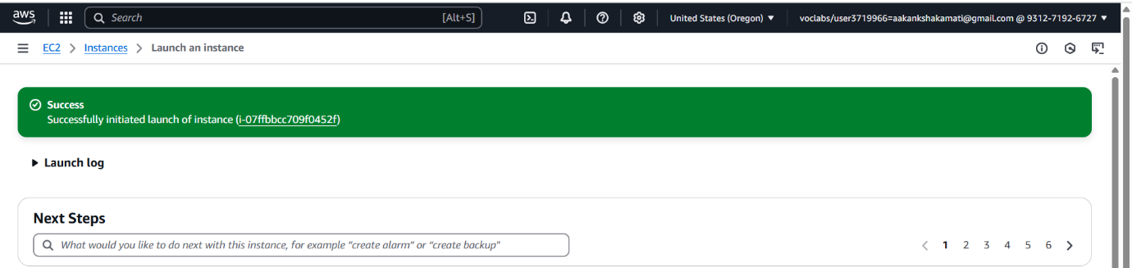

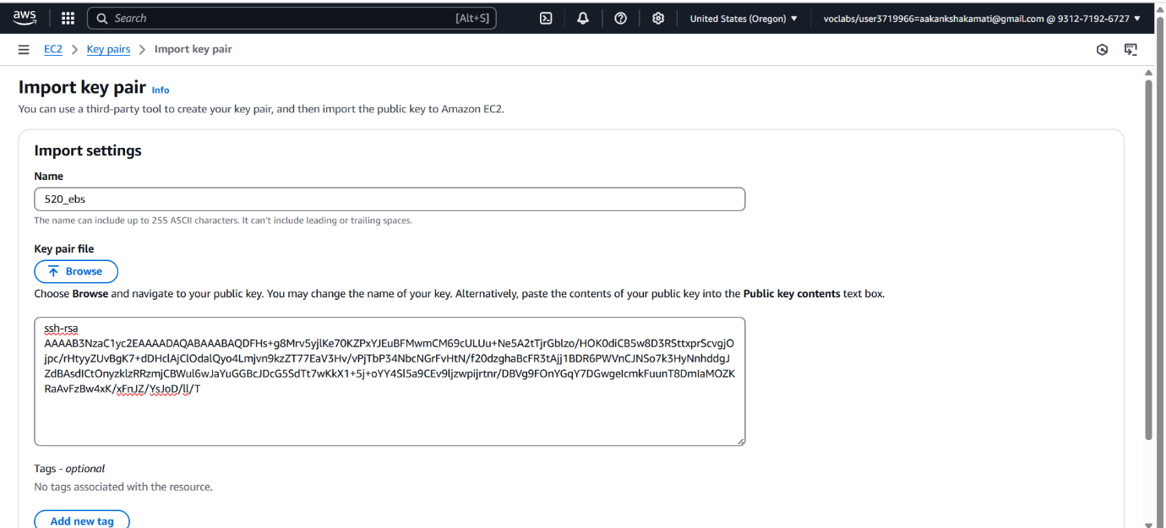

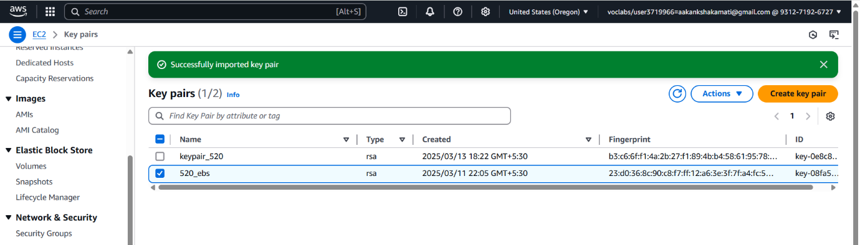

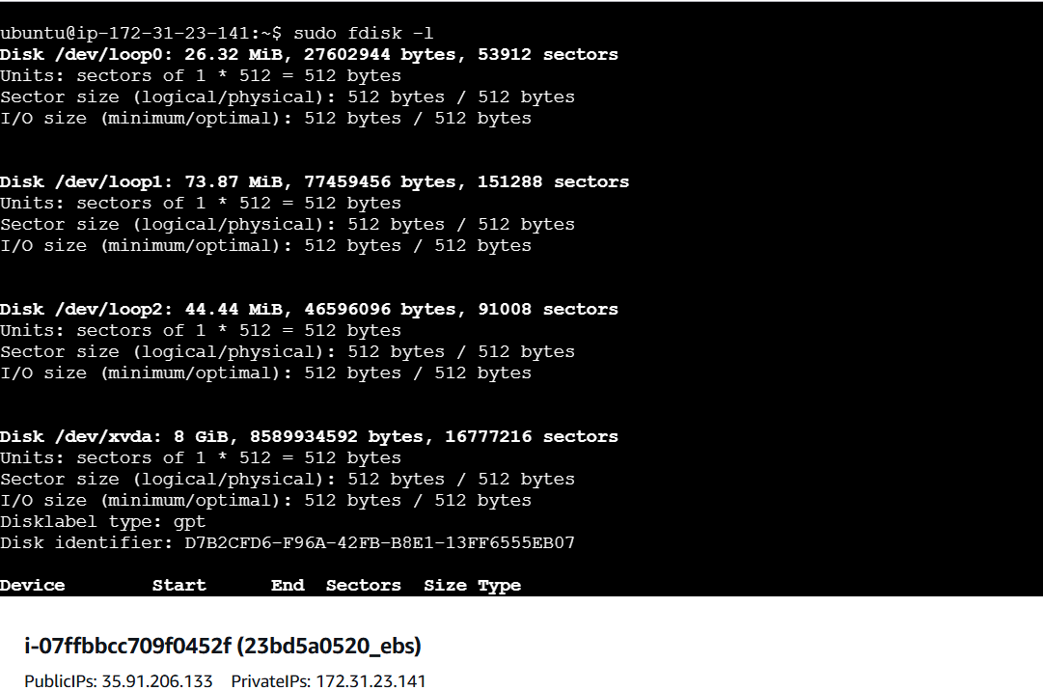

**Step 3: Creating a Snapshot:**

1. **Go to old Instance**
2. **Move to Volumes → Select the Volume 10 GiB**
3. **Click on Action → Click on Create SnapShot**

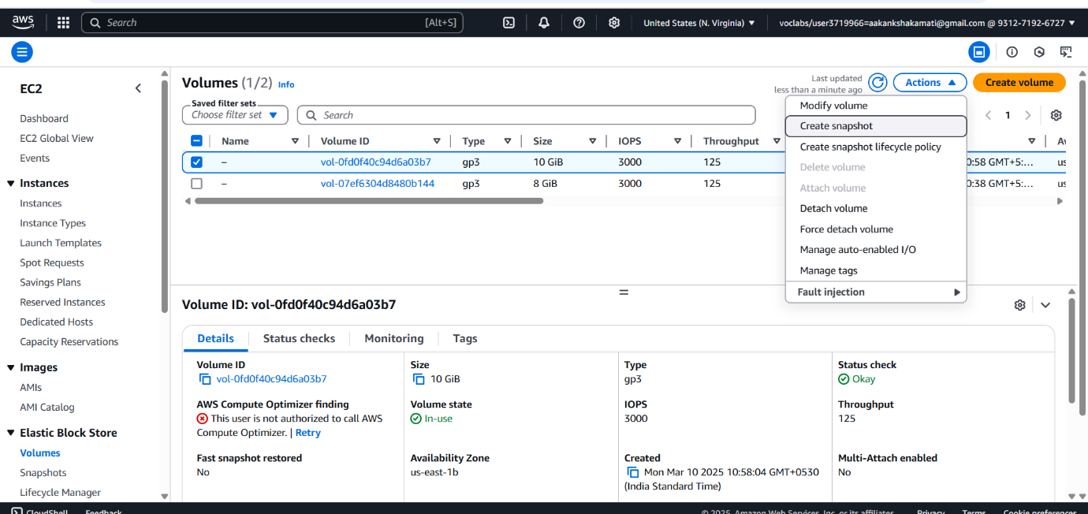

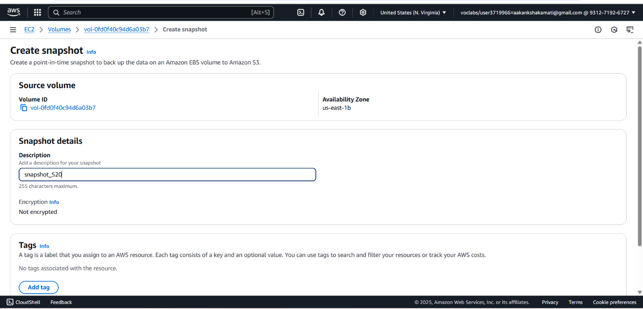

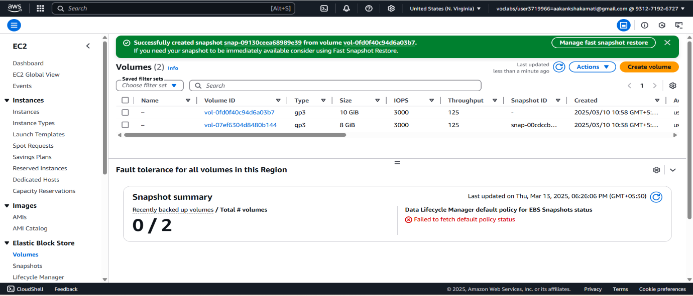

Step 4: Attach our Snapshot to Second EC2 Instance

1. Wait Until Snapshot created with Snapshot ID & Status: Okay
2. Goto Snapshot → Action → click on Create volume from snapshot

You will get Information like

* + 1. Volume settings ,
    2. Tags - optional ,
    3. Snapshot summary

This are default information which are get by Snapshot

Click on Create volume, now it will successfully create volume[ID vol-0df027b98bd332f6e](https://us-east-1.console.aws.amazon.com/ec2/home?region=us-east-1#VolumeDetails:volumeId=vol-0df027b98bd332f6e).

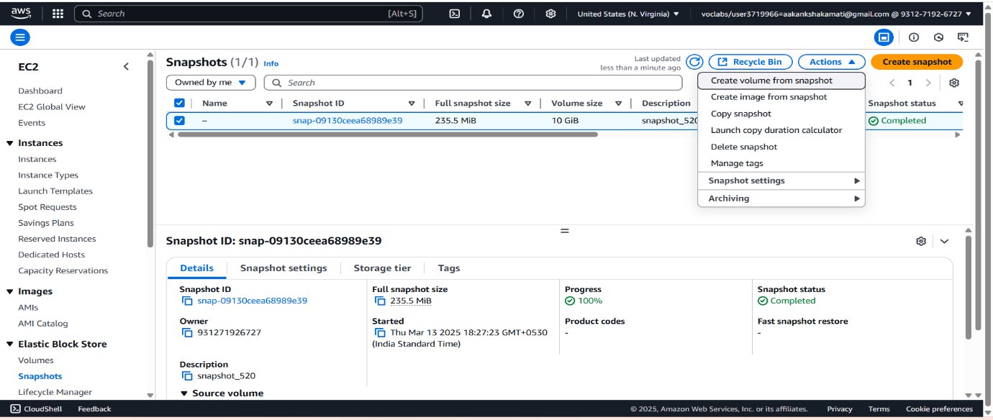

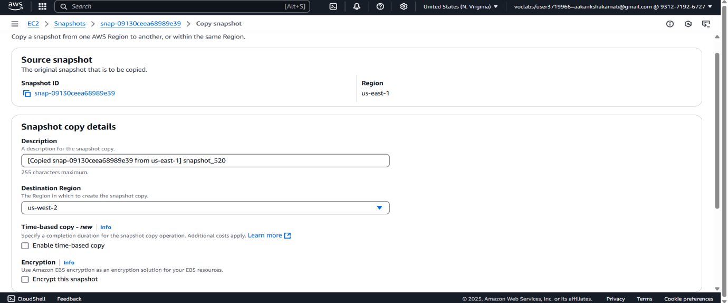

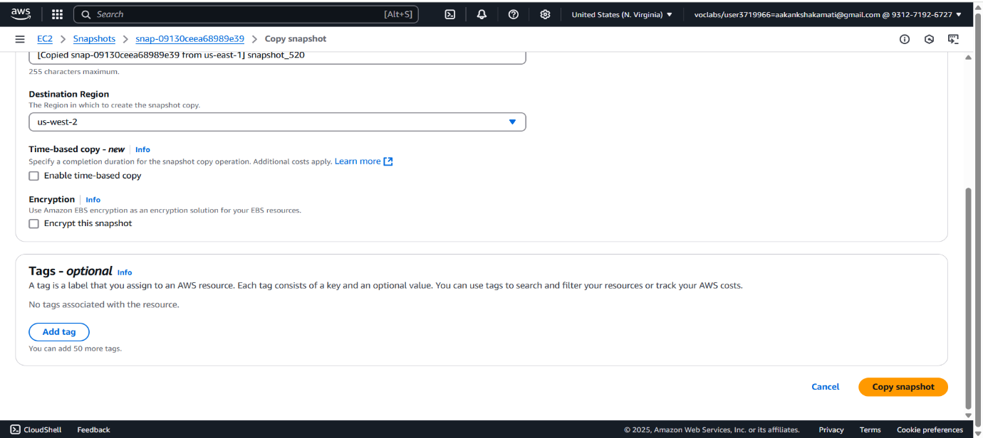

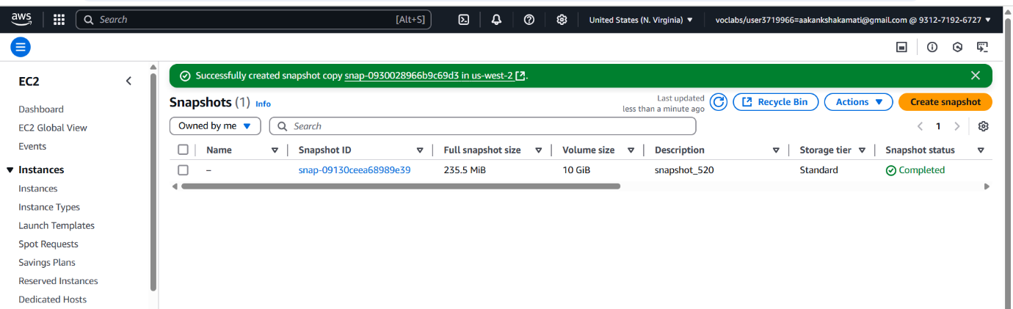

a.Now Rename the Snap-Volume as Snap-Rollno-otherRegion

b. Now Select Particular snap-volume ID → goto → Action → click Attach Volume →

Basic details: Select Other Region Instance

Device Name: /dev/sdk

Click on attach volume

Thats it Volume is attached to other Instance

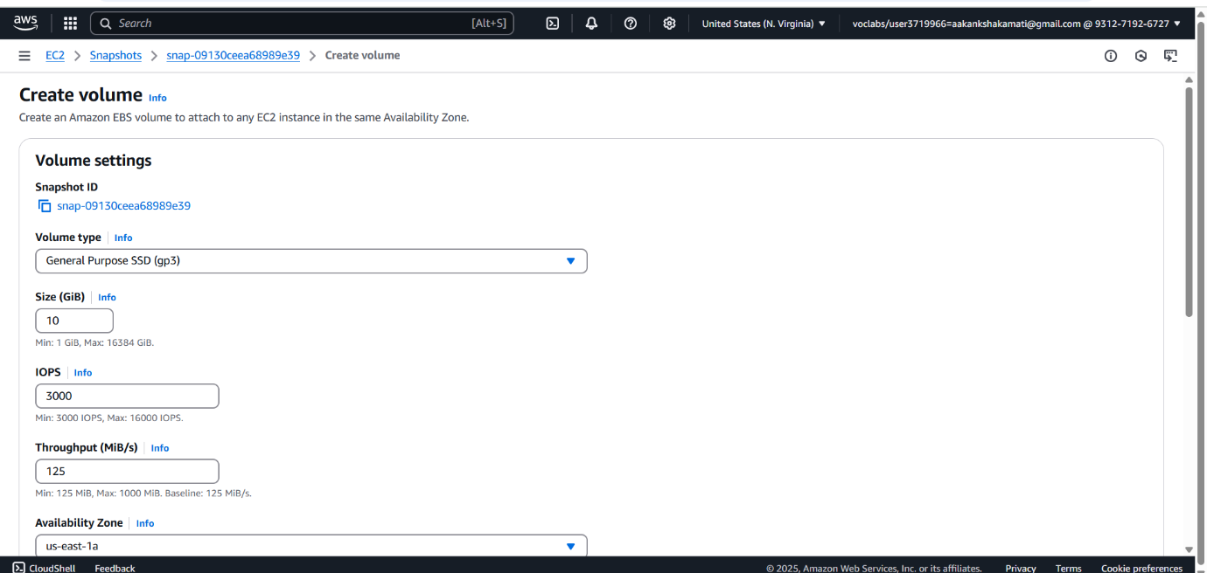

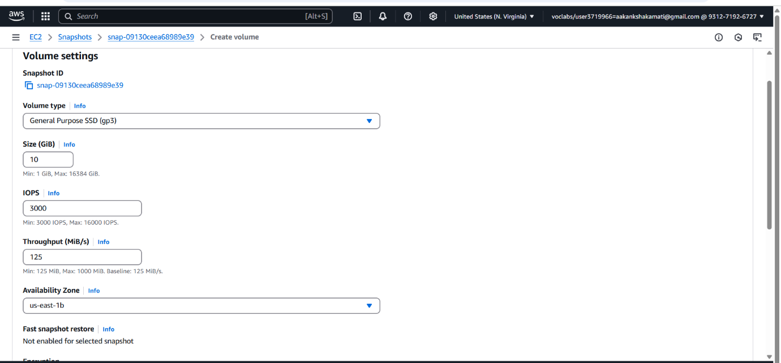

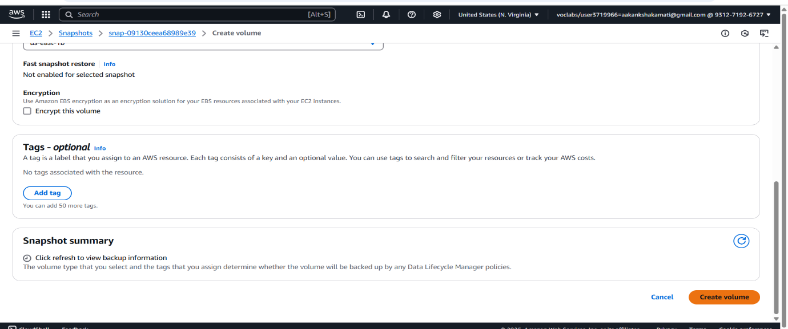

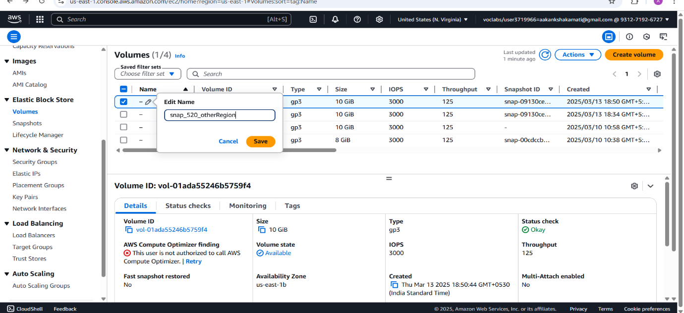

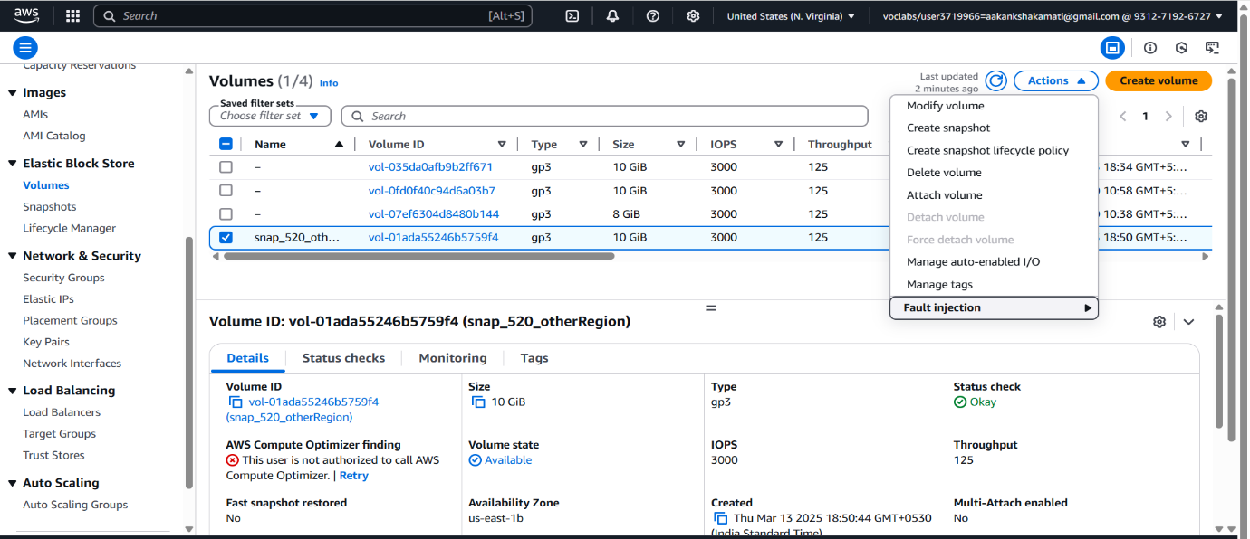

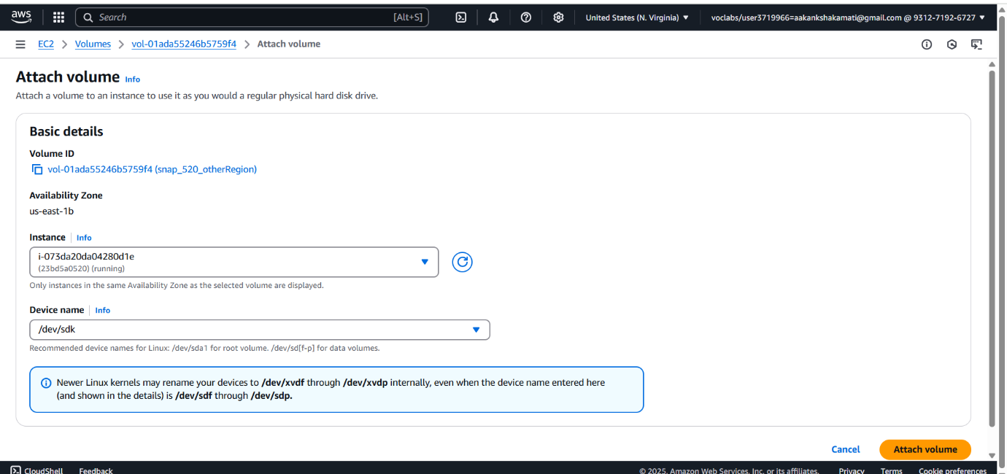

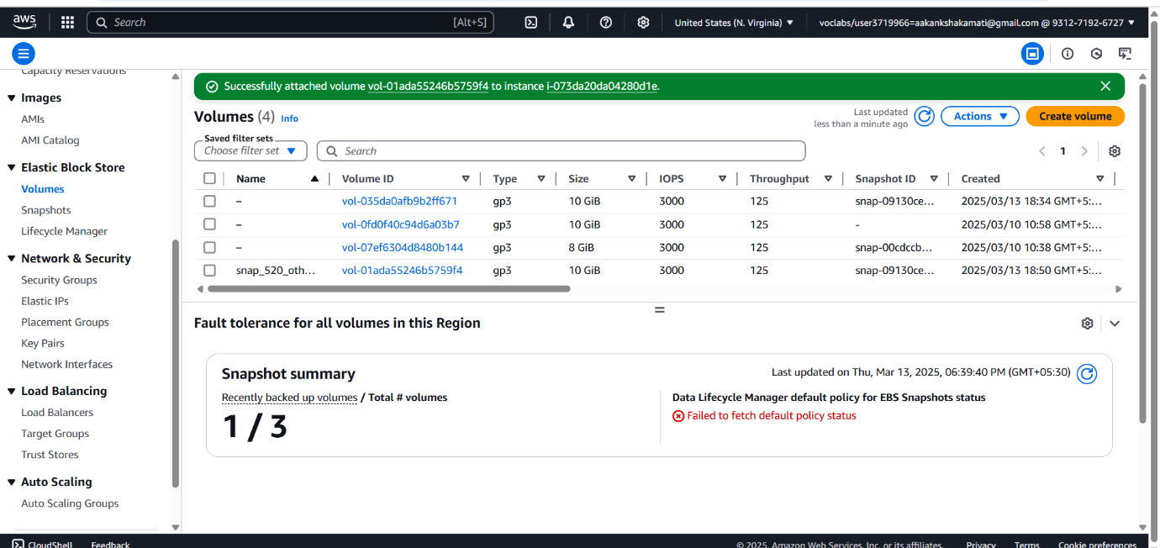

a. Go to Terminal Region-2

b. Now run the command as **sudo fdisk -l (You will get 10GiB Data Attached)**

c. Repeated the Commands earlier we did

