View File

Download File

You Can

Fetches Files Based on User Input.

Home Page

Login

Register

User Interface

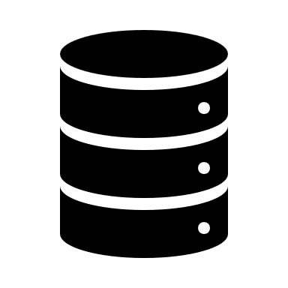

Database