**BASIC PROGRAMS**

1:write program to test Hello World.

#include<iostream>

using namespace std;

int main()

{

    cout<<"Hello world ! ";

}

Output :



2:Write a program to adddition of two numbers .

#include<iostream>

using namespace std;

int main()

{

    int a,b;

    cout<<"Enter two numbers : "<<endl;

    cin>>a>>b;

    int c = a+b;

    cout <<"Addition is :"<<c;

}

Output :

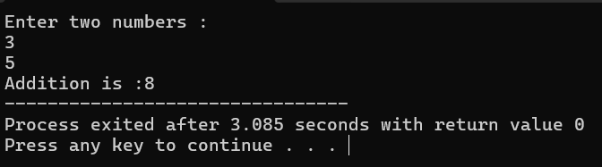

3:Write a program to swap two numbers.

#include <iostream>

using namespace std;

int main() {

    int a, b;

    cout << "Enter two numbers to swap: ";

    cin >> a >> b;

    cout << "Before swapping:" << endl;

    cout << "a = " << a << endl;

    cout << "b = " << b << endl;

    // Swapping without temporary variable

    a = a + b;

    b = a - b;

    a = a - b;

    cout << "After swapping:" << endl;

    cout << "a = " << a << endl;

    cout << "b = " << b << endl;

    return 0;

}

Output:

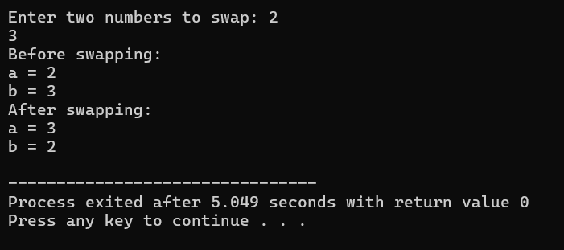

4. Write a program to accept an integer and check if it is even or odd.

#include <iostream>

using namespace std;

int main() {

    int num;

    // Input from the user

    cout << "Enter an integer: ";

    cin >> num;

    // Check if the number is even or odd

    if (num % 2 == 0) {

        cout << num << " is even." << endl;

    } else {

        cout << num << " is odd." << endl;

    }

    return 0;

}

Output:



5. Write a program to accept a number and check if it is divisible by 5 and 7.

#include <iostream>

using namespace std;

int main() {

    int num;

    // Input from the user

    cout << "Enter a number: ";

    cin >> num;

    // Check if the number is divisible by both 5 and 7

    if (num % 5 == 0 && num % 7 == 0) {

        cout << num << " is divisible by both 5 and 7." << endl;

    } else {

        cout << num << " is not divisible by both 5 and 7." << endl;

    }

    return 0;

}

Output:

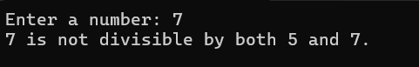

6. Write a program, which accepts annual basic salary of an employee and calculates and displays the

Income tax as per the following rules.

Basic: < 1, 50,000 Tax = 0

1, 50,000 to 3,00,000 Tax = 20%

> 3,00,000 Tax = 30%

#include <iostream>

using namespace std;

int main() {

    double basicSalary, tax;

    // Input from the user

    cout << "Enter the annual basic salary of the employee: ";

    cin >> basicSalary;

    // Calculate tax based on the provided rules

    if (basicSalary < 150000) {

        tax = 0;

    } else if (basicSalary >= 150000 && basicSalary <= 300000) {

        tax = 0.20 * basicSalary;

    } else {

        tax = 0.30 * basicSalary;

    }

    // Display the calculated tax

    cout << "Income tax: " << tax << endl;

    return 0;

}

Output:

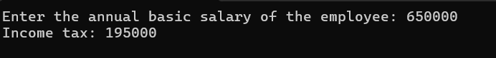

7. Accept a lowercase character from the user and check whether the character is a vowel or consonant.

(Hint: a, e, i, o, u are vowels)

#include <iostream>

using namespace std;

int main() {

    char ch;

    // Input from the user

    cout << "Enter a lowercase character: ";

    cin >> ch;

    // Check if the character is a vowel or consonant

    if (ch == 'a' || ch == 'e' || ch == 'i' || ch == 'o' || ch == 'u') {

        cout << ch << " is a vowel." << endl;

    } else {

        cout << ch << " is a consonant." << endl;

    }

    return 0;

}

Output :



8. Write a program to input angles of a triangle and check whether triangle is valid or not.

#include <iostream>

using namespace std;

int main() {

    int angle1, angle2, angle3;

    // Input angles from the user

    cout << "Enter the three angles of the triangle: ";

    cin >> angle1 >> angle2 >> angle3;

    // Check if the angles form a valid triangle

    if (angle1 + angle2 + angle3 == 180 && angle1 > 0 && angle2 > 0 && angle3 > 0) {

        cout << "The triangle with angles " << angle1 << ", " << angle2 << ", and " << angle3 << " is valid." << endl;

    } else {

        cout << "The triangle with angles " << angle1 << ", " << angle2 << ", and " << angle3 << " is not valid." << endl;

    }

    return 0;

}

Output:

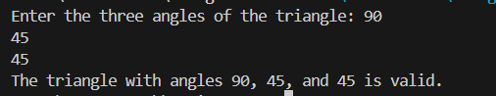

9:Write a program to find factorial of a given number. ex:no5 fact=5*4*3*2*1=120

#include <iostream>

using namespace std;

// Function to calculate factorial

int factorial(int n) {

    // Base case: factorial of 0 is 1

    if (n == 0) {

        return 1;

    } else {

        // Recursive case: factorial of n is n multiplied by factorial of (n-1)

        return n * factorial(n - 1);

    }

}

int main() {

    int num;

    // Input from the user

    cout << "Enter a number to find its factorial: ";

    cin >> num;

    // Call the factorial function and display the result

    cout << "Factorial of " << num << " is: " << factorial(num) << endl;

    return 0;

}

Output :



10:Write a program to find m to the power n. m=3 and n=4 so 3*3*3*3

#include <iostream>

using namespace std;

// Function to calculate power using recursion

int power(int m, int n) {

    // Base case: if n is 0, return 1

    if (n == 0) {

        return 1;

    } else {

        // Recursive case: multiply m by power(m, n-1)

        return m * power(m, n - 1);

    }

}

int main() {

    int m = 3; // Base number

    int n = 4; // Power

    // Calculate m raised to the power of n

    int result = power(m, n);

    // Display the result

    cout << m << " raised to the power of " << n << " is: " << result << endl;

    return 0;

}

Output :



11:Check if number is a prime number or not.:

#include <iostream>

using namespace std;

bool isPrime(int num) {

    if (num <= 1) {

        return false;

    }

    for (int i = 2; i * i <= num; i++) {

        if (num % i == 0) {

            return false;

        }

    }

    return true;

}

int main() {

    int num;

    cout << "Enter a number: ";

    cin >> num;

    if (isPrime(num)) {

        cout << "The number " << num << " is a prime number." << endl;

    } else {

        cout << "The number " << num << " is not a prime number." << endl;

    }

    return 0;

}

Output:



12:Sum of series : 1+2+3+….+n

#include<iostream>

using namespace std;

int main()

{

int i,n,sum=0;

cout<<"1+2+3+......+n";

cout<<"\nEnter the value of n:"; cin>>n;

for(i=1;i<=n;++i)

    sum+=i;

cout<<"\nSum="<<sum;

return 0;

}

Output :

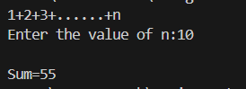

13:Check whether the number is palindrome or not?

#include <iostream>

using namespace std;

int main() {

    int num;

    cout << "Enter a number: ";

    cin >> num;

    int originalNum = num;

    int reversedNum = 0;

    while (num > 0) {

        int digit = num % 10;

        reversedNum = reversedNum * 10 + digit;

        num /= 10;

    }

    if (originalNum == reversedNum) {

        cout << "The number is a palindrome." << endl;

    } else {

        cout << "The number is not a palindrome." << endl;

    }

    return 0;

}

Output:



14:Write a program to find sum of all even and odd numbers between 1 to n.

#include <iostream>

using namespace std;

int main() {

    int n;

    cout << "Enter a number: ";

    cin >> n;

    int evenSum = 0;

    int oddSum = 0;

    for (int i = 1; i <= n; i++) {

        if (i % 2 == 0) {

            evenSum += i;

        } else {

            oddSum += i;

        }

    }

    cout << "Sum of even numbers between 1 to " << n << " is: " << evenSum << endl;

    cout << "Sum of odd numbers between 1 to " << n << " is: " << oddSum << endl;

    return 0;

}

Output:

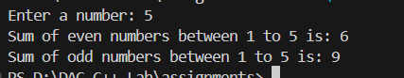

15: Write a program to enter a number and print its reverse.

#include <iostream>

using namespace std;

int main() {

    int num;

    cout << "Enter a number: ";

    cin >> num;

    int reversedNum = 0;

    while (num > 0) {

        int digit = num % 10;

        reversedNum = reversedNum * 10 + digit;

        num /= 10;

    }

    cout << "Reverse of the number " << num << " is: " << reversedNum << endl;

    return 0;

}

Output :

