16:Write a program to print all Prime numbers between 1 to n.

#include <iostream>

using namespace std;

int main() {

    int n;

    cout << "Enter a number: ";

    cin >> n;

    cout << "Prime numbers between 1 to " << n << " are: ";

    for (int i = 2; i <= n; i++) {

        bool isPrime = true;

        for (int j = 2; j * j <= i; j++) {

            if (i % j == 0) {

                isPrime = false;

                break;

            }

        }

        if (isPrime) {

            cout << i << " ";

        }

    }

    cout << endl;

    return 0;

}

Output:



17:Write a program to check entered number is Armstrong number or not.

#include <iostream>

#include <cmath>

using namespace std;

int main() {

    int num;

    cout << "Enter a number: ";

    cin >> num;

    int originalNum, remainder, sum = 0, n = 0;

    originalNum = num;

    while (originalNum != 0) {

        originalNum /= 10;

        n++;

    }

    originalNum = num;

    while (originalNum != 0) {

        remainder = originalNum % 10;

        sum += pow(remainder, n);

        originalNum /= 10;

    }

    if (num == sum) {

        cout << "The number " << num << " is an Armstrong number." << endl;

    } else {

        cout << "The number " << num << " is not an Armstrong number." << endl;

    }

    return 0;

}

Output :



18:Write a program to find greatest of three numbers using nested if-else.

#include <iostream>

using namespace std;

int main() {

    int num1, num2, num3;

    cout << "Enter three numbers: ";

    cin >> num1 >> num2 >> num3;

    if (num1 > num2) {

        if (num1 > num3) {

            cout << "The greatest number is: " << num1 << endl;

        } else {

            cout << "The greatest number is: " << num3 << endl;

        }

    } else {

        if (num2 > num3) {

            cout << "The greatest number is: " << num2 << endl;

        } else {

            cout << "The greatest number is: " << num3 << endl;

        }

    }

    return 0;

}

Output :

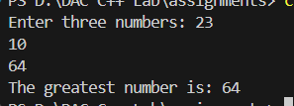

19:Create menu driven program for Pizza Shop.And display total amount.

#include <iostream>

using namespace std;

int main() {

    int choice;

    double pizzaPrice = 0, totalAmount = 0;

    cout << "Welcome to Pizza Shop!" << endl;

    cout << "1. Pepperoni Pizza" << endl;

    cout << "2. Margherita Pizza" << endl;

    cout << "3. Vegetarian Pizza" << endl;

    cout << "4. Exit" << endl;

    cout << "Enter your choice: ";

    cin >> choice;

    while (choice != 4) {

        switch (choice) {

            case 1:

                cout << "You have chosen Pepperoni Pizza. Price: $10" << endl;

                pizzaPrice = 10;

                break;

            case 2:

                cout << "You have chosen Margherita Pizza. Price: $12" << endl;

                pizzaPrice = 12;

                break;

            case 3:

                cout << "You have chosen Vegetarian Pizza. Price: $8" << endl;

                pizzaPrice = 8;

                break;

            default:

                cout << "Invalid choice. Please try again." << endl;

                break;

        }

        int quantity;

        cout << "Enter quantity: ";

        cin >> quantity;

        totalAmount += pizzaPrice * quantity;

        cout << "Total amount: $" << totalAmount << endl;

        cout << "1. Pepperoni Pizza" << endl;

        cout << "2. Margherita Pizza" << endl;

        cout << "3. Vegetarian Pizza" << endl;

        cout << "4. Exit" << endl;

        cout << "Enter your choice: ";

        cin >> choice;

    }

    cout << "Thank you for shopping at Pizza Shop! Have a great day!" << endl;

    return 0;

}

Output :

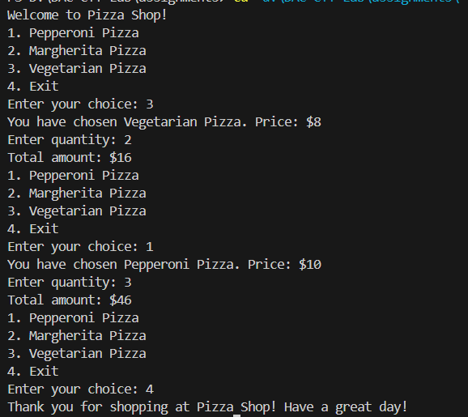

20:Accept a single digit from the user and display it in words. For example, if digit entered is 9, display Nine.

#include<iostream>

using namespace std;

int main()

{

    int ch;

        cout<<" \n Enter a number you want to see in word: "<<endl;

        cin>>ch;

        switch(ch)

        {

            case 1:

                cout<<"One";

            break;

            case 2:

                cout<<"Two";

            break;

            case 3:

            cout<<"Three";

            break;

            case 4:

            cout<<"Four";

            break;

            case 5:

            cout<<"Five";

            break;

            case 6:

            cout<<"Six";

            break;

            case 7:

            cout<<"Seven";

            break;

            case 8:

            cout<<"Eight";

            break;

            case 9:

            cout<<"Nine";

            break;

            case 10:

            cout<<"Ten";

            break;

            default:

            cout<<"Enter number till 10 !";

            break;

        }

}

Output:

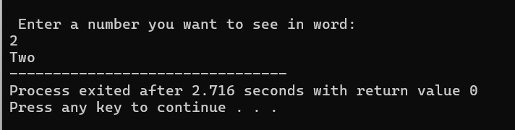

21. Write a program, which accepts two integers and an operator as a character (+ - * / ), performs the

corresponding operation and displays the result.

#include<iostream>

using namespace std;

int main()

{

    int a,b;

    char ch;

        cout<<" \n Enter two numbers: "<<endl;

        cin>>a>>b;

        cout<<"Enter the operator to operator : ";

        cin>>ch;

        switch(ch)

        {

            case '+':

                cout<<"Addition is : "<<a+b;

            break;

            case '-':

                cout<<"Subtraction is : "<<a-b;

            break;

            case '*':

            cout<<"Multiplication is :"<<a*b;

            break;

            case '/':

            cout<<"Division is : "<<a/b;

            break;

            default:

            cout<<"Enter correct operator !";

            break;

        }

}

Output :

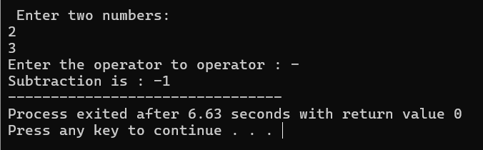

22:Write a program that accepts numbers continuously as long as the number is positive and prints the sum of the given numbers.

#include <iostream>

using namespace std;

int main() {

    int number;

    int sum = 0;

    cout << "Enter a number: ";

    cin >> number;

    while (number >= 0) {

        sum += number;

        cout << "Enter a number: ";

        cin >> number;

    }

    cout << "\nThe sum is " << sum << endl;

    return 0;

}

Output : 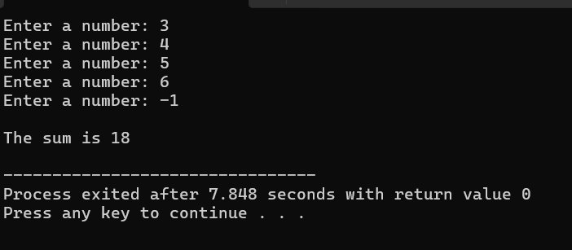

23. Write a program to accept two integers x and n and compute x raised to n.

#include <iostream>

using namespace std;

int main() {

    int number;

    int pow;

    cout << "Enter a number: ";

    cin >> number;

    int num = number;

    cout << "Enter a Power: ";

    cin >> pow;

    for(int i=1;i<pow;i++)

    {

        number = number * num;

    }

    cout<<"Result :"<<number;

}

Output :

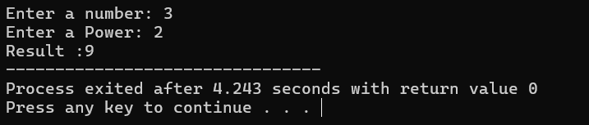

24. Write a program to accept a character, an integer n and display the next n characters.

#include <iostream>

using namespace std;

int main() {

    char character;

    int n;

    cout << "Enter a character: ";

    cin >> character;

    cout << "Enter the number of characters to display: ";

    cin >> n;

    cout << "The next " << n << " characters after '" << character << "' are: ";

    for (int i = 1; i <= n; ++i) {

        char nextChar = character + i;

        cout << nextChar << " ";

    }

    cout << endl;

    return 0;

}

Output :

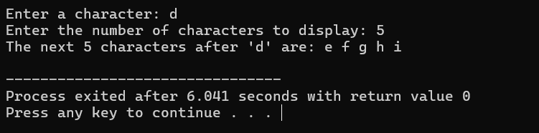

25. Write a program to calculate factorial of a number. For e.g. factorial of 5 = 5! = 5 *4*3*2*1 = 120.

#include <iostream>

using namespace std;

int factorial(int n) {

    if (n == 0)

        return 1;

    return n * factorial(n - 1);

}

int main() {

    int number;

    cout << "Enter a number to calculate its factorial: ";

    cin >> number;

    int result = factorial(number);

    cout << "Factorial of " << number << " = " << result << endl;

    return 0;

}

Output:

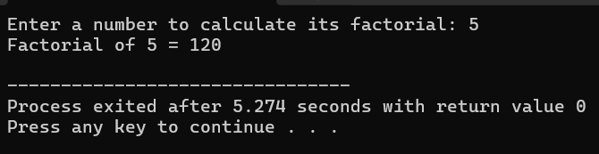

26. Accept two numbers and calculate GCD of them.

#include <iostream>

using namespace std;

int gcd(int a, int b) {

    while (b != 0) {

        int temp = b;

        b = a % b;

        a = temp;

    }

        return a;

}

int main() {

    int num1, num2;

    cout << "Enter first number: ";

    cin >> num1;

    cout << "Enter second number: ";

    cin >> num2;

    int result = gcd(num1, num2);

    cout << "GCD of " << num1 << " and " << num2 << " is " << result << endl;

    return 0;

}

Output:

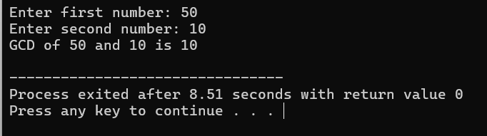

28. Write a menu driven program to do following operations :

a) Compute area of circle

b) Compute area of rectangle

c) Compute area of triangle

d) Exit

Display menu, ask choice to the user, depending on choice accept the parameters and perform the operation. Continue this process until user selects exit option.

#include<iostream>

using namespace std;

int main()

{

    int ch;

    float r, pi = 3.14,a;

    cout<<"Enter your choice: \n 1. Area of circle \n 2. Circumferance of a circle : \n 3. volume of Sphere \n";

    cin>>ch;

    cout<<"Enter the Redius of a circle : ";

    cin>>r;

    switch (ch)

    {

        case 1:

        a=pi*r*r;

        cout<<"Area of circle is :"<<a;

        break;

        case 2:

        a=2*pi*r;

        cout<<"Circumferance of Circle is :"<<a;

        break;

        case 3:

        a=4/3*pi*r*r*r;

        cout<<"Volume of Sphere is :"<<a;

        break;

        default:

        cout<<"Enter valid Choice !!!";

    }

}

Output :

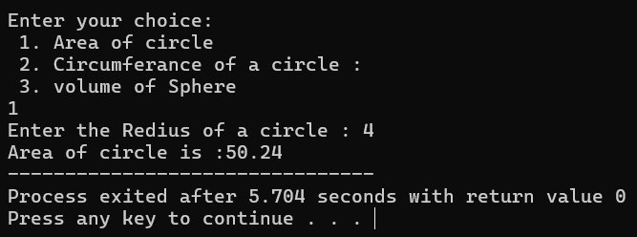

29. Write a program to print all prime numbers between 1 to n

#include <iostream>

using namespace std;

bool isPrime(int num) {

    if (num <= 1)

        return false;

    for (int i = 2; i * i <= num; ++i) {

        if (num % i == 0)

            return false;

    }

    return true;

}

void printPrimes(int n) {

    cout << "Prime numbers between 1 and " << n << " are:\n";

    for (int i = 2; i <= n; ++i) {

        if (isPrime(i))

            cout << i << " ";

    }

    cout << endl;

}

int main() {

    int limit;

    cout << "Enter the limit (n): ";

    cin >> limit;

    printPrimes(limit);

    return 0;

}

Output:

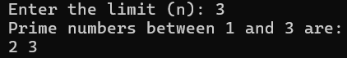

30:Write a program to create an array of integers and perform following operations on that array like

finding the sum, average, maximum and minimum number in that array. Accept the numbers of the

array from user.

#include &lt;iostream&gt;

using namespace std;

int main() {

    int n;

    cout &lt;&lt; &quot;Enter the number of elements in the array: &quot;;

    cin &gt;&gt; n;

    int arr[n];

    cout &lt;&lt; &quot;Enter the elements of the array: &quot;;

    for (int i = 0; i &lt; n; i++) {

        cin &gt;&gt; arr[i];

    }

    int sum = 0;

    for (int i = 0; i &lt; n; i++) {

        sum += arr[i];

    }

    double average = static_cast&lt;double&gt;(sum) / n;

    int max = arr[0];

    int min = arr[0];

    for (int i = 1; i &lt; n; i++) {

        if (arr[i] &gt; max) {

            max = arr[i];

        }

        if (arr[i] &lt; min) {

            min = arr[i];

        }

    }

    cout &lt;&lt; endl &lt;&lt; &quot;Sum: &quot; &lt;&lt; sum;

    cout &lt;&lt; endl &lt;&lt; &quot;Average: &quot; &lt;&lt; average;

    cout &lt;&lt; endl &lt;&lt; &quot;Maximum: &quot; &lt;&lt; max;

    cout &lt;&lt; endl &lt;&lt; &quot;Minimum: &quot; &lt;&lt; min;

    return 0;

}

Output:

