**SQL Exercise 3**

1. Display all the Supplier names with the initial letter capital.

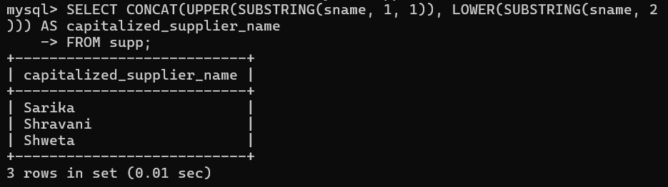

1. Display all the Supplier names in upper case.

select upper(sname) from supplier;

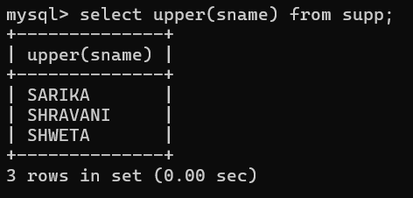

1. Display all the Supplier names in lower case.

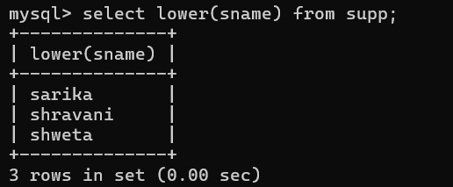

1. Display all the Supplier names padded to 25 characters, with spaces on the left.

select lpad(sname,25,' ') from supplier;

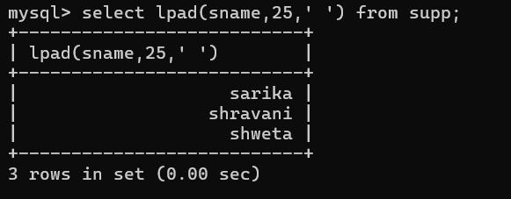

1. Display all the Supplier names (with ‘la’ replaced by ‘ro’).

HINT: REPLACE.

select sname,replace(sname,'ra','ro') ra_ro from supplier;

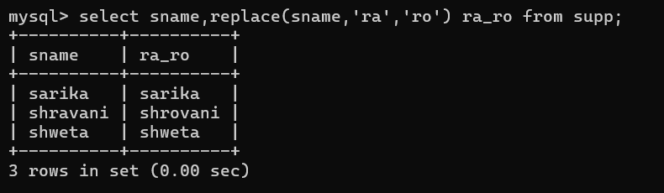

1. Execute the above command with the translate function and note the difference in output.

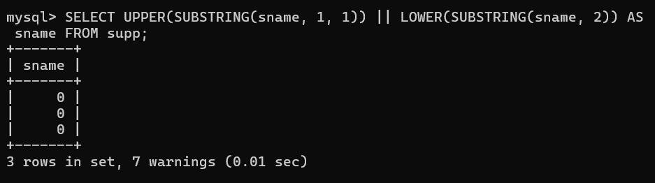

1. Display the Supplier names and the lengths of the names.

select sname, length(sname) from supplier;

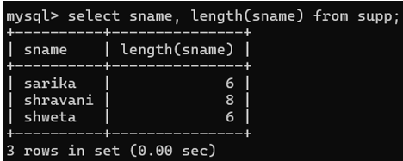

1. Use the soundex function to search for a supplier by the name of ‘BLOKE’.

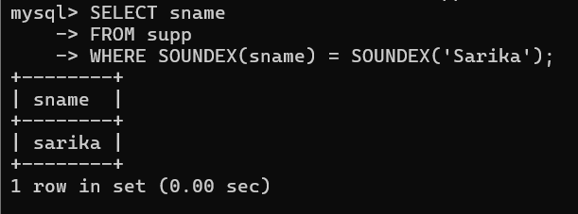

1. Display the Supplier name and the status (as Ten, Twenty, Thirty, etc.).

select sname, status from supplier;

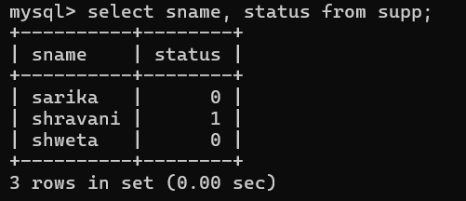

1. Display the current day (e.g. Thursday).

select dayname(curdate()) day;

