**SQL Exercise 6**

1. Display all the Suppliers with the same Status as the supplier, ‘CLARK’.

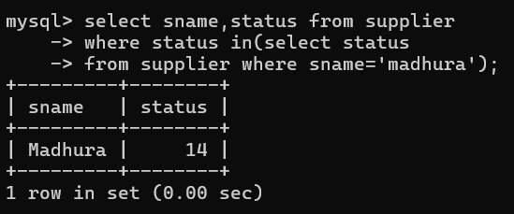

1. Display all the Employees in the same department as the employee ‘MILLER’.

select * from emp where deptno in(select deptno from dept where ename

='miller');

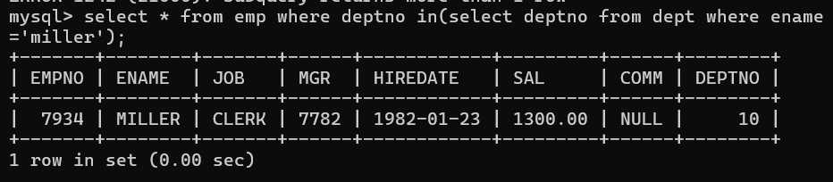

1. Display all the Parts which have more Weight than all the Red parts.

select * from parts p where p.weight>(select weight from parts m

where m.color='red');

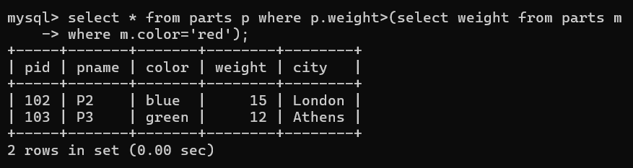

1. Display all the Projects going on in the same city as the project ‘TAPE’.

select jname from projects where city=(select city from projects wher

e jname='tape');

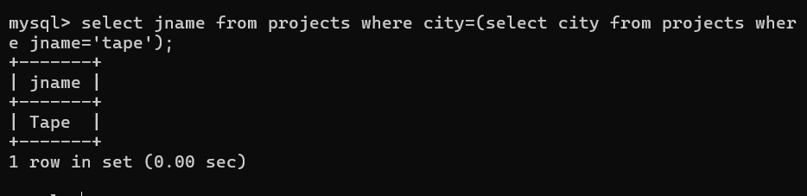

1. Display all the Parts with Weight less than all the Green parts.

select pid,pname,color from parts where weight <(select weight from p

arts where color='green');

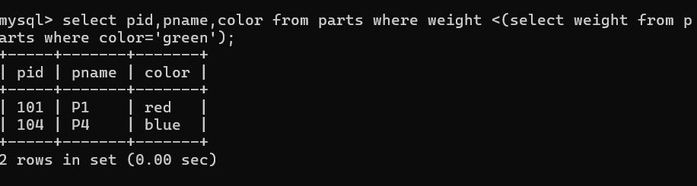

1. Display the name of the Supplier who has sold the maximum Quantity (in one sale).

select sname from supplier where sid =(select sid from spj where qty =(select max(qty) from spj));

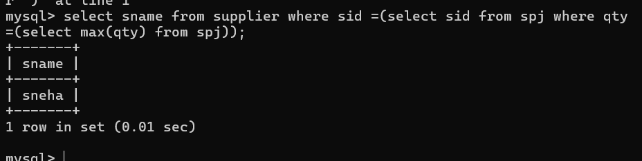

1. Display the name of the Employee with the minimum Salary.

select ename,min(sal) from emp having min(sal);

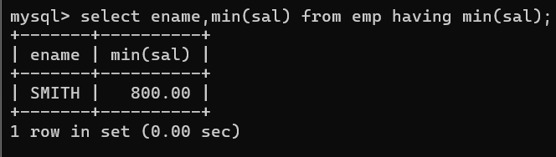

1. Display the name of the Supplier who has sold the maximum overall Quantity (sum of Sales).

select sname from supplier where sid = (select sid from spj where qty

=(select max(qty) from spj));

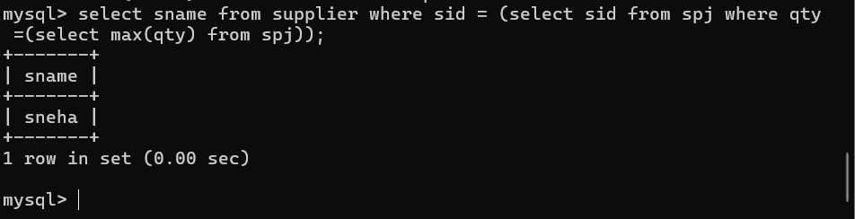

1. Display the name of the Department with the maximum number of Employees.

select d.deptno,d.dname,count(*) from dept d,emp e where d.deptno=e.deptno group by deptno order by deptno desc limit 1;

