RA Output
Pre – requisites -
1. Install Python.
2. Install VS Code.
3. Clone the git – repo
AakanshaMittal/CsvCompare
4. Install libraries:
WINDOWS - pip install pandas openpyxl
MAC – pip3 install pandas openpyxl

a. Transforming the RPT File
- Column M (Exclusion Code) to Last column. Home -> Number -> General.
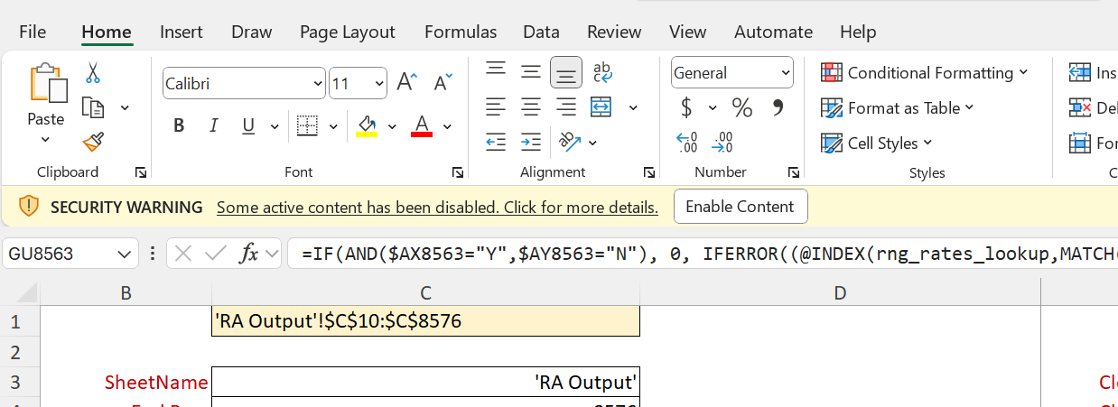

- Select All and copy it.
- Goto File -> Blank book -> Paste there.
- Save this book as .csv file in the same folder in which code is present.
- After saving, close this book, and reopen the .csv version which you just save it. (Please close the book in which you copied the content otherwise the .csv version will not open).
- Delete the first extra column and then save it again and close it.

b. Transforming the UI Exported File -
1. Open the excel file which you downloaded from the UI, again select the whole column from Exclusion Code (L) to the last, and select the Generic from Home -> Number.
2. Then Goto file -> Save as -> Choose or browse the location (Preferrable the same where your code is), choose .csv version and then save it.

c. Run the python script named as – DataValidationRAOutput.py
