WEEK 4
Predictive Modeling and Optimization in Logistics Systems
Dataset: Delivery_Logistics(2).csv
Primary modeling file: Delivery_Logistics_Cleaned.csv
Tools: Python • Pandas • NumPy • Scikit-learn • Matplotlib

Executive Summary
This Week 4 project extends the Week 2 cleaning and Week 3 analytics work into predictive modeling and logistics optimization. The cleaned dataset contains 25,000 delivery records and 15 source columns. The target is delivery_time_hours. To prevent target leakage, post-outcome fields such as delayed, delivery_status, delivery_rating, and delivery_cost were excluded from the predictive feature set. The model uses operational information that can reasonably be available before or during delivery planning.
Five predictive approaches were compared: a mean baseline, Linear Regression, Decision Tree, Random Forest, and Gradient Boosting. Linear Regression produced the strongest overall holdout performance with MAE 1.283 hours, RMSE 1.622 hours, and R² 0.728. Its 3-fold cross-validation MAE was 1.284 hours, indicating good stability. A tuned Gradient Boosting model was retained as the strongest tree-based interpretation model; its holdout MAE was 1.285 hours and R² 0.727.
On the 5,000-row test set, the final model flagged 1,364 deliveries (27.28%) as potentially risky because predicted delivery time exceeded expected delivery time. This is a model-based risk indicator, not an observed delay label. Weather and distance were the dominant features in the tree-based interpretation, supporting practical recommendations around weather buffers, distance-aware planning, risk-based monitoring, and resource allocation.

1. Introduction
Predictive analytics allows logistics organizations to estimate delivery outcomes before a shipment is completed. Accurate delivery-time prediction can support scheduling, customer estimates, vehicle allocation, partner management, contingency planning, and operational monitoring. Week 4 therefore moves from descriptive analysis toward a predictive decision-support workflow.
The work remains consistent with the earlier internship stages: Week 2 established a validated cleaned dataset, while Week 3 analyzed delivery performance, costs, operating conditions, and bottlenecks. The Week 3 report also used the cleaned Week 2 dataset and retained separate measures for the source delay flag and time-based on-time performance.

2. Problem Definition
Logistics companies need to estimate actual delivery time in advance so that potentially slow shipments can be identified, delivery schedules can be improved, vehicles and partners can be allocated more effectively, customer estimates can be improved, delays can be reduced, and operating efficiency can be strengthened.
Machine-learning problem: Predict the actual delivery time of a shipment using information available before or during the delivery-planning process.

3. Business Objective
- Predict delivery_time_hours for unseen deliveries.
- Compare multiple regression models using MAE, RMSE, and R².
- Use cross-validation to assess stability.
- Use model outputs to identify potential delivery-time risk.
- Translate model findings into practical logistics recommendations.
- Evaluate analytical scenarios without claiming real-world route optimization.

4. Dataset Description
The primary modeling dataset is the cleaned Week 2 file Delivery_Logistics_Cleaned.csv. It contains 25,000 rows and 15 source columns. Week 2 validation found zero missing cells and zero exact duplicate rows. The cleaned workflow also repaired corrupted delivery IDs and decoded timestamp-like time values into numerical hours.
Dataset characteristic | Observed value
Rows | 25,000
Columns | 15
Missing cells | 0
Exact duplicate rows | 0
Actual delivery time | 0–19 hours
Expected delivery time | 2–24 hours
Important source variables and their operational roles:
- delivery_partner: delivery-service provider handling the shipment.
- package_type: type/category of package being transported.
- vehicle_type: vehicle used for delivery.
- delivery_mode: service mode such as standard, express, same day, or two day.
- region: broad operating region.
- weather_condition: weather context associated with the delivery.
- distance_km: delivery distance.
- package_weight_kg: package weight.
- expected_time_hours: expected/planned delivery time.
- delivery_time_hours: actual delivery duration and prediction target.
- delivery_cost: recorded delivery cost; useful for analysis but excluded from prediction because availability timing is uncertain.
- delivery_rating: customer/recorded outcome rating; treated as post-outcome.
- delayed: source delay label; treated as outcome-related.
- delivery_status: delivery outcome/status; treated as post-outcome.

5. Target Variable
The target variable is delivery_time_hours. It is suitable because it is the direct operational quantity that the business wants to estimate before the shipment is completed.
Statistic | Value
Mean | 6.25 h
Median | 6.00 h
Minimum | 0 h
Maximum | 19 h
Standard deviation | 3.14 h
Q1 | 4 h
Q3 | 8 h
IQR | 4 h
IQR outliers | 203 observations above 14 h
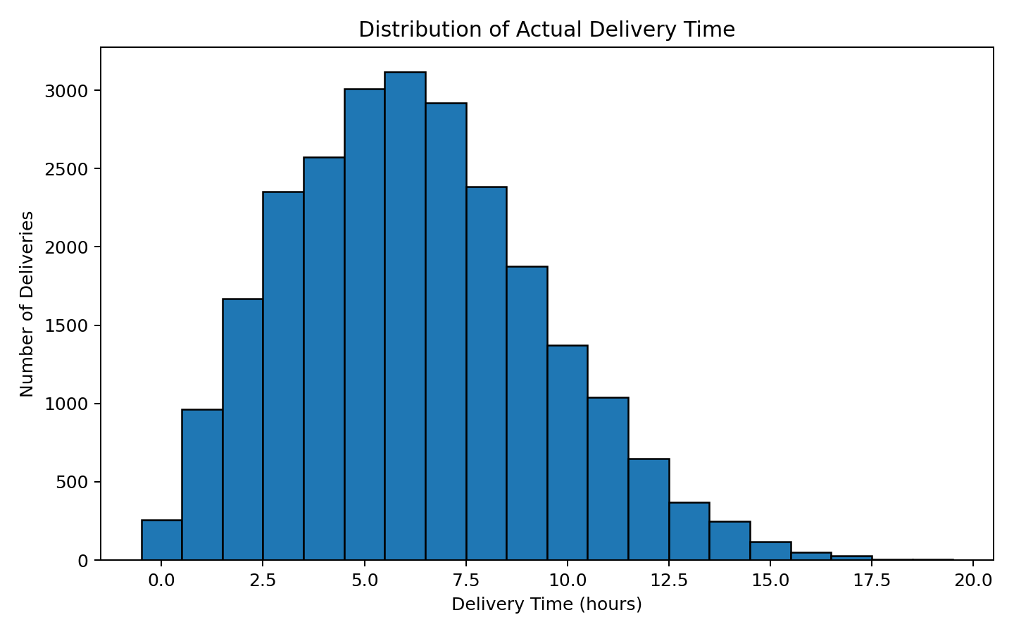
Figure 1. Distribution of actual delivery time.

6. Feature Selection
Variable | Decision | Reason
delivery_partner | Suitable | Known from assignment/work allocation before delivery.
package_type | Suitable | Known from shipment information.
vehicle_type | Suitable | Planned/assigned operational resource.
delivery_mode | Suitable | Service level selected for the shipment.
region | Suitable | Operational geography is known.
weather_condition | Suitable / operationally conditional | Can be known or estimated at planning time, depending on workflow.
distance_km | Suitable | Known from shipment/route planning.
package_weight_kg | Suitable | Known from shipment information.
expected_time_hours | Suitable | Planning-time expectation and useful predictor.
distance_expected_ratio | Engineered | Distance divided by expected time; created without using actual delivery outcome.
delayed | Excluded | Outcome-related and can be derived from actual performance.
delivery_status | Excluded | Post-delivery outcome/status.
delivery_rating | Excluded | Post-delivery/customer outcome.
delivery_cost | Excluded from prediction | Timing/availability is uncertain and may reflect completed delivery conditions.
delivery_id | Excluded | Identifier rather than an operational predictor.

7. Data Leakage Prevention
Leakage prevention is critical because a prediction made before delivery cannot legitimately use information that becomes known only after the delivery outcome. The source delayed flag is especially important: Week 3 identified 1,203 records where the source delayed flag and the simple time-based comparison do not agree. Therefore, the source flag is retained for descriptive analysis but not used to predict actual delivery time.
The model also excludes delivery_status and delivery_rating. Delivery_cost is excluded from the predictive pipeline because the dataset does not establish that the recorded cost is available before delivery or independent of delivery execution. It remains available for cost-time analysis.

8. Data Preprocessing
- Loaded the cleaned Week 2 dataset without overwriting the original.
- Validated shape, columns, data types, missing values, and duplicate rows.
- Separated target delivery_time_hours from predictors.
- Created distance_expected_ratio = distance_km / expected_time_hours.
- Used median imputation for numerical fields and most-frequent imputation for categorical fields inside the ML pipeline.
- One-hot encoded categorical variables.
- Scaled numerical variables for Linear Regression.
- Performed the train-test split after feature/target definition.
- Kept preprocessing inside scikit-learn pipelines so transformations are learned from training data.

9. Train-Test Split
An 80/20 split with random_state=42 was used, producing 20,000 training records and 5,000 test records. The dataset contains no explicit timestamp/date field, so a time-based split could not be justified from the available columns. The test set remained unseen during model fitting and model selection.

10. Model Selection
- Baseline: predicts the mean delivery time and provides a reference point.
- Linear Regression: interpretable, fast, and useful for establishing a strong additive baseline.
- Decision Tree Regressor: captures nonlinear relationships and rule-based interactions.
- Random Forest Regressor: averages many trees and can model nonlinear patterns more robustly.
- Gradient Boosting Regressor: sequentially improves errors and is useful for nonlinear operational relationships.

11. Model Training and Evaluation
MAE measures the average absolute prediction error in hours. RMSE gives larger errors more weight, which is useful when unusually large delivery-time misses matter. R² measures the proportion of target variation explained by the model. Lower MAE/RMSE are better; higher R² is better.
Model | MAE (h) | RMSE (h) | R² | CV MAE (h)
Baseline | 2.5136 | 3.1124 | -0.0000 | 2.5400
Linear Regression | 1.2831 | 1.6224 | 0.7283 | 1.2843
Decision Tree | 1.3956 | 1.7791 | 0.6732 | 1.4364
Random Forest | 1.3159 | 1.6648 | 0.7139 | 1.3240
Gradient Boosting | 1.2852 | 1.6258 | 0.7271 | 1.2935
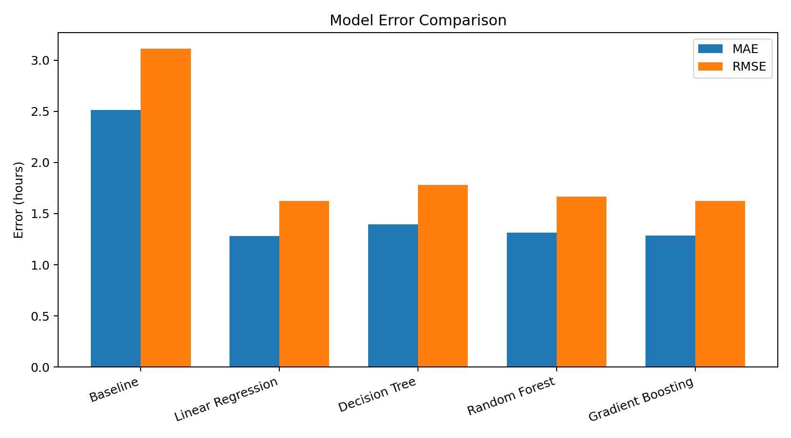
Figure 2. Holdout MAE and RMSE comparison.
Linear Regression is the best overall model in this experiment: it has the lowest holdout MAE and RMSE and the highest R² among the compared models. Its cross-validation MAE (1.2843 h) is almost identical to its holdout MAE (1.2831 h), supporting stability.

12. Cross-Validation
Three-fold shuffled K-Fold cross-validation was applied to the training set. The reported CV metric is mean absolute error. Cross-validation reduces dependence on a single train-test split and helps assess whether model performance is stable across different training/validation partitions.
Model | 3-fold CV MAE
Baseline | 2.5400 h
Linear Regression | 1.2843 h
Decision Tree | 1.4364 h
Random Forest | 1.3240 h
Gradient Boosting | 1.2935 h

13. Hyperparameter Tuning
Gradient Boosting was selected as the strongest tree-based candidate based on cross-validation and its close holdout performance. A small GridSearchCV was run on a reproducible 5,000-row training subset to avoid excessive tuning. The selected settings were then refit on the complete training set.
Parameter / result | Value
n_estimators | 120
learning_rate | 0.08
max_depth | 2
min_samples_leaf | 5
Tuned holdout MAE | 1.2852 h
Tuned holdout RMSE | 1.6258 h
Tuned holdout R² | 0.7271
The tuned tree model did not outperform Linear Regression on the final holdout metrics. Therefore, it is used as a supporting interpretation model rather than replacing the simpler final model.

14. Final Model
Final model: Linear Regression. It was selected because it delivered the best combination of MAE, RMSE, R², cross-validation stability, and interpretability. The decision is not based on R² alone. The model also has lower computational and communication complexity than the tree ensembles.
Metric | Result
Final model | Linear Regression
Holdout MAE | 1.2831 h
Holdout RMSE | 1.6224 h
Holdout R² | 0.7283
3-fold CV MAE | 1.2843 h

15. Feature Importance
Because the final model is Linear Regression, ordinary tree impurity importance is not applicable to it. To satisfy the operational interpretation requirement, feature importance was therefore calculated from the tuned Gradient Boosting model. One-hot encoded category-level importances were aggregated back to the original business variables. These values indicate predictive contribution within the model; they do not prove causation.
Original feature | Aggregated importance
distance_km | 63.9294%
weather_condition | 35.9751%
distance_expected_ratio | 0.0698%
package_type | 0.0099%
vehicle_type | 0.0071%
package_weight_kg | 0.0055%
delivery_partner | 0.0032%
delivery_mode | 0.0000%
expected_time_hours | 0.0000%
region | 0.0000%
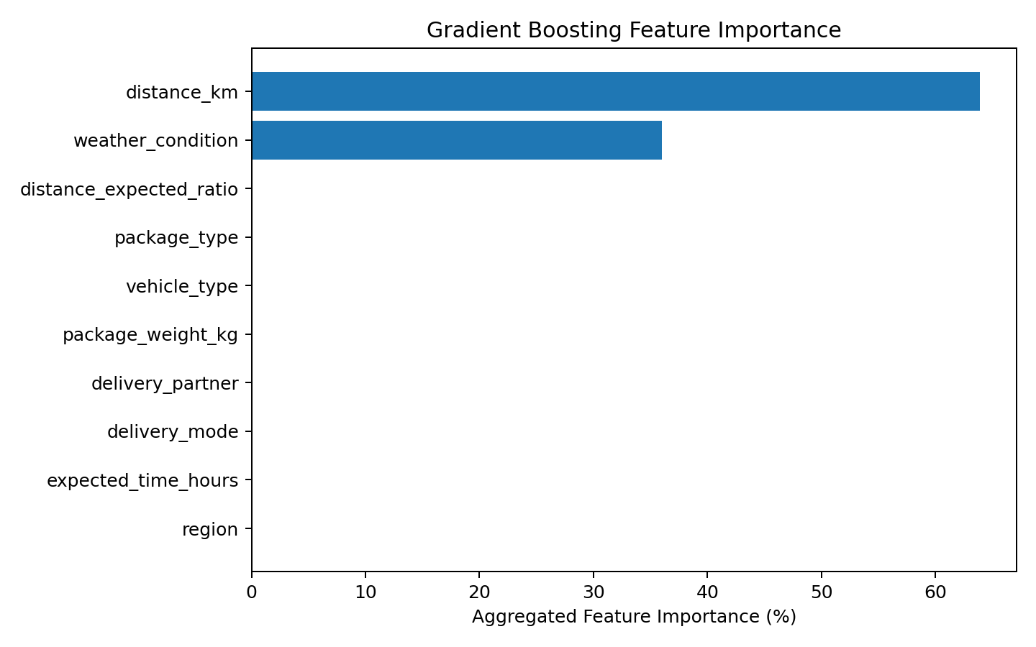
Figure 3. Aggregated feature importance from tuned Gradient Boosting.

16. Actual vs Predicted Analysis
The final Linear Regression model was applied to the unseen 5,000-row test set. The scatter plot below compares actual and predicted delivery time. Points closer to the diagonal represent smaller prediction errors.
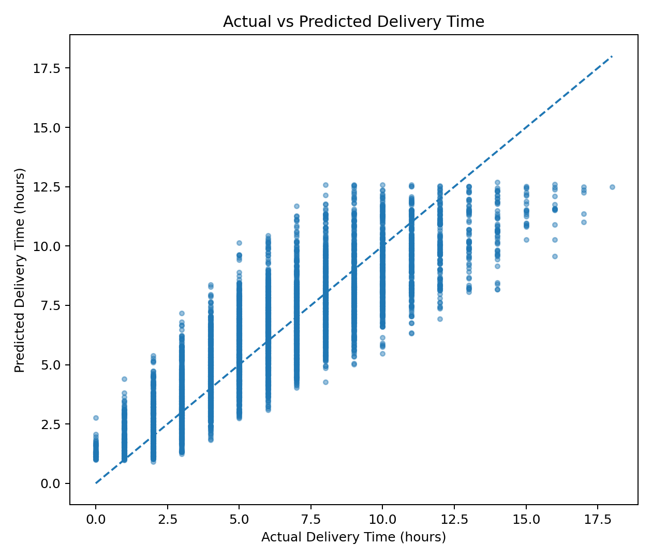
Figure 4. Actual versus predicted delivery time.

17. Residual Analysis
Residual = Actual - Predicted. The mean residual was 0.036 hours and the residual standard deviation was 1.622 hours. The observed residual range was approximately -5.14 to 6.43 hours. The near-zero mean indicates little overall directional bias.
Residual measure | Result
Mean residual | 0.036 h
Residual standard deviation | 1.622 h
Minimum residual | -5.135 h
Maximum residual | 6.425 h
90th percentile absolute error | 2.678 h
95th percentile absolute error | 3.198 h
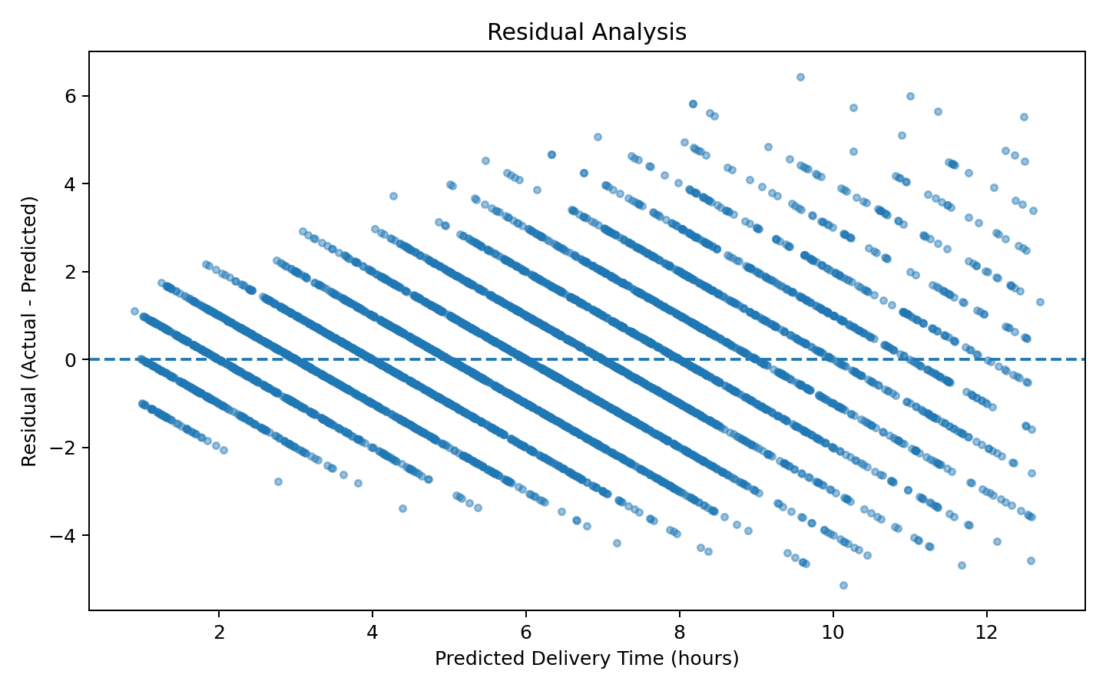
Figure 5. Residuals versus predicted delivery time.
Absolute errors increase for higher predicted delivery times, but the residual means remain close to zero across prediction ranges. This suggests the model is not strongly biased toward systematic overprediction or underprediction, although high-time cases remain harder to predict.

18. Potential Delay Risk
A model-based potential-delay indicator was created as: predicted delivery time > expected delivery time. This must not be confused with the dataset's observed delayed flag. On the 5,000-row holdout set, 1,364 deliveries were flagged, equal to 27.28%.
Risk metric | Value
Test deliveries | 5,000
Potentially risky deliveries | 1,364
Potential delay rate | 27.28%
Average model MAE | 1.283 h
Suggested average planning buffer reference | 1.283 h
90th percentile absolute error reference | 2.678 h
The error-based buffer figures are references derived from actual model errors, not guaranteed service-level buffers. A 1.283-hour average error describes typical model error, while a 2.678-hour 90th-percentile absolute error is a more conservative planning reference. Operational policy should validate any buffer before deployment.

19. Risk by Region, Partner, Vehicle, and Weather

Region
Region | N | Avg predicted h | Avg expected h | Risk %
west | 1095 | 6.26 | 12.62 | 31.32%
north | 980 | 6.28 | 13.10 | 28.37%
central | 985 | 6.38 | 13.10 | 26.50%
south | 962 | 6.10 | 13.21 | 25.57%
east | 978 | 6.02 | 13.24 | 24.13%

Delivery Partner
Delivery Partner | N | Avg predicted h | Avg expected h | Risk %
blue dart | 599 | 6.16 | 12.48 | 29.72%
ecom express | 558 | 6.27 | 13.08 | 28.49%
amazon logistics | 535 | 6.36 | 12.96 | 28.22%
shadowfax | 548 | 6.31 | 13.06 | 28.10%
ekart | 537 | 6.11 | 12.75 | 27.93%
dhl | 584 | 6.33 | 13.33 | 27.91%
xpressbees | 555 | 6.18 | 13.10 | 25.77%
fedex | 529 | 6.26 | 13.19 | 25.71%
delhivery | 555 | 5.92 | 13.46 | 23.42%

Vehicle Type
Vehicle Type | N | Avg predicted h | Avg expected h | Risk %
scooter | 875 | 6.36 | 12.91 | 29.26%
bike | 848 | 6.23 | 12.98 | 29.13%
ev bike | 826 | 6.10 | 12.66 | 27.60%
ev van | 818 | 6.28 | 12.95 | 26.28%
van | 832 | 6.06 | 13.28 | 25.96%
truck | 801 | 6.23 | 13.51 | 25.22%

Weather Condition
Weather Condition | N | Avg predicted h | Avg expected h | Risk %
rainy | 816 | 7.81 | 12.61 | 40.93%
stormy | 839 | 8.78 | 13.36 | 38.50%
foggy | 872 | 6.43 | 13.40 | 28.90%
clear | 817 | 4.82 | 12.67 | 21.54%
hot | 817 | 4.66 | 12.88 | 18.36%
cold | 839 | 4.73 | 13.30 | 15.38%
Weather shows the clearest segmentation in this test set: stormy deliveries have the highest average predicted time (8.78 h) and 38.50% potential-delay risk, while rainy deliveries have 7.81 h predicted time and 40.93% potential-delay risk. Clear, hot, and cold conditions show lower model-based risk. These are predictive associations and should not be interpreted as causal effects without further controlled analysis.
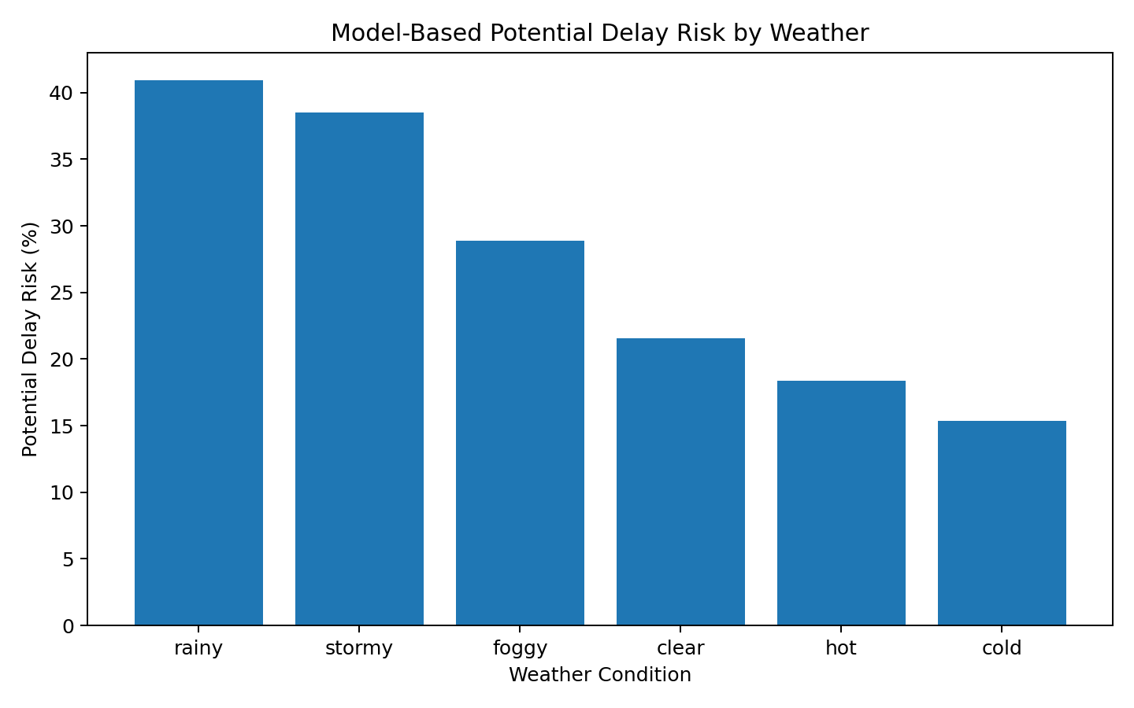
Figure 6. Model-based potential-delay risk by weather condition.

20. Logistics Optimization Strategies
- Vehicle allocation: use model-based risk scores to prioritize higher-risk shipments for suitable vehicle capacity or faster operational resources, while checking sample sizes and vehicle availability.
- Delivery partner allocation: monitor partner-specific risk rates rather than using a single overall ranking. Allocation decisions should consider workload, capacity, geography, and sample size.
- Regional resources: the West test segment has the highest potential-delay rate (31.32%); it can be prioritized for operational review, not automatically treated as causally worse.
- Weather contingency: stormy and rainy conditions show materially higher predicted risk, supporting extra monitoring, contingency capacity, and planning buffers when such conditions are known.
- Delivery-time buffers: use empirical model error as a reference. The 90th-percentile absolute error is 2.68 hours, but any customer-facing buffer should be validated operationally.
- Cost-time tradeoff: delivery cost has a strong descriptive relationship with delivery time in this dataset (correlation approximately 0.679), but cost was excluded from the predictive model because its pre-delivery availability is not established.
- Route optimization limitation: the model does not perform route optimization. No GPS, road-network, traffic, or route-sequence information is available in the modeling data.

21. Optimization Scenario Analysis
The following are analytical segments/simulations, not implemented operational strategies. They show how the model could support prioritization.
Scenario | N | Avg predicted h | Avg expected h | Potential delay % | Avg cost
A - Current analytical baseline | 5000 | 6.21 | 13.04 | 27.28% | 860.80
B - Risk-based priority segment | 1364 | 7.63 | 5.59 | 100.00% | 1063.52
C - Cost-conscious Q1 segment | 1250 | 3.46 | 13.02 | 13.12% | 300.40
Scenario B isolates the 1,364 model-flagged risky deliveries. Their average predicted time is 7.63 hours versus 6.21 hours for the overall test set. Scenario C isolates the lowest-cost quartile; its average cost is ₹300.40 and potential-delay rate is 13.12%. These comparisons illustrate tradeoffs for prioritization, not proof that moving shipments between scenarios would cause the measured outcomes.

22. Business Insights

1. Distance is the dominant predictive factor
Finding: distance_km contributes 63.93% of aggregated tuned-GB importance.
Evidence: distance has correlation 0.686 with actual delivery time and dominates tree-based importance.
Business Meaning: longer shipment distance is strongly associated with longer delivery time in this dataset.
Recommendation: use distance-aware planning and prioritize long-distance shipments for early monitoring.

2. Weather materially separates risk levels
Finding: stormy and rainy cases have the highest predicted-time/risk levels.
Evidence: stormy average predicted time 8.78 h; rainy 7.81 h; risk 38.50% and 40.93% respectively.
Business Meaning: adverse weather is an important predictive operating condition.
Recommendation: add weather-triggered contingency planning and monitoring.

3. The final model is operationally stable
Finding: holdout MAE and CV MAE are nearly identical.
Evidence: 1.2831 h holdout MAE versus 1.2843 h CV MAE.
Business Meaning: performance is not dependent on one random split.
Recommendation: retain the model as a baseline decision-support model and validate periodically.

4. Potential delay risk is concentrated enough to support triage
Finding: 27.28% of test deliveries are model-flagged.
Evidence: 1,364 of 5,000 holdout records have predicted time above expected time.
Business Meaning: a risk queue can reduce monitoring effort compared with treating every shipment identically.
Recommendation: prioritize the flagged group for review rather than treating the prediction as a guaranteed delay.

5. West has the highest regional model-based risk
Finding: West has 31.32% potential-delay risk.
Evidence: 1,095 test deliveries in West, with average predicted time 6.26 h.
Business Meaning: West is a useful candidate for operational review.
Recommendation: investigate local route, weather, partner mix, and capacity conditions before changing resources.

6. Vehicle categories show different risk profiles
Finding: scooter has 29.26% risk while truck has 25.22%.
Evidence: the test-set group rates differ, while average predicted times remain relatively close.
Business Meaning: vehicle choice may be useful for segmentation, but the observed differences are not proof of causation.
Recommendation: test vehicle allocation with controlled operational experiments or richer route data.

7. Partner differences are relatively modest
Finding: partner risk ranges from 23.42% for Delhivery to 29.72% for Blue Dart in the test sample.
Evidence: all partner groups have roughly 529–599 test records.
Business Meaning: partner performance should be monitored, but small percentage differences should not drive automatic reallocation.
Recommendation: combine risk rate with workload, service level, capacity, and cost before decisions.

8. Cost and time have a strong descriptive relationship
Finding: delivery cost correlates 0.679 with actual delivery time.
Evidence: cost is strongly associated with time in the historical dataset.
Business Meaning: speed and cost may be linked operationally, creating a tradeoff worth investigating.
Recommendation: evaluate cost-per-time or service-level economics rather than optimizing cost alone.

23. Practical Recommendations
- Deploy the Linear Regression model first as a transparent baseline decision-support tool.
- Create a daily/operational risk queue using predicted time > expected time.
- Use weather-aware monitoring because rainy and stormy conditions show higher model-based risk.
- Prioritize long-distance shipments for early exception management.
- Use model error statistics to inform, but not automatically dictate, delivery-time buffers.
- Review West-region performance using route, partner, and weather details before increasing capacity.
- Avoid using post-delivery fields such as delayed, rating, and status in the prediction pipeline.
- Periodically retrain and recalibrate the model as logistics behavior changes.
- Collect traffic, GPS, route, timestamp, depot, and capacity features in future versions to support more advanced optimization.
- Treat optimization scenarios as analytical recommendations until validated in live operations.

24. Challenges and Limitations
- The dataset is historical and may not represent future operating conditions.
- No real-time traffic information is available.
- No GPS coordinates or road-network information is available.
- Weather is represented categorically rather than with detailed forecasts or severity measurements.
- The dataset does not provide explicit timestamps for a defensible temporal split.
- Delivery cost may reflect information unavailable before delivery, so it was excluded from predictive modeling.
- The source delayed flag is not identical to a simple actual-time-versus-expected-time rule.
- Feature importance is predictive/model-specific and does not establish causation.
- Scenario analysis is not a live optimization engine and does not measure actual operational improvements.

25. Reflection
This project demonstrates the transition from descriptive logistics analytics to predictive decision support. The most important learning is that model quality depends not only on algorithm choice but also on target definition, leakage prevention, preprocessing design, validation, and operational interpretation. The comparison showed that a simple Linear Regression model can outperform more complex ensembles on the selected metrics. At the same time, the tree-based model helped explain which operational variables were most useful for prediction. The project also demonstrated that a prediction should be converted into a risk indicator carefully rather than being treated as a guaranteed outcome.

26. Conclusion
The Week 4 predictive modeling project successfully used the actual cleaned logistics dataset to predict delivery time without target leakage. Five approaches were compared using MAE, RMSE, R², and cross-validation. Linear Regression was selected as the final model with MAE 1.283 hours, RMSE 1.622 hours, and R² 0.728. The model was stable under 3-fold validation. A tuned Gradient Boosting model provided complementary feature interpretation, highlighting distance and weather as dominant predictive factors. The test-set risk analysis identified 27.28% of deliveries as potentially risky under the model-based definition. These findings support risk-based monitoring, distance-aware planning, weather contingency measures, and evidence-based resource allocation while recognizing the limits of historical data and the absence of route/GPS/traffic information.

27. Internship Submission Description (200–300 words)
This Week 4 internship project focused on predictive modeling and logistics optimization using the cleaned Delivery Logistics dataset. Python, Pandas, NumPy, and Scikit-learn were used to prepare the data, define delivery_time_hours as the prediction target, engineer a distance-to-expected-time ratio, and build a leakage-safe machine-learning pipeline. Post-delivery or outcome-related variables such as delayed, delivery_status, delivery_rating, and delivery_cost were excluded from the predictive feature set where their timing could introduce leakage. Multiple regression approaches were compared, including a mean baseline, Linear Regression, Decision Tree, Random Forest, and Gradient Boosting. Model performance was evaluated using Mean Absolute Error (MAE), Root Mean Squared Error (RMSE), and R², with three-fold cross-validation used to assess model stability. Linear Regression provided the strongest overall holdout performance, with MAE of 1.283 hours, RMSE of 1.622 hours, and R² of 0.728. A tuned Gradient Boosting model was additionally used for tree-based feature interpretation. Distance and weather condition were the dominant predictive variables in that analysis. Predictions on the unseen test set were used to identify potential delay risk by comparing predicted delivery time with expected delivery time. The model flagged 1,364 of 5,000 test deliveries as potentially risky, representing 27.28%; this is a model-based indicator rather than an observed delay label. The project translated these findings into logistics optimization recommendations covering vehicle allocation, partner monitoring, regional resource planning, weather contingency measures, delivery buffers, cost-time tradeoffs, and risk-based operational prioritization. Overall, the work demonstrates how machine learning can support data-driven logistics decision-making while maintaining clear limitations around causality, real-time routing, and historical-data dependence.

28. Final Verification
- Actual cleaned Week 2 dataset used: verified.
- 25,000 rows and 15 source columns: verified.
- No missing cells and no exact duplicate rows in modeling input: verified.
- Target delivery_time_hours verified as numeric and suitable: verified.
- Leakage-prone outcome fields excluded: verified.
- 80/20 train-test split with random_state=42: verified.
- Baseline plus four ML regressors compared: verified.
- MAE, RMSE, and R² calculated on unseen test data: verified.
- 3-fold cross-validation performed: verified.
- Reasonable Gradient Boosting tuning performed on a reproducible subset and refit on full training data: verified.
- Final model selected using performance, stability, interpretability, and practical usefulness: verified.
- Actual-versus-predicted and residual analyses generated: verified.
- Potential-delay risk clearly distinguished from observed delay: verified.
- Optimization recommendations labeled as analytical recommendations/simulations: verified.
- Original cleaned dataset was not overwritten: verified.
- All reported numerical results are based on actual execution of the dataset/model pipeline: verified.

Appendix A — Main Output Files
- week4_ml_logistics.py — complete executable Python implementation.
- model_comparison.csv — model metrics and cross-validation results.
- test_predictions_and_risk.csv — unseen test-set predictions and model-based risk flag.
- feature_importance.csv — aggregated Gradient Boosting feature importance.
- optimization_scenarios.csv — analytical scenario comparison.
- region_risk_analysis.csv, delivery_partner_risk_analysis.csv, vehicle_type_risk_analysis.csv, weather_condition_risk_analysis.csv — segment risk tables.
- PNG files — target distribution, model comparison, feature importance, actual-vs-predicted, residuals, and weather risk.

