WEEK 3
Advanced Data Analysis and Visualization in Logistics
Dataset: Delivery_Logistics(2).csv
Source: Week 2 cleaned logistics dataset
Python • Pandas • NumPy • Matplotlib • Seaborn

1. Introduction
Advanced logistics analytics converts delivery records into measurable evidence about speed, reliability, cost, customer experience, and operating conditions. This Week 3 project applies EDA, KPI analysis, correlation analysis, visualization, bottleneck identification, and recommendations to the cleaned Week 2 logistics dataset.

2. Objectives
The objectives were to validate the dataset, calculate meaningful logistics KPIs, explore distributions and group performance, study numerical relationships, identify bottlenecks, and translate evidence into practical supply-chain recommendations.

3. Dataset Description
The cleaned dataset contains 25,000 delivery records and 18 variables covering partner, package, vehicle, mode, region, weather, distance, weight, delivery time, expected time, delay, status, rating, and cost.

4. Methodology
The workflow was: load → inspect → validate → derive analytical flags → descriptive statistics → KPI calculation → group analysis → correlation → visualization → bottleneck identification → recommendations. The original CSV was not overwritten.

5. Data Preparation
There are no missing values and no duplicate rows. Numeric and categorical columns were verified. Distance values are positive. Two derived measures were created: delayed_flag from the source delayed field, and on_time_flag where actual delivery time is less than or equal to expected time. cost_per_km was also calculated safely.
Important KPI definition note: the recorded delayed flag and time-based OTD are not identical. There are 1,203 records marked delayed=yes where actual delivery time is not greater than expected time. Both measures are therefore retained and reported separately.

6. Exploratory Data Analysis

6.1 Descriptive Statistics
Variable | N | Mean | Median | Min | Max | Std | Q1 | Q3 | IQR
distance_km | 25000 | 150.39 | 151.00 | 3.60 | 297.10 | 86.41 | 75.90 | 224.90 | 149.00
package_weight_kg | 25000 | 25.15 | 25.14 | 0.67 | 49.52 | 14.37 | 12.68 | 37.66 | 24.98
delivery_time_hours | 25000 | 6.25 | 6.00 | 0.00 | 19.00 | 3.14 | 4.00 | 8.00 | 4.00
expected_time_hours | 25000 | 13.11 | 8.00 | 2.00 | 24.00 | 7.56 | 8.00 | 16.00 | 8.00
delivery_rating | 25000 | 3.67 | 4.00 | 1.00 | 5.00 | 1.15 | 3.00 | 5.00 | 2.00
delivery_cost | 25000 | 864.94 | 867.54 | 95.67 | 1632.72 | 435.71 | 490.80 | 1237.91 | 747.11
cost_per_km | 25000 | 7.04 | 5.74 | 5.00 | 73.49 | 5.00 | 5.42 | 6.49 | 1.07
Average distance is 150.39 km, package weight is 25.15 kg, actual delivery time is 6.25 hours, expected time is 13.11 hours, rating is 3.67/5, and delivery cost is 864.94.

7. Logistics KPI Analysis
KPI | Value | Definition
Total Deliveries | 25000 | Count of delivery records
On-Time Deliveries | 19534 | Actual time <= expected time
On-Time Delivery % | 78.14 | % of deliveries on time
Recorded Delayed Deliveries | 6669 | delayed = yes
Recorded Delay Rate % | 26.68 | % delayed flag
Average Delivery Time (h) | 6.25 | Mean actual time
Average Expected Time (h) | 13.11 | Mean expected time
Average Delivery Cost | 864.94 | Mean cost
Average Rating | 3.67 | Mean rating / 5
Average Distance (km) | 150.39 | Mean distance
Average Cost per KM | 7.04 | Mean row-level cost/km
The time-based OTD rate is 78.14% (19,534/25,000). The source delayed flag is 26.68% (6,669/25,000). These measures should not be substituted for each other.

8. Correlation Analysis
Distance and delivery cost have the strongest relationship (r=0.991), followed by distance and delivery time (r=0.686). Delivery rating is positively associated with time-based on-time delivery (r=0.681). These are associations, not proof of causation.
Variable | distance_km | package_weight_kg | delivery_time_hours | expected_time_hours | delivery_rating | delivery_cost | delayed_flag | on_time_flag | cost_per_km
distance_km | 1.00 | 0.00 | 0.69 | 0.05 | -0.13 | 0.99 | 0.17 | -0.17 | -0.45
package_weight_kg | 0.00 | 1.00 | 0.00 | 0.00 | -0.00 | 0.10 | 0.00 | 0.00 | 0.14
delivery_time_hours | 0.69 | 0.00 | 1.00 | 0.04 | -0.27 | 0.68 | 0.36 | -0.38 | -0.31
expected_time_hours | 0.05 | 0.00 | 0.04 | 1.00 | 0.46 | -0.03 | -0.59 | 0.53 | -0.12
delivery_rating | -0.13 | -0.00 | -0.27 | 0.46 | 1.00 | -0.16 | -0.78 | 0.68 | 0.04
delivery_cost | 0.99 | 0.10 | 0.68 | -0.03 | -0.16 | 1.00 | 0.21 | -0.20 | -0.42
delayed_flag | 0.17 | 0.00 | 0.36 | -0.59 | -0.78 | 0.21 | 1.00 | -0.88 | -0.05
on_time_flag | -0.17 | 0.00 | -0.38 | 0.53 | 0.68 | -0.20 | -0.88 | 1.00 | 0.05
cost_per_km | -0.45 | 0.14 | -0.31 | -0.12 | 0.04 | -0.42 | -0.05 | 0.05 | 1.00
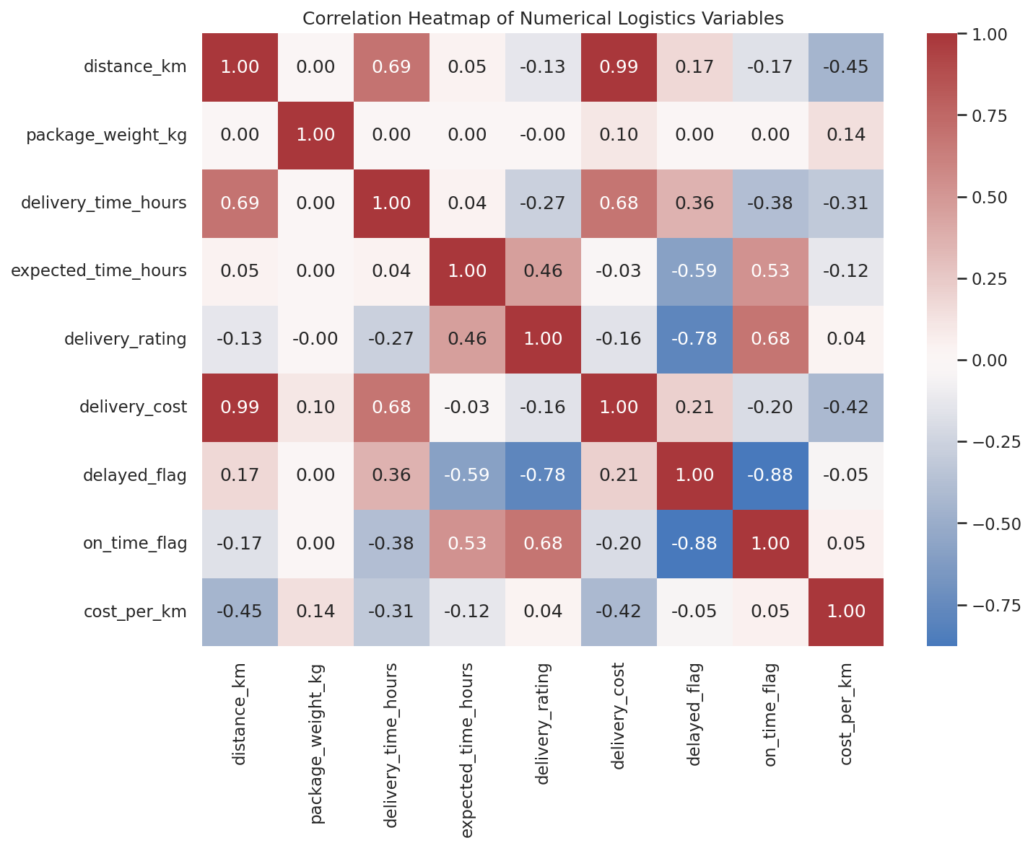

9. Data Visualizations

1. Delivery Status
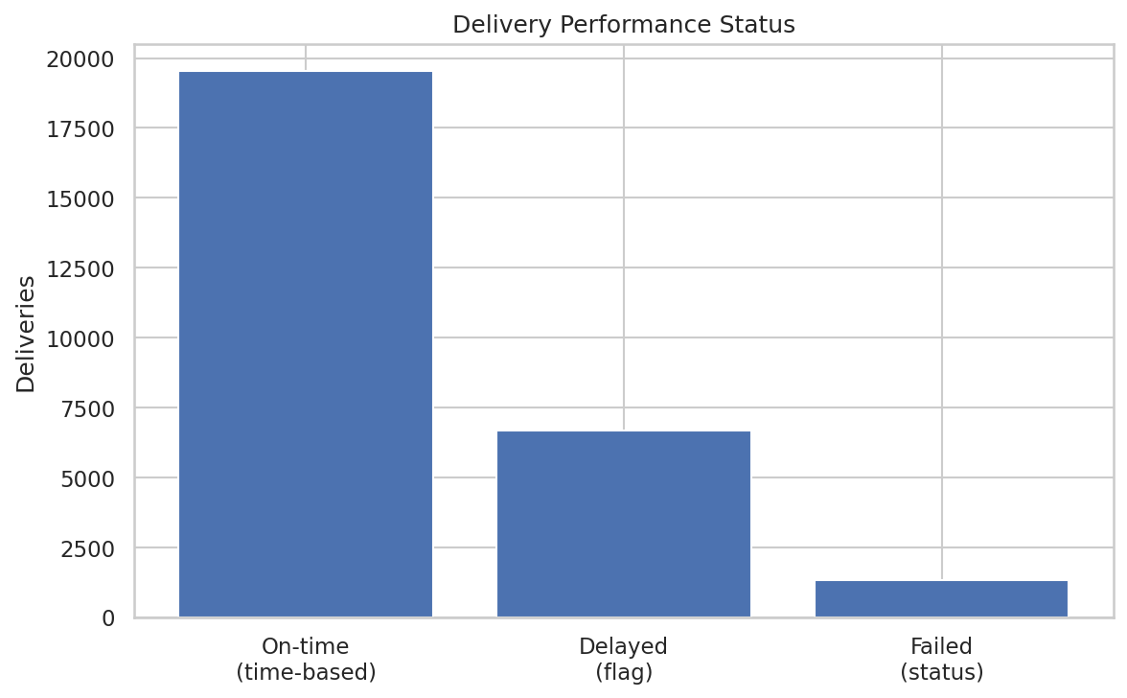
Purpose: Compares time-based on-time records, recorded delays, and failed statuses.
Why selected: A bar chart is appropriate for comparing discrete counts.
Finding: 19,534 deliveries are time-based on time; 6,669 are flagged delayed; 1,328 have failed status.

2. Delivery Time Distribution
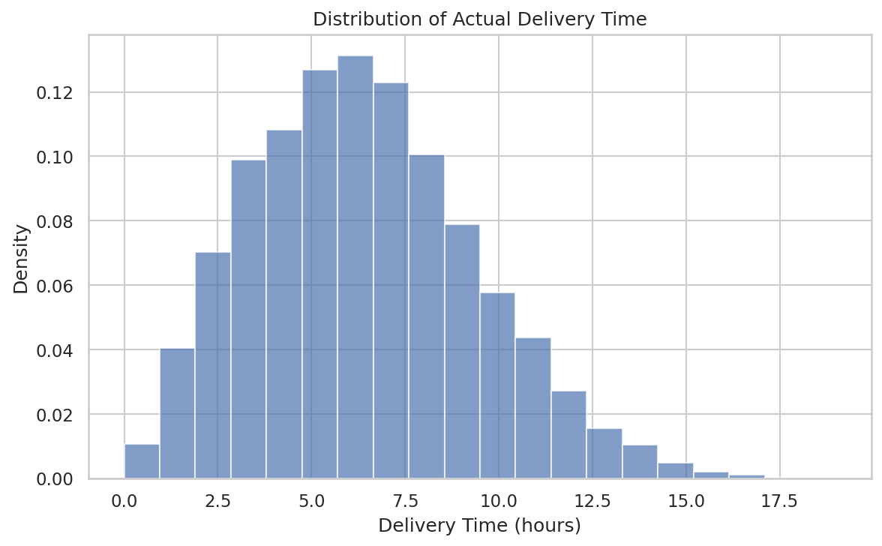
Purpose: Shows the spread and concentration of actual delivery time.
Why selected: A histogram is suitable for a continuous numerical distribution.
Finding: Actual delivery time ranges from 0 to 19 hours and centers around 6 hours.

3. Delivery Cost Distribution
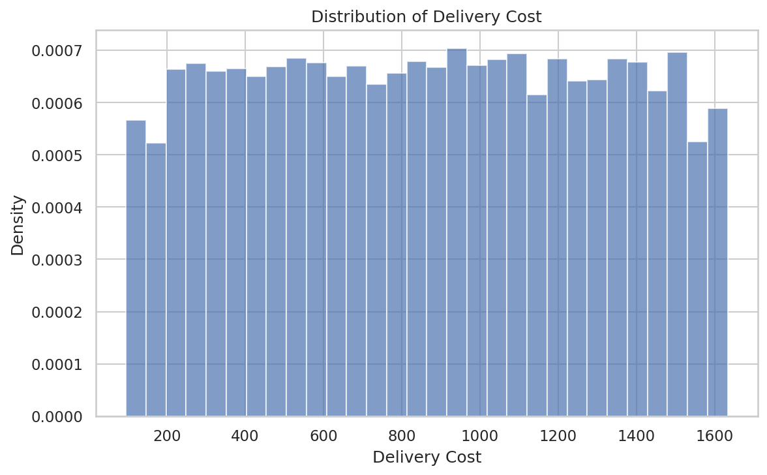
Purpose: Shows the spread of delivery costs and possible high-cost observations.
Why selected: A histogram shows the distribution efficiently.
Finding: Average cost is 864.94 and maximum cost is 1,632.72.

4. Distance vs Delivery Time
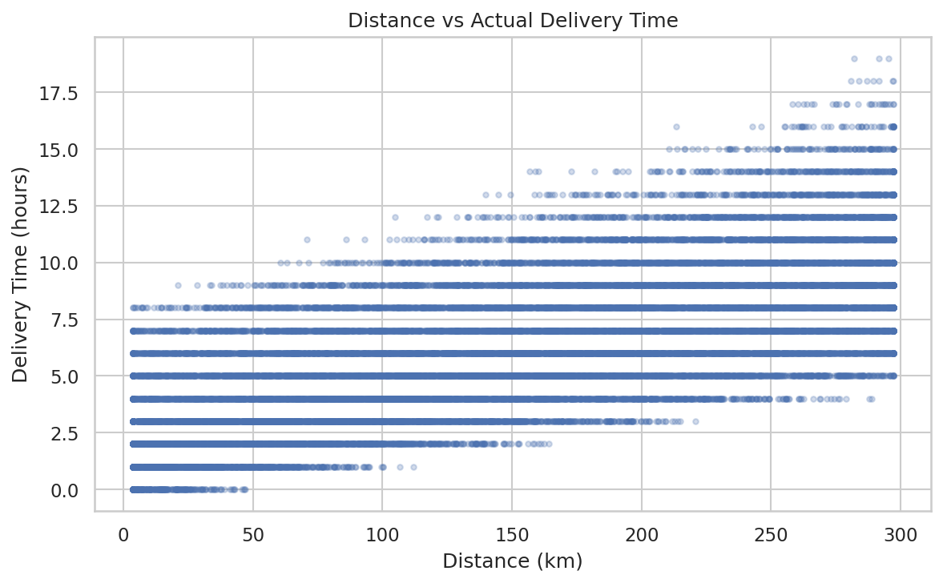
Purpose: Examines the relationship between route distance and actual time.
Why selected: A scatter plot is suitable for two numerical variables.
Finding: The correlation is 0.686, indicating a substantial positive association.

5. Distance vs Delivery Cost
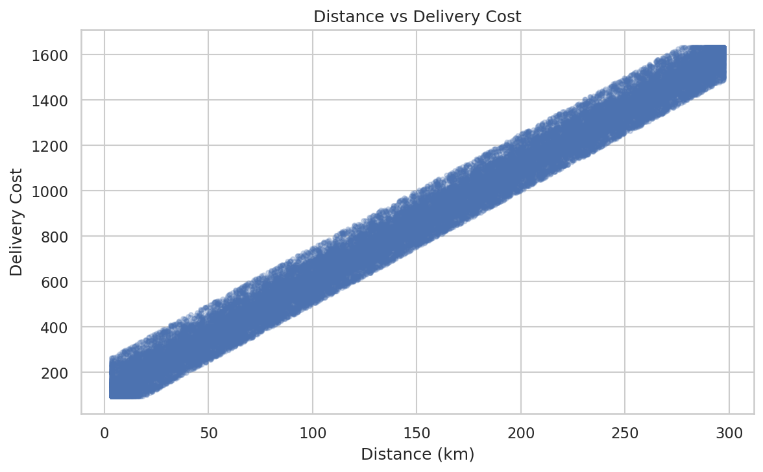
Purpose: Examines whether longer distance is associated with higher cost.
Why selected: A scatter plot shows the relationship at record level.
Finding: The correlation is 0.991, the strongest relationship in the selected variables.

6. Delay Rate by Region
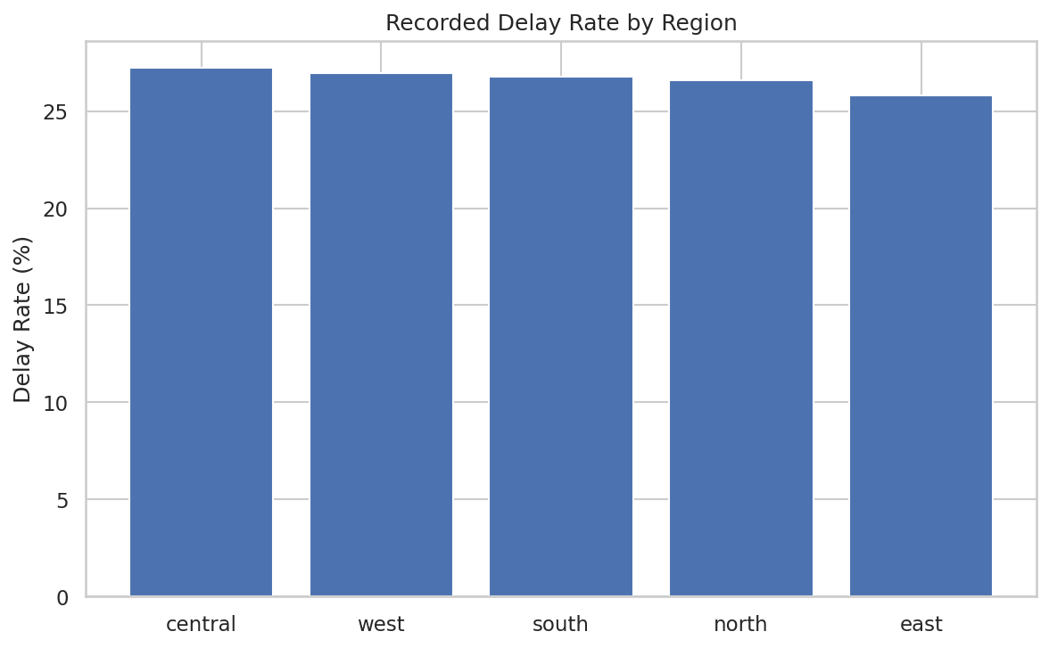
Purpose: Compares recorded delay rates by region.
Why selected: A bar chart makes regional differences clear.
Finding: Central has the highest rate at 27.25%; East has the lowest at 25.80%.

7. Partner Performance
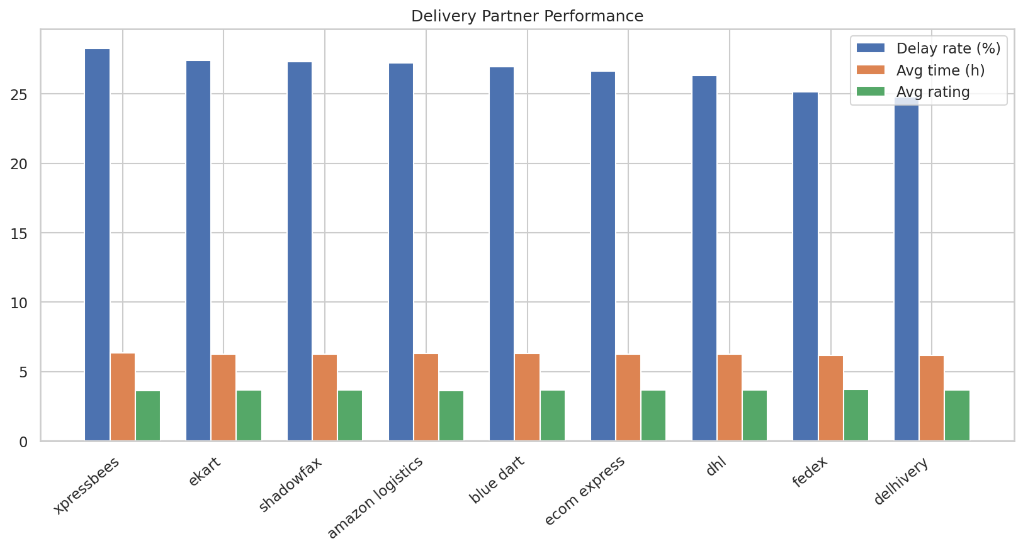
Purpose: Compares delay rate, average time, and rating across partners.
Why selected: Grouped bars support multi-metric comparison.
Finding: Xpressbees has the highest recorded delay rate (28.27%) and lowest rating (3.61).

8. Vehicle Performance
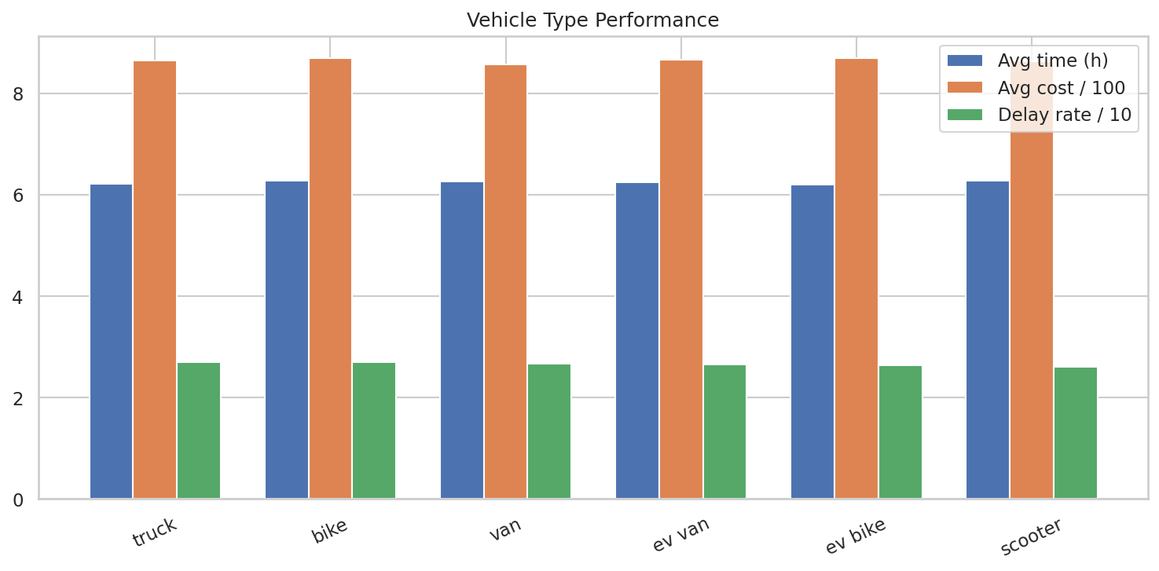
Purpose: Compares vehicle categories using time, cost, and delay indicators.
Why selected: Grouped bars summarize multiple vehicle metrics.
Finding: Vehicle-level differences are relatively small compared with weather and mode differences.

9. Weather Impact
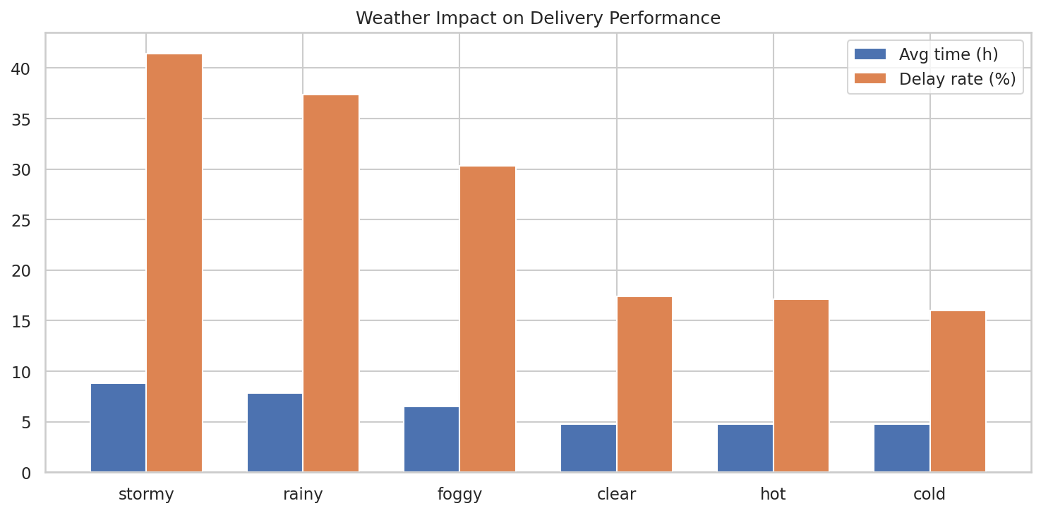
Purpose: Examines delivery time and delay rate under different weather conditions.
Why selected: Grouped bars compare conditions directly.
Finding: Stormy weather has 8.81 h average time and 41.45% delay; clear weather has 4.78 h and 17.43%.

10. Correlation Heatmap
Purpose: Summarizes pairwise numerical relationships.
Why selected: A heatmap efficiently displays many correlations.
Finding: Distance-cost and distance-time are the dominant positive relationships.

9.1 Additional Analysis
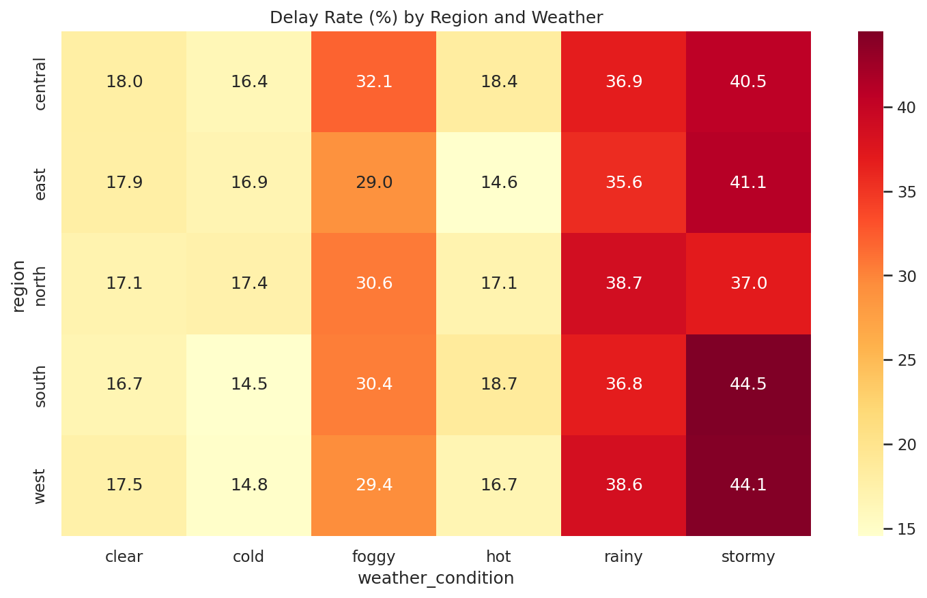
Region × weather analysis indicates higher delay rates under adverse weather across regions; this is descriptive and not causal.
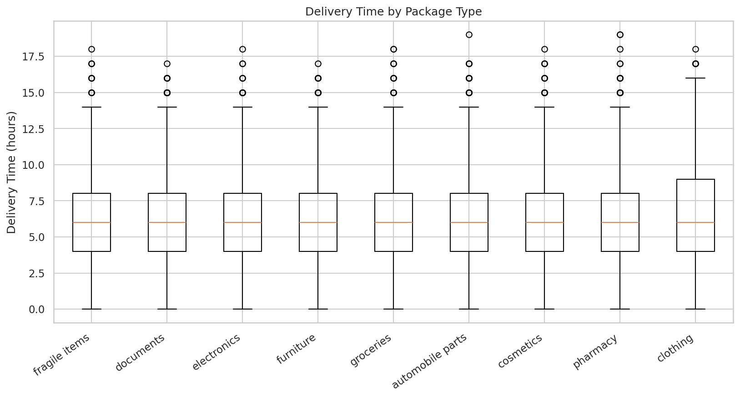
Package type distributions show some variation in delivery time, but package-level average times remain broadly close.
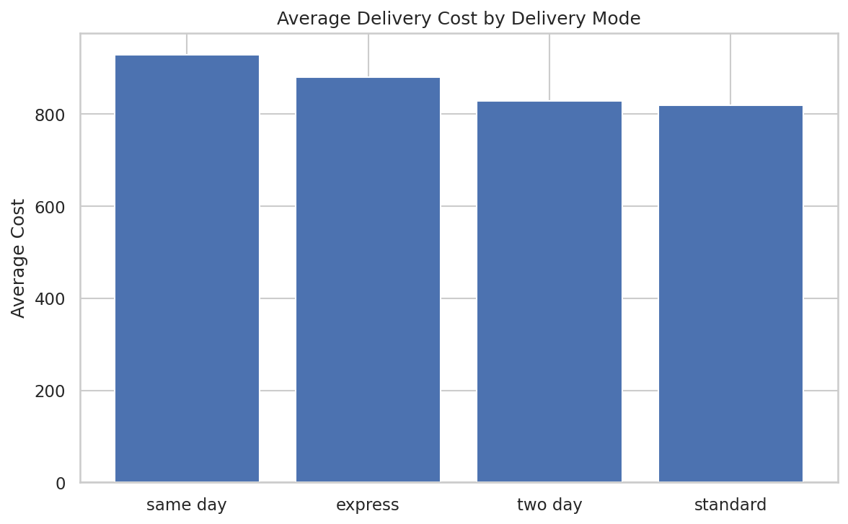
Average delivery cost differs by mode: same-day is highest at 929.87, while standard is lowest at 819.34.

10. Operational Efficiency Analysis
Regional differences are modest, with Central at 27.25% recorded delay and East at 25.80%. Partner differences are also moderate: FedEx has the lowest average delivery time (6.14 h), while Xpressbees has the highest recorded delay rate (28.27%). Vehicle-level delay rates are tightly grouped from 26.14% to 27.04%. Weather and delivery mode show much larger differences.
Stormy and rainy conditions are the strongest weather risk segments. Express mode is also a major service-risk segment, with 73.78% recorded delay and 35.33% time-based OTD, compared with 0% recorded delay and 100% time-based OTD for standard mode. These mode results should be investigated alongside the business rules used to set expected times.

11. Bottleneck Identification

Adverse weather
Observation: Adverse weather
Evidence: Stormy: 8.81 h and 41.45% delay; rainy: 7.80 h and 37.35%.
Possible reason: Weather conditions may constrain operations; the dataset does not prove causation.
Business impact: Higher service-risk exposure and potential customer dissatisfaction.

Express mode
Observation: Express mode
Evidence: 73.78% recorded delay and 35.33% time-based OTD.
Possible reason: Tighter service expectations may make misses more visible.
Business impact: Potential SLA and capacity pressure.

Partner variation
Observation: Partner variation
Evidence: Xpressbees 28.27% delay vs FedEx 25.16%.
Possible reason: Descriptive partner performance differs.
Business impact: Useful input for partner review and segmentation.

Distance-driven cost
Observation: Distance-driven cost
Evidence: r=0.991 between distance and cost.
Possible reason: Longer routes coincide with higher cost.
Business impact: Route design and mileage management are high-value cost levers.

12. Key Analytical Insights
1. Time-based OTD is 78.14%, while the recorded delayed rate is 26.68%; the measures are not identical.
2. Stormy weather has the highest recorded delay rate (41.45%) and longest average delivery time (8.81 h).
3. Rainy weather also performs poorly, with 37.35% recorded delay and 7.80 h average time.
4. Express mode has 73.78% recorded delay and 35.33% time-based OTD, making it the clearest service-risk segment.
5. Distance and delivery cost are extremely strongly associated (r=0.991).
6. Distance and delivery time are positively associated (r=0.686).
7. Central has the highest regional recorded delay rate (27.25%), while East is lowest (25.80%).
8. Xpressbees has the highest partner delay rate (28.27%) and lowest partner rating (3.61).
9. FedEx has comparatively strong partner results: 6.14 h average time, 25.16% delay rate, and 3.70 rating.
10. Vehicle delay rates are close (26.14%–27.04%), so vehicle type alone is not a strong differentiator at aggregate level.

13. Recommendations
- Use weather-aware contingency capacity and planning, especially for stormy and rainy conditions.
- Review express-mode SLA definitions, expected-time targets, routing, and capacity because express has the weakest service indicators.
- Prioritize route and distance optimization because distance is strongly associated with cost and delivery time.
- Use partner scorecards combining delay rate, time-based OTD, average time, rating, and delivery volume.
- Monitor Central for recurring delay patterns and West for cost patterns before making major resource changes.
- Treat vehicle type as a supporting allocation factor because aggregate vehicle differences are small.
- Document and standardize KPI definitions so the delayed flag and time-based OTD are clearly distinguished.
- Build a recurring dashboard segmented by weather, mode, partner, region, and distance bands.

14. Challenges
The key challenge was distinguishing the source delayed flag from a time-based definition of on-time delivery. Unusual values were investigated rather than automatically removed. Another challenge was interpreting correlations without claiming causation and maintaining fair comparisons using delivery counts.

15. Reflection
This project strengthened practical skills in data validation, Pandas EDA, KPI development, groupby analysis, correlation analysis, visualization, and logistics interpretation. It also showed that correct KPI definitions and business context are as important as chart creation.

16. Conclusion
The analysis shows that the logistics operation has a 78.14% time-based OTD rate, 6.25-hour average actual delivery time, 864.94 average delivery cost, and 3.67/5 average rating. Weather and delivery mode create the largest visible service differences, while distance is strongly associated with time and cost. The findings support targeted weather planning, express-mode review, route optimization, partner monitoring, and clearer KPI governance.

