Movies
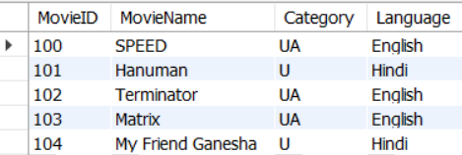

MovieID – Int MovieName-varchar(30) Category- char(2) Language-varchar(25)

SHOWS
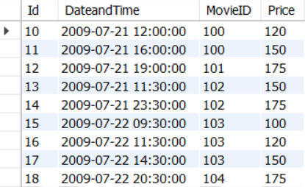

Id -Int | DateandTime-datetime | MovieID-int | Price-int

You need to create PK on MovieID column of Movies table and FK on MovieID column of Shows table

- Select all movies where language is English.
- Retrieve movie id , name which starts from ‘H’
- Select all shows whose languages is 'Hindi'
- Show total count of shows on each day
- Show the total count of A.M(before 12 PM) shows and P.M (after 12PM) shows on each day. Hint: DATE_FORMAT(DateandTime, "%p")
- Show the total price of all shows whose movie name is 'MATRIX'
- Show the maximum price of the show whose movie name is 'Terminator'
- Select number of shows running per movie

