Find all the employees who earn more than the average salary in their departments

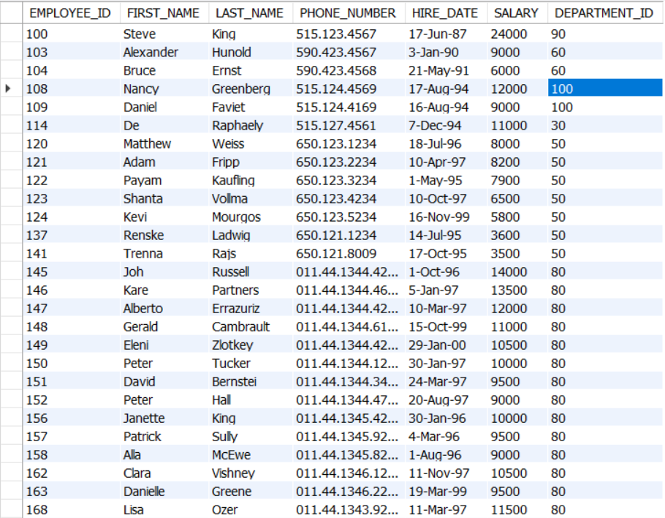

From the Employees and jobhistory tables display details of those employees who have changed jobs more than once .

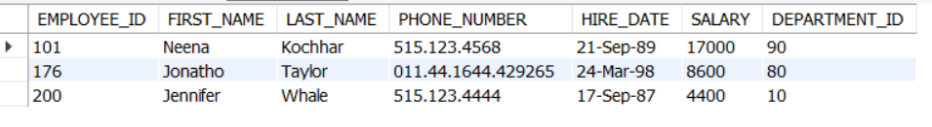

From the following tables (employees) find employees (employee_id, first_name, last_name, job_id, department_id) who have at least one person reporting to them.

