KrishiMitra: An Explainable, Multi-Source Agricultural Decision Support System

Aakar Gupta
School of Computer Science and Engineering (SCOPE)
Vellore Institute of Technology, Chennai, India
aakar.gupta2024@vitstudent.ac.in
Prathamesh Avinash Burange
School of Computer Science and Engineering (SCOPE)
Vellore Institute of Technology, Chennai, India
prathamesh.avinash2024@vitstudent.ac.in
Abstract—Farm-level decisions about what to sow, when to irrigate and where to sell depend on weather, soil and market information that is usually spread across separate tools, while machine-learning studies of crop recommendation often report near-perfect benchmark accuracy without showing how a model behaves when farm inputs are incomplete. This paper presents KrishiMitra, an implemented web-based agricultural decision-support system that combines Open-Meteo forecasts, NASA POWER climatology, the FAO/IIASA Harmonized World Soil Database v2.0, Agmarknet market prices and OpenStreetMap geocoding into one canonical farm summary, served by a FastAPI backend to a React client. Crops are ranked by a deterministic, factor-attributed rule engine (KM-Rules 2.1) covering 12 crops, with explicit sowing-window and data-coverage eligibility rules. An XGBoost classifier trained on a public 22-crop benchmark supplies an independent second opinion: 98.86 % hold-out accuracy (macro F1 98.85 %) with seven inputs and 94.09 % (macro F1 94.01 %) with climate and soil pH only, results that hold for the benchmark rather than for farms. A daily root-zone water balance built on FAO-56 concepts converts forecast evapotranspiration and rainfall into irrigation dates and volumes. The yield regressor, trained on a 20-row sample, records a hold-out coefficient of determination of −5.33 and is therefore labelled low-reliability; most crops instead use reference yields scaled by suitability. The contribution is a software integration that makes data provenance, fallbacks and model reliability visible to the user; field validation remains future work.
Index Terms—agricultural decision support, crop recommendation, explainable AI, XGBoost, irrigation scheduling, FAO-56, HWSD, data provenance

Introduction
Choosing a crop for the coming season depends on its temperature and rainfall tolerance, the soil reaction and nutrient status of the field, the sowing calendar and the likely price of the harvest; scheduling irrigation adds the short-range forecast and the water held in the root zone. Surveys of agricultural decision-support systems (DSS) describe tools that address one of these questions well but interoperate poorly with the others [1], and studies of farmer uptake show that tools are used only when they are relevant, usable and trusted [2]. A user who must combine a weather application, a soil card, a market portal and a crop calendar by hand carries the integration burden that a DSS should remove.
Machine learning (ML) has been applied extensively to the same questions. Crop-recommendation systems learn a mapping from soil nutrients and climate to a suitable crop [3], and reviews document a wide range of ML and deep-learning applications to yield, soil and water management [4]–[6]. Many of these studies report very high accuracy on curated datasets, but accuracy on a benchmark does not show how a model behaves at a location whose conditions lie outside its training distribution [7], nor does it explain a recommendation to the person who must act on it. For decisions with real consequences, interpretable models are preferable to post-hoc explanations of opaque ones wherever they perform adequately [8].
Data availability adds a further constraint. Few smallholders hold a recent laboratory soil test, so nitrogen, phosphorus and potassium values are usually missing; global soil grids provide modelled regional estimates rather than field measurements [9]; numerical weather forecasts cover days, whereas crop suitability depends on seasonal climate; and market data report observed prices, not future ones. A useful DSS must therefore state which inputs it actually had, where each came from and how far a result can be trusted, and it must keep working when a source is unavailable.
This paper addresses the following problem: given a farm location, its area, irrigation system, current crop and an optional soil test, produce (i) a ranked and explained crop recommendation for the coming sowing window, (ii) a seven-day irrigation schedule with volumes, (iii) risk, soil and market indicators and (iv) an explicit statement of the provenance and reliability of every element, degrading gracefully when data are missing. KrishiMitra, the system described here, implements this as a FastAPI service and a React client [10]. Its principal contributions are:
- an implemented, open-source architecture that fuses five live or local sources into one canonical farm summary with per-source status, fallback and provenance metadata, so that every page of the application reports the same recommendation;
- a transparent, range-based crop-suitability engine (KM-Rules 2.1) with explicit eligibility rules and factor-level attribution, kept separate from an independent XGBoost classifier whose agreement or disagreement is reported rather than merged into the ranking;
- a simplified daily root-zone water balance, built on FAO-56 concepts [11], that converts forecast reference evapotranspiration and rainfall into irrigation dates and volumes while exposing every default assumption; and
- a reproducible evaluation that separates benchmark classification metrics, an explicitly negative yield-regression result and functional tests executed for this paper.
The contribution is an engineering integration of established methods rather than a new learning algorithm. No field trial, farmer study or agronomic calibration has been carried out, so the results below describe software behaviour and benchmark performance, not improvements in yield, water use or income. Section II reviews related work; Section III formulates the methodology; Section IV documents the datasets; Section V describes the implementation; Section VI reports the evaluation; and Section VII and Section VIII discuss limitations and conclude.

Related Work and Research Gap
Table I compares the studies that most directly inform KrishiMitra. Reported figures are those of the original authors on their own data and tasks; they are not directly comparable with each other or with KrishiMitra.

Crop Recommendation and Suitability
Pudumalar et al. [3] combined Random Tree, CHAID, k-nearest-neighbour and naive-Bayes learners by majority vote to recommend crops from soil characteristics and yield records. Majority voting reduces the variance of individual learners but makes it difficult to say why a crop was chosen, and the system used no weather, season or price input. Kumar et al. [12] framed crop choice as selecting among competing crops to maximise the net yield rate over a season, linking agronomic and economic criteria. A different tradition scores suitability against expert ranges: the EcoCrop model compares monthly temperature and rainfall with crop tolerance limits and, after calibration, reproduced the observed distribution of sorghum with a true-positive rate of at least 0.967 [13]. Range-based rules need no labelled training data and are directly explainable, but their thresholds must be compiled and calibrated by hand. Tree ensembles such as random forests [14] and gradient-boosted trees [15] learn feature interactions automatically, at the cost of requiring representative labelled data. KrishiMitra adopts range-based scoring as the authoritative ranking and keeps a gradient-boosted classifier only as a second opinion.

Yield Prediction
A systematic review of 50 ML yield studies found temperature, rainfall and soil type to be the most common inputs and artificial neural networks the most common algorithm [6]. Random forests predicted gridded wheat and county-level maize yields with errors of roughly 6–14 % of mean yield but lost accuracy for conditions outside their training range [16]. A deep neural network trained on 2,247 locations and 2,267 maize hybrids reached a root mean square error (RMSE) of 12 % of mean yield [17], and a deep recurrent Q-network reported 93.7 % accuracy [18]; both depend on large training sets that a regional advisory tool rarely has. Paudel et al. [19] stress comparison with no-skill baselines such as the training mean, the reference against which KrishiMitra’s negative coefficient of determination (Section VI) must be read.

Decision-Support Architecture, Irrigation and Soil Data
Zhai et al. [1] assess thirteen DSS for interoperability, scalability, accessibility and usability, and Rose et al. [2] identify fifteen factors, including usability, cost-effectiveness and relevance, that govern adoption. For irrigation, FAO-56 defines reference evapotranspiration (ET₀), crop coefficients (K_{c}) and a root-zone depletion balance [11], with later refinements of the coefficient approach [20]; sensor-driven and crop-model-based schedulers are more precise but need instrumentation or calibration. For soil, HWSD v2.0 harmonises national soil maps into a 30-arc-second (about 1 km) grid with seven depth layers [9]; SoilGrids predicts properties at 250 m from about 150,000 profiles (240,000 in version 2.0) with explicit uncertainty [21], [22]; the repository notes that an earlier version queried SoilGrids online before switching to the offline HWSD lookup.

Explainability and Generalisation
SHAP assigns each feature an additive Shapley-value contribution to a prediction [23], and exact tree algorithms make it practical for gradient-boosted models [24]. Ryo [25] shows that such tools help diagnose agricultural models but argues that performance metrics alone are insufficient for trust. Attribution is not causation, and Meyer and Pebesma [7] show that ML errors outside the training feature space can be far larger than cross-validation suggests, an argument directly relevant to a classifier trained on a public benchmark.

- Comparative Review of Related Agricultural Decision-Support and Machine-Learning Studies
Ref. | Objective | Data or setting | Method | Principal reported result | Documented limitation | Relevance to KrishiMitra
[3] | Site-specific crop recommendation | Soil characteristics, soil types and yield records (India) | Majority vote of Random Tree, CHAID, k-NN, naive Bayes | “High accuracy” (no figure verified) | No weather, season or price input | ML recommendation retained only as second opinion
[12] | Select among competing crops | Seasonal crop data (not given in abstract) | Crop Selection Method (ML) | Higher net yield rate claimed | Data and algorithms unspecified in abstract | Economics reported as a separate trade-off
[13] | Climatic suitability under climate change | FAO-EcoCrop ranges, WorldClim; Africa, SE Asia; sorghum | Calibrated range-based suitability | TPR ≥ 0.967, FNR ≤ 0.026 vs. statistics | Monthly climate only; yield link unresolved | Precedent for range-based KM-Rules scoring
[16] | Global and regional yield prediction | Global wheat grid; US county maize (>30 yr); NE US potato | Random forest vs. linear regression | RMSE ≈ 6–14 % of mean (linear up to ≈49 %) | Weak outside training range | Supports trees; warns on extrapolation
[17] | Maize hybrid yield | 2,247 locations, 2,267 hybrids, 2008–2016 | Deep neural network | RMSE 12 % of mean yield | Single challenge dataset | Shows data scale an NN needs
[18] | Crop yield prediction | Agricultural records (see paper) | Deep recurrent Q-network | 93.7 % “accuracy” | Complex, data-hungry training | Not adopted: opaque for advisory use
[6] | Review of ML yield prediction | 567 records → 50 studies (+30 DL) | Systematic review | T, rain, soil most used; ANN most used | Heterogeneous evaluations | Defines inputs our yield model lacks
[19] | Regional yield forecasting | EU MCYFS; 5 crops; NL, DE, FR | ML workflow with no-skill baselines | Comparable to MCYFS in NL, DE | Worse in FR for some crops; transfer | Baseline view of negative R²
[1] | Survey of Agriculture 4.0 DSS | 13 systems | Comparative analysis | Interoperability gaps identified | Qualitative | Motivates one integrated summary
[2] | DSS uptake by farmers | UK interviews and surveys | Mixed methods | 15 adoption factors | UK context | Usability, relevance; adoption untested here
[11], [20] | Crop water requirements | FAO-56 method and its applications | Penman–Monteith ET₀, K_{c}, depletion balance | International reference method | K_{c} and soil data need local calibration | Basis of simplified scheduler
[21], [22] | Global soil property maps | ≈150,000 / 240,000 profiles; 250 m | ML with covariates; uncertainty (v2.0) | 56–83 % variance explained (v1) | More observations needed | Alternative to HWSD; not used at run time
[23], [24] | Feature attribution | Theory; tree models | Shapley additive explanations | Unique additive attribution | Not causal; baseline-dependent | Explains the yield regressor
[25] | XAI for agricultural data | No-till vs. conventional tillage yields | Several XAI methods | Conditions favouring no-till found | Metrics alone insufficient | Supports cautious attribution

Research Gap and Positioning
The reviewed work either optimises a single prediction task on a curated dataset or surveys DSS qualitatively. We found no comparable open system, among those reviewed, that combines live forecasts, historical climatology, an offline soil grid and market observations in one summary while keeping a transparent rule ranking separate from an ML opinion and reporting the reliability of each output. This claim is bounded by the literature examined here and does not exclude commercial or unpublished tools. Table II maps the gaps to the implemented responses and the limitations that remain.

- Research Gaps and the Corresponding KrishiMitra Design Responses
Research gap | Studies | Implemented response | Evidence in repository | Remaining limitation
Fragmented tools | [1], [2] | One canonical summary feeds every page and report | build_summary, /api/farm/summary | No usability or adoption study
Opaque recommendations | [3], [8] | Range rules with per-factor multipliers and source labels | crop_rules.evaluate_crop | Ranges compiled by hand, not calibrated
Missing soil tests | [9], [22] | HWSD lookup with distance-labelled fallback; factors excluded when absent | hwsd.lookup_soil, coverage field | Grid values are regional estimates
Benchmark over-confidence | [7], [16] | Classifier shown only as second opinion with agreement flag | crop_ml.ml_opinion | No regional test set
Concealed weak results | [6], [19] | Negative R² stored and shown; low-reliability label; fallback | yield_meta.json, model cards | Yield model unusable for decisions
Irrigation not integrated | [11], [20] | Seven-day depletion balance converted to dates and m³ | irrigation.compute_water_balance | Uncalibrated defaults (Z_{r}, p, θ)

System Model and Proposed Methodology

Problem Definition
A request is the input state u = (φ, λ, A, s, c₀, x_{s}), where φ and λ are latitude and longitude, A the area in hectares, s the irrigation system (rainfed, drip, sprinkler or flood), c₀ the current crop and x_{s} an optional soil test of N, P and K (kg/ha) and pH. For each crop c in the knowledge base 𝒞 (|𝒞| = 12), the system constructs a feature vector x_{c}, a suitability score S_{c} ∈ (0, 1], an eligibility flag E_{c} and a yield and net-return estimate. It returns the top-ranked eligible crop, an independent classifier opinion, a seven-day irrigation plan for c₀, seven risk categories and, for every source, its status and provenance. These outputs are advisory: they support, and do not replace, agronomic judgement.

Overall Architecture
Fig. 1 shows the architecture, drawn from the repository at commit 21c73e6 [10]. A React 19 presentation layer calls a FastAPI API layer; the data-integration layer comprises asynchronous clients for the remote services, a memory-mapped reader for the local HWSD v2.0 grid and a SQLite state database; and the decision and analytics layer holds the rule, economics, yield, irrigation, soil and risk services. The ML opinion runs beside these services without feeding back into the ranking. One orchestration function, build_summary, assembles the JSON document that every page and the PDF report consume.
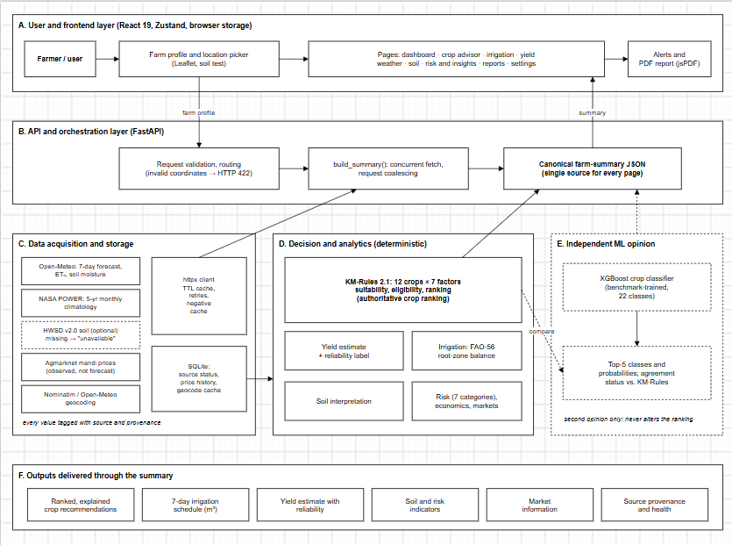
- Overall KrishiMitra architecture (layers A–F). Solid arrows show data flow; dashed elements mark the independent XGBoost opinion, which is compared with, and never fed into, the KM-Rules 2.1 ranking. HWSD v2.0 is optional: without it, soil data are reported as unavailable.

Input State and Data Enrichment
After validation (Fig. 1, layers B and C), four acquisitions run concurrently: the seven-day Open-Meteo forecast, a five-year NASA POWER monthly climatology, the HWSD soil lookup and a reverse geocode followed by market-price queries. Each returns a status (ok, fallback, stale or unavailable), a fetch time and, where relevant, the resolved coordinate and its distance from the farm. Features are then built per crop with a source label attached to each value. Soil pH comes from the farmer’s test when present and otherwise from the HWSD topsoil layer, flagged when a nearby cell was used; N, P and K come only from a soil test. Temperature and humidity are NASA POWER means over the crop’s growing months, falling back to the seven-day forecast mean, and seasonal rainfall is the NASA POWER total over the same months. A value that cannot be obtained is not imputed: the factor is excluded and the exclusion is reported.

Agronomic Crop Recommendation (KM-Rules 2.1)
The knowledge base stores, for each of the 12 crops (wheat, sorghum, pearl millet, barley, green gram, black gram, sugarcane, tomato, potato, onion, turmeric and ginger), a preferred interval [ℓ_{k}, u_{k}] for seven factors k: N, P, K, temperature, relative humidity, pH and seasonal rainfall, together with sowing windows, crop duration and reference economics. Each available factor value x_{k} receives a multiplier
$m_{k}\left(x_{k}\right)=\left\{\begin{matrix}1, & l_{k}≤x_{k}≤u_{k} \\ max​\left(0.2, 1-\frac{l_{k}-x_{k}}{l_{k}}\right), & x_{k}<l_{k} \\ max​\left(0.2, 1-\frac{x_{k}-u_{k}}{u_{k}}\right), & x_{k}>u_{k}\end{matrix}\right.$ (1)
so that a value outside its interval is penalised in proportion to its relative distance from the violated bound, with a floor of 0.2. One exception encodes irrigation feasibility: if seasonal rainfall is below ℓ_{k} on an irrigated farm, m_{k} = 1 and the shortfall is reported as an irrigation requirement. Let 𝒜_{c} be the set of factors available for crop c. The suitability score is the product
Sc=σck∈Ac​mkxc,k, σc=0.5,Δc>60 d1,otherwise (2)
where Δ_{c} is the number of days until the crop’s next sowing window opens (zero while it is open). A coverage ratio |𝒜_{c}|/7 is mapped to High (≥0.85), Medium (≥0.55) or Low confidence; without a soil test at most four factors are available, so coverage cannot exceed 0.57. The multiplicative form, the floor and the 0.5 off-season factor are design choices of KM-Rules 2.1, not values derived from field data. A crop is eligible when
$E_{c}=1​\left[ \left|A_{c}\right|≥2 \right]⋅1​\left[ Δ_{c}≤60 \text{d} \right]⋅1​\left[ S_{c}≥0.40 \right]$ (3)
and crops are sorted in descending lexicographic order of the key (E_{c}, S_{c}, NR_{c}), where
${\text{NR}}_{c}={\hat{Y}}_{c} P_{c}-C_{c}$ (4)
is the net return (INR/ha) computed only when an observed Agmarknet price P_{c} exists (modal price in INR per quintal × 10 = INR/t); C_{c} is a static national reference cost and Ŷ_{c} the yield estimate of Section III-F. Net return therefore breaks ties but never overrides suitability. The highest net return among eligible crops with an observed price is reported separately as the economic trade-off. Algorithm 1 gives the complete procedure; ineligible crops remain listed with their reasons.

Algorithm 1: KM-Rules 2.1 ranking and eligibility (per request)
1: for each crop c ∈ 𝒞 do
2: build x_{c} and source labels (soil test > HWSD; climatology > forecast)
3: S ← 1; 𝒜 ← ∅
4: for each factor k with value x_{k} available do
5: 𝒜 ← 𝒜 ∪ {k}; S ← S·m_{k}(x_{k}) by (1), with rain shortfall → 1 if irrigated
6: if window opens in more than 60 days then S ← 0.5·S
7: E_{c} ← (|𝒜| ≥ 2) ∧ in-season ∧ (S ≥ 0.40); record reasons if false
8: Ŷ_{c} ← yield service; NR_{c} ← (4) if observed price, else −∞
9: sort 𝒞 by (E_{c}, S_{c}, NR_{c}) descending
10: if first crop has |𝒜| ≥ 2 then canonical ← first crop else report “unavailable”
11: trade-off ← argmax NR_{c} over eligible crops with observed price
12: return ranking, attribution, explanations

Independent XGBoost Crop-Classification Opinion
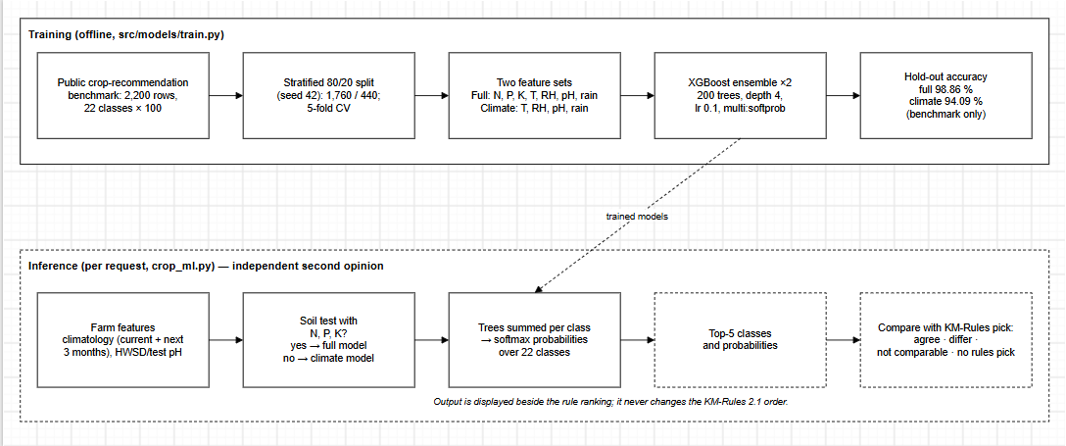
- KrishiMitra XGBoost classification architecture. Training (top) fits two benchmark models; at inference (bottom, dashed) the full model is used only when N, P and K come from a soil test. The top-5 output is compared with, but never alters, the KM-Rules 2.1 ranking. Accuracies are benchmark hold-out results, not field accuracy.
Fig. 2 shows the classifier architecture. The second opinion is a supervised 22-class classifier trained on a public crop-recommendation benchmark [26]. XGBoost [15] fits an additive ensemble of regression trees f_{t} by minimising the regularised objective
$L=\sum_{i=1}^{n}{l}\left(y_{i},{\hat{y}}_{i}\right)+\sum_{t=1}^{T}{\left(γJ_{t}+1/2λ∥w_{t}∥^{2}\right)}$ (5)
where l is the multiclass log loss, J_{t} and w_{t} are the leaf count and leaf weights of tree t, and γ, λ are regularisation weights. Class probabilities follow from the summed tree outputs z_{c} by the softmax p(c|x) = exp z_{c} / Σ_{j} exp z_{j}. Two variants share the configuration 200 trees, maximum depth 4 and learning rate 0.1: the full variant uses N, P, K, temperature, humidity, pH and rainfall, and the climate variant omits N, P and K. At inference the full variant runs only when a soil test supplies N, P and K. Climate inputs are NASA POWER means over the current month and the next three months 𝒲:
T=14m∈W​Tm, R=14m∈W​Rm (6)
with rainfall taken as the mean monthly total because the benchmark’s rainfall column is on a monthly scale; this differs from the seasonal rainfall total used by the rules. The service returns the five most probable classes and compares the top class with the rule-based pick: agree, differ, not comparable or no rule pick. Only green gram and black gram appear both among the 22 benchmark classes and the 12 rule crops, so the comparison is frequently “not comparable”, and the opinion never alters the ranking.

Yield Estimation
Yield follows a three-way rule:
${\hat{Y}}_{c}=\left\{\begin{matrix}g\left(\text{year},e_{c}\right)/{10}^{4}, & c∈\{\text{rice, wheat}\} \\ Y_{c}^{\text{ref}} S_{c}, & Y_{c}^{\text{ref}} \text{known} \\ \text{none}, & \text{otherwise}\end{matrix}\right.$ (7)
where g is an XGBoost regressor (100 trees) trained on year and a one-hot crop indicator e_{c} to predict national yield in hg/ha (10⁴ hg/ha = 1 t/ha), and Y^{ref}_{c} is a static reference yield. Of the 12 rule crops only wheat reaches the regressor; the other eleven use the labelled reference method. The regressor uses no local soil, weather or irrigation input, its band of ± MAE is shown but has no statistical coverage guarantee, and it carries a Low reliability label because its hold-out R² is below 0.3 (Section VI). For this model, and only this model, TreeSHAP [24] decomposes a prediction into additive contributions
$g\left(x\right)=ϕ_{0}+\sum_{j=1}^{M}{ϕ_{j}}\left(x\right)$ (8)
over the features Year, Crop_Rice and Crop_Wheat, with φ₀ the expected model output. These values describe the model’s arithmetic, not a causal effect of the calendar year or crop identity on yield.

Irrigation Scheduling
The scheduler applies a simplified daily root-zone water balance for the farm’s current crop over the forecast horizon (seven days). Following the single-coefficient concept of FAO-56 [11], crop evapotranspiration and effective rainfall are
$ET_{c,t}=K_{c} ET_{0,t}, P_{\text{eff},t}=\left\{\begin{matrix}0.8 P_{t}, & P_{t}≥5 \text{mm} \\ 0, & \text{otherwise}\end{matrix}\right.$ (9)
where ET_{0,t} is Open-Meteo’s FAO-56 reference evapotranspiration [27] (mm/day), K_{c} the FAO-56 mid-season coefficient for the crop (1.0 when none is stored) and P_{t} the forecast rainfall; the 80 %/5 mm effective-rain rule is a project heuristic. Soil water capacity is
$\text{TAW}=1000 \left(θ_{\text{FC}}-θ_{\text{WP}}\right) Z_{r}, \text{RAW}=p \text{TAW}$ (10)
with θ_{FC} and θ_{WP} (m³/m³) taken from a texture table keyed by the HWSD USDA class (loam when texture is unknown), root depth Z_{r} = 0.5 m and depletion fraction p = 0.5; TAW and RAW are in mm. The initial depletion is D_{r,0} = 1000(θ_{FC} − θ)Z_{r}, clipped to [0, TAW], from Open-Meteo’s modelled moisture θ at 9–27 cm, or zero (field capacity) when θ is unavailable. Each day,
$D_{r,t}={\left[D_{r,t-1}+ET_{c,t}-P_{\text{eff},t}\right]}_{0}^{\text{TAW}}$ (11)
where [·]₀^{TAW} denotes clipping to the interval [0, TAW]. Whenever D_{r,t} > RAW, an irrigation refills the root zone and D_{r,t} is reset to 0:
$I_{\text{net},t}=D_{r,t}, I_{\text{gross},t}=I_{\text{net},t}/η$ (12)
with application efficiency η = 0.90 (drip), 0.75 (sprinkler) or 0.60 (flood); for a rainfed farm the net requirement is reported. The volume V (m³) over area A (ha) follows from 1 mm over 1 ha = 10 m³:
V=10 At​Igross,t (13)
Algorithm 2 summarises the procedure. The status is “irrigate now” if D_{r,0} > RAW, “irrigate soon” if the first trigger falls within three days, “scheduled” if later and “not needed” otherwise. These are the implemented equations; KrishiMitra does not compute Penman–Monteith itself, does not model soil water retention curves and has not been calibrated against measured soil moisture.

Algorithm 2: Seven-day root-zone water balance
1: if no forecast day has ET₀ then return “unavailable”
2: (θ_{FC}, θ_{WP}) ← table[texture] or loam; TAW, RAW by (10)
3: D_{r} ← clip(1000(θ_{FC} − θ)Z_{r}) if θ known else 0
4: for t = 1 to horizon do
5: P_{eff} by (9), missing P → 0; D_{r} by (11)
6: if D_{r} > RAW then I_{net} ← D_{r}; I_{gross} ← I_{net}/η; D_{r} ← 0
7: status from D_{r,0} and first trigger; V by (13); return plan

Soil Lookup and Interpretation
The coordinate is converted to a raster row and column of the 30-arc-second HWSD grid [9], read through a memory map, and the mapping unit’s dominant component (largest share, then lowest sequence) in layer D1 (0–20 cm) is read from SQLite. A cell is usable if it is not water, glacier or no-data and has pH, sand, clay or organic carbon. Otherwise cells within 5 km are searched in order of great-circle distance and the first usable one is returned as FALLBACK with its distance, else NO_SOIL_DATA; invalid coordinates or a missing database give UNAVAILABLE. Interpretation issues amendments only when a rule fires, e.g. liming below pH 5.5 (rate from a buffer-pH test) or gypsum above pH 8.4 after a sodicity test. Farmer-measured values, the modelled grid value, a nearby-cell estimate and missing data are kept distinct, and measured values always take priority.

Risk, Market and Explainability Mechanisms
The risk service rates seven categories as low, moderate, high or unavailable: climate (maximum temperature ≥ 35 or ≥ 40 °C, minimum ≤ 4 °C, daily rain ≥ 64.5 or ≥ 115.6 mm, labelled in the code as India Meteorological Department heavy and very-heavy rain, wind ≥ 40 km/h), water, suitability, yield relative to reference, a generic fungal-favourability rule (mean humidity ≥ 80 % with mean temperature 20–30 °C), soil and market dispersion. Market prices are observed modal prices, never forecasts. Explanations come from four distinct mechanisms: (i) per-factor values, intervals, multipliers and source labels; (ii) classifier probabilities, which are often near 1 on the benchmark and are not calibrated, plus the agreement flag; (iii) TreeSHAP for the yield regressor only; and (iv) generated sentences, e.g. why a higher-scoring crop was ineligible.

Datasets and Data Engineering
Table III lists every data source, distinguishing live services, local files and static knowledge, and how each enters the system.

- Dataset Inventory, Provenance, and Use in KrishiMitra
Source | Provider | Access | Type and coverage | Features used | Storage / caching | Downstream use | Important limitation
Crop recommendation benchmark [26] | Kaggle (A. Ingle) | Offline CSV | 2,200 rows, 22 crops × 100; no location or date | N, P, K, temperature, humidity, pH, rainfall (monthly scale) | data/; trained models in models/ | crop_xgb training only | Collection method undocumented; classes nearly separable
FAOSTAT-style yield sample [28] | Hand-made sample modelled on FAOSTAT | Offline CSV | 20 rows, India national, rice (18) and wheat (2), 2010–2029 | Year, crop → yield (hg/ha) | data/ | yield_xgb training; history chart | 15 rows repeat 27,000 hg/ha; 2027–2029 rows are future years
Open-Meteo forecast [27] | Open-Meteo | Live REST | 7-day daily forecast, model grid | T_{max}, T_{min}, rain, rain probability, ET₀, RH, wind; soil moisture 9–27 cm | Memory, TTL 15 min | Irrigation, risk, forecast fallback for T, RH | Modelled values; forecast error
NASA POWER [29] | NASA LaRC | Live REST (monthly, AG) | 5-yr monthly means; meteorology ½° × ⅝° | T2M, PRECTOTCORR, RH2M, solar | Memory, TTL 7 days | Rule and classifier climate inputs | Coarse grid; climatology, not forecast
HWSD v2.0 [9] | FAO and IIASA | Local raster + SQLite (optional) | 30″ (≈1 km), 7 layers; D1 0–20 cm used | pH, sand, silt, clay, texture, OC, N, CEC, AWC | Memory map; LRU cache (4,096) | pH factor, texture for irrigation, soil rules | Regional estimate; fallback ≤ 5 km
Agmarknet mandi prices [30] | AGMARKNET via data.gov.in | Live REST (API key) | Daily arrivals; market level; INR/quintal | Commodity, market, date, min/max/modal price | Memory TTL 6 h; SQLite history | Net return, market risk, alerts | Observed price; public key returns ≤ 10 records
Reverse geocoding [31] | OpenStreetMap (Nominatim); Open-Meteo geocoder | Live REST | Administrative names | District, state; district centroids | SQLite, up to 30 days | Market matching, labels | Not an agronomic measurement
KM-Rules 2.1 knowledge base | Project authors | Python constants | 12 crops | Ranges, calendar, K_{c}, reference yield, price, cost | Code | Rules, irrigation, economics | Hand-compiled; national, uncalibrated

Acquisition and Transformation
NASA POWER is queried for the five most recent complete years (else the preceding five); fill values (−999) are discarded, PRECTOTCORR (mm/day) is multiplied by the days in each month and means are formed per calendar month [29]. Open-Meteo supplies daily variables and the soil moisture at the current hour [27]. A one-time build script converts the official HWSD raster and Access database into a local raster and SQLite tables, writing negative missing-value codes as NULL. For prices, the client queries the farm’s district, then the state (selecting the nearest reporting district located by geocoding), then the whole country; the representative record is the one whose modal price is closest to the pool median. Each chosen observation is stored, so that after a later failure the last observation is returned as stale with lower economic confidence, never as current. Nominatim calls are cached and spaced by 1.1 s, in line with its one-request-per-second policy [31].

Data-Quality Qualifications
Four qualifications govern interpretation. First, the benchmark has exactly 100 rows per crop, no location, date or farm identifier, and nearly separable classes; the project’s own model card notes that the rows appear generated rather than measured, so benchmark accuracy cannot be transferred to farms [7]. Second, the yield sample is described in the repository as hand-made rather than a FAOSTAT export: 15 of its 20 rows carry the identical value 27,000 hg/ha, wheat has only two rows, and the training loader admits the future years 2027–2029 although the history view hides them. Third, HWSD values describe the dominant soil of an approximately 1-km mapping unit, not the field. Fourth, Open-Meteo gives a short-range forecast for scheduling, whereas NASA POWER climatology describes the typical season; neither substitutes for the other.

Implementation and System Integration
Table IV maps each component to its implementation, inputs, outputs and evidence. This section explains how the components are integrated so that every page reports a consistent result.

- Principal Software Components and Their Responsibilities
Component | Implementation | Input | Output | Evidence or limitation
API and model cards | FastAPI, api/main.py, model_cards.py | Query parameters | GET/POST routes; HTTP 422 on invalid coordinates; cards from metadata | CORS open to all origins (development setting)
Data clients and state | src/data/*.py, httpx, SQLite | URLs, cache keys | JSON or status-tagged failure; source health, price history | Retry, back-off, negative cache; tested
Soil engine | hwsd.py, NumPy memmap, SQLite | Coordinate | Properties, result code, provenance | Six tests use a synthetic 5 × 5 grid
Summary service | farm_summary.py | Farm profile | Canonical JSON for all pages | Concurrent identical requests coalesced
Rule engine | crop_rules.py | Features, sources, date | Score, attribution, eligibility | Thresholds not field-calibrated
ML opinion | crop_ml.py, XGBoost | Climatology, soil, test | Top-5, agreement | Benchmark-trained only
Yield service | yield_service.py, SHAP | Crop, score | Estimate, method, reliability, SHAP | R² = −5.33; wheat only via ML
Irrigation | irrigation.py | Forecast, texture, θ, crop, system | Daily balance, dates, m³ | Uncalibrated defaults
Risk and soil rules | risk.py, soil.py | Summary parts | Seven rated categories, amendments | No pest surveillance data
Frontend and report | React 19, Vite, Tailwind, Zustand, Recharts, Leaflet, jsPDF | Summary JSON | Ten pages, alerts, A4 PDF | No automated UI tests

Backend, Routing and the Canonical Summary
The API routes listed in Fig. 1 share one entry point: the crop route additionally accepts what-if temperature and rainfall overrides, and the yield route adds SHAP values and, for reference-method crops, a suitability-sensitivity table. Every advisory route calls build_summary, which keys in-flight requests by their parameters so that concurrent identical requests share one computation. It fetches weather, climatology, soil and geocoding-plus-market data concurrently, evaluates and ranks the 12 crops, computes irrigation, risk and the ML opinion, and returns one document with the fields crops, recommendation, ml_opinion, irrigation, risk and sources. Because the dashboard, crop advisor, yield page, insights page and report all read this document, they cannot disagree about the recommended crop, which the test suite checks.

Caching, Source Health and Graceful Degradation
All remote calls pass through one asynchronous fetcher with per-key locks, connect and read timeouts, up to two attempts with exponential back-off, response validation and an in-memory cache. Successful responses live for source-specific periods (15 min for weather, 7 days for climatology, 6 h for prices). Failures are cached negatively for a period that doubles with consecutive failures up to one hour, and an HTTP 429 response triggers at least a 15-minute back-off. Each outcome updates a SQLite table of last attempt, last success and last error, from which the settings page classifies every provider as connected, degraded (failed now but succeeded within 24 h), unavailable or not queried. Missing data propagate as explicit states rather than defaults: without a forecast, irrigation and climate risk become unavailable; without climatology and forecast, no crop can be scored and the recommendation is withheld with a stated reason; without soil, pH is excluded; without prices, net return is not compared. Uptime is not guaranteed: the free Open-Meteo tier, for example, is limited to non-commercial use and fewer than 10,000 calls per day [32].

Frontend, Notifications and Reporting
The client is a React 19 application with ten routed pages: dashboard, farm profile (with a Leaflet location picker and optional soil-test entry), crop advisor, yield prediction, irrigation advisor, weather, soil, AI insights and risk, reports, and settings with a data-sources and provenance console. Farm profile, settings and notification history persist in browser storage through Zustand. Notifications are evaluated in the browser from the summary (heavy rain, heat and frost, irrigation trigger, soil and crop constraints, price changes and source outages) and de-duplicated per location. Panels driven by a model or rule set carry an information button that opens a model card served by /api/models, listing method, data, split, metrics and limitations from the stored metadata. Reports are generated client-side with jsPDF and include a source-status table. Fig. 3 reproduces two screens captured by the authors from the running application on 28 October 2026 for a preset farm near Nagpur, Maharashtra.
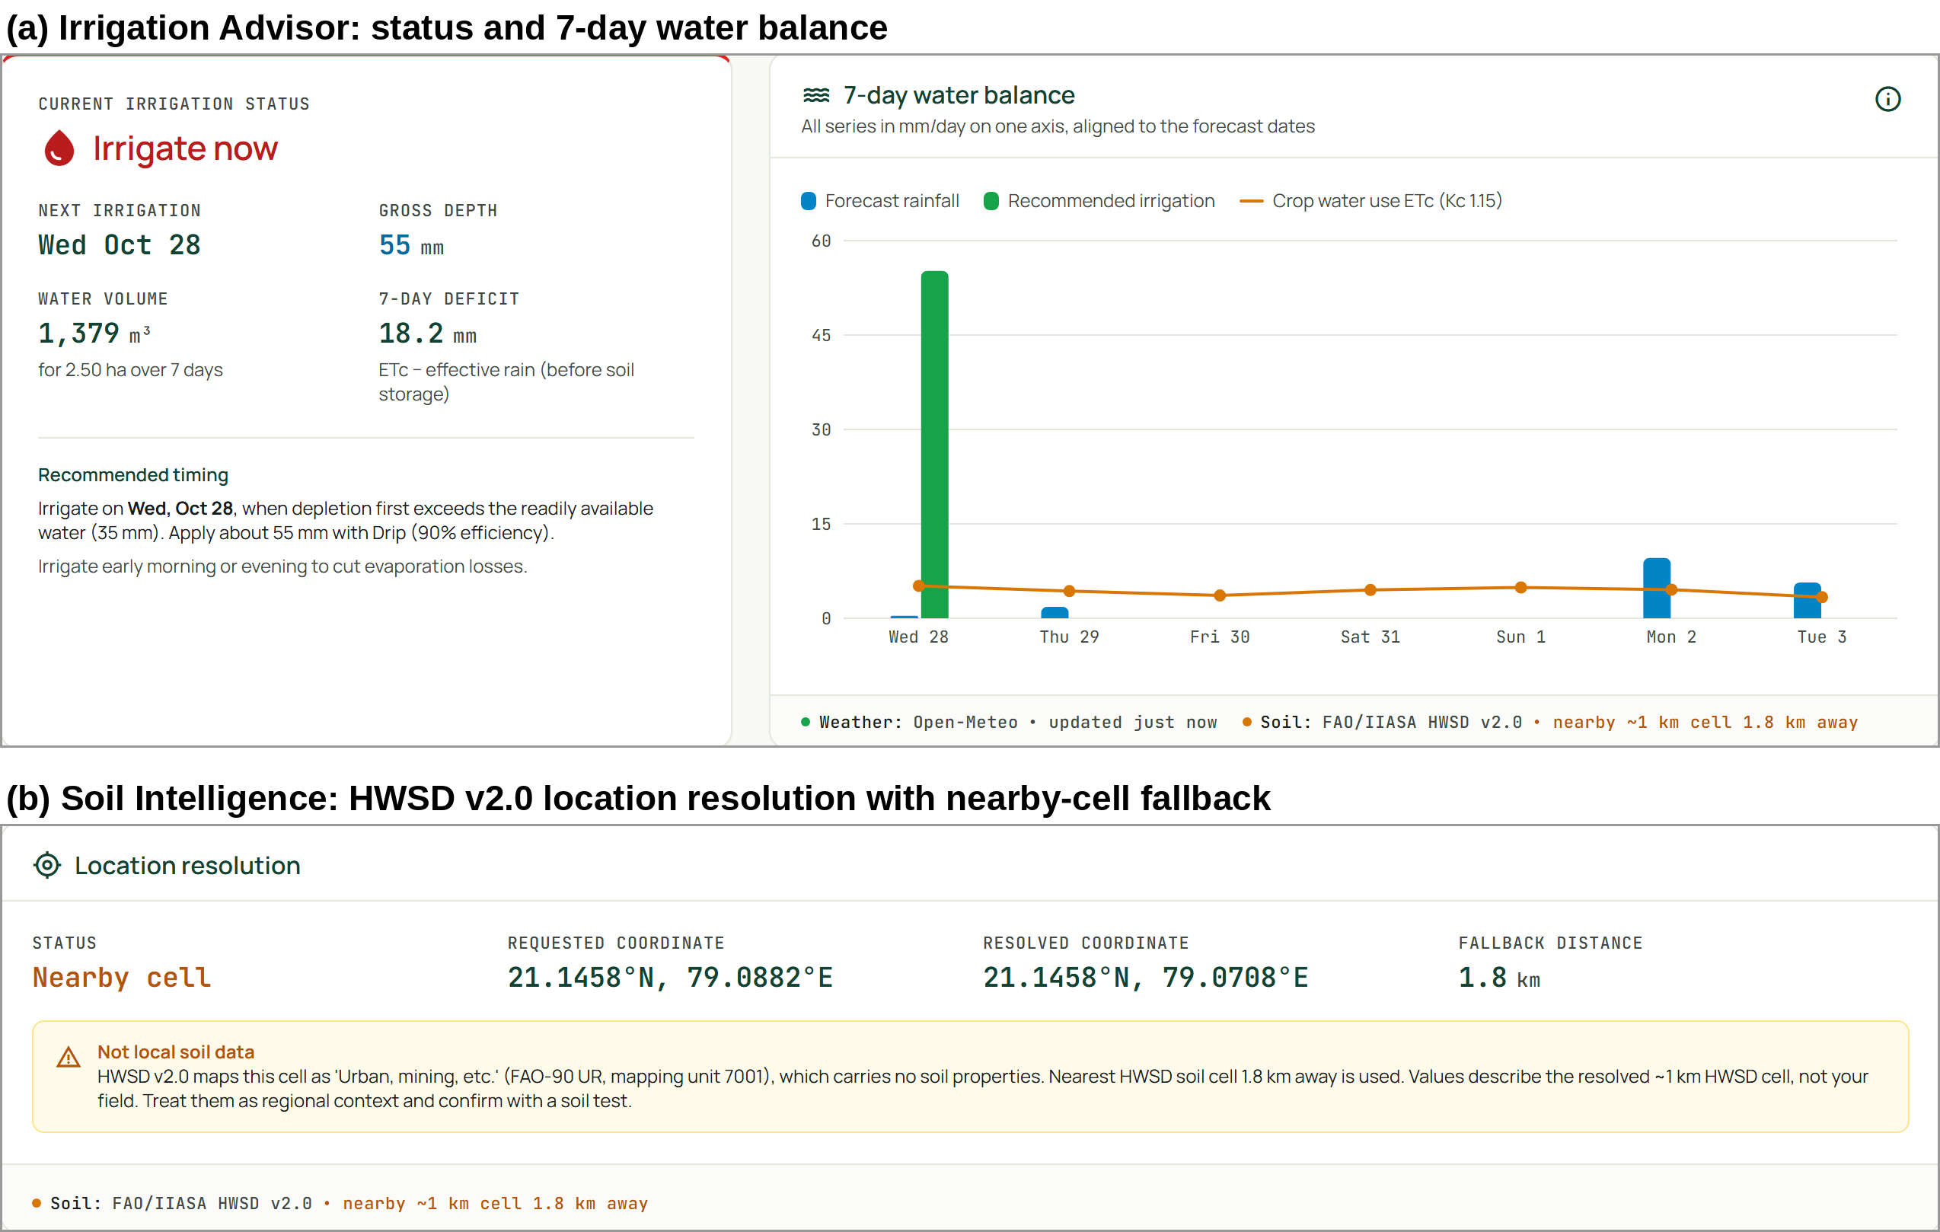
- Authentic screens of the running application (captured by the authors; cropped, not edited). (a) The irrigation advisor for a 2.5-ha drip-irrigated wheat farm. (b) The soil page, where the farm’s own HWSD cell is mapped as urban and a soil cell 1.8 km away is used and labelled as such.
The screens are consistent with the equations of Section III. For the clay texture returned by HWSD, θ_{FC} = 0.36 and θ_{WP} = 0.22 give TAW = 1000 × 0.14 × 0.5 = 70 mm and RAW = 35 mm, as displayed. The modelled moisture θ = 0.271 m³/m³ gives D_{r,0} = 1000 × (0.36 − 0.271) × 0.5 = 44.5 mm > RAW, which yields the status “irrigate now”. The displayed 1,379 m³ corresponds through (13) to 55.2 mm of gross irrigation over 2.5 ha, and the 18.2-mm deficit equals the displayed crop water use (30.4 mm) minus effective rainfall (12.2 mm). This check verifies arithmetic consistency between code and interface, not the agronomic correctness of the schedule.

Experimental Evaluation and Discussion
The evaluation separates three kinds of evidence: predictive metrics stored in the model metadata, functional tests of deterministic logic, and assumptions that remain unvalidated.

Experimental Configuration
The repository was inspected at commit 21c73e6 (24 September 2026). On 28 October 2026 the test suite and the training script were executed in a clean environment (Python 3.13.17, XGBoost 3.4.1, scikit-learn 1.9.1, pandas 3.1.0, SHAP 0.54.1; the repository does not pin versions). Retraining with python -m src.models.train reproduced every stored classifier and regressor metric to the reported precision. The classifier uses a stratified 80/20 split with random seed 42 (1,760 training and 440 hold-out rows, 20 per crop) and stratified, shuffled five-fold cross-validation on all 2,200 rows. Macro precision, recall and F1 average the per-class values over the K = 22 classes:
P=1Kc​TPcTPc+FPc, R=1Kc​TPcTPc+FNc
F1=1Kc​2PcRcPc+Rc (14)

Crop-Classification Results
Fig. 4(a) reports the stored results (model metadata, v2.1, reproduced on 28 October 2026). The full variant reached hold-out accuracy 98.86 % (macro P 98.94 %, R 98.86 %, F1 98.85 %; CV 99.27 ± 0.33 %) and the climate variant 94.09 % (P 94.20 %, R 94.09 %, F1 94.01 %; CV 95.82 ± 0.53 %); because the hold-out set is balanced, weighted and macro averages coincide. The full variant misclassified 5 of 440 rows: lentil was the weakest class (recall 0.85; two rows predicted as mung bean and one as moth bean), and single rows of pigeon pea and rice were predicted as black gram and jute. Without N, P and K, 26 rows were misclassified; pomegranate (F1 0.811, three rows predicted as apple) and orange (F1 0.821, confused with papaya and pomegranate) were weakest, consistent with fruit crops whose climatic ranges overlap once nutrient information is removed.
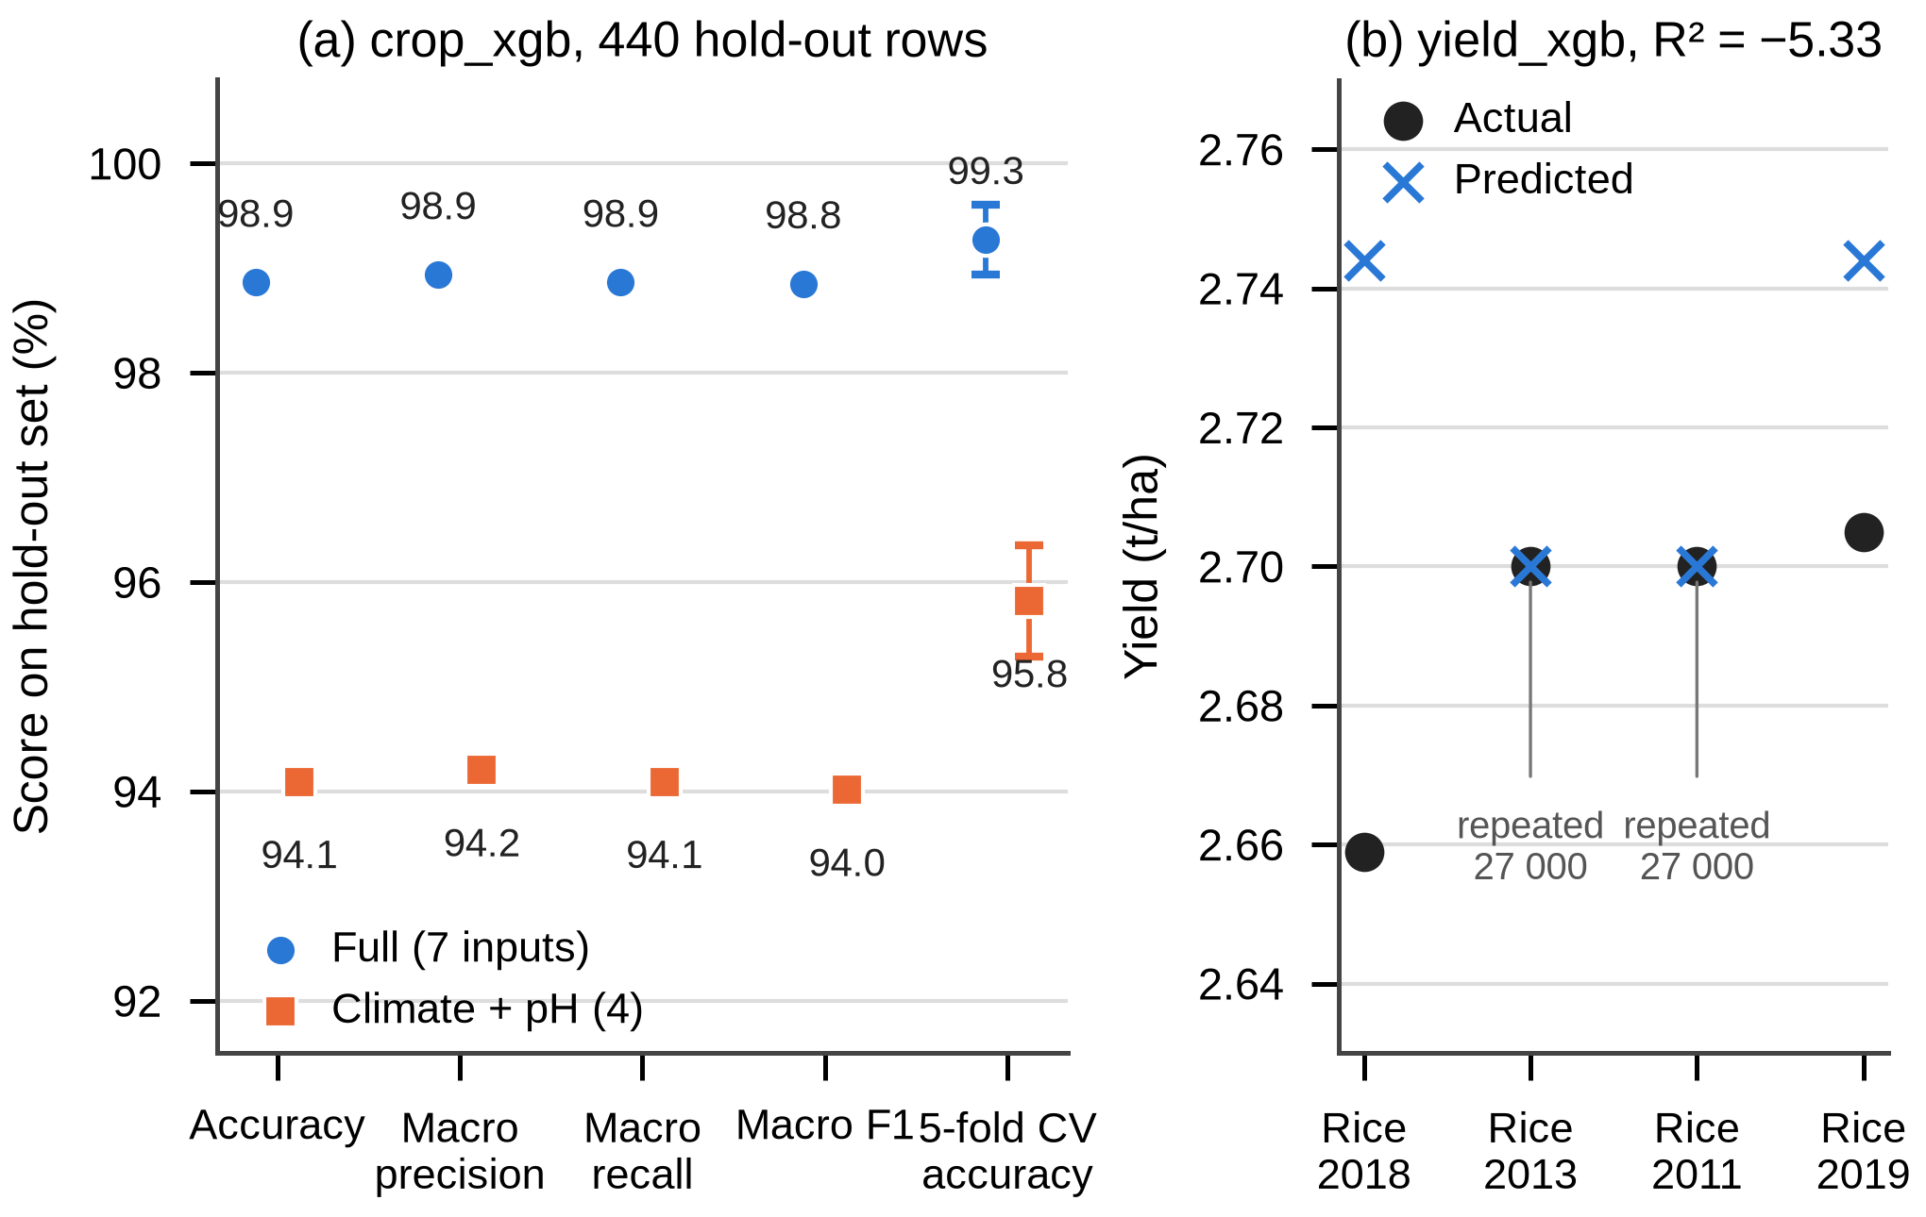
- (a) Hold-out metrics of the two classifier variants; error bars show the cross-validation standard deviation. (b) The four yield hold-out rows in t/ha; two actual values are the repeated 27,000-hg/ha entry. Data: stored model metadata.
These figures measure separability of the benchmark, not agronomic validity. The benchmark’s rows carry no location, its rainfall is on a monthly scale that KrishiMitra must emulate, and a farm’s four-month climate mean can fall outside the benchmark’s feature space, where errors are not bounded by cross-validation [7]. The 4.8-point drop without N, P and K is the more decision-relevant finding: most users will not have a soil test, so the climate variant is the one usually run, and even it is evaluated only on benchmark rows.

Yield-Regression Results
The regressor was trained on 16 rows and tested on 4, all rice (seed 42, random split). With target y_{i} in hg/ha,
MAE=1ni​|yi-yi|, RMSE=1ni​yi-yi2
R2=1-i​yi-yi2i​yi-y2 (15)
the stored results are MAE = 310.0 hg/ha (0.031 t/ha), RMSE = 467.6 hg/ha (0.047 t/ha) and R² = −5.33. A negative R² means the model’s squared error (874,585 hg²/ha²) is 6.3 times that of predicting the hold-out mean (138,200 hg²/ha²). The small absolute error is misleading: the hold-out values span only 26,590–27,050 hg/ha, and two of the four rows (2011 and 2013) are the repeated 27,000-hg/ha entry, which the model reproduces exactly (Fig. 4(b)); the repository README states three, but the stored predictions show two. Wheat never appears in the hold-out set, so its error is unknown. For the current year the model returns 2.70 t/ha for rice and 3.53 t/ha for wheat; TreeSHAP attributes the wheat estimate to a base value of 2.797 t/ha plus 0.692 t/ha from Crop_Rice = 0 and 0.044 t/ha from Year, which shows that the explanation describes one-hot arithmetic rather than agronomy. The model is therefore experimental and unsuitable for decisions; the low-reliability label and the reference fallback are the appropriate responses.

Rule-Engine and Software Verification
No labelled ground truth exists for the rule engine, irrigation, soil or risk logic, so accuracy, precision, recall and F1 are not reported for them. They are verified instead by the 24 pytest functions in tests/test_core.py. Running pytest produced 23 passes and 1 skip in 1.54 s; the skipped test needs the real HWSD dataset, which is not distributed with the repository. The tests cover texture classification and amendment rules; irrigation scheduling and missing ET₀; season labels and sowing windows; HWSD lookup, radius-limited fallback, missing attributes, invalid coordinates and cache isolation on a synthetic 5 × 5 grid; market matching and fallbacks; exponential negative caching (60, 120, 240 s); summaries that survive soil, market, weather and climatology outages; separation of ranking from economics; request coalescing; classifier-variant routing; and agreement between model cards and stored confusion matrices. In the irrigation test (ET₀ = 6 mm/day, no rain, wheat, loam, drip), TAW = 65 mm, RAW = 32.5 mm and ET_{c} = 6.9 mm/day, so depletion first exceeds RAW on day 5 (34.5 mm), giving a gross depth of 38.3 mm, which equals 34.5/0.9 as asserted. The tests do not cover the frontend, the agronomic validity of the ranges or any comparison with field observations.

- Summary of KrishiMitra Evaluation and Reliability
Component | Evaluation method | Dataset or test basis | Metric or outcome | Interpretation | Limitation
Crop classifier | Stratified hold-out + 5-fold CV | Public benchmark, 2,200 rows | Acc. 98.86 % / 94.09 %; CV 99.27 % / 95.82 % | Benchmark separable with or without soil test | No farm or regional test set
Yield regressor | Random 80/20 hold-out | 20-row sample, 4 test rows (rice) | MAE 0.031 t/ha; RMSE 0.047 t/ha; R² = −5.33 | Worse than mean baseline | Placeholder-like data; wheat untested
Rule engine | Unit and integration tests | Controlled summaries with mocked sources | Pass: ranking, eligibility, outages | Logic behaves as specified | Thresholds not validated agronomically
Soil processing | Unit tests | Synthetic 5 × 5 HWSD grid | Pass: lookup, fallback, errors; real-data test skipped | Lookup logic correct on synthetic grid | Real HWSD not tested here
Irrigation scheduler | Unit test; screen check | Constant ET₀; authentic screen | Trigger day 5, 38.3 mm; screen values reproduced | Arithmetic consistent | No field soil-moisture validation
Data clients | Unit tests | Mocked HTTP failures and markets | Pass: back-off 60/120/240 s, fallbacks | Degrades as designed | Live availability not guaranteed
Whole system | Test suite run | 24 tests, 2026-10-28 | 23 passed, 1 skipped (1.54 s) | Backend verified functionally | No UI tests, field trial or user study

Discussion in Relation to Prior Work
The classifier’s scores sit in the range commonly reported for curated crop-recommendation data, but, as the reviews and the area-of-applicability analysis caution [6], [7], such scores say little about performance at new sites; KrishiMitra therefore shows them as a labelled opinion rather than a decision. The yield result confirms the warning of Paudel et al. [19] that a model must beat a no-skill baseline before it is used: with year and crop identity as the only inputs, no tree ensemble can learn the weather and soil effects that the reviewed studies exploit [16], [17]. The range-based rule engine follows the EcoCrop tradition [13] and the interpretability argument of Rudin [8], trading statistical learning for transparency and operation without labelled data. Unlike the reviewed systems, its weakness is calibration rather than generalisation: its intervals and penalty shape are explicit and therefore testable against field data, which is the natural next experiment.

Limitations and Future Work
The following limitations apply to the current implementation; each is paired with a concrete next step, which is proposed rather than completed.
- Benchmark mismatch. The classifier has never been tested on farm data. A labelled regional dataset with sowing records, evaluated with spatially blocked cross-validation and an area-of-applicability check [7], is required before its opinion carries weight.
- No field validation. Recommendations, irrigation schedules and risk ratings have not been compared with observed outcomes. Multi-season field trials and a usability study with farmers and extension workers [2] are needed.
- Yield data. The regressor uses year and crop only, trained on 20 partly placeholder rows. Replacing it with district-level statistics joined to weather and soil features, evaluated against trend and mean baselines [19], is the priority for that module.
- Uncalibrated rules. Intervals, the 0.2 floor, the 0.5 off-season factor and the 0.40 eligibility threshold were set by hand. Calibrating them against regional crop statistics, as EcoCrop does [13], would make the scores testable.
- Irrigation simplifications. Fixed root depth, a single mid-season K_{c}, texture-table water limits and a heuristic effective-rain rule should be replaced by stage-dependent K_{c} [20] and checked against soil-moisture sensors.
- Spatial uncertainty of soil data. HWSD gives one dominant component per 1-km unit; SoilGrids 2.0 uncertainty layers [22] or farm soil tests would reduce this.
- Service dependence. Rate limits (the public data.gov.in key returns at most ten records per call) and free-tier terms constrain deployment; personal keys, persistent caching of climatology and version-pinned dependencies are required for production use, together with a security review of the open CORS policy.

Conclusion
KrishiMitra integrates live forecasts, historical climatology, an offline soil grid, market observations and geocoding into one canonical farm summary that drives a transparent crop ranking, an independent ML opinion, a seven-day irrigation plan and rated risks, while recording the source, status and reliability of every value. The verified findings are deliberately uneven: the classifier separates a public benchmark almost perfectly (98.86 % with seven inputs, 94.09 % without a soil test), the yield regressor performs worse than a mean baseline (R² = −5.33) and is labelled accordingly, and the deterministic modules pass 23 of 24 functional tests with one skipped for lack of the real soil database. The system’s value therefore lies in integration and honest reporting rather than in predictive accuracy; establishing agronomic benefit requires the regional data, calibration and field trials outlined above.

References
- Z. Zhai, J. F. Martínez, V. Beltran, and N. L. Martínez, “Decision support systems for agriculture 4.0: Survey and challenges,” Computers and Electronics in Agriculture, vol. 170, Art. no. 105256, 2020, doi: 10.1016/j.compag.2020.105256.
- D. C. Rose et al., “Decision support tools for agriculture: Towards effective design and delivery,” Agricultural Systems, vol. 149, pp. 165–174, 2016, doi: 10.1016/j.agsy.2016.09.009.
- S. Pudumalar, E. Ramanujam, R. H. Rajashree, C. Kavya, T. Kiruthika, and J. Nisha, “Crop recommendation system for precision agriculture,” in Proc. 8th Int. Conf. Advanced Computing (ICoAC), Chennai, India, 2017, pp. 32–36, doi: 10.1109/ICoAC.2017.7951740.
- K. G. Liakos, P. Busato, D. Moshou, S. Pearson, and D. Bochtis, “Machine learning in agriculture: A review,” Sensors, vol. 18, no. 8, Art. no. 2674, 2018, doi: 10.3390/s18082674.
- A. Kamilaris and F. X. Prenafeta-Boldú, “Deep learning in agriculture: A survey,” Computers and Electronics in Agriculture, vol. 147, pp. 70–90, 2018, doi: 10.1016/j.compag.2018.02.016.
- T. van Klompenburg, A. Kassahun, and C. Catal, “Crop yield prediction using machine learning: A systematic literature review,” Computers and Electronics in Agriculture, vol. 177, Art. no. 105709, 2020, doi: 10.1016/j.compag.2020.105709.
- H. Meyer and E. Pebesma, “Predicting into unknown space? Estimating the area of applicability of spatial prediction models,” Methods in Ecology and Evolution, vol. 12, no. 9, pp. 1620–1633, 2021, doi: 10.1111/2041-210X.13650.
- C. Rudin, “Stop explaining black box machine learning models for high stakes decisions and use interpretable models instead,” Nature Machine Intelligence, vol. 1, no. 5, pp. 206–215, 2019, doi: 10.1038/s42256-019-0048-x.
- FAO and IIASA, Harmonized World Soil Database Version 2.0. Rome, Italy, and Laxenburg, Austria: FAO and IIASA, 2023, doi: 10.4060/cc3823en.
- A. Gupta and P. A. Burange, “KrishiMitra-ADSS,” GitHub repository, commit 21c73e6, Sep. 2026. [Online]. Available: https://github.com/AakarGupta-coder/KrishiMitra-ADSS
- R. G. Allen, L. S. Pereira, D. Raes, and M. Smith, Crop Evapotranspiration: Guidelines for Computing Crop Water Requirements, FAO Irrigation and Drainage Paper 56. Rome, Italy: FAO, 1998.
- R. Kumar, M. P. Singh, P. Kumar, and J. P. Singh, “Crop selection method to maximize crop yield rate using machine learning technique,” in Proc. Int. Conf. Smart Technologies and Management for Computing, Communication, Controls, Energy and Materials (ICSTM), 2015, pp. 138–145, doi: 10.1109/ICSTM.2015.7225403.
- J. Ramirez-Villegas, A. Jarvis, and P. Läderach, “Empirical approaches for assessing impacts of climate change on agriculture: The EcoCrop model and a case study with grain sorghum,” Agricultural and Forest Meteorology, vol. 170, pp. 67–78, 2013, doi: 10.1016/j.agrformet.2011.09.005.
- L. Breiman, “Random forests,” Machine Learning, vol. 45, no. 1, pp. 5–32, 2001, doi: 10.1023/A:1010933404324.
- T. Chen and C. Guestrin, “XGBoost: A scalable tree boosting system,” in Proc. 22nd ACM SIGKDD Int. Conf. Knowledge Discovery and Data Mining, San Francisco, CA, USA, 2016, pp. 785–794, doi: 10.1145/2939672.2939785.
- J. H. Jeong et al., “Random forests for global and regional crop yield predictions,” PLOS ONE, vol. 11, no. 6, Art. no. e0156571, 2016, doi: 10.1371/journal.pone.0156571.
- S. Khaki and L. Wang, “Crop yield prediction using deep neural networks,” Frontiers in Plant Science, vol. 10, Art. no. 621, 2019, doi: 10.3389/fpls.2019.00621.
- D. Elavarasan and P. M. Durairaj Vincent, “Crop yield prediction using deep reinforcement learning model for sustainable agrarian applications,” IEEE Access, vol. 8, pp. 86886–86901, 2020, doi: 10.1109/ACCESS.2020.2992480.
- D. Paudel et al., “Machine learning for large-scale crop yield forecasting,” Agricultural Systems, vol. 187, Art. no. 103016, 2021, doi: 10.1016/j.agsy.2020.103016.
- L. S. Pereira, R. G. Allen, M. Smith, and D. Raes, “Crop evapotranspiration estimation with FAO56: Past and future,” Agricultural Water Management, vol. 147, pp. 4–20, 2015, doi: 10.1016/j.agwat.2014.07.031.
- T. Hengl et al., “SoilGrids250m: Global gridded soil information based on machine learning,” PLOS ONE, vol. 12, no. 2, Art. no. e0169748, 2017, doi: 10.1371/journal.pone.0169748.
- L. Poggio et al., “SoilGrids 2.0: Producing soil information for the globe with quantified spatial uncertainty,” SOIL, vol. 7, no. 1, pp. 217–240, 2021, doi: 10.5194/soil-7-217-2021.
- S. M. Lundberg and S.-I. Lee, “A unified approach to interpreting model predictions,” in Advances in Neural Information Processing Systems 30 (NIPS 2017), Long Beach, CA, USA, 2017, pp. 4765–4774.
- S. M. Lundberg et al., “From local explanations to global understanding with explainable AI for trees,” Nature Machine Intelligence, vol. 2, no. 1, pp. 56–67, 2020, doi: 10.1038/s42256-019-0138-9.
- M. Ryo, “Explainable artificial intelligence and interpretable machine learning for agricultural data analysis,” Artificial Intelligence in Agriculture, vol. 6, pp. 257–265, 2022, doi: 10.1016/j.aiia.2022.11.003.
- A. Ingle, “Crop recommendation dataset,” Kaggle, 2020. [Online]. Available: https://www.kaggle.com/datasets/atharvaingle/crop-recommendation-dataset
- P. Zippenfenig, “Open-Meteo.com Weather API,” version 1.4.0, Zenodo, 2024, doi: 10.5281/zenodo.14582479.
- FAO, “FAOSTAT: Crops and livestock products.” [Online]. Available: https://www.fao.org/faostat/en/#data/QCL
- NASA Langley Research Center, “POWER data sources.” [Online]. Available: https://power.larc.nasa.gov/docs/methodology/data/sources/ (accessed Oct. 28, 2026).
- Open Government Data Platform India, “Current daily price of various commodities from various markets (Mandi),” resource 9ef84268-d588-465a-a308-a864a43d0070, source: AGMARKNET. [Online]. Available: https://data.gov.in/resource/current-daily-price-various-commodities-various-markets-mandi (accessed Oct. 28, 2026).
- OpenStreetMap Foundation, “Nominatim usage policy.” [Online]. Available: https://operations.osmfoundation.org/policies/nominatim/ (accessed Oct. 28, 2026).
- Open-Meteo, “Terms and conditions.” [Online]. Available: https://open-meteo.com/en/terms (accessed Oct. 28, 2026).

