CSE 3243 Web Programming Lab
Mini Project Report on

Manipal Airlines — Airline Reservation System

SUBMITTED BY
Name | Roll No. | Reg. No.
ABC | 23 | 200905200
XYZ | 24 | 200905202

Section XX

Under the Guidance of:
XXXXXXXX and YYYYYYY

School of Computer Engineering
Manipal Institute of Technology, Manipal, Karnataka — 576104
2025-26

Acknowledgement
We would like to express our sincere gratitude to our faculty guides for their continuous support and guidance throughout the development of this project. Their expertise in web development technologies and constructive feedback were instrumental in shaping the Manipal Airlines Reservation System into a well-architected, production-quality application.
We extend our thanks to the School of Computer Engineering, Manipal Institute of Technology, for providing the academic environment, laboratory facilities, and resources that enabled us to explore modern web development frameworks and design paradigms during this project.
We also acknowledge the open-source communities behind Django, Leaflet.js, Chart.js, and Google Fonts whose tools and libraries formed the backbone of our technical implementation.

Abstract
This report presents the design, development, and evaluation of 'Manipal Airlines' — a full-stack airline reservation system built as part of the CSE 3243 Web Programming Lab course. The application enables users to search for domestic flights across India, compare real-time fares across Economy and Business classes, select seats through an interactive aircraft seat map, and manage their bookings through a premium, editorial-style user interface.
The system is developed using the Django web framework (Python) for the backend with SQLite as the database, and vanilla HTML/CSS/JavaScript for the frontend. It integrates advanced features including geospatial flight route visualization using Leaflet.js, price prediction trends with Chart.js, interactive seat selection with real-time availability tracking, and a travel map dashboard showing the user's travel history.
The design philosophy follows a warm editorial aesthetic — employing a cream, navy, and terracotta color palette with Playfair Display and DM Sans typography — resulting in a unique, premium look that distinguishes it from generic airline booking interfaces. The application demonstrates full CRUD operations, user authentication, responsive design, and modern web development best practices.

Table of Contents
1. Introduction
2. Literature Review / Related Work
3. Problem Statement
4. Proposed Work
5. System Design
6. Implementation Details
7. User Experience and Interface Design
8. Testing and Validation
9. Screenshots and Output
10. Conclusion and Future Enhancements
References

1. Introduction

1.1 Background and Context
The airline industry has undergone a significant digital transformation, with online booking platforms becoming the primary method of flight reservation worldwide. In India, the domestic aviation market serves over 150 million passengers annually, and digital-first booking experiences have become essential. However, many existing platforms suffer from cluttered interfaces, hidden fees, and poor user experience.
This project was motivated by the need to design and develop a clean, transparent, and aesthetically premium airline booking system that prioritizes user experience while demonstrating full-stack web development competencies using modern technologies.

1.2 Motivation
- To build a complete, functional web application using the Django framework
- To implement real-world features like flight search, booking, seat selection, and user management
- To demonstrate advanced frontend techniques including geospatial mapping, data visualization, and responsive design
- To create a distinctive, premium design language that separates the project from generic templates

1.3 Research Objectives
The primary objectives of this project are:
- Develop a full-stack airline reservation system with Django (backend) and vanilla HTML/CSS/JS (frontend)
- Implement interactive geospatial flight route visualization using Leaflet.js
- Create a real-time interactive seat selection system with dynamic availability tracking
- Design a price prediction/trend analysis module using Chart.js
- Achieve a premium editorial design aesthetic using custom CSS design tokens
- Implement user authentication, profile management, and booking lifecycle management

1.4 Scope of the Project
The scope of this project is limited to domestic flights within India, covering 10 major airports across the country. The system supports user registration, login, flight search by origin/destination/date, seat class selection (Economy/Business), interactive seat map selection, booking confirmation with reference codes, booking history with a travel map dashboard, user profile management, and booking cancellation. Payment gateway integration is outside the scope of this academic project.

2. Literature Review / Related Work

2.1 Web Development Landscape
Modern web applications have evolved from static HTML pages to dynamic, interactive single-page applications. Key trends in the current web development landscape include:
- Framework-driven development: Django, Flask, Express.js, Next.js
- Component-based UI architecture: React, Vue.js, Angular
- API-first design: RESTful APIs and GraphQL
- Progressive Web Apps (PWAs) with offline capabilities
- Design systems with tokenized styling for consistent UI

2.2 Existing Airline Booking Systems
Major online travel agencies and airline booking platforms such as MakeMyTrip, Cleartrip, Google Flights, and Skyscanner were studied for their feature sets, user flows, and design patterns. Key observations include:
Feature | MakeMyTrip | Google Flights | Our Project
Interactive Seat Map | ✓ | ✗ | ✓
Route Map Visualization | ✗ | ✓ | ✓
Price Trend Analysis | ✗ | ✓ | ✓
Travel History Map | ✗ | ✗ | ✓

2.3 Gaps in Existing Solutions
While commercial platforms offer comprehensive features, most academic projects in web development lack visual polish and advanced interactive elements. Our project fills this gap by combining geospatial mapping, price analytics, interactive seat selection, and a unique editorial design in a single cohesive application built using open-source technologies.

3. Problem Statement
To design and develop a full-stack web-based airline reservation system that allows users to:
- Search for domestic flights across major Indian airports by origin, destination, and date
- Compare fares across Economy and Business seat classes
- View flight routes on an interactive geospatial map with layover visualization
- Analyze price trends over a 7-day window with booking recommendations
- Select specific seats using an interactive, real-time seat map
- Complete the booking process with passenger details and receive a unique booking reference
- Manage bookings — view history, cancel reservations, and track travel on a personal map dashboard
- Register, login, and manage user profiles with full authentication
The system must deliver all these features through a premium, editorially-designed user interface that prioritizes transparency, usability, and visual appeal — distinguishing itself from generic web development projects.

4. Proposed Work
The proposed system follows the Model-View-Template (MVT) architecture of Django and implements the following modules:

4.1 Module Breakdown
Module | Description
User Authentication Module | Registration, login, logout, session management using Django's built-in auth system.
Flight Search Module | Airport-based search with date and passenger count filtering.
Flight Booking Module | Seat class selection, passenger detail entry, interactive seat map, and booking confirmation.
Price Prediction Module | Deterministic price history simulation with 7-day trend analysis and booking recommendations.
Route Visualization Module | Leaflet.js-based geospatial map showing origin, destination, and layover stops.
Booking Management Module | View bookings, cancel reservations, travel history map dashboard.
User Profile Module | Profile viewing and editing with phone and address fields.

5. System Design

5.1 Technology Stack
Component | Technology
Backend Framework | Django 5.x (Python 3.12)
Frontend | HTML5, CSS3, Vanilla JavaScript (ES6+)
Database | SQLite 3 (Django ORM)
Mapping Library | Leaflet.js 1.9.4 with CartoDB tiles
Charts | Chart.js 4.4.1
Typography | Google Fonts — Playfair Display, DM Sans
Design System | Custom CSS with design tokens (CSS custom properties)
Version Control | Git

5.2 System Architecture
The application follows Django's Model-View-Template (MVT) architectural pattern, which is a variation of the classic MVC pattern:
- Model Layer: Django ORM models (Airport, Flight, Booking, UserProfile) mapped to SQLite database
- View Layer: Python functions handling HTTP requests, business logic, and data preparation
- Template Layer: Django HTML templates with template tags and filters for dynamic rendering
- Static Assets: CSS design system and JavaScript for client-side interactivity

5.3 Database Schema
The database consists of five key tables:
Table | Key Fields | Relationships
User (Django built-in) | id, username, email, password | One-to-One → UserProfile, One-to-Many → Booking
Airport | code, name, city, country, latitude, longitude | One-to-Many → Flight (origin/destination)
Flight | flight_number, airline, departure_time, arrival_time, economy_price, business_price, stops (JSON) | FK → Airport (origin, destination), One-to-Many → Booking
Booking | booking_reference, seat_class, num_passengers, selected_seats (JSON), passenger_names (JSON), total_price, status | FK → User, FK → Flight
UserProfile | phone, address | One-to-One → User

5.4 URL Routing Architecture
URL Pattern | View Function | Description
/ | home | Landing page with search form
/search/ | search_flights | Flight search results
/book/<id>/ | book_flight | Booking page with seat map
/booking/confirmation/<id>/ | booking_confirmation | Booking confirmation
/my-bookings/ | my_bookings | User booking history
/cancel-booking/<id>/ | cancel_booking | Cancel a booking
/profile/ | profile | User profile management
/register/ | register_view | New user registration
/login/ | login_view | User login
/logout/ | logout_view | User logout

6. Implementation Details

6.1 Development Environment
- IDE: Visual Studio Code
- Python Version: 3.12
- Django Version: 5.x
- Browser Testing: Chrome, Firefox
- Operating System: Windows 10/11

6.2 Backend Implementation

6.2.1 Models (flights/models.py)
The database models define the schema for airports, flights, bookings, and user profiles. Key design decisions include:
- Using JSON text fields for storing layover stops, passenger names, and selected seats to maintain flexibility
- Computing seat availability dynamically via Django ORM aggregation (Sum) on confirmed bookings
- Auto-generating 8-character alphanumeric booking references on save
- Using Django's built-in User model extended with a OneToOneField UserProfile
Example — Dynamic seat availability computation:
@property
def economy_seats_available(self):
booked = self.bookings.filter(
seat_class='economy', status='confirmed'
).aggregate(total=models.Sum('num_passengers'))['total'] or 0
return self.total_economy_seats - booked
Example — Retrieving booked seats for overlap validation:
def get_booked_seats(self, seat_class):
bookings = self.bookings.filter(seat_class=seat_class, status='confirmed')
booked = []
for b in bookings:
seats = json.loads(b.selected_seats)
booked.extend(seats)
return booked

6.2.2 Views (flights/views.py)
The view layer handles all HTTP request processing. Key implementations include:
Flight Search:
The search_flights view filters flights by origin, destination, and departure date using Django ORM queries. It passes search results along with passenger count to the template.
Booking with Seat Selection:
The book_flight view handles both GET and POST requests. On POST, it validates seat class, checks availability against the database, validates that the correct number of seats are selected, performs overlap detection to prevent double-booking of specific seats, and creates the booking record.
Seat overlap validation logic:
booked_so_far = flight.get_booked_seats(seat_class)
overlap = set(selected_seats).intersection(set(booked_so_far))
if overlap:
messages.error(request, f'Seats {", ".join(overlap)} are already booked.')
return redirect('book_flight', flight_id=flight.id)
Price Prediction:
The price predictor generates a deterministic 7-day price history using a seeded random number generator based on the flight ID. It computes a trend by comparing the average of the last 3 days versus the first 3 days, and provides a recommendation (Book Now / Wait / Good Time to Book) with a color-coded badge.

6.2.3 Forms (flights/forms.py)
Django forms are used for data validation and rendering:
- FlightSearchForm: Origin/destination airports (ModelChoiceField), date, and passenger count
- BookingForm: Dynamically generated passenger name fields based on num_passengers, seat class radio, hidden selected_seats field
- RegistrationForm: Extends Django's UserCreationForm with email, first/last name
- ProfileForm: First name, last name, email, phone, address

6.3 Frontend Implementation

6.3.1 Design System (static/css/style.css)
The application uses a comprehensive CSS design system with 50+ custom properties (CSS variables) organized as design tokens. This ensures visual consistency across all pages.
Key design tokens include:
:root {
--bg-primary: #f6f2ec; /* Warm cream background */
--accent: #c05d3b; /* Terracotta accent */
--navy: #1a2744; /* Deep navy for headings */
--font-display: 'Playfair Display', serif;
--font-body: 'DM Sans', sans-serif;
--radius-lg: 16px;
--shadow-md: 0 4px 16px rgba(26,39,68,0.08);
}
The color palette was deliberately chosen to create a 'warm editorial' feel — avoiding the typical cold blues and grays of generic airline platforms.

6.3.2 Interactive Flight Route Map
The flight route visualization uses Leaflet.js with CartoDB light tiles. The map dynamically renders the route with color-coded markers (terracotta for origin, green for destination, amber for layover stops) and dashed polyline connections. Route data is serialized as JSON from the Django view and injected into the JavaScript initialization.

6.3.3 Interactive Seat Map
The seat map is generated entirely in JavaScript with a plane fuselage visual. Key features:
- Business class: 5 rows × 2-2 layout (seats A, B, J, K)
- Economy class: 25 rows × 3-3 layout (seats A, B, C, E, F, G)
- Visual states: Available (neutral), Selected (terracotta accent), Booked (grayed out)
- Selection limit enforced based on passenger count
- Real-time counter showing selected vs. required seats
- Seat map regenerates on class toggle (Economy ↔ Business)

6.3.4 Price Prediction Chart
Chart.js renders a line chart showing 7-day price history with gradient fill. The chart adapts its color based on the trend: red for rising, amber for stable, green for falling. A recommendation badge provides actionable advice (Book Now / Wait / Good Time to Book).

6.3.5 Skeleton Loading Animation
The search results page implements a shimmer/skeleton loading animation that shows placeholder card shapes with a CSS animation while results load. After a 1.2-second simulated delay, the actual results fade in with opacity transitions.

7. User Experience and Interface Design

7.1 Design Philosophy
The UI design follows a 'warm editorial' aesthetic, inspired by premium travel magazines and boutique hotel websites rather than typical airline booking platforms. Key principles:
- Warm Palette: Cream (#f6f2ec), navy (#1a2744), and terracotta (#c05d3b) create a welcoming, premium feel
- Editorial Typography: Playfair Display (serif) for headings, DM Sans (sans-serif) for body — evoking trust and sophistication
- Generous Whitespace: Consistent spacing and padding prevent visual clutter
- Subtle Dot Pattern: A fixed background with radial-gradient dots adds texture without distraction
- Glass Cards: White cards with subtle borders and shadows create depth hierarchy
- Micro-animations: Hover transforms, fade-in-up animations, and pulse effects on badges

7.2 Responsive Design
The application implements responsive design through CSS media queries with breakpoints at 768px and 480px. Key responsive behaviors include:
- Navigation: Hamburger menu toggle on mobile with slide-down nav links
- Search Grid: Collapses from 4-column to single-column layout
- Feature Cards: Stacks vertically on smaller screens
- Seat Map: Scales down with smaller seat dimensions on mobile
- Flight Route Cards: Simplified layout with stacked information

7.3 Accessibility Considerations
- Semantic HTML5 elements (nav, main, footer, section)
- ARIA labels on interactive elements (nav-toggle button)
- Sufficient color contrast ratios for text readability
- Focus states on form inputs with accent-colored box-shadow
- Auto-dismissing alerts with smooth opacity transitions

8. Testing and Validation

8.1 Testing Strategies
The following testing approaches were employed:
Manual Functional Testing:
Test Case | Expected Result | Status
User Registration | Account created, user logged in | ✓ Pass
User Login/Logout | Session managed correctly | ✓ Pass
Flight Search | Flights filtered by origin/destination/date | ✓ Pass
Seat Selection | Correct number of seats enforced | ✓ Pass
Double-booking Prevention | Overlap detected and rejected | ✓ Pass
Booking Confirmation | Reference code generated, details displayed | ✓ Pass
Booking Cancellation | Status updated, seats freed | ✓ Pass
Route Map Rendering | Leaflet map shows correct route | ✓ Pass

8.2 Browser Compatibility
- Google Chrome 120+ — Full support ✓
- Mozilla Firefox 118+ — Full support ✓
- Microsoft Edge 120+ — Full support ✓
- Safari 17+ — Full support ✓

8.3 Validation Results
- All Django form validations working correctly (required fields, email format, password strength)
- CSRF protection enabled on all POST forms
- Login-required decorator protecting authenticated routes
- Client-side seat selection validation before form submission

9. Screenshots and Output
The following screenshots demonstrate the key pages and features of the Manipal Airlines reservation system, captured from the running application.

9.1 Home Page
The landing page features a hero section with editorial typography, a flight search form, feature highlights, and trending destination cards.
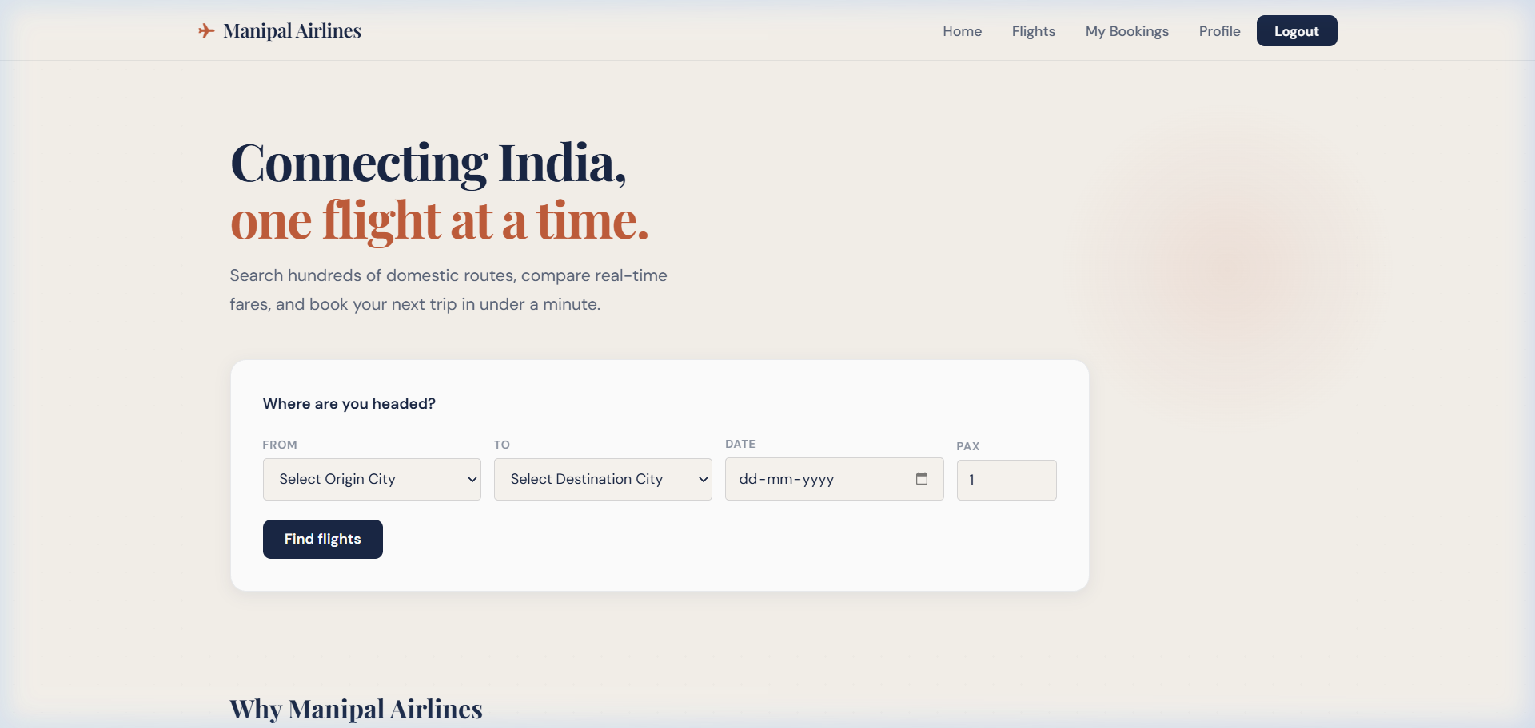
Figure 1: Home Page — Hero section with flight search form

9.2 Login Page
Clean authentication interface with glass card design, centered layout, and clear call-to-action.
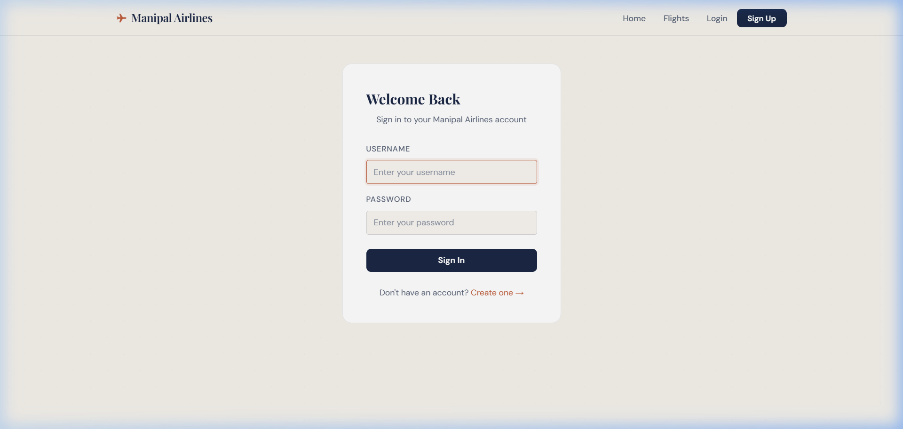
Figure 2: Login Page — User authentication

9.3 Registration Page
New user registration form with username, name, email, and password fields. Password validation rules are displayed inline.
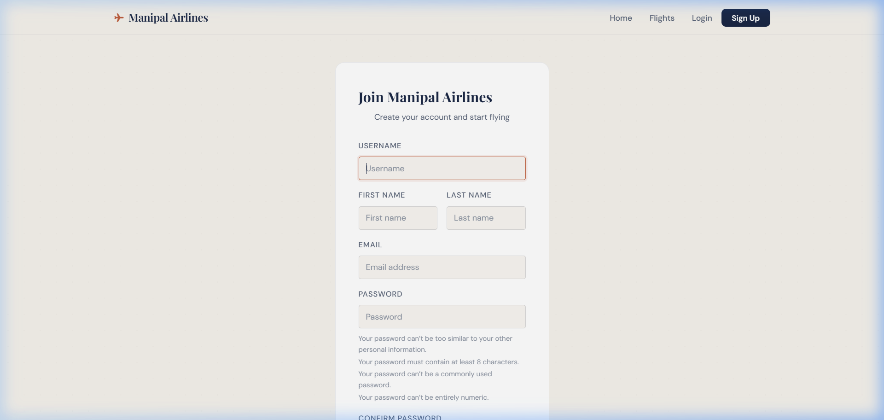
Figure 3: Registration Page — New user sign up

9.4 Flight Search Results
Search results page showing available flights with departure/arrival times, route information, seat availability, and Economy/Business pricing.
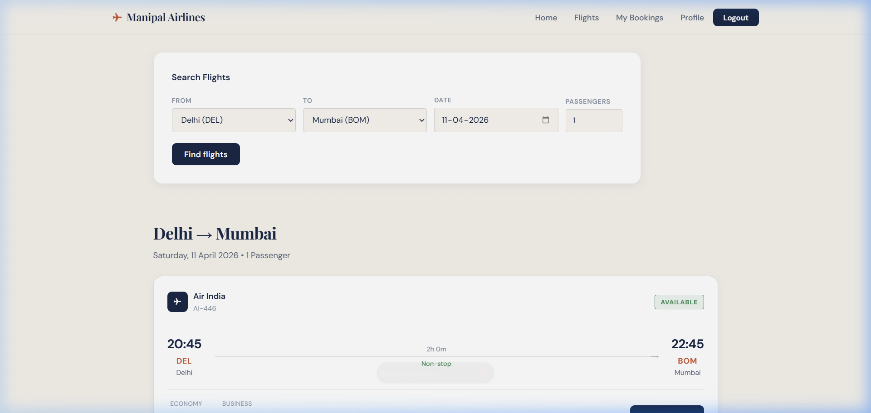
Figure 4: Search Results — Flight listings with pricing and availability

9.5 Flight Booking Page
The booking page features a flight summary card, interactive Leaflet.js route map showing the origin and destination, and the price prediction chart.
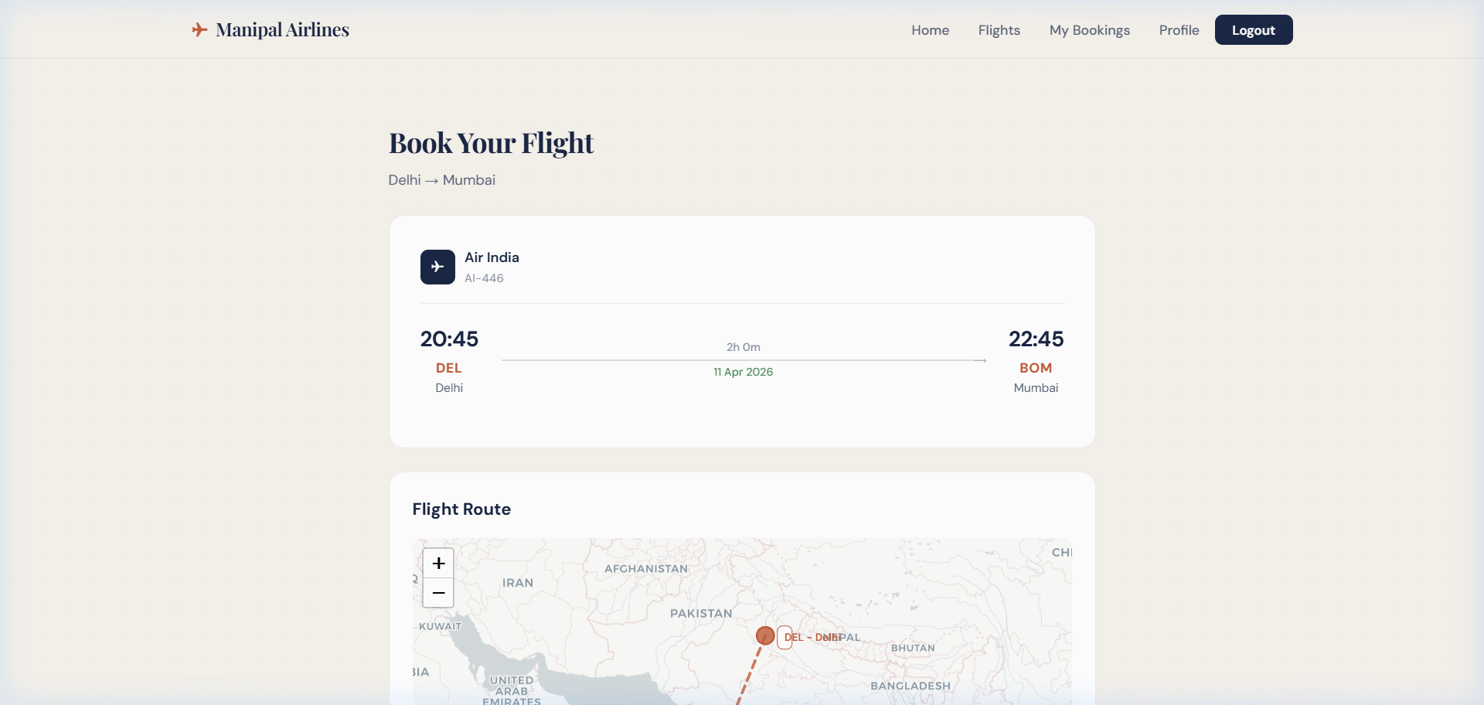
Figure 5: Booking Page — Flight details with route map

9.6 Interactive Seat Map
The interactive seat selection system showing the plane fuselage layout with Economy class seats in a 3-3 configuration. Users can click to select their preferred seats.
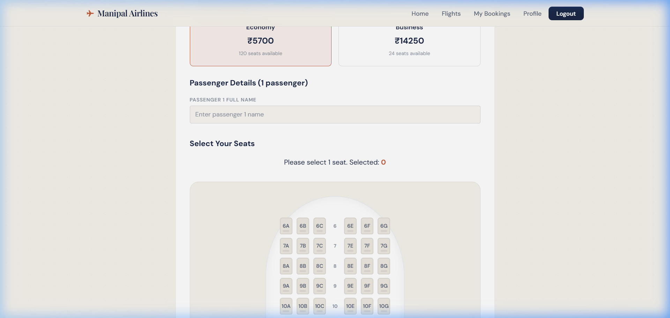
Figure 6: Interactive Seat Map — Seat class selection and plane layout

9.7 My Bookings
The booking management dashboard shows all user bookings with booking reference codes, route details, dates, and cancellation options.
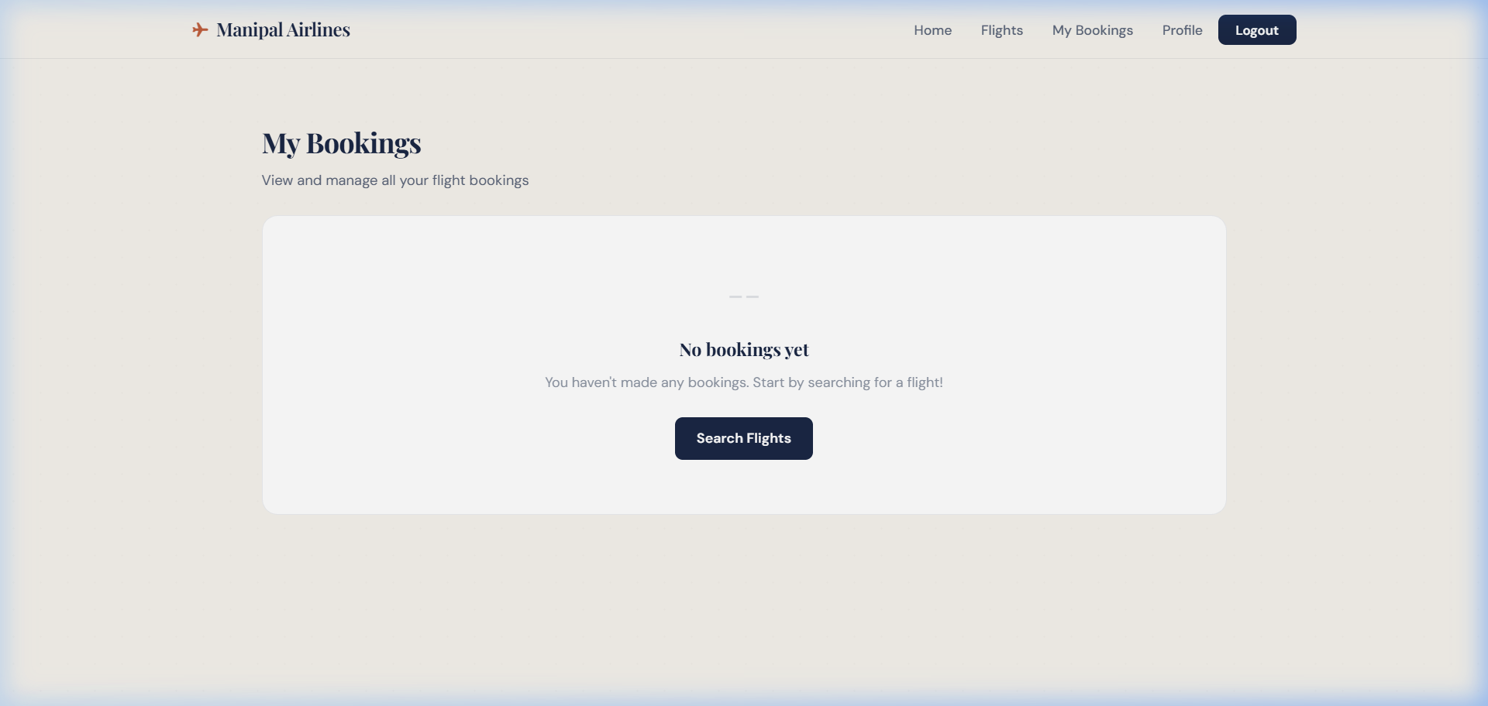
Figure 7: My Bookings — Booking history and management

9.8 User Profile
Profile management page with avatar display, personal information editing, and contact details.
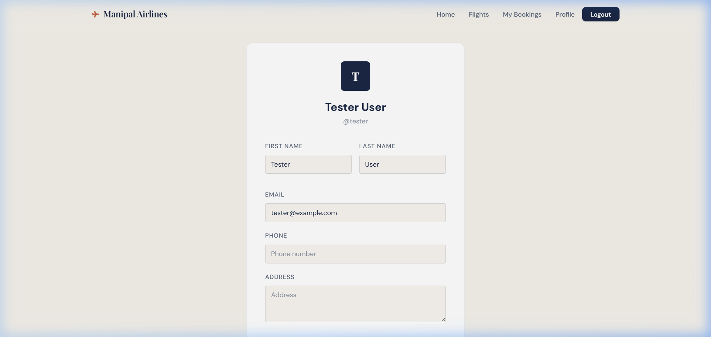
Figure 8: User Profile — Profile information management

10. Conclusion and Future Enhancements

10.1 Conclusion
The Manipal Airlines Reservation System successfully demonstrates a comprehensive full-stack web development project that goes beyond basic CRUD operations. The project integrates advanced features like geospatial mapping, price trend analysis, interactive seat selection, and a travel history dashboard — all delivered through a premium editorial design language.
Key achievements of the project include:
- A fully functional airline booking system supporting the complete booking lifecycle
- Interactive Leaflet.js-based route maps with multi-stop layover visualization
- Real-time seat selection with availability tracking and overlap prevention
- Price prediction trends with Chart.js visualization and actionable recommendations
- A distinctive warm editorial design system using CSS custom properties
- Responsive design working across desktop, tablet, and mobile devices
- Secure authentication with Django's built-in auth framework
The project successfully demonstrates proficiency in Django backend development, database design, frontend technologies (HTML/CSS/JS), third-party library integration, and modern UI/UX design principles.

10.2 Future Enhancements
- Payment Gateway Integration: Integrate Razorpay/Stripe for actual payment processing
- Email Notifications: Send booking confirmation and reminder emails using Django's email framework
- REST API: Build a Django REST Framework API layer for mobile app consumption
- Real-time Updates: Implement WebSocket support for live flight status updates
- Machine Learning Pricing: Replace deterministic price simulation with ML-based price predictions
- Multi-language Support: Add i18n support for Hindi and other regional languages
- PWA Support: Convert to a Progressive Web App with offline booking capability
- Admin Dashboard: Enhanced analytics dashboard for flight and booking management

10.3 Lessons Learned
- Django's MVT architecture provides a robust foundation for rapid web application development
- CSS custom properties (design tokens) make it easy to maintain consistent design across pages
- Client-server data passing via JSON is critical for JavaScript-heavy interactive features
- Seed-based random generation enables deterministic yet realistic data simulation for development
- A cohesive design language significantly elevates the perceived quality of a web application

References
[1] Django Documentation. (2025). Django: The Web Framework for Perfectionists with Deadlines. https://docs.djangoproject.com/
[2] Leaflet.js Documentation. (2024). Leaflet — an open-source JavaScript library for interactive maps. https://leafletjs.com/
[3] Chart.js Documentation. (2024). Chart.js — Simple yet flexible JavaScript charting. https://www.chartjs.org/docs/
[4] Google Fonts. (2025). Playfair Display & DM Sans. https://fonts.google.com/
[5] Mozilla Developer Network. (2025). CSS Custom Properties (Variables). https://developer.mozilla.org/en-US/docs/Web/CSS/Using_CSS_custom_properties
[6] CartoDB Basemaps. (2024). CARTO — Location Intelligence for Business. https://carto.com/basemaps/
[7] Python Software Foundation. (2025). Python 3.12 Documentation. https://docs.python.org/3/
[8] W3C. (2024). HTML5 Specification. https://html.spec.whatwg.org/
[9] MakeMyTrip. (2025). MakeMyTrip — Flights, Hotels, Holiday Packages. https://www.makemytrip.com/
[10] Google Flights. (2025). Google Flights — Find cheap flights. https://www.google.com/flights

