MANIPAL INSTITUTE OF TECHNOLOGY
DEPARTMENT OF COMPUTER SCIENCE & ENGINEERING
CSE4444 - Blockchain Technology | Assignment 2 Submission Report
Student Name: | Aakarsh Jha
Registration Number: | 230905248
Assignment Title: | Blockchain Technology (CSE4444) - Assignment 2
Title of Developed DApp: | CertiTrust: Decentralized Academic Credential Verification System
GitHub Repository Link: | https://github.com/Aakarsh-Jha/Blockchain-Assignment-2

1. Problem Statement & DApp Overview
Academic credential fraud and fabricated degrees pose severe integrity challenges to universities and employers. CertiTrust is an original Decentralized Application (DApp) architected on the Ethereum blockchain that establishes an immutable, publicly verifiable registry for academic qualifications. Authorized institutional authorities issue tamper-proof digital credentials linked to student identities and degree hashes. Third-party verifiers, recruiters, or regulatory bodies can instantaneously query the smart contract on-chain to authenticate credentials without administrative bottlenecks or single points of failure.

2. Technical Stack & Deployment Details
Smart Contract Language: | Solidity (^0.8.20, EVM Version: Paris)
Development & Compilation: | Remix IDE
Target Blockchain Network: | Ganache Local Network (Chain ID: 1337, RPC: http://127.0.0.1:8545)
Deployed Contract Address: | 0xCfEB869F69431e42cdB54A4F4f105C19C080A601
Authority Owner Account: | 0x90F8bf6A479f320ead074411a4B0e7944Ea8c9C1
Frontend Technologies: | HTML5, CSS3 (Modern Glassmorphic UI), JavaScript (Vanilla)
Web3 Integration: | Ethers.js v6
Wallet Integration: | MetaMask Extension (Ganache Localhost RPC)

3. Input Validation & Test Scenario Matrix
In strict compliance with the assignment specifications, the smart contract implements custom modifiers and require() statements to validate all operations. The system was tested across valid, invalid, and unauthorized inputs on the live blockchain:
Test Case | Caller | Test Input | Observed EVM Behavior
TC-01 (Valid Input) | Owner Account | Valid student name ('Aarav Sharma'), course, and hash | Transaction mined successfully in Block #4; Certificate #1 created on-chain.
TC-02 (Invalid Input) | Owner Account | Empty student name string ("") | EVM reverted immediately with: 'Validation Error: Student name cannot be empty.' Zero state change.
TC-03 (Unauthorized Access) | Non-Owner Account | Attempted invocation of issueCertificate() | EVM reverted via onlyOwner modifier: 'Error: Unauthorized! Only the university authority can perform this action.'

4. Screenshots & Execution Evidence
Figure 1: Smart Contract Compilation (Remix IDE)
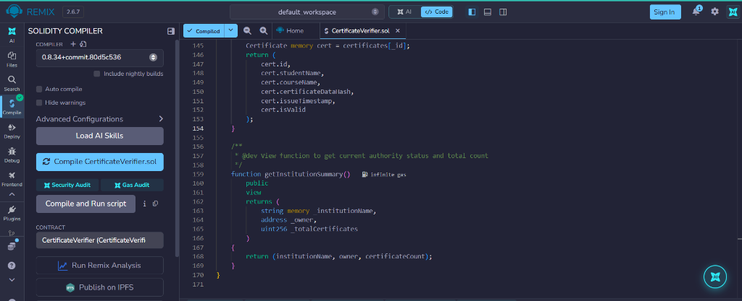

Figure 2: Smart Contract Deployment (Ganache Network)
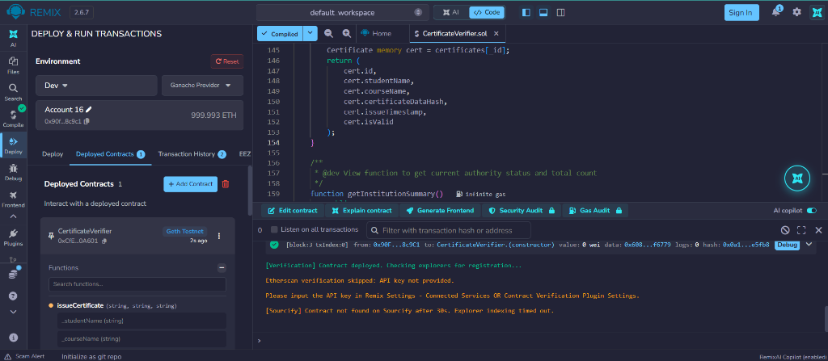

Figure 3: MetaMask Wallet Connection Handshake
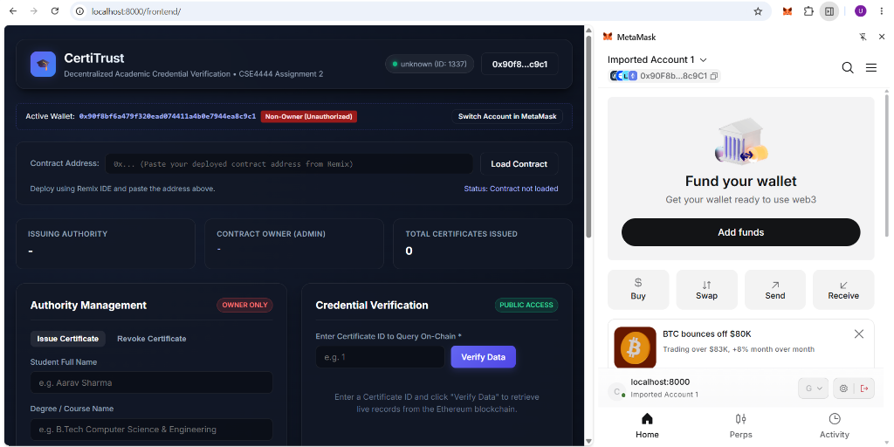

Figure 4: Successful Transaction Execution & Mining (Block #4)
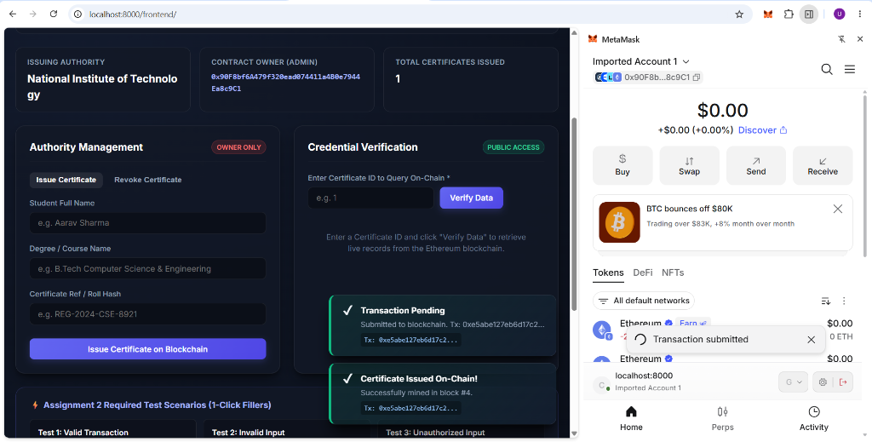

Figure 5: Failed Transaction Revert (Validation / Unauthorized)
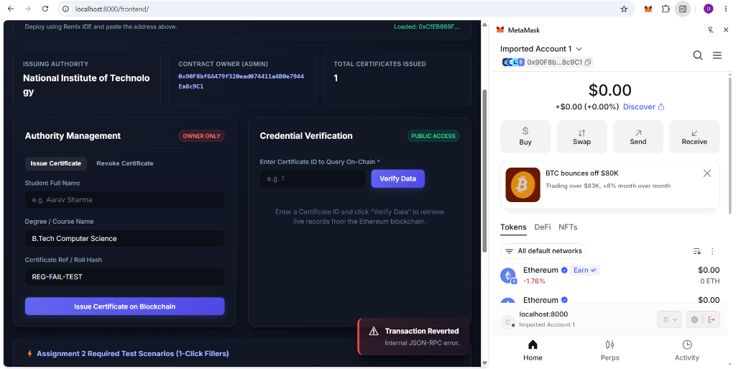

Figure 6: Blockchain Credential Retrieval & Verification in UI
