SCHOOL OF COMPUTER SCIENCE AND ARTIFICIAL INTELLIGENCE |  |  |  |  | DEPARTMENT OF COMPUTER SCIENCE ENGINEERING
Program Name: B. Tech |  |  |  | Assignment Type: Lab |  |  | Academic Year:2025-2026
Course Coordinator Name |  |  |  | Venkataramana Veeramsetty
Instructor(s) Name
  Dr. V. Venkataramana (Co-Ordinator)
  Dr. T. Sampath Kumar
  Dr. Pramoda Patro
  Dr. Brij Kishor Tiwari
  Dr.J.Ravichander
  Dr. Mohammand Ali Shaik
  Dr. Anirodh Kumar
  Mr. S.Naresh Kumar
  Dr. RAJESH VELPULA
  Mr. Kundhan Kumar
  Ms. Ch.Rajitha
  Mr. M Prakash
  Mr. B.Raju
  Intern 1 (Dharma teja)
  Intern 2 (Sai Prasad)
  Intern 3 (Sowmya)
  NS_2 ( Mounika)
Course Code |  |  | 24CS002PC215 | Course Title |  | AI Assisted Coding
Year/Sem |  |  | II/I | Regulation |  | R24
Date and Day  of Assignment |  |  | Week2 - Monday | Time(s)
Duration |  |  | 2 Hours | Applicable to  Batches
Assignment Number:4.1(Present assignment number)/24(Total number of assignments)
 | Q.No. | Question |  |  |  |  |  | Expected Time  to complete
 | 1 | Lab 4: Advanced Prompt Engineering – Zero-shot, One-shot, and Few-shot Techniques  Lab Objectives:  - To explore and apply different levels of prompt examples in AI-assisted code generation.  - To understand how zero-shot, one-shot, and few-shot prompting affect AI output quality.  - To evaluate the impact of context richness and example quantity on AI performance.  - To build awareness of prompt strategy effectiveness for different problem types.  Lab Outcomes (LOs):  After completing this lab, students will be able to:  - Use zero-shot prompting to instruct AI with minimal context.  - Use one-shot prompting with a single example to guide AI code generation.  - Apply few-shot prompting using multiple examples to improve AI responses.  - Compare AI outputs across the three prompting strategies.  Task #1 – Zero-Shot Prompting with Conditional Validation  Objective  Use zero-shot prompting to instruct an AI tool to generate a function that validates an Indian mobile number.  Requirements  - The function must ensure the mobile number:  - Starts with 6, 7, 8, or 9  - Contains exactly 10 digits  Expected Output  - A valid Python function that performs all required validations without using any input-output examples in the prompt.  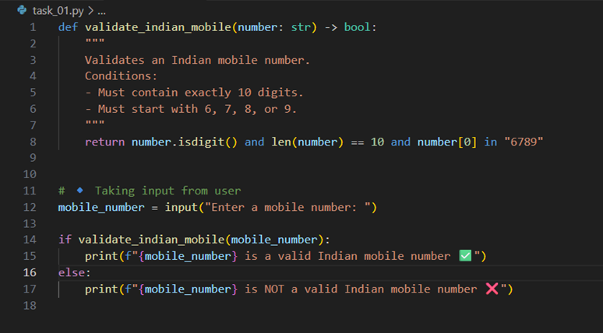  VS Code :  Cursor :  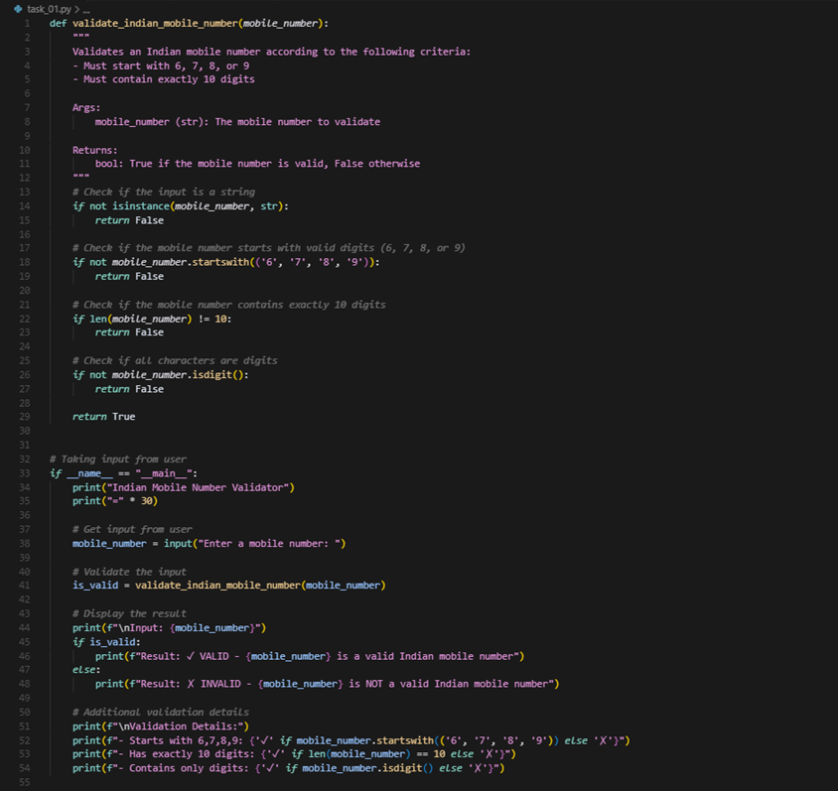  Task #2 – One-Shot Prompting with Edge Case Handling  Objective  Use one-shot prompting to generate a Python function that calculates the factorial of a number.  Requirements  - Provide one sample input-output pair in the prompt to guide the AI.  - The function should handle:  - 0! correctly  - Negative input by returning an appropriate message  Expected Output  - A Python function with correct factorial logic and edge case handling, generated from a single example.  VS Code :  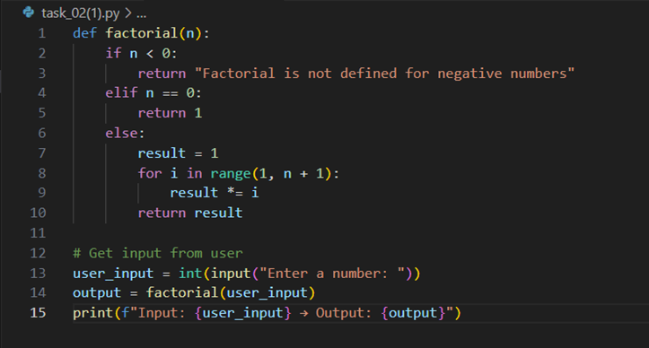  Cursor :  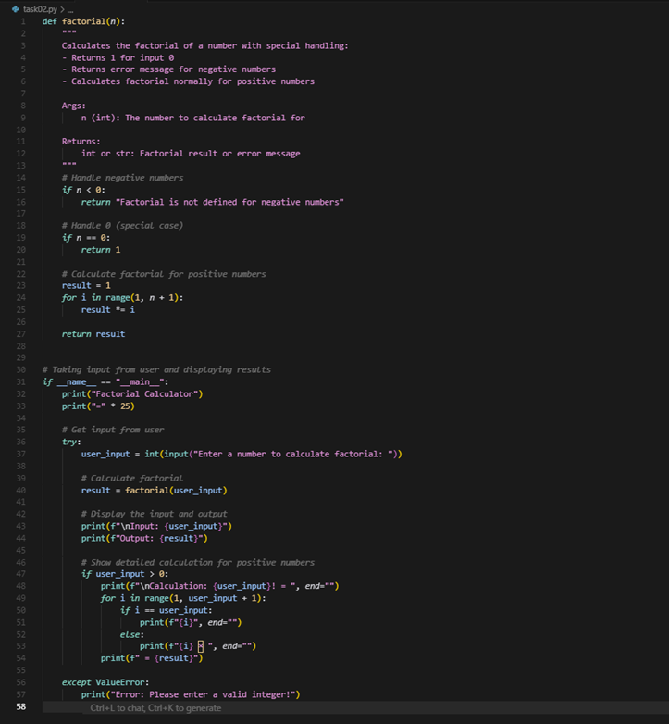  Task #3 – Few-Shot Prompting for Nested Dictionary Extraction  Objective  Use few-shot prompting (2–3 examples) to instruct the AI to create a function that parses a nested dictionary representing student information.  Requirements  - The function should extract and return:  - Full Name  - Branch  - SGPA  Expected Output  - A reusable Python function that correctly navigates and extracts values from nested dictionaries based on the provided examples  VS Code :  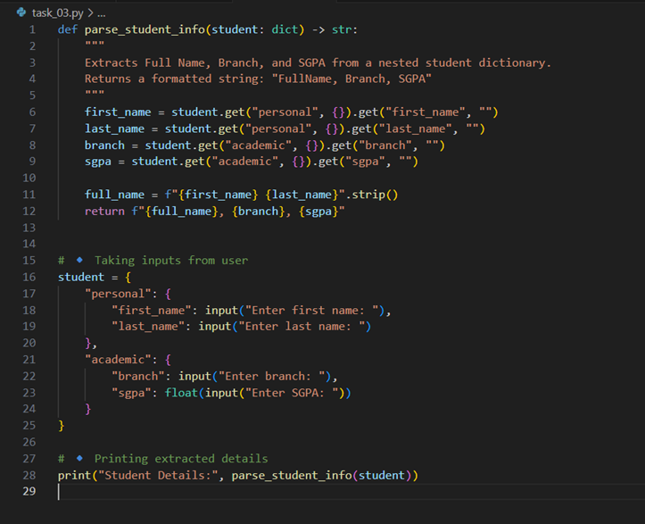  Cursor :  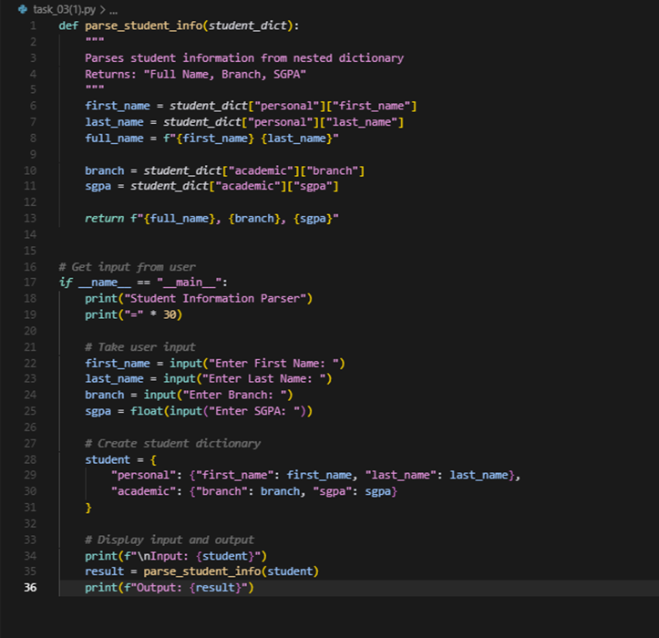  Task #4 – Comparing Prompting Styles for File Analysis  Objective  Experiment with zero-shot, one-shot, and few-shot prompting to generate functions for CSV file analysis.  Requirements  - Each generated function should:  - Read a .csv file  - Return the total number of rows  - Count the number of empty rows  - Count the number of words across the file  Expected Output  - Working Python functions for each prompting style, with a brief reflection comparing their accuracy, clarity, and efficiency.  VS Code :  Zero-shot : 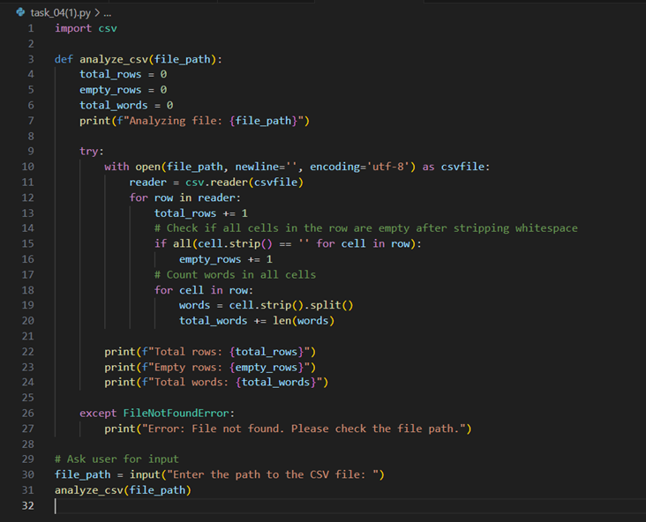  One-shot :  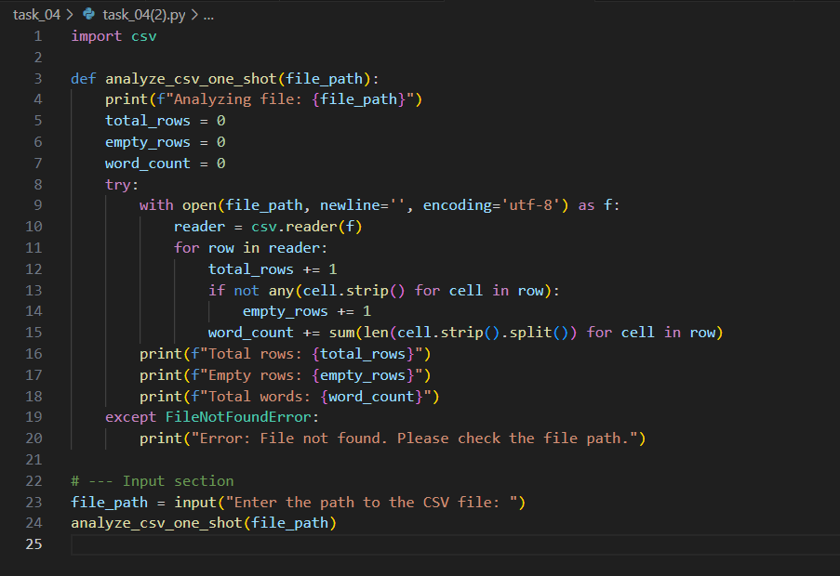  Few-shot :  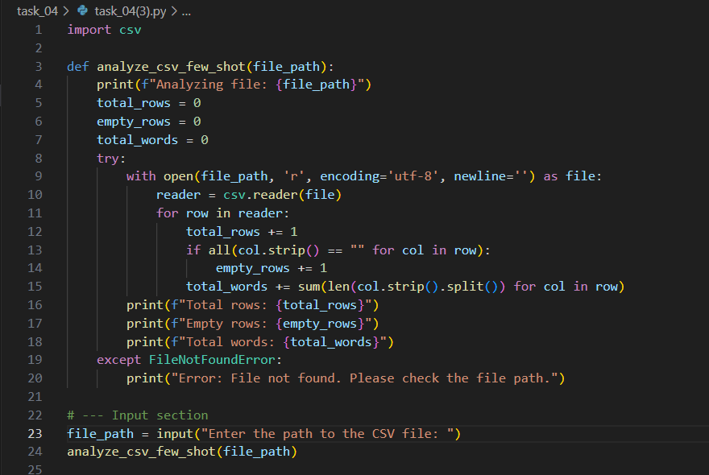  Cursor :  zero-shot :  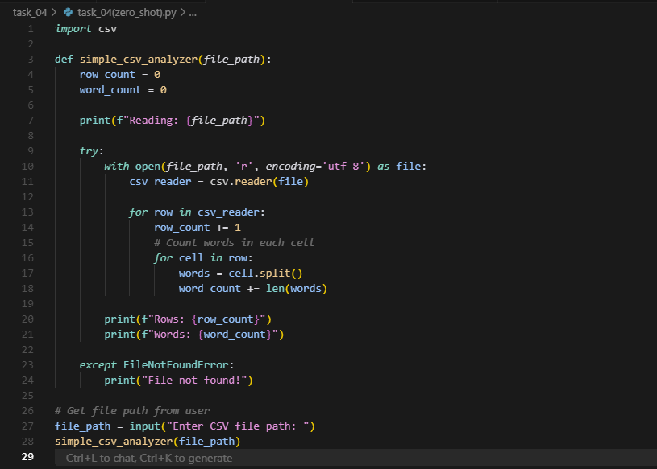  One-shot :  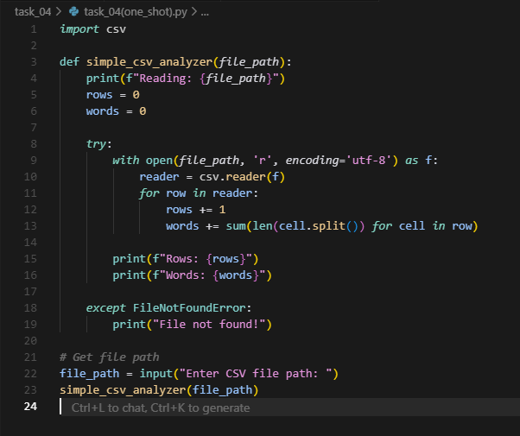  Few-shot :  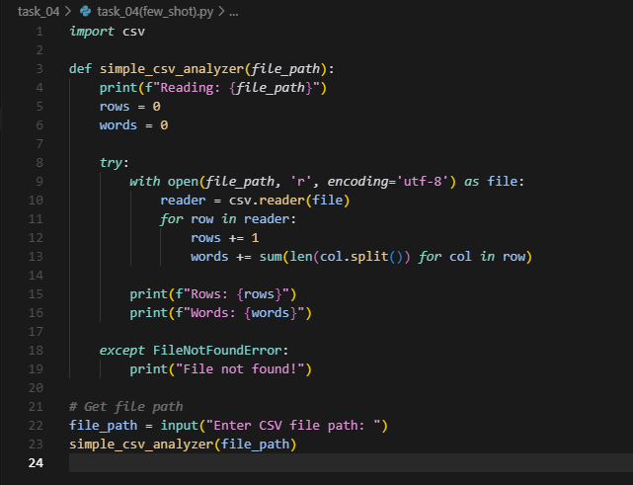  Task #5 – Few-Shot Prompting for Text Processing and Word Frequency  Objective  Use few-shot prompting (with at least 3 examples) to generate a Python function that processes text and analyzes word frequency.  Requirements  The function must:  - Accept a paragraph as input  - Convert all text to lowercase  - Remove punctuation  - Return the most frequently used word  Expected Output  - A functional Python script that performs text cleaning, tokenization, and returns the most common word using only the examples provided in the prompt  VS Code :  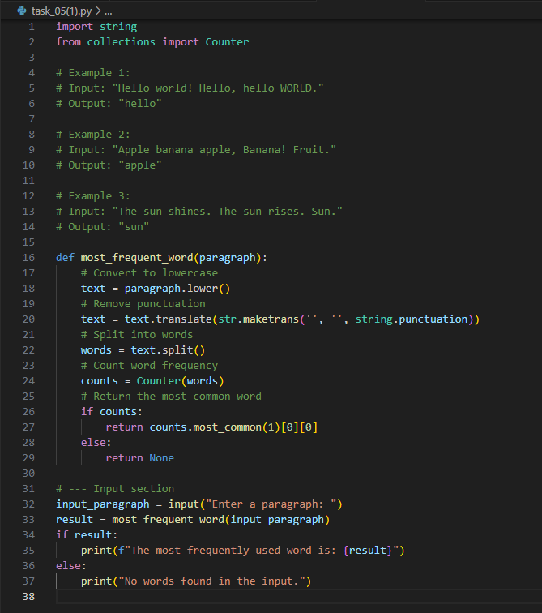  Cursor :  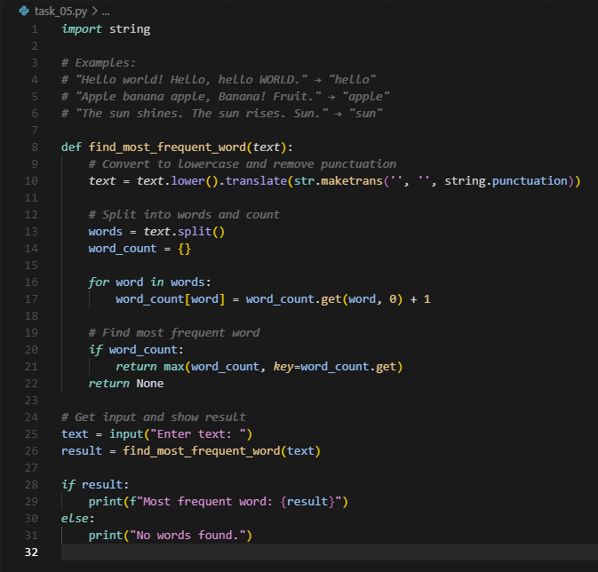  Note: Report should be submitted a word document for all tasks in a single document with prompts, comments & code explanation, and output and if required, screenshots  Evaluation Criteria: |  |  |  |  |  | Week2 - Monday
  Criteria | Max Marks
  Zero Shot (Task #1) | 0.5
  One Shot (Task#2) | 0.5
  Few Shot (Task#3, Task#4 & Task #5) | 1.5
  Total | 2.5 Marks

