Post-Quantum Secure Messaging: A Comparative Performance Study of Classical, ML-KEM, and Hybrid Key Exchange
Aakarsh Prabhu Aditi R. Amar M Bendre
Department of Computer Science and Engineering
R. V. College of Engineering, Bengaluru 560059, India
Guide: Dr. Prapulla S B, Associate Professor | VI Semester, Network Programming and Security, 2025–26

Abstract—Public-key cryptography securing messaging traffic rests on the hardness of discrete logarithms and integer factoring, both of which Shor's algorithm solves in polynomial time on a quantum computer. This exposes confidential messaging to the harvest-now-decrypt-later (HNDL) threat. We present a real-time secure messaging system whose key-exchange primitive is a runtime-selectable, pluggable component supporting classical 2048-bit Diffie-Hellman, NIST-standardised ML-KEM-768 (FIPS 203), and a hybrid X25519+ML-KEM construction, all bound to a uniform AES-256-GCM layer via HKDF-SHA256. Across thirty isolated trials per mode, ML-KEM-768 achieves a median handshake of 0.355 ms versus 9.176 ms for cached DH and 11,344.014 ms for fresh DH — a 31,955× speedup over fresh DH — while fresh DH exhibits a 156× variance spread. The results show post-quantum migration to be a performance upgrade, not a cost.
Index Terms—Post-quantum cryptography, ML-KEM, Kyber, key encapsulation, hybrid key exchange, AES-GCM, secure messaging, WebSockets, benchmarking.
I. INTRODUCTION
Private messaging is among the most confidentiality-sensitive network applications: message contents frequently must remain secret for years or decades, far longer than the minutes-long secrecy lifetime for which most transport cryptography is designed. This long horizon interacts catastrophically with quantum computing. Shor's 1994 result showed that a sufficiently large quantum computer solves the discrete-logarithm and factoring problems in polynomial time, breaking all deployed asymmetric cryptography. Under the harvest-now-decrypt-later model, an adversary records ciphertext today and decrypts it once quantum hardware exists; the adversary needs the machine only once.
NIST standardised the first post-quantum key encapsulation mechanism, ML-KEM, as FIPS 203 in August 2024, and industry (Cloudflare, Google, Apple, AWS) has begun deploying hybrid classical+ML-KEM in production TLS 1.3. The open question is the practical cost of migration. This paper answers it for a messaging workload by building a system in which the key-exchange mode is a pluggable component and measuring the latency, variance and bandwidth of each mode under identical surrounding protocol.
II. BACKGROUND AND RELATED WORK
A. Classical Diffie-Hellman and the Quantum Threat
Diffie-Hellman (1976) lets two parties agree on a shared secret S = g^(ab) mod p over an insecure channel, its security resting on the discrete-logarithm problem. Shor's algorithm collapses this hardness on a quantum computer, as it does for RSA and ECDH. Applications whose confidentiality must outlast the arrival of quantum hardware must migrate now.
B. ML-KEM and Hybrid Constructions
ML-KEM-768 (FIPS 203), a Module-LWE lattice KEM providing AES-192-equivalent security, replaces the mutual exponentiation of DH with encapsulation: the server publishes a public key, the client encapsulates a fresh secret under it, and the server decapsulates. Because ML-KEM is comparatively new, the standard mitigation is a hybrid construction pairing X25519 with ML-KEM and combining the two secrets through HKDF-SHA256 with the domain-separation string "tls13 hybrid", following the IETF TLS 1.3 hybrid design; the session key stays secure while at least one component is unbroken.
III. SYSTEM DESIGN
The system separates concerns into three tiers: a transport tier (WebSocket over TCP with four-byte length-prefixed framing), a key-exchange tier (three pluggable handlers behind a common KexHandler interface selected by a factory), and an application-encryption tier (HKDF-SHA256 → AES-256-GCM). Surrounding services provide bcrypt authentication with 256-bit session tokens, SQLite persistence in WAL mode with a single writer thread, an in-memory router, an offline message queue, and server-side replay protection via message-identifier deduplication over a five-minute window.
A key design choice is the Strategy pattern for key exchange. It forces fair comparison — all modes share identical framing, key derivation, encryption and protocol, so the only variable across trials is the primitive itself — and it makes the system extensible: a new KEM requires only one handler class and one factory entry. A WebSocketAdapter bridges the synchronous crypto code to the asynchronous FastAPI event loop through thread-safe queues, so no primitive needed rewriting.
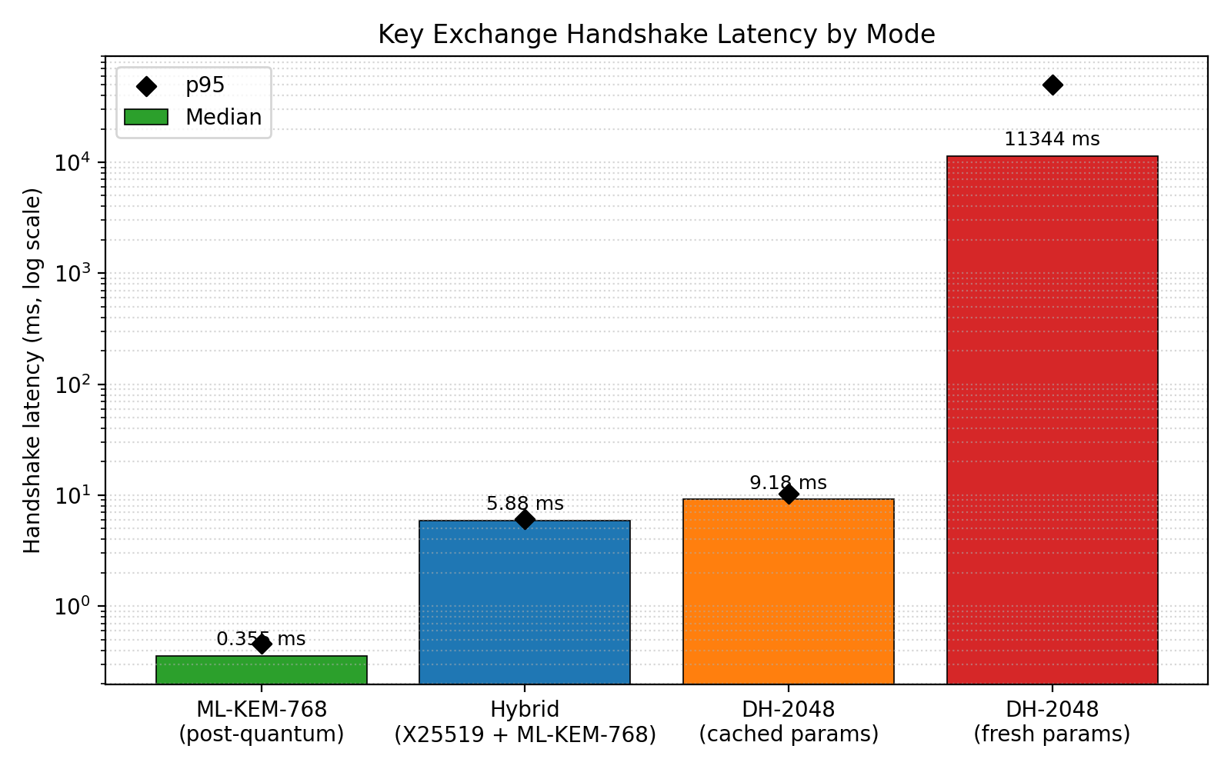
Fig. 1. Median handshake latency by mode (log scale, n = 30).
IV. IMPLEMENTATION
The system is implemented in Python 3.12 using the cryptography library (DH-2048, X25519, AES-256-GCM, HKDF-SHA256) and pqcrypto (ML-KEM-768), with FastAPI/uvicorn for the WebSocket server, bcrypt for password hashing, SQLite for persistence, and Streamlit/Altair for the front end. Every payload is sealed as nonce (12 B) || ciphertext || tag (16 B); decryption verifies the GCM tag before returning plaintext, rejecting any single-bit tampering. An interactive front-end "Encryption Lab" reproduces the scheme in-browser via the Web Crypto API, animating the per-byte transformation and tag verification.
V. METHODOLOGY
Thirty trials are executed per mode across four modes — DH-2048 fresh, DH-2048 cached, ML-KEM-768 and hybrid — for 120 measurements. Each trial spawns a fresh server subprocess to remove cross-trial state, and timing is captured at nanosecond resolution at five checkpoints. Two DH baselines are measured deliberately: fresh parameters (worst case) and cached parameters (realistic deployment), foreclosing apples-to-oranges criticism. Statistics (median, mean, p95, min, max) are computed per mode.
VI. RESULTS
ML-KEM-768 completes a handshake in a median of 0.355 ms, the hybrid in 5.88 ms, cached DH in 9.176 ms, and fresh DH in 11,344.014 ms — a 31,955× speedup of ML-KEM over fresh DH and 26× over cached DH. Strikingly, the hybrid mode is faster than even the cached classical baseline. Table I reports the full statistics.
TABLE I. Handshake Latency Statistics (ms, n = 30 per mode)
Mode | Median | Mean | p95 | Max
DH-2048 fresh | 11,344.014 | 16,586.256 | 50,280.604 | 74,560.434
DH-2048 cached | 9.176 | 9.428 | 10.353 | 14.632
Hybrid | 5.88 | 6.061 | 6.057 | 11.136
ML-KEM-768 | 0.355 | 0.364 | 0.462 | 0.642

A second finding concerns variance. Three modes — ML-KEM, hybrid and cached DH — are effectively deterministic (p95 within ~1% of median). Fresh DH exhibits a 156× spread, from 478.067 ms to 74,560.434 ms, with a p95 exceeding 50 s, driven by the probabilistic safe-prime search (Fig. 2).
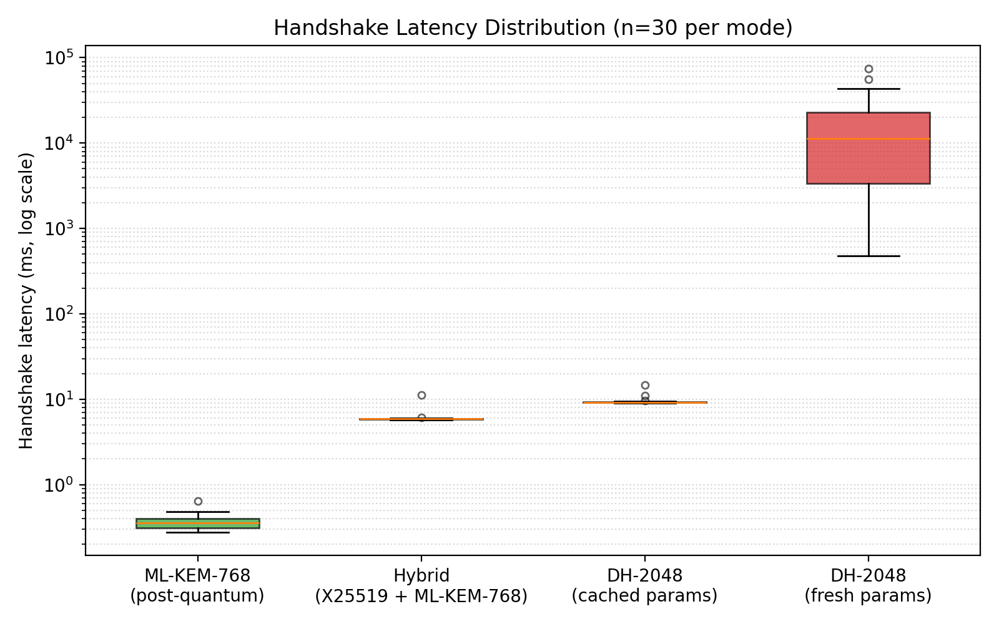
Fig. 2. Handshake latency distribution by mode (log scale).
VII. DISCUSSION
These measurements invert the conventional framing of post-quantum migration. The narrative that post-quantum is correct but costly is not supported here: ML-KEM is orders of magnitude faster than fresh DH and materially faster than cached DH, and the hybrid — offering defence in depth — outruns the cached classical baseline. Independently, fresh DH's heavy tail makes it unfit for interactive use regardless of quantum concerns. Limitations include the server-trusted (non-E2EE) routing model, absence of authenticated key exchange, a single hardware platform, and Python-level overhead; the mode ordering is expected to generalise.
VIII. CONCLUSION
We built and evaluated a real-time secure messaging system with runtime-selectable classical, post-quantum and hybrid key exchange over a uniform AES-256-GCM channel. Post-quantum ML-KEM-768 outperforms cached DH by 26× and fresh DH by ~31,955×, and fresh DH's 156× variance argues against its interactive use independently of the quantum threat. For confidential messaging under HNDL, there is no longer a performance argument for delaying post-quantum migration. Future work includes end-to-end encryption, authenticated handshakes, an ML-KEM-512/768/1024 sweep, and formal protocol verification.
References
[1] W. Diffie and M. Hellman, "New directions in cryptography," IEEE Trans. Inf. Theory, vol. 22, no. 6, pp. 644–654, 1976.
[2] P. W. Shor, "Polynomial-time algorithms for prime factorization and discrete logarithms on a quantum computer," SIAM J. Comput., vol. 26, no. 5, pp. 1484–1509, 1997.
[3] NIST, FIPS 203: Module-Lattice-Based Key-Encapsulation Mechanism Standard, Aug. 2024.
[4] J. Bos et al., "CRYSTALS-Kyber: a CCA-secure module-lattice-based KEM," IEEE EuroS&P, pp. 353–367, 2018.
[5] D. J. Bernstein, "Curve25519: New Diffie-Hellman speed records," PKC 2006, LNCS 3958, pp. 207–228, 2006.
[6] H. Krawczyk and P. Eronen, HKDF, IETF RFC 5869, 2010.
[7] M. Dworkin, GCM and GMAC, NIST SP 800-38D, 2007.
[8] D. Stebila, S. Fluhrer, S. Gueron, Hybrid key exchange in TLS 1.3, IETF draft-ietf-tls-hybrid-design, 2024.
[9] C. Paquin, D. Stebila, G. Tamvada, "Benchmarking post-quantum cryptography in TLS," PQCrypto 2020, LNCS 12100, pp. 72–91.
[10] I. Fette and A. Melnikov, The WebSocket Protocol, IETF RFC 6455, 2011.

