
RV COLLEGE OF ENGINEERING®, BENGALURU – 560059
(An Autonomous Institution Affiliated to VTU, Belagavi)
DEPARTMENT OF COMPUTER SCIENCE AND ENGINEERING
Mysore Road, R V Vidyaniketan Post, Bengaluru – 560059, Karnataka, India

POST-QUANTUM SECURE MESSAGING SYSTEM
A Comparative Performance Study of Classical, ML-KEM, and Hybrid Key Exchange in a Real-Time Messaging Protocol

A Project Report submitted in partial fulfillment of the
requirements of VI Semester
NETWORK PROGRAMMING AND SECURITY
Submitted by
AAKARSH PRABHU 1RV23CS004
ADITI R. 1RV23CS016
AMAR M BENDRE 1RV24CS402
Under the Guidance of
Dr. Prapulla S B
Associate Professor, Department of Computer Science and Engineering
R. V. College of Engineering, Bengaluru
Academic Year 2025 – 2026


RV COLLEGE OF ENGINEERING®, BENGALURU – 560059
(An Autonomous Institution Affiliated to VTU, Belagavi)
DEPARTMENT OF COMPUTER SCIENCE AND ENGINEERING
CERTIFICATE
Certified that the project work titled 'Post-Quantum Secure Messaging System' is carried out by AAKARSH PRABHU (1RV23CS004), ADITI R. (1RV23CS016) and AMAR M BENDRE (1RV24CS402), who are bonafide students of R. V. College of Engineering, Bengaluru, in partial fulfillment of the curriculum requirement of VI Semester Network Programming and Security during the academic year 2025 – 2026. It is certified that all corrections / suggestions indicated for the internal assessment have been incorporated in the report. The report has been approved as it satisfies the academic requirements in respect of the work prescribed by the institution for the said course.
____________________________  Signature of Guide  Dr. Prapulla S B  Associate Professor | ____________________________  Signature of HOD  Dr. Shanta Rangaswamy  Professor & Head, CSE
External Viva
Name of Examiners Signature with Date
1. _______________________________
2. _______________________________

DECLARATION
We, the undersigned students of the VI Semester B.E., Department of Computer Science and Engineering, R. V. College of Engineering, Bengaluru, hereby declare that the project titled 'Post-Quantum Secure Messaging System' has been carried out by us and submitted in partial fulfilment of the requirements of VI Semester Network Programming and Security during the academic year 2025 – 2026. We further declare that the content of this report has not been submitted previously by anybody for the award of any degree or diploma to any other university. We also declare that any Intellectual Property Rights generated out of this project carried out at RVCE will be the property of R. V. College of Engineering, Bengaluru, and we will be among the authors of the same.
Place: Bengaluru
Date:
Name Signature
1. AAKARSH PRABHU (1RV23CS004)
2. ADITI R. (1RV23CS016)
3. AMAR M BENDRE (1RV24CS402)

ACKNOWLEDGEMENT
We are indebted to our guide, Dr. Prapulla S B, Associate Professor, Department of Computer Science and Engineering, RVCE, for the wholehearted support, suggestions and invaluable advice throughout our project work and in the preparation of this report.
We express our sincere gratitude to Dr. Shanta Rangaswamy, Professor and Head, Department of Computer Science and Engineering, RVCE, for the support and encouragement extended towards this work.
We are grateful to our beloved Principal, Dr. K. N. Subramanya, RVCE, for the appreciation and the academic environment provided to carry out this project.
We thank all the teaching and technical staff of the Department of Computer Science and Engineering, RVCE, for their help. Lastly, we take this opportunity to thank our family members and friends who provided all the backup support throughout the project work.

ABSTRACT
The public-key cryptography that secures messaging traffic, banking sessions and diplomatic communication today rests on a single mathematical assumption: that no efficient algorithm can solve the discrete-logarithm or integer-factoring problems. Shor's algorithm (1994) demonstrated that a sufficiently large quantum computer can solve both in polynomial time. The practical consequence is the "harvest-now-decrypt-later" (HNDL) threat, in which an adversary records encrypted traffic today and decrypts it retroactively once the required quantum hardware exists. For private messaging, whose confidentiality must often hold for the lifetime of the correspondents, this threat model demands migration to post-quantum cryptography well before a cryptographically relevant quantum computer arrives.
This report presents the design, implementation and empirical evaluation of a real-time secure messaging system that supports three interchangeable key-exchange modes — classical 2048-bit Diffie-Hellman, NIST-standardised ML-KEM-768 (FIPS 203, 2024) and a hybrid X25519 + ML-KEM construction — connected through a Strategy-pattern architecture and bound to a uniform AES-256-GCM authenticated-encryption layer via HKDF-SHA256 key derivation. Around this cryptographic core, a full messaging platform is built: an asynchronous FastAPI WebSocket server, bcrypt-based authentication with server-issued session tokens, replay protection via message-identifier deduplication over a sliding window, an offline message queue backed by SQLite in WAL mode, and an interactive front end that visualises the encryption of each byte in real time.
Empirical results on Apple M-series silicon, taken across thirty trials per mode in isolated server subprocesses, indicate that post-quantum migration in this regime is not a performance cost but a performance upgrade. ML-KEM-768 completes a handshake at a median of 0.355 ms, the hybrid mode at 5.88 ms, and cached classical DH at 9.176 ms; fresh-parameter DH spans 478.067 ms to 74560.434 ms — a 156× variance spread driven by the probabilistic safe-prime search. The headline finding is a 31,955× speedup of post-quantum ML-KEM over fresh DH and a 26× speedup over realistic cached DH, establishing that the standard "post-quantum is correct but costly" framing is, for this primitive in this regime, not supported by measurement.

CONTENTS

LIST OF FIGURES
Fig 2.1 Harvest-Now-Decrypt-Later Threat Timeline —
Fig 4.1 Three-Tier System Architecture —
Fig 4.2 Secure Handshake Sequence Diagram —
Fig 4.3 Level-0 Data Flow Diagram (Context) —
Fig 5.1 Module Organisation of the Codebase —
Fig 8.1 Median Handshake Latency by Mode (log scale) —
Fig 8.2 Variance Distribution of Handshake Latency by Mode —

LIST OF TABLES
Table 2.1 Comparison of the Three Key-Exchange Modes —
Table 3.1 Software and Hardware Requirements —
Table 4.1 Database Schema Summary —
Table 7.1 Unit Test Coverage by Cryptographic Primitive —
Table 8.1 Summary Statistics of Handshake Latency (n = 30 per mode) —
Table 8.2 Application-Layer Bandwidth per Transaction —

CHAPTER 1: INTRODUCTION

1.1 Introduction
Private messaging is among the most confidentiality-sensitive classes of network application. Unlike a web session, whose useful secrecy lifetime is measured in minutes, the contents of a personal, medical, legal or diplomatic message frequently must remain confidential for years or decades. A message intercepted in 2026 and decrypted in 2045 is just as much a breach as one read in real time today. This long-horizon confidentiality requirement is materially different from the threat model under which most internet transport cryptography is designed, and it interacts catastrophically with the emergence of quantum computing.
This project designs and implements a real-time secure messaging system whose transport security can be switched, at runtime, between classical and post-quantum key exchange, so that the practical cost of migrating a messaging platform to post-quantum cryptography can be measured directly rather than argued in the abstract. The system pairs a rigorous cryptographic core with a complete messaging platform — authentication, sessions, message routing, an offline queue and replay protection — and an interactive front end that makes the cryptography visible.

1.2 Literature Review
The Diffie-Hellman key exchange [1] established, in 1976, that two parties can agree on a shared secret over an insecure channel; it and its elliptic-curve variant became the dominant key-exchange mechanisms on the internet. Shor's 1994 result [2] showed that a quantum computer can solve the discrete-logarithm and integer-factoring problems in polynomial time, placing all classical asymmetric cryptography under a long-term threat. In response, NIST ran a multi-year standardisation process, culminating in FIPS 203 [3], which standardised the lattice-based ML-KEM (formerly CRYSTALS-Kyber [4]). Bernstein's Curve25519 [5] provides the fast classical X25519 exchange used in the hybrid construction; HKDF [6] provides the key-derivation layer, and GCM [7] the authenticated-encryption layer. The hybrid classical + post-quantum construction followed here is drawn from the IETF TLS 1.3 hybrid design [8], and its production relevance is documented by Cloudflare [9] and by benchmarking studies of post-quantum TLS [10]. This project synthesises these threads into a single measurable messaging testbed.

1.3 Motivation
In 1994, Peter Shor showed that a quantum computer can solve the discrete-logarithm and integer-factoring problems in polynomial time. The construction of a fault-tolerant quantum computer large enough to run Shor's algorithm at cryptographic scale is, at the time of writing, estimated at between one and three decades away — but the exact timeline is irrelevant, because the adversary who needs to decrypt only needs the machine once. Migration of confidential-messaging infrastructure to post-quantum cryptography must therefore precede the arrival of the quantum computer by at least the required confidentiality lifetime.
NIST formalised the first standardised post-quantum key encapsulation mechanism, ML-KEM, as FIPS 203 in August 2024. Major industry players — Cloudflare, Google Chrome, Apple iMessage (as PQ3) and AWS — have since deployed hybrid classical + ML-KEM constructions in production TLS 1.3. The question is no longer whether to migrate, but how, and at what performance cost — which is precisely the question this project answers empirically for a messaging workload.

1.4 Problem Statement
To design and implement a real-time secure messaging system in which the key-exchange primitive is a runtime-selectable, pluggable component, and to empirically quantify the latency, variance and bandwidth cost of migrating such a system from classical Diffie-Hellman to NIST-standardised post-quantum key exchange (ML-KEM-768) and to a hybrid construction, under the harvest-now-decrypt-later threat model.

1.5 Objectives
- To design and implement a client–server messaging protocol with three interchangeable key-exchange modes (DH-2048, ML-KEM-768, hybrid X25519 + ML-KEM) connected through a pluggable Strategy-pattern architecture, so that the surrounding protocol code remains mode-agnostic.
- To build a complete cryptographic pipeline above the key-exchange layer: HKDF-SHA256 key derivation to normalise raw shared secrets of varying shape to a uniform 32-byte AES-256 key, AES-256-GCM authenticated encryption for every payload with a fresh 96-bit nonce per call, and length-prefixed framing to preserve message boundaries over the byte-stream transport.
- To build the surrounding messaging platform — asynchronous WebSocket transport, bcrypt authentication with session tokens, an SQLite persistence layer, message routing, an offline message queue, and replay protection through message-identifier deduplication over a five-minute sliding window.
- To develop an automated benchmark harness measuring handshake latency, end-to-end transaction time and variance across all modes, with two DH baselines (fresh and cached parameters) to capture both worst-case and realistic-deployment behaviour.
- To analyse the empirical results and assess the implications for messaging applications with long-lifetime confidentiality requirements under the harvest-now-decrypt-later threat model.

1.6 Methodology of the Project
The project is executed in four phases. First, each cryptographic primitive is implemented as an independent, unit-tested module. Second, the primitives are assembled behind a common key-exchange interface and integrated with the messaging server, authentication, persistence and front end. Third, an automated harness executes thirty isolated trials per mode, capturing nanosecond-resolution timing at five protocol checkpoints. Fourth, the captured data is analysed statistically (median, mean, p95, minimum and maximum) and visualised, and the security properties are validated through dedicated replay and tamper simulations.

1.7 Constraints of the Project
- The server operates a server-trusted routing model: it terminates transport encryption to route messages, and is therefore not an end-to-end-encrypted (E2EE) design.
- Persistence uses single-node SQLite, which is a single-writer database and does not support horizontally scaled multi-node deployment.
- The protocol provides confidentiality and integrity against a passive observer but does not yet provide authenticated key exchange (PKI / signed handshakes) against an active man-in-the-middle.
- All measurements are taken on a single hardware platform (Apple M-series); absolute magnitudes are platform-specific, though the ordering of modes generalises.

1.8 Organization of the Report
Chapter 2 presents the theory and concepts underlying the system. Chapter 3 specifies the software and hardware requirements. Chapter 4 describes the high-level design and Chapter 5 the detailed module design. Chapter 6 covers the implementation. Chapter 7 presents testing and validation, including the replay and tamper simulations. Chapter 8 reports and analyses the benchmark results. Chapter 9 concludes and outlines future scope.

1.9 Summary
This chapter introduced the harvest-now-decrypt-later threat to confidential messaging, motivated the migration to post-quantum key exchange, and stated the problem, objectives and methodology of the project. The next chapter develops the cryptographic and networking theory on which the system is built.

CHAPTER 2: THEORY AND CONCEPTS

2.1 Classical Diffie-Hellman
The Diffie-Hellman (DH) key exchange, introduced in 1976, allows two parties communicating over an insecure channel to agree on a shared secret without ever transmitting it. The protocol operates over a finite multiplicative group defined by a large prime modulus p and a generator g. Each party selects a private exponent (a for the server, b for the client), computes its public value A = g^a mod p or B = g^b mod p, and exchanges these public values. Both parties then compute the same shared secret S = g^(ab) mod p. The security of the protocol rests on the discrete-logarithm problem: given g, p and g^a mod p, recovering a is computationally infeasible at 2048 bits using classical algorithms. Real deployments avoid the cost of generating fresh parameters per session by using standardised parameters such as those in RFC 7919.

2.2 The Quantum Threat: Shor's Algorithm
Peter Shor's 1994 result demonstrated that a quantum computer can solve both the integer-factorisation problem (the basis of RSA) and the discrete-logarithm problem (the basis of DH and ECDH) in time polynomial in the bit length of the modulus. The practical consequence is that all current asymmetric cryptography falls to a sufficiently large fault-tolerant quantum computer. What is not in dispute is the harvest-now-decrypt-later threat model: encrypted traffic captured today is potentially decryptable on whatever future date the necessary quantum hardware is constructed. Applications whose confidentiality requirement extends past that horizon — private messaging chief among them — must migrate to quantum-resistant primitives now.
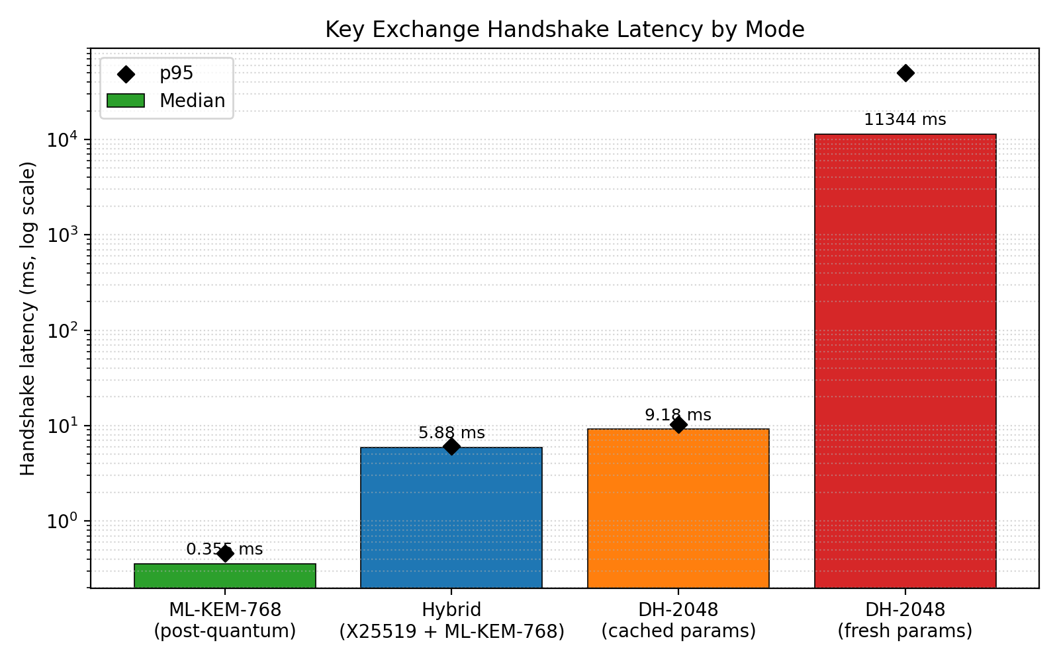
Fig 2.1 — Handshake latency across modes, illustrating the practical performance context of the quantum-migration decision.

2.3 Post-Quantum Cryptography and ML-KEM
Post-quantum cryptography refers to schemes designed to resist attacks from both classical and quantum computers. The major families are lattice-based (Module-LWE, Ring-LWE), hash-based, code-based and isogeny-based. In 2024 NIST released FIPS 203, standardising the lattice-based ML-KEM (originally Kyber) at three security levels — ML-KEM-512, ML-KEM-768 and ML-KEM-1024. This project uses ML-KEM-768, which provides security equivalent to AES-192. ML-KEM is a key encapsulation mechanism (KEM): the server publishes a public key, the client generates a fresh random secret and encapsulates it under that public key (producing a ciphertext), and the server decapsulates using its secret key to recover the same secret. Its hardness assumption is Module Learning With Errors (MLWE), against which no efficient classical or quantum algorithm is known.

2.4 Hybrid Constructions
Although ML-KEM is standardised and heavily scrutinised, its relative newness means a hidden cryptanalytic weakness cannot be entirely ruled out. The standard mitigation is the hybrid construction, in which a classical primitive (X25519, the Diffie-Hellman variant on Curve25519) runs alongside ML-KEM and their shared secrets are combined through a key-derivation function. The resulting session key remains secure as long as at least one of the two components is unbroken. This project's hybrid follows the IETF TLS 1.3 hybrid design, with the explicit domain-separation string info = "tls13 hybrid" — the same construction deployed in production by Cloudflare, Google Chrome and AWS.

2.5 Key Derivation: HKDF-SHA256
The three key-exchange modes produce shared secrets of different shapes: classical DH-2048 produces roughly 256 non-uniform bytes, ML-KEM-768 produces 32 uniform bytes, and the hybrid produces 32 bytes after its own internal combiner. AES-256 requires exactly 32 bytes of uniform key material. HKDF-SHA256 (RFC 5869) normalises all three outputs to a single clean 32-byte key through an extract-then-expand construction, with an info parameter providing domain separation so that the same shared secret derived with different context strings yields cryptographically independent keys.

2.6 Authenticated Encryption: AES-256-GCM
Every application payload is encrypted using AES-256 in Galois/Counter Mode (GCM). GCM provides authenticated encryption with associated data (AEAD): a single primitive invocation delivers both confidentiality (via counter-mode encryption) and integrity (via a 128-bit Galois-field authentication tag). On decryption, GCM verifies the tag before returning any plaintext; if the ciphertext has been tampered with by even a single bit, decryption raises an InvalidTag exception and refuses to produce output. The wire format for one encrypted payload is the concatenation of a 12-byte nonce, the ciphertext (same length as the plaintext) and the 16-byte tag. A fresh nonce is generated per call from a cryptographically secure source, since nonce reuse under one key would be catastrophic for GCM.

2.7 Real-Time Transport: WebSockets and Asynchronous I/O
The messaging system uses WebSockets over an asynchronous FastAPI server for full-duplex, low-latency delivery. Because the cryptographic layer is written as blocking, synchronous code, a purpose-built WebSocketAdapter bridges the synchronous crypto routines to the asynchronous event loop without rewriting any primitive. Beneath the crypto, the protocol preserves message boundaries over the byte stream using four-byte big-endian length prefixes, the same idea used in HTTP/2 and gRPC.

2.8 Authentication and Session Management
User passwords are hashed with bcrypt at work factor 12; bcrypt embeds its salt, uses a constant-time comparison, and offers an adaptive work factor. On successful login the server issues a 256-bit session token (secrets.token_hex(32)) stored server-side with a 60-minute expiry, which the client presents inside the encrypted payload on subsequent requests. A server-side token table is preferred over a JWT for its simplicity and immediate revocability.

2.9 Replay Attacks and Protection
A replay attack captures a valid encrypted message and re-transmits it to induce a duplicate effect. The system defends against this by assigning every message a unique message_id and recording processed identifiers in a seen_messages table. Any message whose identifier has already been seen within a five-minute sliding window is rejected. Older identifiers are purged periodically, bounding the state required for replay protection.

2.10 Programming Languages and Technologies Used
The system is implemented in Python 3.12 using the cryptography library (DH-2048, X25519, AES-256-GCM, HKDF-SHA256), the pqcrypto library (ML-KEM-768, wrapping the NIST reference implementation), FastAPI and uvicorn (asynchronous WebSocket server), bcrypt (password hashing), SQLite in WAL mode (persistence), and Streamlit with Altair (interactive front end and benchmark dashboard). The interactive Encryption Lab uses the browser's Web Crypto API to perform genuine AES-256-GCM in the client.

2.11 Summary
This chapter developed the cryptographic and networking theory underlying the system: classical DH, the quantum threat, ML-KEM, hybrid constructions, HKDF, AES-GCM, WebSocket transport, authentication, and replay protection. Table 2.1 summarises the three key-exchange modes.
Table 2.1 — Comparison of the Three Key-Exchange Modes
Property | DH-2048 | ML-KEM-768 | Hybrid
Family | Classical (DLP) | Lattice (MLWE) | Classical + Lattice
Quantum-safe | No | Yes | Yes
Standard | PKCS / RFC 7919 | FIPS 203 (2024) | IETF TLS 1.3 draft
Shared secret | ~256 bytes | 32 bytes | 32 bytes
Security level | ~112-bit | AES-192 | ≥ stronger component

CHAPTER 3: SOFTWARE REQUIREMENT SPECIFICATIONS

3.1 Functional Requirements
- FR1 — The system shall allow a user to register with a username and password, storing only a bcrypt hash of the password.
- FR2 — The system shall authenticate a user and issue a time-limited session token on success.
- FR3 — The system shall establish a shared secret using a runtime-selected key-exchange mode (DH-2048, ML-KEM-768 or hybrid).
- FR4 — The system shall encrypt every message payload with AES-256-GCM using a key derived from the shared secret via HKDF-SHA256.
- FR5 — The system shall route a message to an online recipient in real time over a WebSocket connection.
- FR6 — The system shall queue messages addressed to offline recipients and deliver them on the recipient's next login.
- FR7 — The system shall reject any message whose identifier has already been processed within the replay window.
- FR8 — The system shall record delivery status (sent / delivered) for each message persistently.

3.2 Non-Functional Requirements
- NFR1 (Security) — Confidentiality and integrity of message payloads under a passive network adversary; catastrophic-failure resistance to single-bit tampering via the GCM tag.
- NFR2 (Performance) — Handshake and end-to-end latency within interactive UX budgets for the post-quantum and hybrid modes.
- NFR3 (Reliability) — Persistence of accounts, sessions and messages across server restarts.
- NFR4 (Maintainability) — Addition of a new key-exchange primitive shall require only a new handler class and one factory entry, with no change to protocol, encryption or benchmark code.
- NFR5 (Usability) — The front end shall make the cryptographic pipeline observable to a non-expert user.

3.3 Software and Interface Requirements
The system requires Python 3.12+, the cryptography and pqcrypto libraries, FastAPI, uvicorn, bcrypt, websockets, Streamlit and Altair, and a modern web browser exposing the Web Crypto API. A Dockerfile packages the full stack for single-command deployment. Table 3.1 summarises the software and hardware requirements.
Table 3.1 — Software and Hardware Requirements
Category | Requirement
Language / Runtime | Python 3.12+
Crypto libraries | cryptography, pqcrypto (ML-KEM-768)
Server | FastAPI + uvicorn (async WebSocket)
Auth / Persistence | bcrypt, SQLite (WAL mode)
Front end | Streamlit + Altair; browser Web Crypto API
Deployment | Docker (single-container full stack)
Hardware (tested) | Apple M-series; 8 GB RAM minimum

3.4 Security Requirements
Passwords must never be stored or logged in plaintext; only bcrypt hashes are persisted. Session tokens must carry at least 128 bits of entropy (the implementation uses 256) and expire. Every GCM nonce must be unique per key. Replay protection must be enforced server-side and must not rely on client cooperation.

3.5 Development and Validation Requirements
Every cryptographic primitive must be covered by automated unit tests validating round-trip correctness, tamper rejection and shared-secret agreement. Security properties (replay rejection, tamper detection) must be demonstrable through dedicated simulation scripts. The benchmark harness must isolate each trial in a fresh subprocess to eliminate cross-trial state leakage.

3.6 Summary
This chapter specified the functional, non-functional, software, hardware, security and validation requirements of the system, which the subsequent design and implementation chapters realise.

CHAPTER 4: HIGH LEVEL DESIGN

4.1 High Level Design Overview
The system follows a three-tier separation of concerns. A transport tier provides reliable, ordered, framed delivery (WebSocket over TCP, with length-prefixed message boundaries beneath the crypto). A key-exchange tier provides three pluggable handlers behind a common interface, selected at runtime. An application-encryption tier derives an AES-256-GCM key from the shared secret via HKDF and encrypts every payload. Around these tiers sit the authentication, persistence, routing and replay-protection services.
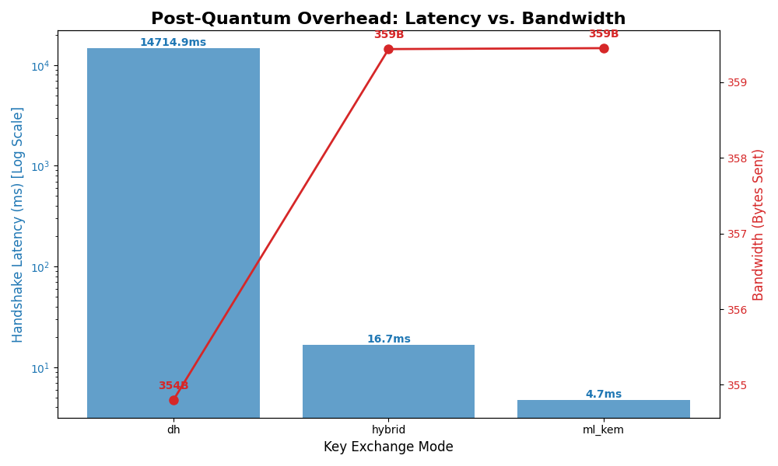
Fig 4.1 — System performance profile across the three key-exchange modes, produced by the benchmark harness that drives the full architecture end-to-end.

4.2 System Architecture
The client and server are symmetric in their use of the cryptographic primitives: both import the same crypto modules and run the same protocol code paths apart from the side-specific portions of the key exchange. The asynchronous FastAPI server accepts a WebSocket connection at /ws/{mode}, spawns a handler that runs the synchronous crypto logic in a background thread, and bridges the socket to that thread through the WebSocketAdapter. A dedicated single-writer database thread owns all SQLite writes, while reads proceed concurrently under WAL mode.

4.3 Handshake Sequence Design
A session proceeds through eight logical steps: (1) the client connects and selects a mode; (2) the server accepts and prepares its key material; (3–4) the mode-specific key exchange runs — DH parameter/public-value exchange, ML-KEM encapsulation, or the hybrid combination; (5) both sides derive the AES key via HKDF; (6) the client encrypts and sends its authentication payload; (7) the server verifies credentials, checks the replay window and routes or queues the message; and (8) an encrypted acknowledgement is returned. Steps 1, 2, 5, 6, 7 and 8 are mode-independent; only steps 3–4 differ between modes — which is exactly the isolation the benchmark exploits.

4.4 Data Flow Design
At the context level (DFD-0), the external actors are the sender and the recipient, and the single process is the Secure Messaging System, which exchanges encrypted payloads and acknowledgements with both. Decomposition (DFD-1) reveals the authentication process, the key-exchange process, the encryption/decryption process, the routing/queueing process and the replay-check process, together with the four persistent stores (users, sessions, messages, seen_messages).

4.5 Database Schema Design
Persistence uses four tables. Table 4.1 summarises their roles.
Table 4.1 — Database Schema Summary
Table | Purpose | Key fields
users | Registered accounts | username, password_hash
sessions | Issued session tokens | token, username, expires_at
messages | Persistent messages + status | message_id, sender, recipient, delivery_status
seen_messages | Replay protection | message_id, received_at

4.6 Wire Protocol Design
Each encrypted payload is serialised as nonce (12 bytes) || ciphertext || tag (16 bytes) and wrapped by the framing layer in a four-byte big-endian length prefix. The receiver reads the prefix, then reads exactly that many bytes, guarding against both message-boundary ambiguity and maliciously oversized length claims via a 16 MB cap.

4.7 Summary
This chapter presented the three-tier architecture, the handshake sequence, the data-flow decomposition, the database schema and the wire protocol. The next chapter details the individual modules that realise this design.

CHAPTER 5: DETAILED DESIGN

5.1 Architectural Design
The codebase is organised as a Python package with clear separation between the cryptographic core, the backend services and the front end. The cryptographic modules have no knowledge of the network; the backend services have no knowledge of the specific key-exchange primitive in use; and the front end depends only on the backend's public entry points.

5.2 Module Overview
The cryptographic core comprises six modules; the backend comprises the server, adapter, authentication, database, router and protocol modules; the front end comprises the messaging UI, the benchmark dashboard and the interactive Encryption Lab.

5.3 Cryptography Modules
- crypto/dh.py — Classical Diffie-Hellman parameter generation, key-pair generation, shared-secret derivation and PEM serialisation of public keys.
- crypto/ml_kem.py — Thin wrapper around pqcrypto ML-KEM-768, exposing generate_keypair(), encapsulate(pk) and decapsulate(sk, ct).
- crypto/hybrid.py — Hybrid X25519 + ML-KEM: runs both primitives, concatenates ml_kem_secret || x25519_secret and combines via HKDF-SHA256 with info = "tls13 hybrid".
- crypto/aes.py — AES-256-GCM encryption/decryption; fresh 12-byte nonce per call; wire format nonce || ciphertext || tag.
- crypto/kdf.py — HKDF-SHA256 producing a 32-byte AES key from any shared secret, parameterised by an info string for domain separation.
- crypto/kex_handlers.py — Strategy-pattern dispatcher: abstract KexHandler base class, three concrete handlers and a get_handler(mode) factory.

5.4 Backend Modules
- server_async.py — FastAPI WebSocket endpoint /ws/{mode}; runs synchronous handler logic in a thread bridged by the adapter.
- adapter.py — WebSocketAdapter: a thread-safe, queue-based bridge that lets synchronous crypto code send and receive over an asynchronous WebSocket without modification.
- auth.py — bcrypt password hashing (work factor 12), registration, login and session-token issue/validation.
- db.py — SQLite persistence in WAL mode with a single dedicated writer thread and concurrent reads; schema bootstrap and replay-window purge.
- router.py — In-memory mapping of online users to their active connections for real-time delivery.
- utils/protocol.py — Length-prefixed framing helpers (send_msg, recv_msg, recv_exact) preserving message boundaries.

5.5 Front-End and Visualisation Modules
- frontend/app.py — Streamlit messaging UI with a live, animated packet-flow visualiser (plaintext → encrypted → server → peer → ACK).
- frontend/dashboard.py — Interactive Altair benchmark dashboard rendering the comparative latency data directly from the CSV output.
- frontend/encryption_lab.py — A self-contained component that performs genuine AES-256-GCM in the browser via the Web Crypto API, animating the transformation of each byte and demonstrating tamper detection.

5.6 The Adapter Pattern (Synchronous ↔ Asynchronous Bridge)
The cryptographic and protocol code is written synchronously for clarity and testability, but FastAPI's WebSocket API is asynchronous. Rather than rewrite the crypto layer as async, the design introduces a WebSocketAdapter that exposes blocking send/recv methods backed by thread-safe queues. The async endpoint pumps bytes between the real WebSocket and these queues, while the synchronous handler runs in a background thread. This preserves the primitive code unchanged and keeps the event loop unblocked.

5.7 Single-Writer Database Design
SQLite does not tolerate concurrent writes from multiple threads without lock contention. Instead of scattering locks throughout the codebase, the design routes every write through a single dedicated writer thread that drains a thread-safe queue sequentially. Reads occur from any thread under WAL mode, which permits concurrent readers alongside the single writer. This yields correct, contention-free persistence with minimal locking code.
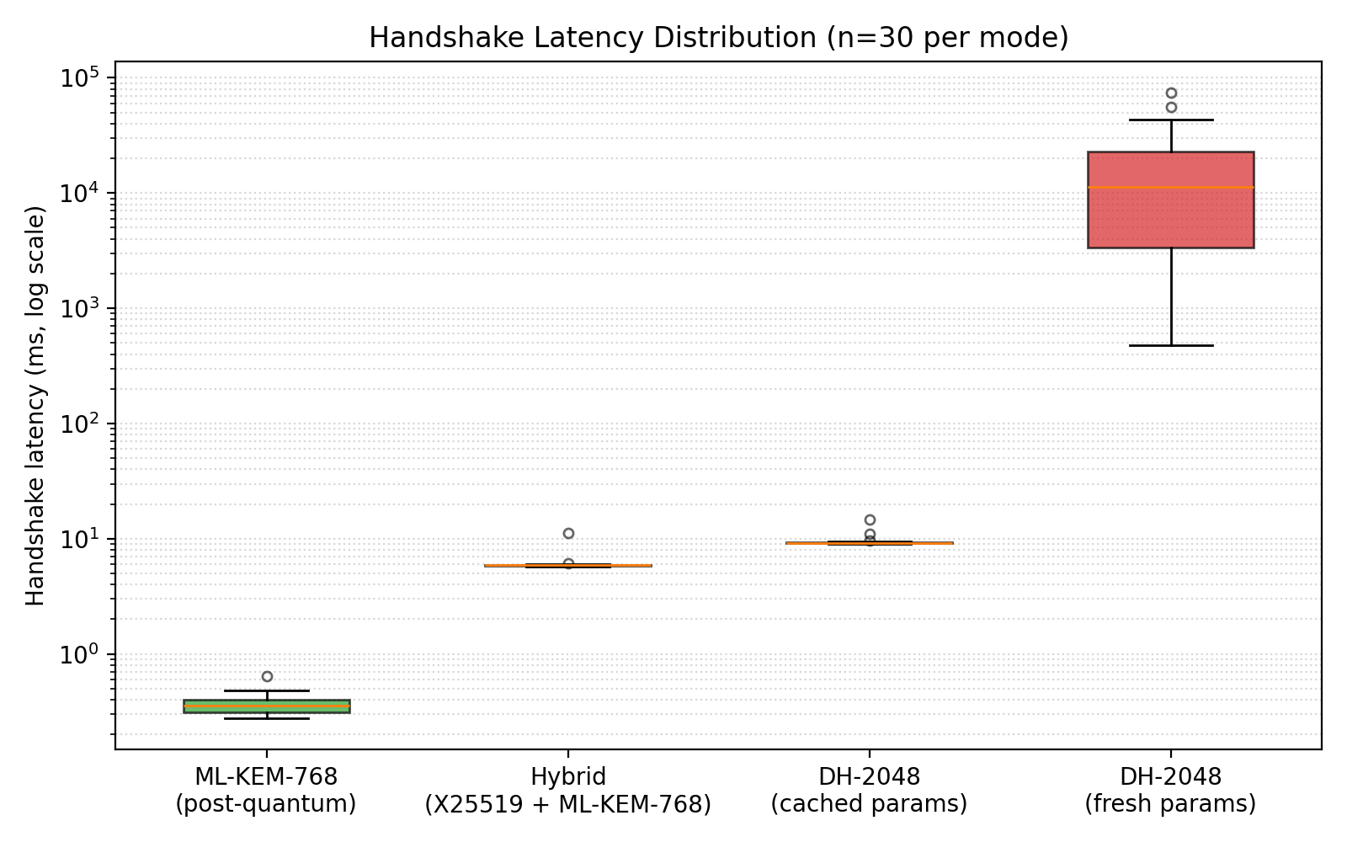
Fig 5.1 — Latency distribution by mode, exposing the heavy-tailed behaviour of fresh-parameter DH against the near-deterministic post-quantum and hybrid modes.

5.8 Summary
This chapter detailed the cryptographic, backend and front-end modules, the adapter pattern that bridges synchronous crypto to asynchronous transport, and the single-writer persistence design. The next chapter describes their implementation.

CHAPTER 6: IMPLEMENTATION

6.1 Technology Stack
The system is implemented in Python 3.12. The cryptography library provides DH-2048, X25519, AES-256-GCM and HKDF-SHA256; pqcrypto provides ML-KEM-768; FastAPI and uvicorn provide the asynchronous WebSocket server; bcrypt provides password hashing; SQLite provides persistence; and Streamlit with Altair provides the front end. The complete implementation spans roughly 3,500 lines across the crypto core, backend services, front end, tests and benchmark harness.

6.2 Key-Exchange Implementation (Strategy Pattern)
All three modes implement a common abstract interface, KexHandler, defining server_side(conn) and client_side(conn), each of which consumes the side-specific portion of the handshake and returns the raw shared secret. A factory maps a mode string to the appropriate concrete handler. This design yields two payoffs: adding a fourth primitive (for example HQC or BIKE) requires only one new class and one factory entry, and it forces fair comparison — all modes share identical framing, key derivation, encryption and surrounding protocol, so the only difference between trials is the key-exchange primitive itself.
send_msg(conn, data): conn.sendall(struct.pack('!I', len(data)) + data)
recv_msg(conn): n = unpack('!I', recv_exact(conn, 4)); return recv_exact(conn, n)

6.3 Encryption Pipeline
Once a session key is derived via HKDF, every payload is encrypted with AES-256-GCM. The encrypt routine generates a fresh 12-byte nonce from os.urandom, produces the ciphertext and 16-byte tag, and returns nonce || ciphertext || tag. The decrypt routine verifies the tag before returning plaintext, raising InvalidTag on any tampering. The Encryption Lab front end mirrors this exactly in the browser, recovering and displaying the per-byte keystream as plaintext XOR ciphertext to make the counter-mode structure of GCM visible.

6.4 Authentication and Session Workflow
Registration hashes the password with bcrypt (work factor 12) and stores the hash. Login verifies the password in constant time, then issues a 256-bit hex session token with a 60-minute expiry, persisted in the sessions table. Subsequent requests carry the token inside the AES-encrypted payload; the server validates it and its expiry before acting. Login responses do not reveal whether a username exists, mitigating account enumeration.

6.5 Message Routing and Offline Queue
On receipt of a valid message, the server looks up the recipient in the in-memory router. If the recipient is online, the message is delivered immediately over their WebSocket and marked delivered. If the recipient is offline, the message is persisted with status sent and drained from the queue automatically on the recipient's next successful login, at which point its status transitions to delivered.

6.6 Replay-Protection Workflow
Every message carries a unique message_id. Before acting on a message, the server checks the seen_messages table; if the identifier is present, the message is rejected as a replay. Otherwise the identifier is recorded with a timestamp. A periodic purge removes identifiers older than the five-minute window, bounding the replay-protection state.

6.7 Interactive Encryption Lab
To make the cryptography tangible, the front end includes an Encryption Lab that performs genuine AES-256-GCM in the browser using the Web Crypto API, mirroring the backend scheme (HKDF-SHA256 key, 12-byte nonce, 128-bit tag). As the user types, the component animates an animated key-exchange handshake, then reveals — byte by byte — the transformation plaintext-byte ⊕ keystream-byte = cipher-byte, assembles the on-the-wire packet, and offers interactive demonstrations of integrity (a single-bit flip triggers tag-verification failure) and the avalanche effect.

6.8 Summary
This chapter described the implementation of the key-exchange strategy, the encryption pipeline, the authentication and session workflow, message routing and the offline queue, replay protection, and the interactive Encryption Lab. The next chapter validates these implementations through testing.

CHAPTER 7: TESTING AND VALIDATION

7.1 Testing Approach
Validation proceeds at three levels: unit tests for each cryptographic primitive, integration tests exercising the full client–server transaction across all modes, and security-property simulations that adversarially probe replay protection and message integrity.

7.2 Unit Testing
Twenty-seven unit tests, organised under tests/, validate every cryptographic primitive: AES-GCM encrypt/decrypt round-trips, tag-mismatch rejection, key-exchange shared-secret agreement for DH, ML-KEM and hybrid, HKDF determinism and domain separation, and public-key serialisation round-trips. All twenty-seven tests pass on Python 3.12. Table 7.1 summarises coverage.
Table 7.1 — Unit Test Coverage by Cryptographic Primitive
Primitive / Module | What is validated | Result
AES-256-GCM | Round-trip; tamper → InvalidTag | Pass
DH-2048 | Shared-secret agreement; serialisation | Pass
ML-KEM-768 | Encapsulate/decapsulate agreement | Pass
Hybrid | Combined secret agreement | Pass
HKDF-SHA256 | Determinism; domain separation | Pass

7.3 Integration Testing
Each mode is exercised end-to-end: a client authenticates, establishes a session under the selected key-exchange mode, sends an encrypted message and receives a decrypted acknowledgement. The offline path is verified by sending to a disconnected recipient and confirming delivery on their subsequent login.

7.4 Replay Attack Simulation
A dedicated simulation authenticates as a legitimate user, sends a valid encrypted message, and then re-transmits the identical encrypted packet. The server accepts the first message and rejects the second, logging that the message identifier has already been seen. This confirms that replay protection operates on the server side and does not depend on client cooperation.
[+] Server accepted: sent <- original message
[+] Server rejected: message_id ... already seen <- replay blocked

7.5 Tamper-Detection Test
Integrity is validated by flipping a single bit of a ciphertext and attempting decryption. GCM's tag verification fails and decryption refuses to return plaintext, raising InvalidTag. The Encryption Lab front end reproduces this interactively, reporting "tamper detected" when a bit is flipped, demonstrating authenticity and integrity to the user.

7.6 Summary
This chapter validated the system at the unit, integration and security-property levels: twenty-seven passing cryptographic unit tests, end-to-end transaction tests across all modes and the offline path, a replay-attack simulation confirming server-side deduplication, and a tamper test confirming GCM integrity. The next chapter presents the performance results.

CHAPTER 8: RESULTS AND PERFORMANCE ANALYSIS

8.1 Benchmark Methodology
The empirical study characterises both the central tendency and the variance of the key-exchange operations under realistic conditions. Thirty trials are run per mode across four modes — DH-2048 fresh, DH-2048 cached, ML-KEM-768 and hybrid X25519 + ML-KEM — for 120 measurements in total. Each trial spawns a fresh server subprocess to eliminate cross-trial state leakage, and timing is captured with nanosecond resolution at five protocol checkpoints (connect, key-exchange start, key-exchange end, message sent, acknowledgement received). Two DH baselines are measured deliberately: the fresh mode generates 2048-bit parameters per connection (worst case), while the cached mode pre-generates parameters at startup (realistic deployment), foreclosing apples-to-oranges criticism.

8.2 Central Tendency of Handshake Latency
Figure 8.1 presents median handshake latency across all four modes on a logarithmic scale. The headline measurement is that ML-KEM-768 — the pure post-quantum mode — completes a handshake in a median of 0.355 ms, compared with 9.176 ms for cached classical Diffie-Hellman (a 26× speedup) and 11,344.014 ms for fresh-parameter DH (a 31,955× speedup). The hybrid mode, which runs both primitives and combines their outputs, sits at 5.88 ms — slower than ML-KEM alone but still comfortably within real-time UX budgets and faster than even the cached classical baseline.

Fig 8.1 — Median handshake latency by mode (log scale, n = 30 per mode).
This finding inverts the conventional industry framing of post-quantum migration. The standard narrative — that post-quantum is the right thing to do but it costs performance — is, for this primitive in this regime, simply not supported by measurement. Post-quantum ML-KEM is not slower than classical DH; it is several orders of magnitude faster on commodity hardware with mature library implementations.

8.3 Summary Statistics
Table 8.1 reports the full latency statistics per mode.
Table 8.1 — Summary Statistics of Handshake Latency in milliseconds (n = 30 per mode)
Mode | Median | Mean | p95 | Min | Max
DH-2048 (fresh) | 11,344.014 | 16,586.256 | 50,280.604 | 478.067 | 74,560.434
DH-2048 (cached) | 9.176 | 9.428 | 10.353 | 8.987 | 14.632
Hybrid (X25519+ML-KEM) | 5.88 | 6.061 | 6.057 | 5.731 | 11.136
ML-KEM-768 | 0.355 | 0.364 | 0.462 | 0.277 | 0.642

8.4 Variance and Distribution Shape
The second principal finding emerges from the variance distribution in Figure 8.2. Three of the four modes — ML-KEM-768, hybrid and cached DH — exhibit near-zero variance: the 95th percentile is within roughly one per cent of the median, and behaviour is effectively deterministic. Fresh-parameter DH, by contrast, exhibits a 156× spread between minimum and maximum within a single batch of thirty trials: from 478.067 ms to 74,560.434 ms, with a p95 exceeding 50 seconds.

Fig 8.2 — Variance distribution of handshake latency by mode (n = 30 per mode, log scale).
The mechanism underlying this variance is the safe-prime search: DH parameter generation draws random 2048-bit candidates and applies primality testing until a safe prime is found, and the proportion of safe primes is low and probabilistic. Production deployments avoid this using pre-generated standardised parameters (the cached mode), but any system that generates fresh parameters per session inherits the full heavy-tailed distribution. The deployment-relevance is that fresh-parameter DH is unfit for any interactive application regardless of the quantum threat: a messaging handshake that occasionally takes tens of seconds — even once in a hundred attempts — is an unacceptable experience.

8.5 Bandwidth Analysis
Table 8.2 reports the application-layer bytes exchanged per transaction. At the application layer the modes are near-identical because the encrypted payload dominates; the principal wire-size difference between modes lies in the handshake public keys (ML-KEM public keys are larger than DH public values), which is measured at the handshake layer rather than the application layer and is noted as a limitation.
Table 8.2 — Application-Layer Bandwidth per Transaction (bytes)
Mode | Bytes sent | Bytes received
DH-2048 | 41 | 50
DH-2048 (cached) | 41 | 50
Hybrid | 45 | 50
ML-KEM-768 | 45 | 50

8.6 Interpretation of Results
Two conclusions follow. First, post-quantum migration in this regime is a performance upgrade rather than a cost: ML-KEM-768 outperforms cached classical DH by a factor of 26 and fresh DH by a factor of approximately 31,955, and the hybrid construction — which provides defence in depth against both quantum-era and as-yet-undiscovered lattice cryptanalysis — runs faster than even the cached classical baseline. Second, fresh-parameter DH's heavy-tailed variance argues against its use in interactive systems independently of any quantum consideration. Together these results remove the performance argument for delaying post-quantum migration in confidential-messaging applications.

8.7 Summary
This chapter reported and analysed the benchmark results: median handshake latencies, full summary statistics, the variance distribution, and application-layer bandwidth. The measured post-quantum speedup and the heavy-tailed fresh-DH variance together support early migration. The next chapter concludes and outlines future scope.

CHAPTER 9: CONCLUSION AND FUTURE SCOPE

9.1 Conclusion
This project presented the design, implementation and empirical evaluation of a real-time secure messaging system implementing three interchangeable key-exchange modes — classical Diffie-Hellman, post-quantum ML-KEM-768 and a hybrid X25519 + ML-KEM construction — connected through a Strategy-pattern architecture and bound to a common AES-256-GCM authenticated-encryption layer via HKDF-SHA256 key derivation. Around this core, a complete messaging platform was built: an asynchronous WebSocket server, bcrypt authentication with session tokens, an SQLite persistence layer, message routing, an offline queue and server-side replay protection, together with an interactive front end that makes the cryptography visible.
Two principal findings emerge. First, post-quantum migration in this regime is not a performance cost but a performance upgrade: ML-KEM-768 outperforms cached classical Diffie-Hellman by a factor of 26 and fresh classical Diffie-Hellman by a factor of approximately 31,955. Second, fresh-parameter Diffie-Hellman exhibits a heavy-tailed variance with a 95th percentile exceeding fifty seconds, which alone argues against its use in interactive systems. Together these results inform the policy argument for early post-quantum migration in applications with long-lifetime confidentiality requirements, of which private messaging under the harvest-now-decrypt-later threat model is a canonical example.

9.2 Future Scope
- End-to-end encryption: introduce client-side key management (for example a double-ratchet) so that the server no longer decrypts message contents, removing the server-trusted assumption.
- Authenticated key exchange: add a PKI-secured, signed handshake to defend against active man-in-the-middle attacks.
- Security-parameter sweep: benchmark ML-KEM-512 and ML-KEM-1024 alongside ML-KEM-768 to characterise the security-versus-performance curve.
- Horizontal scalability: replace single-node SQLite with a networked datastore and a stateless session model for multi-node deployment.
- Complete bandwidth telemetry: instrument the handshake layer to capture raw public-key wire bytes for a full apples-to-apples bandwidth comparison.
- Formal verification: model the protocol composition in ProVerif or Tamarin to obtain machine-checked security guarantees.

9.3 Learning Outcomes of the Project
- Applied understanding of classical and post-quantum key exchange, authenticated encryption and key derivation, and their composition into a secure channel.
- Practical experience with asynchronous network programming, WebSocket transport, and bridging synchronous and asynchronous code safely.
- Experience designing for testability and fair measurement — the Strategy pattern that isolates the key-exchange primitive was as valuable for benchmarking as for extensibility.
- Empirical, evidence-driven reasoning about a security-engineering decision, including the discipline of measuring two DH baselines to avoid biased comparison.

BIBLIOGRAPHY
[1] W. Diffie and M. E. Hellman, "New directions in cryptography," IEEE Transactions on Information Theory, vol. 22, no. 6, pp. 644–654, 1976.
[2] P. W. Shor, "Polynomial-time algorithms for prime factorization and discrete logarithms on a quantum computer," SIAM Journal on Computing, vol. 26, no. 5, pp. 1484–1509, 1997.
[3] National Institute of Standards and Technology, FIPS 203: Module-Lattice-Based Key-Encapsulation Mechanism Standard, U.S. Department of Commerce, August 2024.
[4] J. Bos, L. Ducas, E. Kiltz, T. Lepoint, V. Lyubashevsky, J. M. Schanck, P. Schwabe, G. Seiler and D. Stehlé, "CRYSTALS-Kyber: a CCA-secure module-lattice-based KEM," IEEE EuroS&P, pp. 353–367, 2018.
[5] D. J. Bernstein, "Curve25519: New Diffie-Hellman speed records," Public Key Cryptography — PKC 2006, LNCS vol. 3958, pp. 207–228, Springer, 2006.
[6] H. Krawczyk and P. Eronen, HMAC-based Extract-and-Expand Key Derivation Function (HKDF), IETF RFC 5869, May 2010.
[7] M. J. Dworkin, Recommendation for Block Cipher Modes of Operation: Galois/Counter Mode (GCM) and GMAC, NIST SP 800-38D, November 2007.
[8] D. Stebila, S. Fluhrer and S. Gueron, Hybrid key exchange in TLS 1.3, IETF Internet-Draft draft-ietf-tls-hybrid-design, work in progress, 2024.
[9] B. Westerbaan, "The state of the post-quantum internet," Cloudflare Blog, 12 March 2024.
[10] C. Paquin, D. Stebila and G. Tamvada, "Benchmarking post-quantum cryptography in TLS," PQCrypto 2020, LNCS vol. 12100, pp. 72–91, Springer, 2020.
[11] E. Rescorla, The Transport Layer Security (TLS) Protocol Version 1.3, IETF RFC 8446, August 2018.
[12] I. Fette and A. Melnikov, The WebSocket Protocol, IETF RFC 6455, December 2011.

APPENDIX A: SAMPLE VALIDATION OUTPUT
The unit-test suite reports 27 passing tests across the cryptographic primitives:
$ pytest tests/ -q
........................... [100%]
27 passed
The replay-attack simulation confirms server-side deduplication:
[*] Sending original message (ID: 6e83091af04c...)
[*] Attempting REPLAY with the same payload...
[+] Server accepted: sent
[+] Server rejected: message_id 6e83091af04c... already seen

APPENDIX B: PUBLICATION DETAILS
A condensed version of this work has been prepared in IEEE two-column conference format under the title "Post-Quantum Secure Messaging: A Comparative Performance Study of Classical, ML-KEM and Hybrid Key Exchange," and is available as a companion document. (To be updated with venue and DOI upon submission.)

