IPL Analytics Dashboard using Power BI (SUBMITTED BY:AAKARSH SINGH 2304062)
1. Problem Statement
The Indian Premier League (IPL) generates a vast amount of data including match results, player performances, venues, and team statistics. However, raw datasets are difficult to interpret and do not provide immediate insights.
The problem is to transform this raw IPL data into an interactive and meaningful dashboard that allows users to:
- Analyze team performance
- Understand player statistics
- Evaluate venue trends
- Study match-related factors such as toss decisions
The goal is to build a user-friendly analytical system that converts complex datasets into actionable insights.
2. Solution / Features
To address the problem of analyzing large and complex IPL datasets, an interactive and multi-page dashboard was developed using Power BI. The solution focuses on transforming raw data into meaningful visual insights through proper data modeling, visualization, and user interaction.
2.1 Data Integration and Preparation
Two primary datasets-matches and deliveries—were imported into Power BI. Data cleaning was performed using Power Query to remove errors, handle missing values, and ensure consistency. A relationship was established between the datasets using match identifiers, enabling combined analysis of match-level and ball-by-ball data.
2.2 Interactive Dashboard Design
The dashboard is divided into three structured pages to ensure clarity and ease of analysis:

Page 1: Overview Dashboard
This page provides a high-level summary of IPL data using key performance indicators (KPIs) such as total matches and total runs. It includes charts showing matches won by each team and toss decision distribution. A season slicer is added to allow users to dynamically filter data across different IPL seasons.

Page 2: Venue Analysis
This page focuses on analyzing match distribution across different venues. A bar chart is used to display the number of matches played at each stadium, helping identify the most frequently used venues. Sorting and filtering techniques are applied to highlight top venues for better readability.

Page 3: Player Analytics
This page highlights individual player performance. It includes charts for top 10 batsmen based on total runs and top 10 bowlers based on wickets. The Top N filtering feature is used to focus on key performers, making the analysis concise and impactful.
2.3 Data Visualization Techniques
Various visualization elements are used to enhance understanding:

* KPI Cards for summarizing key metrics
* Bar and Column Charts for comparisons
* Slicers for interactive filtering
* Sorting and Top N Filters for focused analysis

These visual tools make the dashboard intuitive and user-friendly.
2.4 Interactivity and User Experience

The dashboard is designed to be interactive, allowing users to explore data dynamically. The use of slicers enables filtering by season, which updates all visuals in real time. The layout is kept clean and structured to ensure easy navigation across pages.
2.5 Overall Outcome

The final solution successfully converts raw IPL data into an organized and interactive analytical dashboard. It enables users to quickly derive insights related to team performance, player statistics, and venue trends, making it a practical tool for sports data analysis..
3. Dashboard Pages
Page 1: Overview with KPIs and team wins.
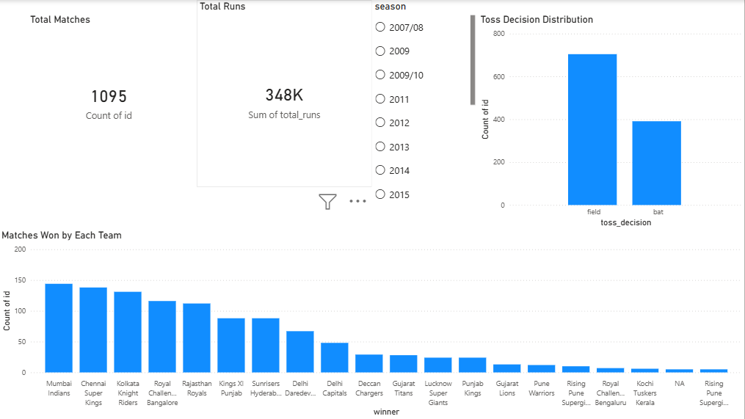
Page 2: Venue analysis.
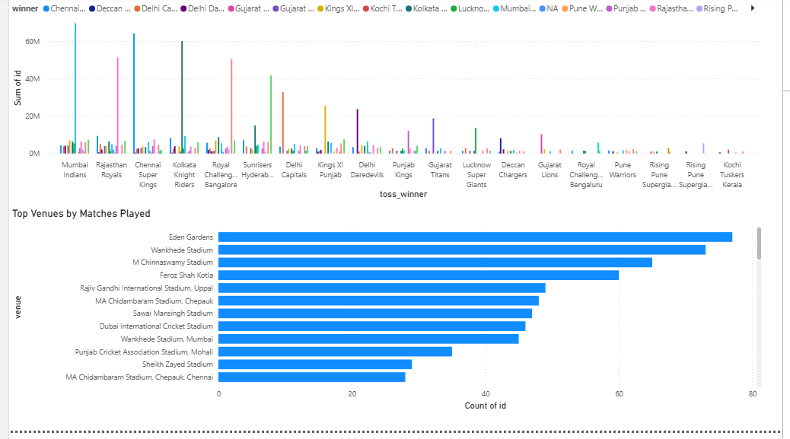
Page 3: Player analytics (top batsmen and bowlers).
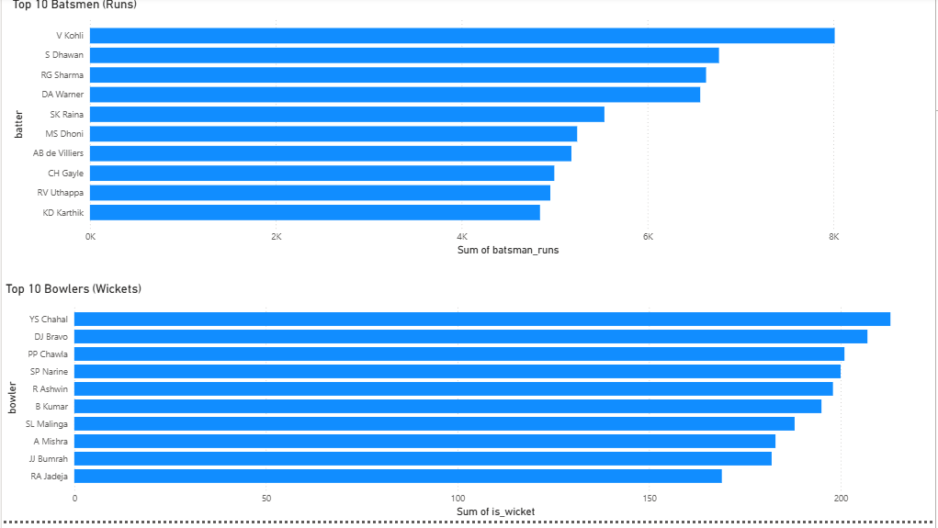
4. Technology Stack
• Tool Used: Microsoft Power BI
• Data Source: IPL dataset (CSV files)
• Techniques Applied:
- Data Cleaning (Power Query)
- Data Modeling (Relationships)
- Data Visualization (Charts, Cards, Slicers)
- Filtering (Top N, Slicers)
5. Unique Points
• Interactive dashboard with filtering (season-wise analysis)
• Multi-page structured design (Overview, Venue, Player)
• Use of Top N filtering to highlight key performers
• Combination of multiple datasets using relationships
• Clean and user-friendly layout for better readability
6. Future Improvements
• Add player comparison feature
• Include advanced metrics like strike rate and economy rate
• Integrate real-time data updates
• Add team-wise detailed analysis page
• Improve UI using themes and custom visuals
7. Conclusion
This project successfully transforms raw IPL data into a structured and interactive dashboard using Power BI. It enables users to quickly analyze team performance, player statistics, and venue trends.
The dashboard demonstrates practical use of data visualization, modeling, and analytical thinking, making it a valuable tool for sports analytics.

