

MINI PROJECT 2021

Name: -DhruvRaj Sanwal

Topic: -Kitchen Fire System

MOTIVATION

Cooking fires are the primary cause of home fires and home fire injuries. The majority of cooking equipment fires start with the ignition of common household items (i.e., wall coverings, paper or plastic bags, curtains, etc.).

## **Facts & Figures**

According to recent statistics, 118,700 fires involved cooking equipment, with 250 deaths and 3880 injuries resulting from these fires. Kitchen fires are most often caused by:

1. Leaving cooking food unattended
2. Placing combustibles too close to the heat source.
3. Unintentionally turning on or not turning off the equipment.

I want to remind the Indian community that cooking is the leading cause of fire injuries on college campuses. Every year, college students experience a growing number of fire related emergencies in their dorm rooms and even many women who have cooking as their daily house hold chores even have fire related problems in house. Through my facts and figure, I show you the main reason behind fire in house is kitchen, now let us discuss what are the particular reason for fire inside a kitchen

* Never leave cooking food on the stovetop unattended, and keep a close eye on food cooking inside the oven.
* Keep cooking areas clean and clear of combustibles (i.e., potholders, towels, rags, drapes and food packaging).
* Keep children and pets away from cooking areas by creating a three-foot “kid–free zone” around the stove.
* Turn pot handles inward so they can’t be bumped and children can’t grab them.
* Wear short, close fitting or tightly rolled sleeves when cooking. Loose clothing can dangle onto stove burners and catch fire.
* Never use a wet oven mitt, as it presents a scald danger if the moisture in the mitt is heated.
* Always keep a potholder, oven mitt and lid handy. If a small grease fire starts in a pan, put on an oven mitt and smother the flames by carefully sliding the lid over the pan. Turn off the burner. Don’t remove the lid until it is completely cool. Never pour water on a grease fire and never discharge a fire extinguisher onto a pan fire, as it can spray or shoot burning grease around the kitchen, thus spreading the fire.
* If there is an oven fire, turn off the heat and keep the door closed to prevent flames from burning you and your clothing. Call the Tufts Police and make sure to have the oven serviced before you use it again.
* If there is a microwave fire, keep the door closed and unplug the microwave. Call the Tufts Police and make sure to have the oven serviced before you use it again. Food cooked in a microwave can be dangerously hot. Remove the lids or other coverings from microwaved food carefully to prevent steam burns.

PROJECT COMPONENTS

* **ARDUINO UNO R3**

The **Arduino UNO** is the best board to get started with electronics and coding. **Arduino Uno** is a microcontroller board based on the ATmega328P. It has 14 digital input/output pins (of which 6 can be used as PWM outputs), 6 analog inputs, a 16 MHz ceramic resonator (CSTCE16M0V53-R0), a USB connection, a power jack, an ICSP header and a reset button. It contains everything needed to support the microcontroller; simply connect it to a computer with a USB cable or power it with an AC-to-DC adapter or battery to get started.

* **GAS SENSOR**

A gas sensor is a device which detects the presence or concentration of gases in the atmosphere. Based on the concentration of the gas the sensor produces a corresponding potential difference by changing the resistance of the material inside the sensor, which can be measured as output voltage. Based on this voltage value the type and concentration of the gas can be estimated.

* **PIEZO BUZZER**

Piezo buzzers are simple devices that can generate basic beeps and tones. They work by using a piezo crystal, a special material that changes shape when voltage is applied to it. If the crystal pushes against a diaphragm, like a tiny speaker cone, it can generate a pressure wave which the human ear picks up as sound. Simple change the frequency of the voltage sent to the piezo and it will start generating sounds by changing shape very quickly!

* **SERVO MOTOR**

A **servo motor** is a type of motor that can rotate with great precision. Normally this type of motor consists of a control circuit that provides feedback on the current position of the motor shaft, this feedback allows the servo motors to rotate with great precision. If you want to rotate an object at some specific angles or distance, then you use a servo motor. It is just made up of a simple motor which runs through a **servo mechanism**.

* **ARDUINO IDE**

**Arduino IDE** where IDE stands for Integrated Development Environment - An official software introduced by Arduino.cc, that is mainly used for writing, compiling and uploading the code in the Arduino Device. Almost all Arduino modules are compatible with this software that is an open source and is readily available to install and start compiling the code on the go.

PROJECT DESCRIPTION

This project is purely created by Aakarshan Bhardwaj, the central target of this project was to study, analyze and design a fire detection and alarm system. This topic was suitable because it covered a basic and important aspect in our modern life. I have gained the valuable experience in the field of Arduino board and alarm system from studying and conducting this project. The objectives of the project were to provide information on fire alarm system in India. Secondly, in the practical part, the objective was to build a demo system to demonstrate how to tackle fire caused by an LPG or any other means. The system is expected to operate satisfactorily not only under fire conditions, but also when faced any conditions to be met in practice the condition about which we are talking here are burning of food, cloth catching fire, wire catching fire and other condition from which fire can cause or formation of fumes occur.

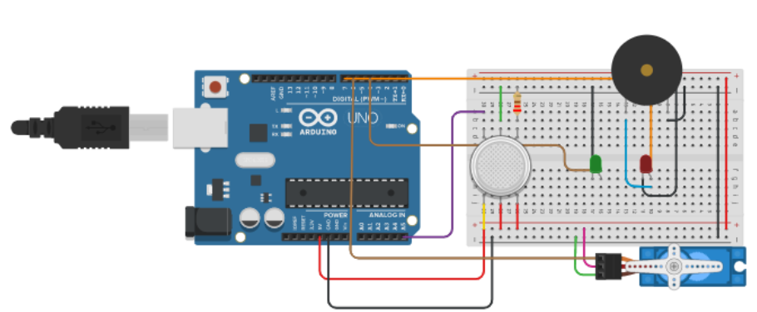

BIBLOGRAPHY

* [https://www.arduino.cc](https://www.arduino.cc/)
* [https://lastminuteengineers.com](https://lastminuteengineers.com/)
* [https://www.tinkercad.com](https://www.tinkercad.com/)
* <https://www.youtube.com>

THANK YOU