

MINI PROJECT

2022

NAME: Aakarshan Bhardwaj

ROLL NO: 2015041

TOPIC: Music Recommendation System

MOTIVATION

Art and music are human creations. Humankind and art cannot function without each other, people have always found music significant in their lives, whether for enjoyment in listening, the emotional response, performance or showing gratitude towards others. With the rise of digital content distribution, we have access to a vast music collection. With millions of songs to choose from, and sometimes is often challenging to find music of your taste. An average human being listens to 52(3minutes songs) daily. Thus, an efficient music recommender system is necessary for the interest of any art form for leisure and service to our human race.

**SOME FACTS ABOUT MUSIC**

1. Music enhances running performance.
2. Music Lowers Stress and improves health.
3. Music Elevates your mood while driving.
4. Music strengthens learning and memory.
5. Music raises IQ and increases verbal intelligence.
6. Music helps with anxiety.
7. Music helps in old age to counter loneliness.

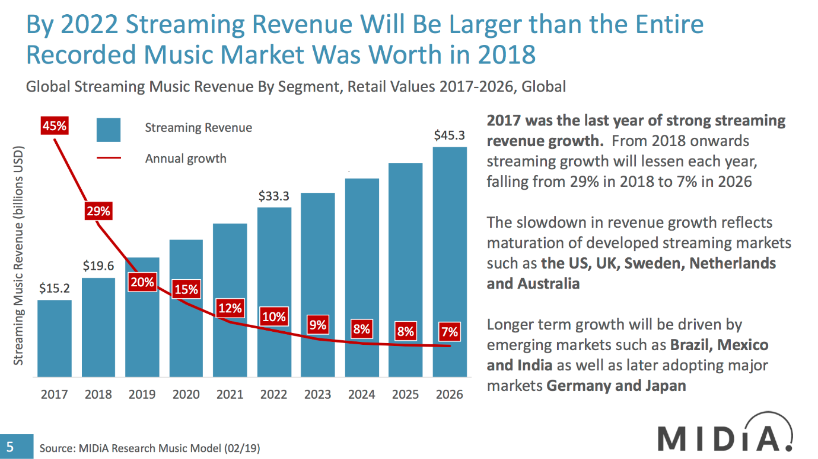

Source: <https://www.midiaresearch.com/blog/midia-research-2018-2026-streaming-music-forecasts>

to help this industry grow in a linear way we need to build the interest of the new generation and let the older generation remain interested in newer music which is similar to older music. The motivation of this project is the same for both the generation as a newer generation should not forget the classical and folk music genre which is getting absolute in today’s world and let the older generation enjoy music as before.

A recommendation system helps the user to get a personalized recommendation, helps the user to take the correct decision in their online transaction, increase sale and redefine the user’s web browsing and e-shopping experience. We have taken one of the implementations of recommendation system in music streaming platform.

PROJECT DESCRIPTION

This project is based on the Spotify dataset of music which is suggested by my project mentor Ms Vishu Tyagi ma’am. My music recommendation system is large-scale and is non-personalised i.e., the data is not oriented for a single user The dataset has relevant data from 1970 to 2021 in altered form. We learn from many factors like, let us understand some factors on which songs are getting recommended.

1. Acoustics: - sound produced by the musical instrument which is not electronically modified
2. Artists: - singer who sang the song
3. Energy: -it represents intensity and activity
4. Song Id: -to manage songs in the application id is given
5. Liveness: -how many vocals are participating
6. Valence: -determine track is happy or sad
7. Year: -release year of song/track

And many more.

First, we analyse the data in a CSV file and check the correlation of features of songs with each other correlation simply defines the relationship among two variables. We used the most popular correlation i.e. Pearson.it returns a value between -1 to 1.

Now we will normalise the dataset to have scalability in the project. The question arises why we need scalability, we know we will measure the distance of songs between each other, but it is not possible as all have different scales to incubate in the project. It can be implemented in 2 steps: -

1. Find max and min values.
2. Value of each data is subtracted from the min value and divided by the difference of max and min.

Now we will do clustering of data from dataset. The algorithm we used here is K-Means Clustering. K means groups we form for our data(we used 10).

Now after applying this algorithm, we found that there are many versions of the same song then we use a content-based filtering recommendation system. here similar features of a song are recommended, to check the similarity between songs we will find the Manhattan distance of all features of the given input and in the case of a similar song we will take account of the oldest version of that song.

recommender**=**AakarshanRecommender(data)

recommender**.**get_recommendations('Venom', 8)

100%|██████████| 174387/174387 [00:12<00:00, 13587.35it/s]

Out[136]:

|  | **artists** | **name** |
| --- | --- | --- |
| **141419** | ['Die Antwoord'] | I Fink U Freeky |
| **19112** | ['Kanye West'] | Father Stretch My Hands Pt. 1 |
| **126591** | ['CORPSE'] | Cabin Fever |
| **38928** | ['Kevin Gates'] | Me Too |
| **142969** | ['Playboi Cart] | Not PLaying |
| **38874** | ['Juice WRLD'] | Hurt Me |
| **124119** | ['Gym Class Heroes', 'The-Dream'] | Cookie Jar (feat. The-Dream) |
| **38992** | ['Migos', 'Nicki Minaj', 'Cardi B'] | MotorSport |

BIBLIOGRAPHY

To understand the concept of content-based recommendation

<https://youtu.be/EjOlN6uVBOg>

To understand the concept of data modelling in ML

<https://www.javatpoint.com/machine-learning>

special thanks to:

Ms Vishu Tyagi ma’am

Mr Arun Chauhan sir

**THANK YOU**