1. To create a new blank document:

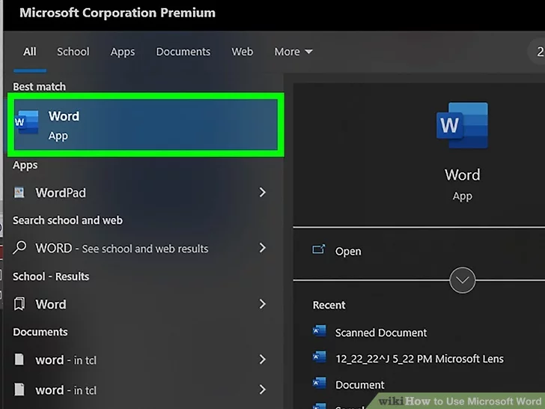1 Step: **Open the Microsoft Word application.** Do this by double-clicking the Microsoft Word icon.

2 Step: Select New, then click Blank document.

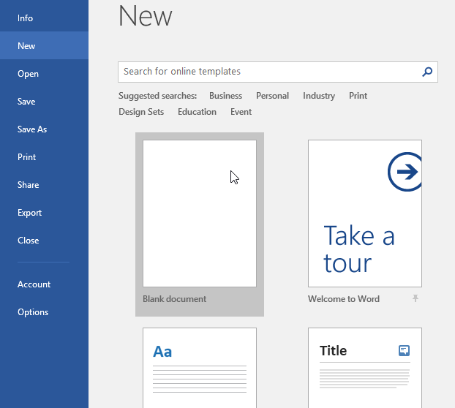

1. Saving a document

1 Step: Click on File. It's in the menu bar at the upper-left of the screen or a tab at the upper-left of the window

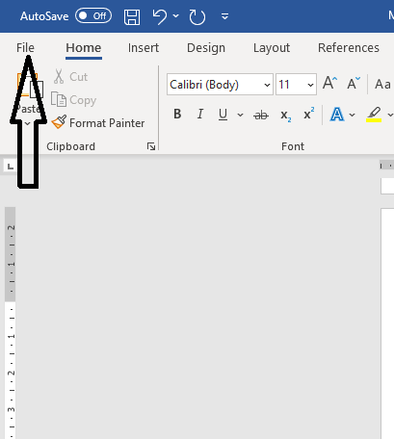

2.Step: Click on Save or Save As The Save dialog box will open.



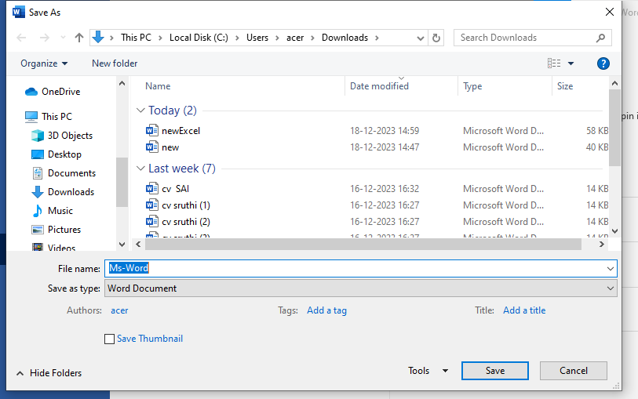3.Step: Write a file name and save in any path.

3. Printing a document

1.Step: Open or create a Microsoft Word document. To do so, click on the blue app with a white document icon and bold "W," then click on File in the menu bar at the upper-left of the screen. Click on Open... to open an existing document or New... to create a new one. When you are ready to print, open the Print dialog box.

2.Step: Click on File. It's in the menu bar at the upper-left of the screen or a tab at the upper-left of the window



3.Step: Click on Print.... The Print dialog box will open

