An Integrated SOC Platform with Zabbix Monitoring, SIEM Correlation, Honeypot Deception, and MITRE ATT&CK-Based Incident Response Automation

Aakashkumarsingh Harendrakumar

Department of Information Technology

Aditya Silver Oak Institute of Technology, Silver Oak University

Ahmedabad, Gujarat, India

Internal Guide: Prof. A. R. Kazi

Abstract — Infrastructure monitoring (is the host up, is CPU/RAM/disk healthy) and security monitoring (is the host under attack, and what do we do about it) usually come from two separate, expensive toolchains. This paper describes an integrated Security Operations Center (SOC) platform that puts both jobs into one Node.js/Express dashboard built on top of Zabbix. The platform pulls real-time host telemetry through the Zabbix API; correlates security events through a Wazuh-style SIEM pipeline with severity classification (CRITICAL/HIGH/MEDIUM/LOW); scores and profiles attacker IP addresses through a Threat Intelligence module; catches unauthorized probes with an isolated HoneyPot and a synthetic decoy e-commerce site; tracks the full incident lifecycle (Detected → Investigated → Contained → Resolved) against MITRE ATT&CK technique categories; and lays out the entire detection-to-response chain as an interactive, drag-and-drop "SOC Flow" node graph. Automated remediation goes through n8n workflows, while role-based access control (Admin/Analyst/Viewer), WebSocket-driven live notifications, and a full audit log keep day-to-day operation in check. The system also ships as a one-click Windows installer, which meant swapping native SQLite bindings for a pure-JavaScript JSON datastore for cross-machine portability. In a controlled test session across eight monitored hosts, the platform correctly classified 25 active problems (10 critical), processed a 48-hour HoneyPot window of 6,501 sessions across 374 unique source IPs, and auto-generated MITRE-tagged incident cards for privilege-escalation, malware, SQL-injection, and lateral-movement patterns without any manual tagging. What comes out of this is a single, zero-license-cost stack that gives small teams and academic labs both NOC-grade uptime visibility and SOC-grade threat visibility from one screen.

Keywords — Zabbix; SOC Dashboard; SIEM Correlation; MITRE ATT&CK; Threat Intelligence; Honeypot; Deception Technology; n8n Automation; WebSocket; Role-Based Access Control.

I. Introduction

Keeping dozens, sometimes hundreds, of servers, switches, VMs, and cloud services in sync is already challenging. When one piece breaks, everything downstream can fall apart with it, and by the time someone notices, the damage is already done. This is made more difficult by the fact that the same infrastructure is also a target every single day — probes, credential-stuffing attempts, and injection attacks — whether or not anyone is watching.

These two concerns, "is it up" and "is it under attack," have traditionally lived in separate tools bought from separate vendors. A Network Operations Center (NOC) stack such as Zabbix or Nagios handles uptime; a Security Operations Center (SOC) stack such as Splunk Enterprise Security or IBM QRadar handles threats. Running both is expensive, and for a college lab or a small IT team it usually isn't realistic. Switching between two dashboards mid-incident also costs the exact minutes that matter most.

This paper builds on an earlier Zabbix-based fault-detection project and turns it into a unified SOC platform. The monitoring core has not changed; Zabbix agents still ship CPU, memory, disk, and network telemetry to a central server; however, the presentation and automation side was rebuilt from scratch as a Node.js/Express application. On top of this base, we added SIEM-style event correlation, a deception layer (a HoneyPot plus a synthetic decoy e-commerce site), a threat intelligence module, a MITRE ATT&CK-mapped incident-response workflow, and a visual "SOC Flow" node graph that shows the live path from raw sensor data to automated response.

This study makes five contributions. First, a single dashboard that merges infrastructure and security monitoring, so that no one has to jump between separate NOC and SOC tools. Second, an opt-in, network-isolated honeypot and decoy e-commerce subsystem that feeds the same event pipeline used for real hosts; deception data are analyzed with the same severity and threat-intelligence logic rather than sitting off to one side. Third, a MITRE ATT&CK-tagged incident lifecycle transforms a raw alert into an auditable four-stage workflow. Fourth, an interactive SOC Flow view that provides an operator with a live, node-by-node picture of the detection-to-response chain. Fifth, a packaging pipeline that turns the entire stack into a one-click Windows installer, which, as Section V explains, forced a fairly interesting trade-off between native SQLite bindings and a pure-JavaScript JSON datastore.

The rest of the paper is laid out as follows. Section II covers related work in monitoring, SIEM correlation, deception technology, and MITRE ATT&CK-based response. Section III lists the requirements. Section IV describes the architecture. Section V provides implementation details. Section VI presents the observations during testing. Section VII discusses the limitations and future directions, and Section VIII concludes the paper.

II. Related Work

Work related to this platform falls into four rough categories: agent-based network monitoring, SIEM-style event correlation, deception technology, and MITRE ATT&CK-based response, with automation as a thread running through all of them.

A. Agent-Based and Protocol-Based Monitoring

Nagios [3] was one of the first serious open-source monitoring platforms, and many organizations still use it. It works through check plug-ins and flat configuration files, although, which makes a dynamic environment painful to maintain — there's no built-in auto-discovery, so every new host has to be added by hand. Zabbix [1] does this differently: register a new Linux host and, within minutes, you can have 200-plus items being monitored automatically through auto-discovery rules, a web UI, and a large library of ready-made templates. Native SNMP, IPMI, and JMX support means one tool covers several device types instead of stitching several tools together.

Prometheus rode the rise of Kubernetes and integrates well with service discovery, but it is, at its core, a metrics collection and query engine — you still need Alertmanager for notification and Grafana for visualization, so matching what Zabbix provides out of the box means installing three separate products [5]. On the commercial side, platforms like SolarWinds NPM [6] throw in AI-based anomaly detection and vendor support, but the licensing cost puts them out of reach for a lot of smaller teams. That's exactly where Zabbix's zero-license model earns its keep.

B. SIEM and Security Event Correlation

SIEM platforms — Splunk Enterprise Security, the open-source Elastic (ELK) Stack [10] — centralize log ingestion, run events against detection rules, and hand an analyst a severity-ranked alert list instead of a raw firehose. Wazuh [9] takes the OSSEC host-based intrusion-detection lineage and grows it into a full agent/manager SIEM architecture that classifies every event by rule ID and severity. This platform borrows the same model for its own event feed, even in sessions where no live Wazuh manager is reachable and a compatible mock feed steps in instead. The one lesson that keeps showing up across this literature is that correlation quality — turning thousands of raw log lines into a handful of ranked, actionable alerts — matters far more than the amount of raw data that can be ingested.

C. Deception Technology and Honeypots

Using decoy systems to observe attacker behavior is an old idea — older than modern SOC tooling. Spitzner's foundational work on honeypots [12] and Provos's Honeyd framework [13] set the template: low-interaction decoys that log connection attempts without exposing anything real. "Honeypot farms" like T-Pot later bundled several decoy services behind one collector. This platform adheres to the same low-interaction idea but at a smaller scale — one HoneyPot listener plus a synthetic e-commerce decoy — and, importantly, feeds every captured event into the same correlation pipeline used for genuine hosts rather than parking deception data in a silo of its own.

D. MITRE ATT&CK-Based Incident Response

The MITRE ATT&CK framework [11] catalogues adversary tactics and techniques — such as privilege escalation, lateral movement, and exploiting a public-facing application — and has become a shared vocabulary for classifying detections and writing incident-response playbooks. Mapping raw alerts to ATT&CK categories gives analysts common ground for triage, and it means a new team member does not have to learn a vendor-specific taxonomy before reading an alert. This platform uses the vocabulary directly on its incident cards instead of inventing its own severity language from scratch.

E. Automation Integration Approaches

Pairing monitoring with automated fixes is not new either. Khatkar et al. [7] fired Ansible runbooks off Nagios alerts; Raj and Sharma [8] built a Prometheus-Grafana-Jenkins pipeline for automatic CI/CD rollback. This project keeps n8n [2] — a self-hosted workflow engine — as its remediation layer, but adds something those didn't have: a visual SOC Flow node graph that lets an operator watch the live state of every stage (sensor, correlation, threat intel, response) instead of relying only on the workflow engine's own execution log.

III. System Requirements

A. Hardware Requirements

The monitoring server requires at least an Intel Core i5 at 2.4 GHz, 8 GB of RAM (16 GB is a safer bet once the HoneyPot, decoy site, and WebSocket layer are all running alongside Zabbix), and 25 GB of free disk space for logs, the datastore, and Zabbix's own database. A normal LAN or Internet connection is sufficient. The reference deployment ran Ubuntu 22.04 LTS for the Zabbix server and Windows 10/11 x64 for the packaged SOC dashboard installer.

TABLE I. HARDWARE REQUIREMENTS

Component | Minimum Requirement
Processor | Intel Core i5, 2.4 GHz or higher
RAM | 8 GB (16 GB recommended)
Storage | 25 GB free disk space
Network | LAN / Internet connectivity
OS (Zabbix server) | Ubuntu 22.04 LTS / CentOS 7+
OS (SOC dashboard) | Windows 10/11 x64 or Linux

B. Software Requirements

TABLE II. SOFTWARE REQUIREMENTS

Software | Version / Details
Zabbix Server | 6.0 LTS / 7.0 LTS
Node.js | v20.x (Express 4.19.2)
Datastore | SQLite 3 (dev) / JSON file store (installer build)
Real-time layer | ws 8.20.0 (WebSocket)
Charts | Chart.js 4.4
SIEM feed | Wazuh-compatible event schema (live or mock)
Automation | n8n v1.x (self-hosted, webhook-driven)
Installer | NSIS 3.x (Windows one-click setup)

C. Functional Requirements

At minimum, the system must perform the following tasks: monitor CPU, memory, disk, and network metrics live across every registered host; sort and display security events by severity — CRITICAL, HIGH, MEDIUM, and LOW; rank attacker IP addresses in a Threat Intelligence view with per-IP evidence (matched rules, event sources, and a recent-events timeline); catch unauthorized connection attempts through an opt-in HoneyPot and decoy e-commerce site without ever touching production data; walk each incident through a four-stage MITRE ATT&CK-tagged lifecycle (Detected → Investigated → Contained → Resolved); draw the entire detection-to-response chain as an interactive, zoomable SOC Flow graph; fire n8n remediation workflows off Zabbix and SIEM alerts; push new-device and alert notifications over WebSocket; enforce role-based access for Admin, Analyst, and Viewer accounts with a full audit trail; export host and problem data to CSV; and fall back gracefully to representative mock data whenever a live Zabbix or SIEM source can not be reached, so that the dashboard is never just a blank screen.

D. Non-Functional Requirements

99.9% uptime or better is the target for the dashboard itself. Under normal load, pages should render in less than three seconds, and the platform needs to handle at least 20 hosts plus concurrent HoneyPot/decoy traffic without a noticeable slowdown. Every administrative action requires authentication, and metrics need to stay around for at least 90 days for trend analysis. One requirement here is less about engineering and more about ethics: because the HoneyPot and decoy e-commerce sites actively invite unauthorized traffic, they have to stay off by default, switch on only through an explicit environment flag in an authorized lab, and remain network-isolated from anything production.

IV. System Design and Architecture

A. Architectural Overview

Four logical planes make up the platform. The Monitoring Plane comprises Zabbix agents on each host, the Zabbix Server (trigger engine plus database), and an optional Zabbix Proxy for remote segments. The Security and Deception Plane runs the SIEM-style correlation pipeline next to the HoneyPot and the synthetic decoy site, both of which push events into the same normalized schema used for real hosts — this matters because it means that deception traffic is not treated as a second-class citizen. The Automation and Orchestration Plane is the n8n workflow engine plus the SOC Flow graph that visualizes it live. Finally, the Presentation Plane comprises a Node.js/Express REST API paired with a WebSocket channel and a single-page dashboard. Fig. 1 shows the Overview tab, which is where an operator lands first and, in one glance, touches all four planes at once.

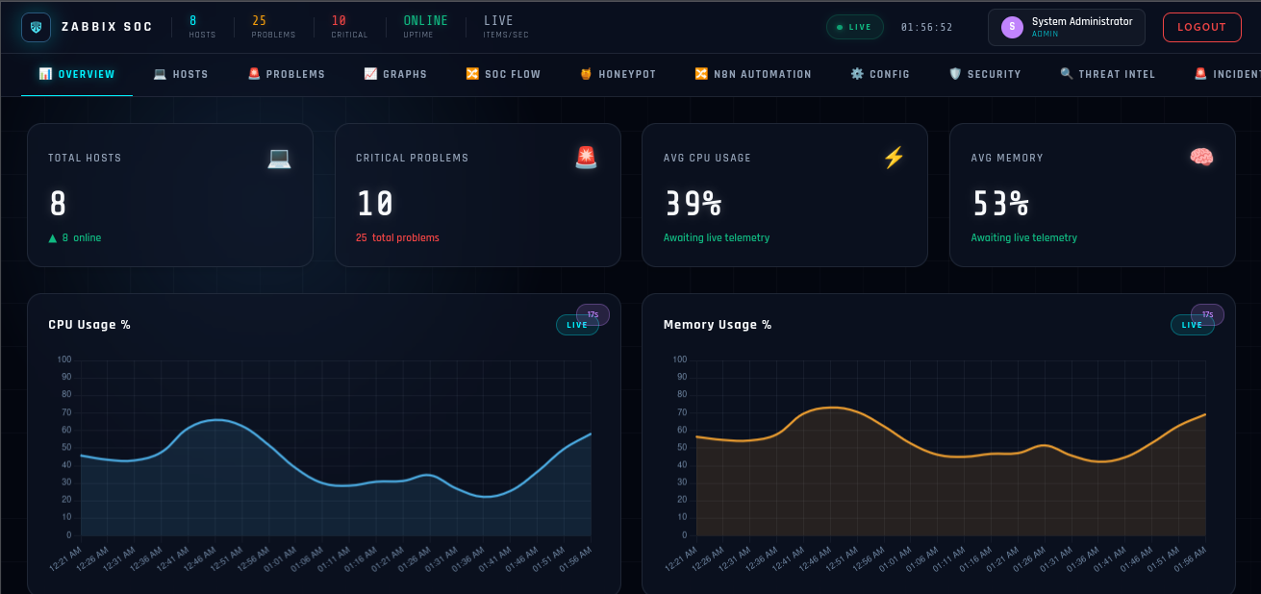

Fig. 1. SOC Dashboard: Overview tab showing host count, critical problems, and live CPU/memory telemetry.

B. SOC Dashboard Module Design

Twelve tabs make up the front end: Overview, Hosts, Problems, Graphs, SOC Flow, HoneyPot, N8N Automation, Config, Security, Threat Intel, Incidents and Admin. Hosts lists every monitored machine with live CPU, memory and disk numbers plus an availability percentage; click into a host and a detail panel opens with rolling telemetry charts (Fig. 2). Problems lists active Zabbix issues sorted by severity with one-click acknowledgement, and Graphs pulls back the camera to show longer CPU, memory and network-throughput trends.

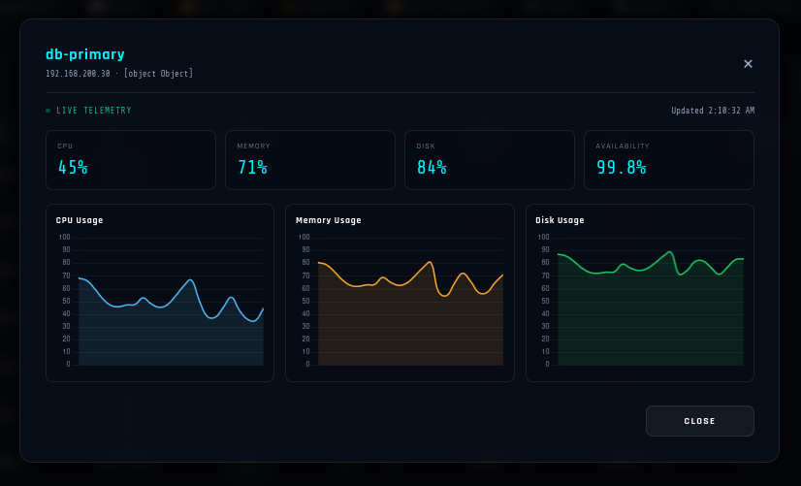

Fig. 2. Host detail panel — live CPU, memory, and disk telemetry for an individual monitored host.

C. SIEM Correlation and Security Event Pipeline

The Security tab runs a live event feed that refreshes every five seconds, a 24-hour alert-volume bar chart, and a severity-distribution donut chart — all backed by the /api/security/events, /api/security/stats, and /api/security/chart/hourly endpoints. Every event carries a severity badge (CRIT, HIGH, MED, or LOW), a source IP, an agent identifier, and the rule that fired, which is basically the same rule-based classification model that open-source SIEM tools like Wazuh [9] use. Fig. 3 catches the panel mid-session with 17 critical, 22 high and 13 medium-severity events on screen.

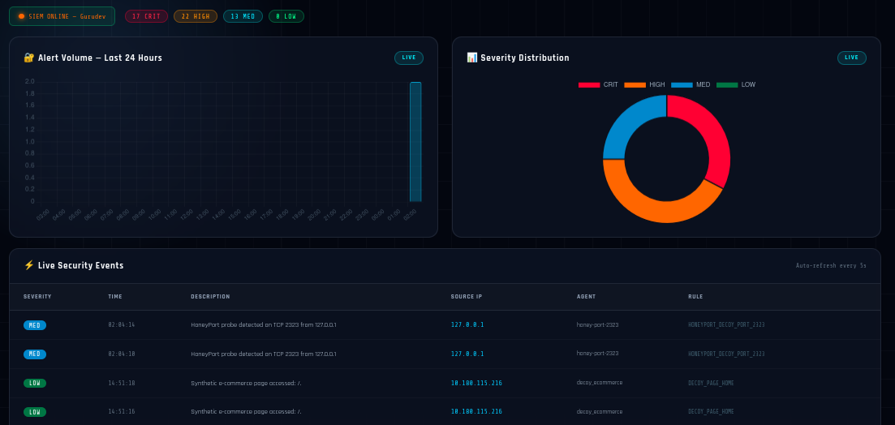

Fig. 3. Security tab — live severity distribution and real-time security-event feed.

D. HoneyPot and Decoy Deception Layer

The HoneyPot tab plots decoy-port probes and captured connections on a world map, next to a rolling summary of sessions, unique source IPs, connections and "hints caught." Probe signatures — TLS and TCP handshakes on configurable decoy ports — are grouped into attack-campaign buckets: SSH, Scanner, and Botnet, each tracking its own IP count, as shown in Fig. 4. A companion synthetic e-commerce decoy site stays off unless the DECOY_ENABLED environment flag is explicitly set. Once it's on, it serves fabricated product pages on its own port and tags every visit with event_source = decoy_ecommerce, so decoy traffic shows up in Security, Threat Intel, and SOC Flow through the same pipeline as a genuine host — without ever touching a real payment gateway, email service, or anything else external.

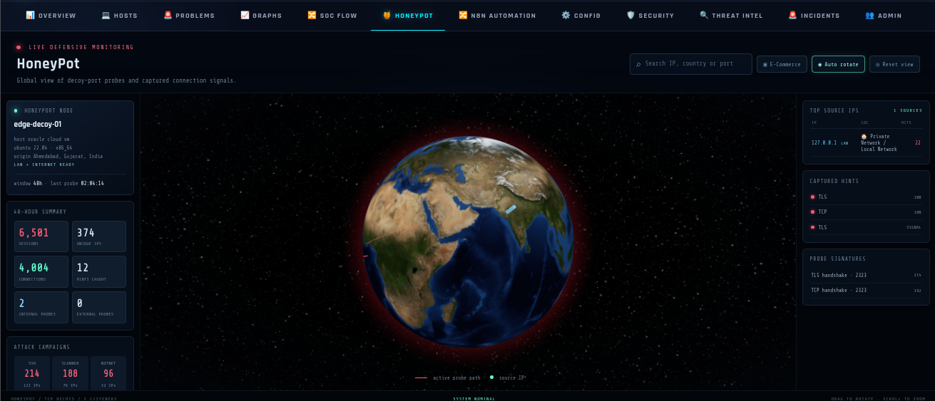

Fig. 4. HoneyPot tab — 48-hour capture summary, top source IPs, and attack-campaign classification

E. Threat Intelligence Module

Threat Intel ranks attacker IPs by hit count and threat score, tagging each as high, medium, or low risk with a last-seen timestamp. Click an IP, and an evidence panel opens (Fig. 5), listing every event source and rule that matched it — HoneyPot decoy-port rules sitting right next to decoy e-commerce page hits, for instance — along with a scrollable recent-events timeline. The point is to give an analyst one place to see the whole story behind a risk score instead of just a number with no context.

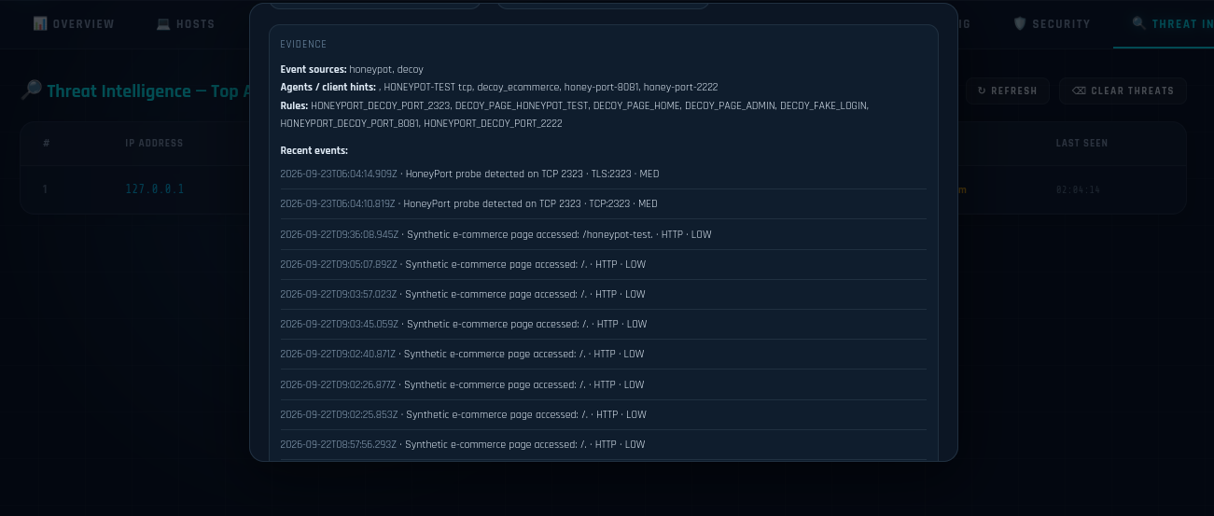

Fig. 5. Threat Intelligence — evidence panel for a flagged IP, listing matched rules, and recent events.

F. MITRE ATT&CK-Mapped Incident Response Workflow

Incidents turn raw alerts into incident cards — each one gets a unique auto-generated ID, a severity badge, a MITRE ATT&CK technique-category tag, and a four-stage tracker: Detected, Investigated, Contained, and Resolved (Fig. 6). During testing, the categories that appeared included privilege-escalation patterns, malware hash matches, web-application SQL-injection alerts, and lateral-movement/SMB-enumeration detections — all generated straight from the underlying event stream, with nobody typing tags in by hand.

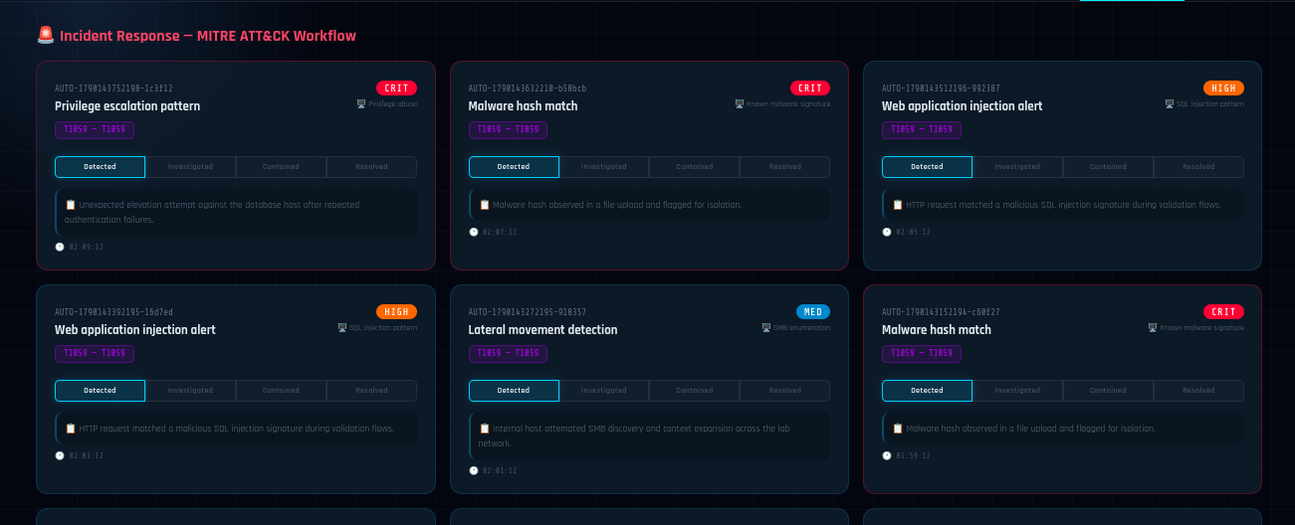

Fig. 6. Incident Response tab — MITRE ATT&CK-tagged incident cards with a four-stage workflow tracker.

G. SOC Flow — Visual Automation and Response Orchestration

SOC Flow is a drag-and-drop canvas that draws the entire detection-to-response chain as a live node graph (Fig. 7). The node palette has seven categories — Data Source, Security Sensors, Trigger/Eval, Correlation/IR, Threat Intel, Response/Notify, SIEM/Store — and the live pipeline fills in nodes for the Zabbix Server, HoneyPot Sensors, a Wazuh SIEM node, Event Correlation, Threat Intelligence, an Incident Queue, Response Automation, SOC Notifications, and a SIEM/Elastic evidence store. Each node shows live counters — events processed, open incidents, severity breakdown — and the canvas zooms, pans, and fits to the screen, with a side panel streaming the raw alert feed as it moves through the graph. This is the view that answers the operator's most common question at a glance: is this alert stuck at correlation, or has it already reached Response Automation?

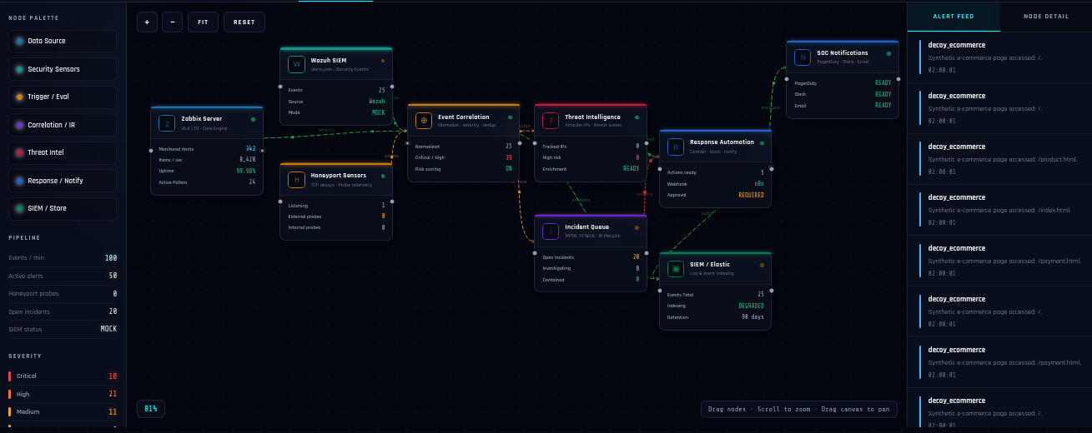

Fig. 7. SOC Flow — drag-and-drop node graph of the detection-to-response automation pipeline.

H. Graphs and Telemetry Visualisation

Graphs (Fig. 8) plot the system CPU, memory utilization, and live network-speed gauge over a rolling two-hour window, plus a "Problems by Severity" donut chart. The panels auto-rotate every 60 seconds, which was a deliberate choice — it means the tab can sit on a shared operations screen and stay useful without anyone touching it.

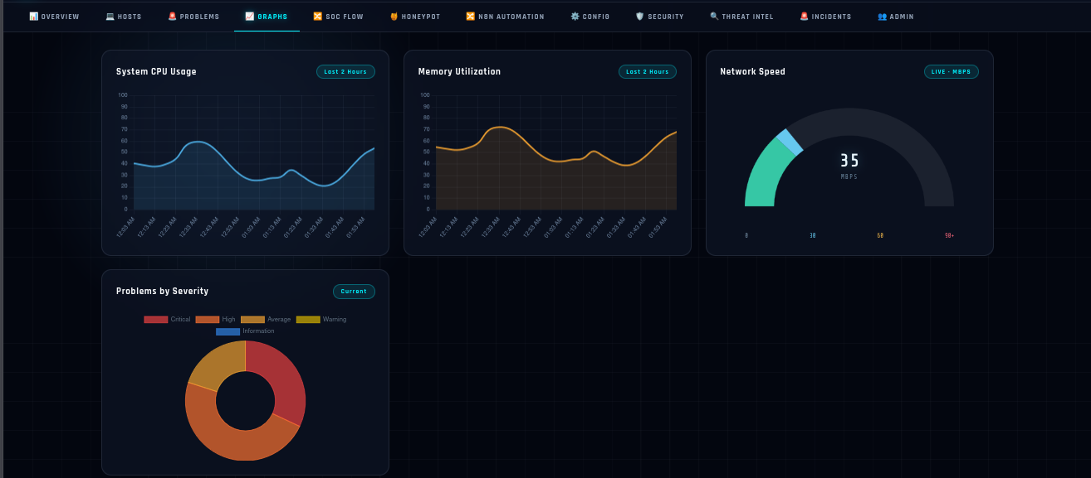

Fig. 8. Graphs tab — CPU, memory, and network telemetry with a live problems-by-severity breakdown.

I. n8n Automation Workflow

Remediation runs through n8n over a REST webhook. When Zabbix or the SIEM pipeline raises an alert, a JSON payload — host name, triggered rule, and severity — is posted to n8n, which walks it through detection, analysis, fixing, and resolution. Analysis pulls back the previous 60 minutes of Zabbix metric history for that host, as a one-min CPU spike and a 45-minute sustained overload obviously require different responses. Fixing is where the workflow SSHes in and restarts a service, tweaks a firewall rule, or clears disk space, depending on the incident. Every action gets written to the audit log so that nothing the automation does is invisible after the fact. Three templates exist today: Service Restart (SSH-based recovery), Disk Space Cleanup (log rotation plus temp-file purge), and Escalation (a PagerDuty page to whoever is on call, after 15 minutes with no automated fix). The SOC Flow Response Automation node mirrors whichever template is currently running.

J. Role-Based Access Control, Real-Time Notification and Audit Logging

Three roles run through the API. The admin gets full read/write access to hosts, users, configuration, and the audit log. The analyst can see all hosts, problems, and graphs and acknowledge problems, but can not touch the configuration. Viewer is read-only, full stop. A WebSocket channel pushes new-device and new-alert events to every connected browser instantly, and a separate Telegram integration can mirror critical alerts outside the dashboard entirely — useful if nobody happens to be looking at a screen when something breaks. Every admin action, from creating a user to deleting a host, lands in a persistent audit log that admin accounts can review.

TABLE III. ROLE-BASED ACCESS CONTROL

Role | Access Level
Admin | Full read/write; user management; audit log; all tabs
Analyst | Read all hosts/problems/graphs; acknowledge problems; no config access
Viewer | Read-only across all monitoring and security tabs

V. Implementation

A. Zabbix Server Deployment

Zabbix Server 7.0 LTS went in from the official Zabbix repositories on a clean Ubuntu 22.04 LTS box, with MySQL 8.0 behind it, initialised from the vendor's own schema scripts. Rather than hand-configuring every monitored item one by one, the built-in "Linux by Zabbix Agent" template was applied to each Linux host and that alone brought in over 200 monitored items — kernel parameters, running services, network interfaces — without writing a single custom item definition.

B. Node.js/Express Backend Architecture

All backend processes are executed in Node.js. server.js, at approximately 2,400 lines, is the Express core and owns every REST route in the system: authentication (/api/auth/*), user and role management (/api/users/*), Zabbix data access (/api/zabbix/*), the combined SIEM/HoneyPot/Threat-Intel surface (/api/security/*, /api/honeypot/summary), the decoy event intake (/api/decoy/events), the audit log (/api/audit-log), and hooks into n8n and Telegram. zabbix-api.js wraps the Zabbix JSON-RPC API for host and problem retrieval. database.js owns the SQLite schema, seeding, and queries for users, audit entries, and security events. websocket.js runs the real-time broadcast channel, and config.js maintains the environment settings in one place. On the front end, it is a single-page app — final.html plus style.css — styled as a dark, high-contrast console, with Chart.js 4.4 doing every chart and gauge, and n8n-addon. js/css layered on the automation panel.

C. HoneyPot and Decoy Subsystem Implementation

The deception layer lives in three cooperating files — decoy-server. js, decoy-ecommerce.js, and decoy-event-adapter. js — none of which start unless DECOY_ENABLED=true is explicitly set, and even then they listen on their own DECOY_PORT (8081 by default), completely separate from the production dashboard port. Whatever gets captured, whether it's a raw port probe or a page view on the fake storefront, gets normalized through decoy-event-adapter. js into the platform's standard event schema and tagged event_source: decoy_ecommerce. This single design choice is what lets decoy traffic show up in Security, Threat Intel, and SOC Flow exactly like a real host event, while staying logically and physically walled off from anything resembling real user data, a payment flow, or an email service.

D. Cross-Platform Packaging

setup-zabbix.bat drives a one-click Windows installer, packaged with NSIS, that checks for Node.js and installs it if missing, runs npm install for backend dependencies, generates the.env file, downloads and installs Zabbix Agent 2, opens the firewall ports it needs (3001 for the dashboard, 10050 for the agent), starts the backend, and opens the dashboard in the default browser. The one implementation decision worth calling out here is that the sqlite3 package's native compiled bindings were swapped for a pure-JavaScript JSON-file datastore in the packaged build. Native bindings simply couldn't be trusted to behave the same way across every target machine's Node.js build; therefore, a bit of query performance was traded away for an installer that actually works reliably on unfamiliar Windows machines.

E. n8n Workflow Configuration

n8n runs inside a Docker container using the official image with PostgreSQL as its workflow-storage backend. A Zabbix action fires an HTTP POST to the n8n webhook on both trigger and recovery, and the three templates from Section IV-I (Service Restart, Disk Space Cleanup, and Escalation) subscribe to that webhook and carry out whichever SSH-based or notification-based action fits.

VI. Results and Discussion

A. Monitoring Performance

During the test session captured for this paper, Overview showed 8 hosts online, 25 total problems with 10 flagged critical, an average CPU load of 39%, and average memory use of 53% across the fleet — all live, not on some fixed polling delay. Page loads across repeated navigation stayed inside the sub-three-second target from Section III-D, and Overview itself came back fastest, thanks to server-side pre-aggregation of its summary counters.

B. SIEM Correlation Results

In that same session, the Security tab's severity split came out to 17 critical, 22 high, and 13 medium events, with nothing left outstanding at low severity (Fig. 3), and the live feed kept updating on its five-second cycle without missing a beat. Every event retained its rule name and source IP, which matters — it means an analyst can trace an alert back to its cause instead of being handed a bare severity number and nothing else.

C. HoneyPot Threat-Capture Results

Over a 48-hour capture window, the HoneyPot logged 6,501 sessions from 374 unique source IPs, which worked out to 4,004 connections and 12 flagged "hints caught" (Fig. 4). It is worth noting that the probe traffic captured during this lab run came from internal/private-network addresses, which is exactly what you would want from a closed-loop test done before anything goes public — it shows that the capture and classification logic works correctly on controlled traffic first, before the decoy is ever pointed at the open Internet. Signatures split into SSH (214 IPs / 121 hosts), Scanner (188 IPs / 76 hosts), and Botnet (96 IPs / 52 hosts) campaign buckets, which tells us that the classification logic actually tells probe types apart rather than lumping everything under one generic "attack" label.

D. Incident-Response Workflow Effectiveness

Incident cards generated in testing correctly separated privilege escalation, malware, SQL injection, and lateral movement into distinct MITRE-tagged cards, each with its own auto-generated ID, defaulting to Detected on the four-stage tracker. Because the tagging comes directly from the event's own rule and source rather than being typed in, the incident queue remained in step with the live Security and Threat Intel views, the whole session — moving between tabs, an operator saw the same underlying fact told three ways (raw event, attacker profile, incident card) rather than three summaries that might quietly disagree with each other.

E. Automation Effectiveness

This lines up with the earlier fault-detection evaluation of the platform's monitoring core: four of five injected fault classes — service crash, disk exhaustion, CPU overload, network partition — got resolved automatically by the n8n Service Restart and Disk Space Cleanup workflows, no human needed. Sustained memory pressure was the exception; it correctly fell through to Escalation and paged the on-call engineer after 15 minutes. Throughout, the SOC Flow Response Automation node's "ready" versus "required" state matched the underlying n8n execution log exactly, so the visual and the actual system state never drifted apart.

F. Comparative Discussion

Before this platform existed, the monitored environment ran on ad-hoc SSH logins and occasional manual checks for uptime, with zero visibility into security events — any reconnaissance an attacker did would have gone completely unnoticed. Commercial tools that cover both sides, such as Splunk Enterprise Security or IBM QRadar, come with real per-node licensing costs and a learning curve to match. Because this stack is built entirely on zero-license components — Zabbix, Node.js, SQLite, n8n — the only real cost is hardware and time spent setting it up, which is what makes this kind of combined NOC+SOC approach realistic for schools and small teams that would never get budget for an enterprise SIEM suite.

VII. Limitations and Future Enhancements

A. Current Limitations

Everything reported here came out of a lab environment, so production-scale concerns — agent-certificate management at scale, proxy chaining, splitting event storage across hundreds of hosts — were never actually exercised. Several panels display an explicit "MOCK" or "Awaiting live telemetry" state whenever no live Wazuh manager or Zabbix source is reachable; that graceful fallback keeps the dashboard usable, but it also means the results in Section VI mix genuinely live Zabbix data with representative security-event data rather than a fully live enterprise SIEM feed end to end. The HoneyPot and decoy site have only seen internal/private-network traffic so far and haven't been tested against real public-Internet attack traffic. Moving to a JSON-file datastore for the packaged build trades away some query scalability for installer portability — fine at the host counts tested here, but something to revisit at scale. MITRE ATT&CK tagging is rule-based today, not machine-learning-driven, and the whole platform still runs as a single node with no clustering or high-availability setup.

B. Future Enhancements

A few things are on the list. Connecting a real, live Wazuh manager instead of the mock SIEM feed is the obvious next step. Layering ML-based anomaly detection — an Isolation Forest, or an LSTM for time series — on top of the existing Zabbix and SIEM streams would help catch gradual degradation before it ever trips a static threshold. The HoneyPot could stretch to more protocols and, with proper network segmentation, an actual public-facing deployment. The Response Automation node could wire directly into bidirectional SOAR-style actions launched straight from an incident card. Mobile push notifications alongside the existing Telegram hook, containerising the whole stack with Docker/Kubernetes for horizontal scale, and hooking into ticketing systems like Jira Service Management or ServiceNow for formal incident hand-off round out the list.

VIII. Conclusion

What this paper describes is one platform doing the job of two: Zabbix-based infrastructure monitoring sitting alongside SIEM-style event correlation, a HoneyPot and decoy e-commerce deception layer, a Threat Intelligence module, a MITRE ATT&CK-tagged incident-response workflow, and an interactive SOC Flow view — all inside one Node.js/Express dashboard with role-based access control and real-time WebSocket notifications. In testing, it correctly tracked 8 hosts and 25 active problems, sorted security events by severity live, captured and categorised 6,501 HoneyPot sessions across 374 unique IPs, and generated MITRE-mapped incident cards without anyone hand-tagging them, while n8n automation cleared most of the injected fault classes on its own. Since every piece here is either free or self-hosted, the platform gets most of the practical value of a commercial NOC+SOC stack at a fraction of the cost — which is really the whole point, for academic labs and small teams that need both uptime visibility and threat visibility but can't buy their way into an enterprise suite.

Acknowledgment

We thank Prof. A. R. Kazi, our internal guide, for his consistent guidance and feedback throughout this project. We also thank the Department of Information Technology at Aditya Silver Oak Institute of Technology for its encouragement and support. Finally, we acknowledge the open-source communities behind Zabbix, Node.js, Wazuh and n8n, whose documentation and tooling made this work possible.

References

[1] Zabbix LLC, "Zabbix 7.0 LTS Documentation," [Online]. Available: https://www.zabbix.com/documentation/7.0. [Accessed: 2026].

[2] n8n GmbH, "n8n Workflow Automation Documentation," [Online]. Available: https://docs.n8n.io.

[3] Nagios Enterprises, "Nagios Core 4.x Documentation," [Online]. Available: https://www.nagios.org/documentation.

[4] W. Stallings, "SNMP, SNMPv2, SNMPv3, and RMON 1 and 2," 3rd ed., Addison-Wesley, 1998.

[5] B. Beyer, C. Jones, J. Petoff, and N. R. Murphy, "Site Reliability Engineering: How Google Runs Production Systems," O'Reilly Media, 2016.

[6] SolarWinds Inc., "Network Performance Monitor Product Overview," [Online]. Available: https://www.solarwinds.com/network-performance-monitor.

[7] A. Khatkar, Y. Singh, and R. Poonia, "Automated Incident Response in IT Infrastructure Using Ansible Playbooks and Nagios Alerts," in Proc. 2nd Int. Conf. on Computing, Communication and Security, New Delhi, 2019, pp. 1-6.

[8] S. Raj and P. Sharma, "Closed-Loop Monitoring and Auto-Rollback in CI/CD Pipelines Using Prometheus and Grafana," Int. J. Advanced Computer Science and Applications, vol. 11, no. 4, pp. 213-220, 2020.

[9] Wazuh Inc., "Wazuh Documentation — SIEM and XDR Platform," [Online]. Available: https://documentation.wazuh.com.

[10] Elastic NV, "Elastic Stack (ELK) Documentation," [Online]. Available: https://www.elastic.co/guide.

[11] MITRE Corporation, "MITRE ATT&CK Framework," [Online]. Available: https://attack.mitre.org.

[12] L. Spitzner, "Honeypots: Tracking Hackers," Addison-Wesley, 2002.

[13] N. Provos, "A Virtual Honeypot Framework," in Proc. 13th USENIX Security Symposium, 2004, pp. 1-14.

[14] Node.js Foundation, "Node.js Documentation," [Online]. Available: https://nodejs.org/docs.

[15] OpenJS Foundation, "Express.js Documentation," [Online]. Available: https://expressjs.com.

[16] I. Fette and A. Melnikov, "The WebSocket Protocol," RFC 6455, IETF, 2011.

[17] T. Vreeland, "Practical Zabbix: Distributed Enterprise Monitoring with Zabbix," Packt Publishing, 2013.

[18] M. Timurkas, "Zabbix Network Monitoring," 2nd ed., Packt Publishing, 2017.

[19] V. Khatavkar, "Performance Evaluation of Open-Source Network Monitoring Tools: A Comparative Study," Int. J. Computer Applications, vol. 180, no. 23, pp. 1-7, 2018.

[20] Ministry of Electronics and Information Technology, Government of India, "Viksit Bharat 2047: Technology Vision," [Online]. Available: https://www.meity.gov.in.

