Environment Setup
- Retail dataset – Customer, Product, Order, Regions etc.. from github
- Create a new Azure account
- Create a new Resource Group RG_Databricks_E2E under the linked subscription.
  - This RG is the bundle of multiple resources such as Storage Blob, Azure Fabric etc to manage access, permission easily in one unified place.
- Create or add a resource – Data lake (service on top of Azure storage blob). Create new resource under group > Choose storage account of Azure under Marketplace > enable Hierarchy > Save
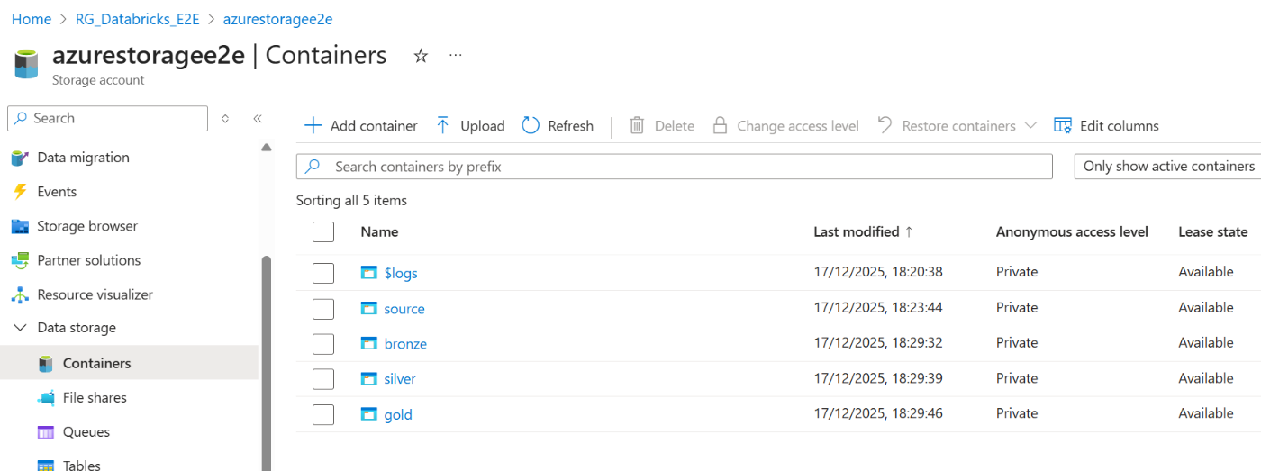
- Create 4 directories (customer, orders, products, region) under a container source and upload the 1st parquet file. And create 3 separate containers for bronze, silver and gold. Note – These containers are nothing but our data lake

- Add the Azure Databricks to the group.
- Now, we have databricks and Storage Blob in our group. Now if the databricks needs to access the data from storage Blob, it fails. So, to connect two resource we need to add one more resource into our group called Access Connector for Azure Databricks. This helps databricks to connect and access Storage Blob data always. Its time to launch the databricks from the Azure end itself.

Note: We can create only 1 meta store per region in Databricks

- Now if you are an Account Admin (Generally we are Workspace Admin), we should create a new meta store by mapping a new container in Storage Blob for meta store, so that the whole meta store data gets stored inside this container.
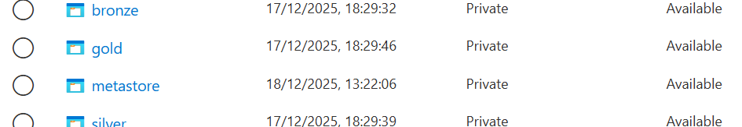
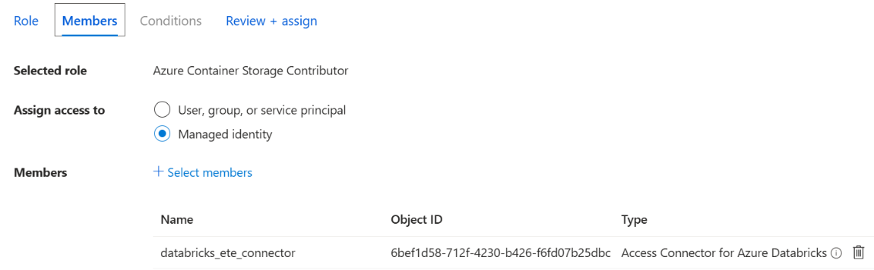
- Important Step- Now we need to give databricks access to storage blob to connect with our data. For that, initially choose the role – “Azure Container Storage Contributor” then assign the role to our databricks access connector.
Quick shot:
Only few azure services such as fabric, databricks etc uses a connector to access other resources such as Storage Blob. All other services would be done through RBAC. In this case, to access storage data by databricks – It has separate connector “Access connector for databricks” which needs to be assigned on our service (Storage)
- Now the next step is – Either create a meta store or catalog inside databricks and map the new external location created in storage blob to this.
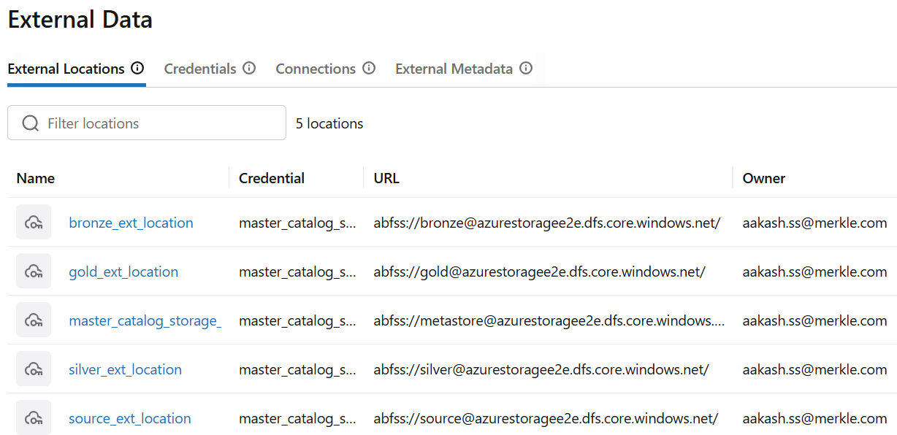
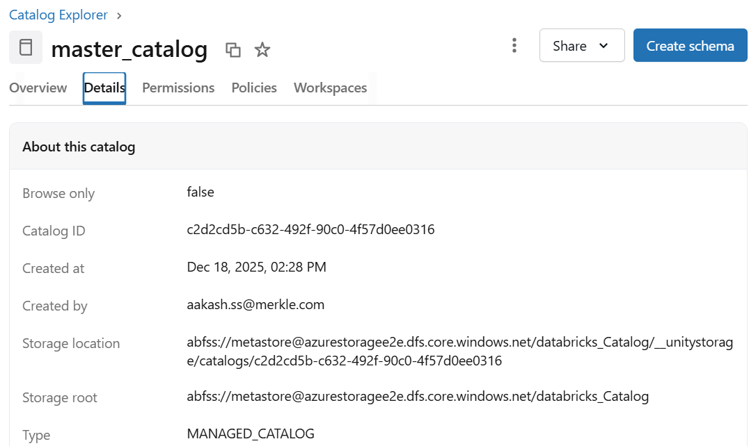
- Do the same for all other required containers like Silver, Bronze, and Gold etc..using the same Credential (Access Connector URL).
- Now create a new schema called Bronze and no need to define the external location rather it automatically stores in default – metastore location i.e) Managed Table that we given for our master catalog.
- Data Ingestion > Azure data lake storage > use the right ext location to connect > define the bronze schema > use the file to load > Now the files gets ingested as table into our Bronze schema.

Data Ingestion
- Stream the data of Orders from source using Autoloader and write it to bronze container.
df = spark.readStream.format('cloudFiles')\
.option("cloudFiles.format", "parquet")\
.option("cloudFiles.schemaLocation", "abfss://bronze@azurestoragee2e.dfs.core.windows.net/checkpoint_orders")\
.load("abfss://source@azurestoragee2e.dfs.core.windows.net/Orders")\
.withColumn("Received_ts", current_timestamp())

df.writeStream.format('parquet')\
.outputMode('append')\
.option("checkpointLocation", "abfss://bronze@azurestoragee2e.dfs.core.windows.net/checkpoint_orders")\
.option('path', "abfss://bronze@azurestoragee2e.dfs.core.windows.net/orders")\
.trigger(once=True)\
.start()
- Now use the parameter for file_name instead of calling each file separately using dbutils.widgets
- One step above - Now use a separate Notebook for parameter dictionary. Use that master_paramater Notebook for all Notebooks.
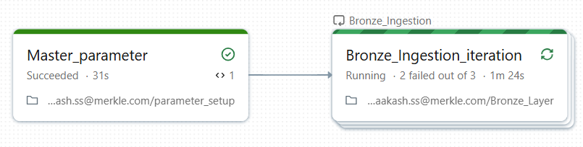
- Create a pipeline of 2 Notebooks (Master_pipeline > Ingestion) by giving the parameter dependencies.
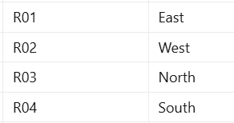
1st file sourced

Quick Shot
Auto Loader does NOT handle UPSERTS.
It only:
- Detects whether a file is new or already processed
- Uses checkpoint metadata - RockyDB
- Processes only new files
- Avoids reprocessing old files
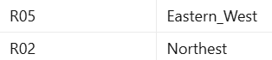
If a new file contains old records, Auto Loader will still ingest them.
2nd file sourced

UPSERT is handled by
- Delta Lake
- MERGE INTO
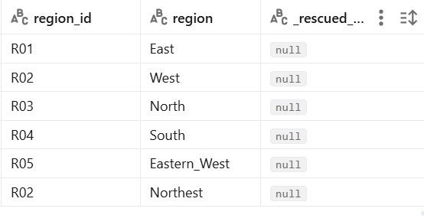
- DLT APPLY CHANGES
- Or custom deduplication logic
End Result after streaming (Autoloader)

Transformations
- Now create each Notebook for each segment – orders, customers etc for transformation
- On each Notebook, do read the data from source (Azure or databricks Managed table), do transform and write to the Azure silver container
- Also create a external table using the same above written data.
%sql
create table if not exists master_catalog.silver.customers
using delta
location "abfss://silver@azurestoragee2e.dfs.core.windows.net/Customers"

Note:
If the external location is delta, then use delta for our table creation (or) if its parquet then use parquet on creation. But the format is delta, it enables ACID property, Time travel, Schema enforcement & evolution, and so on. Hence if we created the table as PARQUET, we can convert it to DELTA using CONVERT TO DELTA using external location.
CONVERT TO DELTA parquet.`abfss://bronze@azurestoragee2e.dfs.core.windows.net/Customers_test`
Thus the parquet format gets changed to delta by adding the delta_log on top of it.

Gold Layer
- Create a dataframe by reading the delta files from the silver layer.
- Split the above df into 2 dataframe – New DF and Old DF based on the matching ID to identify the updated record and new record from the whole data.
- Use the parameter for initial load. If the param value is 1, then directly load the full refresh data else based on the 2 df’s (new and old) apply a logic to do upsert.
- If its value is 0 then incr load, in this case – we have to do as per the procedure –
  - Capture only the old/existing with updated values rows and populate only the updated_date value as current_timestamp.
  - Capture only the new entries and populate both create_date & update_date as current_timestamp
  - To identify the old updated one, use the hash value to compare and fetch it.
  - Then join both new and old df into one.
  - Use this final table (both new + updated records) for UPSERT process to write the data to our end ext table using the deltaTable lib

if (int(load_flag) == 0) and (validate_init==0):
df_new_full = spark.sql(f'''
select main.*, monotonically_increasing_id()+1+{max_key} as DimCustomerKey, current_timestamp() as created_date, current_timestamp() as updated_date from df_new left join customer_df main on main.customer_id = df_new.customer_id ''' )
df_new_full = df_new_full.dropDuplicates()

print(f"Incr load of {df_new_full.count()} - New records inserted")

df_old_full = (
spark.sql(""" SELECT main.*, df_old.DimCustomerKey, df_old.created_date FROM df_old
LEFT JOIN customer_df main ON main.customer_id = df_old.customer_id """)\
.withColumn("updated_date", current_timestamp()).dropDuplicates()\
.withColumn("src_hash", sha2(
concat_ws(
"||", "customer_id", "email", "city", "state", "domain", "Full_Name", "DimCustomerKey" ), 256 ) ))

gold_df = spark.table("master_catalog.gold.DimCustomers")
tgt_hashed = gold_df.withColumn(
"tgt_hash",
sha2(concat_ws("||", "customer_id", "email", "city", "state", "domain", "Full_Name", "DimCustomerKey"), 256)
)

df_updated = (
src_hashed.alias("src")
.join(tgt_hashed.alias("tgt"), "customer_id")
.filter(col("src.src_hash") != col("tgt.tgt_hash"))\
.select("src.customer_id", "src.email", "src.city", "src.state", "src.domain", "src.Full_Name", "src.DimCustomerKey", "tgt.created_date", "src.updated_date")
)

print(f"Incr load of {df_updated.count()} - Old records inserted")

df_full = df_new_full.unionByName(df_updated)

else:
df.withColumn("DimCustomerKey", monotonically_increasing_id() + 1)\
.withColumn("created_date", current_timestamp())\
.withColumn("updated_date", current_timestamp())\
.dropDuplicates()\
.write.format('delta')\
.mode('overwrite')\
.option("overwriteSchema", "true")\
.option('path','abfss://gold@azurestoragee2e.dfs.core.windows.net/Customers')\
.saveAsTable('master_catalog.gold.DimCustomers')

print(f"Initial load of {spark.sql("select count(*) from master_catalog.gold.DimCustomers").first()[0]} - New records inserted")

from delta.tables import DeltaTable

if int(load_flag) ==1:
print("Initial load process got successfully completed")
else:
df_full = df_full.dropDuplicates()
if spark.catalog.tableExists("master_catalog.gold.DimCustomers"):
deltaTable = DeltaTable.forPath(spark, "abfss://gold@azurestoragee2e.dfs.core.windows.net/Customers")
deltaTable.alias('trg').merge(df_full.alias('src'), 'trg.DimCustomerKey = src.DimCustomerKey') \
.whenMatchedUpdateAll() \
.whenNotMatchedInsertAll() \
.execute()
print("Upsert process got successfully completed")
else:
df_full.write.format("delta")\
.mode('overwrite')\
.option('path','abfss://gold@azurestoragee2e.dfs.core.windows.net/Customers')\
.save("master_catalog.gold.DimCustomers")
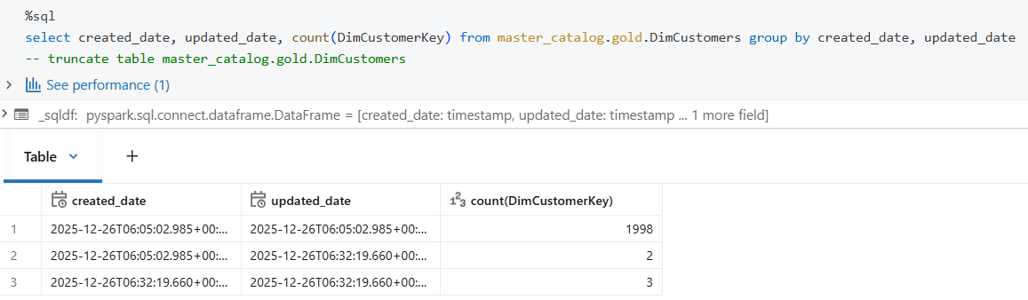
print("Since table not exist, new ext table got created")

DLT framework for SCD process
- Here, we have 4 feeds – Customers, Products, Region and Orders. Out of this Orders files are our fact table rest of Dimensional table.
- In that, we applied the incremental and SCD type 1 logic to Customer files. So, now we can apply both SCD type 1 and 2 on Products using DLT framework.
- The flow is – Streaming table on Silver layer > Streaming View of the previous Streaming tbl > Materialized view to apply the SCD on the view.
- Thus it steams the data from the silver layer (Only Append works, if its overwrite then we need to call skipCommitChanges), then view is called upon it and that view is used to write the end gold table by applying the SCD.
@dlt.table(name = "DimProducts_stg")
def DimProducts_stg():
return spark.readStream.table("master_catalog.silver.products")

@dlt.view(name = "DimProducts_view")
def DimProducts_view():
return spark.readStream.table("DimProducts_stg")

dlt.create_streaming_table(
name = "DimProducts1",
comment = "This is the final table for DimProducts")

dlt.apply_changes(
target = "DimProducts1",
source = "DimProducts_view",
keys = ["product_id"],
sequence_by = "Received_ts",
stored_as_scd_type = 1)

dlt.create_streaming_table(
name = "DimProducts2",
comment = "This is the final table for DimProducts")

dlt.apply_changes(
target = "DimProducts2",
source = "DimProducts_view",
keys = ["product_id"],
sequence_by = "Received_ts",
stored_as_scd_type = 2)

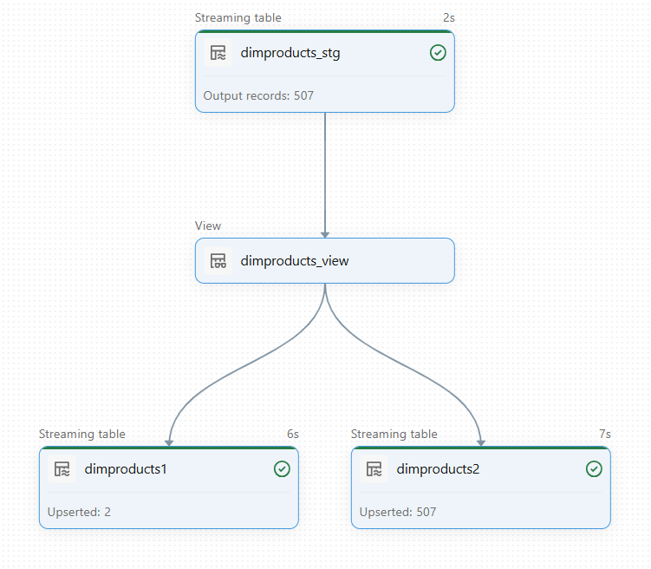
Dimensional Fact Model
- Now we need to join all dimension table such as Customers and Products (exclude Region as its not required) with the fact table – Orders
cust_df = spark.sql("select customer_id,DimCustomerKey from master_catalog.gold.dimcustomers")
prod_df = spark.sql("select product_id from master_catalog.gold.dimproducts")
display(prod_df)
df_fact = df.join(cust_df,df.customer_id==cust_df.customer_id, "left")\
.join(prod_df,df.product_id==prod_df.product_id, "left")\
.select(cust_df.DimCustomerKey, df.order_id, df.product_id, df.order_date, df.year, df.quantity, df.total_amount)
display(df_fact)

from delta.tables import DeltaTable

df_fact = df_fact.dropDuplicates()
if spark.catalog.tableExists("master_catalog.gold.FactOrders"):
deltaTable = DeltaTable.forPath(spark, "abfss://gold@azurestoragee2e.dfs.core.windows.net/FactOrders")
deltaTable.alias('trg').merge(df_fact.alias('src'), "trg.Order_id = src.Order_id AND trg.DimCustomerKey = src.DimCustomerKey\
AND trg.product_id = src.product_id") \
.whenMatchedUpdateAll() \
.whenNotMatchedInsertAll() \
.execute()
print("Upsert process got successfully completed")
else:
df_fact.write.format("delta")\
.mode('overwrite')\
.option('path','abfss://gold@azurestoragee2e.dfs.core.windows.net/FactOrders')\
.saveAsTable("master_catalog.gold.FactOrders")
print("Since table not exist, new ext table got created")

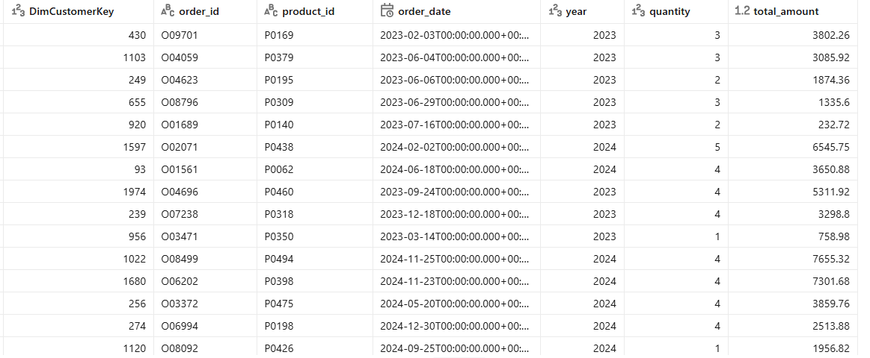
- Just keep the required keys or id’s from the dimensional table and keep all calculating columns from fact table into a final fact table. In this all our records are mapped into 1 single fact table using the primary key from all dimensional tables.

End of End – to – End Project

