**Problem Statement**

**Lab 2: Simple circuits implementation**

**Consider the below circuit diagrams and implement the same using iverilog.**

**Generate the output for various test cases**

**Generate the GTKWave form for the same**

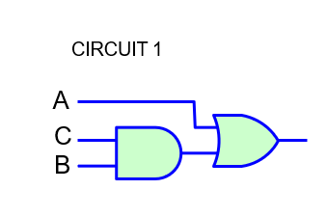

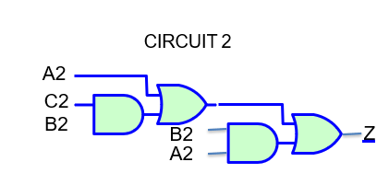

**Circuit 3**

