Team Members:
Aakash Desai: PES1UG24CS006
Aarush Muralidhara: PES1UG24CS010

Choice of Input Language: C++

Constructs Chosen:
1) Array Declaration
2) Function Definition
3) Function Declaration (Prototype)
4) Selection Statements (If/If-Else)
5) Simple Data-Type (Declaration)

For our project, the files named config.py is shared by the main.py, lexer.py and parser (for each construct).
It is as shown:
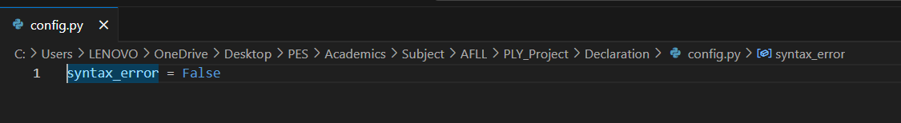
The general structure of every folder is as follows:
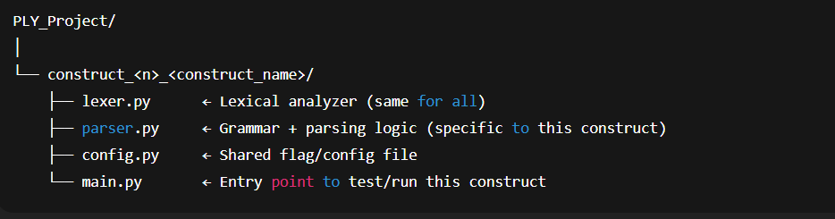

Every construct (and construct folder) shares the same main.py file and lexer.py
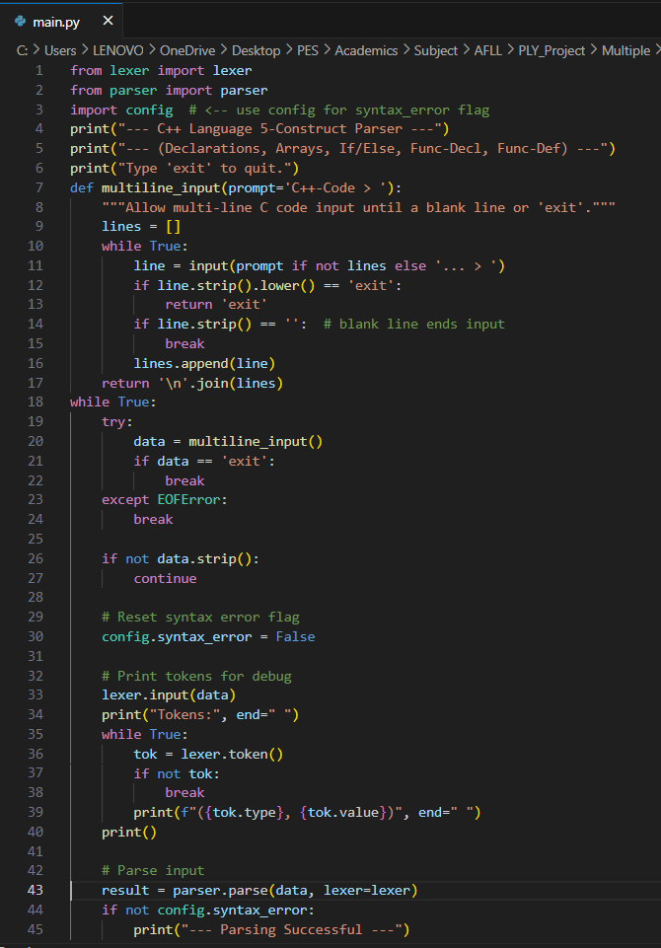
Main.py file

The main.py file serves as the driver program that connects the lexer and parser components of the project. It allows the user to enter C++-like code interactively, tokenizes the input using the lexer, and then parses it using the grammar rules defined in parser.py. The script displays the sequence of tokens generated and reports whether the parsing was successful or if any syntax errors were found. It continuously accepts input until the user types exit, making it easy to test various code snippets for different C++ constructs. In short, main.py acts as the bridge between lexical analysis and syntax analysis, providing a clear way to verify if the entered code follows the defined grammar.
The only change that is to be made in each main.py file would be in line 2, importing from the matching parser.py file.

Lexer.py
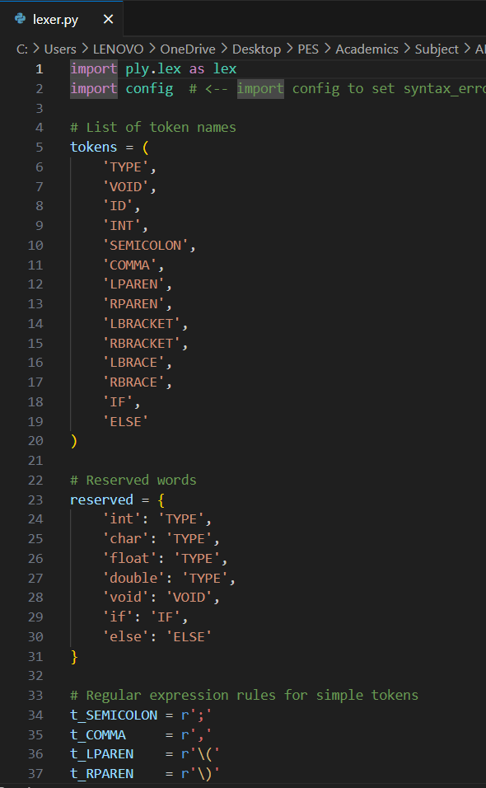

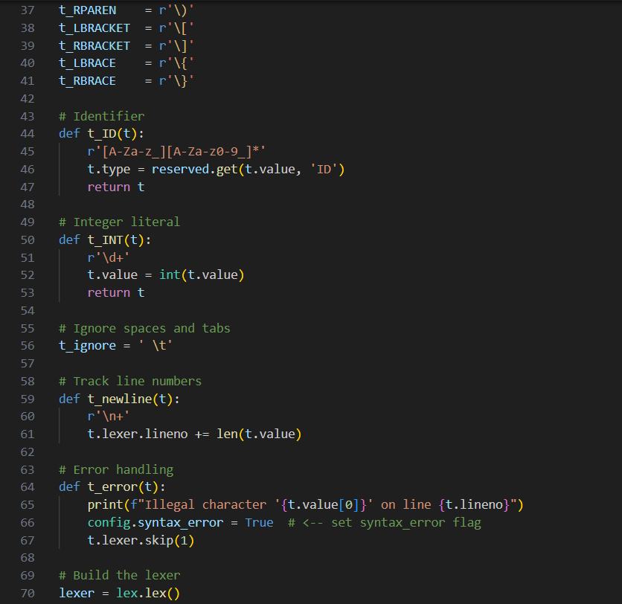

The lexer.py file is responsible for lexical analysis, which is the first phase of the compiler process. It uses the PLY (Python Lex-Yacc) library to break the user’s C++-like source code into a sequence of tokens, such as keywords (int, if, else), identifiers, numbers, operators, and punctuation symbols. Each token is defined by a regular expression rule, allowing the lexer to recognize valid lexical patterns in the code. The lexer also ignores unnecessary elements like spaces and comments while keeping track of line numbers for accurate error reporting. In short, lexer.py transforms raw input text into structured tokens that are passed to the parser for syntax analysis.

Every Construct has its own unique parser.
1)Array Construct
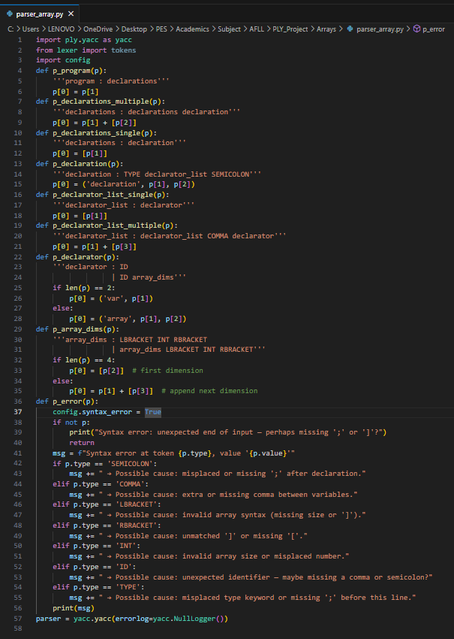

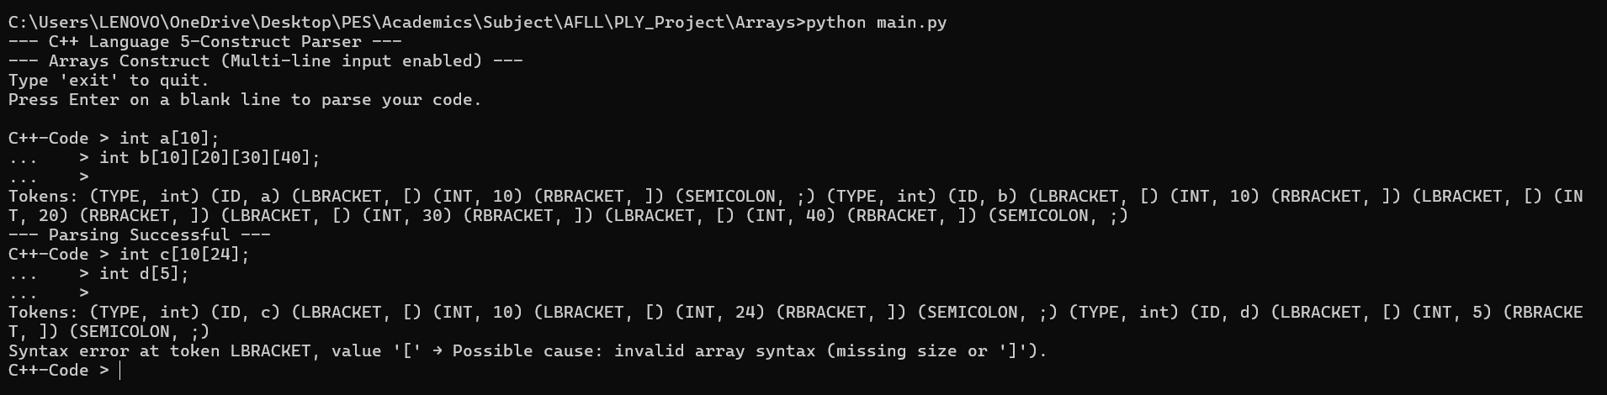
1)Output Verification

___________________________________________________________________________

Description of the Array Declaration Parser Construct
This parser module focuses exclusively on array-related declarations using PLY’s YACC component. It defines grammar rules to recognize array identifiers and validate one-dimensional or multi-dimensional array size specifications using square brackets. The construct supports multiple declarators separated by commas and allows arrays to be declared along with their dimensions. It also accumulates dimension values as part of the parse tree for later semantic processing. A dedicated error-handling routine (p_error) is included to detect mistakes such as missing or mismatched brackets, invalid array sizes, or misplaced commas, and to produce meaningful, user-friendly syntax error messages.

2)Syntax Verification for Function Definition
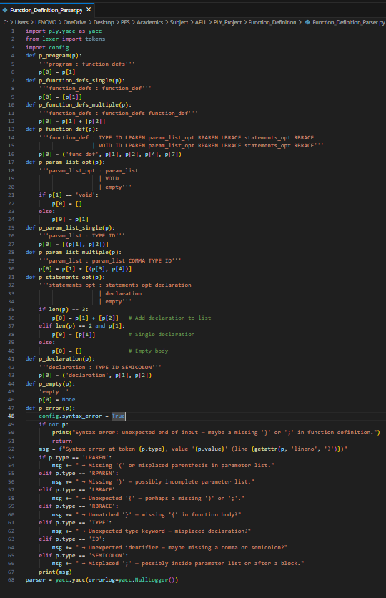

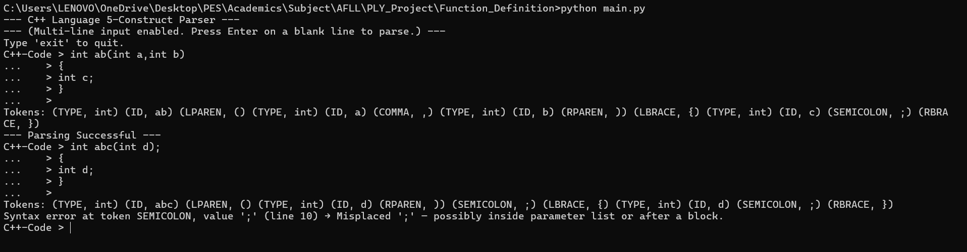
2)Output Verification

_________________________________________________________________________

Description of the Function Definition Parser Construct
This parser module handles the syntax rules related to function definitions using PLY YACC. It supports multiple function declarations, type-based return values, optional or empty parameter lists, and function bodies that may contain zero or more declarations. The construct parses parameter lists with identifiers and types, allows void or typed parameters, and builds structured parse results for further semantic processing. A specialized error handling routine (p_error) detects and reports syntax issues such as missing parentheses, braces, commas, or semicolons, and provides clear messages to help identify incorrect or incomplete function declaration syntax.

3)Syntax verification for Function Declaration (Prototype)
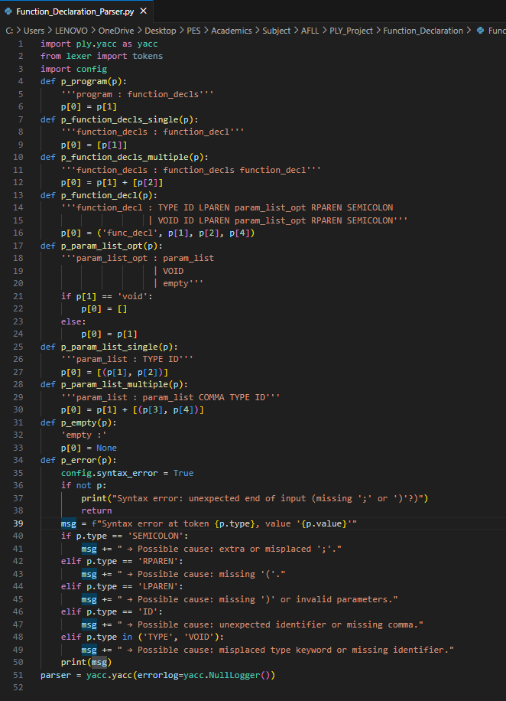

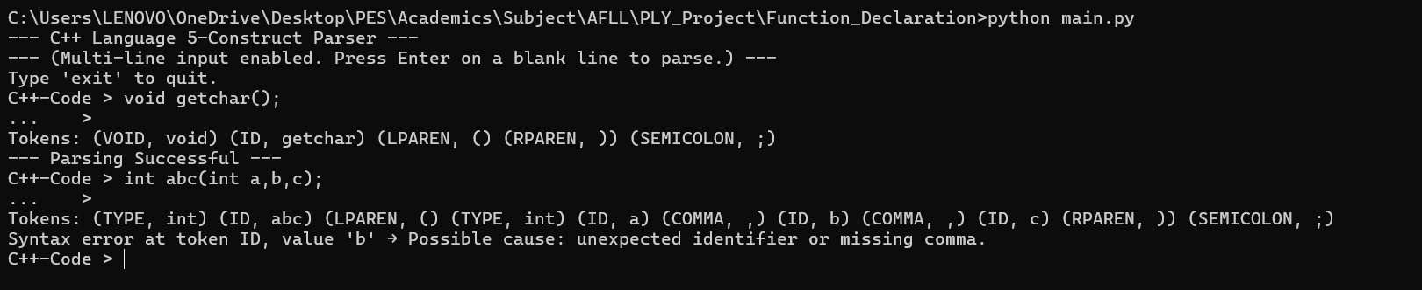
3)Output Verification

_________________________________________________________________________

Description of the Function Declaration Parser Construct
This parser module handles the syntax rules for function declarations using PLY YACC. It supports multiple function declarations with or without parameters and allows both typed and void return types. The grammar validates parameter lists that may contain zero, one or multiple typed identifiers separated by commas and builds structured parse output for later stages. The error handling function (p_error) identifies incorrect syntax involving missing parentheses, extra or missing semicolons, invalid parameter formats, or misplaced identifiers and prints clear, user focused diagnostic messages.

4)If- Else Construct
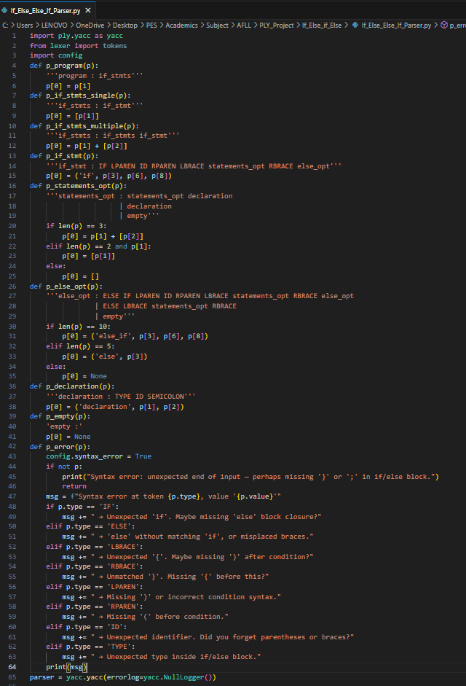

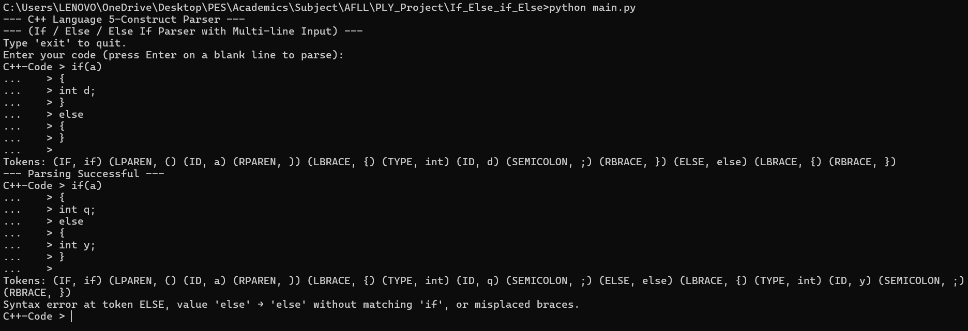
4)Output Verification

_________________________________________________________________________

Description of the If Else Else If Parser Construct
This parser module defines and validates the syntax for conditional statements using PLY YACC. It supports if statements, nested statements inside braces, optional else blocks, and chained else if constructs. The grammar also handles optional inner statements which may include declarations or blocks, building structured parse output for further semantic processing. The error handling function (p_error) detects mistakes such as missing braces, unmatched parentheses, misplaced else clauses, incorrect condition syntax, or misplaced identifiers and provides clear and meaningful diagnostic messages to guide correction.

5)Simple Data-Type Declaration
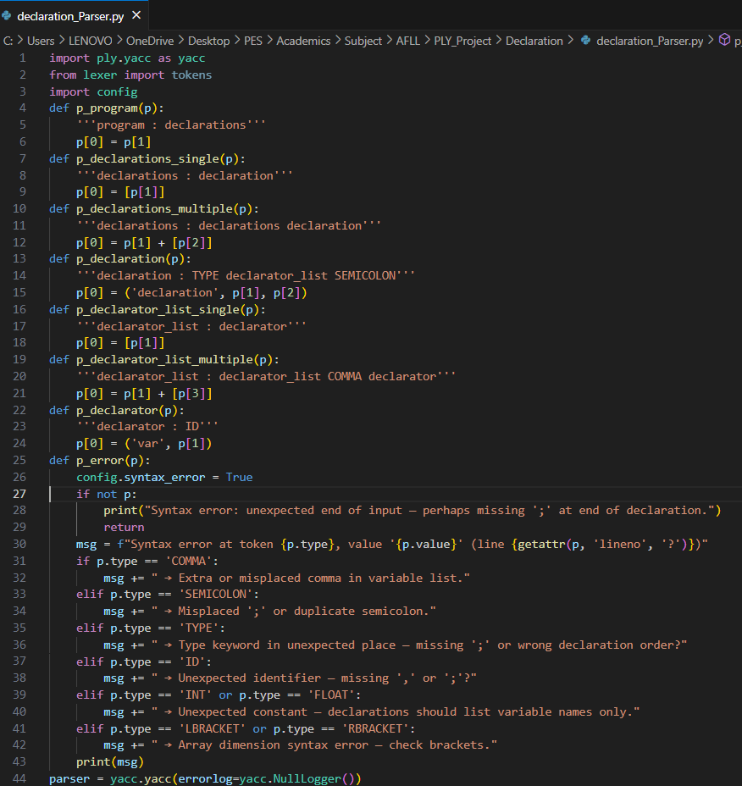

5)Output Verification
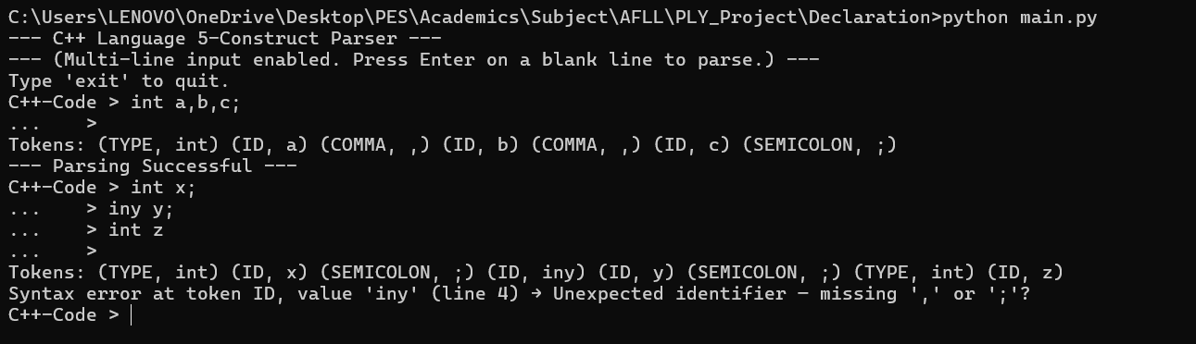

________________________________________________________________

Description of the Variable Declaration Parser Construct
This parser module processes normal variable declarations using PLY YACC. It supports multiple declarations in a single statement using commas and ensures that each declared element is a valid identifier. The grammar builds structured output for later semantic analysis and separates declarations into individual components. The error handling routine (p_error) identifies common declaration mistakes such as missing semicolons, misplaced commas, incorrect type placement, numeric constants used as identifiers, and invalid or incomplete variable list syntax while producing clear and helpful diagnostic messages.

Conclusion
In this assignment, a modular parsing solution for C++ language constructs was successfully designed and implemented using the Python Lex-Yacc (PLY) library. The project was structured to validate each of the five chosen constructs—declarations, arrays, conditional statements, function declarations, and function definitions—independently, using a dedicated parser for each.
By creating a distinct parser.py for each construct, we were able to focus on its specific grammar and test it in isolation, ensuring correctness and extensibility. A single, shared lexer.py efficiently tokenized all C++ syntax elements, demonstrating code re-use. As shown in the output verifications, each specialized parser successfully validated its respective grammatical structure and handled syntax errors gracefully.

