

**PES UNIVERSITY**

**Course Title:UE23CS242A: Web Technologies**

**Semester: III**

**Credits:4**

**Course Type: Core / Elective / Special Topic:Core**

**Experiential Learning (2025-26):**

(Banana problem) Level -1

**Problem Statement:**

During the annual Samarpana Marathon, organized in honor of the army, participants are required to register through an online form. However, existing registration forms often lack proper interactivity, real-time input validation, and a responsive design, leading to incomplete entries, errors, and reduced user satisfaction. For this marathon, it is also mandatory for every participant to select a T-shirt size, as wearing the official Samarpana T-shirt is compulsory for the run. The form must not only validate user inputs but also provide dynamic feedback, ensure mobile-friendly responsiveness, and display a reference table of available T-shirt sizes for clarity.

If any required field is empty, an alert must show up asking to fill the required empty field. Display the date and time while the form is being filled for user convenience.

**HTML5 (Structure of the form), CSS(Responsive and visually appealing design), JavaScript (Dynamic interactivity and validation), Form Validation Techniques , User Interface (UI) & User Experience (UX) Design, Responsive Web Design.**

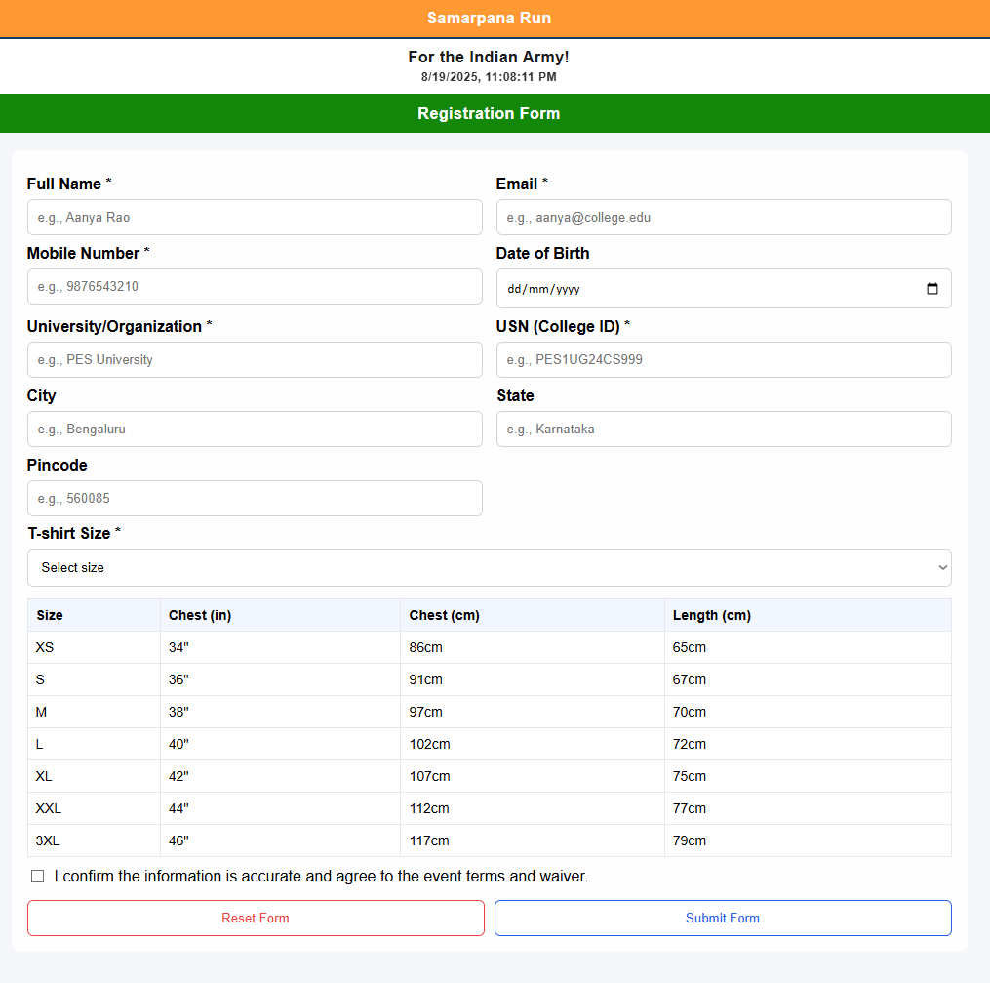

Rubrics:

| HTML | 3 marks |
| --- | --- |
| CSS (UI/UX) | 3 marks |
| Javascript | 4 marks |
| Total | 10 marks |