

**PES UNIVERSITY**

**PES University, Electronic City Campus, Hosur Road, Bangalore- 560 100**

**Department of Computer Science & Engineering**

**Curriculum of CSE**

**Course Title:**UE23CS242A: Web Technologies

**Semester: III**

**Credits:4**

**Course Type: Core / Elective / Special Topic:Core**

**Experiential Learning (2025-26):**

**(Orange Problem) Level -2**

**Problem Statement:**

Design and develop a single, responsive web page that demonstrates the integration of key modern web technologies. The page should showcase the use of **HTML5 multimedia elements** (audio and video), implement the **Geolocation API** to retrieve and display user location, utilize **Flexbox** for layout design, simulate **asynchronous data fetching** using **Promises** and **async/await**, and demonstrate the conversion of **XML to JSON** for structured data representation. This project aims to provide an interactive learning interface that combines functionality, responsiveness, and dynamic data handling.

**HTML5 Multimedia API** – Embed and control video/audio

**Geolocation API** – Get and display user's current location

**Asynchronous Data Simulation** – Using **Promises** and **async/await with Axios**

*Use url -* ***https://jsonplaceholder.typicode.com/comments***

**XML to JSON Conversion** – Demonstrate parsing XML and converting to JSON

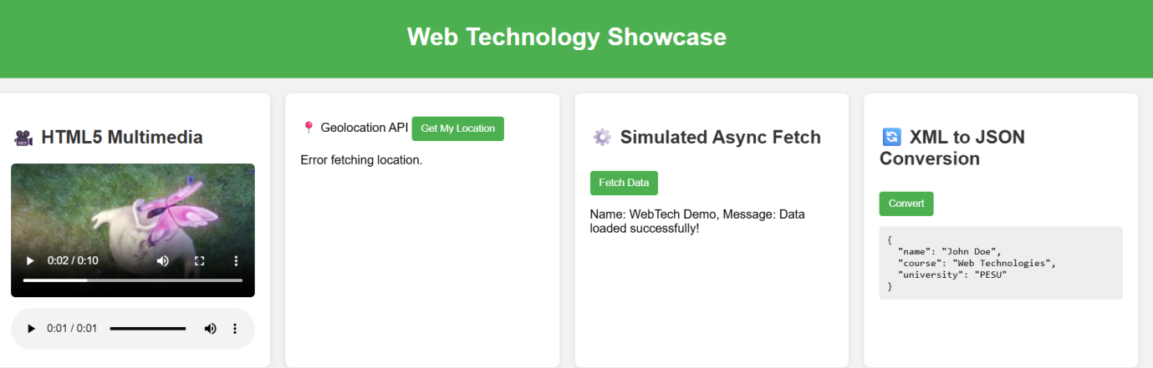

Rubrics:

|  |  |
| --- | --- |
| HTML5 Media | 2 marks |
| Geolocation | 2 marks |
| Axios | 2 marks |
| JSON | 2 marks |
| ReactJS | 2 marks |
| Total | 10 marks |