Java Design Patterns
Hands-On Lab
Singleton Pattern • Factory Method Pattern

Exercise 1: Implementing the Singleton Pattern

Scenario
A logging utility class must have exactly ONE instance throughout the entire application lifecycle. Multiple Logger instances could produce inconsistent logs, duplicate entries, or mixed output. The Singleton pattern solves this by controlling instantiation so that only the first call creates an object — every subsequent call returns the same pre-created instance.

Concept Notes

What is the Singleton Pattern?
The Singleton pattern is a creational design pattern that restricts a class to one instance and provides a global access point to that instance. It is one of the Gang of Four (GoF) patterns.

Key Rules of the Singleton Pattern
- The constructor must be private — external code cannot call new Logger().
- A private static field holds the single instance inside the class.
- A public static getInstance() method returns the existing instance (creating it on the first call).

Singleton vs Regular Class

Aspect | Detail
Constructor access | private (Singleton) vs public (regular class)
Instantiation | Controlled inside the class vs free (caller uses new)
Instance count | Guaranteed one vs unlimited
Global access | Via static method vs via variable/parameter
Use cases | Logger, Config, DB connection pool vs most other objects

UML Class Diagram
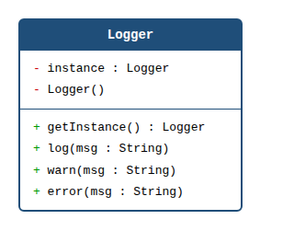
Figure 1: Logger Singleton class diagram

Project Structure
Project name: SingletonPatternExample
- src/Logger.java — the Singleton class
- src/SingletonTest.java — test class that verifies only one instance is created

Step 1 — Create the Logger Singleton Class (Logger.java)
The Logger class uses lazy initialisation: the instance is only created when getInstance() is first called, not at class-loading time. The three conditions required for a proper Singleton are highlighted in the code:
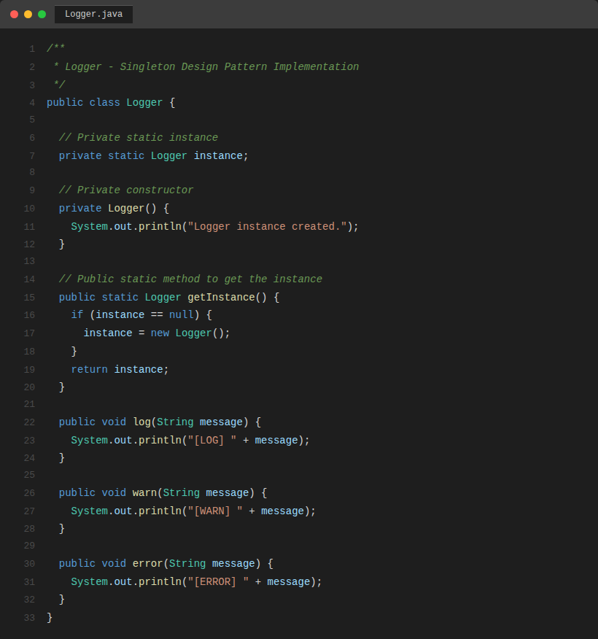
Screenshot 1: Logger.java — Singleton class with private constructor, private static field, and public static getInstance()

Step 2 — Create the Test Class (SingletonTest.java)
The test class obtains three separate references to Logger and verifies that all three point to the exact same object using the == reference equality operator and hashCode() comparison:
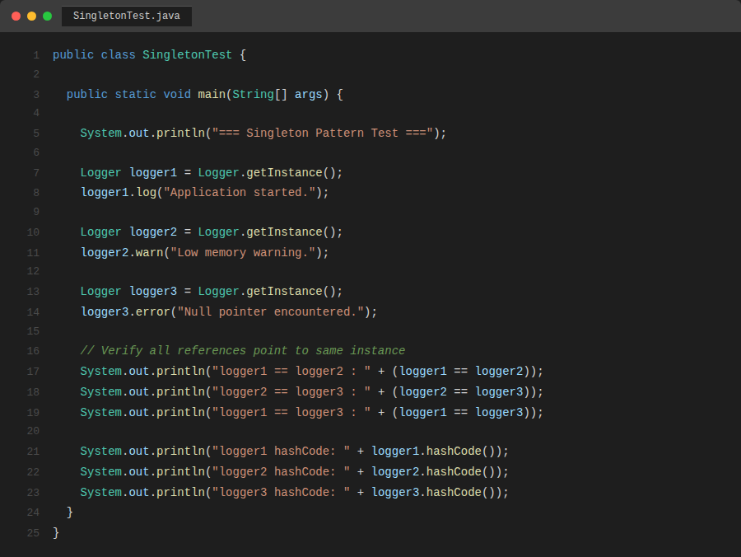
Screenshot 2: SingletonTest.java — obtains three references and verifies they are the same instance

Step 3 — Compile and Run
Navigate to the src folder and compile both files, then run SingletonTest:
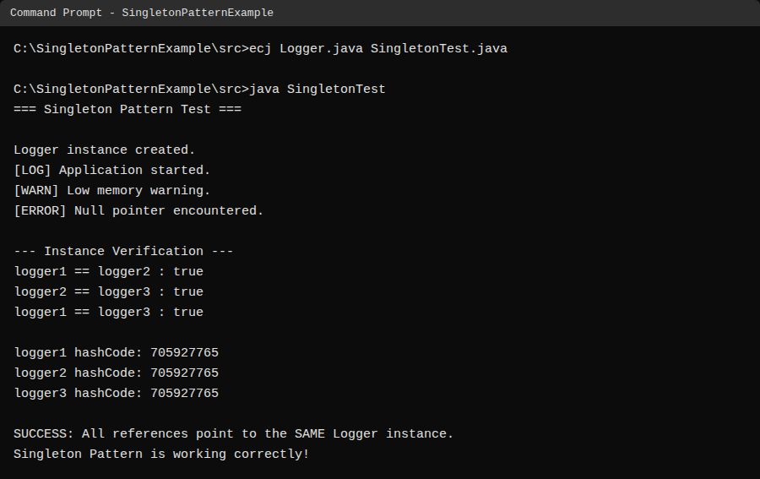
Screenshot 3: Terminal output — Logger is instantiated only once; all three hashCodes are identical; pattern verified

Output Analysis
The output confirms three fundamental properties of the Singleton pattern:
- "Logger instance created." appears only once — the constructor ran exactly once.
- logger1 == logger2 == logger3 are all true — all references are the same Java object.
- All three hashCode values are identical — Java's default hashCode is memory-address-based, so equal values prove they are the same object in memory.

Exercise 2: Implementing the Factory Method Pattern

Scenario
A document management system needs to create Word, PDF, and Excel documents. Rather than having the client code call new WordDocument() or new PdfDocument() directly — which tightly couples the client to concrete types — the Factory Method pattern delegates instantiation to dedicated factory classes. The client only ever talks to the abstract Document interface and DocumentFactory, and is completely unaware of the concrete classes.

Concept Notes

What is the Factory Method Pattern?
The Factory Method pattern is a creational design pattern that defines an interface for creating an object but lets subclasses decide which class to instantiate. The key idea: define a method (the "factory method") in an abstract class or interface, and let concrete subclasses override that method to produce specific product objects.

Factory Method vs Direct Instantiation

Aspect | Detail
Coupling | Client decoupled from concrete classes vs client knows exact types
Extensibility | Add new type by adding new factory subclass only vs must modify client code
Polymorphism | Client uses Document/DocumentFactory abstractions vs uses concrete types
Testing | Easy to mock factories vs harder to isolate
GoF category | Creational vs N/A

UML Class Diagram
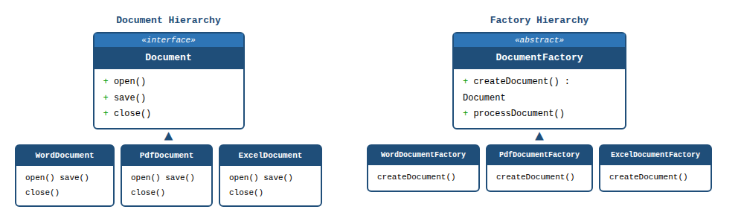
Figure 2: Factory Method pattern — Document interface hierarchy (left) and DocumentFactory hierarchy (right)

Project Structure
Project name: FactoryMethodPatternExample
- src/Document.java — common interface for all document types
- src/WordDocument.java, PdfDocument.java, ExcelDocument.java — concrete products
- src/DocumentFactory.java — abstract factory with the factory method
- src/WordDocumentFactory.java, PdfDocumentFactory.java, ExcelDocumentFactory.java — concrete factories
- src/FactoryMethodTest.java — test/demo class

Step 1 — Define the Document Interface
The Document interface declares the contract every document type must fulfil: open(), save(), and close(). The client always programs to this interface, never to the concrete classes.
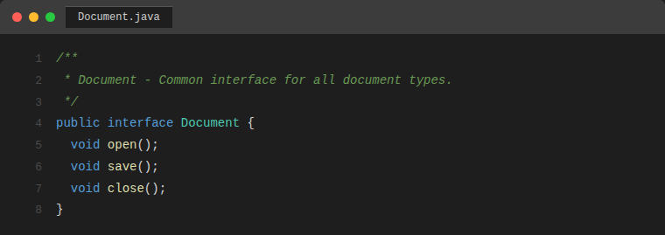
Screenshot 4: Document.java — interface defining the common contract

Step 2 — Create Concrete Document Classes
Each concrete class implements the Document interface and provides type-specific behaviour. All three follow the same structure; they differ only in their print messages.
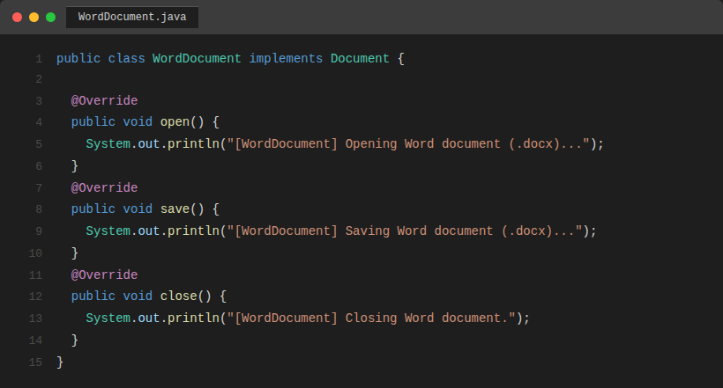
Screenshot 5: WordDocument.java — concrete implementation for .docx files
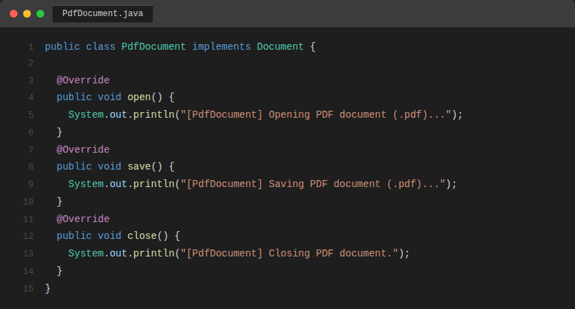
Screenshot 6: PdfDocument.java — concrete implementation for .pdf files
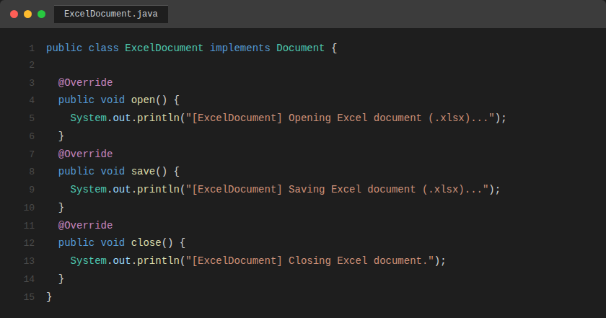
Screenshot 7: ExcelDocument.java — concrete implementation for .xlsx files

Step 3 — Create the Abstract DocumentFactory
DocumentFactory declares the factory method createDocument() as abstract. It also provides a processDocument() template method which calls createDocument() internally — demonstrating how the abstract class can use its own factory method without knowing the concrete type.
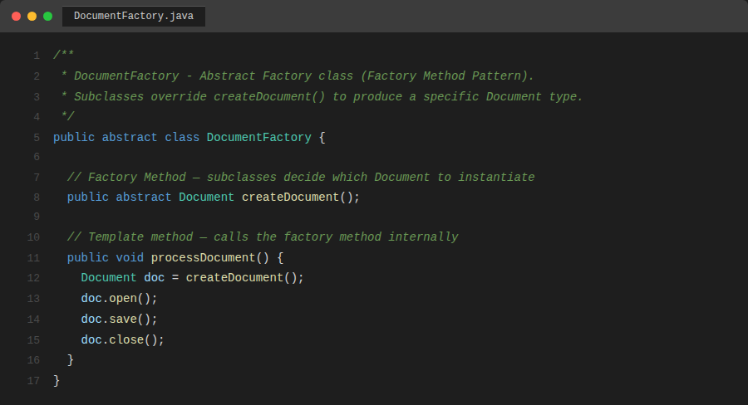
Screenshot 8: DocumentFactory.java — abstract factory with factory method and template method

Step 4 — Create Concrete Factory Classes
Each concrete factory extends DocumentFactory and overrides createDocument() to return the specific Document subtype it is responsible for. The client never calls new WordDocument() directly — it always goes through the factory.
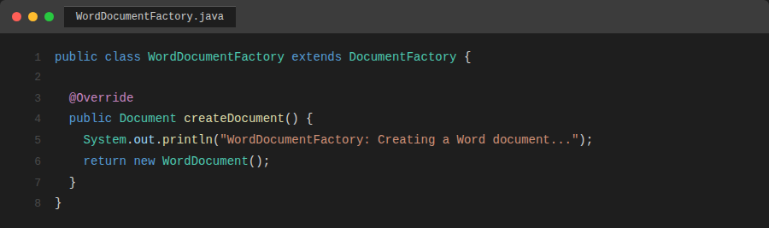
Screenshot 9: WordDocumentFactory.java
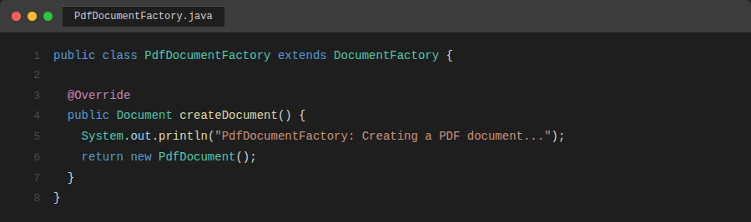
Screenshot 10: PdfDocumentFactory.java
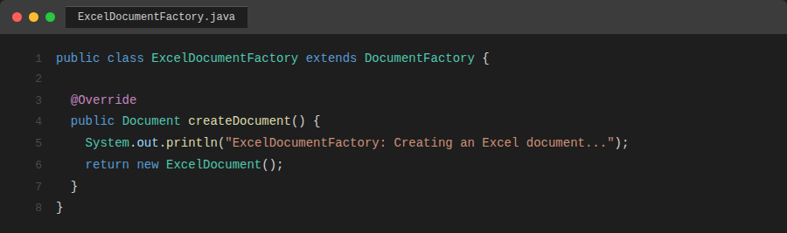
Screenshot 11: ExcelDocumentFactory.java

Step 5 — Create the Test Class (FactoryMethodTest.java)
The test class demonstrates that the same client code — using only DocumentFactory and Document references — can work with all three document types. Adding a fourth document type (e.g., CsvDocument) would require zero changes to this test class.
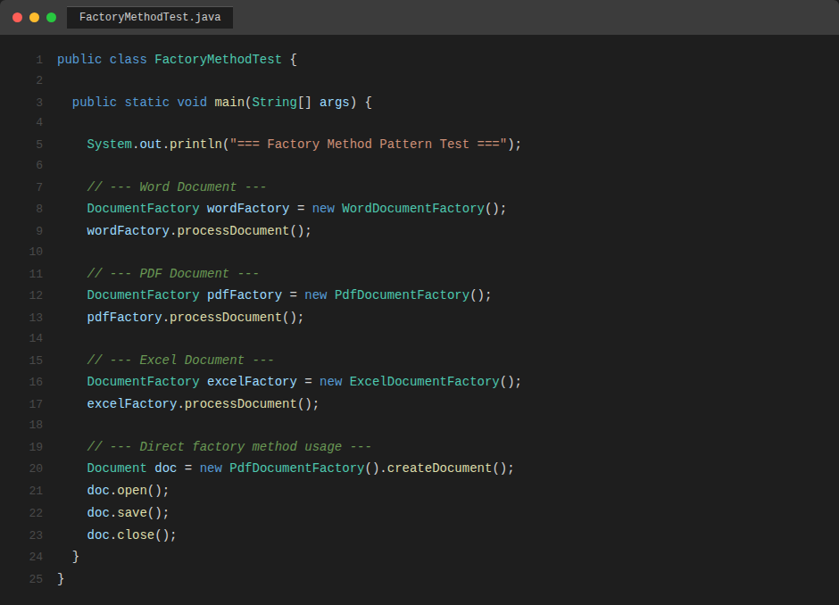
Screenshot 12: FactoryMethodTest.java — client code that is fully decoupled from concrete classes

Step 6 — Compile and Run
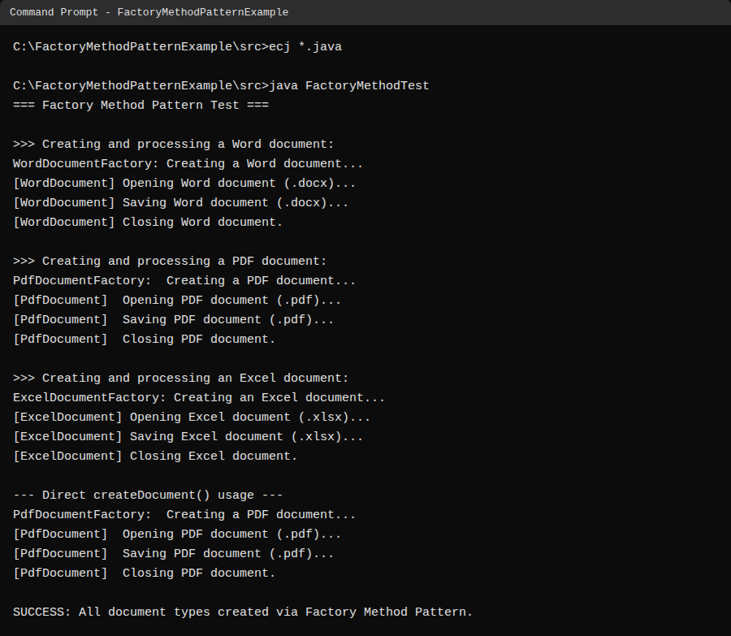
Screenshot 13: Terminal output — all three document types created and processed successfully via Factory Method

Output Analysis
The output confirms that the Factory Method pattern is working correctly:
- Each concrete factory creates the correct product type without the client knowing the concrete class.
- processDocument() calls open(), save(), and close() in the correct order through the Document interface.
- The direct createDocument() call also works — factories can be used both ways.
- Adding a new document type (e.g., PowerPoint) requires only a new concrete class and a new factory — the client test code needs no modification.

Conclusion
Both creational design patterns were successfully implemented and verified:
- Exercise 1 — Singleton Pattern: The Logger class guarantees a single instance via a private constructor and a static getInstance() method. The test confirmed that all three references share the same Java object (identical references and hashCodes), and that the constructor ran exactly once.
- Exercise 2 — Factory Method Pattern: The document management system decouples the client from concrete document types using an abstract DocumentFactory and a Document interface. Three document types (Word, PDF, Excel) were created and processed without the client code referencing any concrete class. The architecture is open for extension: new document types can be added with zero changes to existing code.
Together these patterns illustrate the two primary goals of creational design patterns: controlling how many instances exist (Singleton), and controlling how objects are created while keeping the client decoupled from concrete types (Factory Method).

