React JS — Hands-On Lab (A2)
Building the Student Management Portal (StudentApp)

Prerequisites
The following tools were used to complete this hands-on lab:
- Node.js
- NPM (Node Package Manager)
- Visual Studio Code

Task Overview
A React application named StudentApp was created for a Student Management Portal. Three components were built:
- Home — displays “Welcome to the Home Page of Student Management Portal”
- About — displays “Welcome to the About Page of Student Management Portal”
- Contact — displays “Welcome to the Contact Page of Student Management Portal”
All three components were then rendered together from App.js.
Estimated time to complete this lab: 30 minutes.

Step-by-Step Implementation

Step 1 — Create the React Project
Open the terminal (Command Prompt) and run the following command to scaffold a new React project named StudentApp:
npx create-react-app StudentApp
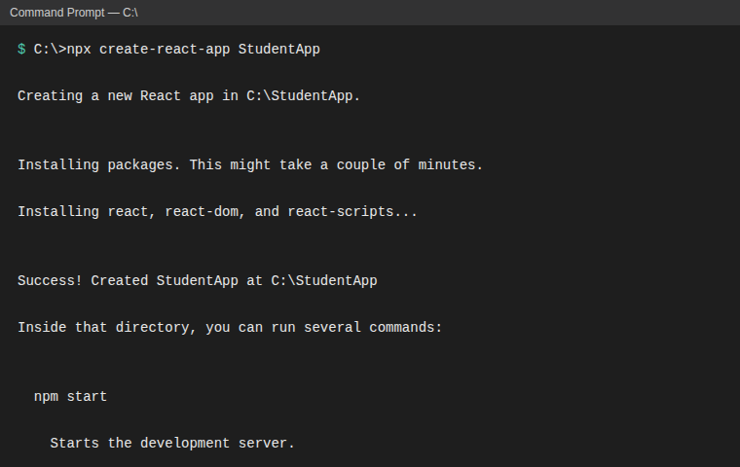
Figure 1: Creating the React project “StudentApp”

Step 2 — Create the Components Folder and Home Component
Inside the src folder, a new folder named Components was created, and a file Home.js was added inside it with the following code:
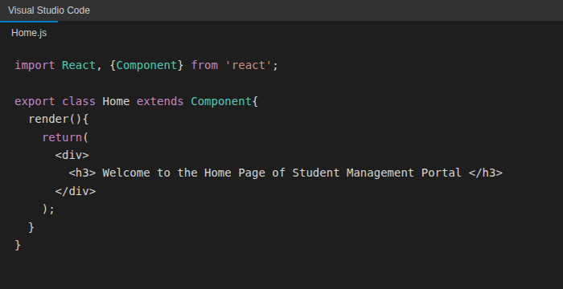
Figure 2: Home.js — class component
Explanation: Home is declared as a class component that extends React.Component. Every class component must implement a render() method, which returns the JSX to be displayed. Here it returns a <div> containing an <h3> heading with the welcome message for the Home page.

Step 3 — Create the About Component
A second file, About.js, was added under src/Components with the following code:
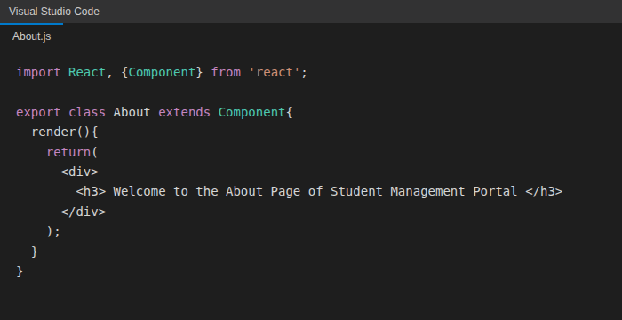
Figure 3: About.js — class component

Step 4 — Create the Contact Component
A third file, Contact.js, was added under src/Components with the following code:
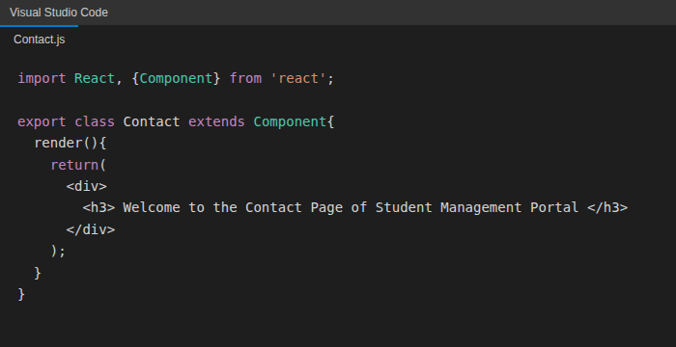
Figure 4: Contact.js — class component
Each of the three components follows the same pattern: import React and Component, declare a class that extends Component, and implement render() to return the JSX markup for that page.

Step 5 — Invoke All Three Components in App.js
App.js was edited to import and render the Home, About, and Contact components together:
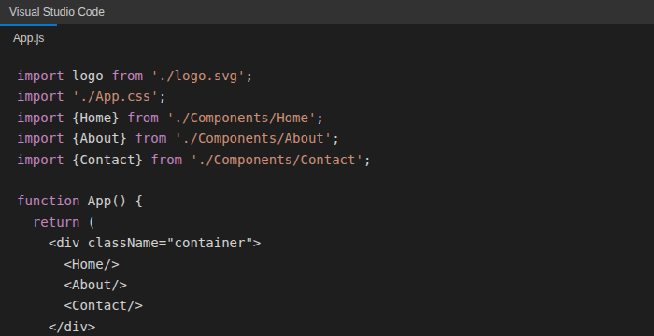
Figure 5: App.js — composing Home, About and Contact
Explanation: App is a function component (no class, no render() method needed — the function body itself returns the JSX). It imports the three custom components and places them inside a container <div>, so all three render one after another on the page.

Step 6 — Run the Application
From the project's root folder, the development server was started with:
cd StudentApp
npm start
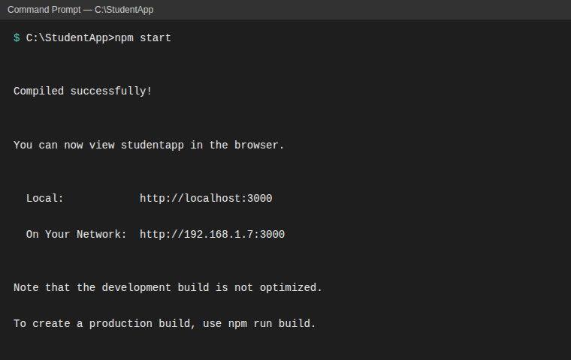
Figure 6: Starting the development server

Step 7 — View the Output in the Browser
The browser automatically opens to http://localhost:3000, where all three components are rendered on the page, confirming that the components were created and called correctly:
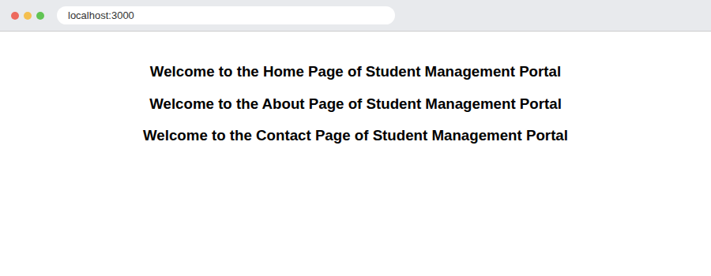
Figure 7: Verified output — Home, About and Contact components rendered together

Conclusion
This lab successfully demonstrated how to scaffold a React application, create multiple class components (Home, About, Contact), and compose them inside a parent function component (App) so they render together on a single page. The final verified output at localhost:3000 confirms that all three components display their respective welcome messages correctly, meeting every objective listed at the start of this lab.

