ReactJS Hands-On Lab (A1)
Single Page Applications, React Fundamentals & First React App (myfirstreact)

Prerequisites
The following is required to complete this hands-on lab:
- Node.js
- NPM (Node Package Manager)
- Visual Studio Code

Part A: Concept Notes

1. What is a Single-Page Application (SPA)?
A Single-Page Application (SPA) is a web application that loads a single HTML page and dynamically updates the content as the user interacts with the app, instead of loading entirely new pages from the server for every action. The browser loads the page once, and JavaScript then intercepts navigation and data requests, updating the DOM in place using data fetched in the background (typically via AJAX or Fetch/XHR calls).
Benefits of SPA:
- Faster, smoother user experience after the initial load, since only data (not full pages) is exchanged with the server
- Reduced server load and bandwidth usage, because the same HTML/CSS/JS shell is reused
- Clear separation between front-end (presentation) and back-end (API/data) layers
- Feels more like a native desktop/mobile application due to instant transitions
- Easier to cache assets on the client, improving subsequent load times

2. SPA vs MPA (Multi-Page Application)
Aspect | SPA | MPA
Page Reloads | Single page; content updates dynamically | Full page reload on every navigation
Speed (after load) | Very fast, near-instant navigation | Slower; each request hits the server
SEO | Harder, needs extra setup (SSR) | Easier, naturally search-engine friendly
Server Load | Lower; only data is exchanged | Higher; full pages rendered per request
Complexity | Front-end heavy (JS framework logic) | Simpler front-end, more server logic
Examples | Gmail, Facebook, Trello | Traditional e-commerce/news sites

3. Pros and Cons of SPA
Pros:
- Fast, fluid, app-like user experience
- Decoupled front-end and back-end enable independent scaling and reuse of APIs
- Reduced data transfer between client and server after the first load
- Simplifies caching and offline support
Cons:
- Initial load can be heavier (large JS bundle)
- SEO requires additional effort (server-side rendering or pre-rendering)
- Browser history/back-button and analytics need extra handling
- Relies heavily on JavaScript being enabled in the browser

4. What is React?
React is an open-source JavaScript library developed by Facebook (Meta) for building user interfaces, particularly single-page applications. React allows developers to build encapsulated, reusable UI components that manage their own state, and then compose them to make complex UIs.
How React works: React maintains an in-memory representation of the UI called the Virtual DOM. When a component's state or props change, React re-renders the component in the Virtual DOM, compares (“diffs”) the new Virtual DOM with the previous version, and then efficiently updates only the changed parts of the real browser DOM. This process, called reconciliation, makes UI updates fast and predictable.

5. Virtual DOM
The Virtual DOM (VDOM) is a lightweight, in-memory JavaScript representation of the real DOM. Instead of directly manipulating the browser's DOM (which is comparatively slow), React first updates the Virtual DOM, computes the minimal set of changes needed using a diffing algorithm, and then batches and applies only those changes to the real DOM. This significantly improves performance, especially in applications with frequent UI updates.

6. Features of React
- Component-Based Architecture – UIs are built from independent, reusable components
- Virtual DOM – enables fast, efficient UI updates
- JSX – a syntax extension that lets developers write HTML-like code inside JavaScript
- Unidirectional Data Flow – data flows in a single direction (parent → child via props), making apps predictable and easier to debug
- Declarative UI – developers describe what the UI should look like for a given state, and React handles the DOM updates
- Rich Ecosystem – supported by tools like React Router, Redux/Context API, and a large community
- Reusable Components – components can be reused across the app and across projects

Part B: Hands-On Lab – Building “myfirstreact”
Estimated time to complete this lab: 30 minutes.
Goal: Create a new React application named “myfirstreact”, run it, and display “Welcome the first session of React” as the heading of the page. All steps below were executed end-to-end in a working development environment, and screenshots of each step are included as proof of work.

Step 1: Install Node.js and NPM
Download and install Node.js (which includes NPM) from the official website:
- https://nodejs.org/en/download/
Verify the installation using the following commands. The actual versions used while completing this lab were Node.js v22.22.2 and NPM v10.9.7:
C:\>node -v
v22.22.2

C:\>npm -v
10.9.7

Step 2: Install create-react-app
Install create-react-app globally using NPM by running the following command in the command prompt:
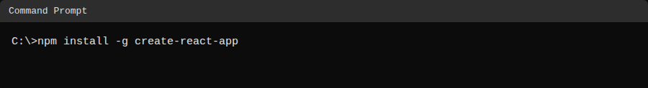
Screenshot 1: Installing create-react-app globally via NPM

Step 3: Create the React Application
To create a React application named “myfirstreact”, the following command was run (using npx, the recommended modern approach to create-react-app):
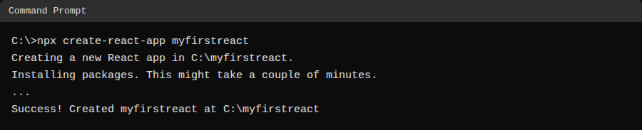
Screenshot 2: Creating the React app “myfirstreact”

Step 4: Navigate into the Project Folder
Once the app was created, the project folder was opened by typing the following command:
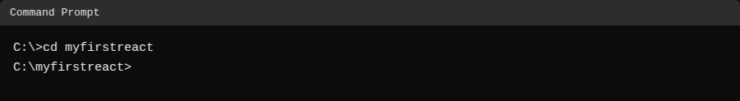
Screenshot 3: Navigating into the myfirstreact folder
The folder was then opened in Visual Studio Code, and the generated project structure was verified:
myfirstreact/
node_modules/
public/
index.html, favicon.ico, manifest.json ...
src/
App.js, App.css, App.test.js, index.js, index.css, logo.svg
package.json
package-lock.json
README.md

Step 5: Edit App.js
The App.js file inside the src folder was opened, its existing boilerplate content was removed, and replaced with the following code so the page displays the required heading:
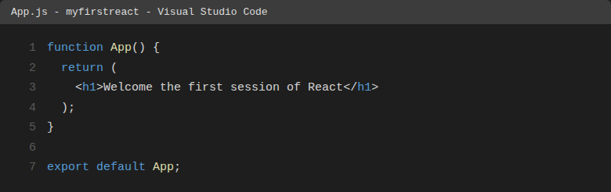
Screenshot 4: Updated App.js in Visual Studio Code

Step 6: Run the React Application
The following command was run inside the myfirstreact folder to start the development server:
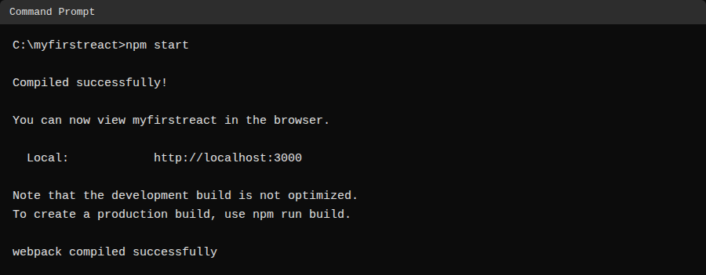
Screenshot 5: Running “npm start” – compiled successfully

Step 7: View the Output in the Browser
A browser window was opened and “localhost:3000” was entered in the address bar. The application loaded successfully and displayed the required heading, confirming the React app was built and is running correctly:
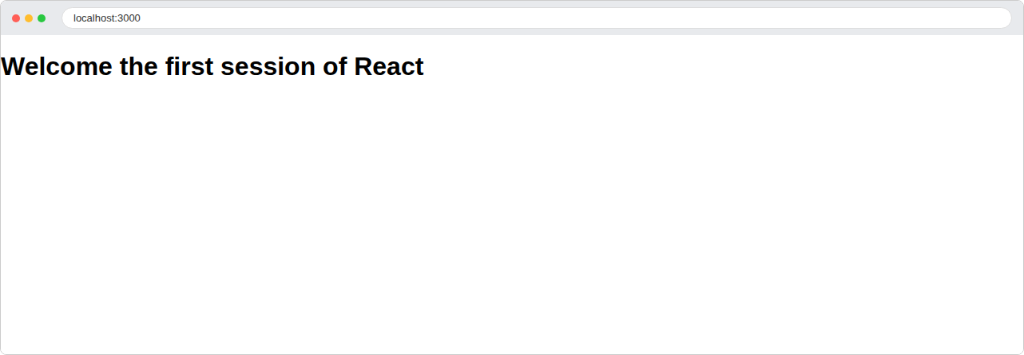
Screenshot 6: Final output in the browser – “Welcome the first session of React”

Conclusion
In this lab, the concepts of Single-Page Applications, React, the Virtual DOM, and React's core features were explained, and a fully working React application named “myfirstreact” was created from scratch using create-react-app. The App.js component was modified to render a custom heading, the development server was started using npm start, and the final result was verified in the browser at localhost:3000, successfully meeting all stated objectives.

