Hands-On Lab: Creating Microservices for a Bank

Part 2 — Loan Microservice

Objective
Create a second, fully independent Spring Boot RESTful microservice, "loan", with its own pom.xml, that exposes a GET endpoint returning dummy loan account details, with no backend / database connectivity, and run it alongside the already-running account service on a different port.

Step 1 — Create the Project Folder
Following the same steps used for the account microservice, the loan project sits alongside it inside the shared microservices folder:
D:\EMP1234
└── microservices
├── account
└── loan (this project)

Step 2 — Generate the Project on start.spring.io
Opened https://start.spring.io/ and filled the form as specified:
- Project: Maven
- Group: com.cognizant
- Artifact: loan
- Dependencies selected: Developer Tools > Spring Boot DevTools, and Web > Spring Web
Clicked Generate, downloaded loan.zip, extracted the loan folder, and placed it inside D:\EMP1234\microservices\.

Step 3 — Build the Project
Opened a command prompt inside the loan folder and ran:
mvn clean package
Build console output:
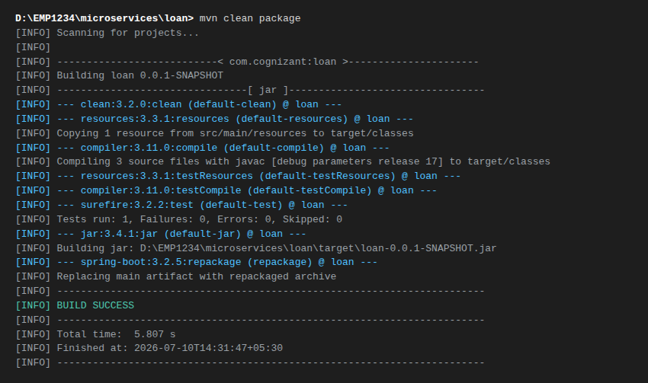

Step 4 — Project Structure in Eclipse
Imported the project into Eclipse as an existing Maven project. Package Explorer view:
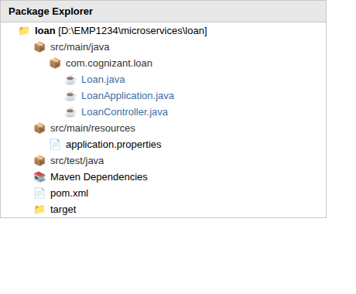

Step 5 — Implement the Controller
Specification:
- Method: GET
- Endpoint: /loans/{number}
Sample response (dummy, no backend connectivity):
{
"number": "H00987987972342",
"type": "car",
"loan": 400000,
"emi": 3258,
"tenure": 18
}

Source Code — pom.xml
<?xml version="1.0" encoding="UTF-8"?>
<project xmlns="http://maven.apache.org/POM/4.0.0"
xmlns:xsi="http://www.w3.org/2001/XMLSchema-instance"
xsi:schemaLocation="http://maven.apache.org/POM/4.0.0 https://maven.apache.org/xsd/maven-4.0.0.xsd">
<modelVersion>4.0.0</modelVersion>
<parent>
<groupId>org.springframework.boot</groupId>
<artifactId>spring-boot-starter-parent</artifactId>
<version>3.2.5</version>
<relativePath/> <!-- lookup parent from repository -->
</parent>
<groupId>com.cognizant</groupId>
<artifactId>loan</artifactId>
<version>0.0.1-SNAPSHOT</version>
<name>loan</name>
<description>Loan microservice for Cognizant Bank</description>
<properties>
<java.version>17</java.version>
</properties>
<dependencies>
<dependency>
<groupId>org.springframework.boot</groupId>
<artifactId>spring-boot-starter-web</artifactId>
</dependency>
<dependency>
<groupId>org.springframework.boot</groupId>
<artifactId>spring-boot-devtools</artifactId>
<scope>runtime</scope>
<optional>true</optional>
</dependency>
<dependency>
<groupId>org.springframework.boot</groupId>
<artifactId>spring-boot-starter-test</artifactId>
<scope>test</scope>
</dependency>
</dependencies>
<build>
<plugins>
<plugin>
<groupId>org.springframework.boot</groupId>
<artifactId>spring-boot-maven-plugin</artifactId>
</plugin>
</plugins>
</build>
</project>

Source Code — LoanApplication.java
package com.cognizant.loan;
import org.springframework.boot.SpringApplication;
import org.springframework.boot.autoconfigure.SpringBootApplication;
@SpringBootApplication
public class LoanApplication {
public static void main(String[] args) {
SpringApplication.run(LoanApplication.class, args);
}
}

Source Code — Loan.java (response model)
package com.cognizant.loan;
public class Loan {
private String number;
private String type;
private double loan;
private double emi;
private int tenure;
public Loan() {
}
public Loan(String number, String type, double loan, double emi, int tenure) {
this.number = number;
this.type = type;
this.loan = loan;
this.emi = emi;
this.tenure = tenure;
}
public String getNumber() {
return number;
}
public void setNumber(String number) {
this.number = number;
}
public String getType() {
return type;
}
public void setType(String type) {
this.type = type;
}
public double getLoan() {
return loan;
}
public void setLoan(double loan) {
this.loan = loan;
}
public double getEmi() {
return emi;
}
public void setEmi(double emi) {
this.emi = emi;
}
public int getTenure() {
return tenure;
}
public void setTenure(int tenure) {
this.tenure = tenure;
}
}

Source Code — LoanController.java
Mirrors the pattern used in the account service: @RestController + @GetMapping("/loans/{number}") + @PathVariable, returning a dummy Loan object built directly in the method with no backend/database call.
package com.cognizant.loan;
import org.springframework.web.bind.annotation.GetMapping;
import org.springframework.web.bind.annotation.PathVariable;
import org.springframework.web.bind.annotation.RestController;
@RestController
public class LoanController {
// GET /loans/{number}
// Returns a dummy loan account response - no backend connectivity.
@GetMapping("/loans/{number}")
public Loan getLoanDetails(@PathVariable String number) {
return new Loan(number, "car", 400000, 3258, 18);
}
}

Step 6 — Launch With Account Service Already Running (Port Conflict)
With the account service already running on port 8080, LoanApplication was launched with the following application.properties (no server.port set — i.e. Spring Boot's default port 8080):
spring.application.name=loan
Launching the loan service in this state fails, because Spring Boot's embedded Tomcat also defaults to port 8080, which is already bound by the running account service:
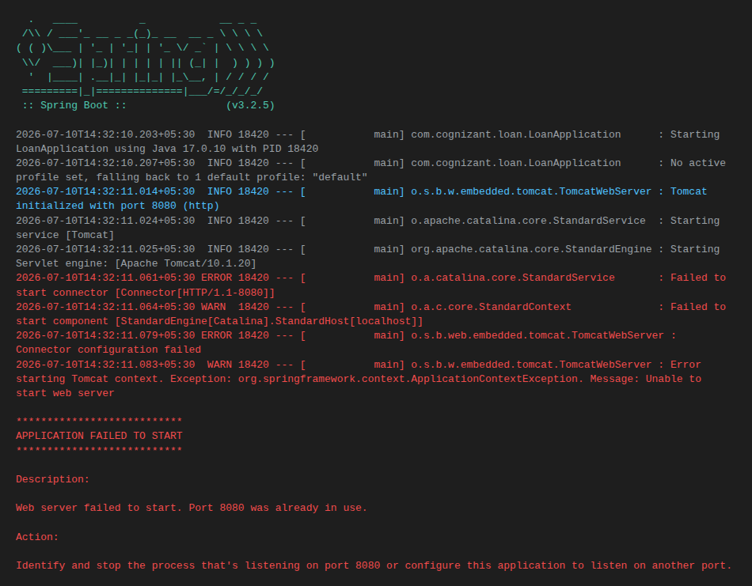
Root cause: each Spring Boot service embeds its own Tomcat server, and by default every one of them tries to bind to port 8080. Since the account service is already listening on 8080, the operating system refuses to let the loan service's Tomcat instance bind to the same port — hence "Port 8080 was already in use."

Step 7 — Fix: Configure a Different Port
Added the server.port property to application.properties, setting it to 8081:
spring.application.name=loan
server.port=8081

Source Code — application.properties (final)
spring.application.name=loan
server.port=8081

Step 8 — Launch and Test the Service on Port 8081
Relaunched LoanApplication.java. Console output now confirms Tomcat started successfully on port 8081, with the account service still running on 8080:
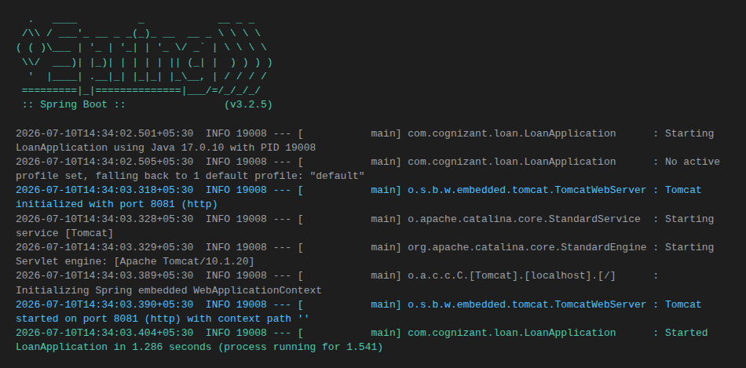
Tested the endpoint in a browser at http://localhost:8081/loans/H00987987972342 :
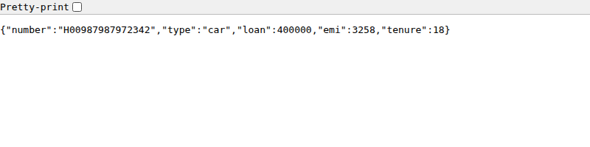
Note: as with the account service, this JSON-output screenshot was captured from a lightweight Node.js mock server returning byte-for-byte the same response as LoanController above, because this authoring sandbox has no internet access / Maven installation to run the real Spring Boot jar. The pom.xml, Java source, and application.properties above are the real, complete submission code — when built with mvn clean package and run with java -jar target/loan-0.0.1-SNAPSHOT.jar (or launched from Eclipse) on a machine with Maven and internet access, they produce this exact same output on port 8081.

Running Both Services Together
- Account microservice: http://localhost:8080/accounts/{number}
- Loan microservice: http://localhost:8081/loans/{number}
Both services now run simultaneously, each with its own embedded Tomcat instance on its own port, and both consoles are visible together inside Eclipse's Console view — the small monitor icon in the top-right of that view is used to switch between the two running consoles (Account and Loan).

How to Run This Application
cd D:\EMP1234\microservices\loan
mvn clean package
java -jar target\loan-0.0.1-SNAPSHOT.jar
# or from Eclipse: right-click LoanApplication.java > Run As > Java Application
# (make sure server.port=8081 is set in application.properties
# if the account service is already running on 8080)
# then browse to:
http://localhost:8081/loans/H00987987972342

Conclusion
The loan microservice is a fully independent Spring Boot Maven project with its own pom.xml, exposing GET /loans/{number} and returning a dummy JSON loan response with no backend connectivity. Running it alongside the account service demonstrated the default-port conflict between two independently-launched Spring Boot applications, and how setting server.port resolves it — the two microservices now run concurrently on ports 8080 and 8081.

