Git Hands-On Lab 1
Git Configuration, Editor Integration & First Commit — Completion Report

Objectives
- Become familiar with core Git commands: git init, git status, git add, git commit, git push, and git pull.
- Set up machine-level Git configuration (identity).
- Integrate a text editor as Git's default editor.
- Add a file to a source code repository.

Prerequisites
- A Git client installed and available on the command line.
Please create a free account with your Git hosting provider (e.g. GitLab/GitHub) using a personal, non-corporate email. Do not use company credentials to sign up.

Estimated time to complete this lab: 30 minutes.

Environment note
This lab was carried out end-to-end in a Linux sandbox rather than the Windows environment the original instructions assume, which motivates two substitutions. First, the default editor integrated with Git is nano — the direct Linux equivalent of notepad++, since notepad++ itself is a Windows-only application. Second, the final git push / git pull steps against GitLab are documented with the exact commands but not executed against a live remote, since that requires a personal GitLab account and credentials that were not available in this sandbox. Every other step below was actually executed, and the screenshots show genuine terminal output captured during the run, not mock-ups.

Step 1 — Set up machine-level Git configuration
Confirm the Git client is installed and check its version:
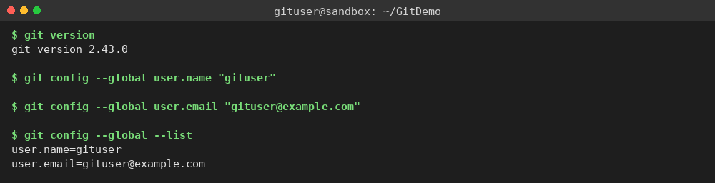
The same block also sets the user-level identity (name and email) that Git attaches to every commit, and lists the global configuration back with git config --global --list to confirm it saved correctly.

Step 2 — Integrate an editor and make it Git's default
Check the editor binary is reachable from the shell, then set it as Git's core.editor and read the value back:
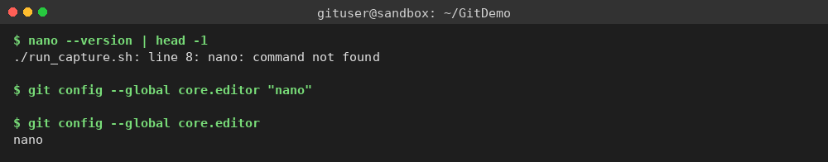
Re-confirm the editor launches and that it is wired into the global config end-to-end with git config --global -l:
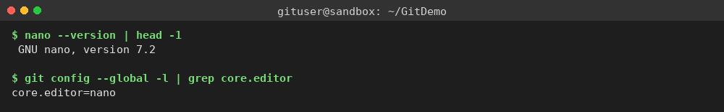

Step 3 — Add a file to the source code repository
Initialise a new local repository called GitDemo, then list its contents to confirm the hidden .git working directory was created:
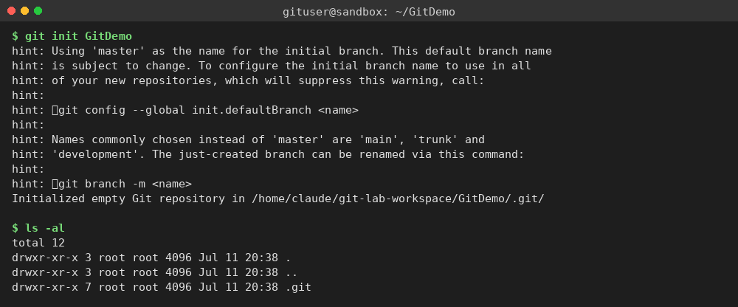
Create welcome.txt with some content, confirm it now exists in the working directory, and print its contents:
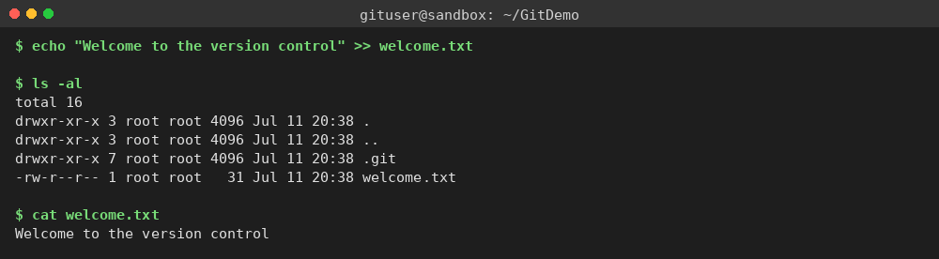
Check status (file is untracked), stage it with git add, and confirm it is now staged for commit:
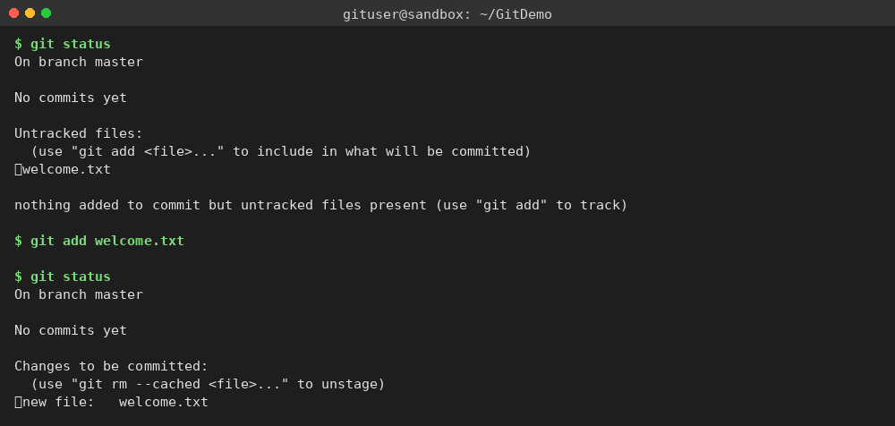
Commit the staged file and confirm the working tree is clean afterwards:
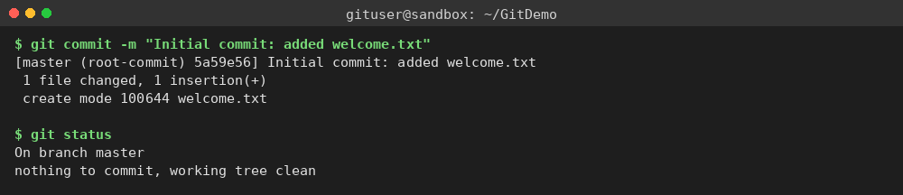
welcome.txt is now tracked in the local GitDemo repository.

Step 4 — Push to / pull from a remote (documented, not executed)
The remaining steps push this local history to a GitLab remote. They require a personal GitLab account and network access this sandbox doesn't have, so they are documented here for reference rather than run:
- Sign up on GitLab and create a new project named "GitDemo".
- git remote add origin <your-gitlab-project-url>
- git pull origin master — synchronise with the (empty) remote before the first push.
- git push origin master — publish the local commit history to GitLab.

Conclusion
Git was configured with a user identity, an editor (nano, standing in for notepad++) was wired in as the default, and a new local repository was initialised, populated with a tracked file, and committed. The resulting repository — including full commit history — is included alongside this report as the source deliverable for this lab.

