Git Hands-On Lab 2
Ignoring Unwanted Files with .gitignore — Completion Report

Objectives
- Explain git ignore.
- Explain how to ignore unwanted files using git ignore.
- Implement the git ignore command to ignore unwanted files and folders.

Prerequisites
- A working Git environment (see Lab 1).
- An editor integrated as Git's default editor.
- A Git repository in the local system, with a remote repository in GitLab.
Please create a free account with your Git hosting provider (e.g. GitLab/GitHub) using a personal, non-corporate email. Do not use company credentials to sign up.

Estimated time to complete this lab: 20 minutes.

Task
Create a ".log" file and a log folder in the working directory of the GitDemo repository from Lab 1. Update the .gitignore file so that, on committing, these files (.log extensions and log folders) are ignored. Verify that git status reflects this correctly for the working directory, local repository, and remote repository.

Step 1 — Create files that should be ignored
Starting from the clean GitDemo repository left by Lab 1, confirm the working tree is clean:
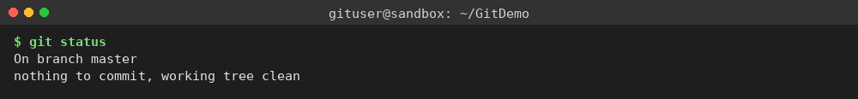
Create a stray log file and a log folder with a file inside it:
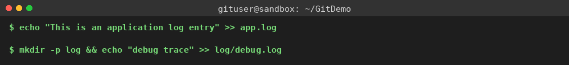
List the directory and check status — both app.log and log/ show up as untracked, which is the problem this lab solves:
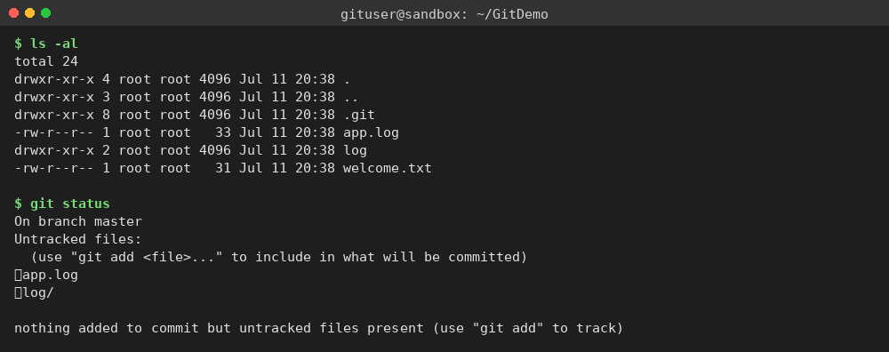

Step 2 — Create and apply .gitignore
Create a .gitignore file with two patterns — *.log to match any file ending in .log, and log/ to match the log directory and everything inside it — then confirm its contents:
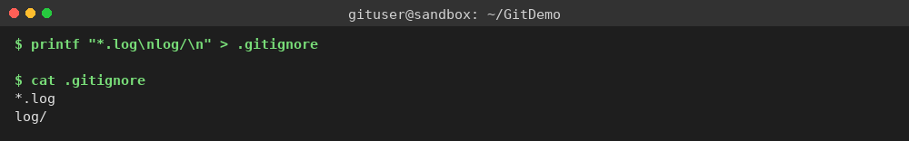
Re-run git status: app.log and log/ have disappeared from the untracked list — only the new .gitignore file itself needs to be added. This confirms the ignore rules are working as expected:
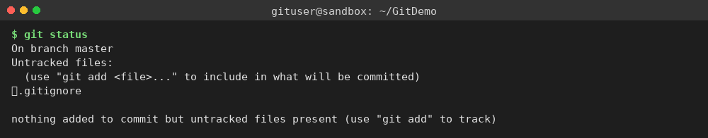

Step 3 — Commit .gitignore and verify final state
Stage and commit .gitignore, then re-check status to confirm the repository is fully clean while app.log and log/debug.log remain physically present on disk, untouched by Git:
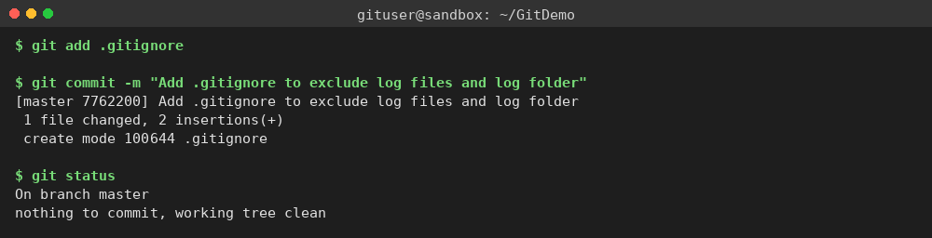

Result
git status confirms the working directory, the local (staged) repository, and the committed repository all agree: app.log and log/ are excluded from version control by the .gitignore rules, while welcome.txt and .gitignore itself remain tracked. A remote GitLab repository was not pushed to in this sandbox (see the Environment note in the Lab 1 report) — the same git push origin master command from Lab 1 would propagate this commit and the same ignore behaviour to GitLab.

