Git Hands-On Lab 3
Branching and Merging — Completion Report

Objectives
- Explain branching and merging.
- Explain creating a branch request in GitLab.
- Explain creating a merge request in GitLab.
- Construct a branch, make changes on it, and merge it back into master (trunk).

Prerequisites
- A working Git environment (see Labs 1 and 2).
- P4Merge installed, for visual diffs on Windows.
Please create a free account with your Git hosting provider (e.g. GitLab/GitHub) using a personal, non-corporate email. Do not use company credentials to sign up.

Estimated time to complete this lab: 30 minutes.

Environment note
P4Merge is a graphical diff/merge tool that needs a desktop display; it can't run headlessly in this sandbox. Its role in this lab — showing a visual, side-by-side diff between master and GitNewBranch — is covered functionally below with git diff, which reports the same underlying change set from the command line. The command that would open the same comparison in P4Merge is documented in Step 2 for reference.

Branching

Step 1 — Create a new branch
Create GitNewBranch, then list all branches — note the * marking master as the currently checked-out branch:
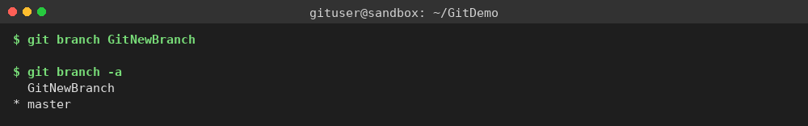

Step 2 — Switch to the new branch
Check out GitNewBranch and list branches again — the * now points at GitNewBranch:
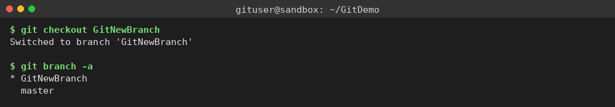

Step 3 — Add content and commit on the branch
Add a new file with some content, stage it, and commit it — this commit exists only on GitNewBranch so far:
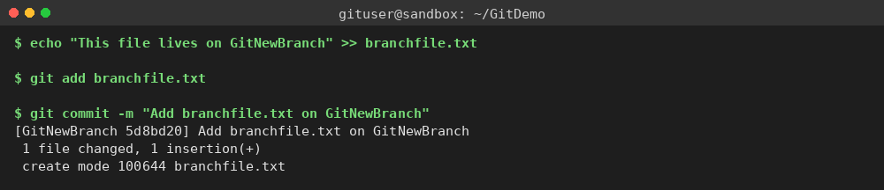

Step 4 — Check status
Confirm the working tree is clean on GitNewBranch, then switch back to master:
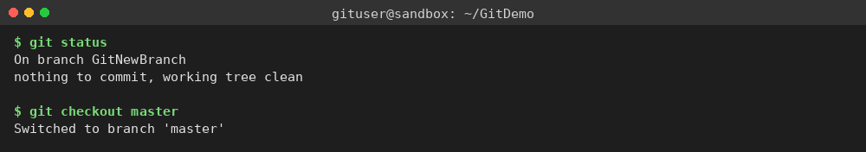

Merging

Step 1 — Switch to master
Already shown above — master is checked out at the end of the previous screenshot.

Step 2 — Compare master and the branch
List the command-line differences between the two branches with git diff, then merge GitNewBranch into master. Because master had not moved since the branch point, Git performs a fast-forward merge:
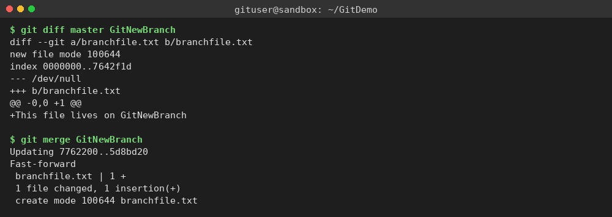
The same comparison as a visual, side-by-side diff in P4Merge (documented command, not run in this sandbox — see the Environment note above):
git difftool --tool=p4merge master GitNewBranch

Step 3 — Merge, inspect history, and clean up
View the commit graph with git log --oneline --graph --decorate to confirm the branch commit is now part of master's history, delete the now-merged branch, and check status:
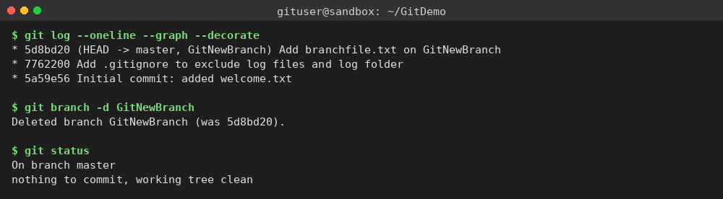
Finally, list branches once more to confirm GitNewBranch is gone and only master remains:

Result
branchfile.txt, created and committed on GitNewBranch, is now part of master's history after the merge. git log --oneline --graph --decorate shows a clean, linear history (a fast-forward merge, since master had no divergent commits), and git branch -a confirms the feature branch was successfully deleted after merging, exactly as the lab requires.

