Hands-On Lab: Styling React Components
Application: Cognizant Academy Cohort Dashboard (CSS Modules)

Objectives
- Understanding the need for styling react components
- Working with CSS Module and inline styles

Task Summary
- Download and build the attached react application, restore node packages.
- Create a new CSS Module file: CohortDetails.module.css.
- Define a css class 'box': width 300px, display inline-block, 10px overall margin, 10px top/bottom padding, 20px left/right padding, 1px black border, 10px border radius.
- Define a css style for the <dt> tag selector with font-weight 500.
- Import the CSS Module in the CohortDetails component and apply the box class to the container div.
- Style the <h3> element: green when cohort status is "ongoing", blue in all other scenarios.

Approach / Steps Followed
1. Created CohortDetails.module.css as a CSS Module (file name ends in .module.css so Webpack/CRA automatically scopes class names locally to the component that imports it).
2. Defined the .box class exactly per spec (300px width, inline-block, 10px margin, 10px top/bottom + 20px left/right padding, 1px solid black border, 10px border-radius) and a bare 'dt' tag selector with font-weight: 500.
3. In CohortDetails.jsx, imported the module as: import styles from './CohortDetails.module.css' and applied it to the container div using className={styles.box} — this is how CSS Modules are consumed (as a JS object mapping class names to their generated, collision-free identifiers).
4. The <h3> heading color rule is dynamic (depends on data), so it is implemented with an inline style rather than the CSS Module: style={{ color: cohort.status === 'ongoing' ? 'green' : 'blue' }}. This demonstrates the difference between CSS Modules (static, reusable, scoped class-based styling) and inline styles (per-instance, data-driven styling).

Source Code — CohortDetails.module.css
.box {
width: 300px;
display: inline-block;
margin: 10px;
padding: 10px 20px;
border: 1px solid black;
border-radius: 10px;
}
dt {
font-weight: 500;
}

Source Code — CohortDetails.jsx
import React from 'react';
import styles from './CohortDetails.module.css';
// -----------------------------------------------------------
// CohortDetails - Academy team dashboard component
// Uses CSS Module (className) + inline style (for status color)
// -----------------------------------------------------------
const cohorts = [
{ id: 1, name: "React JS - Batch 21", trainer: "Priya Menon", status: "ongoing" },
{ id: 2, name: "Java Full Stack - Batch 14", trainer: "Arun Kumar", status: "completed" },
{ id: 3, name: "Python & Data - Batch 9", trainer: "Sneha Reddy", status: "ongoing" },
{ id: 4, name: ".NET Core - Batch 6", trainer: "Vikram Singh", status: "completed" }
];
function CohortDetails() {
return (
<div style={{ fontFamily: "Segoe UI, Arial, sans-serif", padding: "20px" }}>
<h1>Cognizant Academy - Cohort Dashboard</h1>
{cohorts.map((cohort) => (
// "box" class applied to the container div via CSS Module
<div key={cohort.id} className={styles.box}>
{/* h3 color depends on status: green for ongoing, blue otherwise */}
<h3 style={{ color: cohort.status === "ongoing" ? "green" : "blue" }}>
{cohort.name}
</h3>
<dl>
<dt>Trainer</dt>
<dd>{cohort.trainer}</dd>
<dt>Status</dt>
<dd>{cohort.status}</dd>
</dl>
</div>
))}
</div>
);
}
export default CohortDetails;

CSS Modules vs Inline Styles
- CSS Modules: written in a real .css file, support pseudo-classes/media queries, class names are locally scoped at build time to avoid collisions, applied via className.
- Inline styles: JS objects passed via the style prop, best for values that are computed at runtime (like the status-based color here), but do not support pseudo-classes or media queries.

Output Screenshot
Below is the rendered dashboard: each cohort is displayed inside a 'box'-styled card (border, radius, padding, margin from the CSS Module), with the heading colored green for "ongoing" cohorts and blue for "completed" ones.
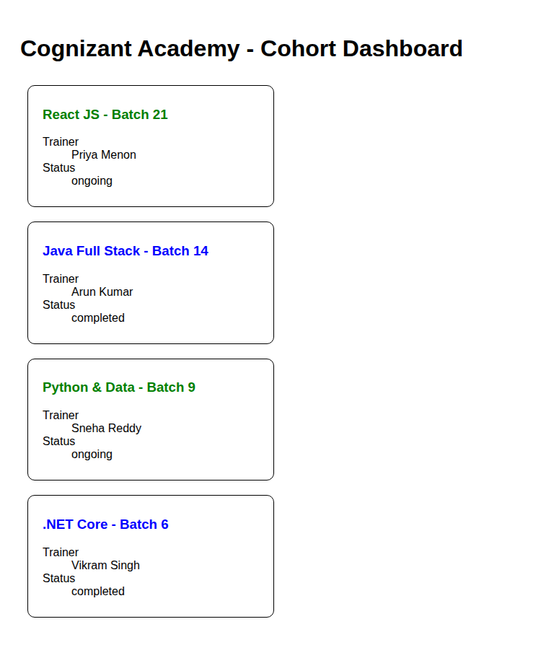

How to Run This Application
# unzip the provided react application
cd <app-folder>
npm install
# add CohortDetails.module.css and update CohortDetails.jsx as above
npm start

Conclusion
This lab demonstrates two complementary approaches to styling React components — CSS Modules for reusable, collision-free static styling (className={styles.box}) and inline styles for per-instance, data-driven styling (the ongoing/completed heading color) — and shows how both can be combined in a single component.

