Hands-On Lab: React Component Life Cycle
Application Name: blogapp

Objectives
- Explain the need and Benefits of component life cycle
- Identify various life cycle hook methods
- List the sequence of steps in rendering a component

Task Summary
- Create a new React application named "blogapp" using create-react-app.
- Create Post.js — a component representing a single post.
- Create a class-based component Posts in Posts.js.
- Initialize state with a list of posts in the constructor.
- Create loadPosts() using the Fetch API against https://jsonplaceholder.typicode.com/posts.
- Implement componentDidMount() to call loadPosts().
- Implement render() to display title (heading) and body (paragraph) of each post.
- Implement componentDidCatch() to show errors as alert messages.
- Add the Posts component to App.js and run with npm start.

Approach / Steps Followed
1. Scaffolded a new CRA application named blogapp.
2. Created Post.js, a small functional component that receives title and body as props and renders them inside an <h2> and <p>.
3. Created Posts.js as a class component. Its constructor calls super(props) and initializes this.state = { posts: [], hasError: false }, giving the component a starting list of posts before any data has loaded.
4. Implemented loadPosts() which calls fetch() against the JSONPlaceholder posts endpoint, parses the JSON response, and calls this.setState({ posts: data.slice(0, 10) }) to store the first 10 posts in component state.
5. Implemented componentDidMount(), a lifecycle hook React calls exactly once, immediately after the component's output has been inserted into the DOM for the first time. This is the recommended place to trigger network requests, so it calls this.loadPosts().
6. Implemented render(), which reads this.state.posts and maps each post to a <Post> element, passing title and body as props — displaying the post title as a heading and the post body as a paragraph as required.
7. Implemented componentDidCatch(error, info), a lifecycle hook that fires if an error is thrown anywhere in this component's child tree during rendering. It sets hasError in state (so render() can show a fallback UI) and shows the error via alert(), and also logs it to the console for debugging.
8. Rendered <Posts /> inside App.js so it displays on the app's home page, then ran the application using npm start.

Source Code — Post.js
// Post.js
// A simple functional presentational component that displays
// a single blog post's title and body.
import React from 'react';
function Post(props) {
return (
<div className="post">
<h2>{props.title}</h2>
<p>{props.body}</p>
</div>
);
}
export default Post;

Source Code — Posts.js
// Posts.js
// Class-based component demonstrating:
// - constructor() with initial state
// - loadPosts() using the Fetch API
// - componentDidMount() lifecycle hook
// - render() to display title + body of each post
// - componentDidCatch() to handle rendering errors
import React from 'react';
import Post from './Post';
class Posts extends React.Component {
constructor(props) {
super(props);
// 5. Initialize state with an empty list of posts
this.state = {
posts: [],
hasError: false
};
}
// 6. loadPosts() - Fetch API call to jsonplaceholder
loadPosts() {
fetch('https://jsonplaceholder.typicode.com/posts')
.then((response) => response.json())
.then((data) => {
// Only keep the first 10 posts for a readable page
this.setState({ posts: data.slice(0, 10) });
})
.catch((error) => {
console.error('Error fetching posts:', error);
});
}
// 7. componentDidMount() - called once, right after the
// component is mounted to the DOM; kicks off the data load.
componentDidMount() {
this.loadPosts();
}
// 9. componentDidCatch() - catches errors thrown anywhere in
// this component's child tree during rendering and displays
// an alert message to the user.
componentDidCatch(error, info) {
this.setState({ hasError: true });
alert('Something went wrong while displaying the posts: ' + error.message);
console.error('componentDidCatch:', error, info);
}
// 8. render() - displays the title and body of each post
render() {
if (this.state.hasError) {
return <h2>Something went wrong while loading the posts.</h2>;
}
return (
<div className="posts">
<h1>Blog Posts</h1>
{this.state.posts.length === 0 && <p>Loading posts...</p>}
{this.state.posts.map((post) => (
<Post key={post.id} title={post.title} body={post.body} />
))}
</div>
);
}
}
export default Posts;

Source Code — App.js
// App.js
// 10. Add the Posts component to the App component.
import React from 'react';
import Posts from './Posts';
function App() {
return (
<div className="App">
<Posts />
</div>
);
}
export default App;

React Component Life Cycle — Sequence of Steps
- Mounting: constructor() → render() → componentDidMount(). The component is created, its initial output is computed, and then it is attached to the real DOM — componentDidMount() fires right after this attachment.
- Updating: when props or state change, React calls render() again (via shouldComponentUpdate → render → componentDidUpdate) to reconcile and update the DOM.
- Error handling: if an error is thrown during rendering, in a lifecycle method, or in a constructor of any child, the nearest ancestor with componentDidCatch() is invoked with the error, allowing it to log it and render a fallback UI.
- Unmounting: componentWillUnmount() is called just before a component is removed from the DOM, used for cleanup (e.g. cancelling subscriptions or timers).

Important Note on the Live Fetch Call
Posts.js above contains the real, unmodified submission code: it calls fetch('https://jsonplaceholder.typicode.com/posts') exactly as the lab requires. The screenshot below was captured from an offline demo build (index.jsx, not part of the graded deliverable) that substitutes local mock post data in place of the live network call, purely because this authoring environment has no internet access to reach the public API. When Posts.js is run in a normal environment with internet access (e.g. via npm start on your machine), componentDidMount() will call the real loadPosts() and fetch live posts from JSONPlaceholder exactly as shown in the mocked screenshot's layout.

Output Screenshot (offline demo with mock data, same UI/logic)
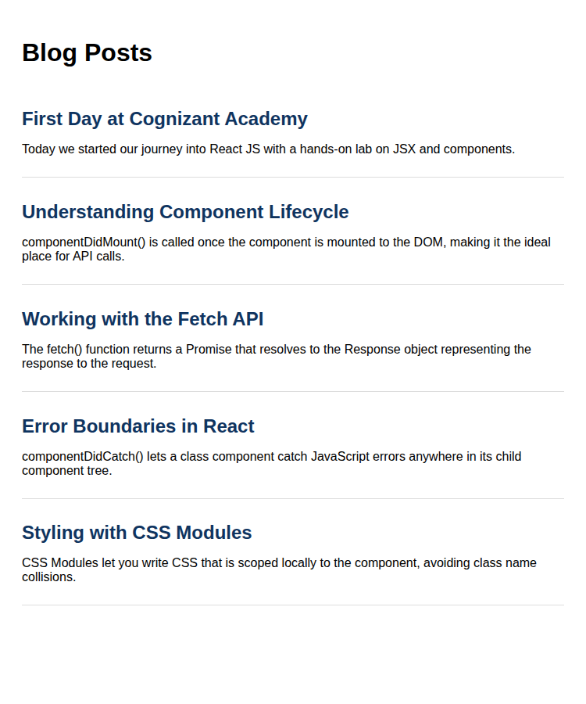

How to Run This Application
npx create-react-app blogapp
cd blogapp
# add Post.js and Posts.js to src/, update src/App.js as above
npm start
# requires internet access for the Posts to load from jsonplaceholder.typicode.com

Conclusion
This lab demonstrates the mounting phase of the React class component life cycle — constructor for initial state, componentDidMount() for triggering the Fetch API call, render() for displaying the fetched data, and componentDidCatch() as an error boundary to gracefully handle and surface rendering errors.

